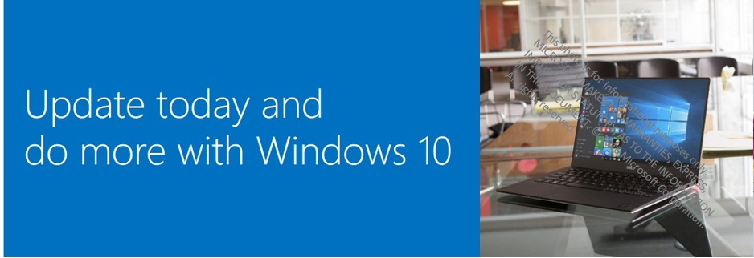

………

How to get it
<FirstName>, the November update for Windows 10 is ready for you! Here’s what you need to know.

Your device below will begin receiving prompts to install the Windows 10 update next week. If you don’t want to wait, you can upgrade through <insert deployment tool> as soon as you like. Just like installing Windows 10, running the upgrade is really easy. It will only take 30-60 minutes, depending on your network connection, and all of your data and settings will migrate during the update. Go to URL <insert resource name and URL> for more information.

Device to be updated: <DeviceName> - <Model>

If you have not updated by noon local time on <date>, your device will be automatically updated.

Note: If you have a valid business reason for remaining on your current operating system, you may opt out <insert resource URL> by <date>.

Learn More
This Windows 10 update includes some great new enterprise features <insert resource URL> for your Windows 10 device, including enhanced security with Windows Hello for Business, enhanced functionality in Microsoft Edge, and the ability to easily reset your work device.

Check out these resources for more helpful information:

- Connecting remotely to the corporate network <insert resource URL>
- Application compatibility <insert resource URL>
- FAQs <insert resource URL>
- Known Issues <insert resource URL>
- Be more productive using producitivity guides <insert resource URL>

Information & Support
Technical Assistance —
- Visit URL <insert resource name and URL> to give feedback and get support.
- Contact your local Helpdesk Call Center <insert resource URL>.

Thank you,
<Signature>

 | Get the Windows 10 November update today! | Company Logo

