Microsoft Digital Civility Index (DCI) 2017 – Global



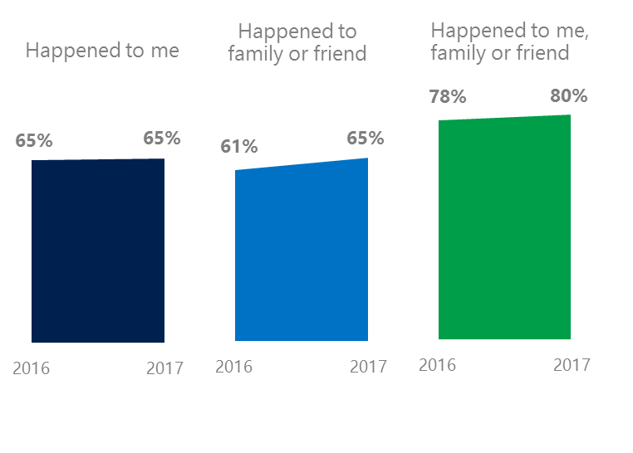The 2017 Civility, Safety and Interaction Online study examines the extent of negative behaviors and online interactions and their consequences. These results build on last year’s study and were based on interviews with teens ages 13-17 and adults ages 18-74. The scope of research increased to encompass 23 countries and 20 online risks (nine newly included countries, three added risks).[1]

Online risks increased for family & friends **widespread**

Themes for 2017

1. The overall level of online risks and consequences held steady with a small increase among family and friends.
2. Targets of online risks often named acquaintances, friends or family as perpetrators.
3. Encouraging signs emerged as people began to evolve their approaches towards the challenges of negative online interactions.
4. Millennials (ages 18-34) had the highest lifetime exposure to online risks while Baby Boomers (ages 50-74) reported the highest level of civil behavior.
5. Females bore the brunt of bullying, harassment and their consequences.

Hoaxes, scams & frauds drove Intrusive risks

 1Global DCI held steady at 65%

Nearly two-thirds of internet users had experienced an online risk while the relative ranking between risks remained steady. The addition of new countries and online risks to the study had a small impact on overall YOY trends. DCI would have fallen three points to 62%, a favorable trend, without these changes. We maintained and added to the four risk categories.

**Intrusive:** Unwanted Contact (41%) and Hoaxes, Scams & Frauds (27% as a collective) were the two most prevalent risks. The addition of the latter risk caused a six-point increase in the category YOY. The Intrusive category would have been unchanged YOY without this addition.

**Behavioral:** Behavioral risks were unchanged YOY. More than one in five had experienced being Treated Mean (21%), the fourth highest individual risk overall.

**Sexual:** One in four had experienced Unwanted Sexting (received or sent, 25%) which ranked as the third most common risk online.

**Reputational:** Among Reputational risks, Doxing (9%) fell three points and helped to push the category down slightly YOY.

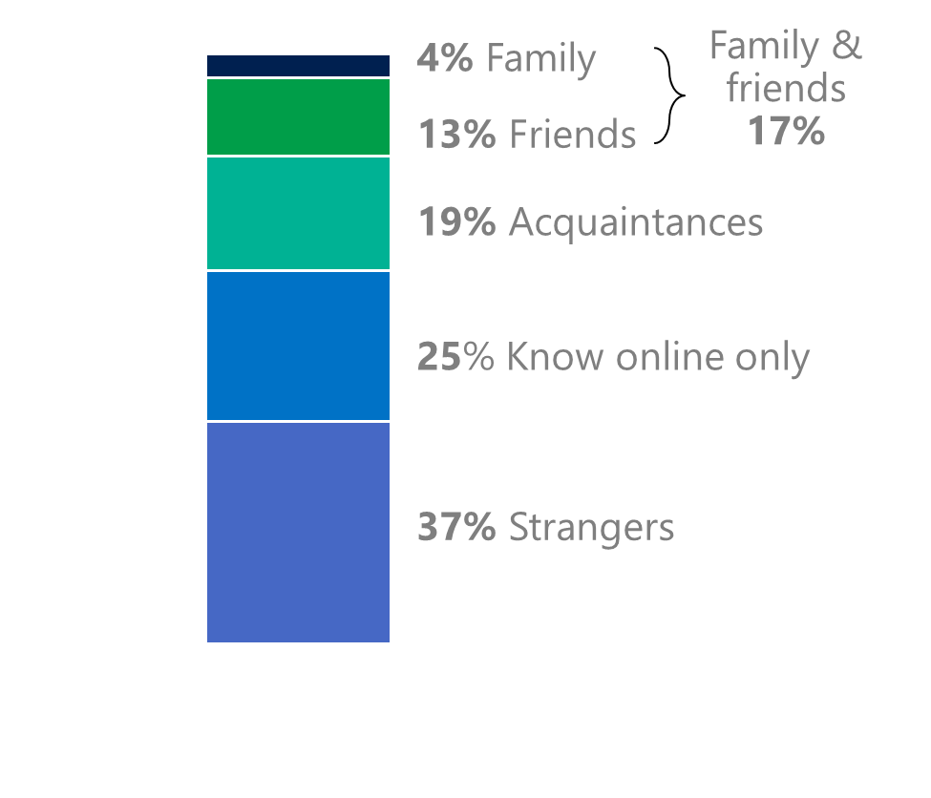2Targets of online risks often named their inner social circle as perpetrators

17% of perpetrators were family or friends

(among those who said they were treated unsafely or uncivilly)

Although many believe online risks are facilitated by the anonymity provided by the internet, these experiences often involved people they knew personally including family and friends (17%). Overall, slightly more than half (53%) had met their perpetrator in real life; about the same as in 2016. Among those who met the perpetrator, 76% had met their perpetrator before the risk occurred. Familiarity with the perpetrator in real life was related to an increased exposure to online risks. The average number of risks was 66% higher among those who had met their perpetrator in real life vs. those who had not (4.9 vs. 2.9).

Loss of trust was the biggest consequence

Familiarity with the perpetrator in real life also affected exposure to consequences. Nearly seven in 10 respondents (68%) suffered at least one consequence from online risks with loss of trust online and offline being the most common. Among those who had met their perpetrator in real life, 53% lost trust in others online and 42% lost trust in others offline. This compared to a loss of trust online (37%) and offline (23%) for those who had not met the perpetrator in real life.

3 Encouraging signs emerged

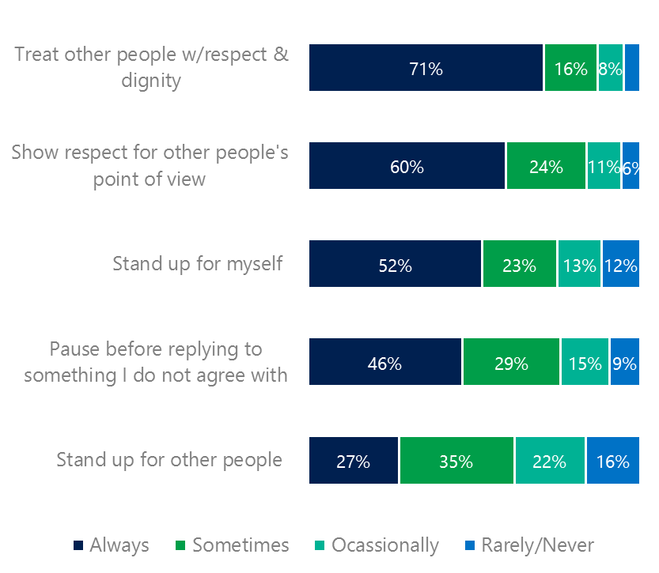There were signs that people had evolved new ways to manage negative online interactions. A clear majority of respondents stated that they actively tried to treat others with respect and dignity while protecting themselves, and to a lesser extent, others online. People were less confrontational (10%, -11 points YOY) and more likely to stand down rather than retaliate (9%, -8 points YOY) in response to being abused. A quarter said they tried to be more constructive in their criticism of others.

Reports of civil behavior were widespread

More people knew where to find help if needed (45%, +8 points YOY) while nearly half (46%, -2 points YOY) said they were extremely or very confident in managing online risks.

Females were more likely than males to always treat others with respect and dignity (74%, 68%) and to always show respect for other’s points of view (62%, 57%). Like females, older respondents reported higher levels of civil behavior than younger respondents.

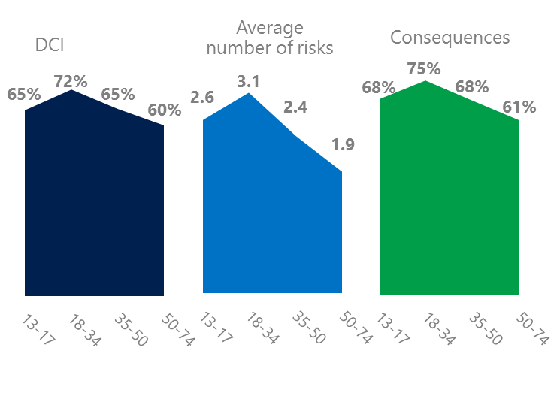4 Millennials had the highest lifetime risk exposure

Three in four Millennials experienced a consequence from online risks

Millennial generation respondents (ages 18-34) had the highest levels of risk exposure as measured by DCI (72%), average number of risks (3.1) and consequences from risks (75%). One possible explanation for these high levels is that Millennials were the first generation to grow up in a digital, media-saturated world with abundant free time to explore and experiment. Nearly one in five (17%) said they were not treated in a safe or civil manner online which was highest among all age groups. As a result, 43% of Millennials were extremely or very concerned about online risks.

Conversely, the Baby Boom generation (ages 50-74) had the lowest online risk exposure (60%), consequences (61%) and concerns about online risks (32%). More importantly, this age group reported the highest levels of civil behavior online as defined by the Microsoft Digital Civility Challenge, announced in 2017. They were more likely to treat others with respect and dignity and to be thoughtful in online exchanges when people disagreed. In general, civil behavior increased with age except for standing up for others. Teens ages 13-17 scored the highest on this item among all age groups at 29%.

Boomers were the most respectful & civil

5 Females bore the brunt of harassment, bullying & their consequences

56% of females were harassed

Teenage girls ages 13-17 experienced higher levels of harassment than teenage boys ages 13-17 (56% vs. 47%) – which this study defined as Unwanted Contact, Unwanted Sexting, Online Harassment, Cyberbullying or Misogyny. Like teenage girls, more than half of adult women (56%) experienced at least one of five types of harassment. Adult men reported a slightly lower level of harassment (54%).

The severity of consequences from harassment was higher for females than males. Adult and teenage females were more likely to lose trust in others online and offline, have greater life stress and had higher rates of depression. Consequences from harassment were greater for teenage girls compared to adult women. Teenage girls and boys were nearly three times more likely to have thoughts of suicide compared to adult women and men.

1. 9 new countries: Argentina, Colombia, Peru, Hungary, Ireland, Italy, Japan, Malaysia, Vietnam

   14 Wave 1 countries: Australia, Belgium, Brazil, Chile, China, France, Germany, India, Mexico, Russia, South Africa, Turkey, UK, US

   3 new online risks: Hoaxes, Frauds and Scams as one collective risk, Microaggression, Misogyny