Batch Process
Manual
V 1.0

Table of Contents
Purpose 3
Sign In 3
New Batch Process 4

Purpose
The manual will give instructions on how to create a new batch process.

Sign In

- Install the two solutions that were provided: CRM Dynamics Foundation API and Batch Process

- Verify that there are two configuration records in the API Configuration entity. If they are not present, please ask CRM Dynamics.
- Login to Core API by going to Foundation API > Settings. The credentials provided will be used by the Batch Process to talk to your CRM instance.

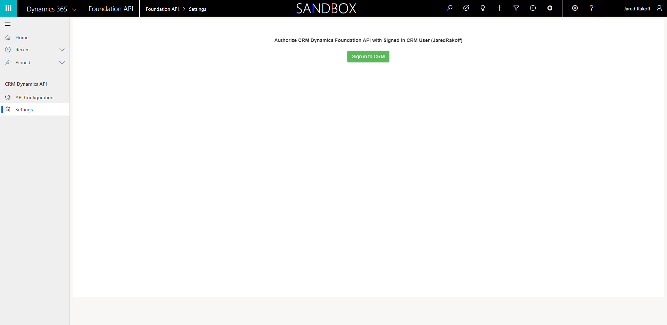
- Navigate to the “Batch Process” API Configuration record. Fill in the Host, this is mandatory for the batch process to work. The Host field is the url of your CRM Instance.
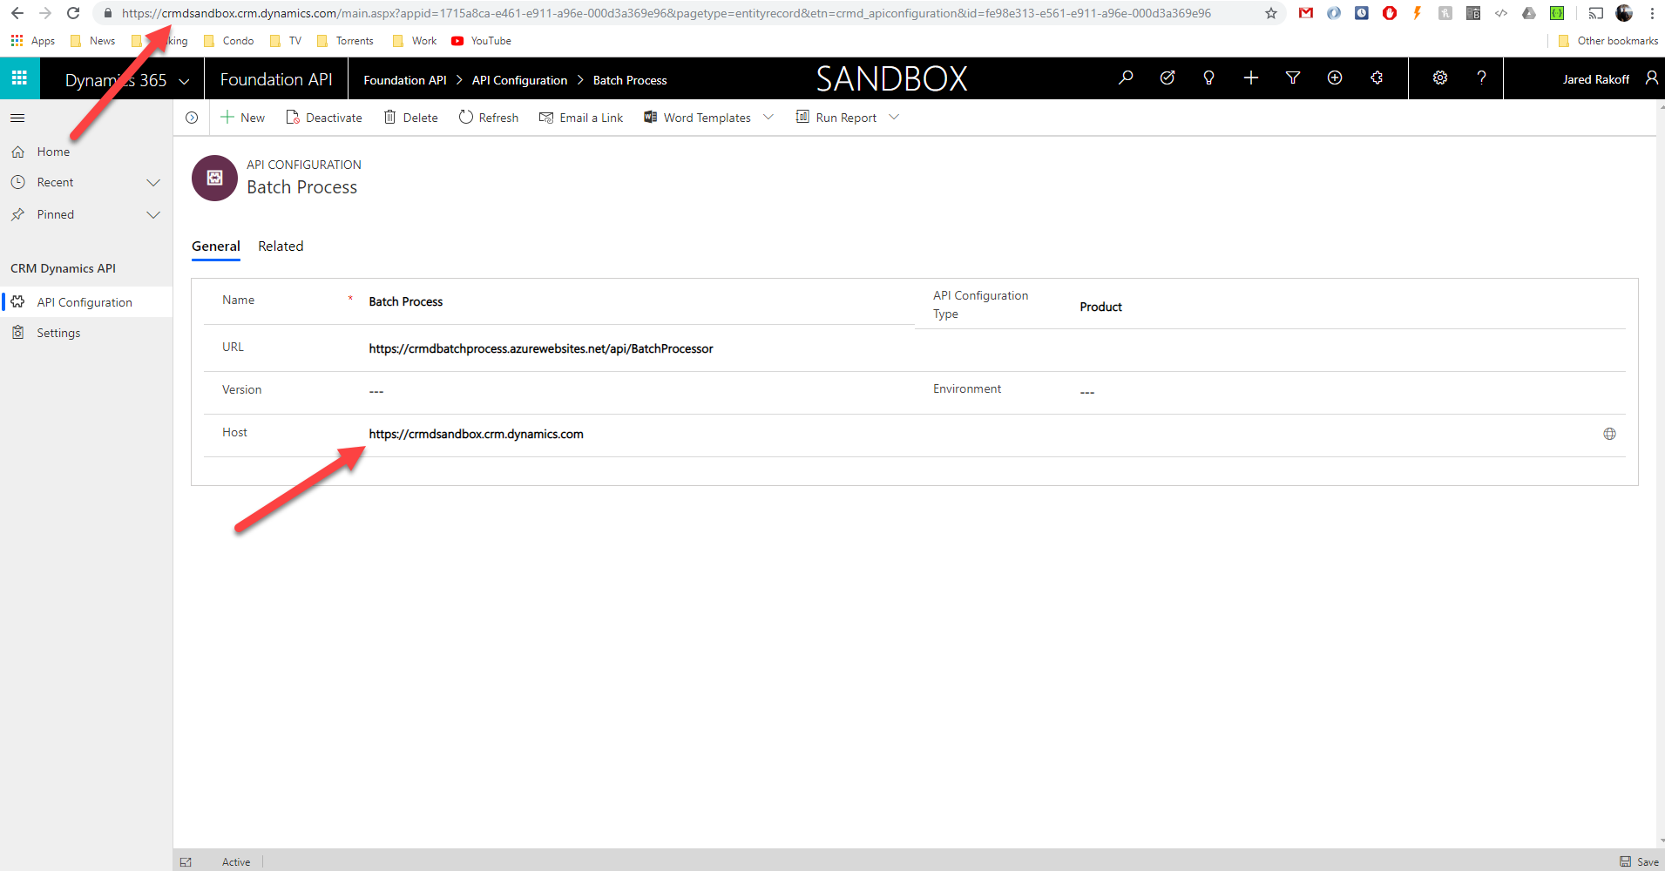

New Batch Process

- Navigate to Batch Process.

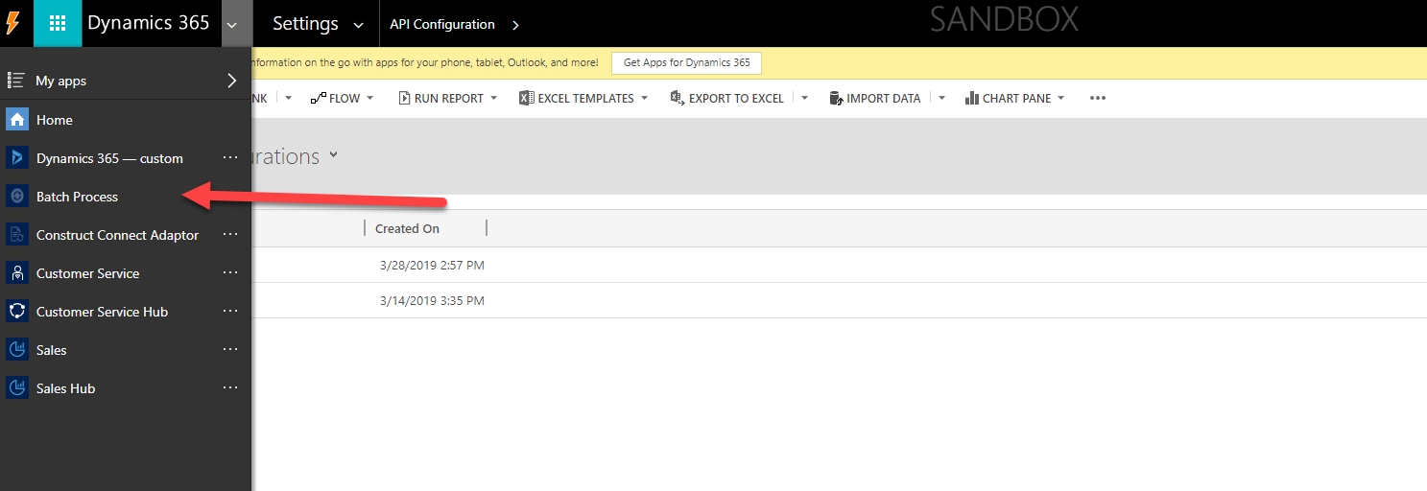

- Create a record and select an Active workflow of your choice.

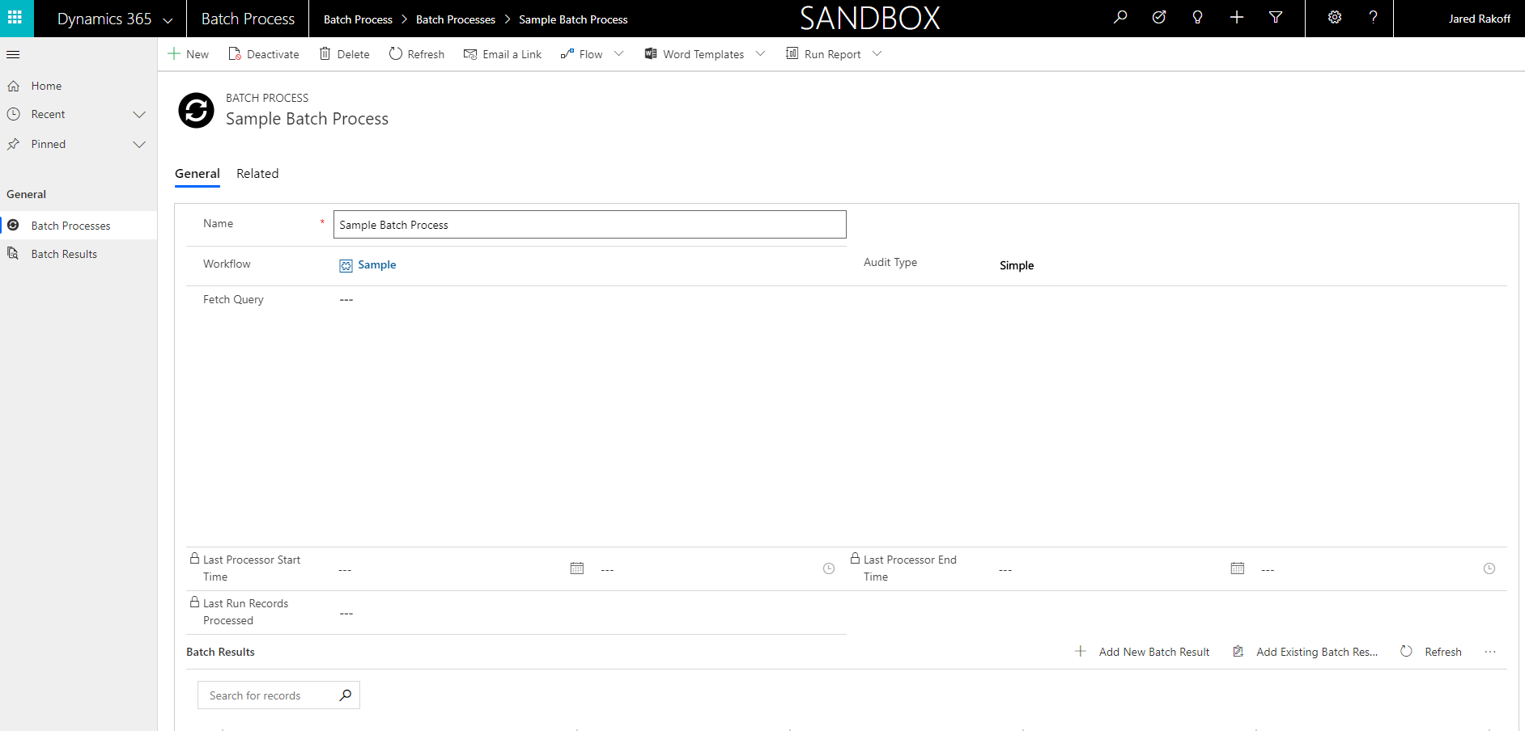

- Make note of the Process’ Entity and verify that the workflow is set to run on demand.

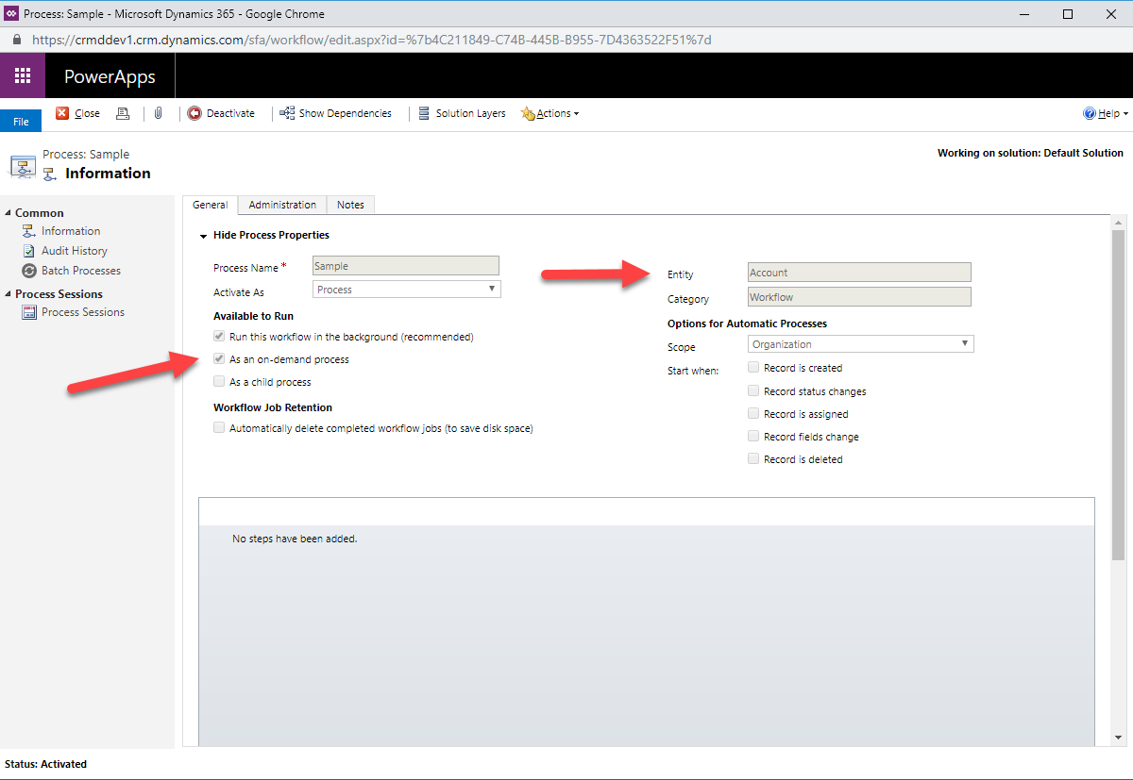

- Define your audience for the workflow to run against. The entity must match your workflow entity of step #3. Use advanced find to create your Fetch Query. Download the fetch XML when complete.

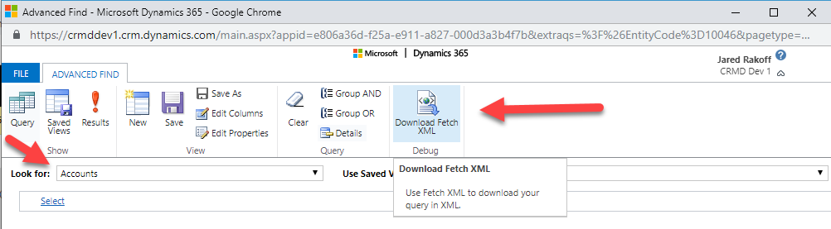

- Copy and Paste the fetch query from step #4 into the Fetch Query of the Batch Process and save.

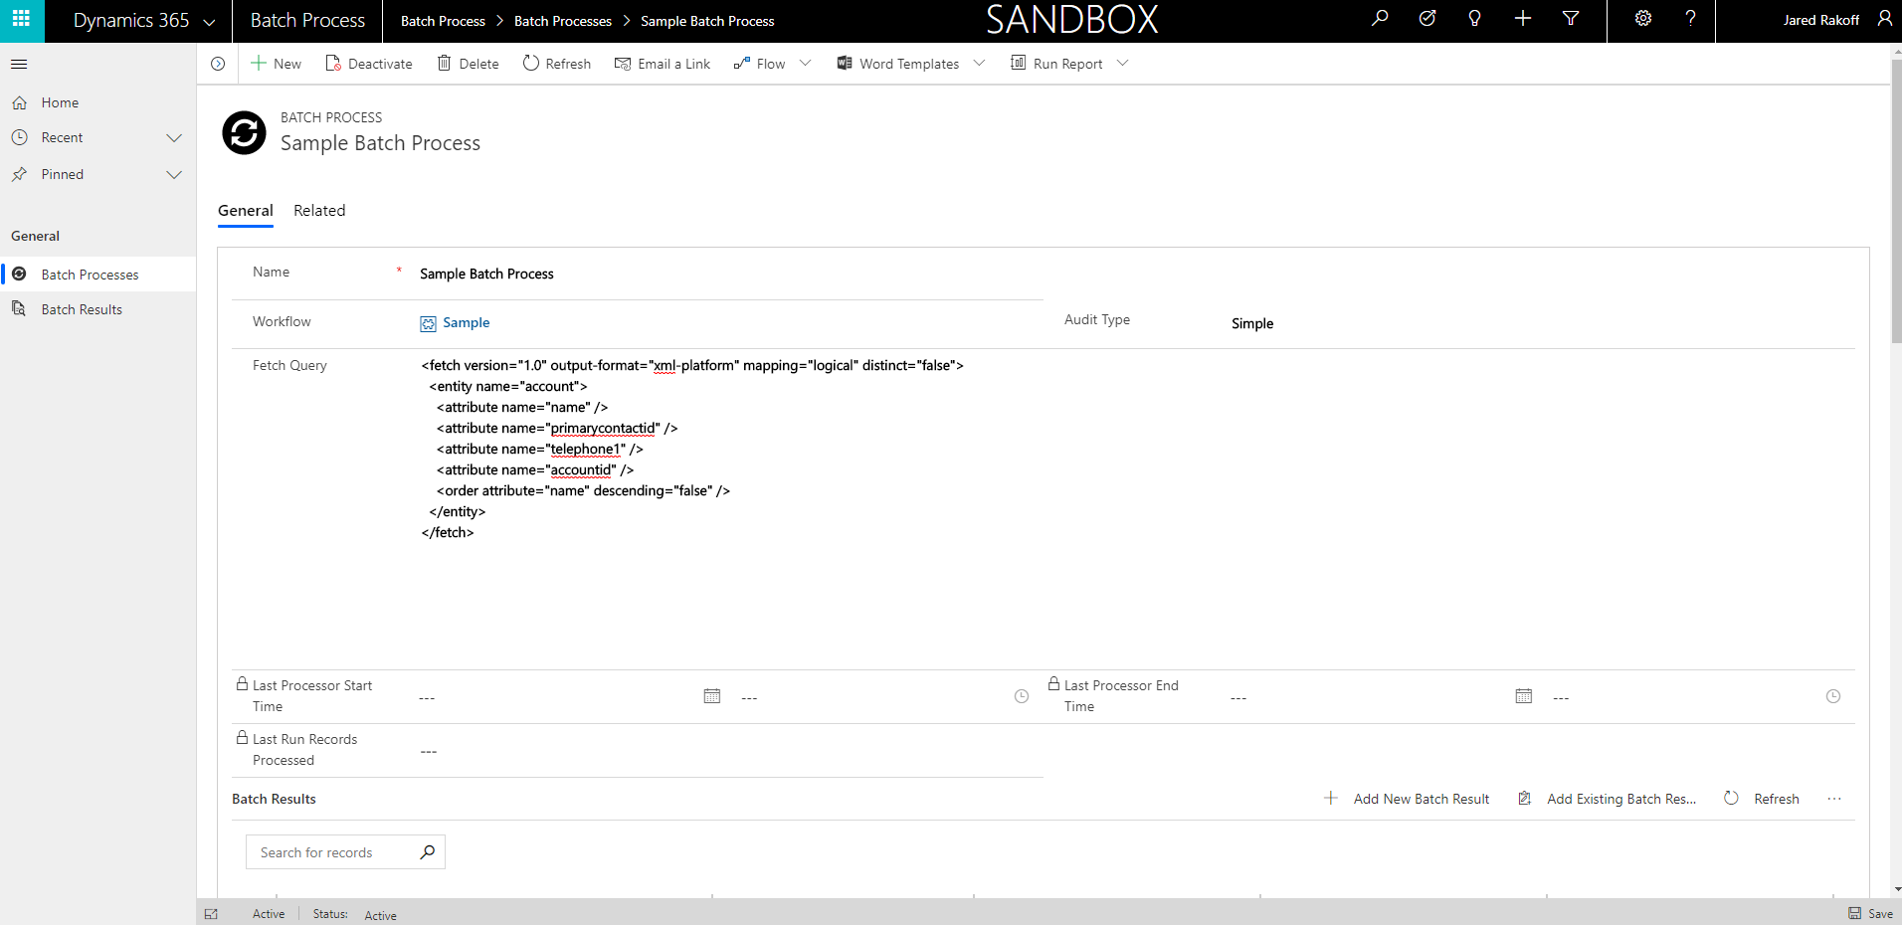

- You may choose Audit Type to be simple or extended. Simple auditing will only show the total number of records processed with the start/end processing time. The Extended Audit Type will have additional details such as the GUID and Name of each record that was processed. This data is shown on a field called Run Results.

- Define whether the Batch Process runs one time or on a recurring schedule. Scroll down to the bottom of the Batch Process form after it has been created.

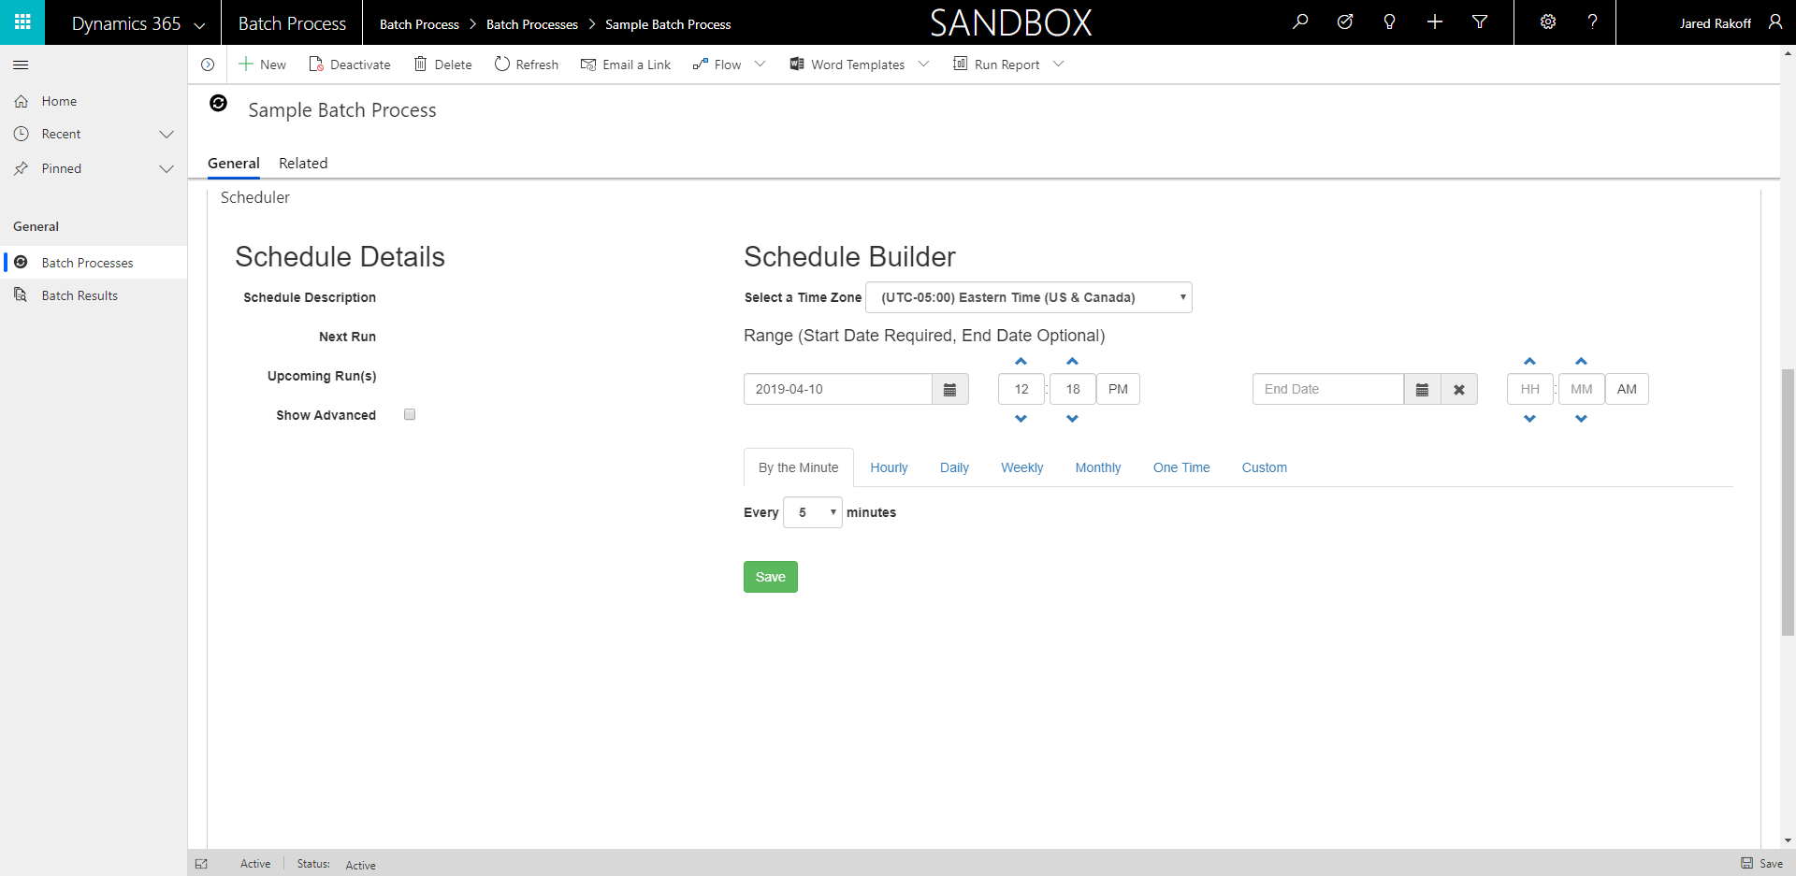

- Set Schedule

Configure the schedule by adding the mandatory Start Date and an end date if needed.

A preview of up to four Upcoming Run will be shown so that the user can verify the schedule. Click Show Advanced to display more details.

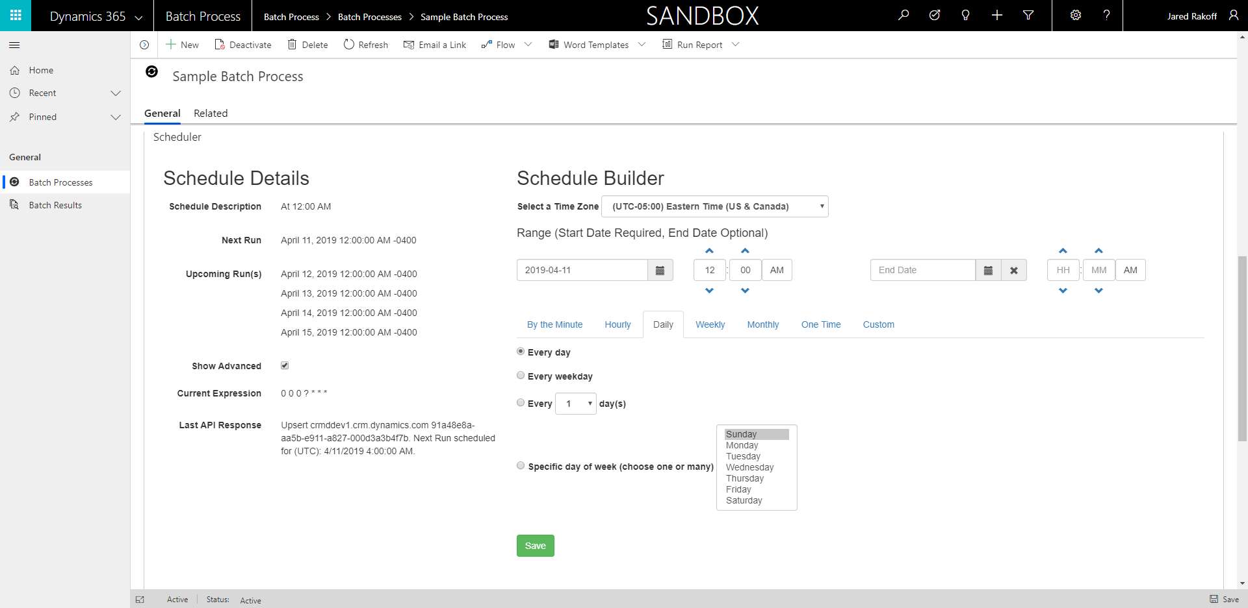

- Custom Schedule

In order to create a Custom Schedule, click the Custom tab. Navigate to the custom schedule builder and create a schedule expression. Click save after any updates to confirm any changes. Verify the modified Upcoming Runs.
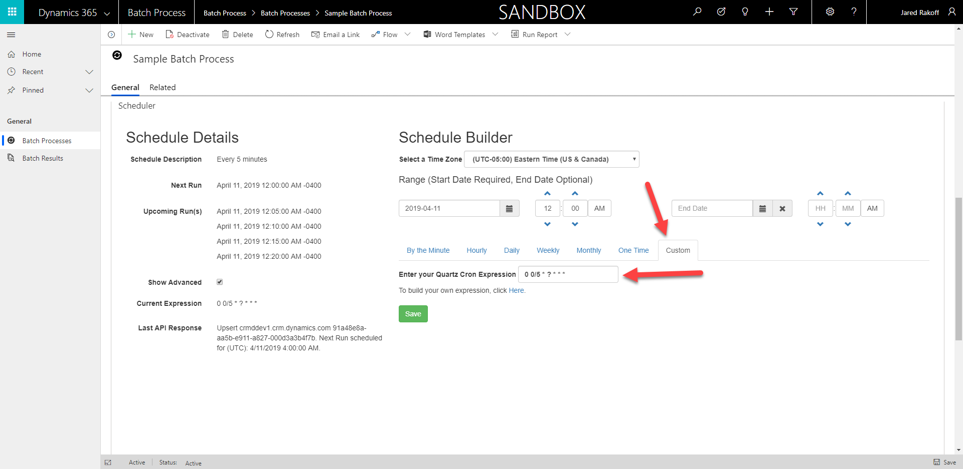

- View Results

The results of the batch process will be shown in the sub-grid on the form.
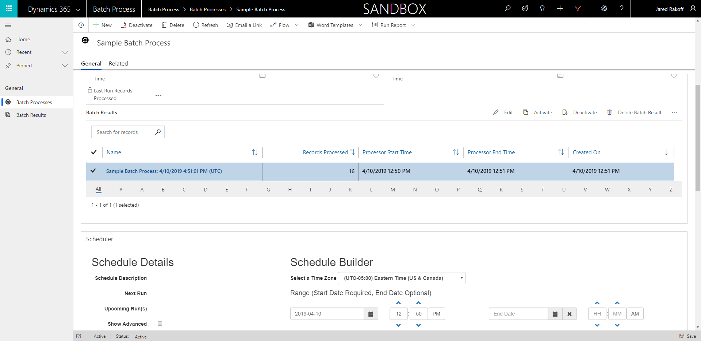

Below is an example of the details of the Batch Result record.
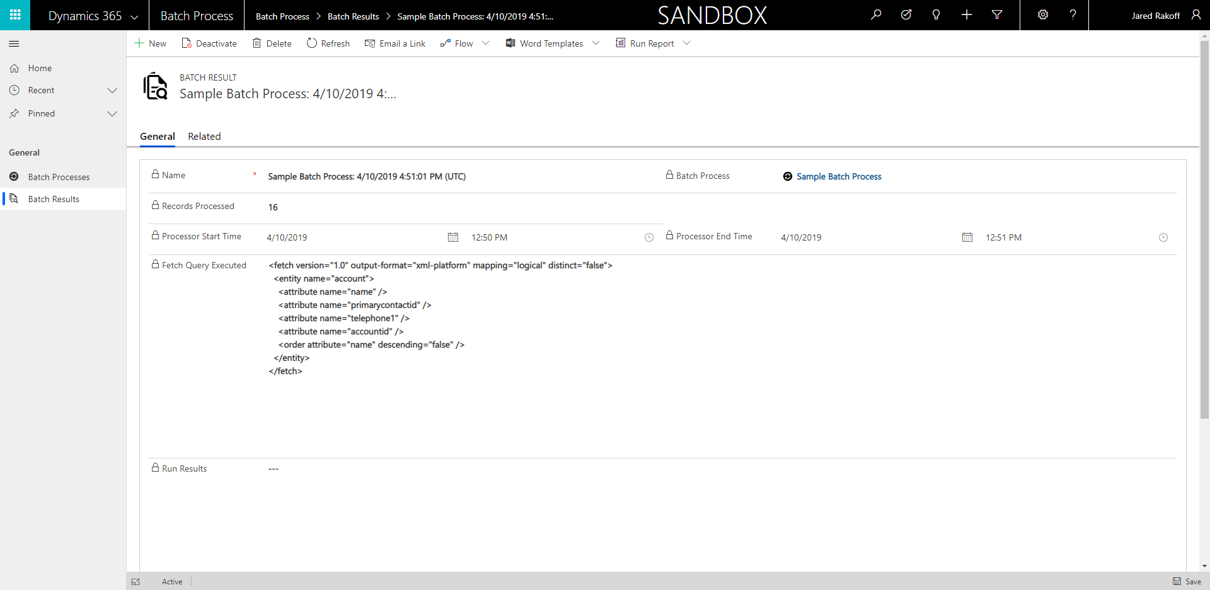

Note: We do not recommend a frequency less than 5 minutes. All Batch Processes will be queued to run at the Next Run time and it can take up to one minute to begin execution. After execution is complete, the Next Run and the Upcoming Run(s) will be updated accordingly.

