DD ListBox– User Manual

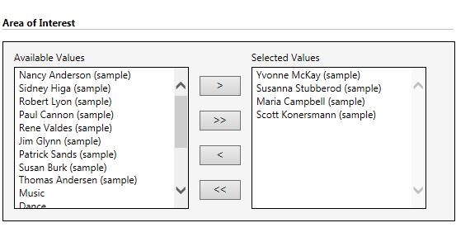

Contents

DD ListBox user guide......................................................................................................................3

DD ListBox User Guide

Follow below steps to configure DD Listbox tool:-
In this example, we have configured DDListbox for system entity i.e. Account and entity Contact. The list of contacts would be available for selection on Account entity.

1. Click on ‘INKEY’ site-map area on your CRM instance. Then, click on ‘DDListBox’ button.

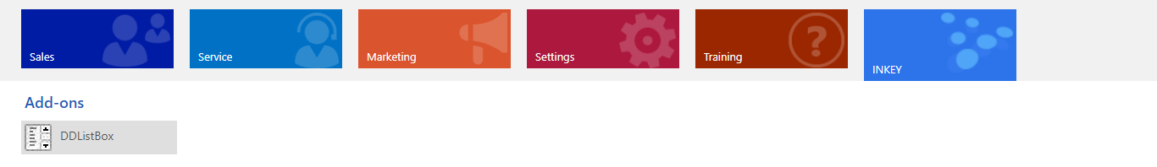
2. Then, click on ‘New’ button to create a new DDListBox entity configuration record.

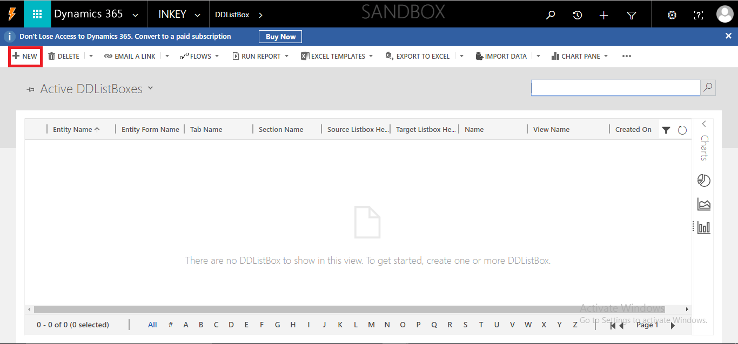

3. On click of the ‘New’ button, following ‘DD ListBox’entity form will get open.

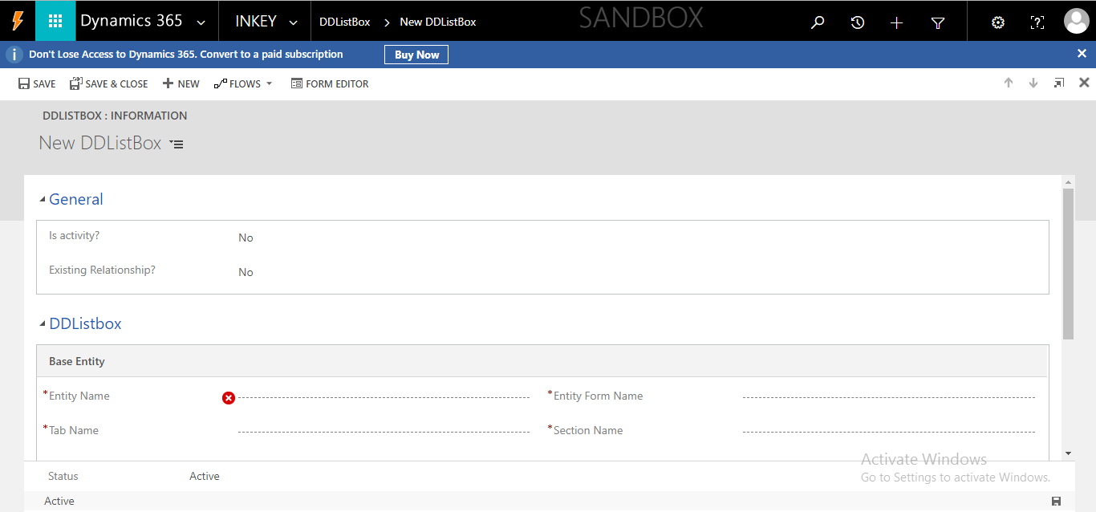

The ‘Is activity?’ and ‘Existing Relationship?’ both are “Yes/No” type boolean fields.
When the user keeps the values for both these fields as “Yes”, you will see the following form.

4. When the user keeps the values for ‘Is Activity?’ = ‘Yes/No’ and ‘Existing Relationship?’ = ‘Yes’, he will see an extra section ‘Mediator Entity’ on entity form. This section can be used to fill details regarding the existing relationships that can be used.

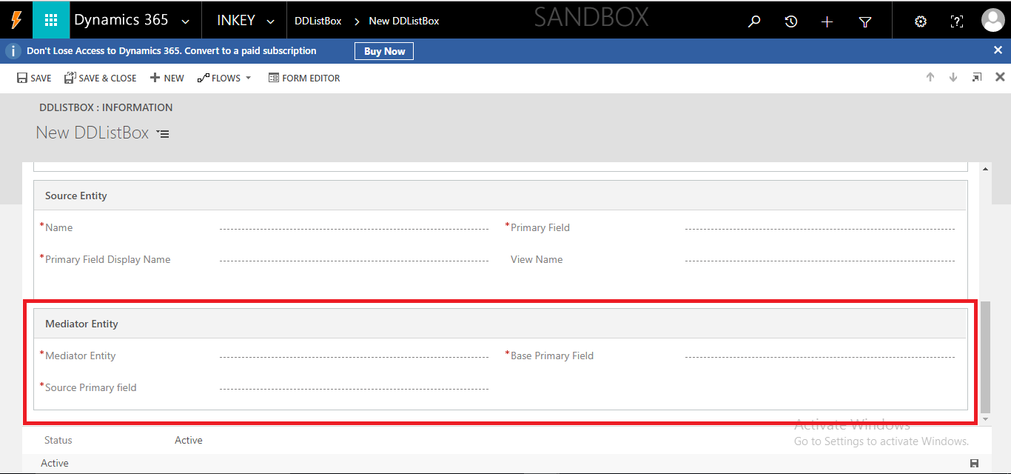

5. Specify the values for the fields provided on the form.
NOTE: All schema names should be in small letters and it’s case sensitive.

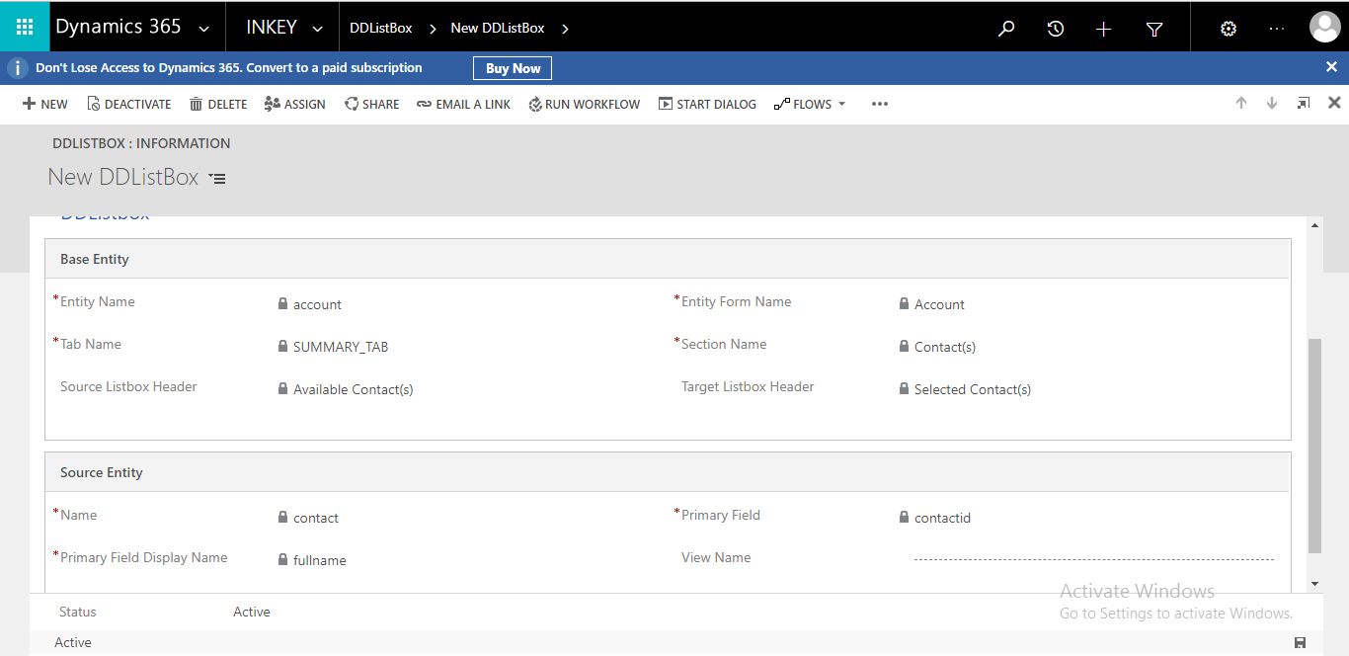

- Is Activity?: By default the value of this field will be “No”, but if the host entity, on which you would like to configure this tool, is CRM activity like Task, Email, Phone Call, etc. then change the value to “Yes”.
- Existing Relationship?: By default it will be “No”, but if you already have an existing N: N relationship (here the host entity would be of non-activity type) or a mediator entity for CRM activity type (Task, Email, Phone Call, etc.) then change it’s value to “Yes”. If the value of this field is “No” then the tool will create the N: N relationship by itself. And if the host entity is of activity type, it will create the mediator entity and set up 1: N from activity to this mediator entity and N:1 from the mediator entity to the Source entity. If the value is “Yes” then it will ask for the existing N: N relationship or the mediator entity name and relationship names.
- Entity Name: Schema name of an entity. In this example, the value of this field is “account”.
- Entity Form Name: Form name of account entity where you want to place the DDListbox control.
- Tab Name: Tab area of account entity form, where you want to place the DDListbox control.
- Section Name: A new “Section” on account entity form will be created with this name. This tool will be placed in this section.
- Source Listbox Header: Heading for the source list box.
- Target Listbox Header: Heading for the target list box.
- Name: Name of the source entity, the data of this entity will be displayed and a many-to-many relationship will be created between account and this entity. In this example, it is contact.
- Primary Field: Name of the primary key column of the source entity. In this example, it is 'contactid'.
- Primary Field Display Name: Name of the primary display field. In this example, it is the full name.
- View Name: Name of source entity view. It is an optional field. If the user specifies the value for this field then the data gets displayed/filtered as per this view at source list box. In this example, we’ve specified “Active Contacts” view. If the user does not fill value for this field then the tool will display all contact records into source list box.
- Existing N: N relationship name: This field will only be visible when Is Activity? the field has value as “No” and Existing Relationship? has the value “Yes”. You need to provide the name of the existing N: N relationship that needs to be reused for the DDListbox.
- Mediator Entity: This field will only be visible when Is Activity? the field has value “Yes” and Existing Relationship? has a value “Yes”. You need to provide the name of the existing mediator entity that needs to be reused for the DDListbox.
- Base Primary Field: This field will only be visible when Is Activity? the field has value “Yes” and Existing Relationship? has a value “Yes”. You need to provide the name of the existing base primary lookup field on the mediator entity that needs to be reused for the DDListbox.
- Source Primary Field: This field will only be visible when Is Activity? the field has value “Yes” and Existing Relationship? has a value “Yes”. You need to provide the name of the existing source primary lookup field on the mediator entity that needs to be reused for the DDListbox.

6. Now, let’s verify the newly configured tool at account entity.
7. Go to the Sales area.
8. Click on Accounts option.
9. Click on New button to create a new record as highlighted in following screen print.
NOTE: This add-on does not work in create mode.
10. After creating a new record, navigate to the Tab specified during DDListbox Configuration (Step 5 (Sub-item 3) – Tab name).
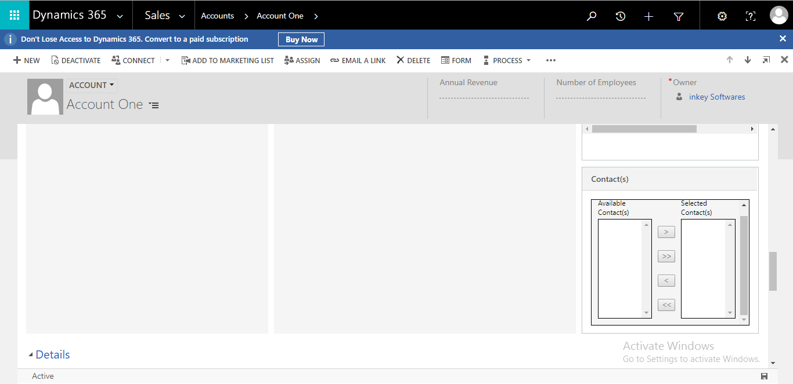
11. Drag the required values from Left to Right and vice versa.

