Automate the move to Standard

Automate moving from Microsoft ISV add-on EAM solution to the standard 'Asset Management Add-in' for Dynamics 365 Supply Chain Management.

Microsoft Dynamics 365: Modernizing EAM
Asset tracking to track and manage the complete lifecycle of the asset.
Preventive maintenance for tracking, managing, and monitoring the maintenance needs
Predictive maintenance uses machine learning models for preventive maintenance based on EAM data.
Work order management and scheduling for planning (automatically or manually) based on key parameters such as worker capacity, availability, or work order criticality.
Integrated planning combined with production job scheduling helps with decision-making when machine repairs are needed.
Spare parts tracking to effectively manage inventory.
Cost control to make it easy to manage the estimated and actual cost of maintenance.
Out-of-box insights (KPIs) provide a rich set of analytics to measure an asset’s effectiveness using uptime, downtime, repairs, mean time between failures, mean time between stops, and mean repair time.
microsoft Dynamics 365 EAM capabilities
Organizations are moving at an ever-increasing pace towards digital transformation by taking advantage of new and emerging trends such as industrial IoT, AI, mobile, predictive analytics, and mixed reality applications.
Assets within these organizations are becoming increasingly interconnected, providing in many cases real-time signals not just about their operations but also about the health of the assets themselves. This combined with deep machine learning, predictive analytics, and mixed reality (MR) is reshaping the future of EAM.
Microsoft’s transformative EAM solution brings together the best of what Microsoft provides in Dynamics 365, Power Apps, Power BI, IoT, MR, ML and Dynamics 365 for Field Service application to provide a modern, connected solution for organizations that manage assets in customer locations. Microsoft’s Asset Management works ‘out of the box’ for Finance and Supply Chain Management for up to 100 assets.
The EAM solution will make it easier for customers to plan and predict asset maintenance there by maximizing the lifespan of assets and reducing costs and production downtime.

Automated migration from older and ISV EAM solutions
Customization is one of the biggest risks in any ERP implementation. Simplify and enhance performance of ERP by getting rid of customizations and older ISV solution.
Adopt the standard AI-enhanced, transformative EAM solution in built in Dynamics 365
Migration from older and ISV EAM solutions to Microsoft standard is simplified and automated with tools and a systematic approach to reduce effort and costs.
The approach is to analyze the current implementation of the EAM solution and use purpose-built tools to automate the migration to standard Dynamics 365 EAM solution.
Step 1 is to assess your readiness to
- upgrade current AX versions to Dynamics 365
- migrate from any third party EAM solution to the standard 'Asset Management Add-in' for Dynamics 365 Supply Chain Management

The Assessment Offering
Sonata’s Upgrade Assessment, a three-week assessment using Sonata’s unique tool set and approach to analyze Business processes, current AX systems to recommend the strategy for a direct migration path to the new D365
A 3-week assessment will determine the feasibility of automated upgrade, the effort to upgrade and number of customizations that can be re-used to reduce time to adopt standard in Dynamics 365 for Supply chain. Key deliverable is solution approach, estimate of cost and time.
Assessment Objective: Define Upgrade path with a focus on adopting standard, reusing existing investments with optimized effort
Automate moving from Microsoft ISV add-on EAM solution to the standard 'Asset Management Add-in' for Dynamics 365 Supply Chain Management.

Step 1: Assessment

Duration: 3 Weeks

Cost: $15, 000
aSSESSMENT Offering
Sonata’s Accelerated Upgrade assessment includes:
- Functional assessment to baseline modules and business processes
- Technical Assessment analyze the existing AX code, systems and processes to make recommendations for the migration and list existing customizations to leverage
- Presentation of Upgrade Strategy to all stakeholders that includes functional and technical recommendations and shortest upgrade path with estimated costs and assured saving to agree on next steps

Benefits of an Assessment Phase
- Ability to strategize with predictable budgets, the migration to standard
- Leverage Sonata’s unique tool set and approach for risk free, automated code migrations AND move to standard
- Direct upgrades from any version of Microsoft AX to Dynamics 365 via Unique tool saving effort & hence cost in the range of 30 to 60%

Contact Sonata for risk-free upgrades
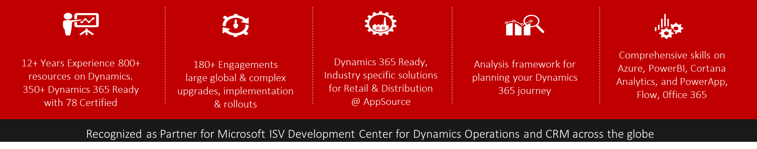
Sonata is Microsoft recognized ‘ISV Development Center’ for Dynamics 365 operations and CRM across the Globe. Sonata has deep expertise and global scale on the entire Microsoft stack with 180+ Dynamics Engagements, global & complex upgrades, implementation & rollouts, Cortana, Power BI, Flow, Power Apps, Azure

