Genogram
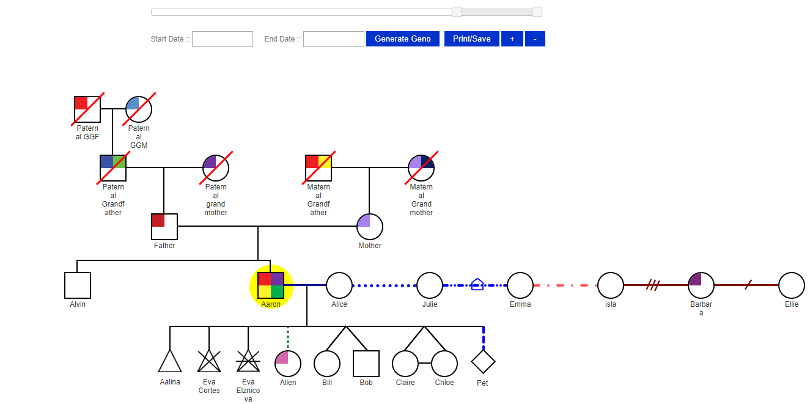

Multiple Husbands:
Click on Alice record to check multiple husbands.
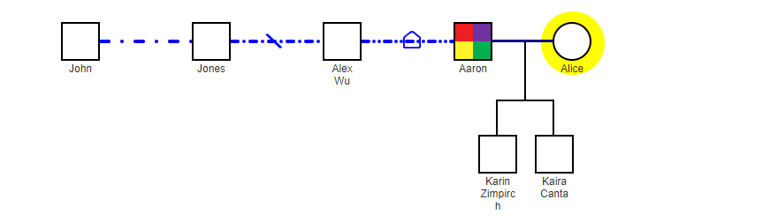

Start Date and End Date:
Julie Date:
StartDate-29/08/2018 EndDate-21/09/2030
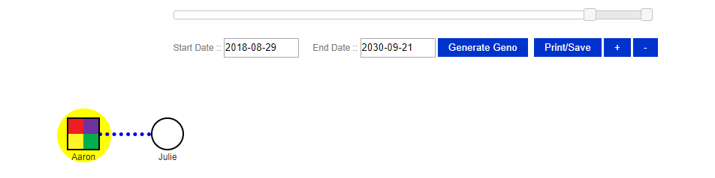
Father Date:
StartDate-2/09/1930 EndDate-3/12/2020
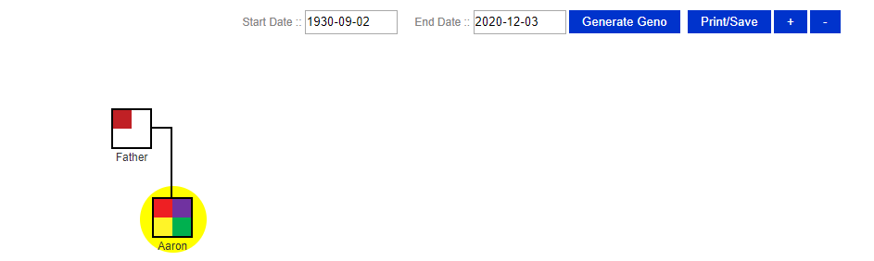

Nodes In between the Start Date and End date:
