SNC/Shipping

The App SNC/Shipping handles part of essential packing and shipping process in a typical company. A few new tables and pages give the user the opportunity to form a “Shipping Order” and to add sales positions to single parcels.
Related to a single carrier these “Shipping Orders” are aggregations for shipments to a unique location.
The user has the option to add parcel specific information like tracking numbers to every “Parcel Line” underneath a “Shipping Order”. Information like a parcels weight is calculated from item master data regularly but could be overwritten. Dimensions like length, height and width are addable per parcel.
As well the described functionality is applicable to default documents like “Sales Order”, “Purchase Order” (in case of “Return Order”).
Because SNC/Shipping is using Shipping Agents and Shipping Agents Service Codes you have to set the User Experience to “Suite”.

Key Usage Scenarios
- Setup „SNC/Shipping“
Profile – Order Processor
  - Open new List „Shipping Order List“
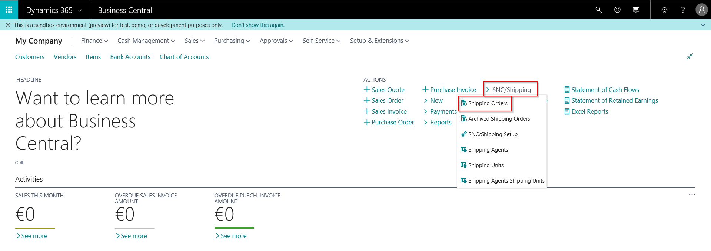

  - You should receive a Notification to set up “SNC/Shipping”
  - Follow the wizard
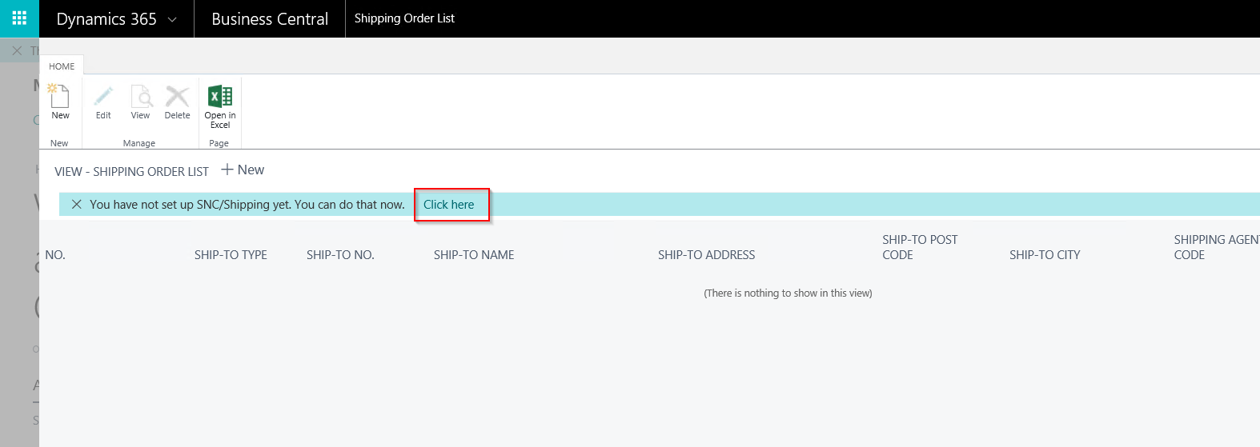
  - Add shipping units to shipping Agents. Shipping Units are parcels or pallets for example.
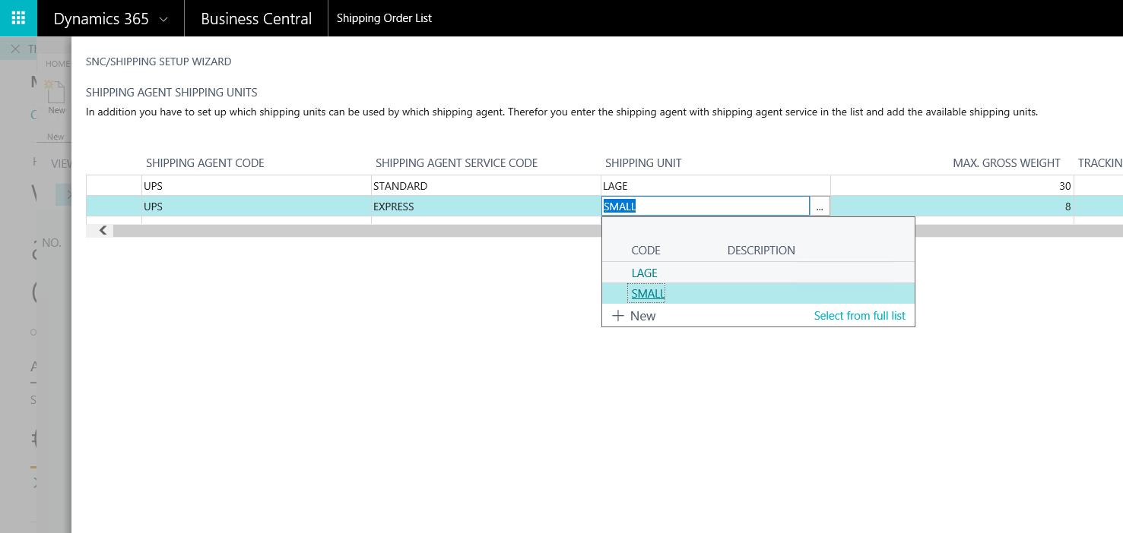

- To pack a Sales Order with SNC/Shipping
Profile – Order Processor
  - Create a new Sales Oder with a Shipping Agent you set up Shipping Units in step 1
    - For example Cust. 10000
    - Verifiy that the Shipping Agent Code is filled in the Sales Order. If you’re working with Shipping Agent Service Codes verify that this code is filled, too.
    - Add one or more items
  - Release Sales Order
  - Use new Action “Create Shipping Order”
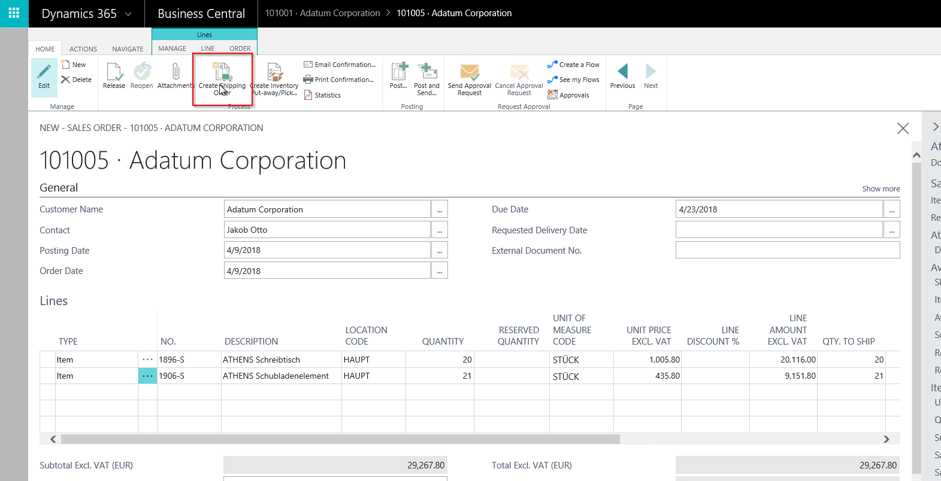
  - Choose “New Shipping Order”
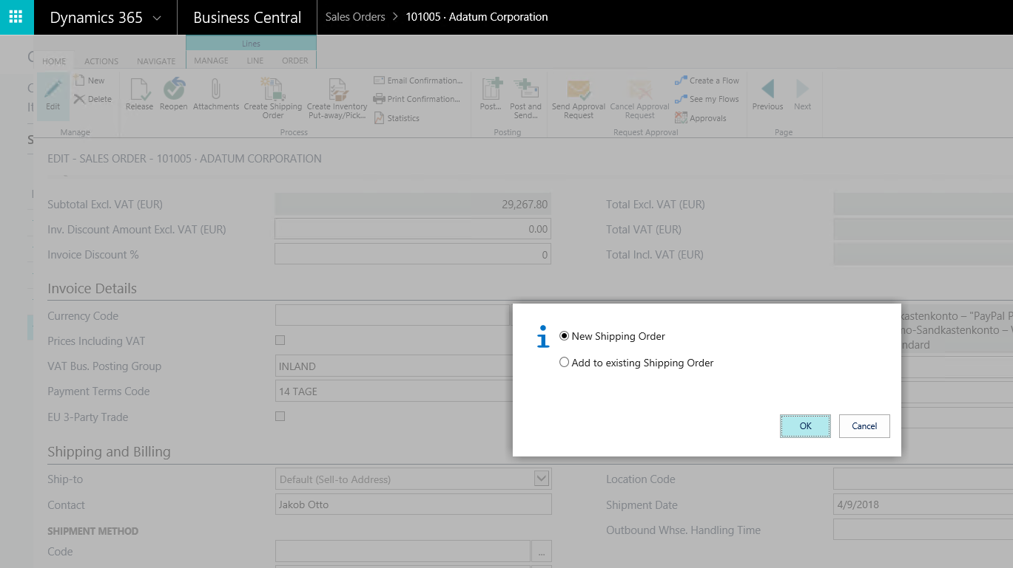
  - Select a “Shipping Unit” in which the items should be shipped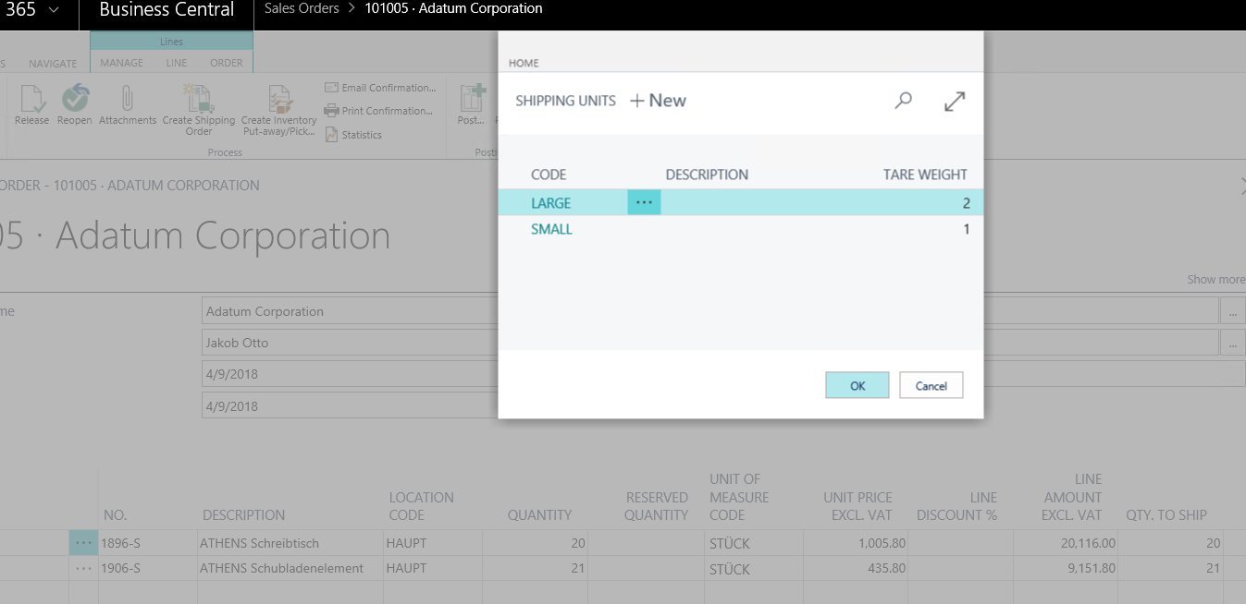
  - Discover the new “Shipping Order” with one parcel and the Sales Order Positions contained.
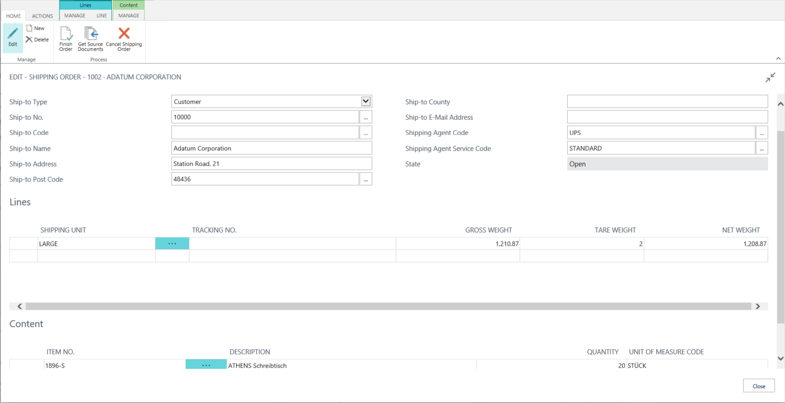
  - From here one can add another Shipping Unit and move parts of the content.
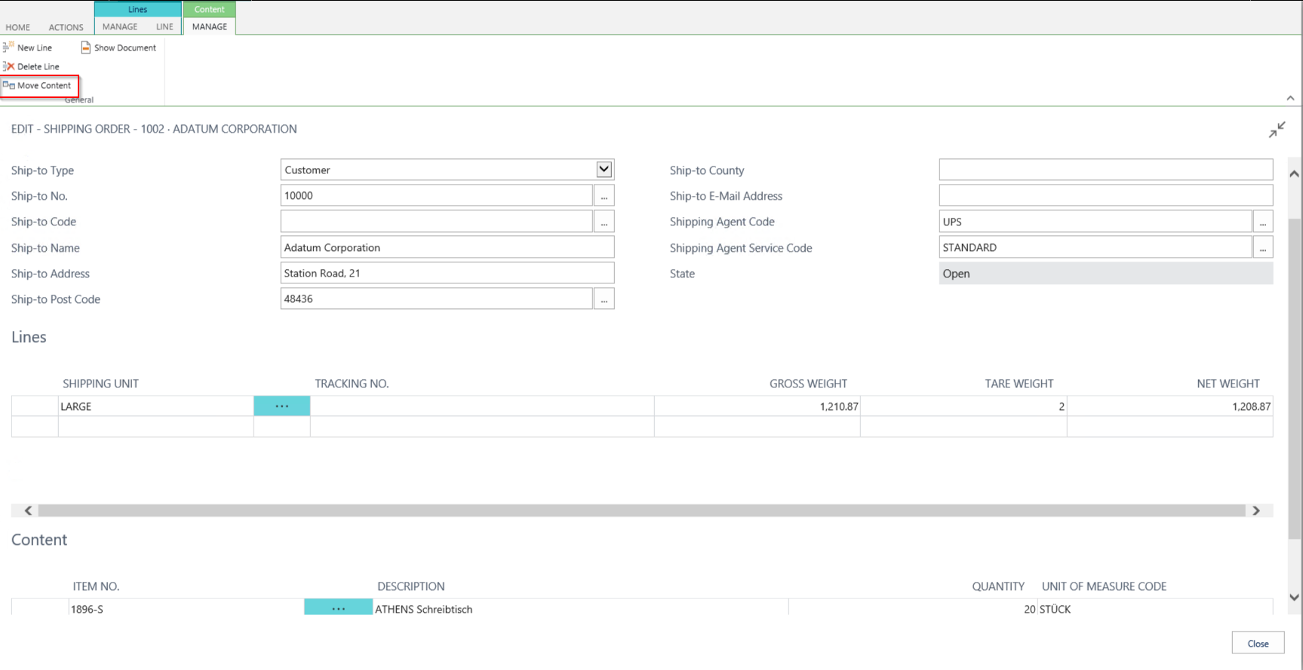
  - Add “Tracking No.” for specific parcels given by the shipping agent
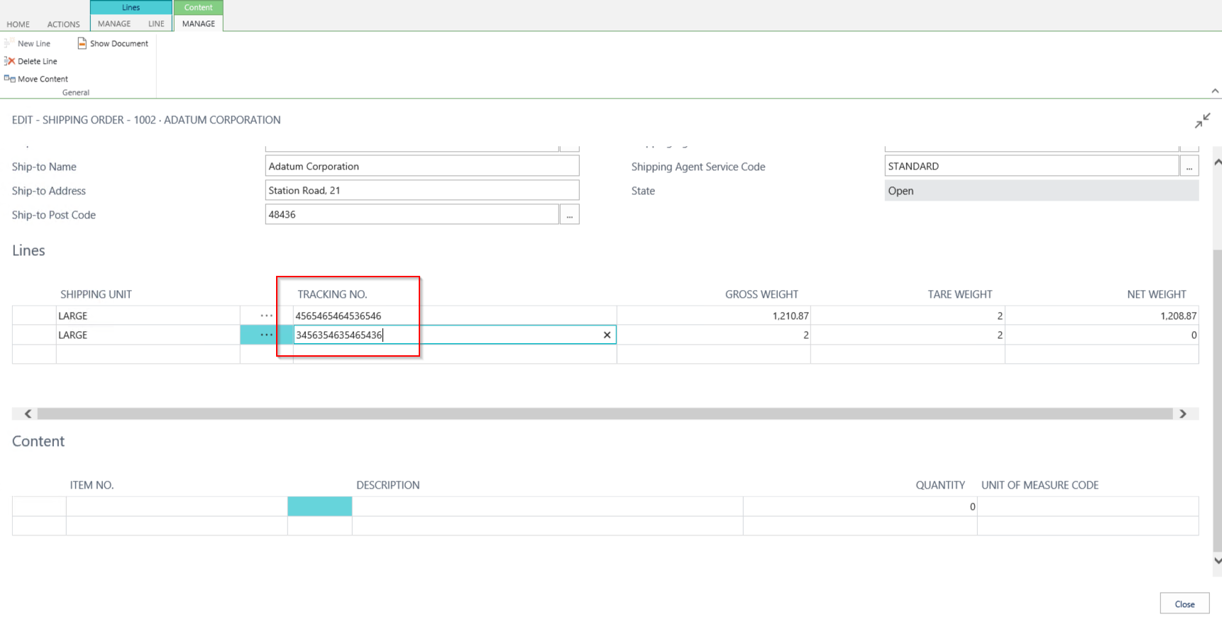

  - In the end one can finish the packing process by pressing “Finish Order”.

- Create a “Shipping Order” and add Sales Orders afterwards
Profile – Order Processor
  - Open “Shipping Order List” and create a new shipping order
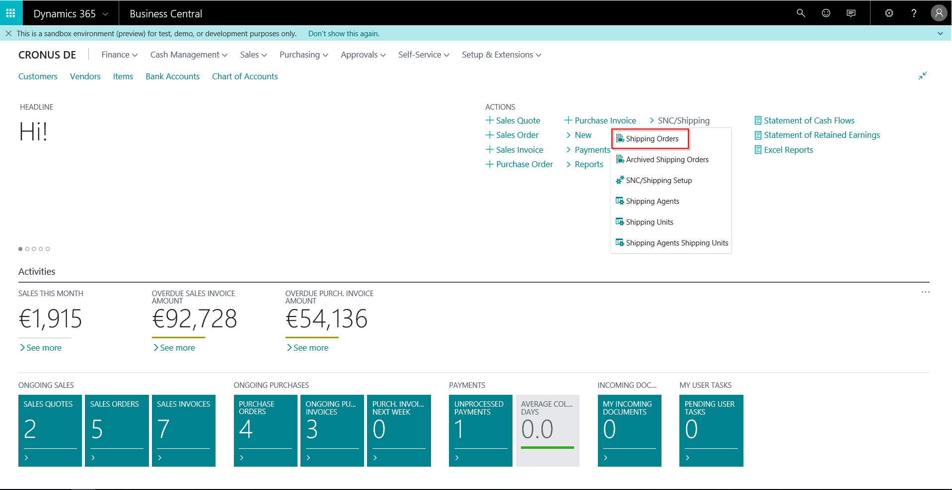
  - Choose Shipping Agent and Shipping Agent Service Code
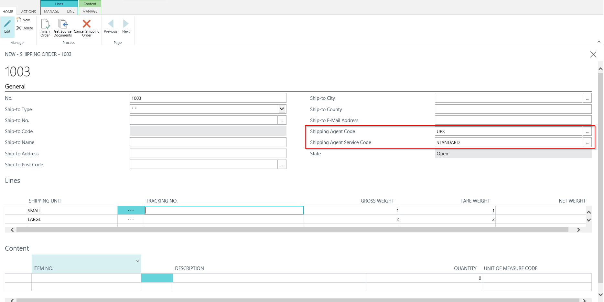
  - Create “Shipping Units” by adding lines to the “Shipping Order”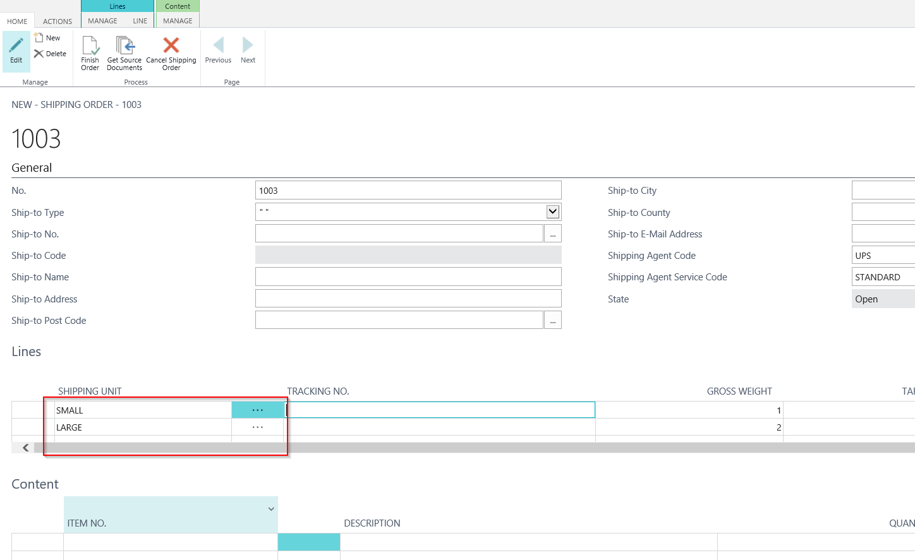

  - Use the action “Get Source Documents” to select Sales Orders. (There must be existing Sales Orders. Sales Order has to be set up with the Shipping Agent and Shipping Agent Service used in the Shipping Order. Sales Order Status has to be “released”.)
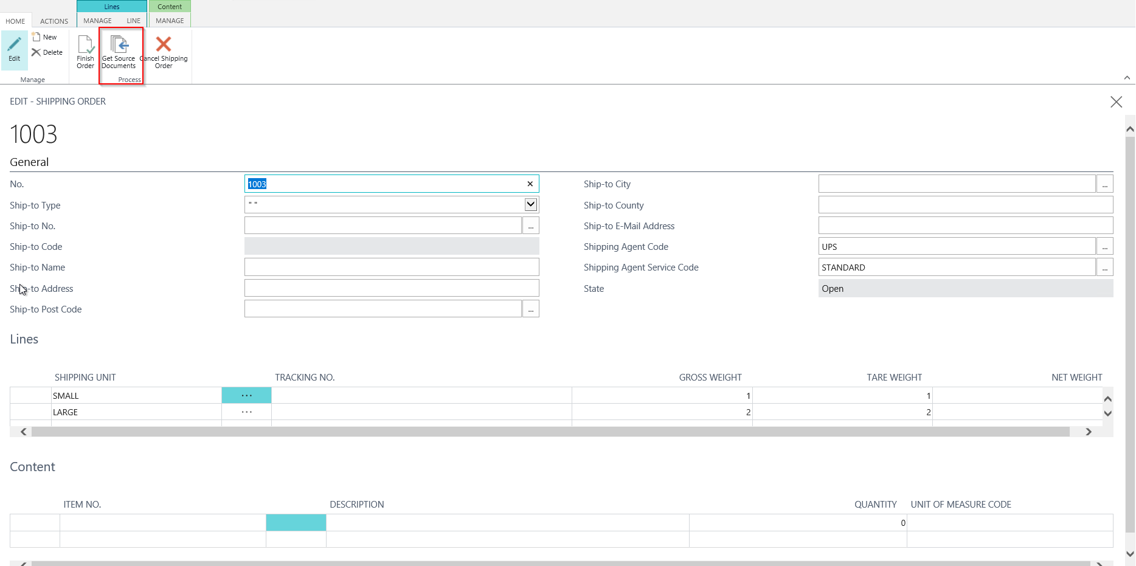
  - Add Sales Positions of a Sales Order to the “Shipping Order”
    - Select Sales Order
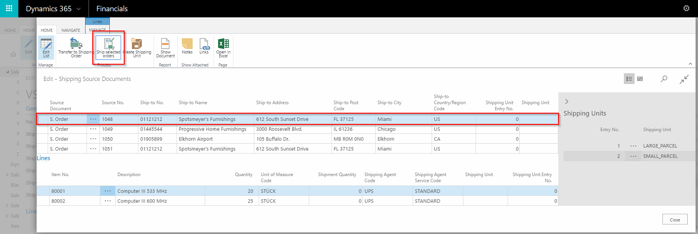
    - Use Action “Ship selected orders”
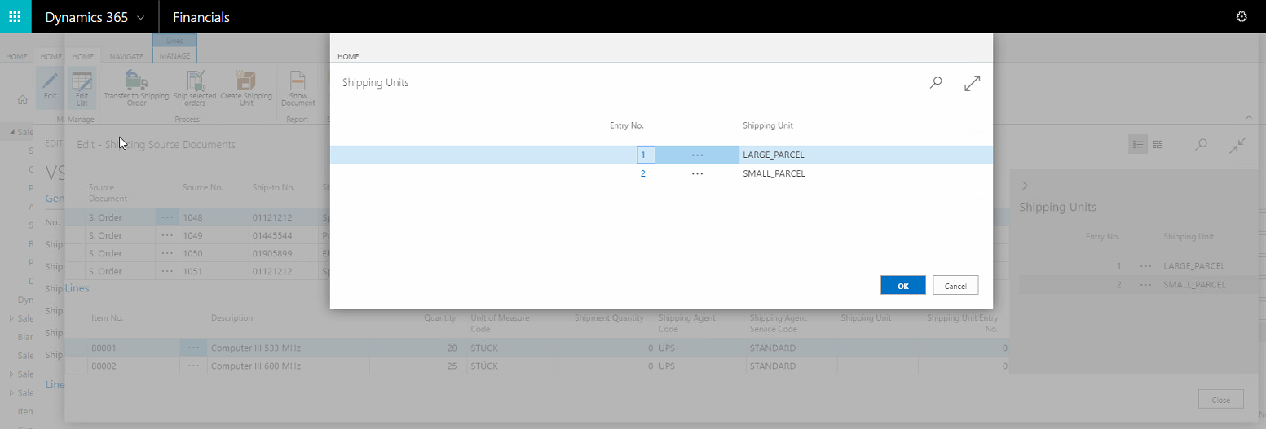
    - Discover filled fields “Shipping Unit” and “Shipping Unit Entry No.”

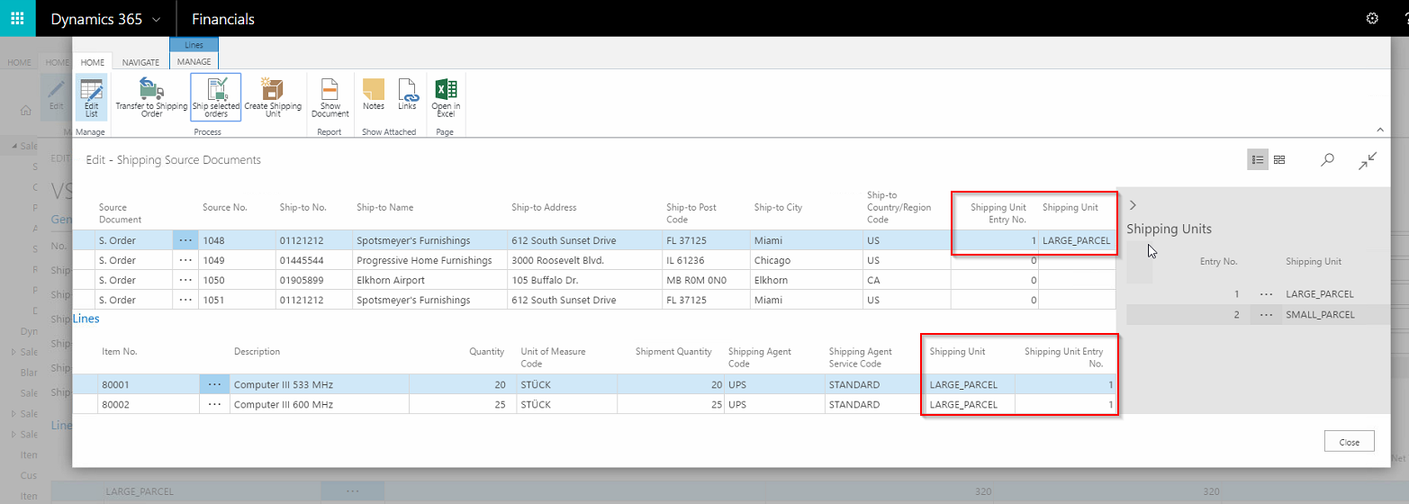

    - Leave the dialog by choosing “Transfer to Shipping Order” and discover some “content” in one of your “Shipping Order Lines”
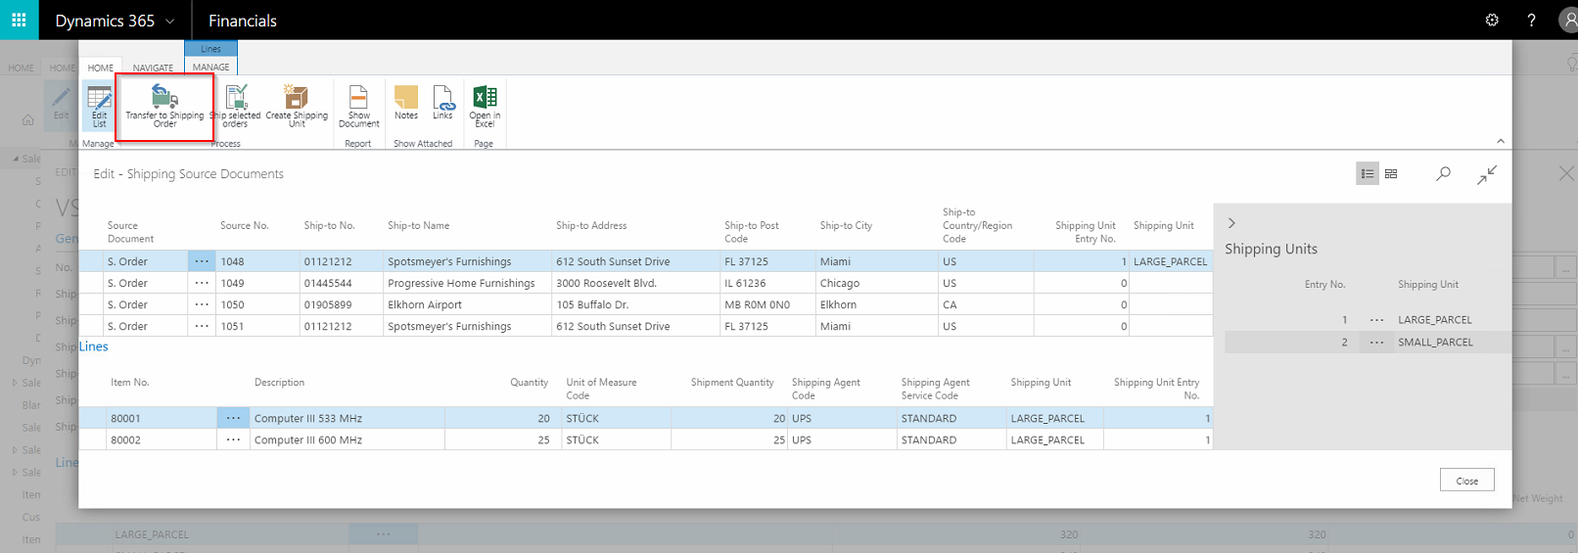

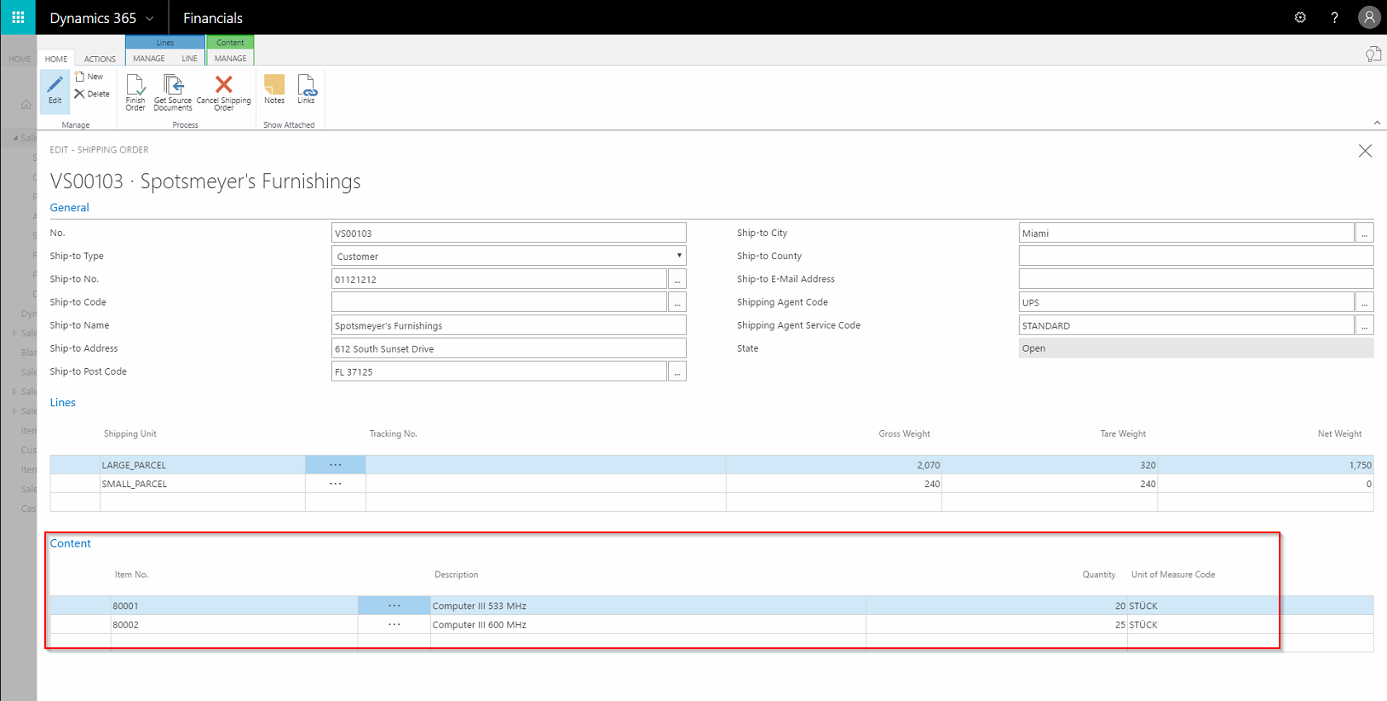
  - Add “Tracking No.” for specific parcels given by the shipping agent
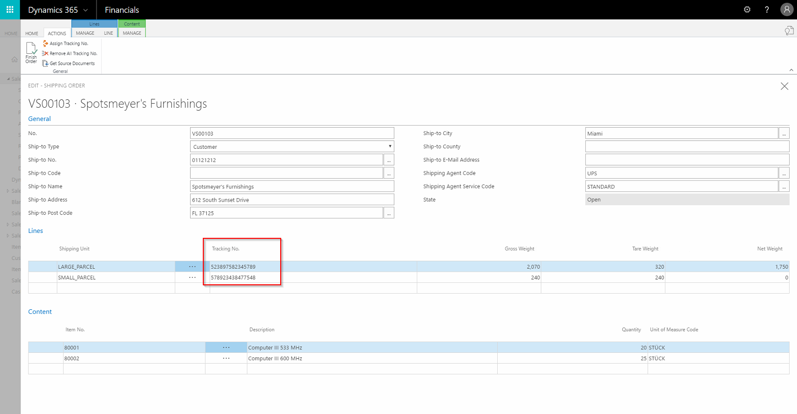
  - In the end one can finish the packing process by pressing “Finish Order”.

