Microsoft Dynamics 365 RETAIL
Available in three deployments, Cloud (multi-tenant), On-Demand (single tenant), and On-Premise for reliable taxation and ease of use. This guide provides instructions for using the Vertex tax engine with the following Microsoft Dynamics 365 Finance and Operations modules:

Address Cleansing | Customer  Pre-Tax Calculation
Retail | Point of Sale  eCommerce  Failover
Sales and Marketing Module | Sales Order  Invoice  Returns

Components
The Vertex Tax Links setup uses the following components to automate address validation (also known as address cleansing) and sales tax calculation:
- Microsoft Dynamics 365 – An application that automates your ERP processes.
- Vertex Tax Links for D365 Finance and Operations – A connector that links your Dynamics 365 Finance and Operations with the Vertex Cloud or Vertex O Series tax engine.
- Vertex O Series – A tax engine that validates ship-to addresses and calculates sales tax (powers the Vertex Cloud)
- Vertex Cloud – A portal to the Vertex O Series tax engine. Vertex Cloud provides an interface for configuring the registrations, products, categories, and customer exceptions that support the Vertex O Series tax engine.

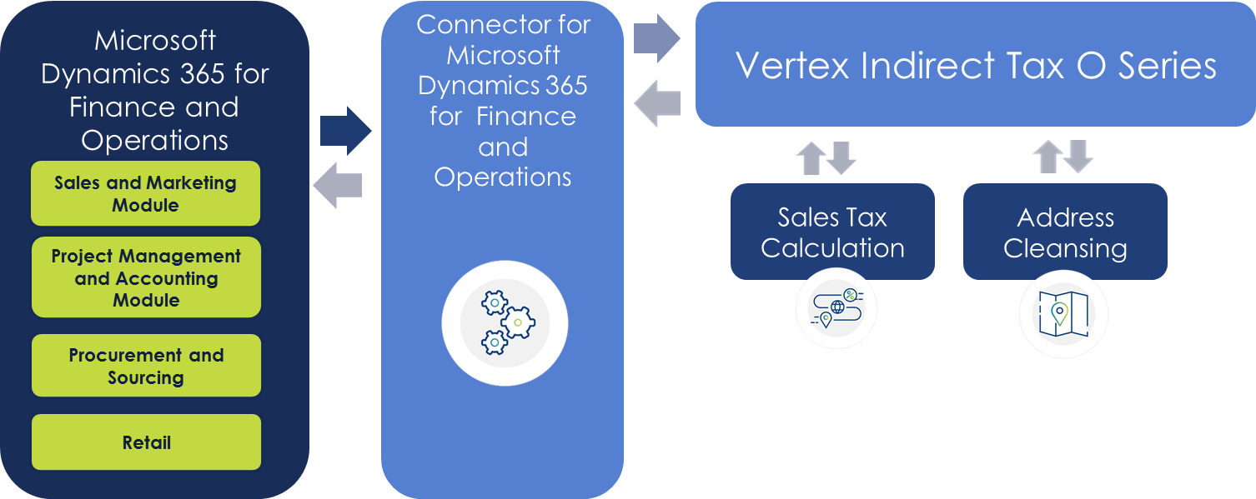

- Sales transactions created in your eCommerce or POS system can be configured to use Vertex to cleanse addresses and calculate tax in the Retail module
- The O Series tax engine cleanses the ship-to address, calculates the sales tax, and sends an XML response message back through Tax Links to the Retail module.
- Address Cleansing is provided by the Vertex integration, as a correct address is critical in ensuring the correct tax jurisdiction is used in calculating the appropriate sales or use tax. This is not a batch or one-time feature.
- Retail sales transactions can be uploaded to D365 Finance and Operations via a custom Vertex batch process delivered as part of Tax Links for Microsoft D365 for Retail
- Uploaded retail transactions create a sales order and invoice either by sales transactions or in aggregate by session
- Invoiced retail transactions reflect posted sales tax by product and jurisdiction
- Last run our custom distribution batch job that posts the invoiced tax details to Vertex’s tax journals for future tax return preparation; you can file your own returns or Vertex can provide the service for you

Supported Versions
D365 Retail | - D365 Retail 8.0, 8.1  - D365 Finance and Operations 8.0, 8.1  - Separate Licenses (Both Tax Links for D365 Finance and Operations and Tax Links for D365 Retail are required)

