Microsoft Dynamics 365 Business Central Mail Utility

Contents
- Introduction
- Configuration
- Sending mail
- Job Queue

Introduction

Mail utility tool helps Customer to send the multiple reports in the single click. Customer can send the Reports in the different formats like PDF, Word, Excel and XML. To send the daily batch reports user can also configure the Mail utility as the Job Queue entry from the mail utility setup page.
Mail Utility needs to have SMTP Setup. While configuring the SMTP give the Email ID from which you want to send the Mail.
Mail Utility will have two kinds of Permission sets. Basic Permission Set and Admin Permission Set.
Basic Permission Set will have all the permissions for Mail Utility functionalities, except Setup permission.
Admin Permission Set will have all the permission including the Setup.
Configuration
Before Sending the Batch mail, it needs the SMTP Setup and Mail Utility Setup.
- SMTP Setup
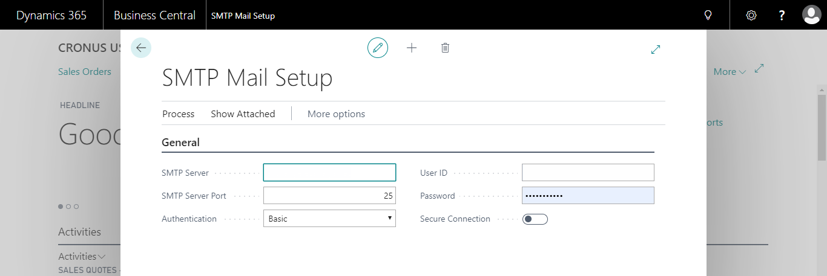
- Mail Utility Setup
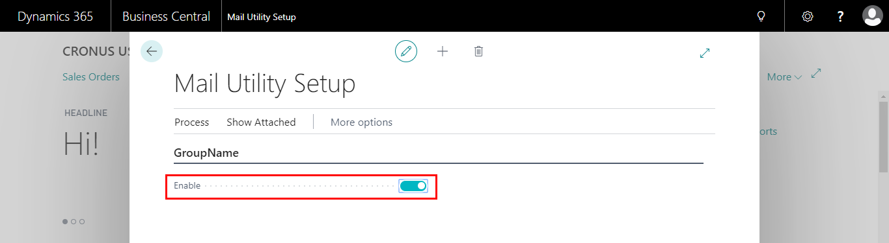

Sending mail
In the report selection page user need to select the
- Report ID : User need to select the report id to generate the report
- Send Email : User needs to select the reports to send
- Email Subject : Mentioned Email Subject will be added to the mail.
- Mail Body : Attached description will be added to email body
- Recipients Email ID : Enter Mal id Who receives the Email.
Note: if user wants to send to multiple addresses then mail id should be separate with ‘;’.
- Attachment type : Report will be generated in the mentioned format.it will attach same to the Email.
- Status : Once email has sent Email Status will be appear here like sent or failed
- Response Message : If Email status is failed, Response from the Server will be shown.
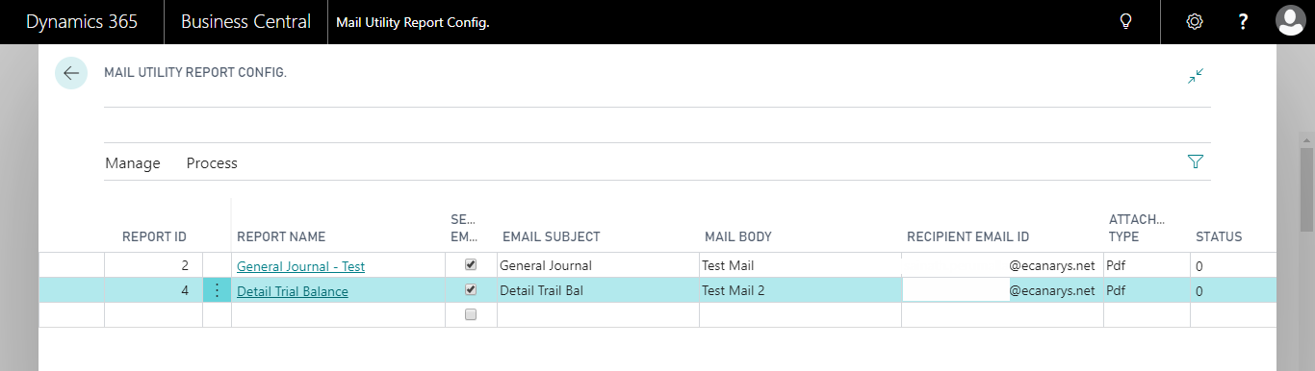

After creating the entries, click on the action Send Mail to send the E-Mail.
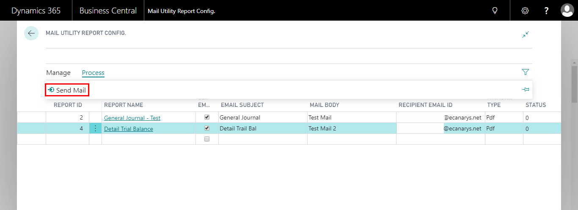
Once the Mail has sent you will get a message, Click on OK
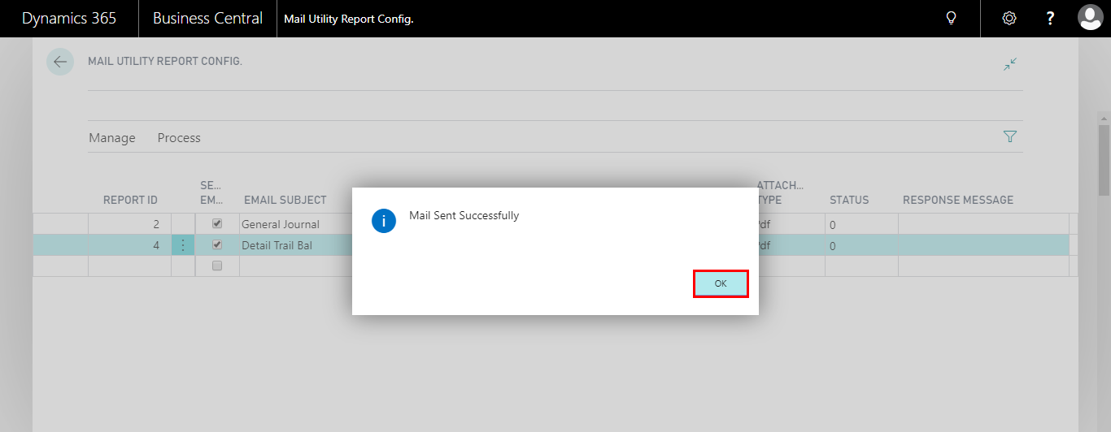

User can check Mail status sent or failed by checking the Status field. Please see the below screenshot.
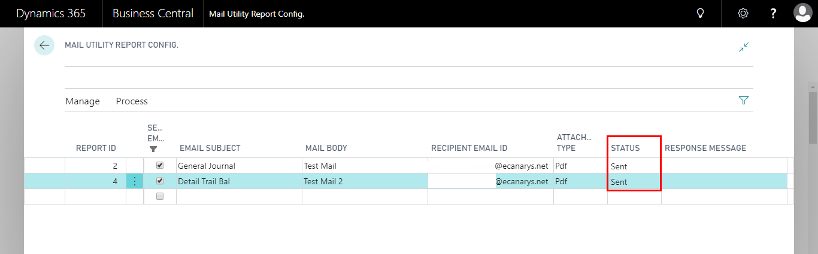
User can track the Email History in the Mail Utility History page.
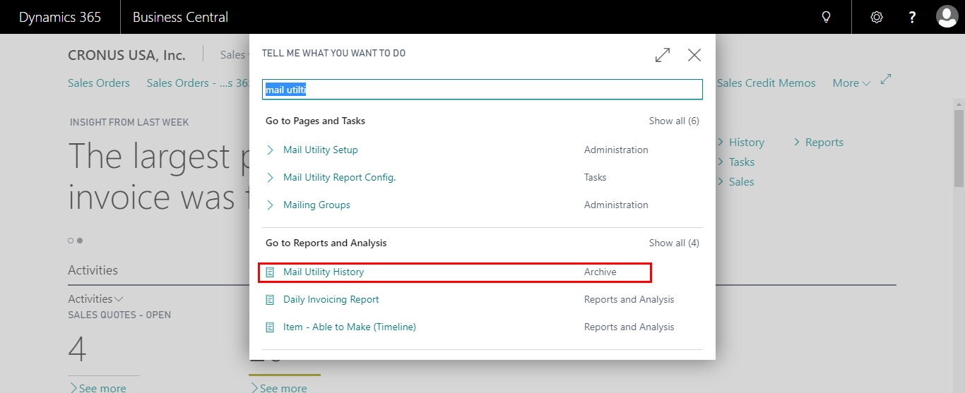

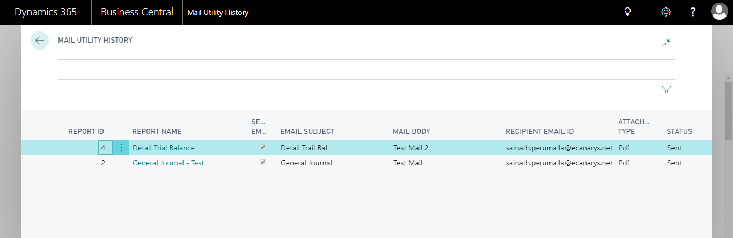
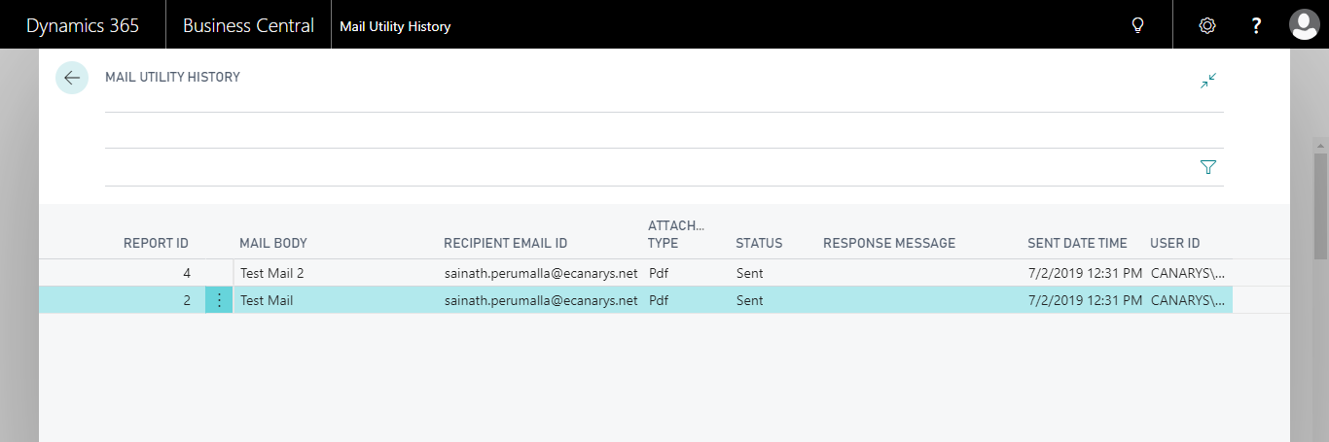

Job Queue
Click on the Create job Queue action in the Mail Utility Setup page
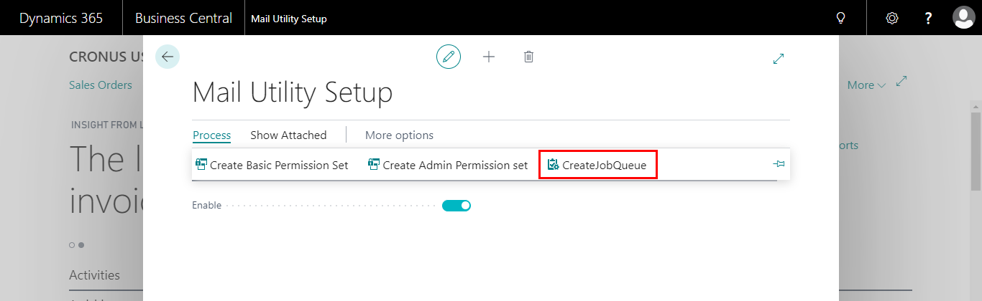
Once the job Queue entry is created the you will get a message, Click on OK
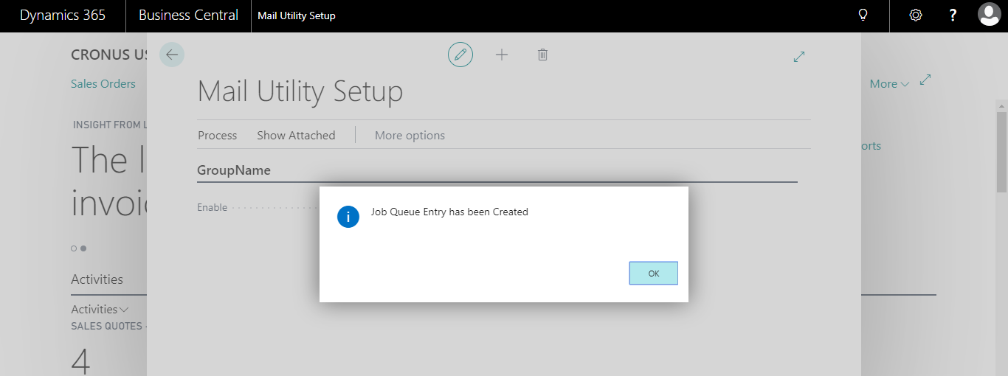
It will open the Configured Job Queue entry Page of Mail Utility.
