PragmaCaseManagement Installation Guide

Version 1.0.0

Document Version History

# | Date | Author | Reason | Version
1 | 08/Sep/2017 | Pragmasys | Initial Version | 0.1

Table of Contents
1 Introduction 4
2 PragmaCaseManagement Installation 5
2.1 Steps to install PragmaCaseManagement on CRM: 5
2.2 Steps for Master Data Import: 6
2.3 Files with entity name to import Data: 11
2.4 Email Configuration 11
2.5 Security Roles 13

Introduction
Ready to Deploy Master Data Driven Customer Service Workflow Automation Solution
- In this era of consumer dominated world it’s not the business but the customers are deciding the ‘Customer Centricity’ of the business. Hence operational efficiencies and differentiated service has become necessity but that is just not sufficient – consistent customer experience has also become the key. Continuous innovation in products, services and processes raise demand for rapid changes in customer service flows further increasing the challenges faced by customer service organizations. Pragmasys offers a configurable Customer Service Workflow Automation Solution which transfers the control of setting up the support process flows from developers to business users. It provides comprehensive case management capabilities including ability to define multiple flows based on different criteria, multistep sequential processes with defined SLAs.
Business users can:
- Define masters for various stages of process flow and associated statuses.
- Define different service processes flows based on products / business lines or any other criteria and set up stages and their transition based on different statuses.
- Define assignment rule for each stage with flexibility to assign the Case either to individual or Queue or team.
- Define Service Level Agreement / Turn Around Time at case level as well as at each stage of resolution process flow.
- Define the communication/notification template for internal and external SMS/Email communication. This helps in providing timely update to customer on progress of the service request.
- Predefined Case Management Dashboards.
How does it Benefit an Organization?
- Pragmasys Customer Service Workflow Automation solution routes the case / service request based on defined process, so 100% compliance is achieved without any lapses. Users are free from assigning it to others and can focus only on their task while system takes care of the routing needs.
- Due to tracking of time to accomplish a task (SLA / TAT) resolution times are improved.
- Eliminates customer call backs for status updates with up-to-date status information on resolution progress.
- Overall this solution provides a consistent and differentiated experience to customers there by improves customer satisfaction.
- Real time changes to the process flows which enables Organizations to focus on continuously optimizing the business process without worrying about the development time required for IT teams and reduces dependency on IT teams.
- This also helps in providing consistent user experience across business lines thus improving the user adoption.

PragmaCaseManagement Installation

Steps to install PragmaCaseManagement on CRM:
- Login into MS CRM using the System Administrator/Customizer role.
- Navigate to Customizations>Solutions>Import the solutions.
- Import the solution named “PragmaCaseManagement_1_0_0_0_managed.zip “.
- Close the window once the solution installed successfully.

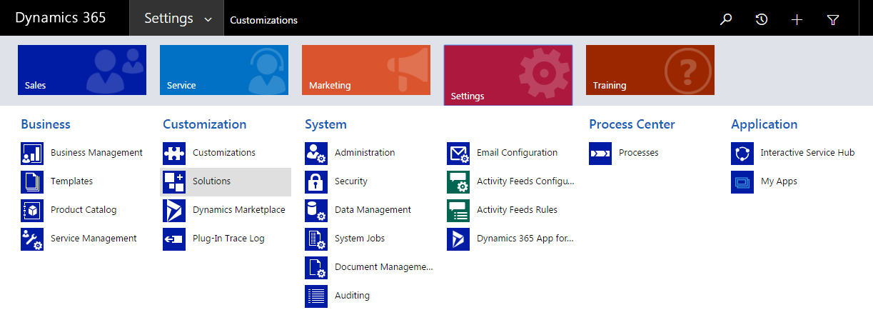

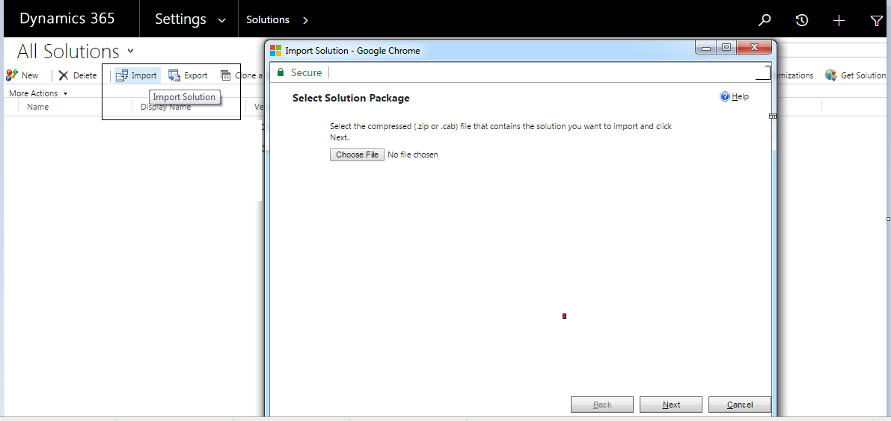

- Browse and import the below solutions.
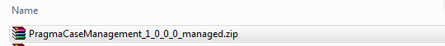

- Check under the solutions once import done successfully.

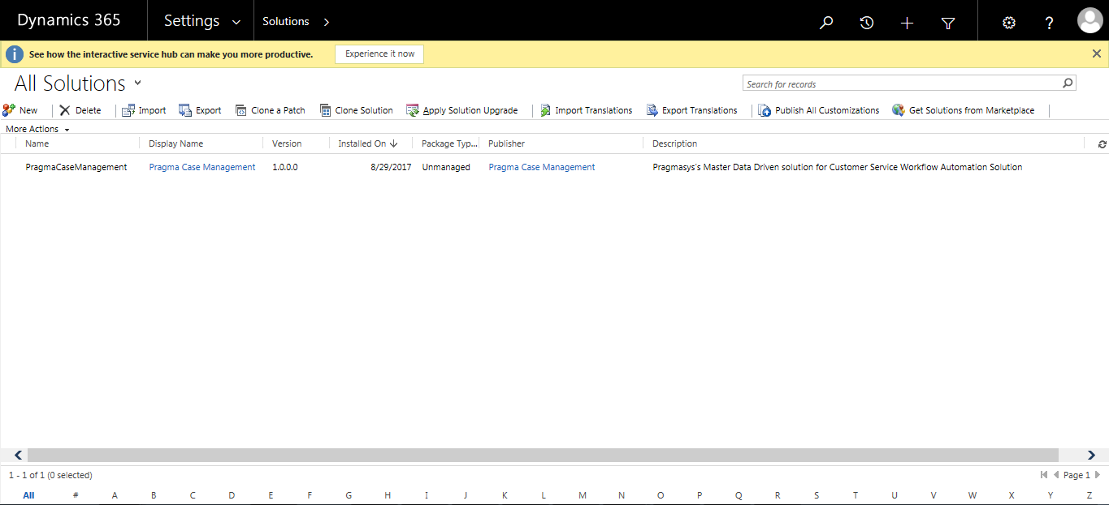

Steps for Master Data Import:
- To import data (i.e. .csv files) For that go to setting > data management > import
- Following form will open, then click to ‘import data’
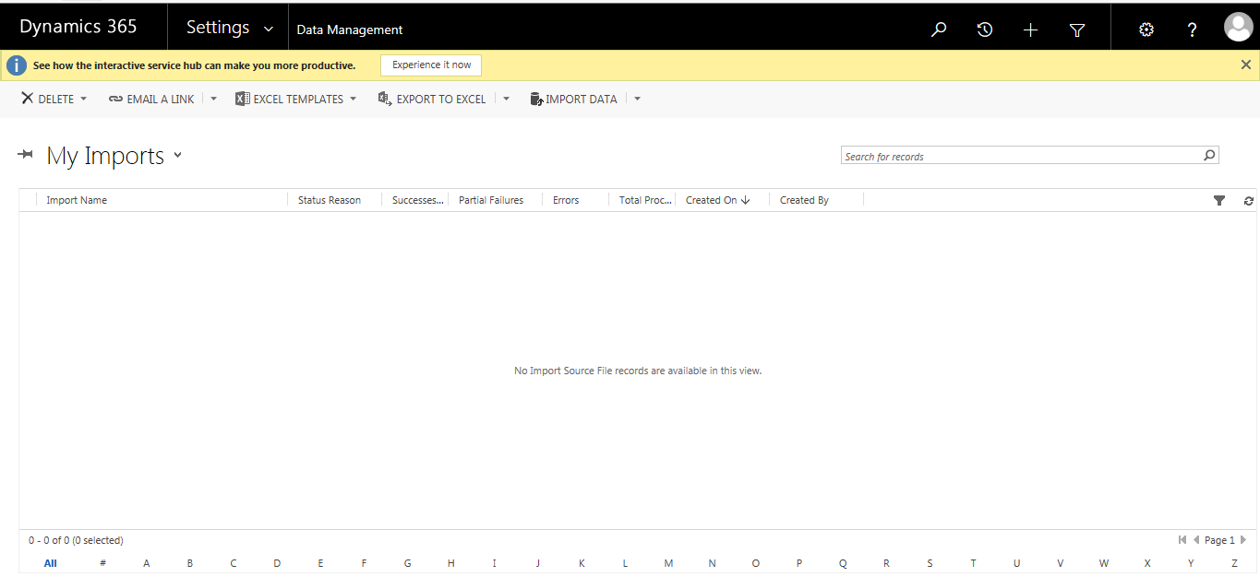

- Following form will open, then click to ‘Browse’ and Select file sequentially.

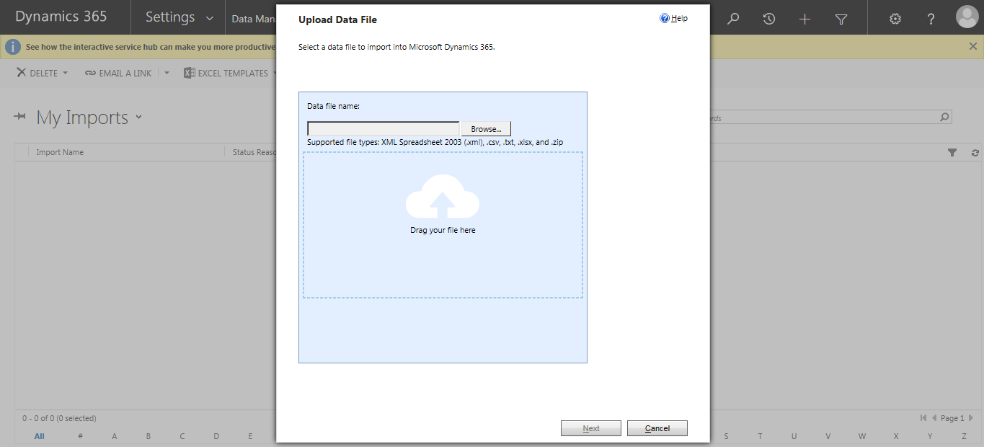

- Click on next
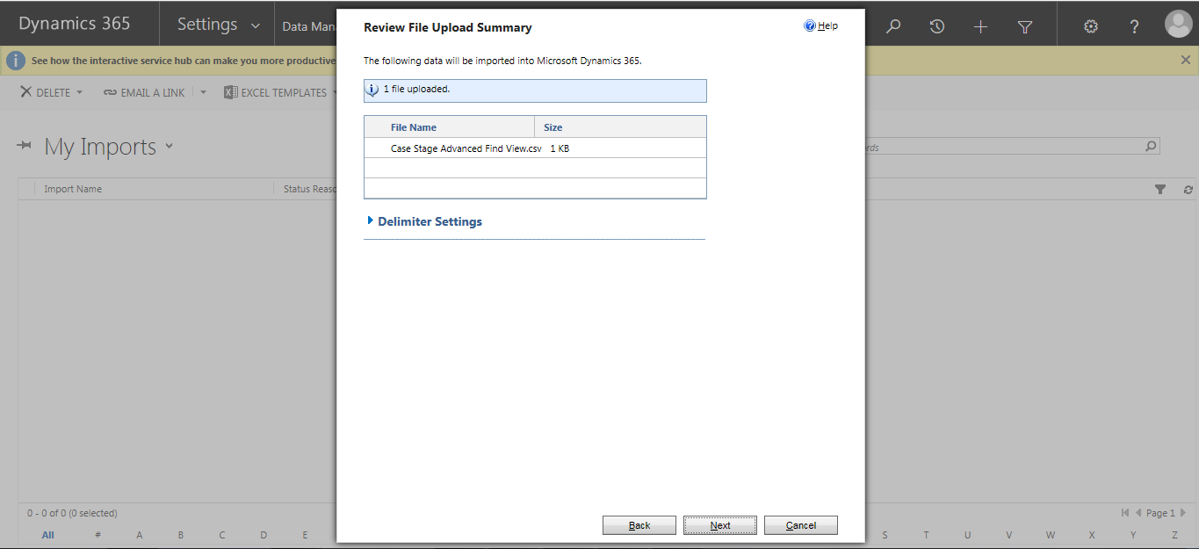

- Click on next
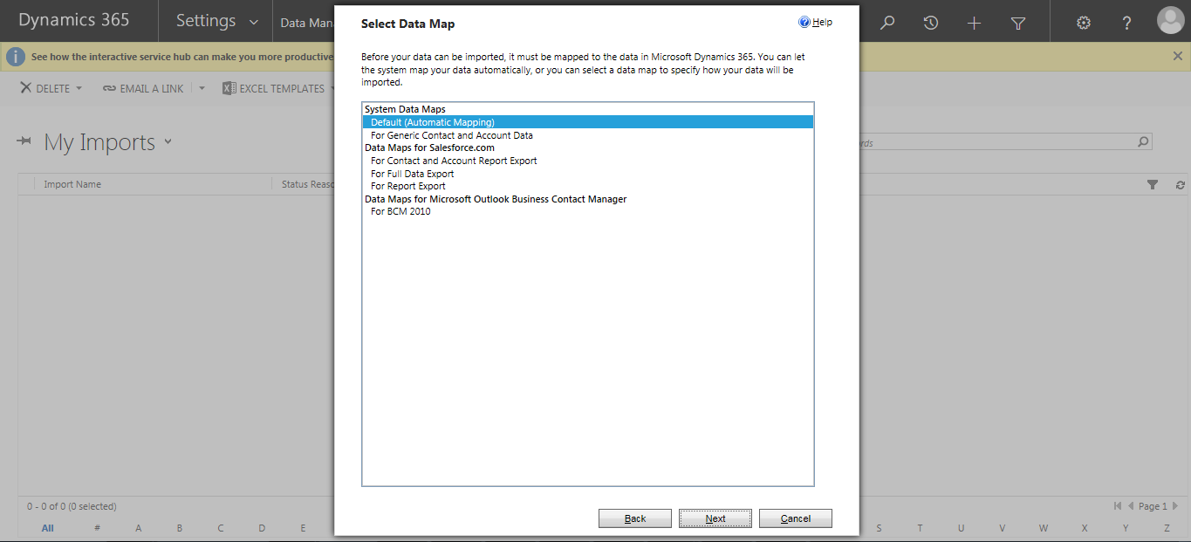

- Select entity name given against file name and then Click on next.

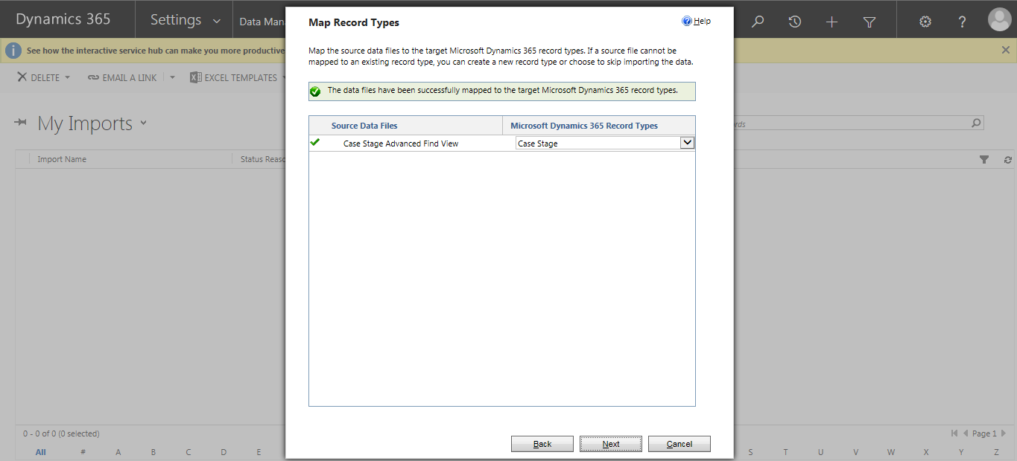

- Click on next
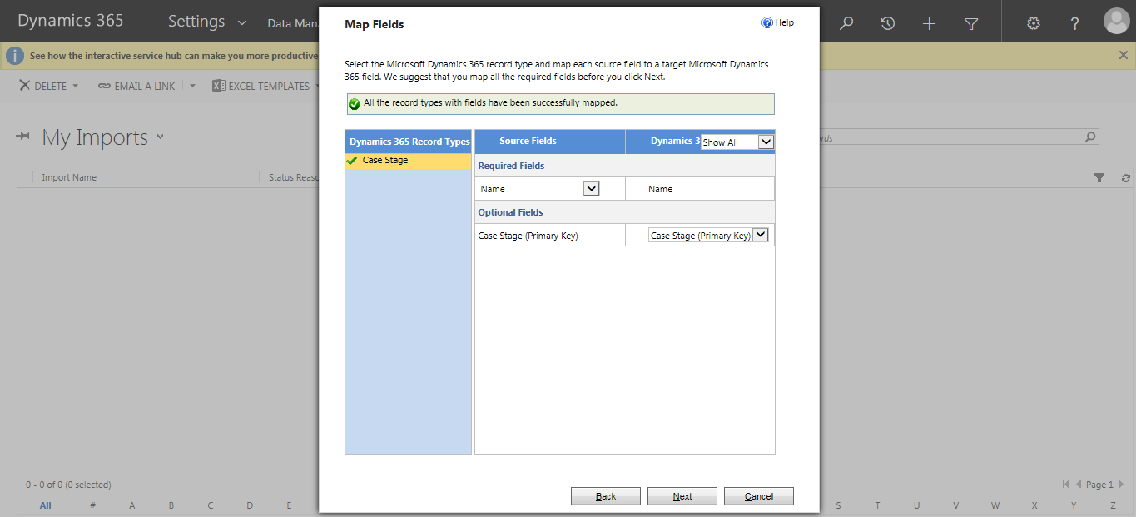

- Click on next
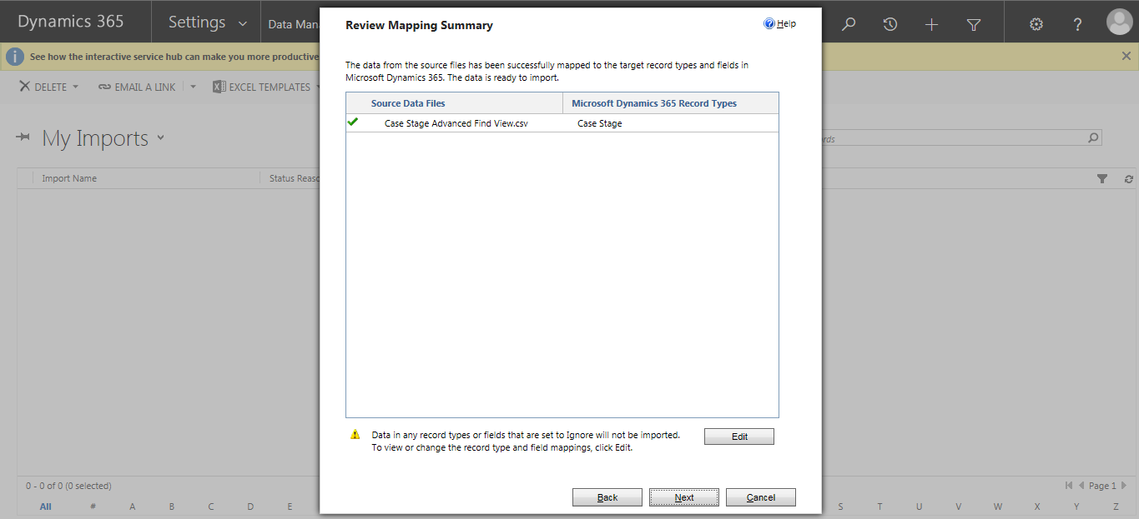

- Click on submit
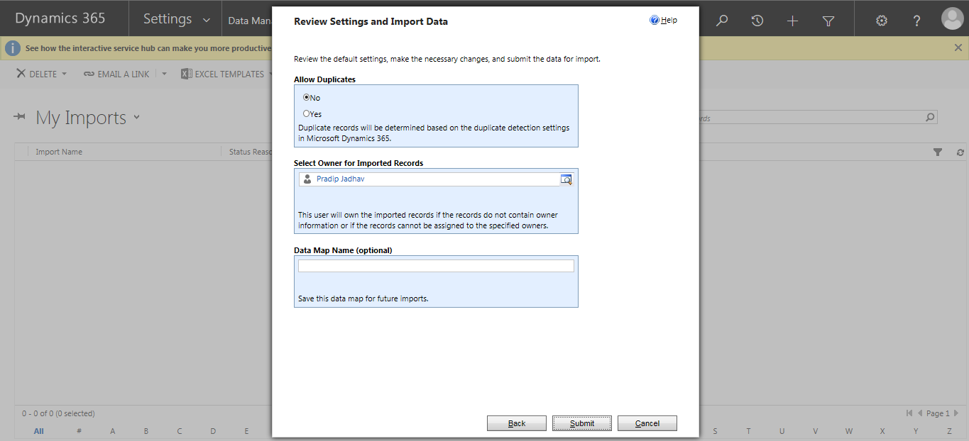

- Click on finish

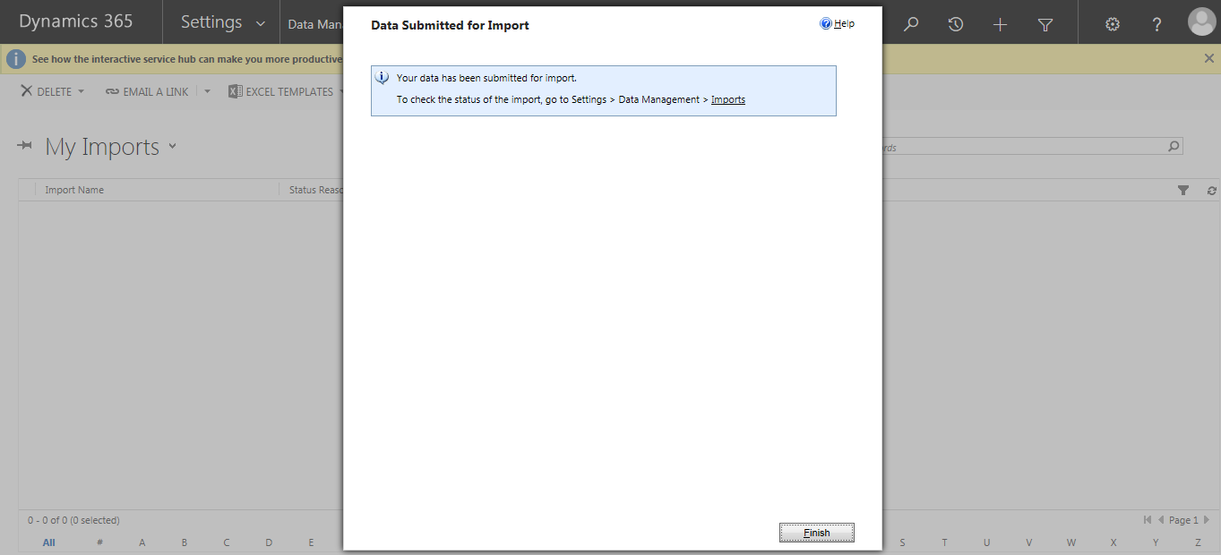

- Check whether all data imported or not as shown in below. If Any error occurs the click on that file & Solve errors

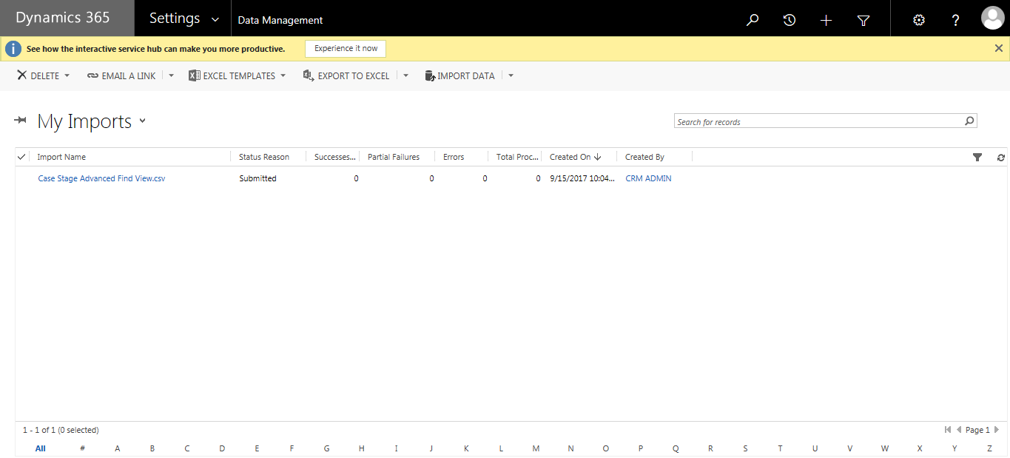

Files with entity name to import Data:
No | Entity Name to select | Csv file
1 | Case Stage
2 | Case Stage Status

Email Configuration
Get guid of administrator user of mscrm and using plugin registration tool replace in unsecure configuration of plugin where key is “emailsentfromid”. Do this for below 2 step

PragmaCaseManagement.CaseManagementPost: Update of incident

PragmaCaseManagement.CaseManagementPost: Create of incident

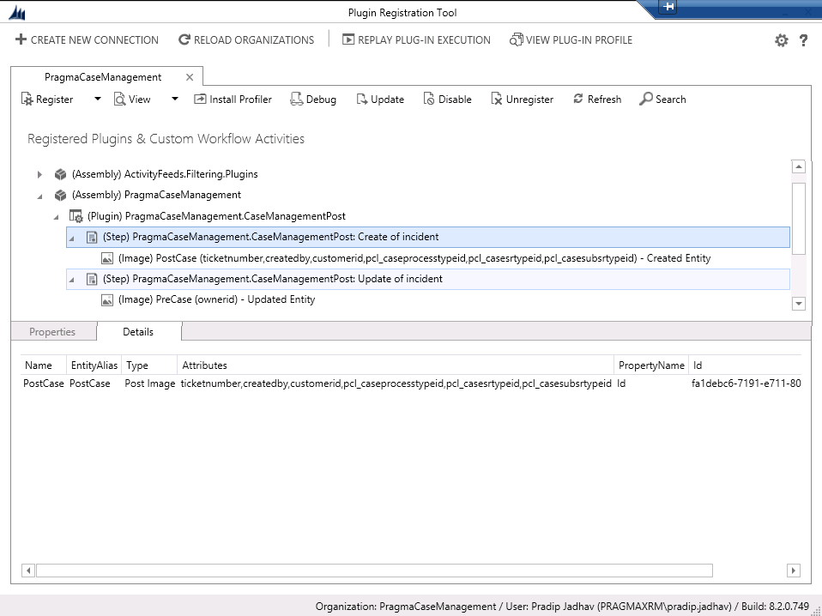

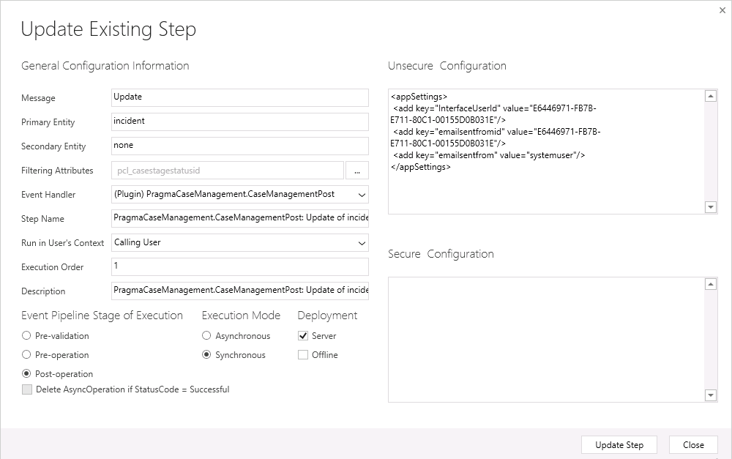

Security Roles
We have added 2 security roles named Central Operations Case Management and Contact Center Executive Case Management Assign that security Role to User and Team.

