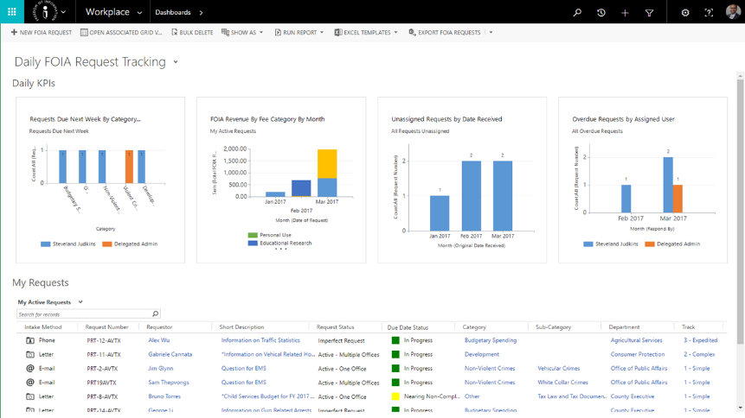

Public Records Tracker™ (PRT) is specifically designed to help federal, state and local agencies quickly & cost-effectively meet Public Records Act (PRA) and Freedom of Information Act (FOIA) compliance requirements.

* Request tracking and routing
* Auto-response to requests
* Dashboards to manage requests
* Activity management
* Track Emails and communications
* Auditing capabilities
* Fee tracking
* Fully configurable
* Portal for constituents
* Maintains FOIA compliance
* O365 Integration with Records management

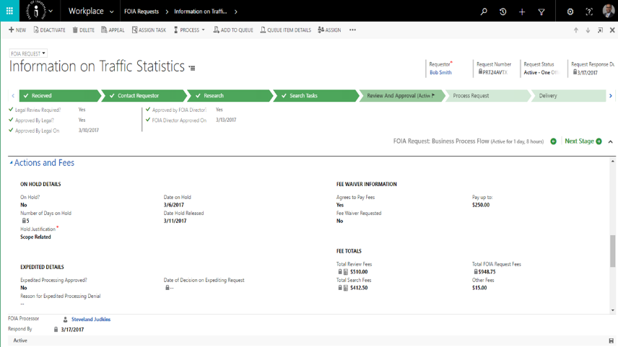

Turnkey. Always On.

With Public Records Tracker™, you have anywhere-access to public records requests via an Internet browser. A user-friendly business process design and automation control panel streamlines tasks with automated reminders and notifications. PRT makes responding to PRA and FOIA requests easy and efficient. Graphical dashboards and reports provide all the information needed to track, manage and respond to requests for public records at your fingertips.