**DD List Box – Import and Registration guide**

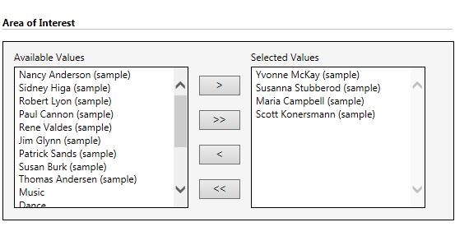

**Contents**

[Import Solution...................................................................................................................................3](#Import Solution)  
 [Register DD List Box Add-on.............................................................................................................5](#Register View Creator Add-on)

[Security Role Privilege.......................................................................................................................7](#Security Role Privilege)

[Uninstalling the DD List Box.............................................................................................................8](#Unstalling View Creator)

[Known issues......................................................................................................................................8](#Known Issues)

[Points to keep in mind........................................................................................................................8](#Points to keep in mind)

**Import Solution**

Once you download the DDListBox package, there will be a CRM solution named as DDListbox_1_0_managed.zip

Below are the steps to import this solution on CRM instance:-

1. Login to your CRM instance.
2. Go to Settings area and select Solutions option.

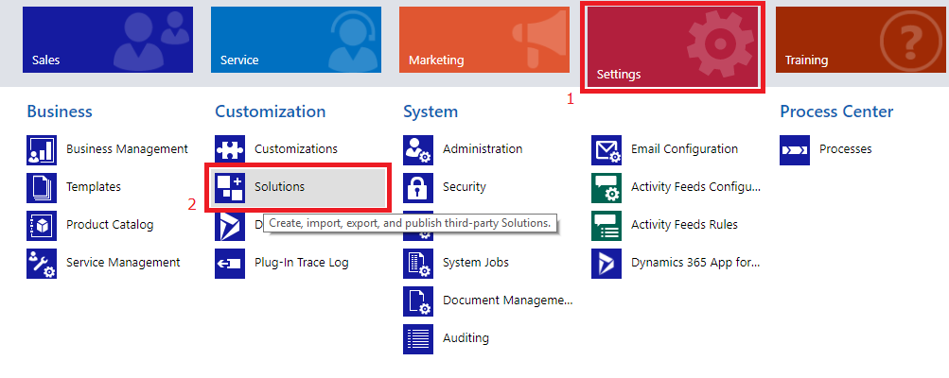

1. Click on Import button



1. Import **DDListbox_1_0_managed.zip** solution.

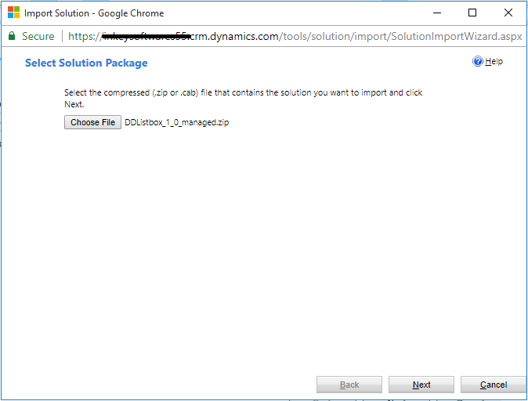

1. Make Sure that you check “Enable any SDK message processing steps included in the solution” while importing this solution.

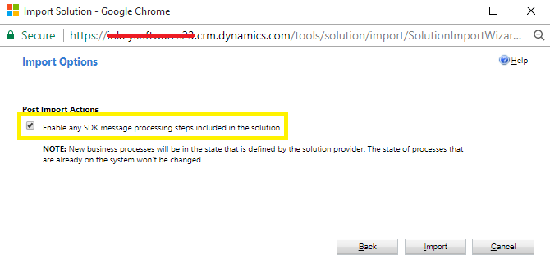

1. Finally, click on Import button. If everything goes well, then, it means that you have deployed the add-on successfully.

**Security role priviledges**

To Configure and access a demo of this tool user must have security role, either could be a **System Administrator** or a **System Customizer.**

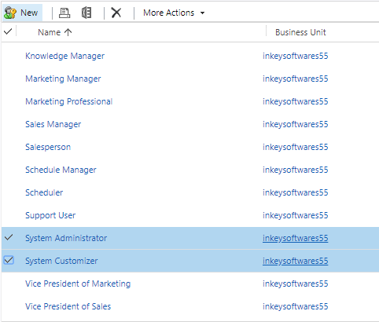

**Register DD ListBox Add-on**

1. Open the DD ListBox managed solution by navigating Settings -> Solutions -> DD ListBox

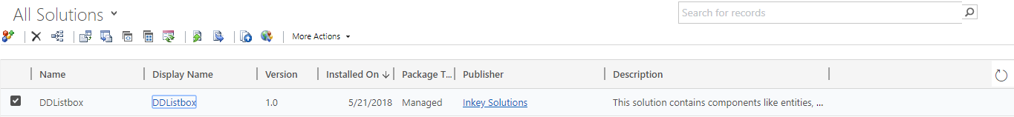

2. In the solution pop-up window, navigate to the ‘Configuration’ tab to provide necessary details for Add-on registration.

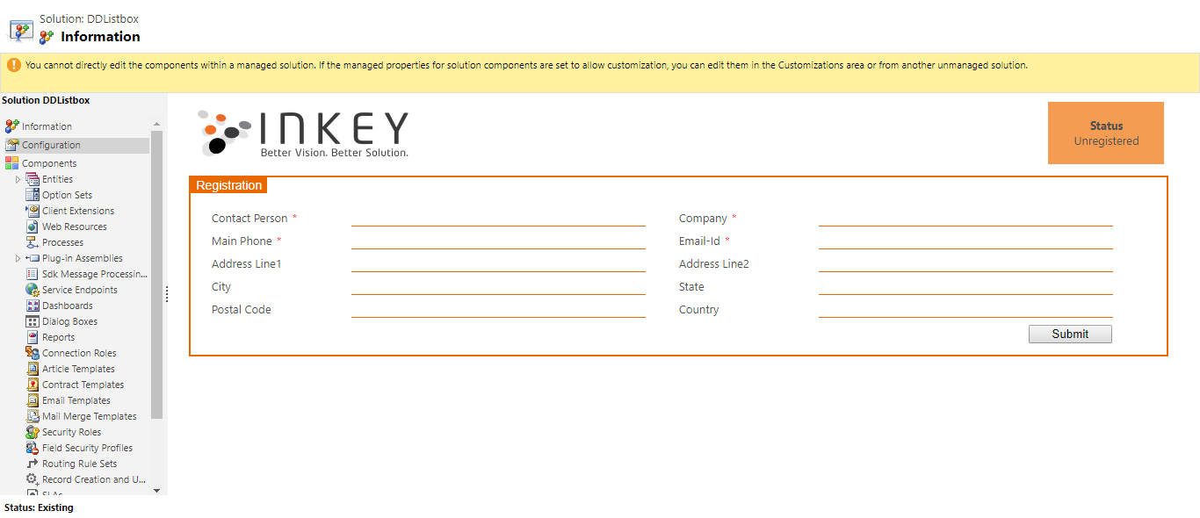

3. Fill all the required details as specified in the ‘Configuration’ and click on the ‘Submit’ button.

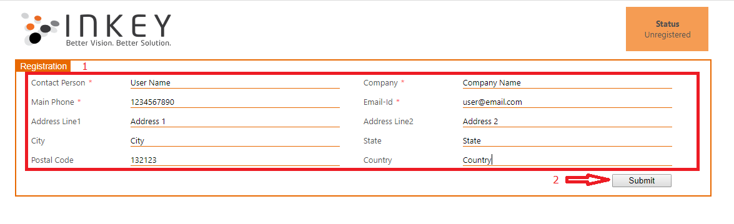

4. If everything goes well, the add-on will get registered successfully and you would be able to see the window as below:

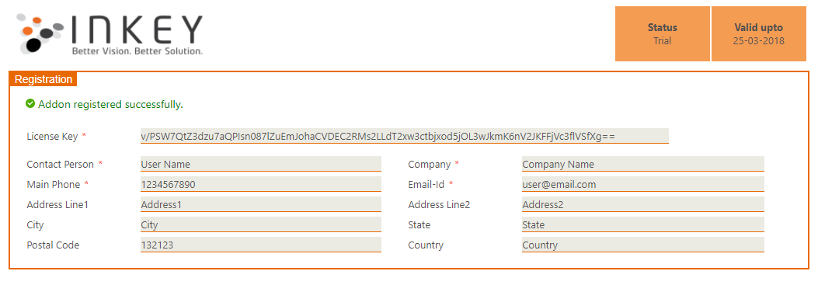

**Security Role Privilege**

To configure and access this tool, the user must have the role of **DDListBox.**



**Uninstalling DD ListBox**

1. The user must manually remove the DD ListBox HTML web resource from the configured entities.  
2. Uninstall the DD ListBox add-on as usual, by deleting the solution.

**Known Issues**

1. This add-on does not support,

**A.** **Microsoft dynamics CRM app** for tablet and mobiles. However, the same is working very well when we access Dynamics CRM using tablet or mobile browsers. Use the arrow buttons to move the values from source to destination and vice versa when accessing this tool in tablet or mobile browsers..

**B. Multiple items drag & drop.** Although, the same can be achieved using the arrow buttons.

**C.** **More than one DDListbox controls cannot be configured on a same form for a particular entity.**

1. If you want to use this add-on for the General tab of any entities then please consider the following scenario.
   1. Create new entity, in this example it is Account. (Schema name is “account”).
   2. Try to configure DDListbox on that entity’s General tab, then the following message gets appeared:

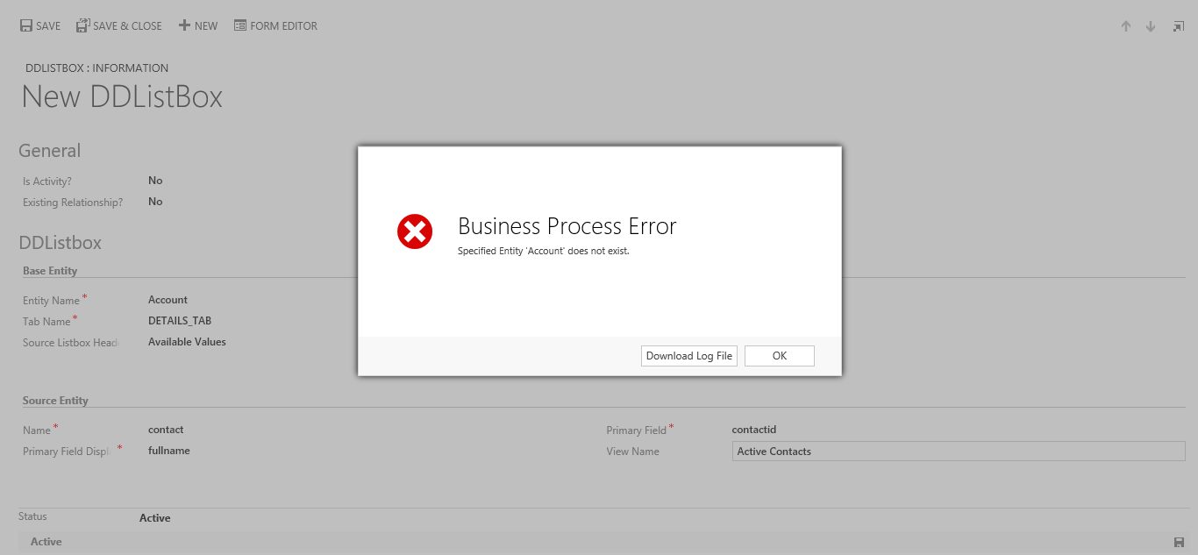

* 1. Now go to Account entity form and validate the name of the General tab as shown in following screen print.

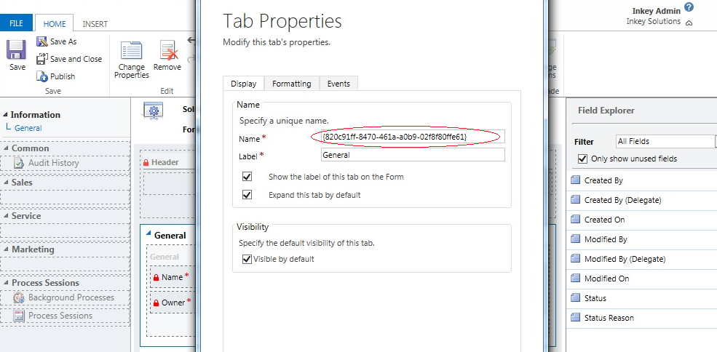

* 1. Just rename the general tab from GUID value to “general” and publish the Form xml.

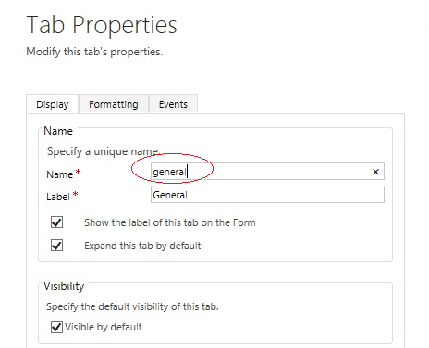

**Points to keep in mind**

**1.** The user must have all required privileges for the entities for which Many to Many relationships needs to be implemented.  
**2.** Register the trial and contact us at ‘sales@inkeysolutions.com’ to purchase a licensed copy.  
**3.** For the trial version of the add-on, the user will have limitations as below:  
==> DD ListBox can be configured on a maximum of 1 entity (System or Custom).  
==> Maximum 5 records can be associated with a Many to Many relationships.  
**4.** The entities relationships created from this tool will not be deleted when you uninstall the tool.  
**5.** You can uninstall the DD ListBox add-on as usual, by deleting the solution. But, uninstalling the solution, does not unsubscribe the solution. If you’re discontinuing use of the add-on, you must first unsubscribe the solution.  
**6.** This add-on works only in edit mode.  
**7.** This add-on will create a many-to-many relationship between the entity (on which you would like to deploy this tool) and source entity to store the data.  
**8.** For CRM activity, this add-on will create mediator entity and relationships between the mediator entity plus host activity and target entity.   
**9.** When you undo this tool by deleting the DDListbox control, at that time we are not deleting the many-to-many relationship, mediator entity, and relationships. This prevents data loss. So, if you do not need the data then make sure you delete this relationships and mediator entity manually.   
OR  
If you want to reuse the same data again then reconfigure the add-on for similar entities using DDListbox link at ‘Add-ons’ Area, INKEY tab.