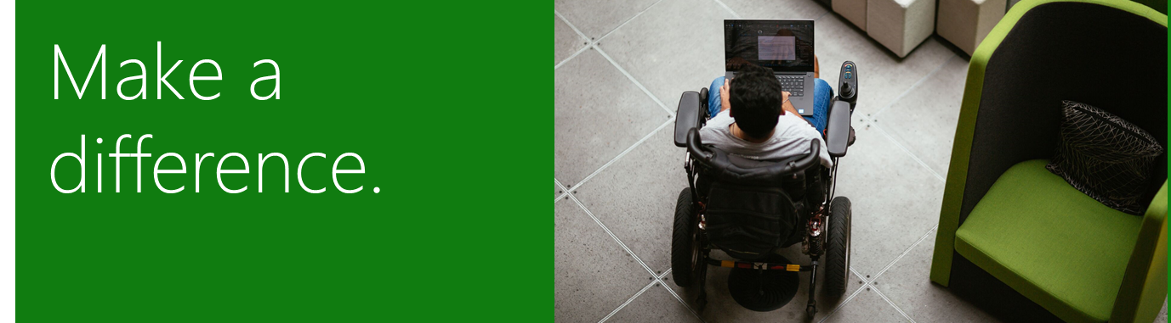

Microsoft Disability Scholarship

The Disability Scholarship at Microsoft delivers on the mission of Microsoft’s cross disability employee resource group to empower and enable people with disabilities. This scholarship enables high school students with disabilities to go to college and target a career in the technology industry. In addition, we hope to contribute to increasing the pool of persons living with a disability enrolling in higher education and, in the long term, decrease the unemployment bias for this demographic.
This scholarship will be awarded to promising high school seniors who plan to attend a vocational or academic college and have a financial need. The amount of this renewable scholarship to be awarded is $5,000 per year, up to $20,000 total, which is paid through the Seattle Foundation on behalf of the disability Employee Resource Group (ERG) at Microsoft to the recipient’s school’s Financial Aid Office.
All completed applications must be submitted by March 1, 2021.

Scholarship Requirements
To be considered for the Microsoft Disability Scholarship, you must:
- Be a current high school senior living with a disability (as defined by the World Health Organization), whether that be visual, hearing, mobility, cognitive, speech or other disability.
- Plan to attend an undergraduate program in a 2 or 4-year University/College or Technical College in the fall of the academic year following high-school graduation. Schools must be in the USA or have a USA-Affiliate for financial transactions (contact Seattle Foundation to verify non-USA school’s eligibility).
- Declare an approved major in engineering, computer science, computer information systems, law, business, or a related field (e.g. paralegal, pre-law, finance, business administration, or marketing).
- Demonstrate a passion for technology.
- Demonstrate leadership at school and/or in the community.
- Have a high school cumulative GPA of 3.0 or higher.
- Require financial assistance to attend college.
- Enrollment status must be full-time or half-time.

How to Apply
To apply for a Microsoft Disability Scholarship, email the following items to scholarships@seattlefoundation.org as one, complete submission.

- Résumé. Your résumé should include the following information:
- Extracurricular activities (school and community related)
- Honors and awards that you have received (if possible, include awards that are technology related)
- Work experience
- Transcript. Include an unofficial copy of your current academic transcript. (If selected as a finalist applicants will need to provide the Seattle Foundation with official versions)
- Three essays.
- In no more than 500 words, describe how you plan to be engaged in the technology industry or technology law or policy in your career.
- In no more than 500 words, please share your vision of how Microsoft can innovate its future devices and services solutions to creatively & successfully support those living with disabilities in the workplace and in daily life to reach their potential.
- In no more than 300 words, describe how your disability has impacted you and your financial need for this scholarship.
- Two letters of recommendation.
- At least one letter must be from a faculty or staff member at your school.
- Letters of recommendation should be original and should not be duplicates of college recommendation letters. Do not include relatives as references.
- Complete Application Form
Fill out the entire Application Form on the following page. You can type the information or print clearly.

Email all of the above in ONE email with the naming convention**
Microsoft Disability Scholarship 2020 LASTNAME, FIRSTNAME
Ex: Microsoft Disability Scholarship 2020 DOE, JANE
Please send to scholarships@seattlefoundation.org by March 1, 2021.

** Please ensure that your application packet includes all of the required information and documents before sending. We will not accept additional documents sent separate from the original application packet, and only complete application packets will be reviewed.

Final selection will be complete, and those selected to receive the Microsoft Disability Scholarship will be notified at the end of April 2021.

Microsoft Disability Application Form

Name: Click here to enter text.
Street Address: Click here to enter text.
City: Click here to enter text.
State: Click here to enter text.
Zip Code: Click here to enter text.

Phone Number: Click here to enter text.
Email Address (please use personal address, not school email): Click here to enter text.

High School Name: Click here to enter text.
Graduation Date: Click here to enter a date.

What colleges and universities have you applied to?
Click here to enter text.
Click here to enter text.
Click here to enter text.

Which colleges and universities have you already been accepted to (if applicable)?
Click here to enter text.
Click here to enter text.
Click here to enter text.

College or university you plan to attend (if known): Click here to enter text.

List any other scholarships you’ve been awarded:
Click here to enter text.
Click here to enter text.
Click here to enter text.

How did you hear about this scholarship? (Select one)
Choose an item.

Signature:
I affirm that the information included with my application is true and accurate in all respects and that I intend to pursue a degree in higher education. I also understand that if selected, the awarding of funds is contingent upon my full-time enrollment in an accredited institution and that the funds will be paid directly to the institution and used towards the cost of my education. I authorize the Seattle Foundation to release the information in this application to relevant scholarship reviewers for the sole purpose of assessing my scholarship application. To the best of my ability, I have redacted or removed any sensitive personal information from application attachments that I do not wish to share with the scholarship reviewers (e.g. Student IDs and/or Social Security Numbers).

Signature Date

