App Source – Consulting Services - Power BI

RPA Power BI Reporting: 1-Wk Proof of Concept

A productive engagement to bring the value of Power BI to your Blue Prism robotic process automation solution.

In this 1-week proof of concept we will work along-side you and your team to create a prototype report to take back to your organization. Take full advantage of your existing Blue Prism platform by viewing outcomes in an interactive and collaborative manner.

Viewing and demonstrating results, a high-level controller function, outcome tracking or aligning with business objective KPIs are just some of the possible benefits of Blue Prism reporting brought to you by Power BI.

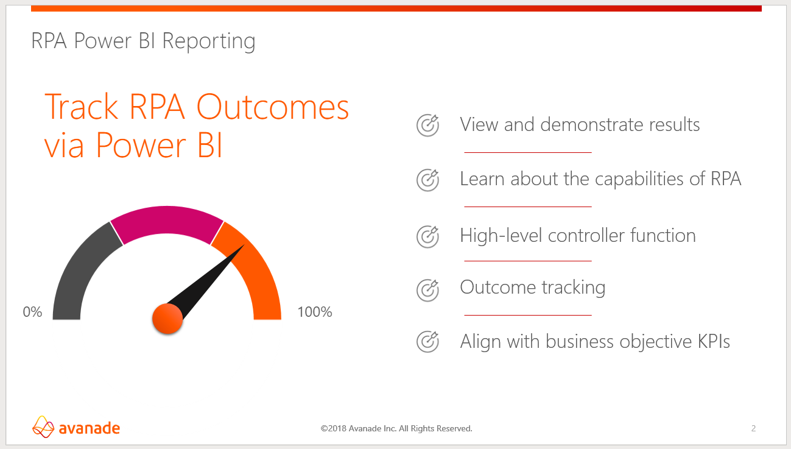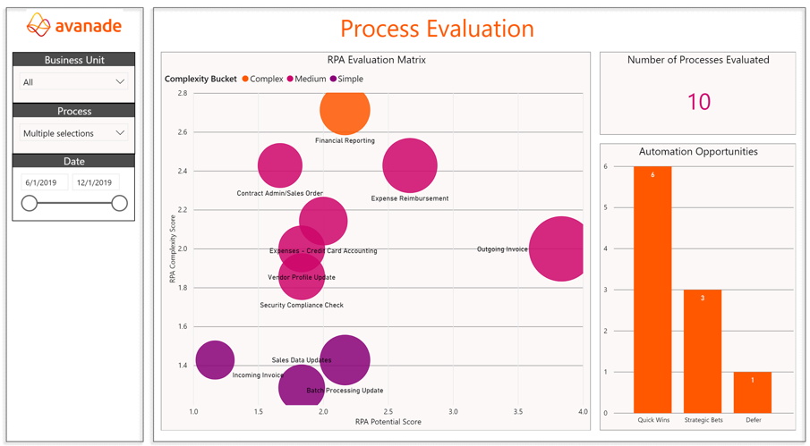

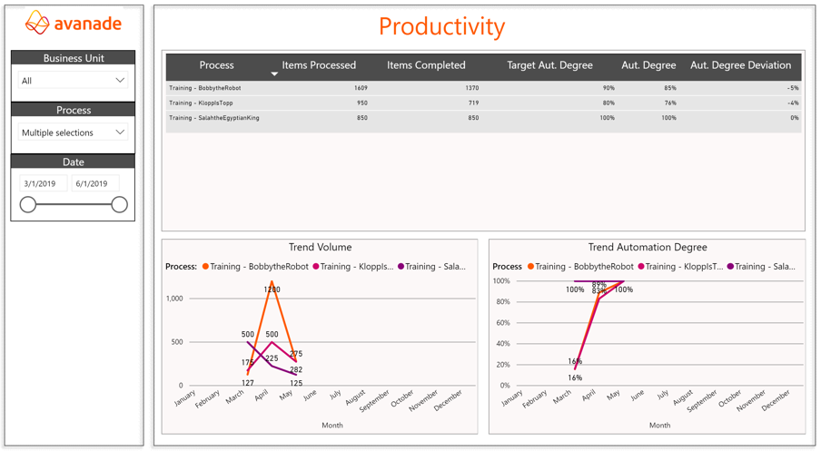

Agenda
Day 1
- Initial meetings with stakeholders to review the status of your Blue Prism installation and to agree on detailed requirements for the proof of concept
- Prepare and share a plan of development
- Start implementation of rapid proof of concept
Day 2-4
- Implement rapid proof of concept
Day 5
- Present result of proof of concept
- Providing next steps to implement full version of RPA/Blue Prism reporting

Deliverables
This engagement includes the following activities and topics:
- A rapid prototype solution that informs how your organization will utilize Power BI reporting to RPA outcomes
- The source code of the project

Note
- Travel cost additional depending on site location and resource availability.
- This estimate is non-binding and for reference only.

