NOTATION: Procedure starts with step four setup and installation of the Woocommerce Connector App.
Designated Guide Accents.
Italicized – Designates and action. (Ex. Select, click, hover)
Bold – Designates an item that an action interacts with. (Ex. click Save, hover over the Settings Button)
Underlined – Designates a location on the screen. (Ex. Top Right, Bottom Center, Right Center)

- Start by logging into the organization that you would like to utilize the Woocommerce Connector App on.
- In the top right of your screen select the search button.
- In the search bar of the window that pops up, type Assisted Setup and the list of search options will automatically appear.
  - 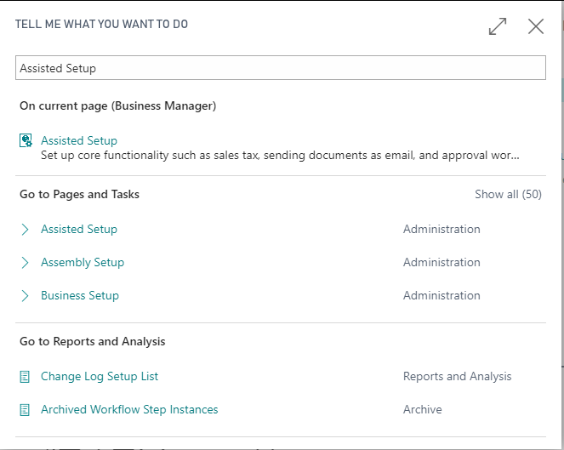
- Select the first assisted setup option.
- On the bottom of the assisted setup list you’ll select the option Set up Woocommerce Connector.
  - 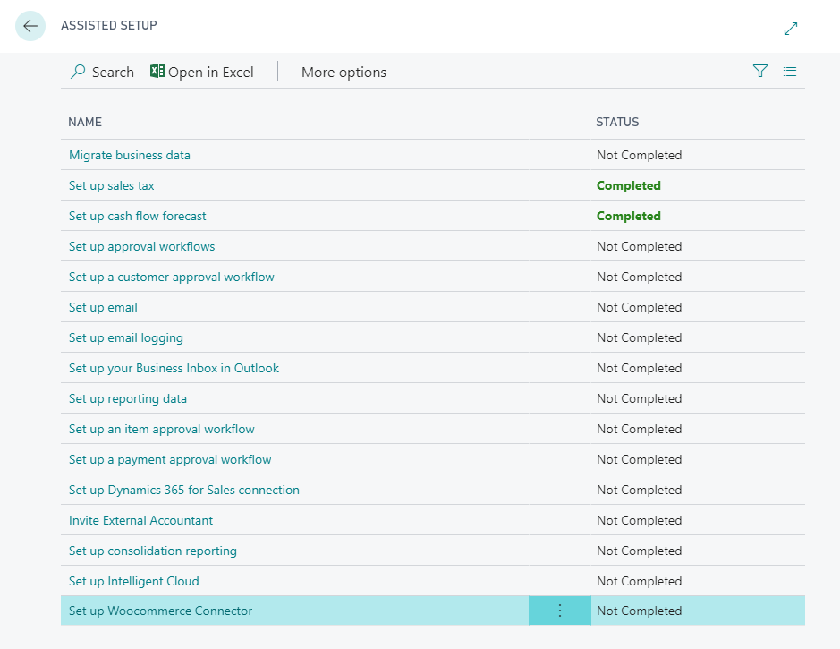
- The next window that appears is the beginning of the Woocommerce Connector App setup and installation process. Follow the prompts of the process. Please refer to the steps below if you need any clarification.
- Step 1. To specify the store URL first login to your WordPress account. In the top left of your WordPress dashboard, hover over your site name, when the drop down appears select visit store.
  - Once your store page has come up, copy the URL and paste it into the assisted setup window.
    - 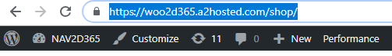
  - Your wizard should look like the following with your URL in place of this sample. Click next.
    - 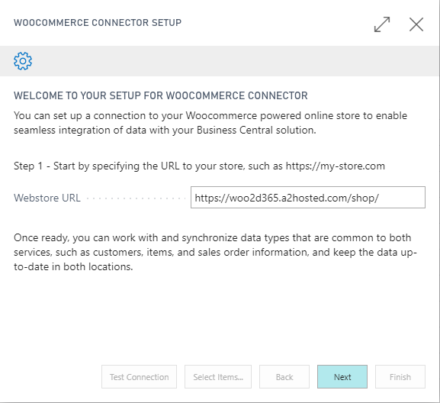

- Step 2. Next you’ll need to get your store specific keys.
  - To find your store specific key you’ll start in your WordPress Dashboard.
  - Select the WooCommerce tab on the left hand side of the screen and then select settings from the menu options.
    - 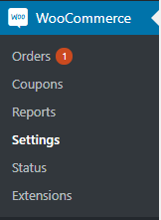
  - On the settings page you’ll find tabs across the top center of the page. Select the last tab labelled API.
    - 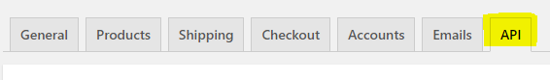
  - Once you’ve arrived at the API tab ensure that the checkbox for Enable the REST API is selected and select save changes.
    - 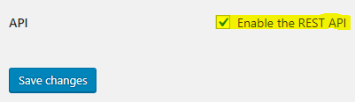
  - After that select Keys/Apps on the left center part of the screen.
    - 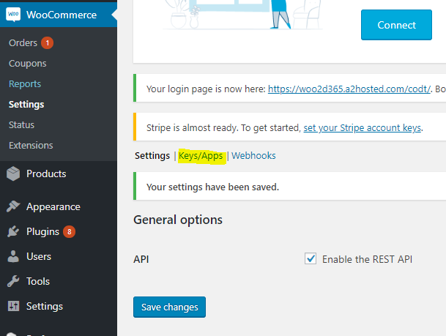
  - Then select Add key which can be found just below Keys/Apps button.
    - 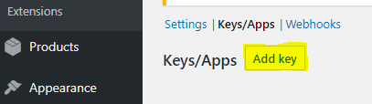
  - In the Description field type Business Central API Key. Make sure the user is your name, and make sure that the drop down options under permissions is marked as Read/Write. Select Generate API key.
    - 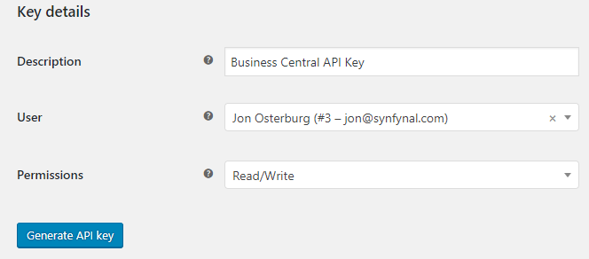
  - You will now have two keys on your screen. The Consumer Key and the Consumer Secret. Copy each and paste the Consumer Key and the Consumer Secret into the designated place in the Woocommerce Connector App setup window.
    - 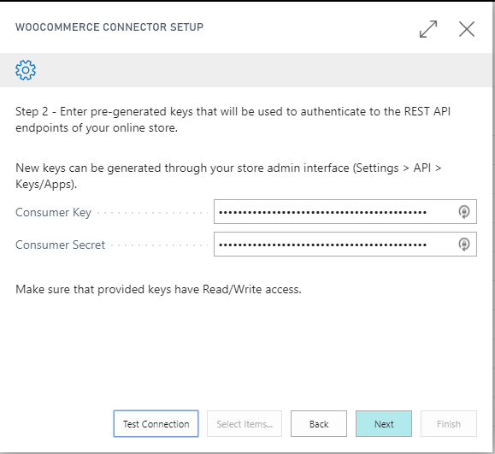
  - Once you’ve got your Consumer Key and Consumer Secret entered, click Test Connection.
  - After the Test Connection has been confirmed, click Next.
- Step 3. During this part of the wizard you’ll be setting up the posting groups and other information that will reflect in business center.
  - Customer Posting Group - Specifies the default Customer Posting Group that will be used for customers that are imported from webstore.
  - Gen. Bus. Posting Group - Specifies the default Gen. Bus. Posting Group that will be used for customers that are imported from webstore.
  - Default Unit of Measure - Specifies the default inventory Unit Of Measure that will be used for items that are imported from webstore.
  - Default Location Code - Specifies the default inventory Location that will be used for sales orders that are imported from webstore.
  - Inventory Posting Group - Specifies the default inventory Posting Group that will be used for items that are imported from webstore.
  - Gen. Prod. Posting Group - Specifies the default Gen. Prod. Posting Group that will be used for items that are imported from webstore.
    - 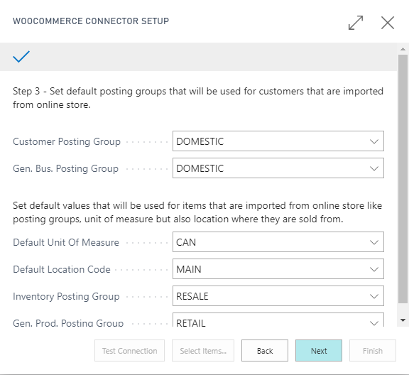
- Step 4. The step in the setup includes selecting the items you’d like to mark for your online store. If you decide not to do this at this point in time you can set this up later on in the Woocommerce Connector Setup.
    - 