Avtex Public Records Tracker
User Guide

Table of Contents
Document Overview 2
User Guide Overview 2
Public Records Tracker Overview 2
Navigation of the User Interface 2
The Navigation Menu 3
Record Views 5
Other Navigation Elements 11
User Set-up 13
Dashboards 14
Dashboard Selector 15
Managing Requests and Requestors 17
Requestors 17
FOIA Requests 19
Exporting Records to Excel for Re-import 31
Using the Business Process Flow 33
Managing Documents 35
Appendix I – Administrators Quick Start Guide 36
Configuring System Settings 36
Configuring Privacy Settings 44
Configuring Document Management Settings 45

Document Overview

User Guide Overview
This document is designed to instruct the End User on how to use the Public Records Tracker (PRT) 2016 system. In this document will take the user through the system a series of step guides that will cover the life cycle of the FOIA request and fulfillment process.
This document is split out into 6 main sections listed below:
Public Records Tracker Overview
User Set-up
Dashboards
Managing Requests and Requestors
Using the Business Process Flow
Managing Documents
Appendix I – Administrators Quick Start Guide

- Note: This guide is not intended to provide detailed knowledge content of any or all of the system settings, nor how to configure, or implement the Avtex Public Records Tracker (PRT). This is a reference for using the PRT system as it is currently designed.

Public Records Tracker Overview
The Public Records Tracker (PRT) allows city, county, state and federal organizations to log, track, route, fulfill and collect fees for FOIA Requests submitted by their constituents. PRT manages the entire life cycle of the FOIA process including:
- Constituent profile management and request submission via portals
- Intake and routing
- Search and review of public records for fulfillment
- Tracking tasks from external offices or agencies
- Calculating fees for work performed by the organizations staff as well as duplication costs.
- Managing denials and exemptions
- Document Management

Navigation of the User Interface
Navigation through the PRT User Interface (UI) is designed similar to that of a modern day website. It includes controls that can take you from your home page to any other section within the system so you can perform your daily FOIA duties. This section is designed to show you how to get around the system, as well as learning some terms that will help you understand the nuances of the PRT System. Navigation of the UI consists of the following elements:

- The Navigation Menu
- Record Views
- Hyperlinks
- Sub-Grid Views

The Navigation Menu
The Navigation Menu is the main method for getting to different Areas and Sub-Areas of the system. Areas are logical groupings of the different Sub-Areas within the System. Sub-Areas are where you go to work with the different types of records to track your FOIA Requests, Requestors, Tasks, etc.
The screenshot below displays the different elements of the Navigation Menu. Each of the elements is numbered and described in the corresponding list below.
The PRT Navigation Menu

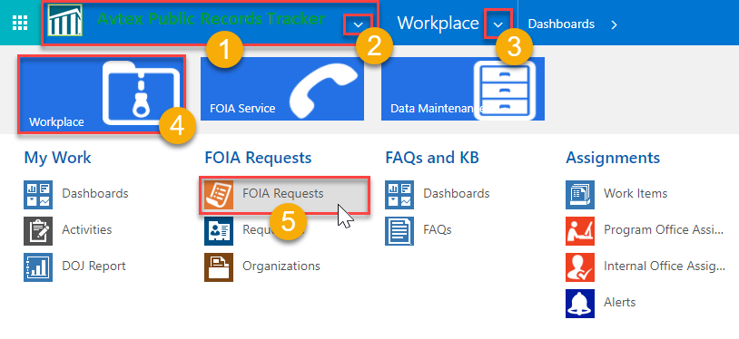
- The Home Button – The home button takes you to your default landing page.
- The App Switcher Button – The App Switcher button exposes the Public Records Tracker App, which is pictured above. This app is does not include the Settings menu.
- The Area Tile – The area tiles bring you to a series of Sub-Areas, depending on what you need to do in the system. When you click an Area tile, the corresponding Sub-Area tiles will appear below.
  - Workplace: This is where you go when you need to process FOIA Requests, log and work on your activities, check on your workload using Dashboard charts, research topics in the Knowledge Base, or assign work to other people, offices or agencies.
  - FOIA Service: This is where FOIA Staff can manage constituent inquiries, complaints, and appeals to their Public Records Requests.
  - Data Maintenance: This is where you go to configure data that drives system configurations and automation, such as Delivery Methods, Fee Schedules, FOIA Request Tracks, Offices, and Exemptions.
- The Sub-Area Tile – The Sub-Area tiles take you to the various record type within the PRT System such as Requestors, FOIA Requests, Dashboards and Activities. Clicking on a sub-area tile will direct you to a Record View as pictured below.

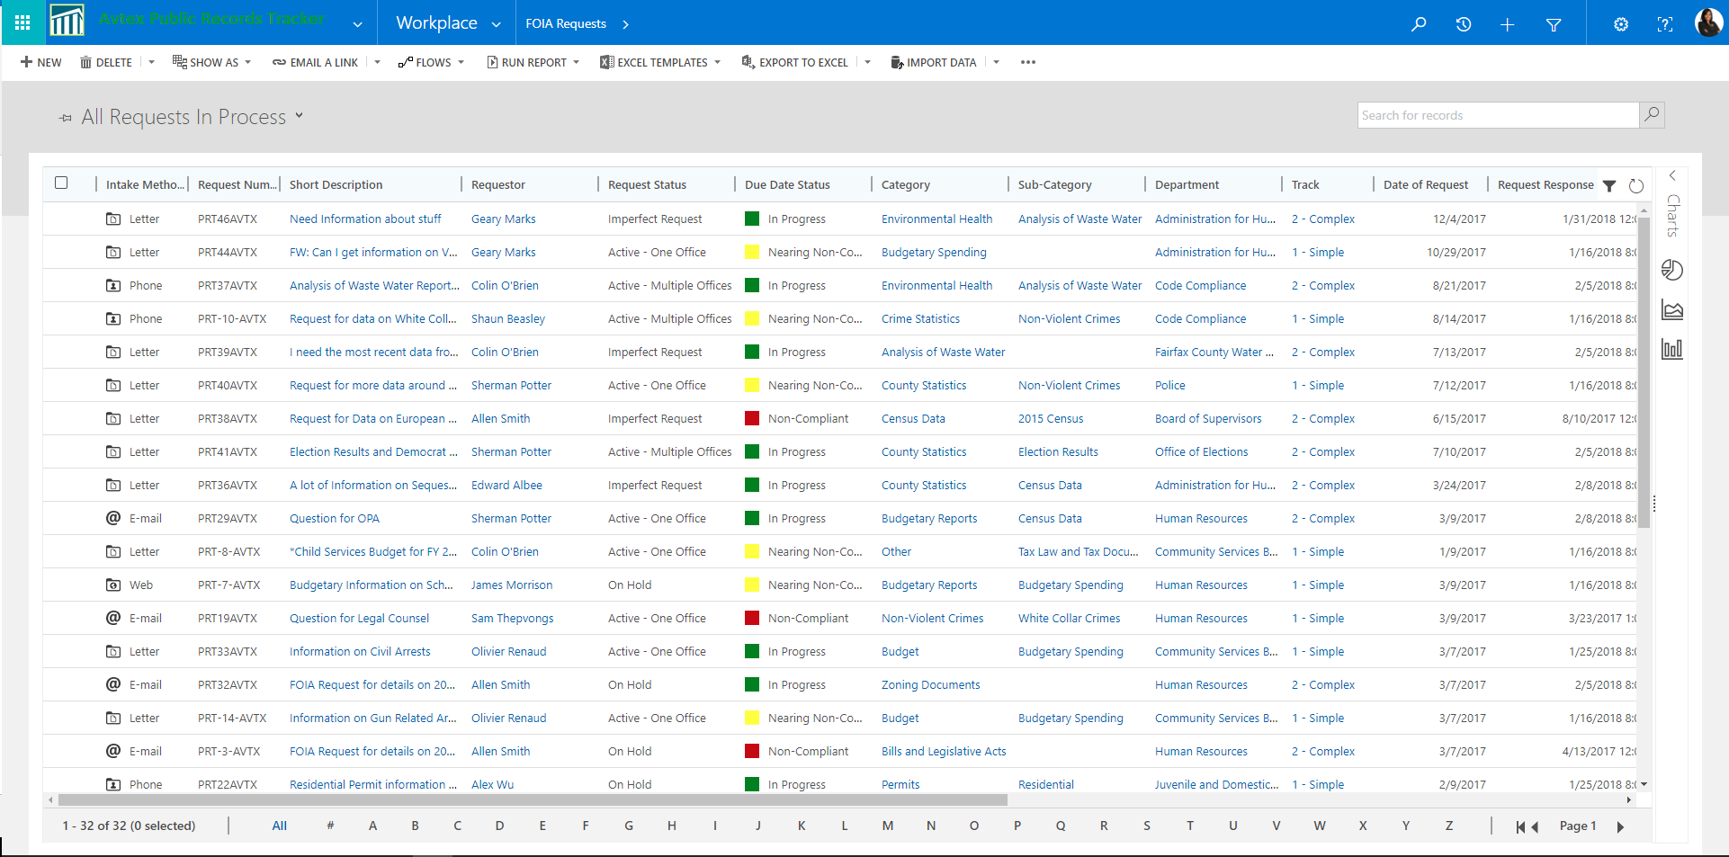

- The “Breadcrumb” buttons – The Breadcrumb buttons are buttons that can take you back from your current location in the system to where you were previously. For example, in the screenshot above, shows (moving left-to-right) that you are in the Workplace area, in the Requestor sub-area, and currently on the Requestor record for Colin O’Brien. You can “backtrack” to the Requestor’s view by clicking the Requestors breadcrumb button.

Record Views
Record views are tabular lists of data records within the PRT System. For example, the screenshot below shows a View of FOIA Requests.
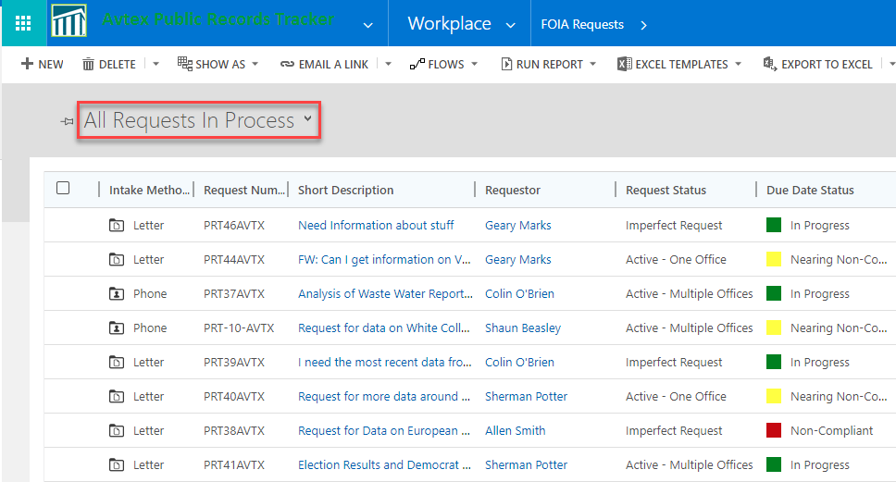
As you can see from the name of the view, this is a list of all of the FOIA Requests that are currently in an “Open” status. This is not a complete list of all of the requests in the database, but rather a sub-set or filtered list of FOIA Requests. Every type of record in the system uses these filtered views to display different record sets depending on what you are trying to do. We refer to these lists as System Views. You can create your own list views by applying custom filters (described later in this section) and saving them. We refer to these lists as Personal Views.

Selecting Views
You can select views using the View Selector control, then clicking on the view’s name. The screenshot below describe the different areas of the View Selector.
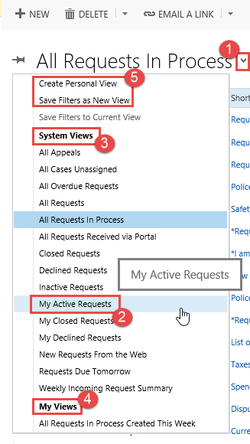
- View Selector control – Clicking the down arrow will expose the list of views for a given record type.
- You can select a different view by clicking the view’s Name.
- System views – System views are pre-configured views that cannot be modified unless you are a System Administrator. System Views are listed first.
- Personal views – Personal Views are views that you have created using a number of techniques described later in this section. Personal views are listed in the My Views section at the list.
- Create View Options – you can create new views by selecting one of 2 options at the top of the view list:
  - Create Personal View
  - Save Filters as New View
You can sort the data in these views by clicking the column header buttons. The order (ascending or descending) is indicated by the arrows in the column headers.

Sorting Views
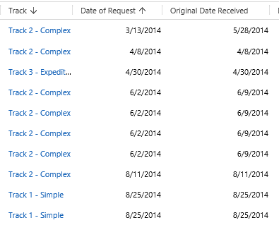
Additionally, you can pin your favorite view, so that each time you visit a sub-area, you are presented with the view of your choice. Simply navigate to that view and click the push-pin icon.
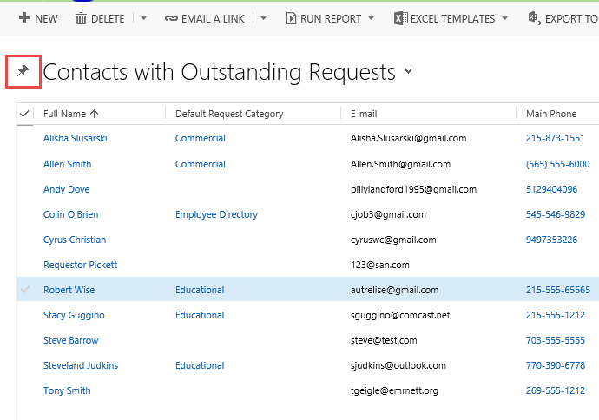

Filtering System Views
You can add your own filters to System Views by clicking the funnel icon in the upper right hand corner of the view.
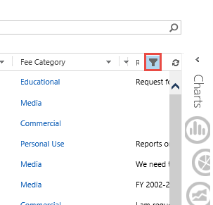
When filters are turned on, you can use the column headers to define the records you want to show or hide using simple Conditions. The screenshot below shows applying a filter on the Date of Request column to only show FOIA Requests that were received this week.
Clicking the OK button applies the filter.
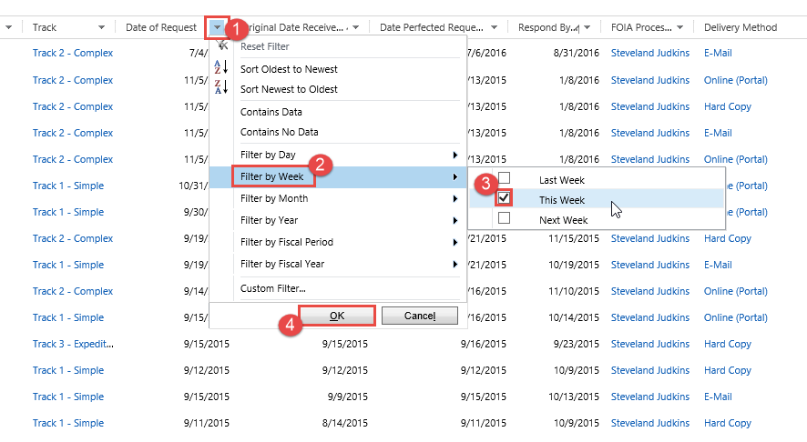

The conditions available for filtering on a column depend on the type of data contained in that column. For example, DateTime columns use date fields and will only filter based on time periods. Drop-down fields (called option sets) will only filter on the values you can select from that drop-down list.
You can apply as many filters as you need to get to the data you want to work with. You can remove the filters by clicking the Funnel icon again.
You can save your Filters to a new view:
- Click on the View Selector.
- Select the option to Save Filters as New View.

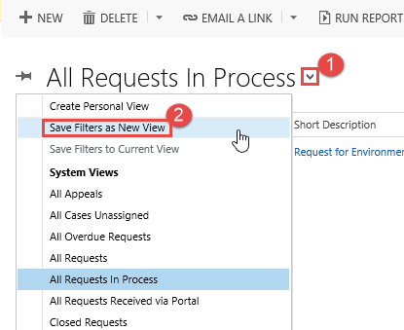

- Enter a name for your view, then click the Save button.

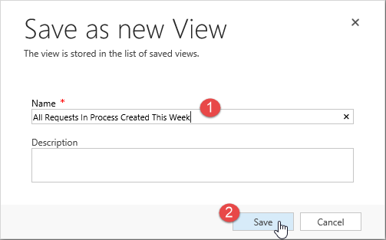

Your view will be instantly available within the My Views section of the view selector list.

Taking Action on Views
You can take certain actions on records within a view by:
- Selecting the record (row) within the view
- Then clicking a button on the Command Bar

Assigning a record using the Command Bar
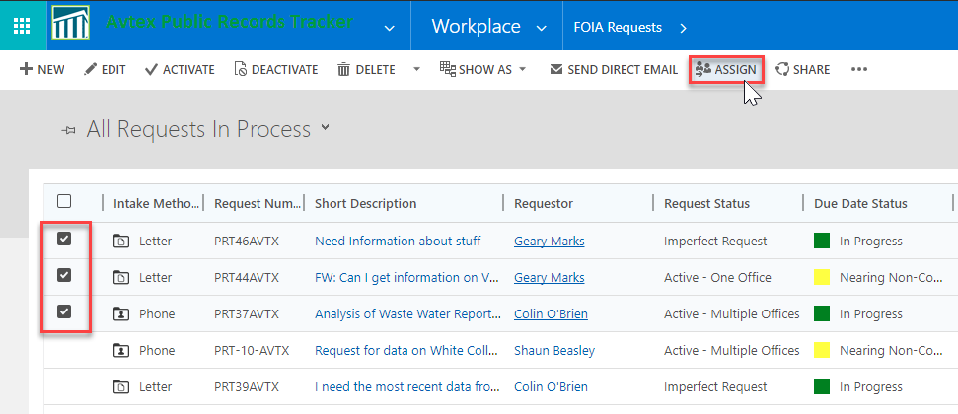
We will describe some of the functions included in the Command Bar later in this guide.

Other Navigation Elements
Some additional areas within the Navigation Bar are pictured in the screenshot below along with their corresponding description.
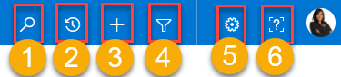

- Global Search box – You can search on any record in the system based on full text search on any entity configured for search. Results can be configured to be displayed grouped by the record type, or by relevance.
  - Enter the search terms into the Search box.
  - Select an additional filters/facets from the left pane.
  - Open the record by clicking on the record listed below the record type.

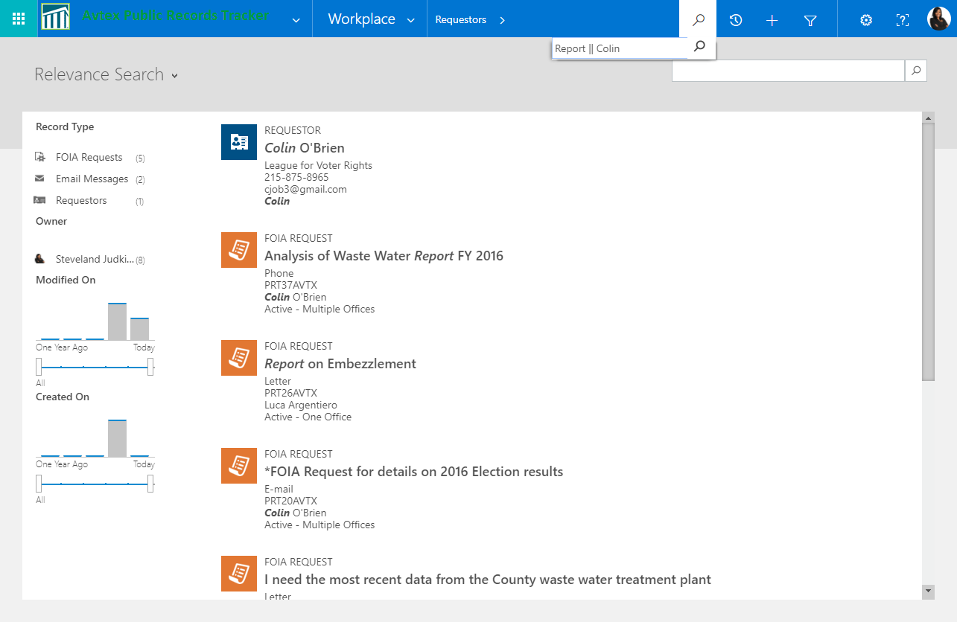

- Most Recently Used list – This button will display all of the records that were recently accessed in previous sessions. You can also pin these records so they are always displayed.

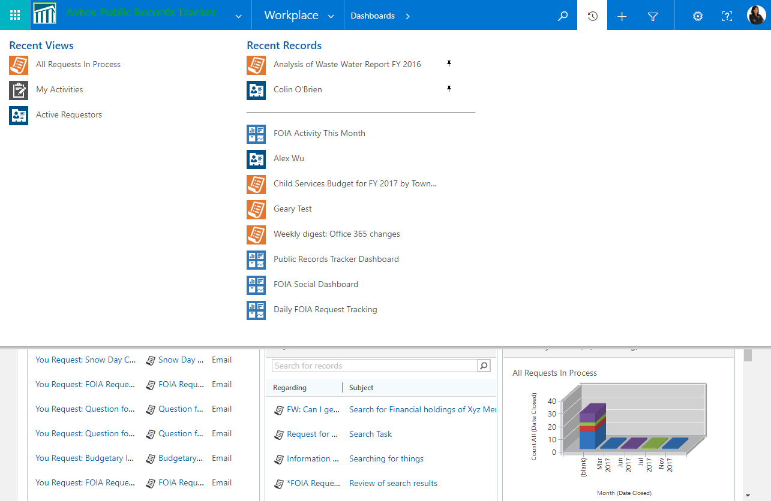

- Quick Create – Allows you to quickly add new records to the system. Click the + icon, then select the type of record you wish to create

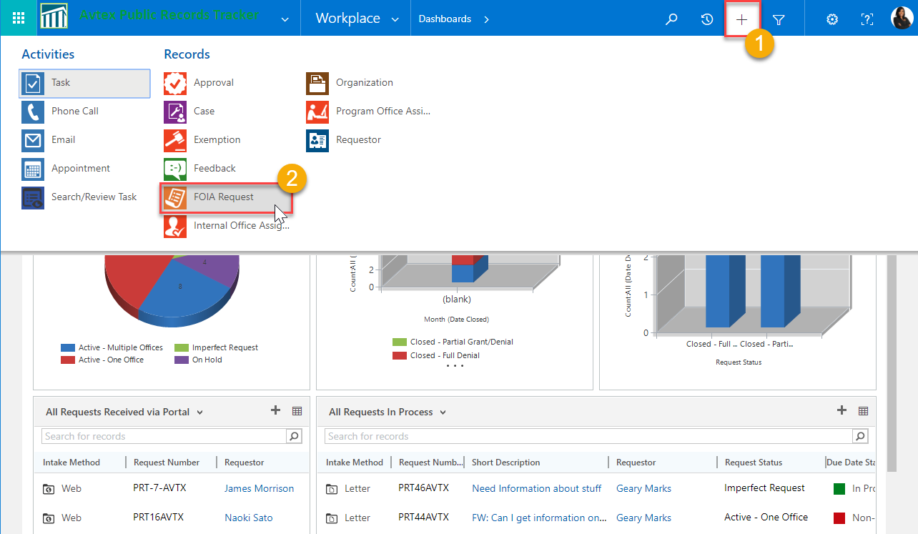
In the Quick Form, enter the required data, then click the Save button.

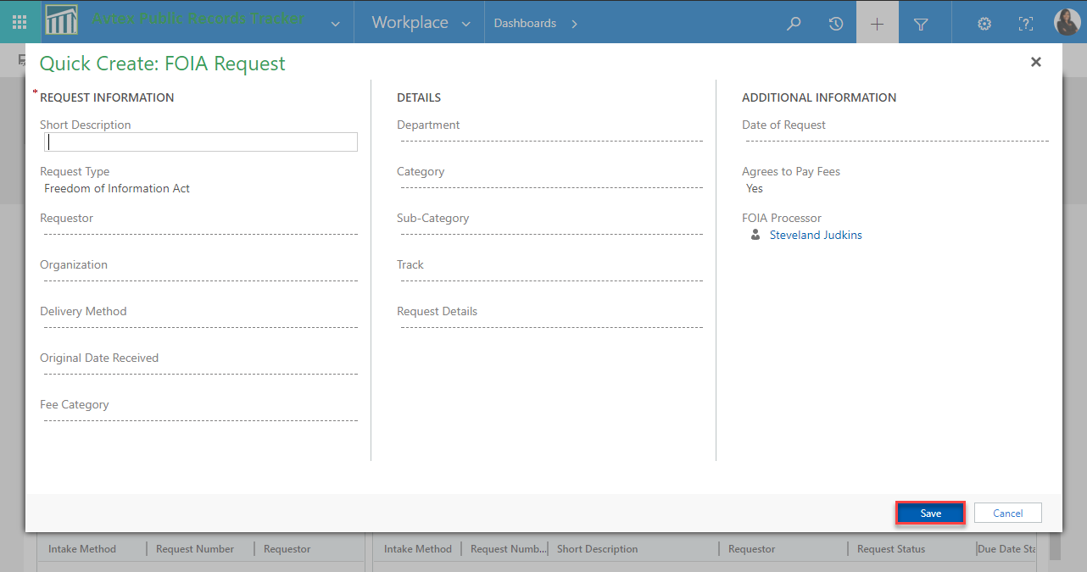

- Advanced Find – This allows you to perform advanced searches on the data in the PRT System.
- Personal Options button – Allows you to set your personal option, detailed in the section below.
- User Logout button – This button logs you out of your session.
- Help – Displays the guided help topics, videos, and self-led tours of the system.

User Set-up
Now that you know how to navigate PRT, we will take a look at setting your personal options.
- Click the Gear icon in the Navigation bar.

- Select Options from the menu

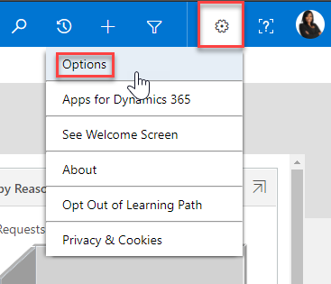
- In the Options dialog, use the tabbed navigation to set your personal system options. Below is a brief description of the items in each section:
  - General: General settings such as Landing page, Time Zone and Currency.
  - Synchronization: Manages filters you apply to CRM records that synchronize with your Outlook instance.
  - Activities: Your default start and end times for scheduling your Organizations tasks, phone calls, search/review tasks, and appointments
  - Formats: Sets your currency, dates, and time format based on your country of origin
  - Email Templates: Manages your personal Email templates to communicate with your Requestors or Agencies you communicate with
  - Email Signatures: Manage you email signatures similar to your signatures stored in Outlook.
  - Email: Settings that detail how CRM Manages emails sent to you or being sent from PRT. Your CRM Administrator will recommend how you set up these values

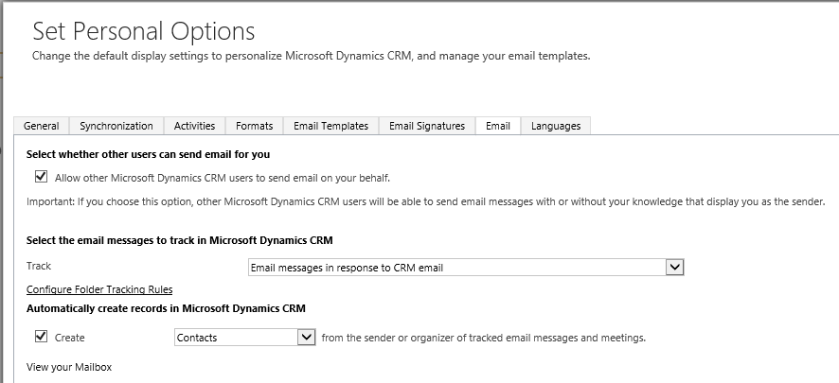

  - Languages: Set your default language.

Dashboards
PRT Dashboards not only offer an at-a-glance view of the work you and your team is performing within the system, but it also gives you a way to visually navigate through the system.
You can access your dashboards by navigating to Workplace Dashboards
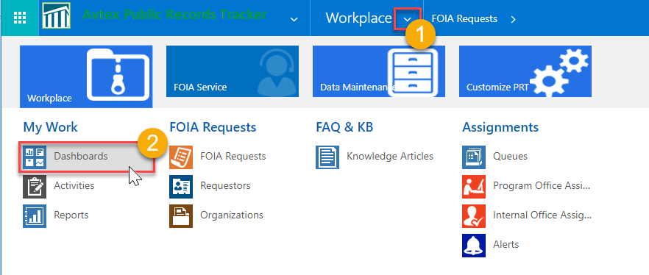
Some of the Dashboard’s features and functionality is listed below.

Dashboard Selector
Similar to the View Selector, you can select one of many Dashboard by clicking on the dashboard selector control.
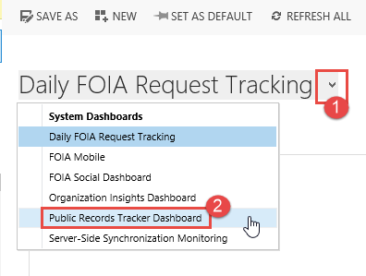

From the Dashboard, you can pop-out a chart to see the record view to which that chart corresponds.
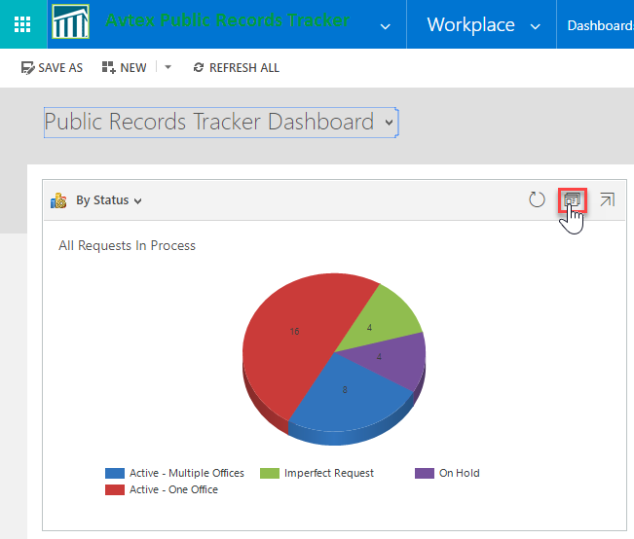
From here, you can automatically filter the view by clicking on the bar to filter only the records that pertain to that bar. In this case, clicking on the purple pie slice will only show records that currently On-Hold.
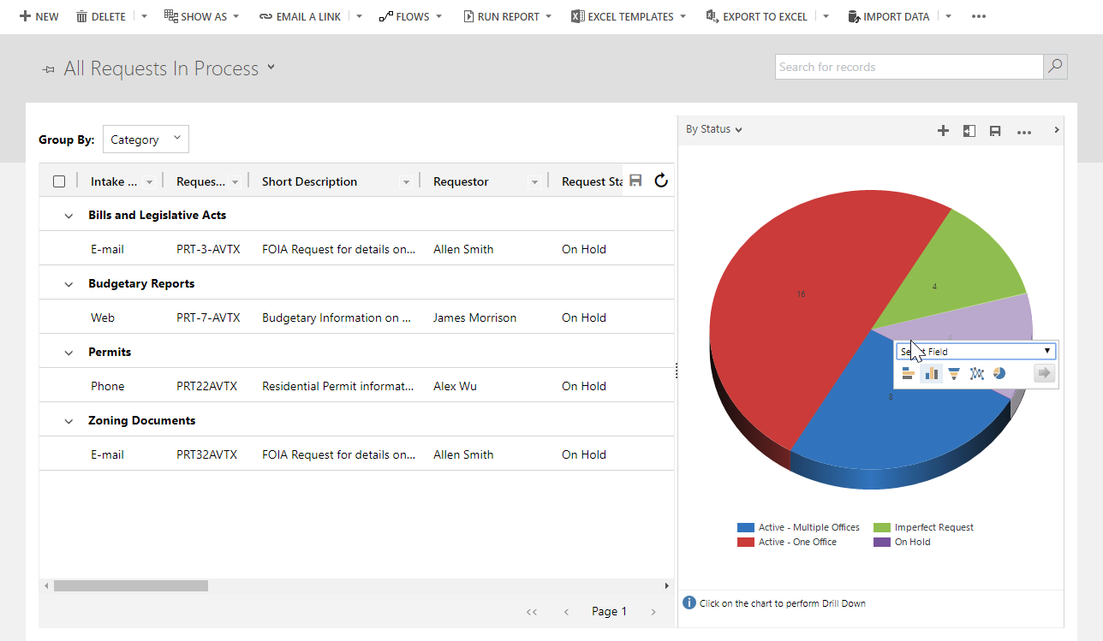
You can also interact with Views embedded in a Dashboard. The screenshot below shows the functions you can perform on a view embedded on a Dashboard.
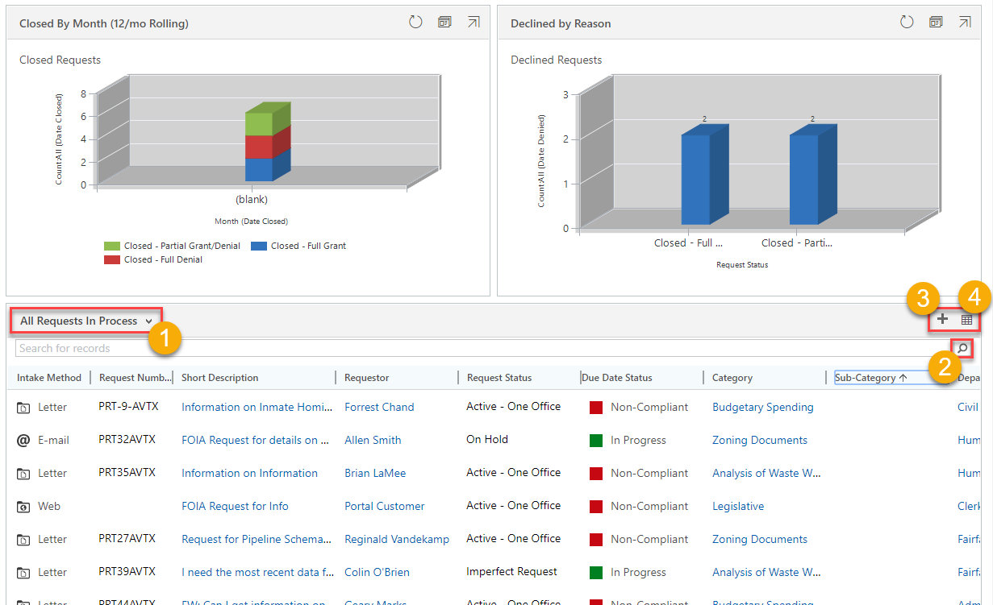
- Change the view using the View Selector control
- Search for records within that view
- Add a New FOIA record
- Pop-out the view to select records and take actions using the Command Bar

Managing Requests and Requestors
Now that you have a firm understanding of the PRT System components, let’s look at how to manage you Requestors and the FOIA Requests that come in through your various channels.

Requestors
Requestors are people/constituents that place the FOIA Request with your Organization. They may be individuals or employees of an Organization. The Requestor record allows you to know key information about the person or organization placing the FOIA Request. All FOIA Requests must be tied to a Requestor. Within the Requestor record, you can enter or update contact information, view the Requestors outstanding FOIA Requests, manage their Online Profile information, log activities (phone calls, emails) as well as any notes you may have on the Requestor.
Requestors are managed within the Requestor sub-area by navigating to Workplace Requestors
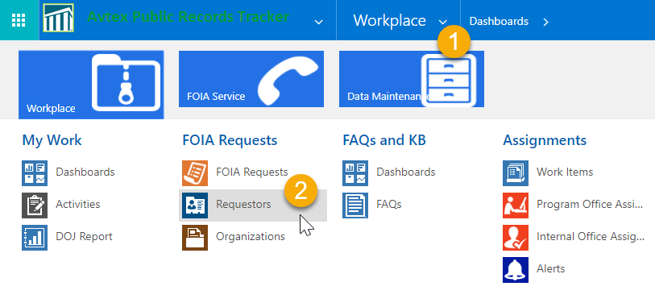

In the Requestors view, you can click the Full Name field to open their record, or create a new record by clicking the New button in the Command Bar.
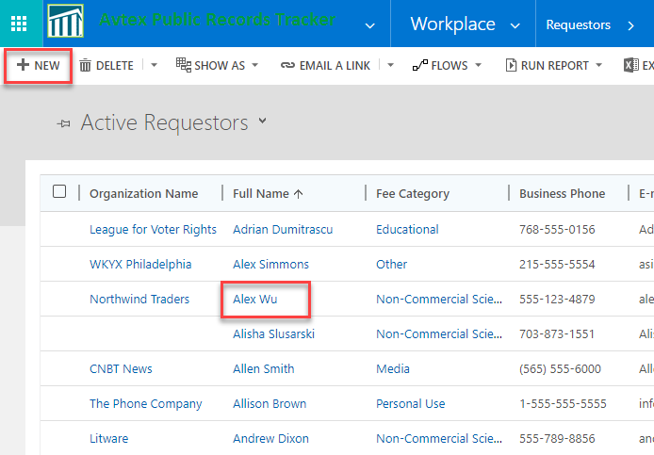

Anatomy of the Requestor Form
Below is a screenshot of the Requestor form that details the areas and actions you can take on a Requestor record.
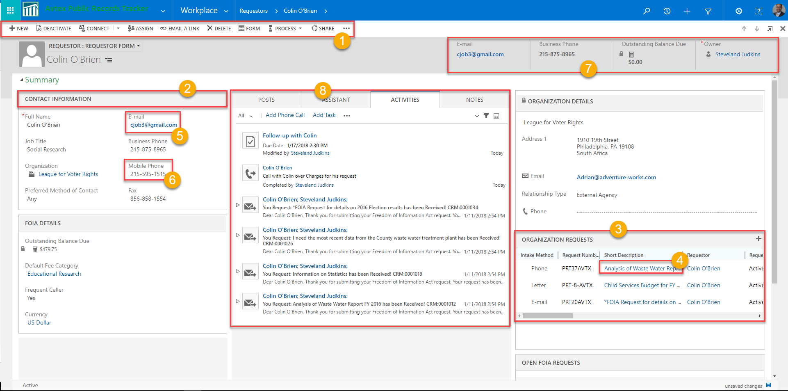
- Command Bar: The Command Bar lets you perform actions against the record, such as Assigning the Requestor to another user, Emailing a hyperlink to someone so they can quickly open the Requestors record from an email, or Sending an email to that Requestor
- Section Header: Sections arrange fields into logical groups on the form
- Sub-Grids: Sub-Grids are embedded list views that show other records in the system that are intrinsically tied to that record, such as the requestor’s Open Requests, or recommended KB Articles.
- Hyperlinked records: You can click a Hyperlink to take you directly to that record from any sub-grid record or lookup field
- Email Field: Launches an Outlook Email to the Address entered in that field.
- Phone Number Field: Click to call that Phone Number using your organization’s Skype for Business telephony system.
- Header Row: Shows key data at the top of the form so it is easy to spot.
- Social Pane: Area where you can log Activities, Notes, or search for KB Articles

FOIA Requests
FOIA Request records contain all of the data that you need to log, manage, assign and track Freedom of Information Act requests submitted to your Organization via Email, Phone, Web, or other channels configured by your System Administrator.
Among other things, FOIA Requests are the main form where you can:
- Log any and all communications about the request with the requestor
- Assign tasks in internal and external offices or agencies.
- Send and receive emails manually or through workflow rules
- Store the requested documents via SharePoint integration
- Track time and money spent on the request based on your Organization’s Fee Schedule
- Track compliance to your Organization’s non-disclosure policies

Anatomy of the FOIA Request Form
Below are a series of Screenshots from a high level, down to the details, along with instructions on how to manage the data within the FOIA Request form.

Header
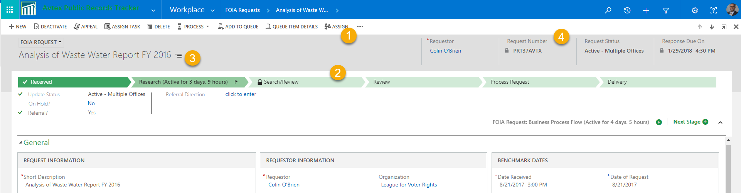
The Header is similar to the Requestor Header and is made up of the following components:
- Command Bar: Allows you to perform actions such as Assigning the request to another user
- Header Row: Contains key information such as the Requestor, Due Date and Request Tracking number
- Business Process Flow: The Business Process flow visualizes you request process. This will be covered in a later section in the guide.
- Tab Selector: Allows you to Jump to any tab within the FOIA Request record

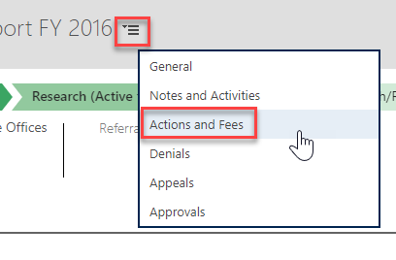

Related Records
Each FOIA Request contains numerous “Child” records logged against it. The screenshot below details the records that you can associate or create within the context of the FOIA record.
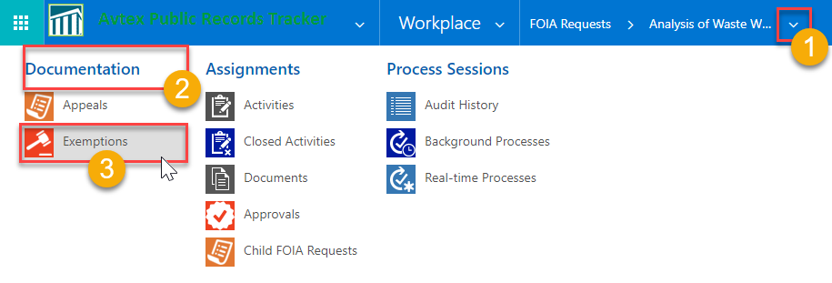
- The Related Records control: Click the down-arrow next to the FOIA Request’s navigation button to expose and select the related records.
- Record Group: The records are grouped by these headers:
  - Documentation: FOIA Request files stored and managed in SharePoint (covered in a later section of this guide), Appeals and Exemptions.
  - Assignments: Records used to track or assign work on this FOIA Request, such as Activities, Internal Office Assignments, Assignments to program offices (departments) within your organization, Outside agencies (for Federal Organizations), Date Tracking for external work performed on the FOIA Request
  - Process Sessions: Where System Administrators can monitor automated activities performed against this record.
- The Individual Records: That are associated to this FOIA Request. Clicking on this Navigation tile will take you to an Associated Record View.

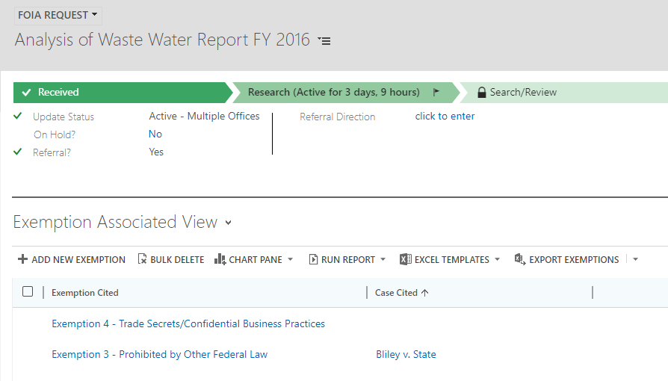

General Tab – Request Information
These are narrative fields that contain the key descriptions of the Request (Short and Long) and the final description of the Documents provided to the Requestor, so that the Requestor understands exactly what documents or files were provided.
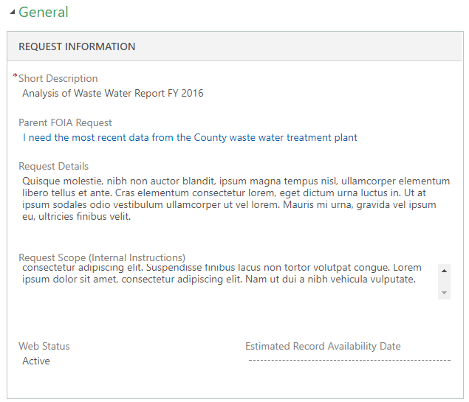

General Tab – Requestor Information and Requestor Details
The Requestor Information allows the user to set to set the values for the Requestor and the Requestor’s Organization. It also displays the metadata around their request. If the Requestor record is updated, the Requestor Details card is updated too. These fields are Read Only.
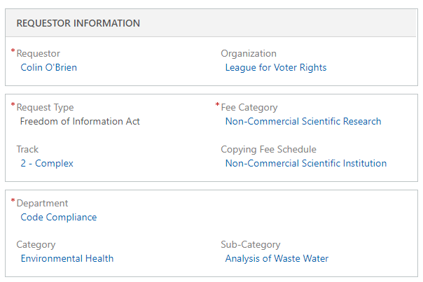
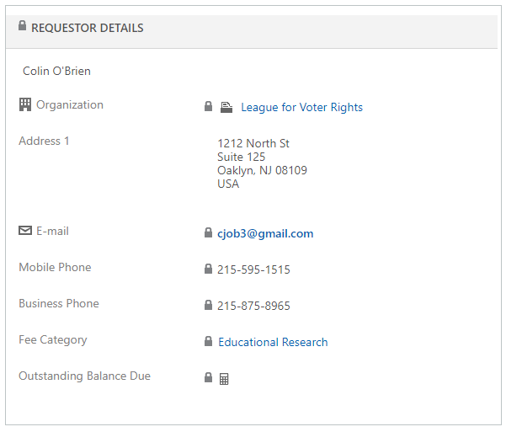

General Tab – Request Details and Tracking Information
These sections contain high-level FOIA Request information, such as Intake and Delivery Methods, Benchmark Dates, etc.
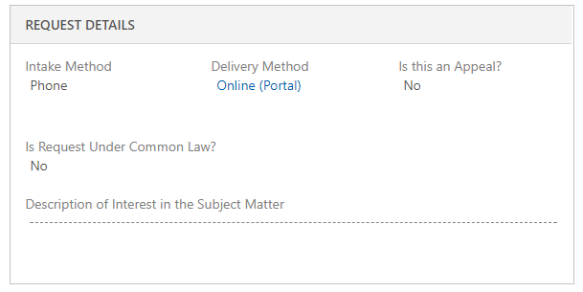
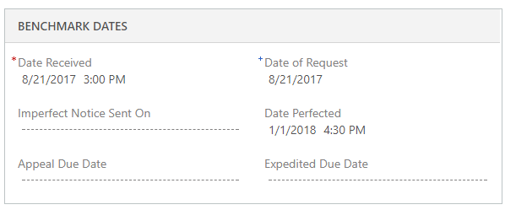

Notes and Activities
The Activity Pane allows users to quickly view, log, complete, and filter on Activities, Notes, and KB Articles pertaining to the FOIA Request
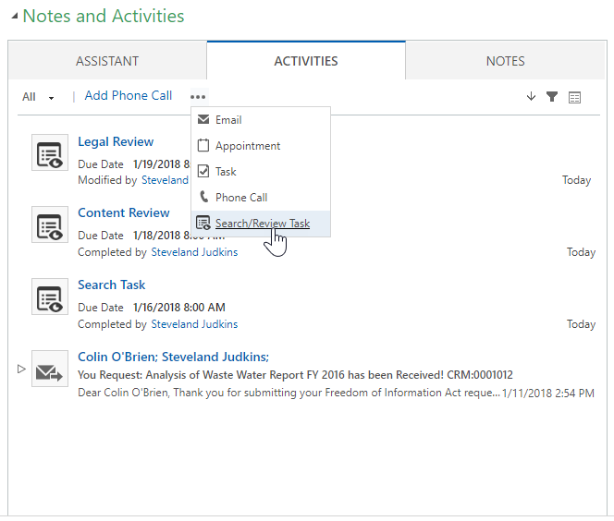
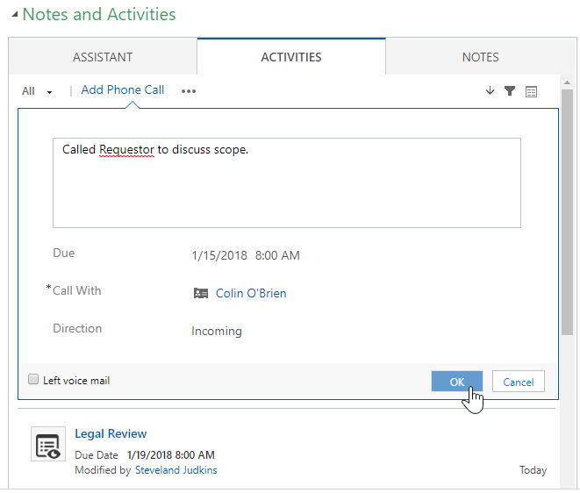
You can log notes:
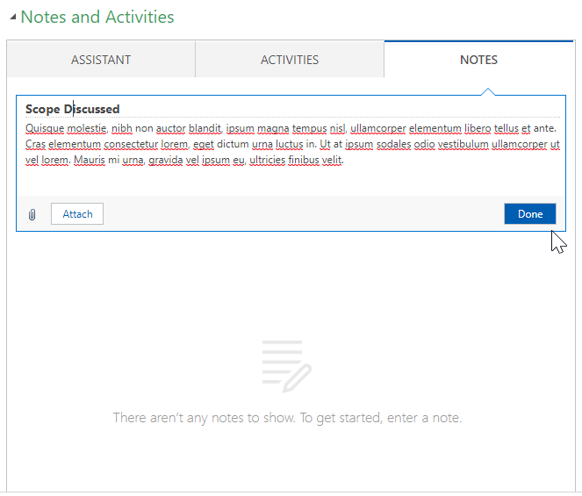
You can search for Knowledge content, such a FAQs or other articles configured by your System Administrator to provide quick answers to common questions, documents, or other content. You can search based on keywords, or filter on other fields in the FOIA Requests to suggest the right KB Article
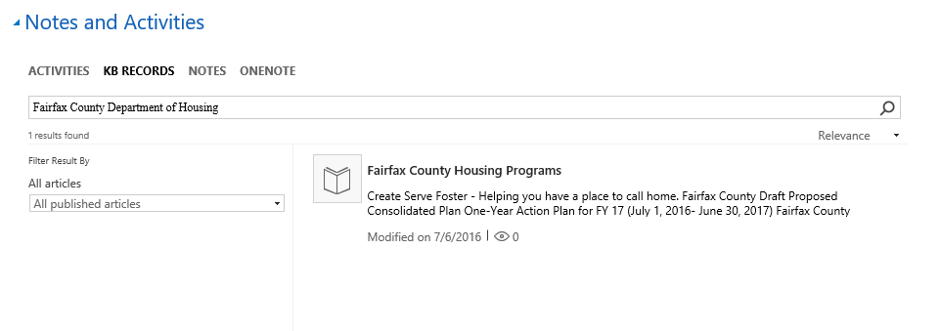
You can attach the Article to the FOIA Request so that other people can see the information:
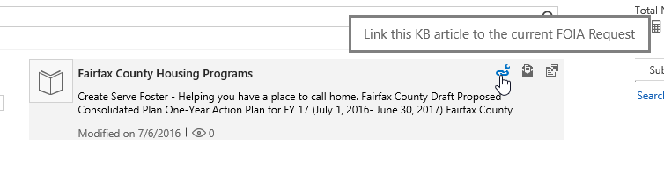
You can pop-out an Article to view the full content:
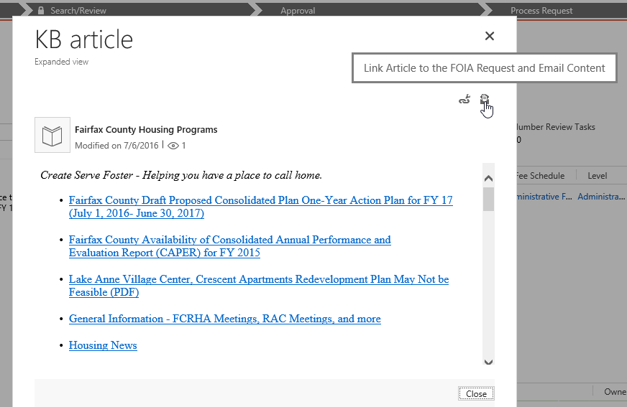

Notes and Activities – Search and Review Tasks
Search and Review Tasks allow user to log, assign and track time against the FOIA Requests Search/Review Process.
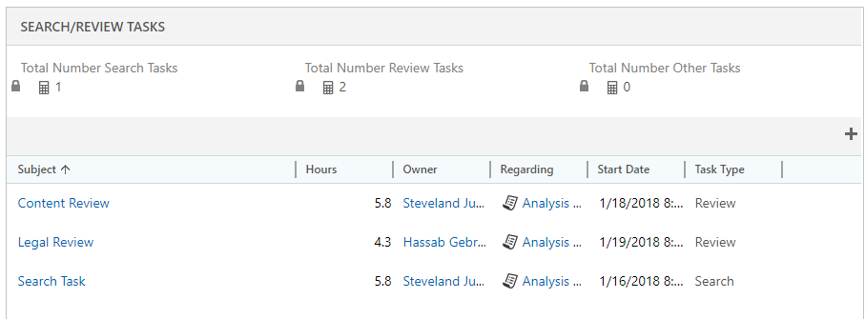

You can launch a new search and review task from the Activities Pane, the Search/Review Tasks sub-grid, or the FOIA Request Record’s Command Bar
Launch from the Command Bar
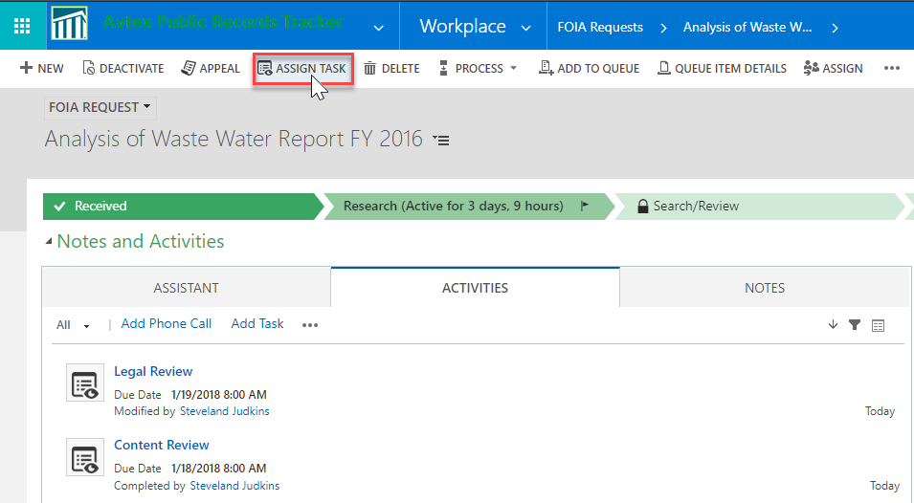
Launch from the Sub-Grid
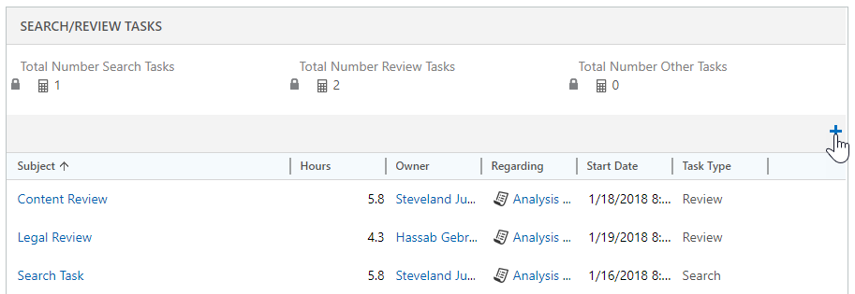

Launch from the Activity Pane
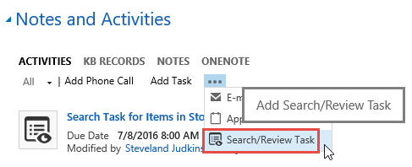
The Search/Review Task record allows you to track the Hours spent on the task, as well as the fee schedule/fee level to calculate the total fee for a given Search/Review task.
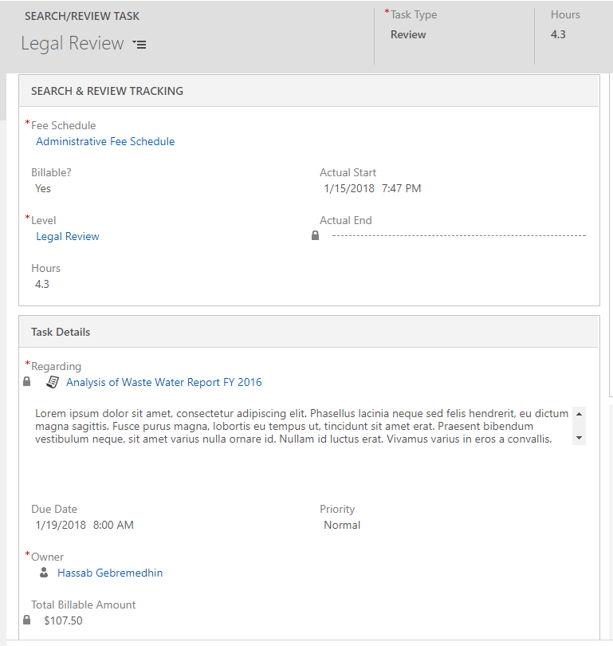

You can also assign the Task to other users or teams.
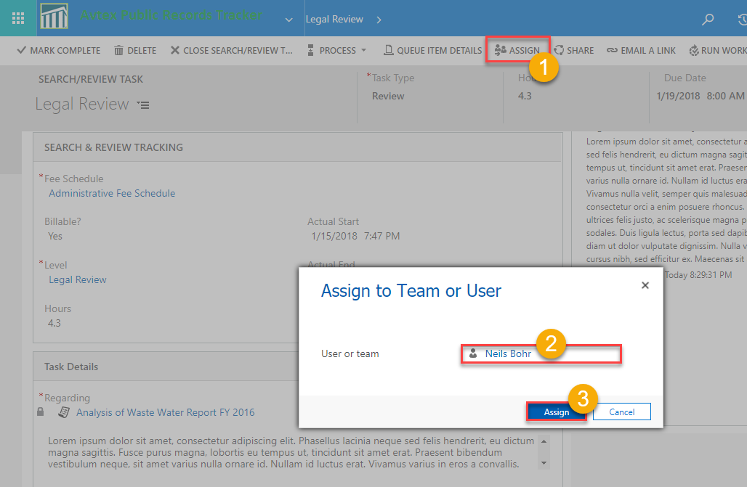
To assign a task to an external user, you will need to track it manually through one of the External Assignment records. The screenshot below shows an Program Office Assignment. Depending on your organization and user base will determine which Search/Review tasks you will use throughout the organization.
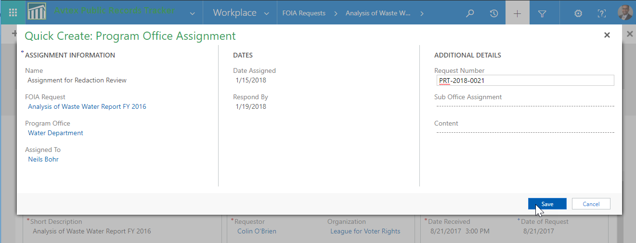

Actions and Fees – FOIA Request Actions
The Actions and Fees tab covers numerous events during the life cycle of a FOIA Request. The screenshot below shows 4 sections that capture benchmark Actions that affect the Response Due Date
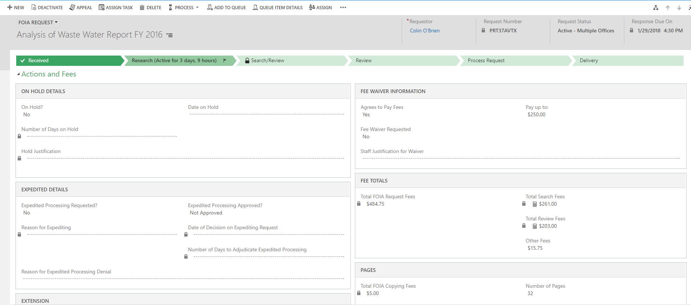
The screenshot below shows the calculated fields that determine the FOIA Fees associated with the Request. Total Search/Review Tasks are only calculated once the corresponding tasks have been completed. Only Tasks that are tagged as billable will be calculated.
It is also important to note that these fees can only be calculated once the Fee Schedule and Request Fees records have been configured.
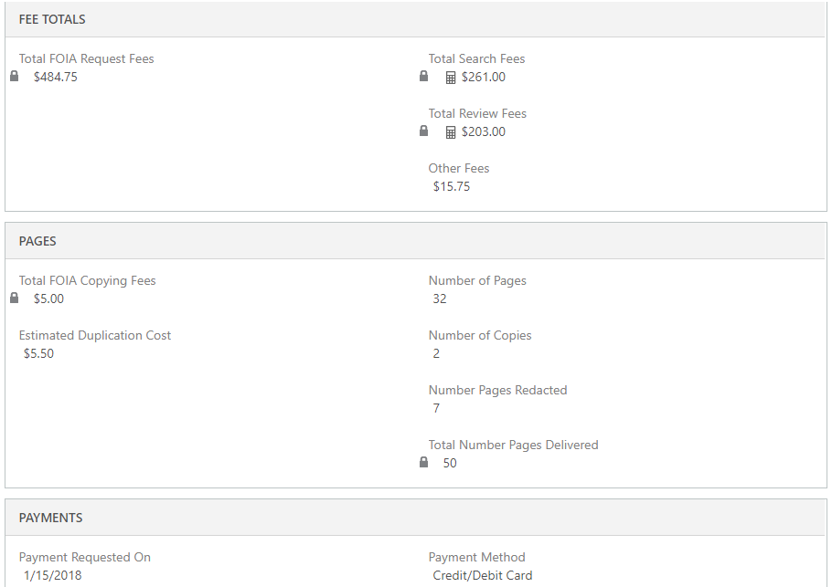

Denials and Exemptions
City, County, State and Federal laws have non-disclosure Statutes that prevent certain documents from being released to the public. Sometime only sections of a document require redaction, in other cases, an entire FOIA Request may be denied based on the conditions within these stautes.
You can log these Denial Reasons and cite the proper Statues in the Denials tab. To add a new Exemption, click the Add Record icon.
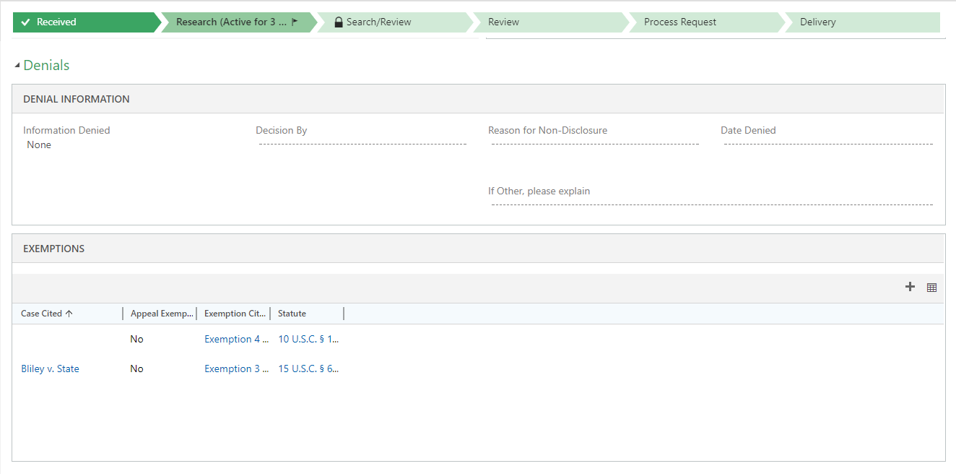
You can cite the Statute and reason for denial, then click the Save button.
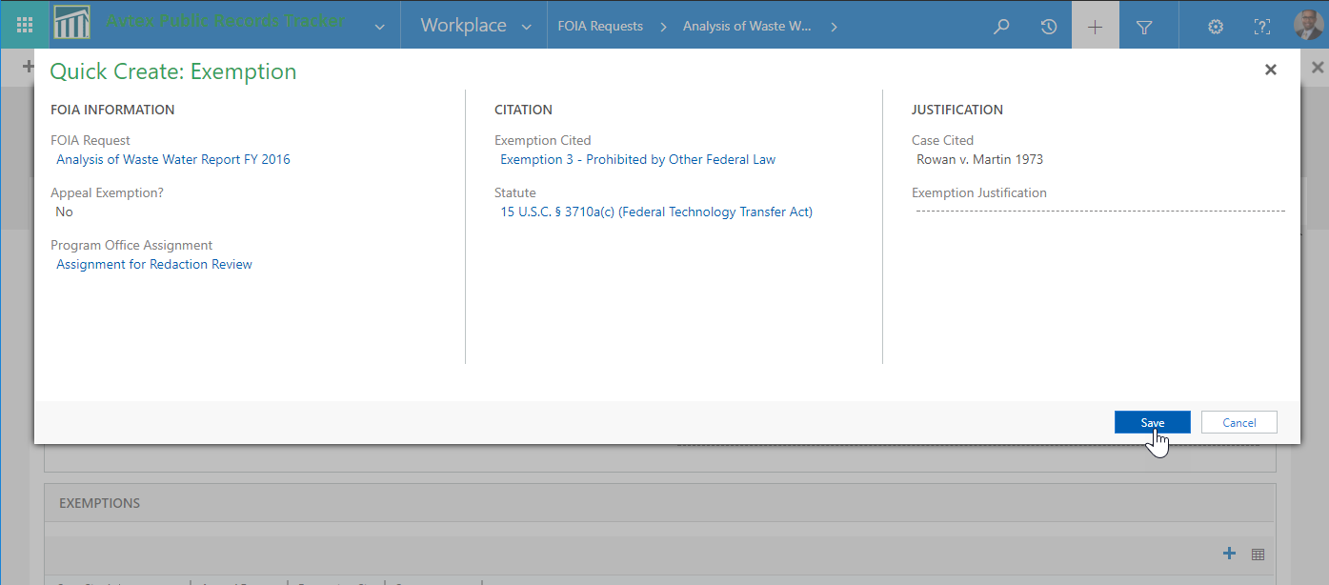

Exporting Records to Excel for Re-import
You can quickly update records in PRT by using the Export to Excel for re-import.
From any view, click the Export to Excel button on the Command Bar, then follow the instructions to export. Export option include Excel Online and Excel (Desktop)
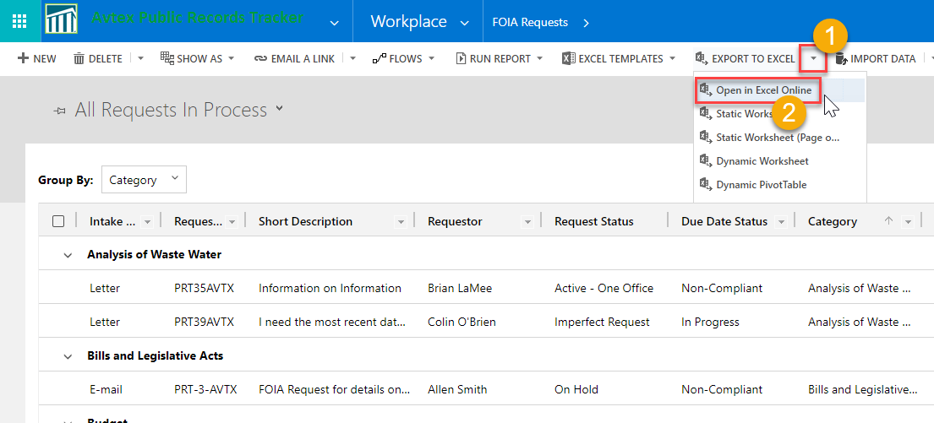
You can make your edits, then click the Save Changes to CRM button.

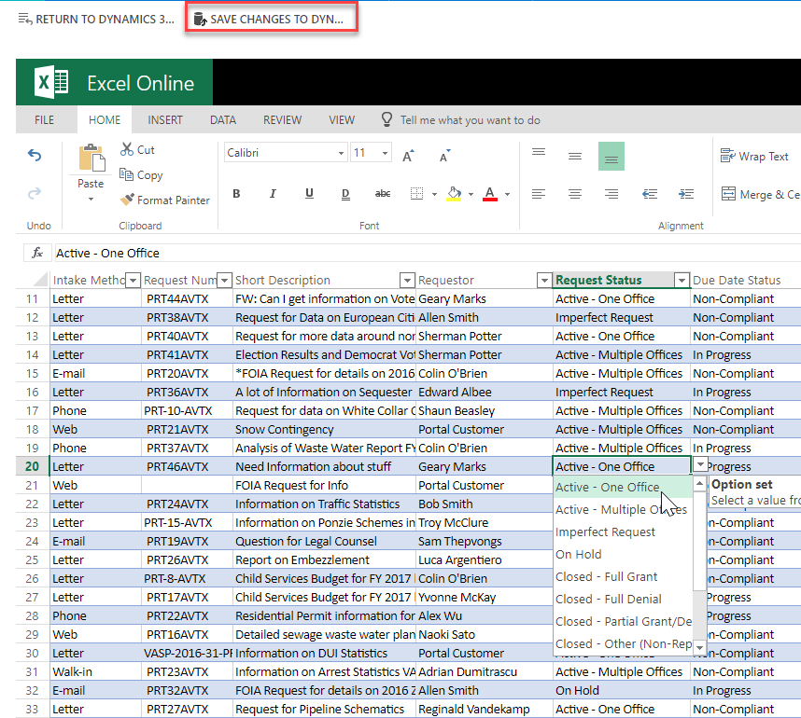

Using the Business Process Flow
The Business Process Flow is not only a visualization of the FOIA Request process, but it can be tailored to guide users through the data collection process.
At each stage, key data elements can be exposed to guide the FOIA Processor to collect the right data at the right time. The Flog icon lets the user know the current stage in the business process
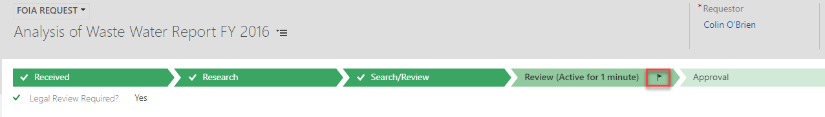
You can advance to the next process by clicking the Next Stage button.
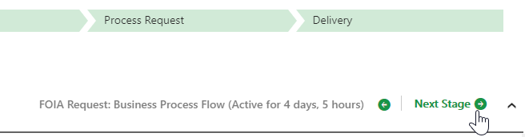
If there are required data fields at a particular stage, you will not be able to advance to the next Stage until the required fields are filled out.
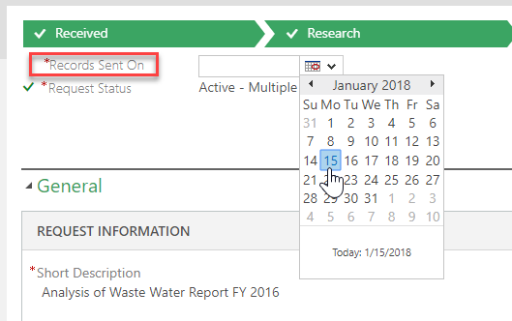
The order of the Stages may change based on conditions within the FOIA Record, such as if the initial Request Status in the Received stage is Imperfect. In this case, a new Stage appears.
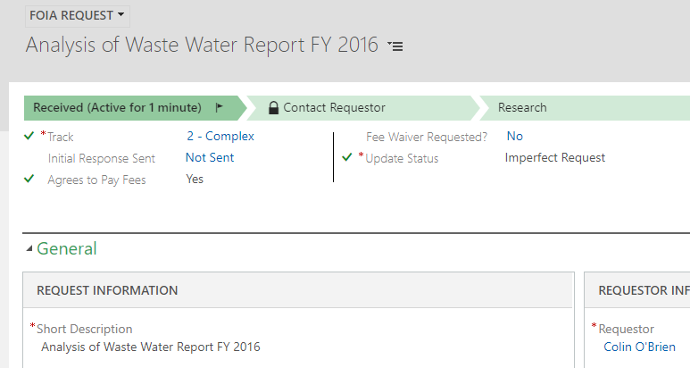
The FOIA Processor must call the Requestor to perfect the request.
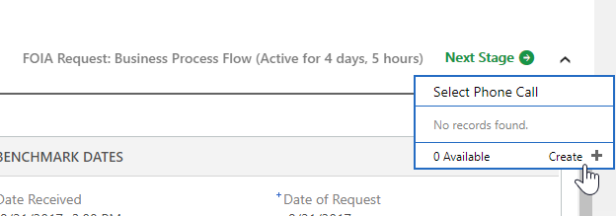
In the example below, if a Request requires Approval, a new Stage appears:
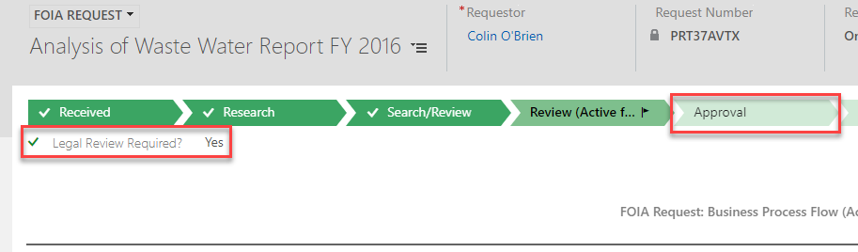

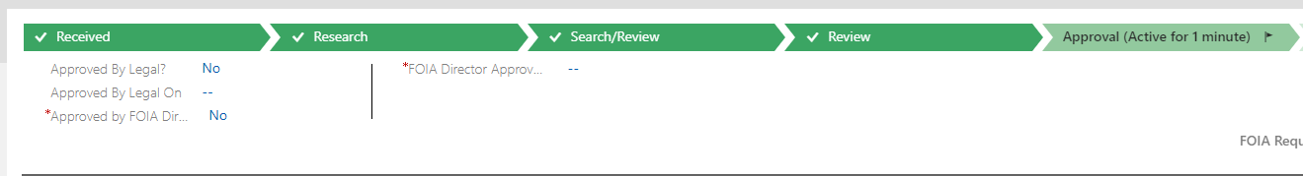

Managing Documents
You can store most types of files within the FOIA Request record by navigating to the Documents view within the record’s Navigation Area.
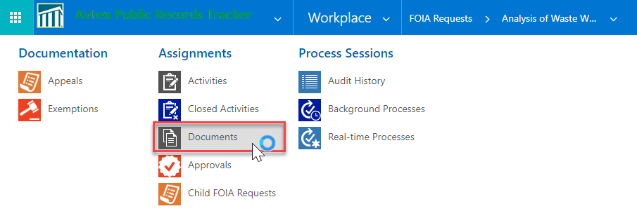
The SharePoint document library will be embedded in an Associated View tied to that specific FOIA Request record.
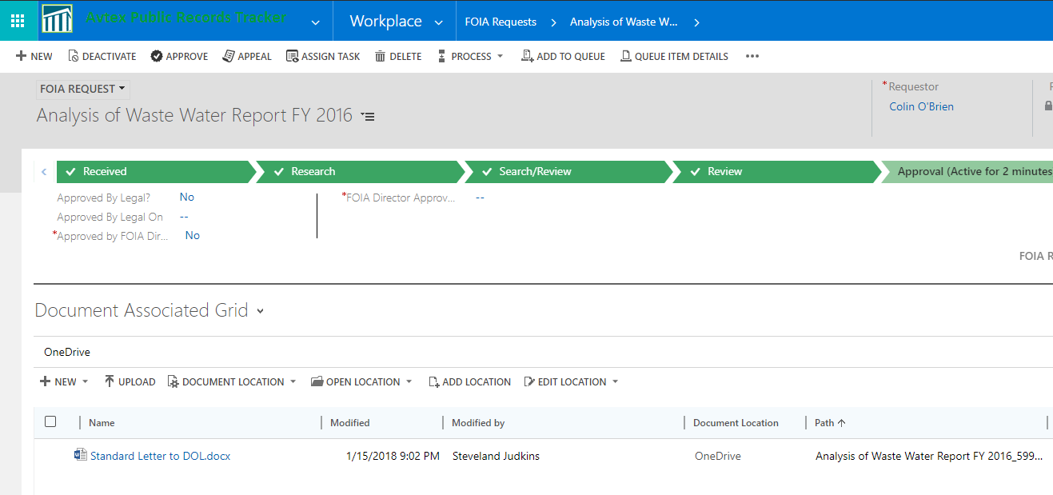
In the SharePoint location, you can add folders, search for other documents, upload files, create new files, even check-in/check-out sensitive files.
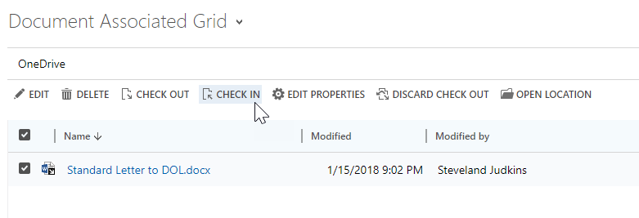
You can easily launch the files by clicking on the File Name
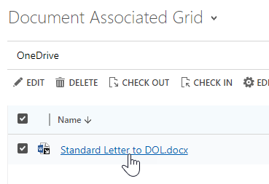

Appendix I – Administrators Quick Start Guide
The section is broken down into the following sub-sections:
- Configuring System Settings
- Configuring Privacy Settings
- Configuring Document Management Settings

Configuring System Settings
System Settings control multiple areas within PRT, such as Auditing, Email Integration, etc. To configure the necessary PRT System Settings follow the steps below:
- Navigate to Customize PRT Administration

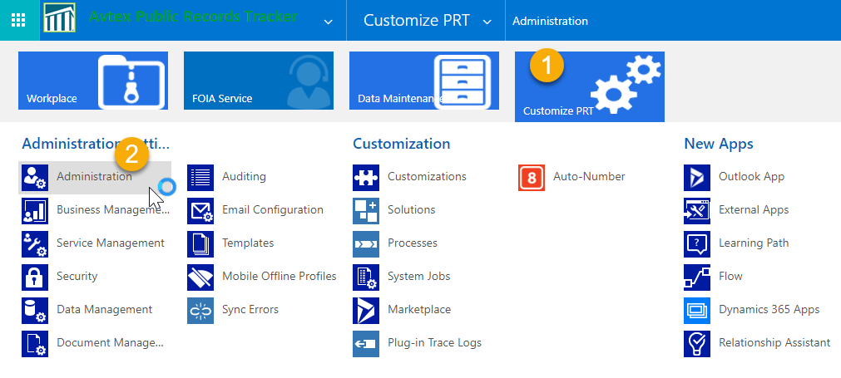
- In the Administration page, click System Settings

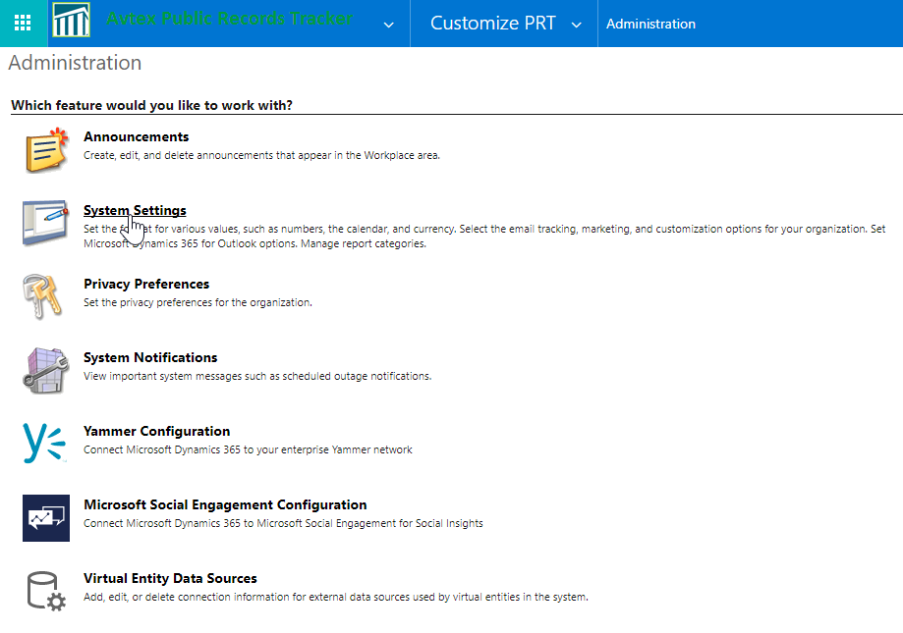

- On the General tab, there are multiple default values already in place. Update the following values outlined below. In the Set blocked file extensions for attachments textbox, clear the existing values from the textbox, then, copy and paste the following values into the textbox.

- NOTE: The following list contains restricted file extensions in PRT:
ade;adp;app;asa;ashx;asmx;asp;bas;bat;cdx;cer;chm;class;cmd;com;config;cpl;crt;csh;dll;exe;fxp;hlp;hta;htr;htw;ida;idc;idq;inf;ins;isp;its;jar;js;jse;ksh;lnk;mad;maf;mag;mam;maq;mar;mas;mat;mau;mav;maw;mda;mdb;mde;mdt;mdw;mdz;msc;msh;msh1;msh1xml;msh2;msh2xml;mshxml;msi;msp;mst;ops;pcd;pif;prf;prg;printer;pst;reg;rem;scf;scr;sct;shb;shs;shtm;shtml;soap;stm;tmp;url;vb;vbe;vbs;vsmacros;vss;vst;vsw;ws;wsc;wsf;wsh

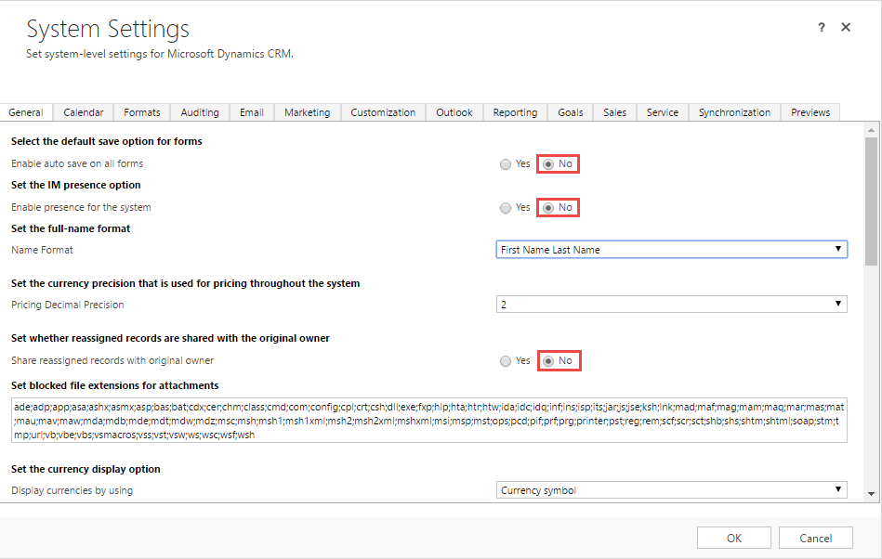

- For the remain sections in the General tab, update the following values outlined below:

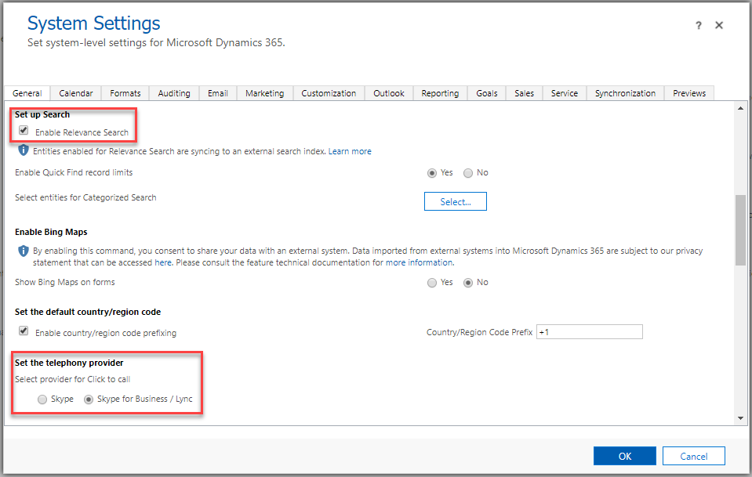

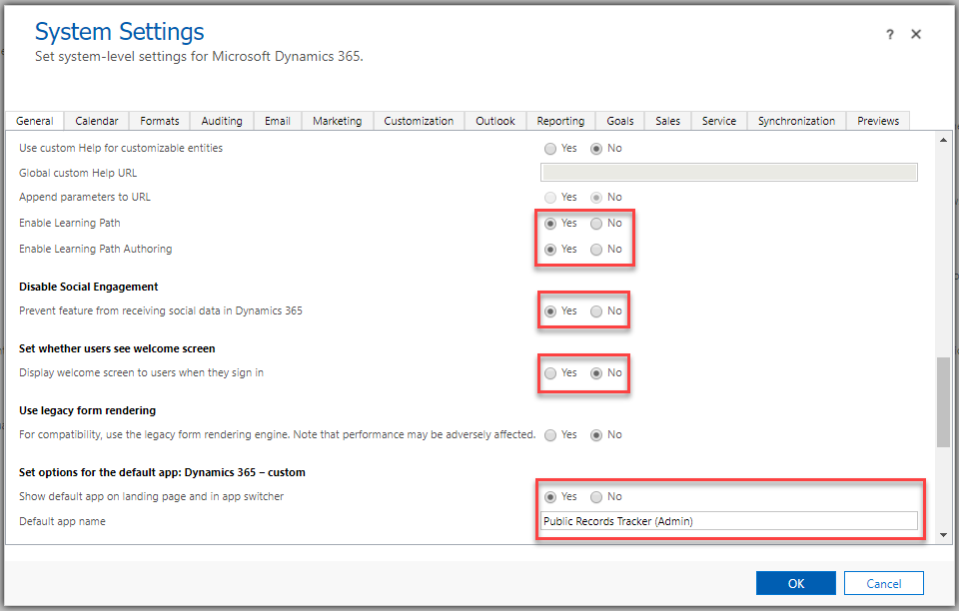

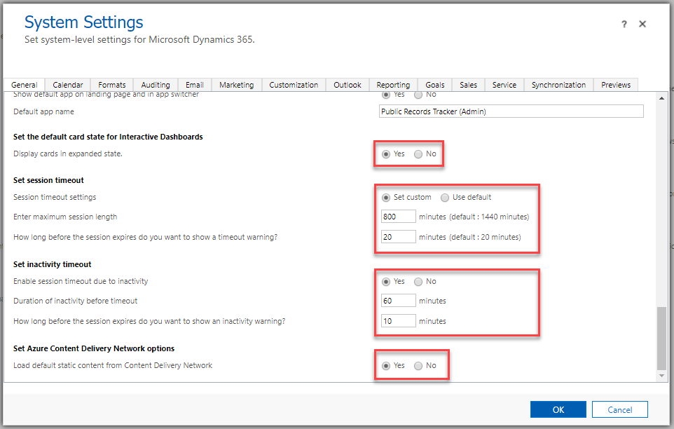

- In the Audit tab, select the following checkboxes outlined below.

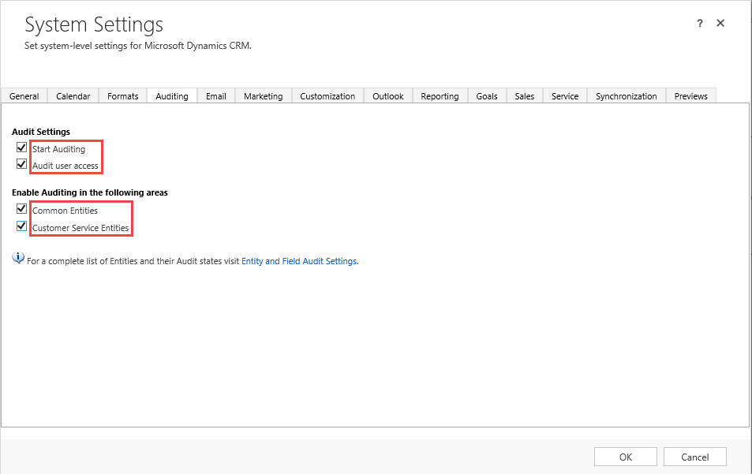

- In the Email tab, update the values in the fields outlined below

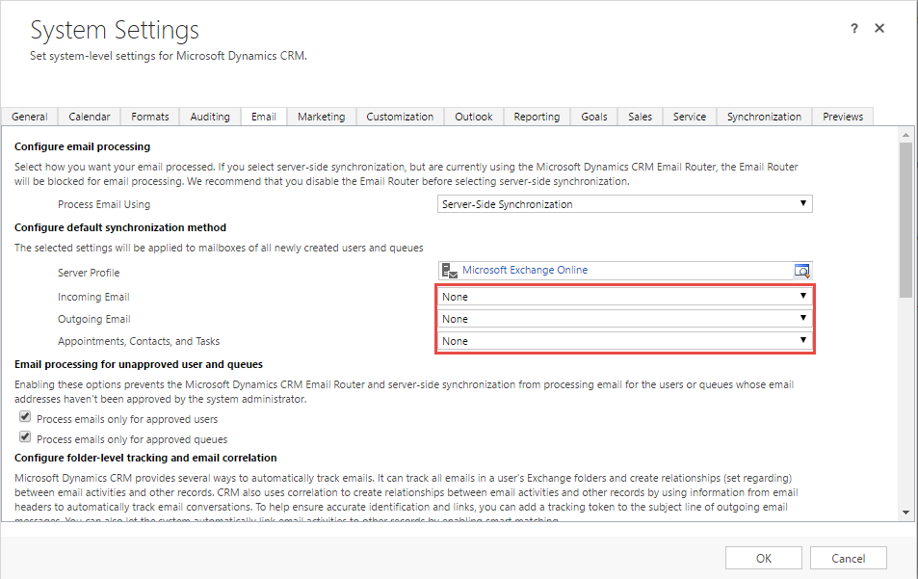

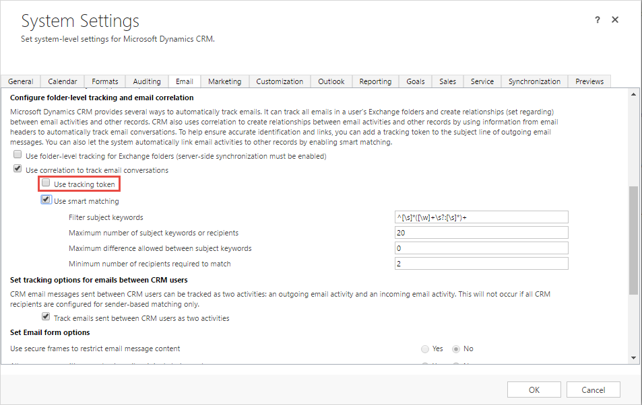

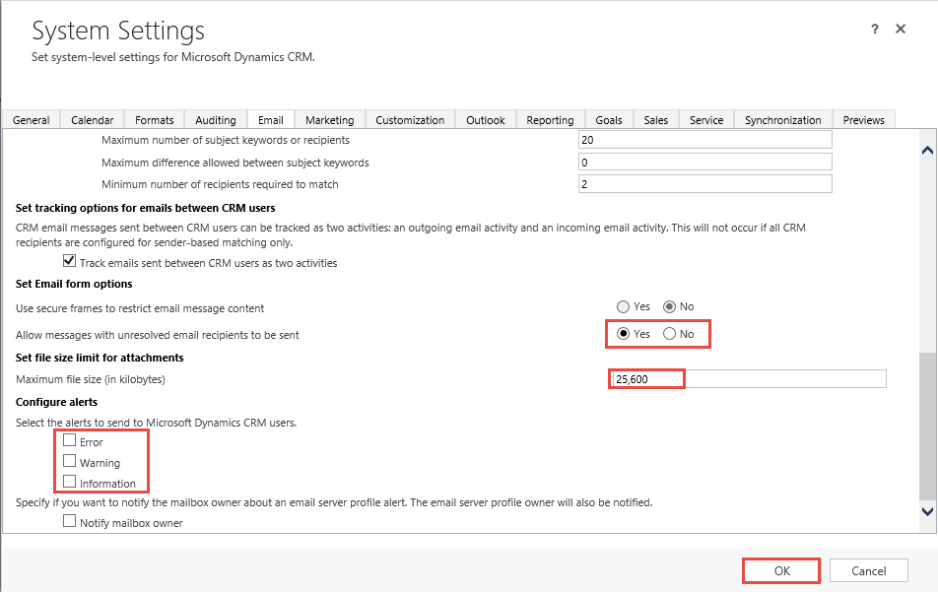

- In the Outlook tab, select the values in the fields as outlined below.

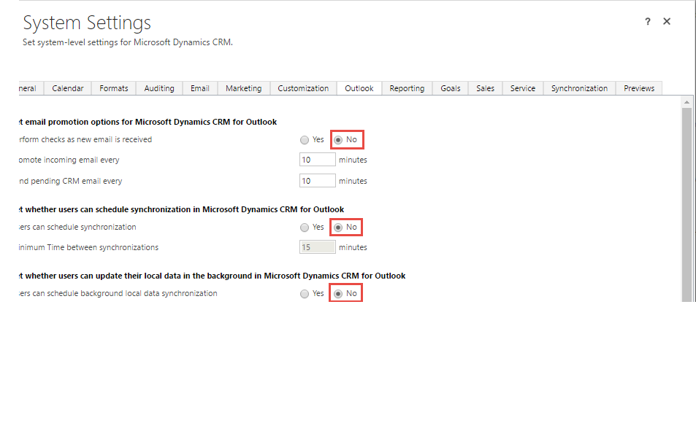
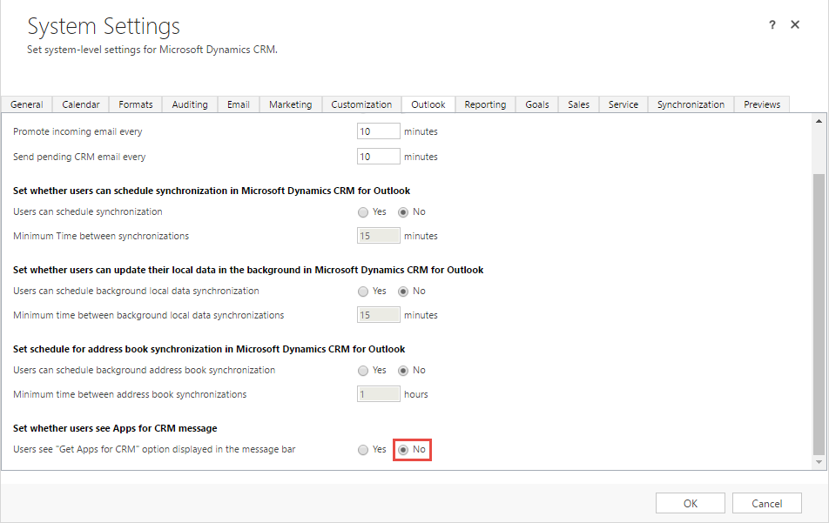

- In the Service tab, select the values in the fields as outlined below. Then, click the OK button.

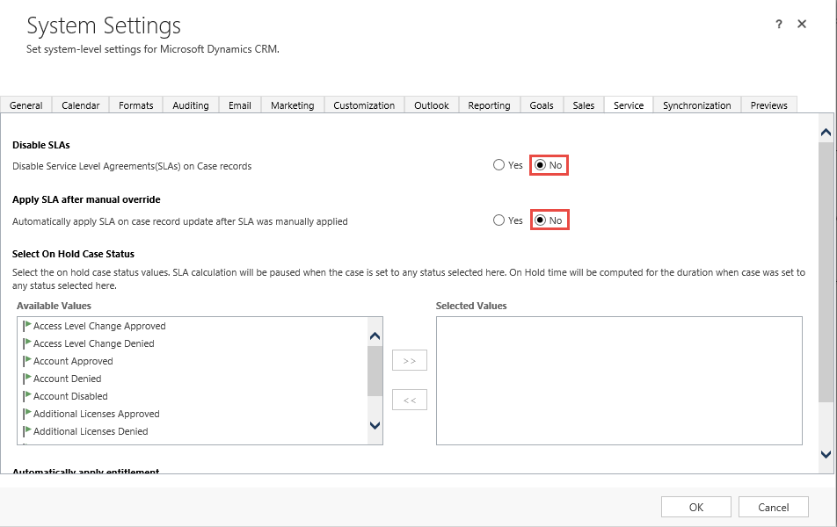

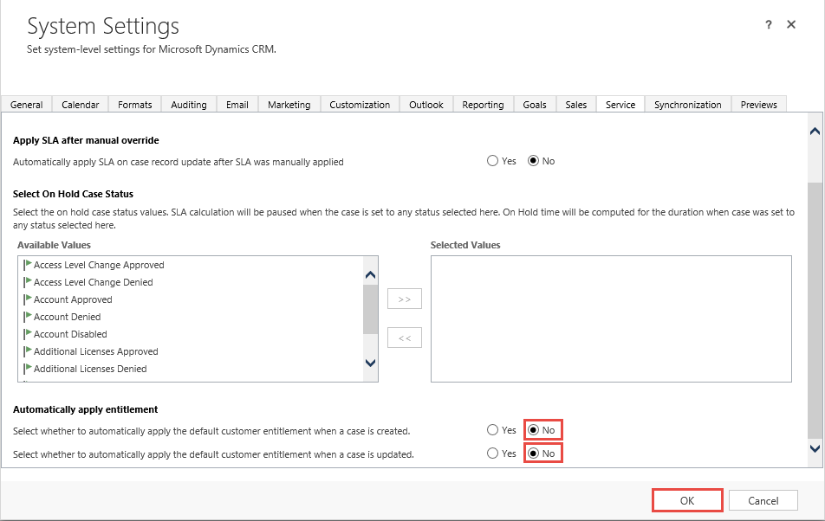

Configuring Privacy Settings
Privacy Preferences control how the system logs internal errors and sends them to Microsoft product support. To disable these setting, follow the steps below.
- In the Administration page, click Privacy Preferences

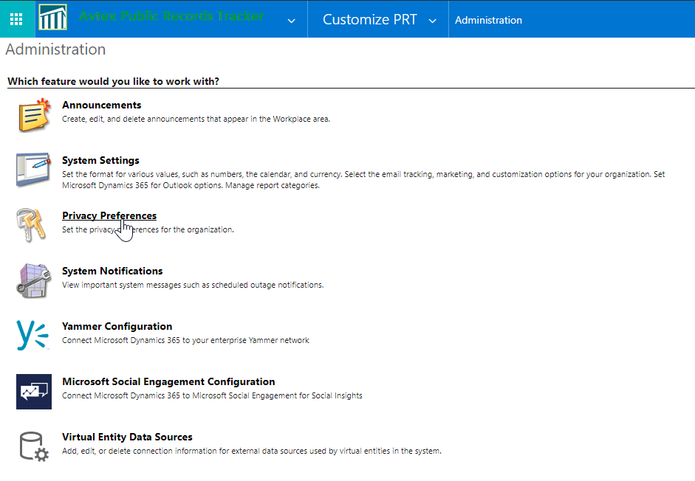

- In the Privacy Preferences dialog, select the checkboxes outlined below, then click the OK button

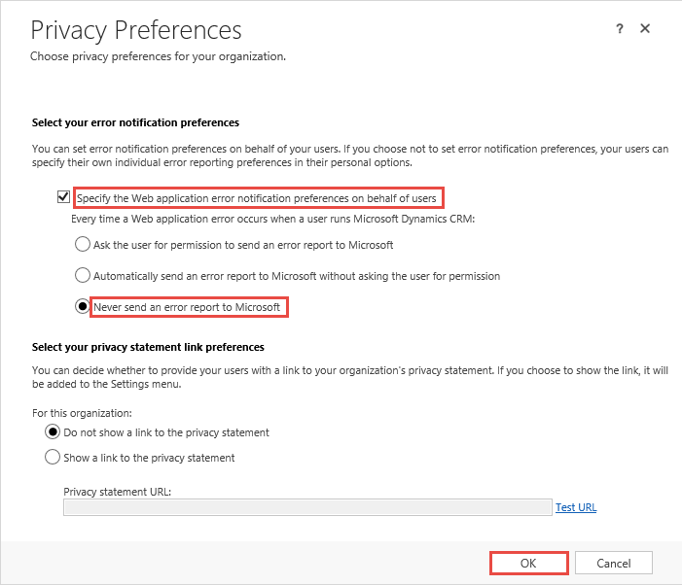

Configuring Document Management Settings
The Document Management settings area is where Dynamics CRM can be configured to integrate with SharePoint Online, as well as other O365 document management tools. PRT is configured to use SharePoint Online as it main document repository for all PRT documents. To configure Dynamics CRM for SharePoint integration, follow the steps listed below.
- Navigate to Settings Document Management

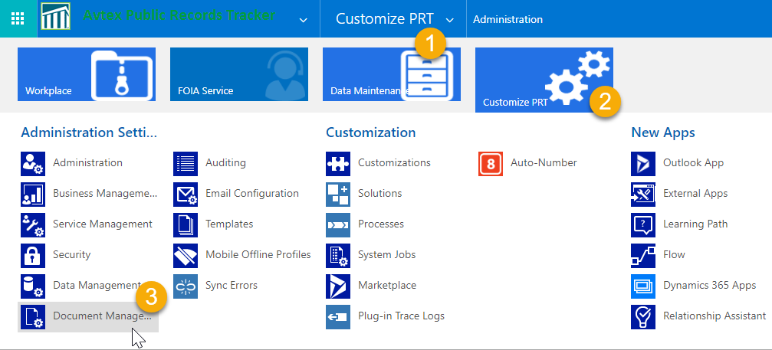

- In the Document Management page, click on Enable Server-Based SharePoint Integration.

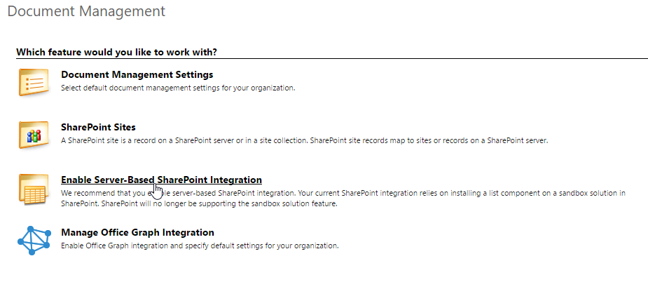
- In the Enable Server-Based SharePoint Integration wizard, click the Next button.

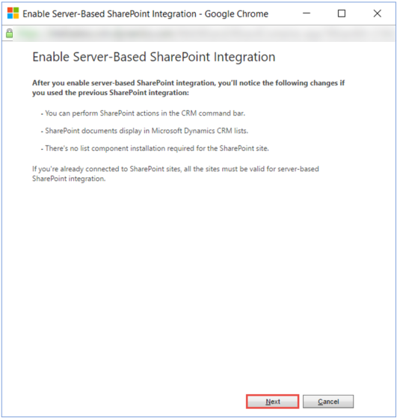
- In the Define Deployment step, keep the default value and click the Next button.

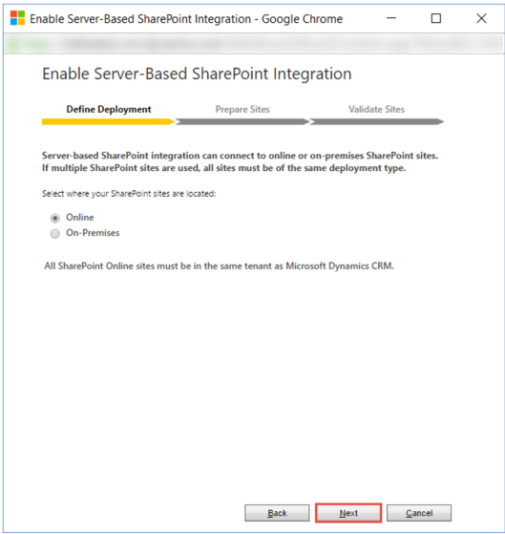

- In the Prepare Sites step, enter a valid SharePoint site collection URL.

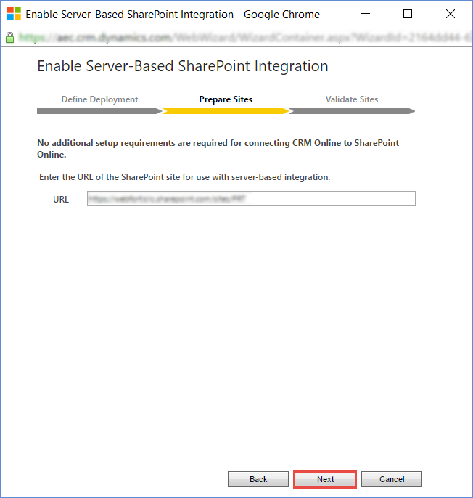

- After you have entered the appropriate URL, click the Next button.
- In the Validate Site step, when the validation is complete, click the Enable button.

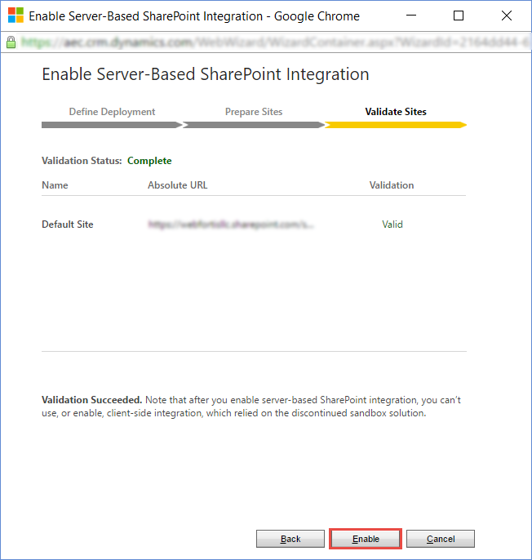

- In the final step, check the Open Document Management Settings wizard checkbox, then click the Finish button.

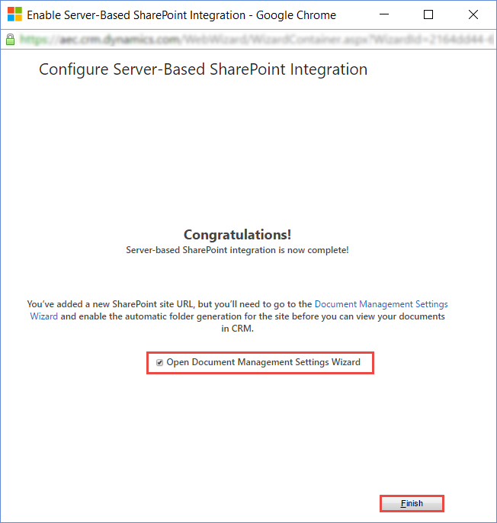

- In the Document Management Settings dialog, ensure that the following entities have been checked off in the Entities pane, and the proper SharePoint site collection (specified in Step 5 above) has been entered in the Site URL box and then click the Next button.

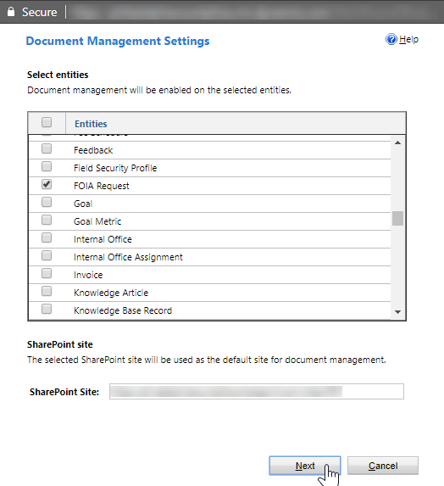

- On the next page, check the Based on Entity checkbox, select Requestor from the drop-down. Then, click the Next button.

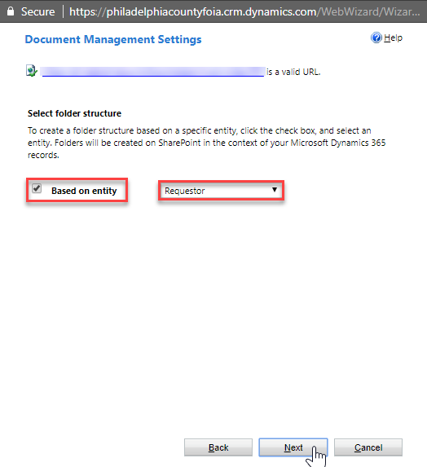

- In the Message from Webpage alert, click the OK button.

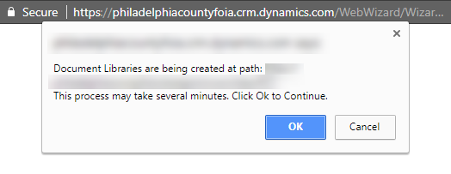

- When the all the Status fields are updated to Created and/or Already Existed, click the Finish button.

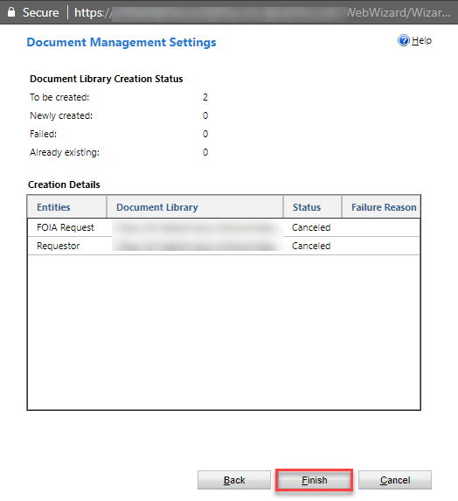

Hyperlinks are found throughout the PRT System displayed as lookup controls. These controls will be explained in the section Anatomy of the Requestor Form
Sub-Grid views are embedded in various records throughout the system to show you other records that are associated to the one you are reading. More information on this type of navigation is covered in the section Anatomy of the Requestor Form
Relevance Searching is currently restricted to Dynamics CRM Online only

