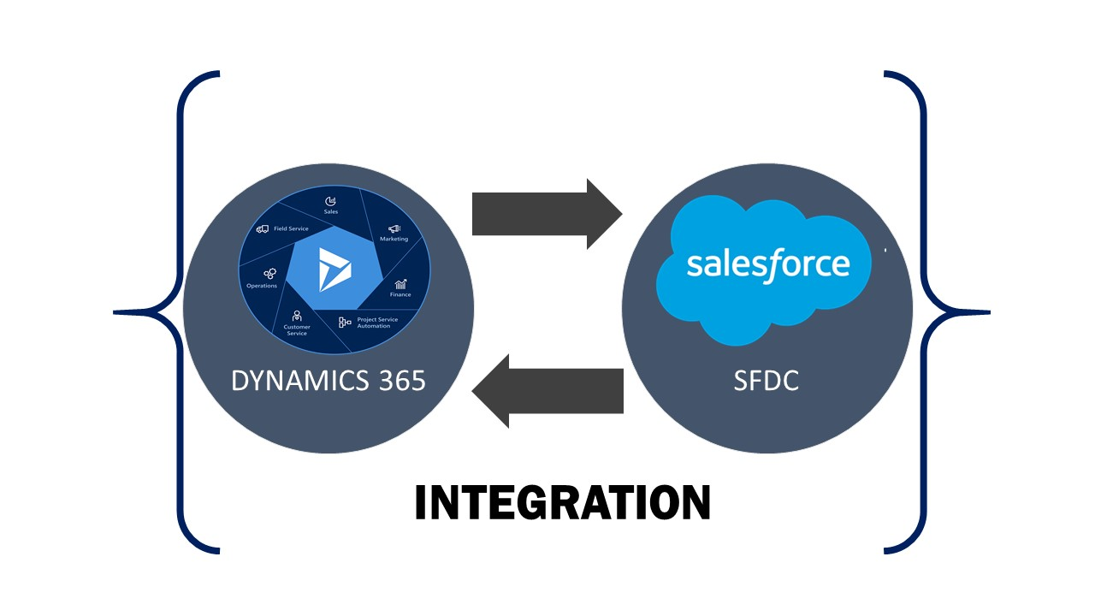

OA D365 F&O SFDC INTEGRATOR

OA D365 F&O SFDC INTEGRATOR

Table of Contents

OA D365 F&O SFDC INTEGRATOR i
Table of Contents ii
1 Overview 1
1.1 Product Features 1
1.2 Configurable features 1
1.3 Benefits of Data Integrator 2
1.4 Turn Key Solutions 2
2 Setup for Integration 3
2.1 Setup for Integration on Azure Portal 3
2.2 Setup for Integration on D365 For Finance and Operations 3
2.2.1 Database Log Setup 5
2.2.2 Salesforce Setup in D365 6
2.2.3 Detailed Information on Salesforce Entity Fields. 11
3 Entity Integration Manual – D365 F&O SFDC 13
3.1 Customer 13
3.2 Customer Group 21
3.3 Product 24
3.4 Opportunity 26
3.5 Quotation and Quotation Line 28
3.6 Sales Order 31
4 Salesforce Setup 34
4.1 Remote Site Settings 34
4.2 Credentials Setup on Salesforce for D365 F&O 35

TABLE OF CONTENTS

Figure 2.1 Azure App Registration. 3
Figure 2.2 Enter the Client ID of the app made in the first step. 4
Figure 2.3 Salesforce credentials form 4
Figure 2.4 Testing Connection 5
Figure 2.5 Salesforce success message setup. 5
Figure 2.6 Entity Creation for integration 7
Figure 2.7 Created Entity's General settings. 7
Figure 2.8 Configuration of the created Entity. 8
Figure 2.9 Configure the created data entity. 8
Figure 2.10 Entity default values for salesforce. 9
Figure 2.11 Validate mapping for Entity created. 10
Figure 2.12 Validated Entity Info Message 10
Figure 2.13 Validated Entity Confirmation on Form Level. 11
Figure 3.1 Customer Creation in D365 F&O 14
Figure 3.2 Address in Customer 15
Figure 3.3 Contact Information in Customer 15
Figure 3.4 Employee Responsible in Customer Creation 16
Figure 3.5 Customer creation in Salesforce 16
Figure 3.6 Customer creation confirmation in D365 F&O 17
Figure 3.7 Customer Synchronized in Salesforce 17
Figure 3.8 Updating customer's Invoice and Delivery 18
Figure 3.9 Updating Customer's Sales order defaults. 18
Figure 3.10 Customer updated successfully. 19
Figure 3.11 Updated Values Synchronized Successfully. 19
Figure 3.12 Changes made to Price group and Customer Service Rep in Salesforce 20
Figure 3.13 Value updated (Price Group) in D365 F&O (Customer) 20
Figure 3.14 Value updated (Sales Responsible) in D365 F&O (Customer) 20
Figure 3.15 Creation of Customer Group 21
Figure 3.16 Customer Group Success Message (D365 F&O) 22
Figure 3.17 Customer Group Validation on SFDC. 22
Figure 3.18 Updating Customer Group on Salesforce 23
Figure 3.19 Customer Group Successfully Updated on D365 F&O 23
Figure 3.20 Item Creation in D365 F&O 24
Figure 3.21 Item Successfully synchronized (Message in D365 F&O) 24
Figure 3.22 Item Synchronized Successfully in Salesforce. 25
Figure 3.23 Opportunity in D365 F&0 Creation 26
Figure 3.24 Opportunity synchronization successful message in D365 F&O 26
Figure 3.25 Opportunity Created successfully on Salesforce. 27
Figure 3.26 Quotation creation in D365 FO 28
Figure 3.27 Quotation Line Creation in D365 F&O 29
Figure 3.28 Quotation Successfully Created with line in Salesforce 29
Figure 3.29 Quote Line updation in Salesforce 30
Figure 3.30 Qty and Unit Price Successfully updated in D365 F&O for Quotation 30
Figure 3.31 Sales Order creation in D365 F&O (Header) 31
Figure 3.32 Sales Order line creation in D365FO 32
Figure 3.33 Successfully created Sales Order in SFDC from D365 32
Figure 3.34 Sales Order invoiced in D365 F&O Successfully invoiced in SFDC too. 33
Figure 4.1 Salesforce Remote Site Settings Setup 34
Figure 4.2 Remote Site Settings Details 34
Figure 4.3 AX Login Credentials Setup on Salesforce. 35
Figure 4.4 AX Login Credentials Setup form 35

Overview
SFDC is CRM system used to maintain and process customer centric relational data while Dynamics 365 Finance & Operations, an ERP application, used to maintain customer business related transactional data.
In businesses, these specific systems need to share their data so as, the two-system work in unison. Thus, an interface solution is required which makes sharing data simple, reliable and extensible.
SFDC is used to manage business contacts, track leads, enter sales orders, and perform other sales and marketing activities, and where Microsoft Dynamics 365 Finance & Operations is used to perform accounting functions, manage your company’s chart of accounts, and maintain customer, vendor, item, employee, and other records.

Product Features
- Admin user can create functions to perform any calculation/ conversion before the data is pushed to destination system.
- Admin can define a default value for a field which is mandatory in destination, but no corresponding data is available at source.
- Admin user can add additional filter logic to ensure that the junk data is not pushes to destination system
- Admin can specify which users can and cannot initiate sync
- Allows user to manually resync failed transactions
- Logs are maintained for all transactions (success & failed)
- Salesforce extension for Invoice data.

Configurable features
- Entities to be synced.
- Direction of Sync for each Entity.
- Batch Mode of synchronization.
- For each Entity, actions allowed at the destination system (Insert/ Delete/ Update).
- Field mapping for each Entity.
- Fields in an Entity that should/shouldn’t be updated at the destination system.
- Multiple tables of an Entity in Dynamics 365 Finance & Operations can be mapped to a single Salesforce Objects.

Benefits of Data Integrator
- Easy
- Configurable
- Scalable
- Standalone Integrated solution

Turn Key Solutions
Entities like Customer, Contact, Products, Opportunity, Quotation, Sales order & Invoice are already available with configuration and field mapping. If required others can be configured with minimum customization.

Setup for Integration

Setup for Integration on Azure Portal
Step 1- Firstly register an application on Azure as shown in the below figure.
Steps to make application on azure are mentioned in this link: https://docs.microsoft.com/en-us/azure/active-directory/develop/quickstart-v1-add-azure-ad-app.
After completing the steps take a note of ActiveDirectoryTenant, ActiveDirectoryResource, ActiveDirectoryClientAppId and ActiveDirectoryClientAppSecret.
Figure 2.1 Azure App Registration.

Setup for Integration on D365 For Finance and Operations
Step 2: - Login into D365 Finance and Operations application and feed the Client Id in the below mentioned form along with Name and Current User ID.
Path: -System Administration > Setup > Azure Activity Directory applications.
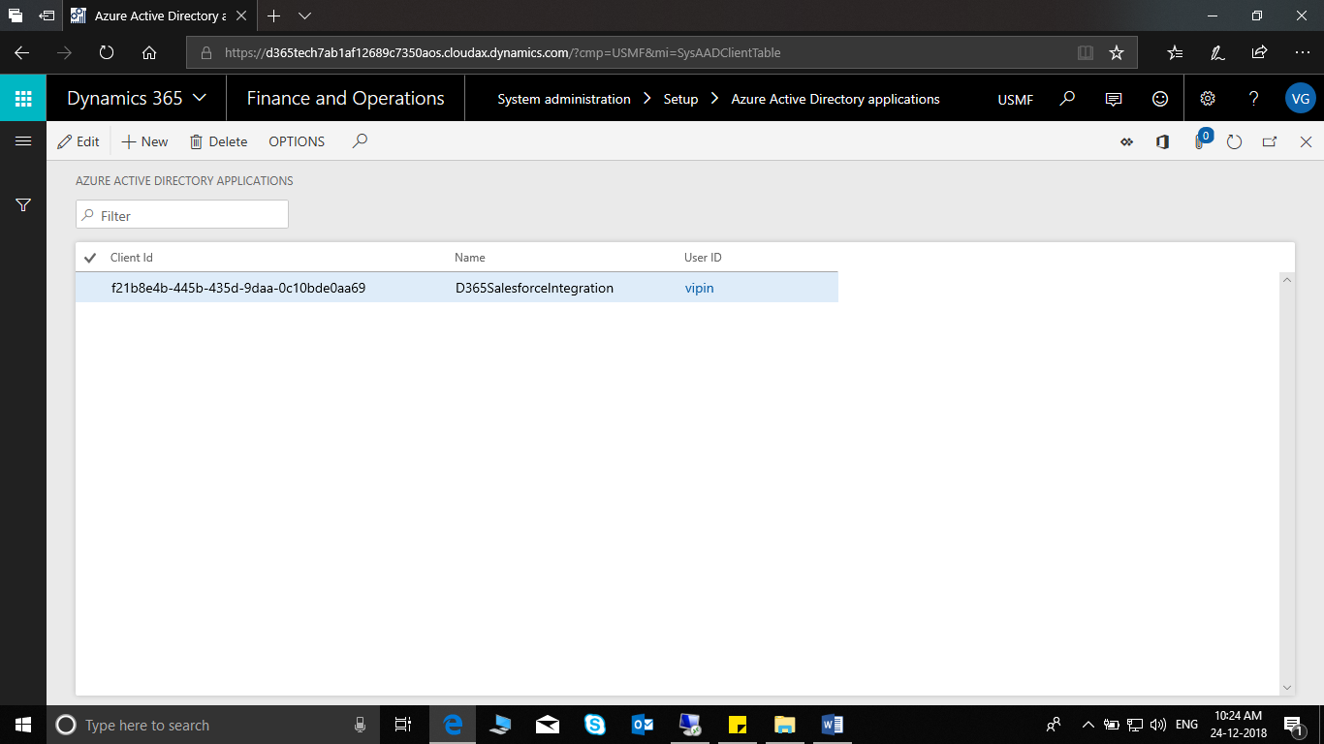
Figure 2.2 Enter the Client ID of the app made in the first step.
Step 3: Perform the Salesforce setup by entering the user Id and password. User Id is same which is used to login into Salesforce and password field will be concatenation of salesforce password with security token received on mail.
Path: -Salesforce Integration > Setup > Salesforce Credentials
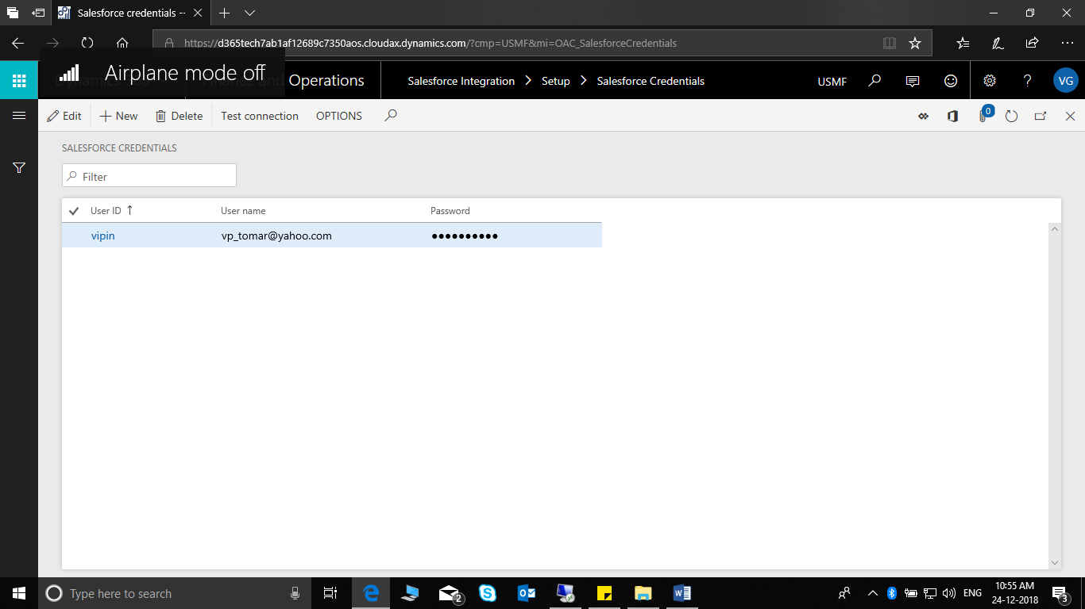
Figure 2.3 Salesforce credentials form
After entering the User id and Password perform the validation by clicking on the Test connection button in the action pane. On successfully validation, Test connection successful message appears, otherwise connection failed message comes.
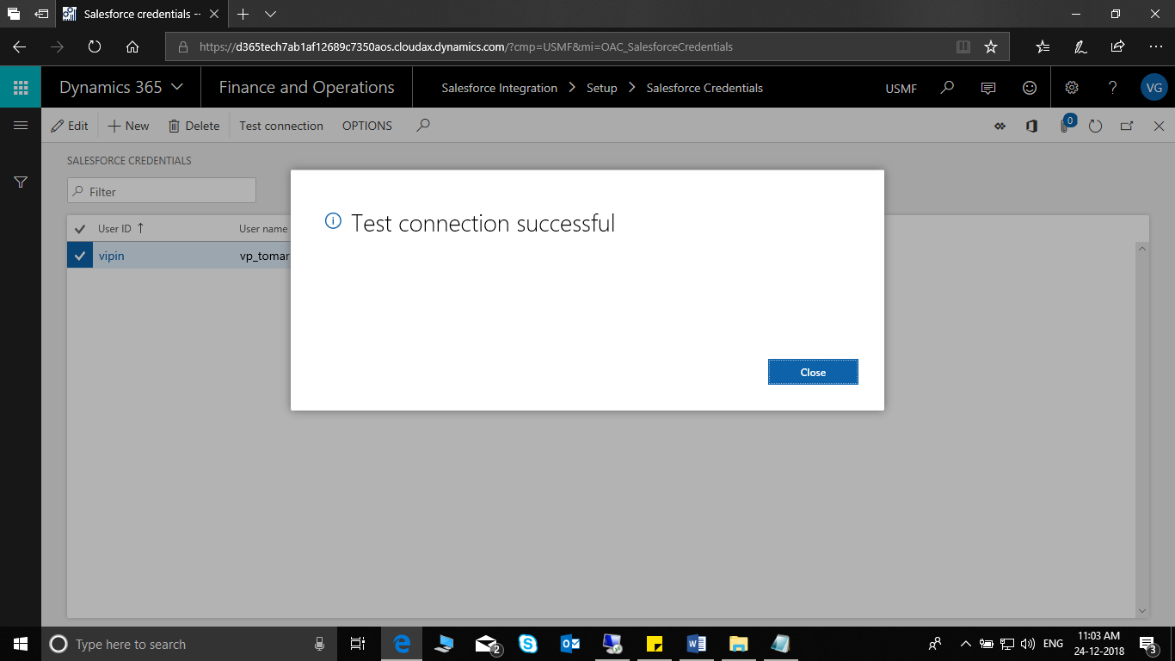
Figure 2.4 Testing Connection
Step 4 :Switch on the Display synchronize success message option on the form given in the path below.
Path: -Salesforce Integration > Setup > Salesforce Parameters > General Tab.
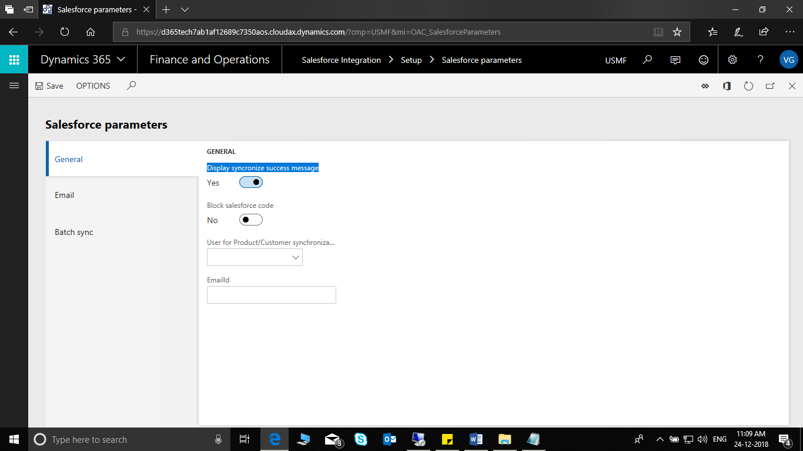
Figure 2.5 Salesforce success message setup.

Database Log Setup
Database log setup is required to trigger the data synchronization in Salesforce for every insertion/Update/Deletion in D365 Finance and Operations.

Steps to create setup
Path: -System Administration > Setup > Database Log Setup
Step 1: Click on New
Step 2: Click on Next and check the option show all tables and show all tables name.
Step 3: Select the tables as per details mentioned below and click next.
Step 4: For the respective tables select option Track new transactions, Update and Delete and click finish.

Below is the list of all the tables, which are required to be setup in database log for synchronization of below entities
- Customer
- Contact
- Product
- Opportunity
- Quotation
- Sales Order
- Customer Group

S NO. | Node Name | Table Name | Entity
1 | Not Specified | ContactPerson | Contact
2 | General ledger | CustGroup | Customer Group
3 | General ledger | CustInvoiceJour | Sales Order
4 | General ledger | CustInvoiceTrans | Sales Order
5 | Quotation | CustQuotationJour | Quotation
6 | General ledger | CustTable | Customer
7 | Not Specified | DirPartyLocation | Customer
8 | Not Specified | DirPartyLocationRole | Customer
9 | Trade | EcoResStorageDimensionGroupItem | Product
10 | Trade | EcoResTrackingDimensionGroupItem | Product
11 | Trade | InventModelGroupItem | Product
12 | Trade | InventTable | Product
13 | Not Specified | LogisticsElectronicAddress | Customer
14 | Not Specified | LogisticsPostalAddress | Customer
15 | General Ledger | OAC_CustContractsSalesforce | Customer
16 | Bank | RCashTable | Customer
17 | Trade | SalesLine | Sales Order
18 | Quotations | SalesQuotationLine | Quotation
19 | Quotations | SalesQuotationTable | Quotation
20 | Trade | SalesTable | Sales Order
21 | Sales and marketing series | SmmOppurtunityTable | Oppurtunity

Salesforce Setup in D365
Step 1: Salesforce Entity Setup for Integration.
Let us demonstrate the steps for custom/standard entity creation for integration.
Path: -Salesforce Integration > Setup > Entity.
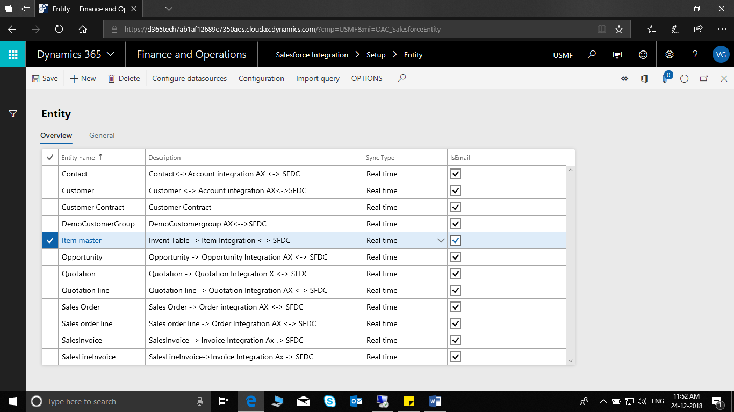
Figure 2.6 Entity Creation for integration
1.Click on New -> Give the Entity Name -> Description.
2.Go to the General Tab Page and mark the required settings as shown in the below figure.
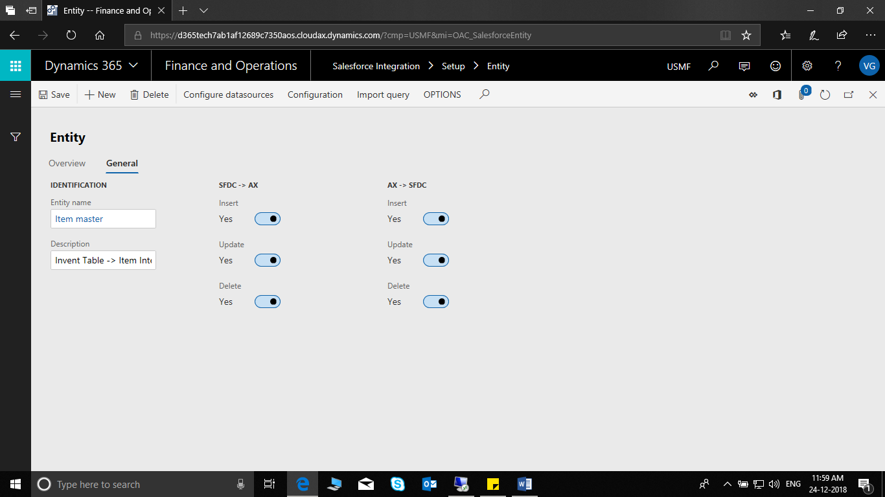
Figure 2.7 Created Entity's General settings.

3. Click on Configuration of the selected entity.
Figure 2.8 Configuration of the created Entity.
4.Form like this should open as shown in the below screenshot.
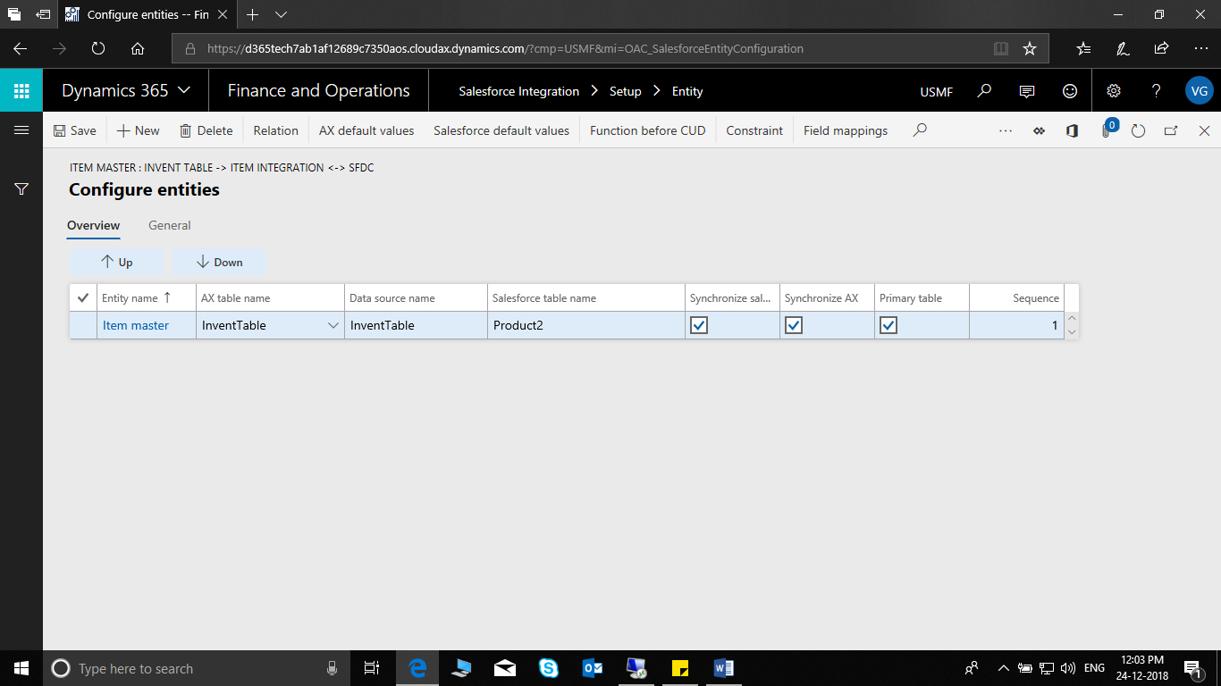
Figure 2.9 Configure the created data entity.
Steps for the configuring and setting up Entity.
1.Give the entity name, D365 F&O Table name and enter a unique data source name for the mentioned table name.
2.Select the primary table, Synchronize AX and Salesforce check box if it is applicable.
3.Select the option Field Mapping on the selected record. Here we will mention the salesforce table and will map the D365 F&O fields to the respective salesforce table’s fields. After this process the Salesforce’s table name will flow in the entity record as shown in the above screenshot where salesforce table name is Product2.
Below screenshot explains the salesforce field mapping.
4.Mention the salesforce table name in the salesforce field drop down menu and the related fields on the at the righthand side. Post this process you can come back to the entity form and complete the setup.
5.If the entity has certain value and the user does not want that to be processed then constraint field can be used where we can specify the field name and value.
6.If the entity has any condition before update, insert and delete then it can be mentioned in the form Function before CUD.
7.Entity’s default values for salesforce can be mentioned in the salesforce default values form, using these values the entity will be initialized in salesforce.
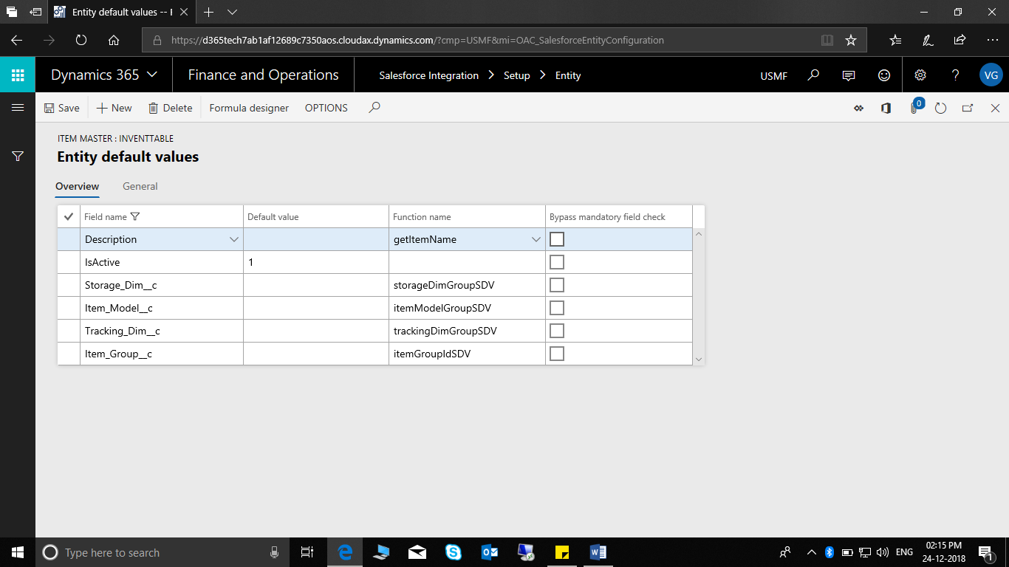
Figure 2.10 Entity default values for salesforce.
8. As explained in point number 7 we can specify the default values for Dynamics 365 Finance & Operations too, following values will be considered when the data will be created in D365 F&O.
9.If the specified entity’s field has relation it should be mentioned in the relation form. This form comes into where data is normalized, and the fields have relation with each other.
For e.g.: Address in D365 F&O
10. After these steps the user must validate mapping.

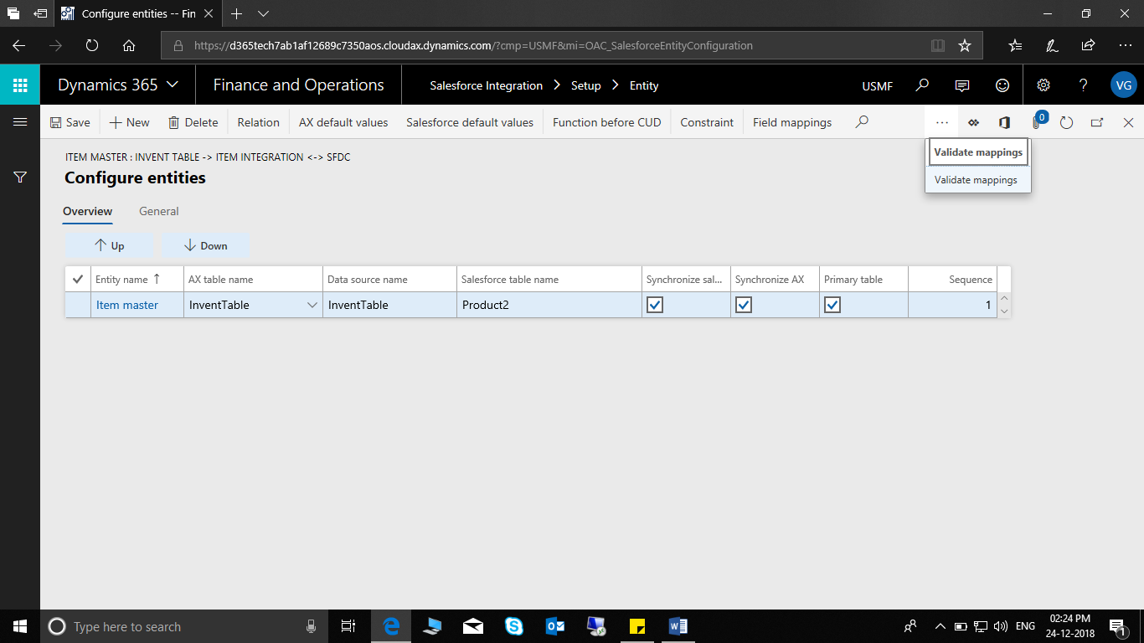
Figure 2.11 Validate mapping for Entity created.
The result should be as shown in the screenshot below.
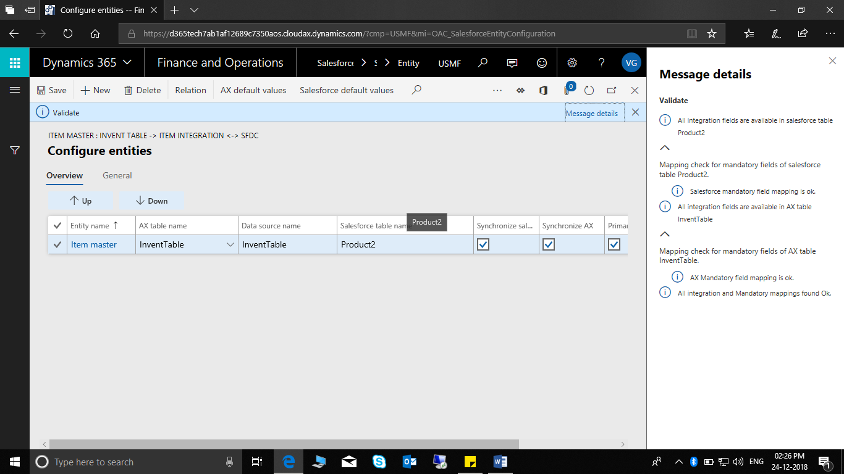
Figure 2.12 Validated Entity Info Message
This is a mandatory step as this will enable validate mandatory field in the general tab of the entity, by default this is set to no and after validating the mentioned it is set to yes on success and moving forward the current data entity’s integration one of the main requirements is met.

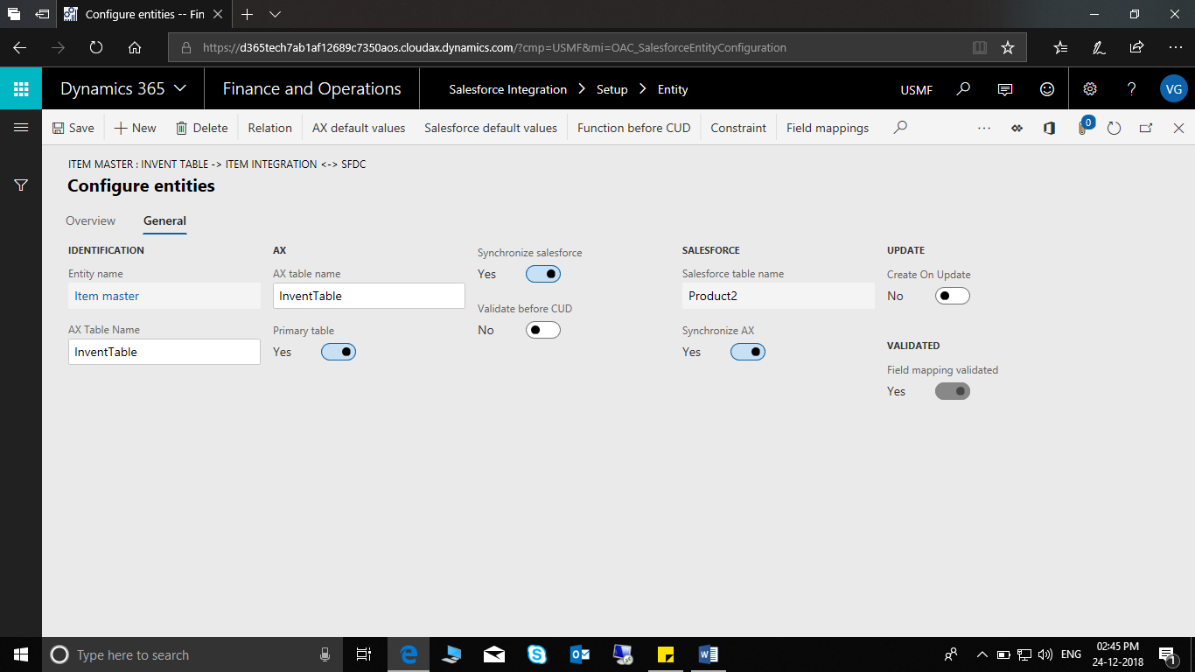
Figure 2.13 Validated Entity Confirmation on Form Level.

Detailed Information on Salesforce Entity Fields.

SheetName | Field Headers | Description
FieldMapping | EntityName | Entity Name
FieldMapping | AXTableName | Dynamics 365 Finance & Operations Table Name
FieldMapping | DataSourceName | Same Like Dynamics 365 Finance & Operations Table Name - In Case when Same table is used multiple times, then it can be identified using this name. Data source name also clarifies the purpose of table.  For Example: Billing address and shipping address both use same table LogisticsPostalAddress, but one is used for Billing address and other for Shipping address.
FieldMapping | AXFieldName | AX table field name
FieldMapping | SalesforceFieldName | Salesforce field name
FieldMapping | SalesforceTableName | Salesforce object name
FieldMapping | UpdateAXFields | Only in case value is "Yes", then Synchronization from salesforce to AX will occur.
FieldMapping | UpdateSFDCFields | Only in case value is "Yes", then Synchronization from Ax to salesforce will occur.
DefaultFieldMethodMappings | EntityName | Entity Name
DefaultFieldMethodMappings | AXDataSourceName | Same Like Dynamics AX Table Name - In Case when Same table is used multiple times , then it can be identified using this name. Data source name also clarifies the purpose of table.  For Example: Billing address and shipping address both use same table LogisticsPostalAddress, but one is used for Billing address and other for Shipping address.
DefaultFieldMethodMappings | Table | Dynamics AX Table Name
DefaultFieldMethodMappings | TypeAXorSFDC
DefaultFieldMethodMappings | FieldName | D365 F&O Field name
DefaultFieldMethodMappings | Salesforce fieldname | Salesforce field name
DefaultFieldMethodMappings | DefaultValue | Default value of the field
DefaultFieldMethodMappings | Description - Field mapping method remarks | Method Description with return value of field
DefaultFieldMethodMappings | FunctionName | Name of the static function in Class "OAC_SalesforceIntegrationStaticFunction"

Entity Integration Manual – D365 F&O SFDC

Customer
Current Field Mapping:
Sr.No. | SALESFORCE |  | Dynamics 365
1 | Parent Account (New field) | <== | Invoice account
2 | Account Number | <== | Account
3 | Account Name | <== | Name
4 | City (Billing Address) | <== | City
5 | State/PROV (Billing Address) | <== | State/province/territory
6 | Country (Billing Address) | <== | Country/region
7 | Zip/Postal Code (Billing Address) | <== | ZIP/postal code
8 | City (Shipping Address) | <== | City
9 | State/PROV (Shipping Address) | <== | State/province/territory
10 | Country (Shipping Address) | <== | Country/region
11 | Zip/Postal Code (Shipping Address) | <== | ZIP/postal code
12 | Telephone | <== | Telephone
13 | Fax | <== | Fax
14 | Website | <== | Website
15 | Buying Group | <== | Sales order pool
16 | Annual Rebate {Check box} | <== | Customer rebate group
17 | Price Group | <==> | Price group
18 | Agent Code | <== | Commission group
19 | US/CDN Account | <== | Currency
20 | Customer Service Rep | <==> | Customer service rep.
21 | ACCOUNT OWNER | <==> | Employee responsible
22 | Account on Hold {Check box} | <== | Invoicing and Delivery on hold
23 | Payment Terms | <== | Terms of payment

- Customer is created from Dynamics 365 Finance & Operations and synced to Sales Force.
- Click on Salesforce Integration > Common > Customer > on the Action Pane, on the Customer tab, in the New group, click Customer to create a new customer record.
- Enter values in the following fields on the Customer form:
- Customer Account
- Name
- Customer Group
- Terms of Payment
- Customer Service rep.
- Country
- Zip/postal code
- Street
- City
- Province/Territory
- Telephone
- Fax

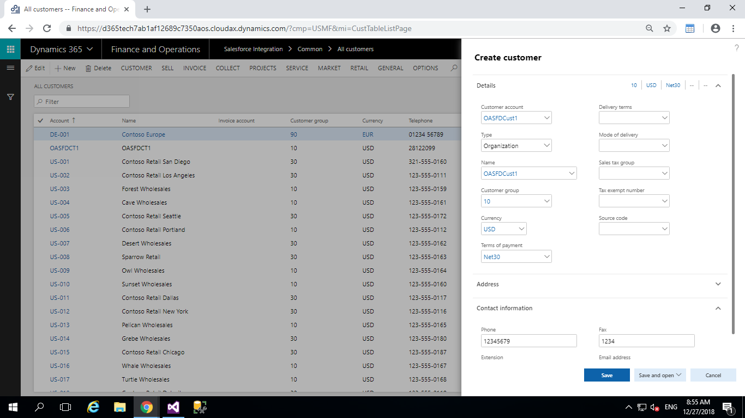
Figure 3.1 Customer Creation in D365 F&O
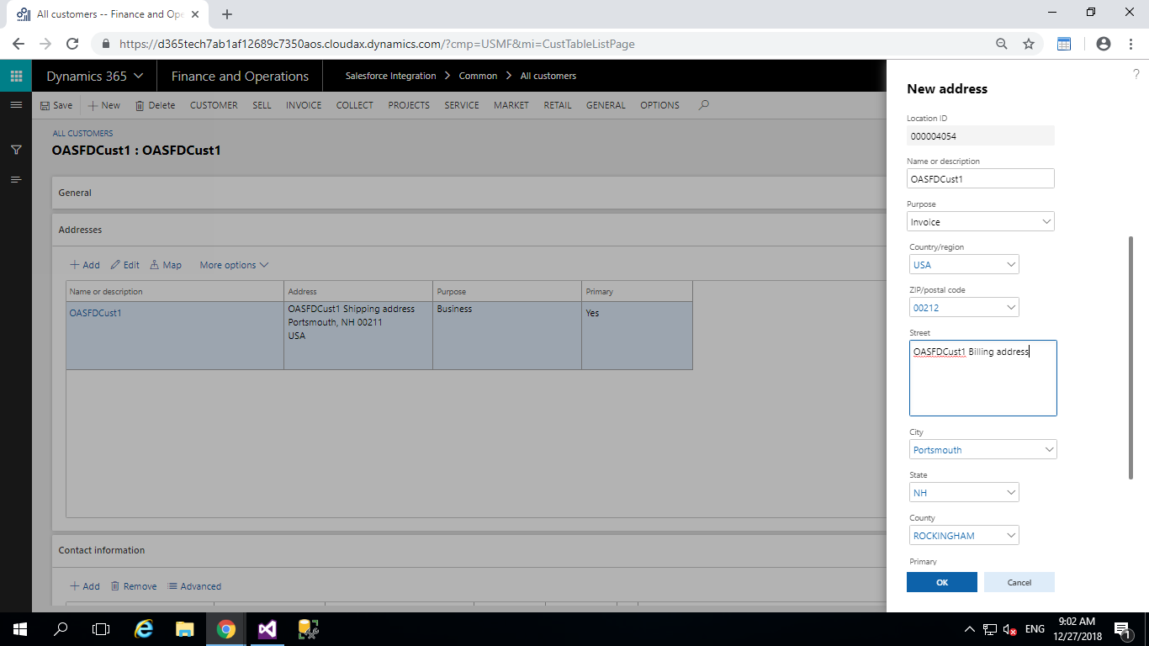
Figure 3.2 Address in Customer
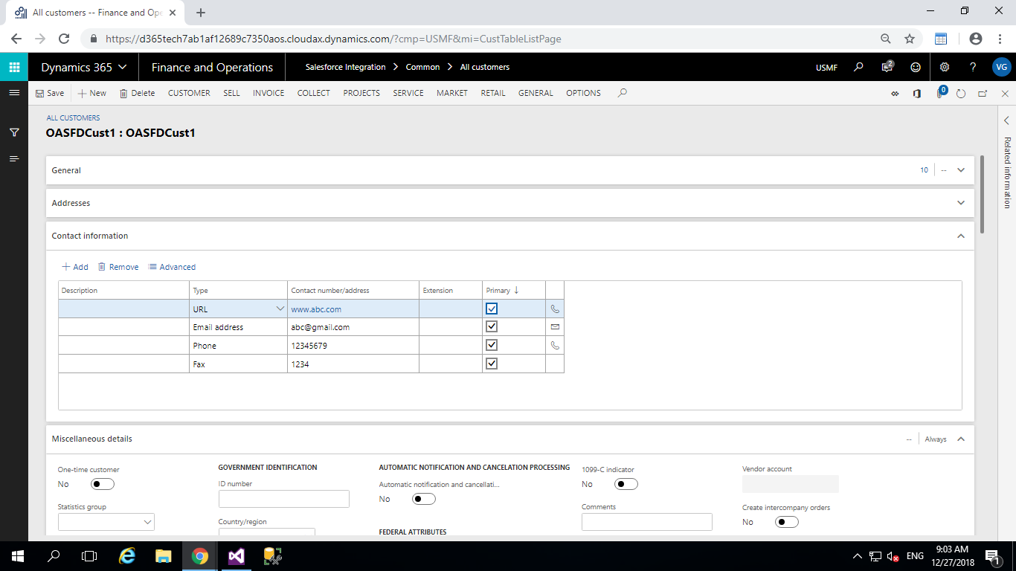
Figure 3.3 Contact Information in Customer
- Employee responsible should be same as the user in salesforce.
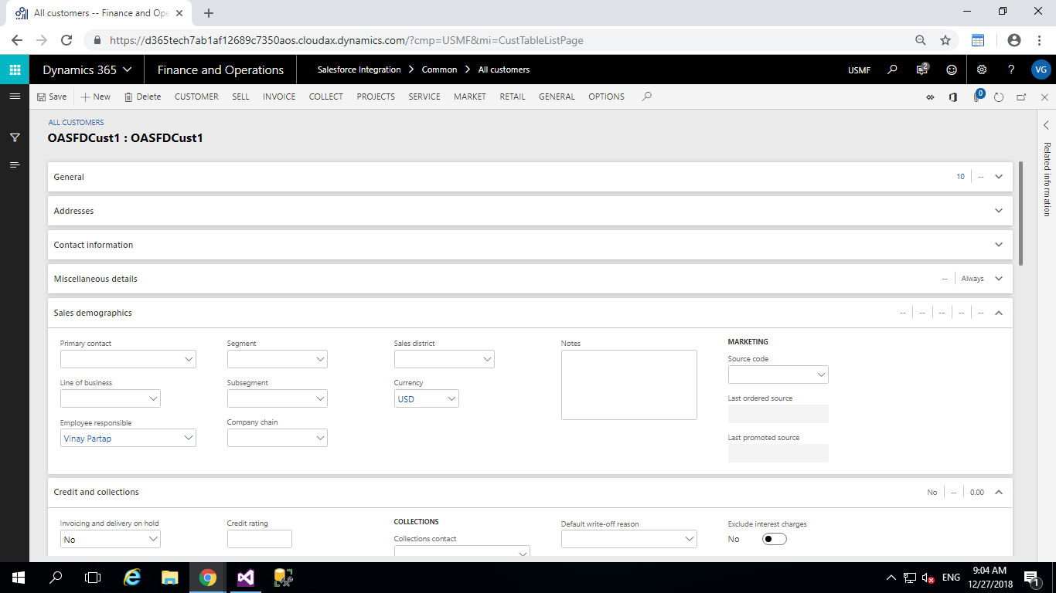
Figure 3.4 Employee Responsible in Customer Creation
- Save the Customer and navigate to Salesforce Integration>Setup>Salesforce instant creation.
- Or else if batch job is configured the customer will be automatically synchronized.

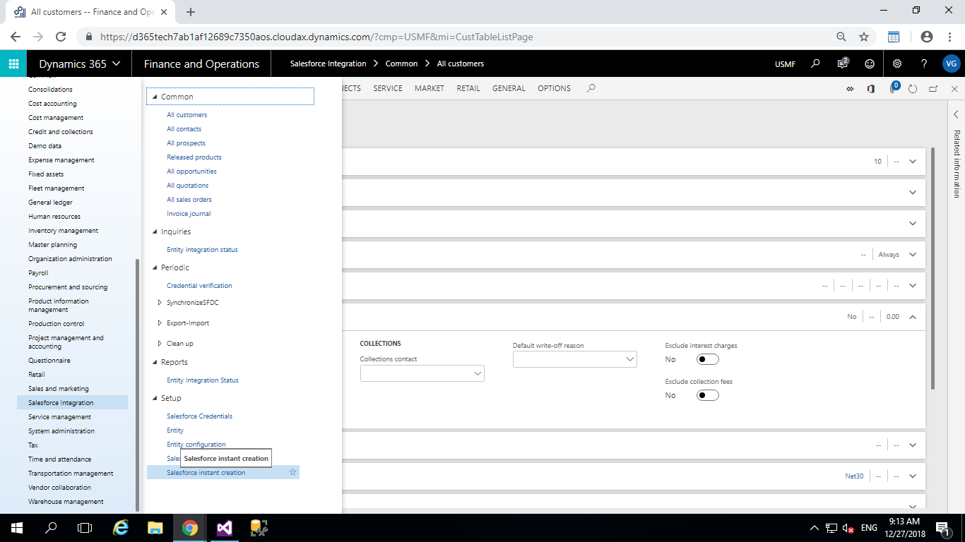
Figure 3.5 Customer creation in Salesforce
- Upon successful creation the output of the above click should look as follows shown in the below screenshot.
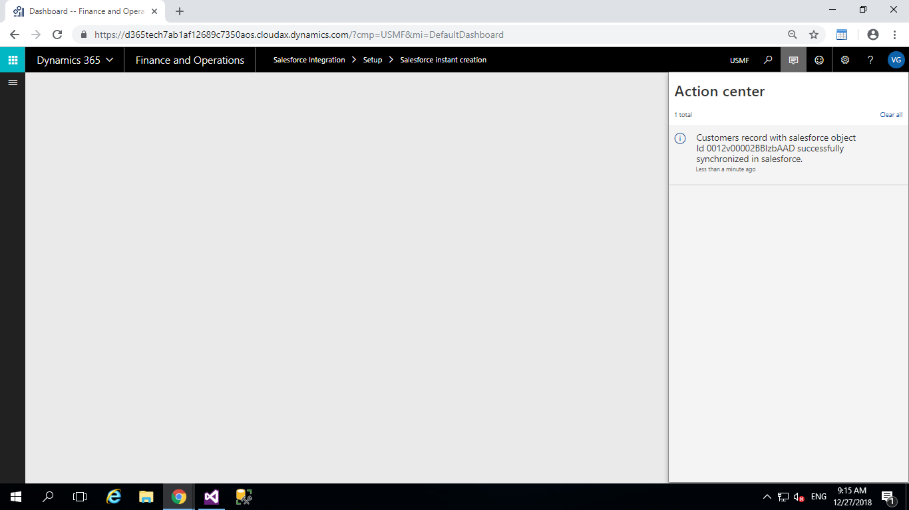
Figure 3.6 Customer creation confirmation in D365 F&O
- Verify the above in salesforce
- Click on Accounts. Sales force shows the customer with Name “OASFDCust1”.
- Open the Customer /Account and click Edit. The field displayed in the Account information form in Sales force can be matched with the fields entered in the AX for the same customer.
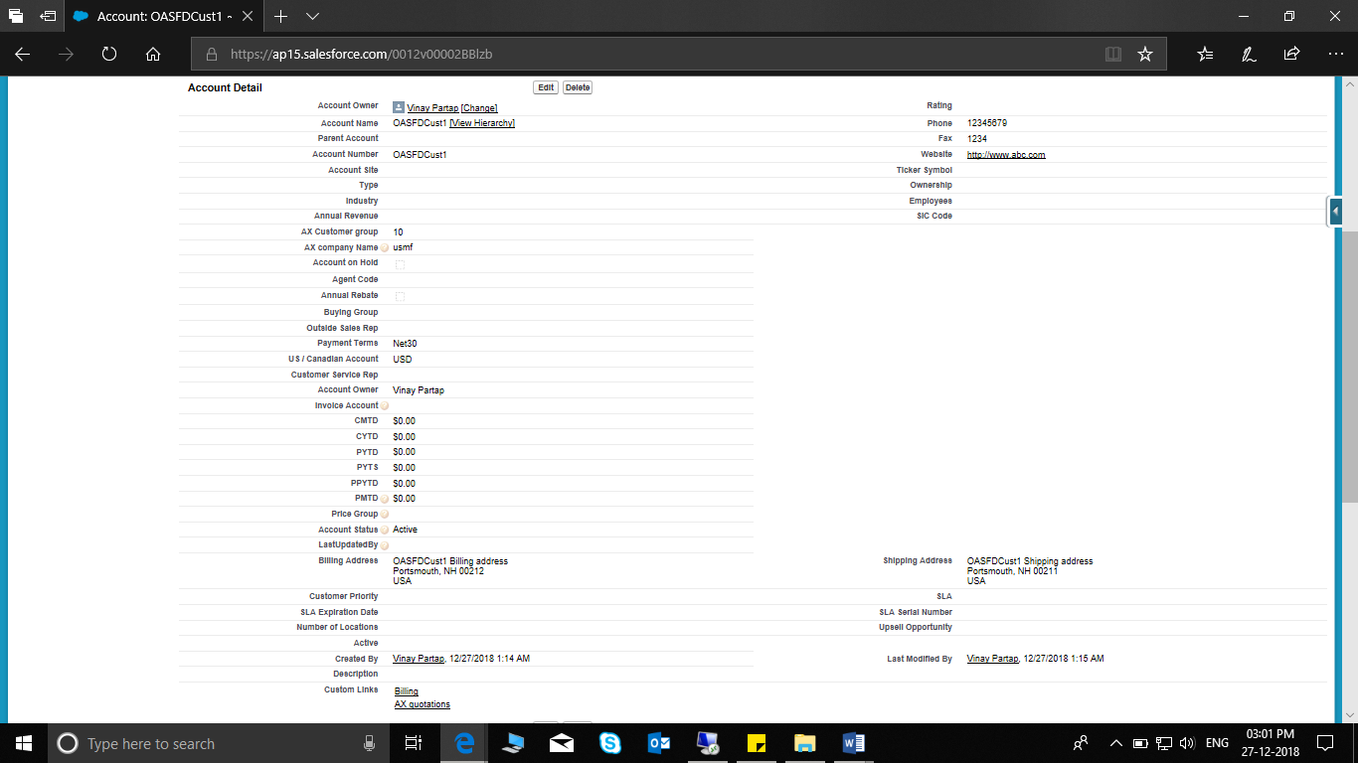
Figure 3.7 Customer Synchronized in Salesforce
- we can also update the values in D365 F&O, and the updated values will be reflected in salesforce.
- Invoice account – Invoice and Delivery tab
- Sales order pool
- Customer rebate group
- Price group
- Commission group
- Save the customer and click on instant salesforce creation or else the batch job will automatically run, and the system shows the message “Customers record with salesforce object Id -- successfully synchronized in salesforce.” These fields get updated in sales force for the same account.

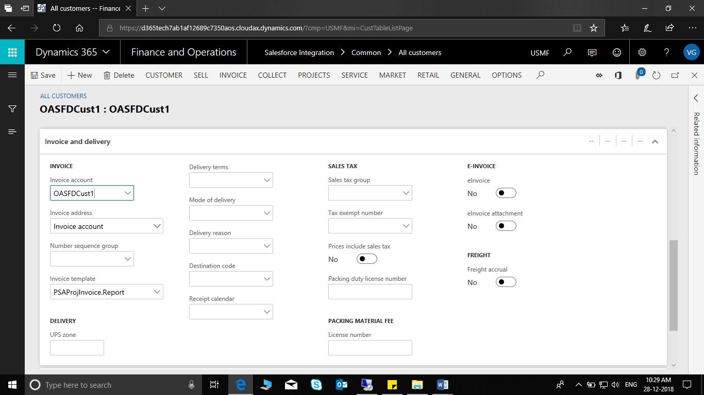
Figure 3.8 Updating customer's Invoice and Delivery
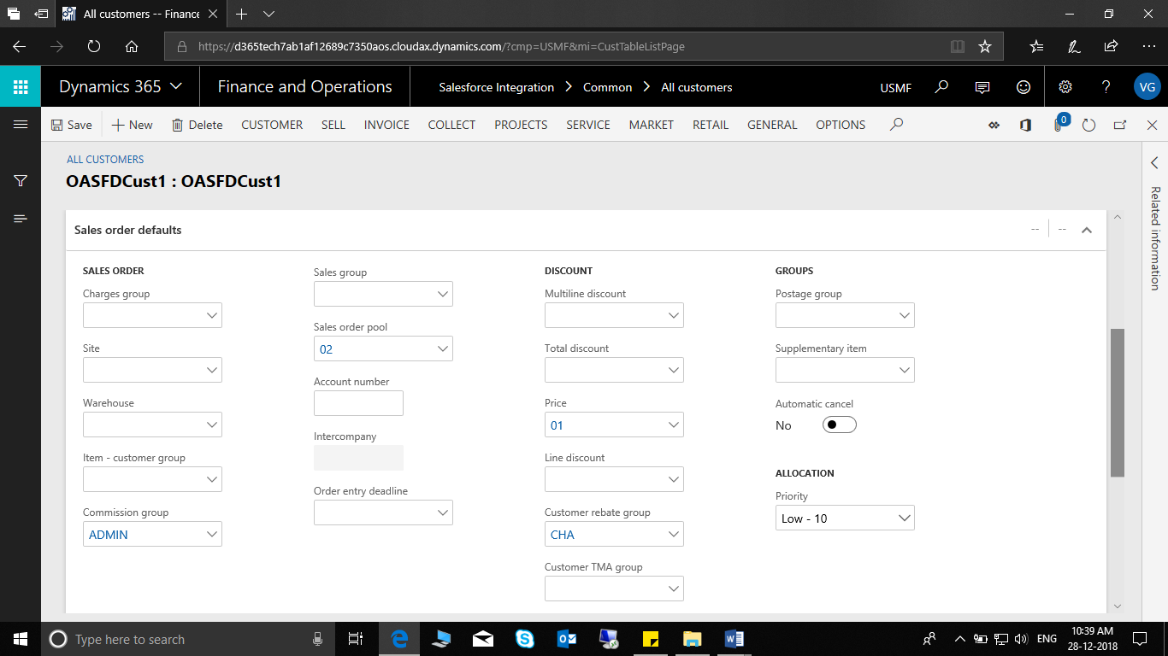
Figure 3.9 Updating Customer's Sales order defaults.
Figure 3.10 Customer updated successfully.
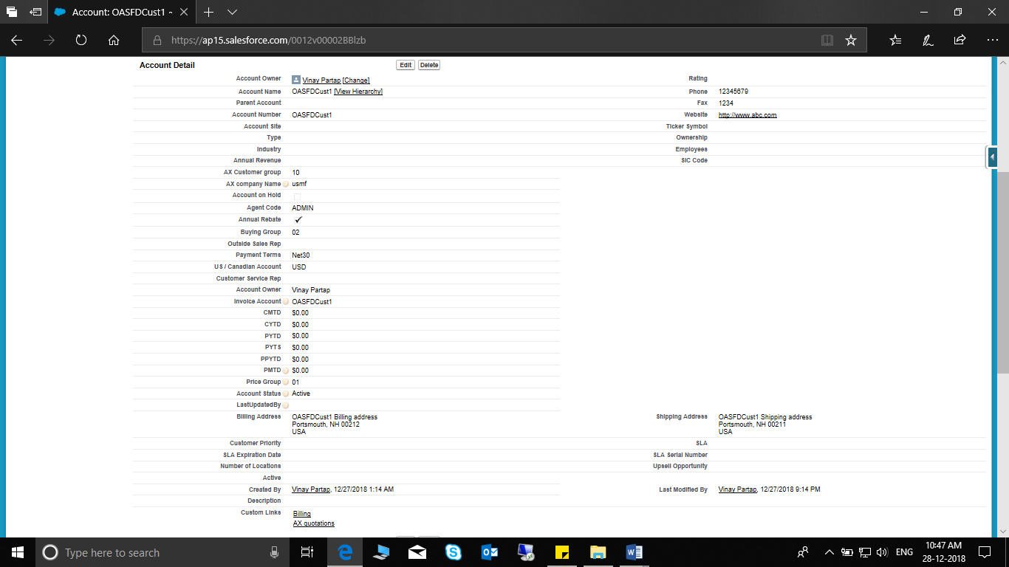
Figure 3.11 Updated Values Synchronized Successfully.
- In case, following fields are updated in Sales force, these will be updated in AX, provided (for enum fields) the values exist for these fields in AX.
-Price Group
-Customer Service Rep
-ACCOUNT OWNER
- Sales Force: Change “Price Group and customer Service Rep” fields

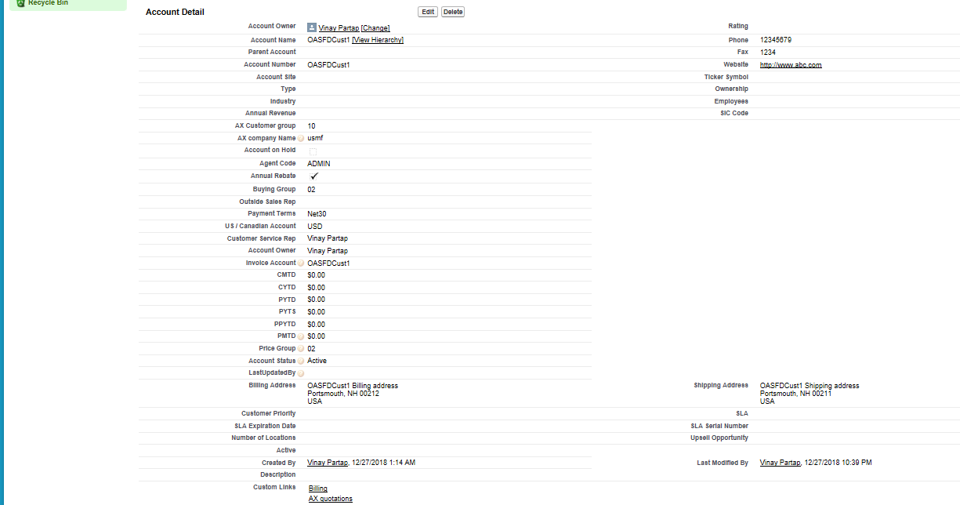
Figure 3.12 Changes made to Price group and Customer Service Rep in Salesforce
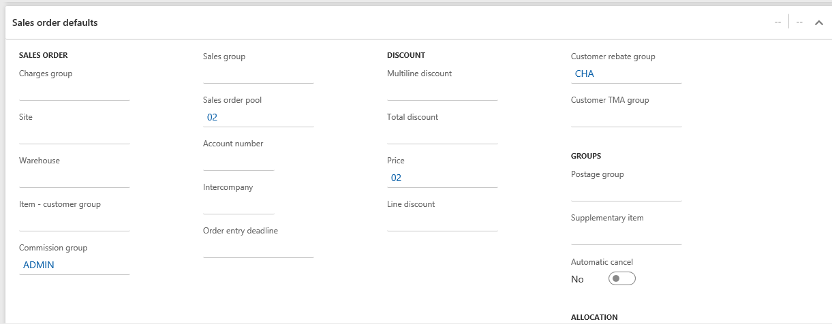
Figure 3.13 Value updated (Price Group) in D365 F&O (Customer)
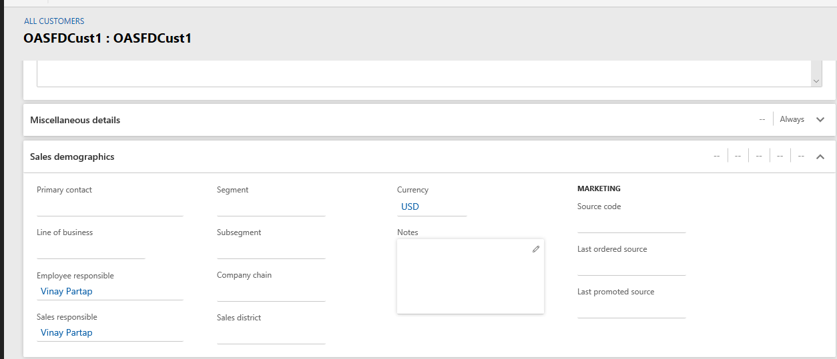
Figure 3.14 Value updated (Sales Responsible) in D365 F&O (Customer)

Customer Group
Current Field Mapping
Sr. No. | SALESFORCE |  | Dynamics 365
1 | CustGroup | <==> | Customer Group
2 | Name | <==> | Description
3 | PaytermID | <==> | Terms of Payment
4 | Clearing Date | <==> | Time between invoice due date and payment date
5 | Tax Group Id | <==> | Default Tax Group

- Path: Accounts receivable > Setup > Customer Groups
- Create a new customer group and save it.
- Save the Customer Group and navigate to Salesforce Integration>Setup>Salesforce instant creation.
- Or else if batch job is configured the customer group will be automatically synchronized.

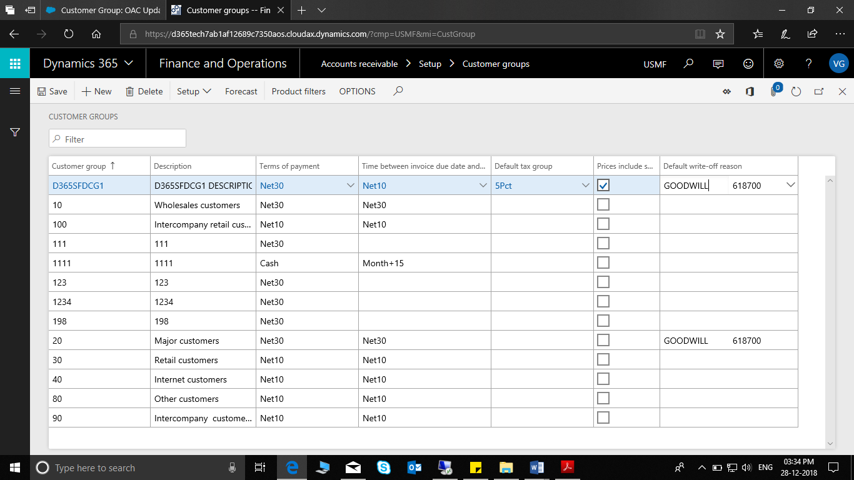
Figure 3.15 Creation of Customer Group
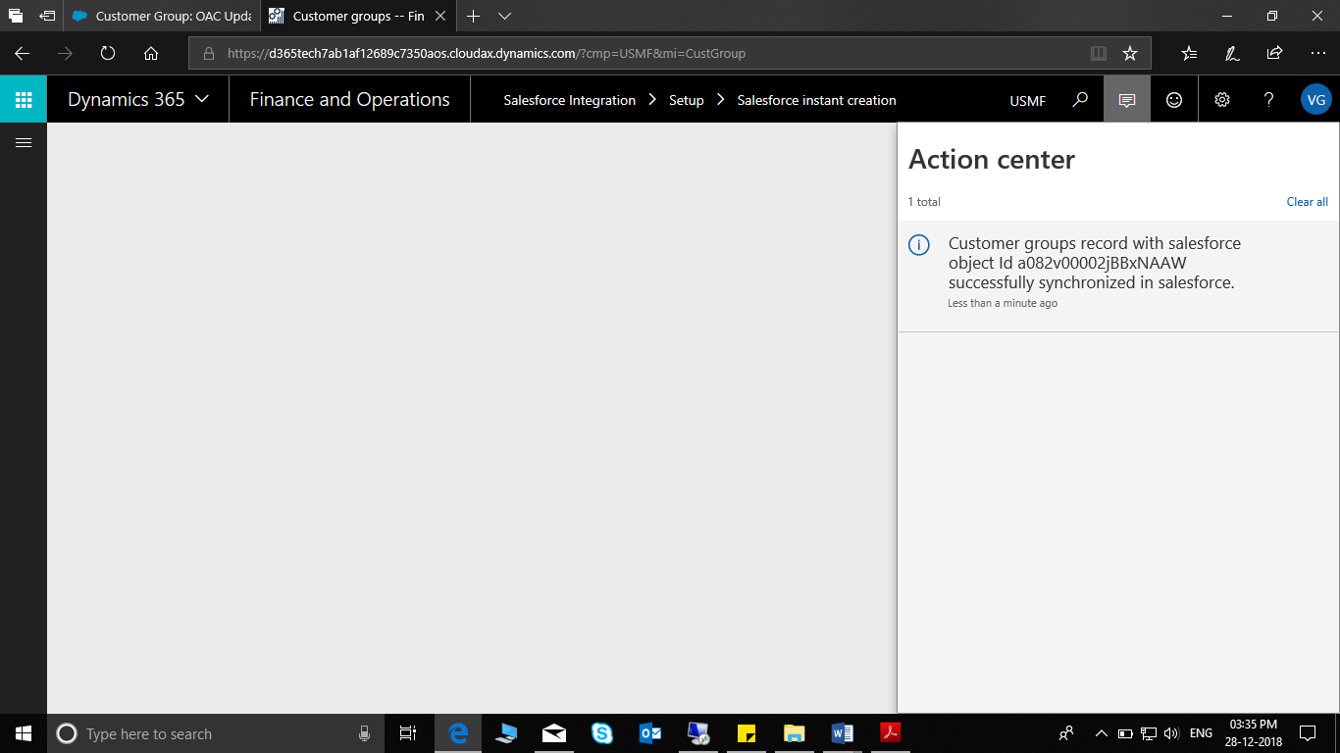
Figure 3.16 Customer Group Success Message (D365 F&O)
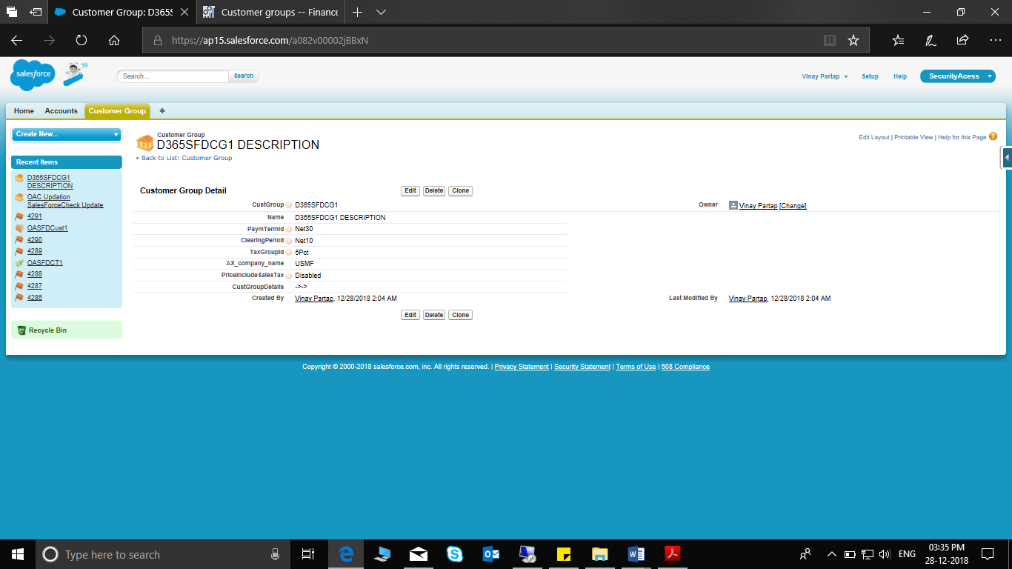
Figure 3.17 Customer Group Validation on SFDC.
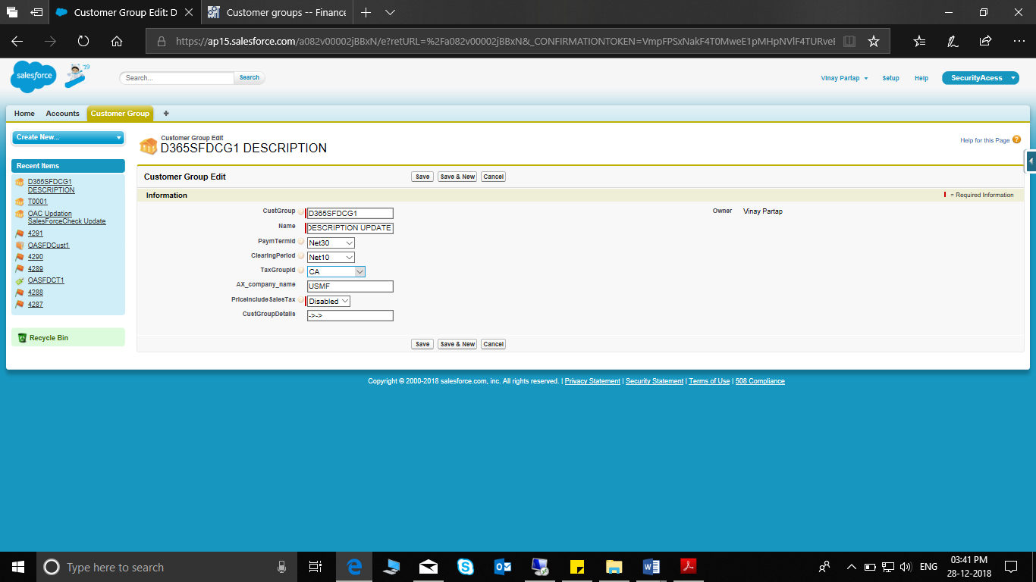
Figure 3.18 Updating Customer Group on Salesforce
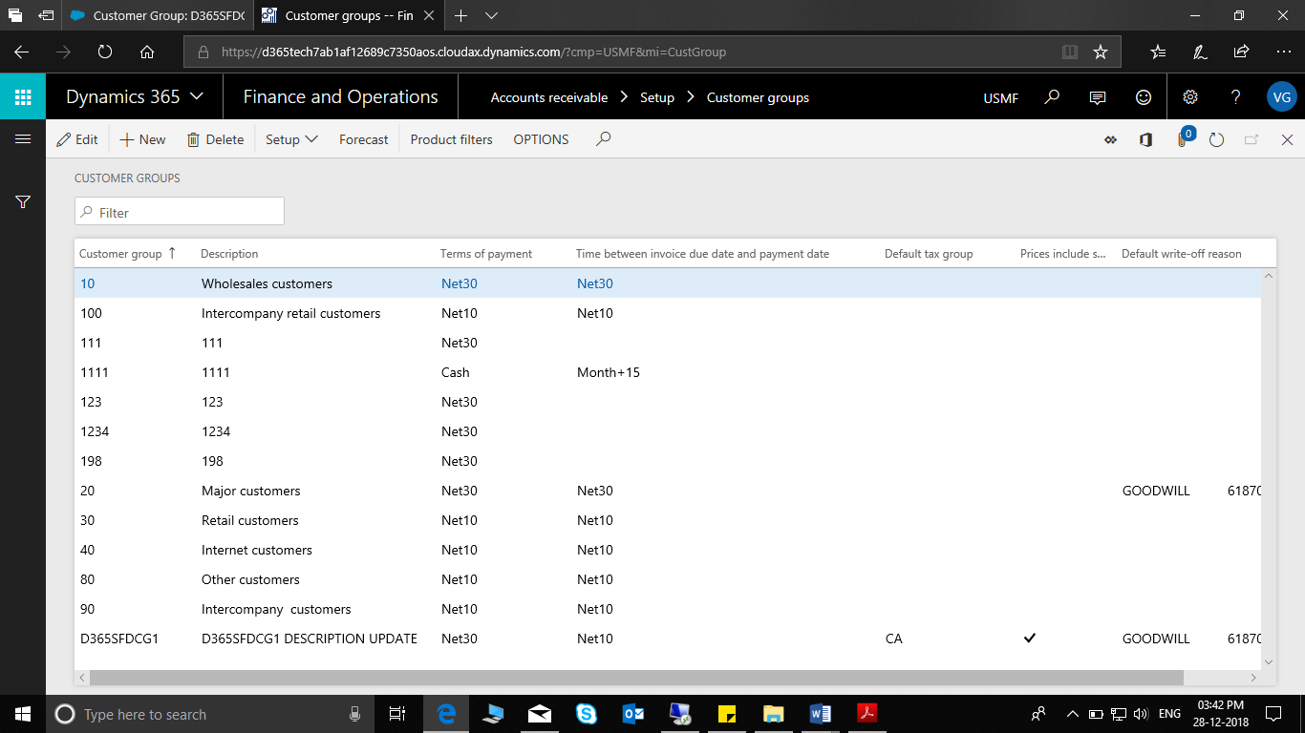
Figure 3.19 Customer Group Successfully Updated on D365 F&O

Product
Current Field Mapping
Sr. No. | SALESFORCE |  | Dynamics 365 F&O
1 | Product Code | <==> | Item Number
2 | Product Name | <==> | Search Name
3 | Storage dimension group | <==> | Storage Dim
4 | Item Group | <==> | Item Group
5 | Tracking dimension group | <==> | Tracking Dim
6 | Item model group | <==> | Item Model

- Navigate to Salesforce Integration > Common > Released Products.
- Click on New and provide details of the new product as shown in the below screenshot.

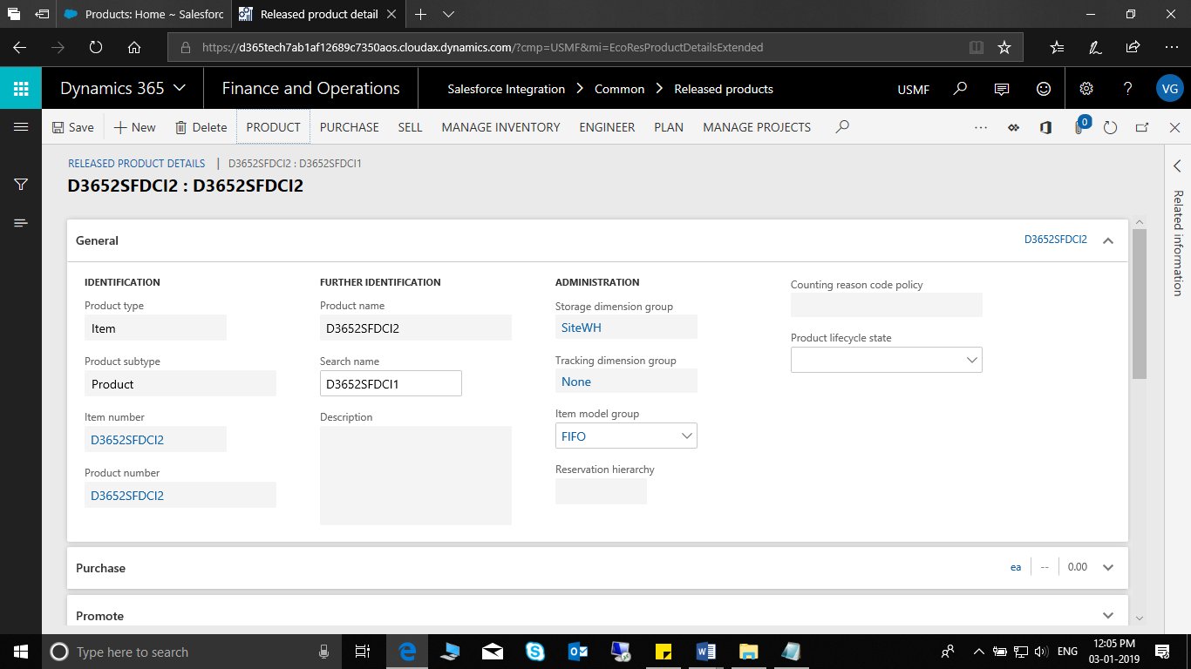
Figure 3.20 Item Creation in D365 F&O
- Save the Item and navigate to Salesforce Integration>Setup>Salesforce instant creation.
- Or else if batch job is configured the item will be automatically synchronized.
Figure 3.21 Item Successfully synchronized (Message in D365 F&O)
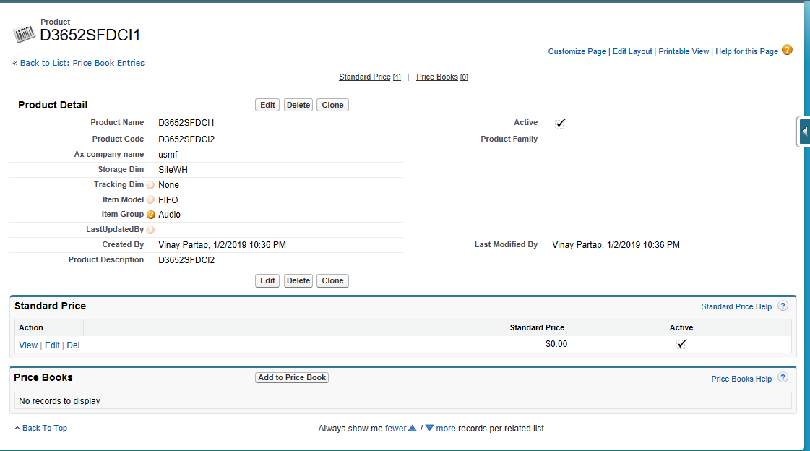
Figure 3.22 Item Synchronized Successfully in Salesforce.
- If any changes are made in product in salesforce the same will be reflected in d365 F&O.

Opportunity
Current Field Mapping

Sr. No. | SALESFORCE |  | D365 F&O
1 | AX_OpportunityId | <== | Opportunity ID
2 | Opportunity Name | <== | Subject
3 | Amount |  | Estimated revenue

- Opportunity is created in AX and synced to sales force.
- Click on Salesforce Integration > Common > All opportunities > on the Action Pane, on the Opportunity tab, in the New group, click Opportunity to create a new Opportunity record.
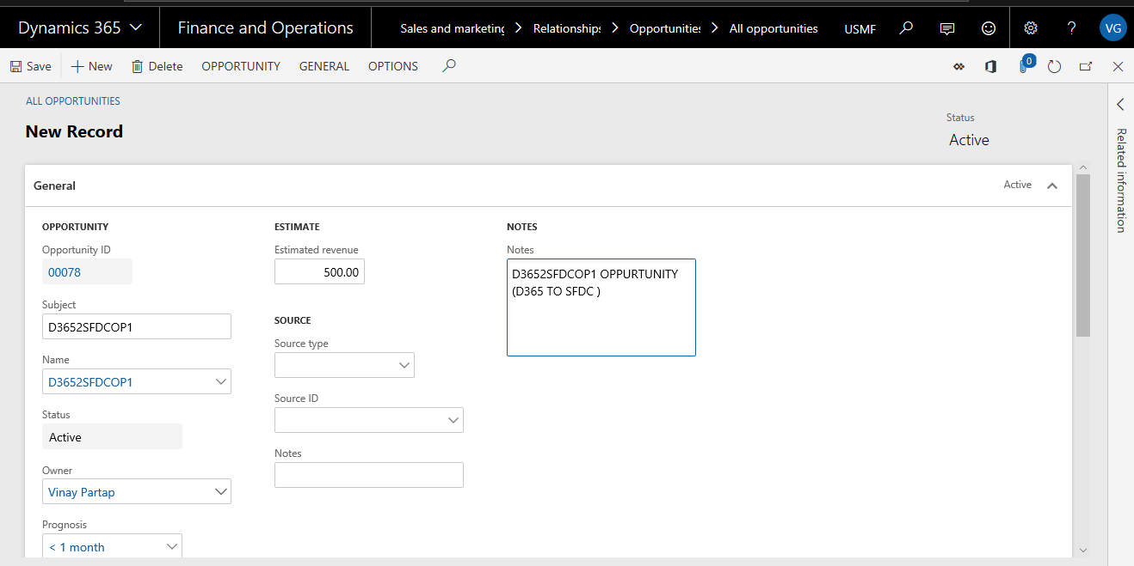
Figure 3.23 Opportunity in D365 F&0 Creation
- Save the Item and navigate to Salesforce Integration>Setup>Salesforce instant creation.
- Or else if batch job is configured the item will be automatically synchronized.

Figure 3.24 Opportunity synchronization successful message in D365 F&O
- To verify the Opportunity in Sales Force, open the opportunity in the sales force
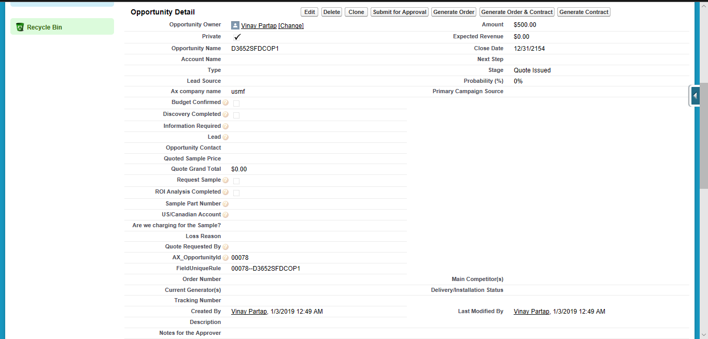
Figure 3.25 Opportunity Created successfully on Salesforce.
- Similarly, user can make changes in Salesforce and the changes will reflect in D365 F&O.

Quotation and Quotation Line
Current Field Mapping

S No. | SALESFORCE |  | D365 F&O
1 | Description | <== | Description
2 | Ax_quote_number__c | <== | QuotationId
3 | Name | <== | QuotationName
4 | Ax_quote_number__c | <== | QuotationId
5 | Product | <== | Item No.
6 | UnitPrice | <== | SalesPrice
7 | Quantity | <== | SalesQty

- Sales Quotation is created in D365 F&O and synced to sales force.
- Click on Salesforce Integration > Common > All opportunities > on the Action Pane, on the Opportunity tab, in the New group, click Quotation to create a new Quotation.
- Create a quotation in D365 F&O using the opportunity that is already created/used in Salesforce.
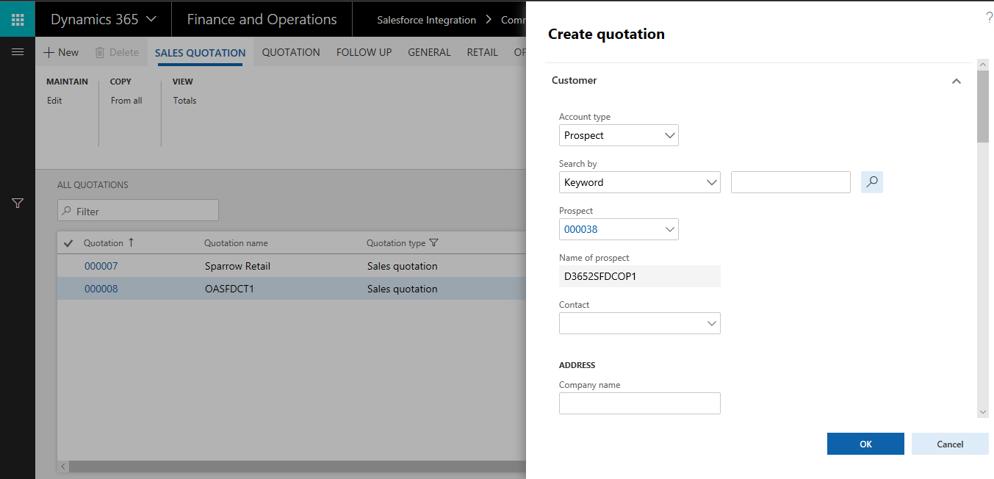
Figure 3.26 Quotation creation in D365 FO
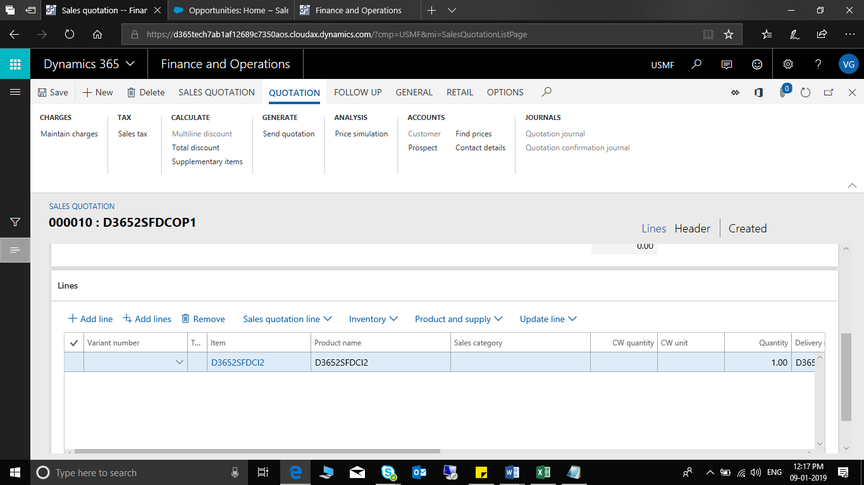
Figure 3.27 Quotation Line Creation in D365 F&O
- We have used the item that was previously created in SFDC.
- Save the Item and navigate to Salesforce Integration>Setup>Salesforce instant creation.
- Or else if batch job is configured the item will be automatically synchronized.
- The success message will be same as the shown in the above entities.

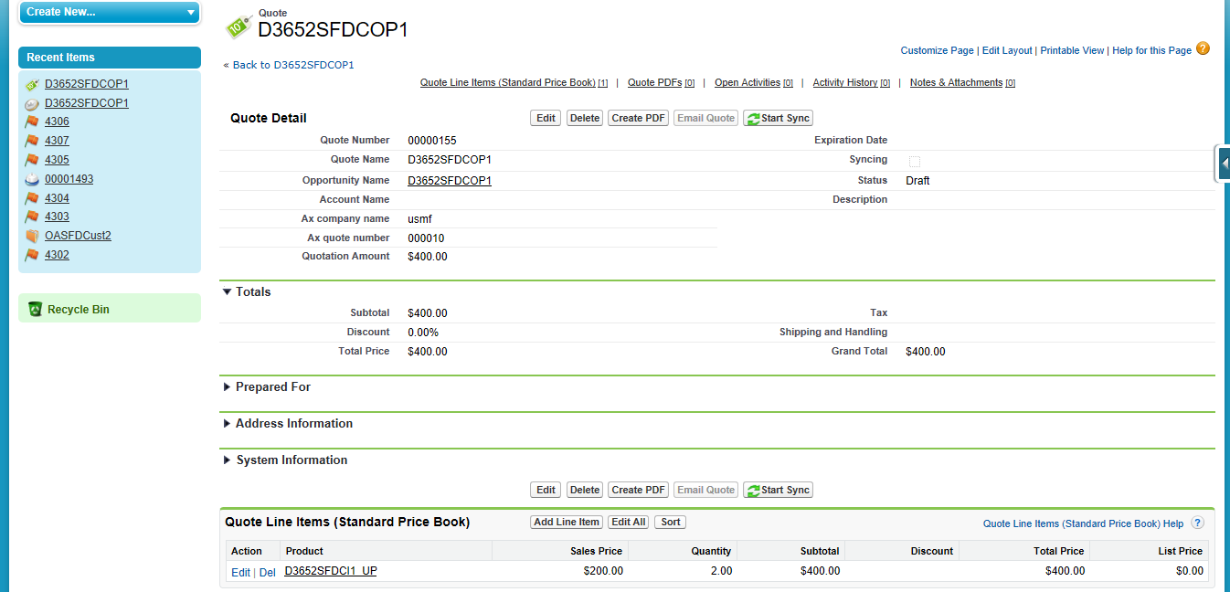
Figure 3.28 Quotation Successfully Created with line in Salesforce
- If we update line’s values such as sales price and quantity in the newly created quote in SFDC it will successfully update as shown in the below screenshot.
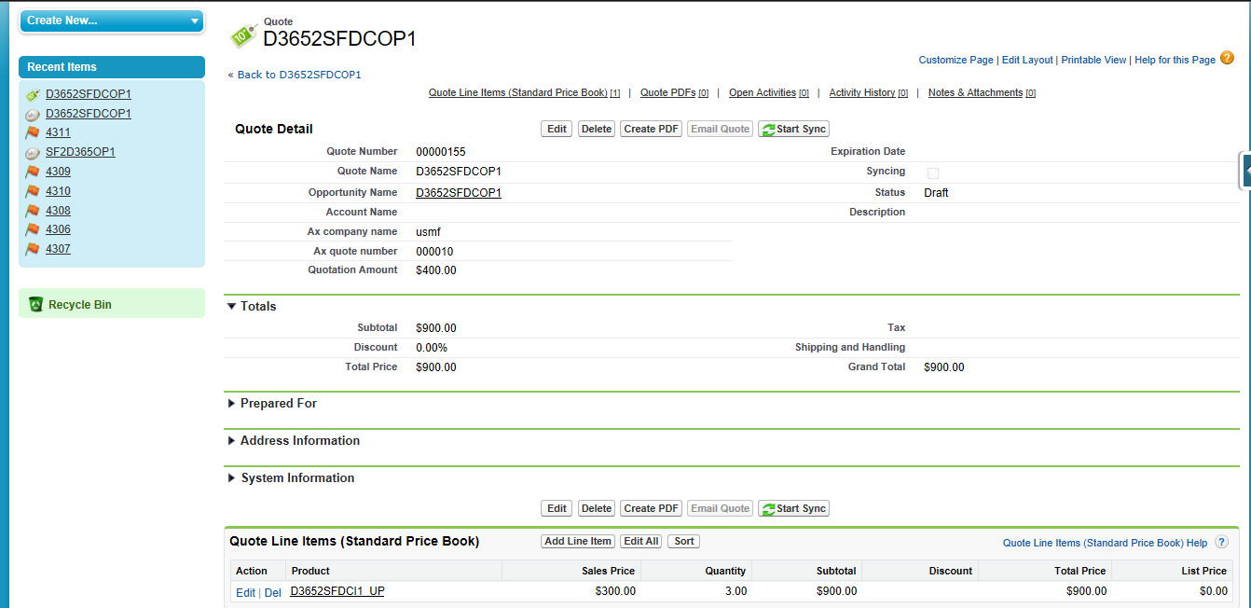
Figure 3.29 Quote Line updation in Salesforce
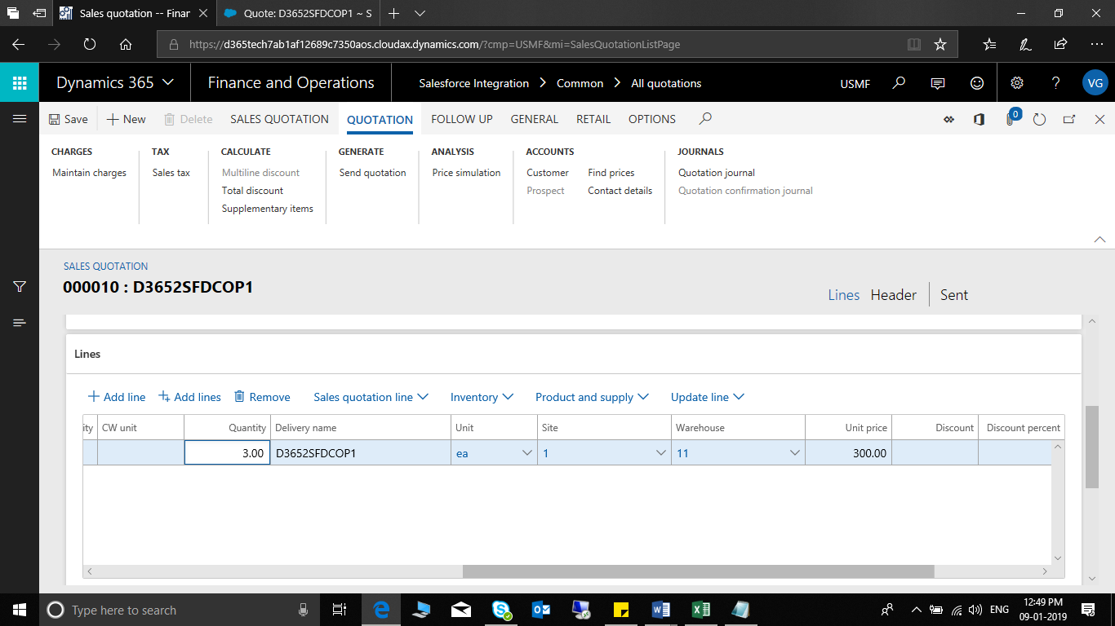
Figure 3.30 Qty and Unit Price Successfully updated in D365 F&O for Quotation

Sales Order
Current field mapping
SALESFORCE |  | D365 F&O
Sales ID | <== | Sales order number
Account ID | <== | Customer Account
Sales Name | <== | Name
Shipping Date Requested | <== | Effective Date
Name | <== | Description
Sales Id | <== | Sales order number
Product | <== | Item No.
Sales Price | <== | Unit Price
Sales Qty | <== | Quantity
Description | <== | Name

- Sales Order is created in D365 F&O and synced to sales force.
- Go to AR>Orders>All Sales Orders and click new.
- Choose the customer Account already created in SFDC
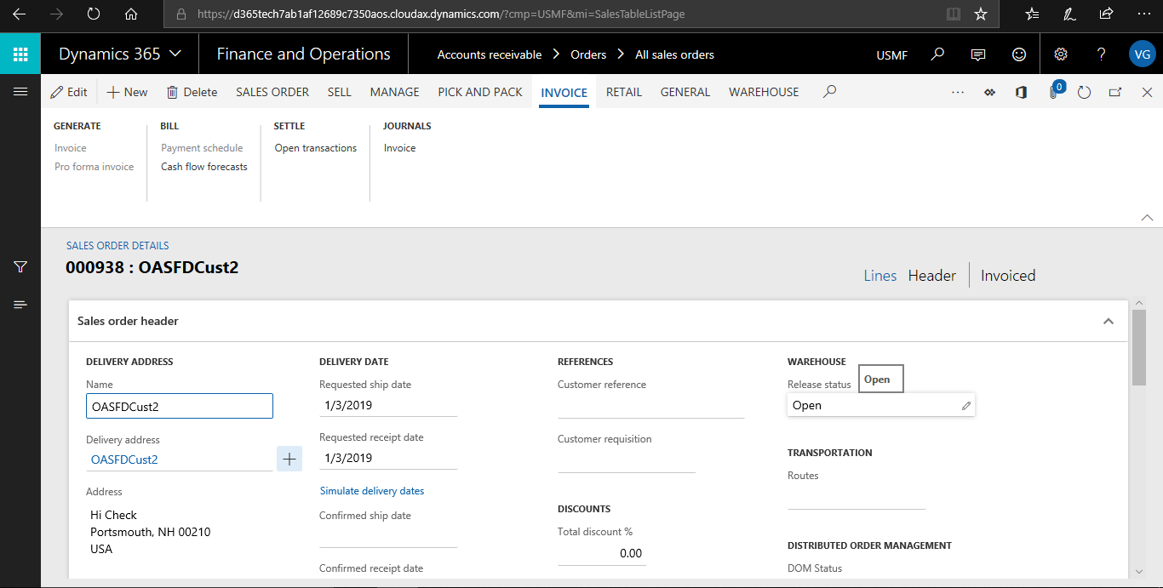
Figure 3.31 Sales Order creation in D365 F&O (Header)

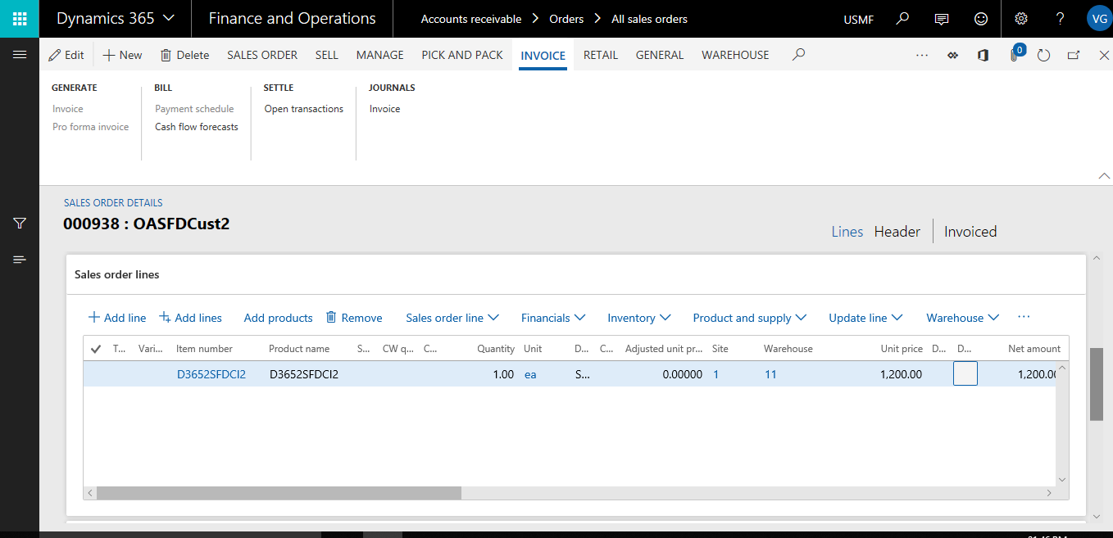
Figure 3.32 Sales Order line creation in D365FO
- Save the Sales Order and in generate Tab Click Confirm Sales Order.
- Save the Order and navigate to Salesforce Integration>Setup>Salesforce instant creation.
- Or else if batch job is configured the order will be automatically synchronized.
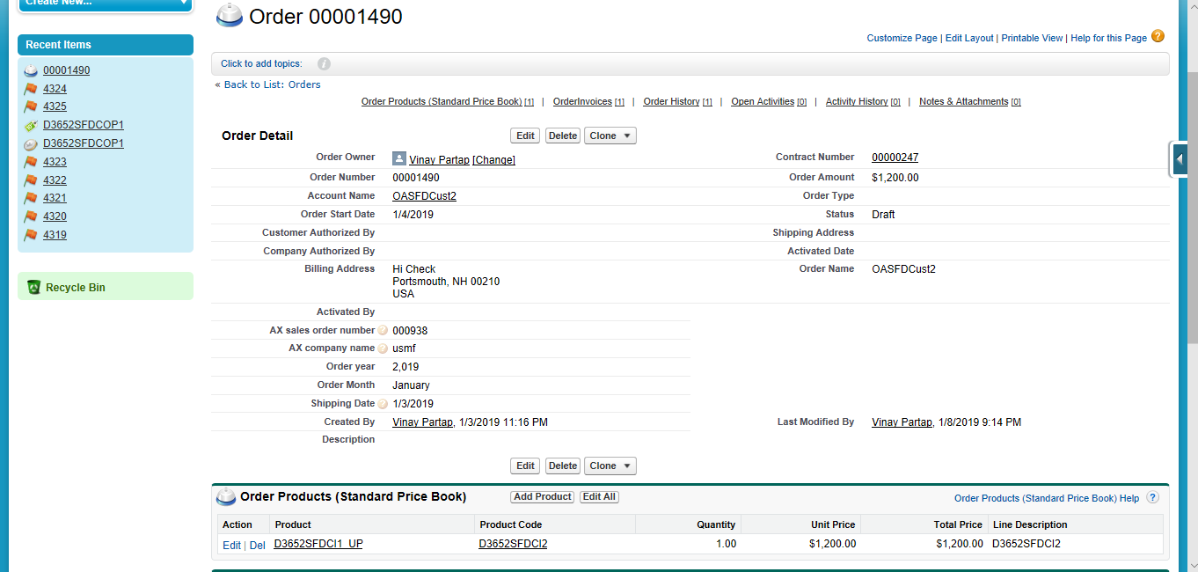
Figure 3.33 Successfully created Sales Order in SFDC from D365
- Generate the post packing slip in Pick and Pack Tab
- On success go to the invoice tab and click invoice.
- If the order is successfully invoiced, then save the Order and navigate to Salesforce Integration>Setup>Salesforce instant creation.
- Or else if batch job is configured the order will be automatically synchronized.

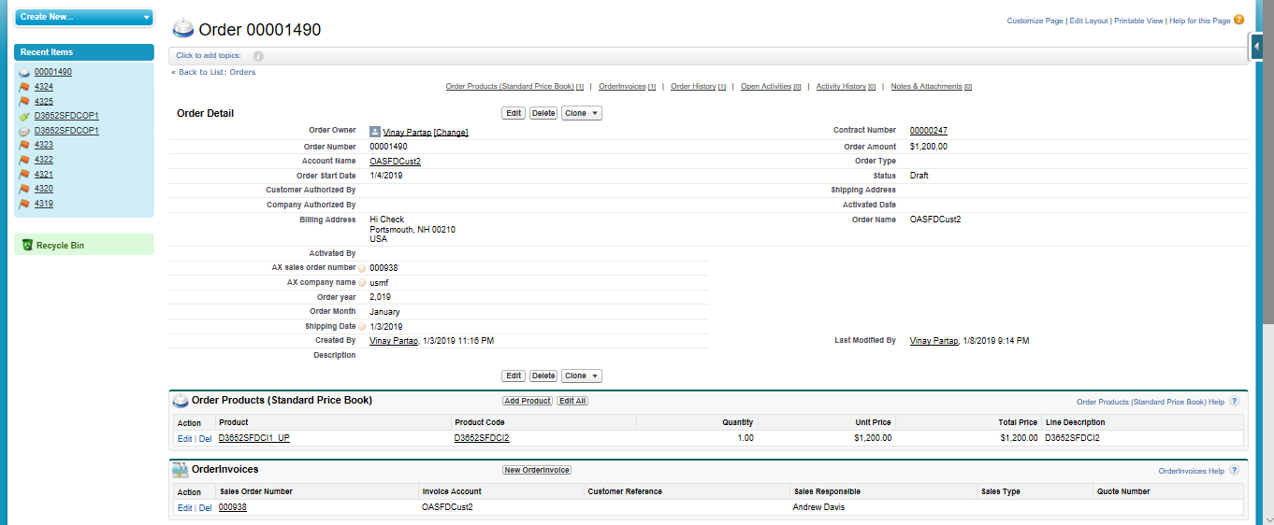
Figure 3.34 Sales Order invoiced in D365 F&O Successfully invoiced in SFDC too.

Salesforce Setup

Remote Site Settings
Login into www.Salesforce.com with your credentials, go to setup and on the left pane in the menu tree click on administer>Security Control>Remote Site Settings.

Figure 4.1 Salesforce Remote Site Settings Setup
Click on new and a page will open asking for details of the site where the connector/solution for D365 has been hosted.
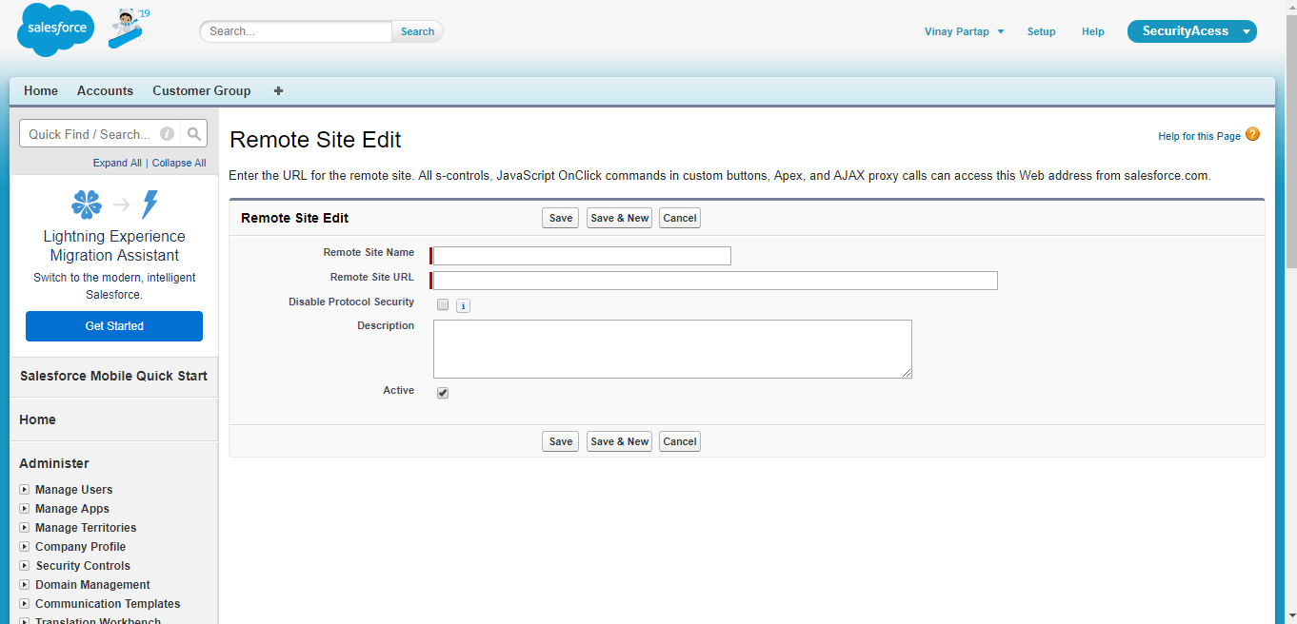
Figure 4.2 Remote Site Settings Details
Provide details such as Remote Site Name & Remote Site URL.

Credentials Setup on Salesforce for D365 F&O
Now go to all tabs section in salesforce and there is a form with name AX Login Credentials.
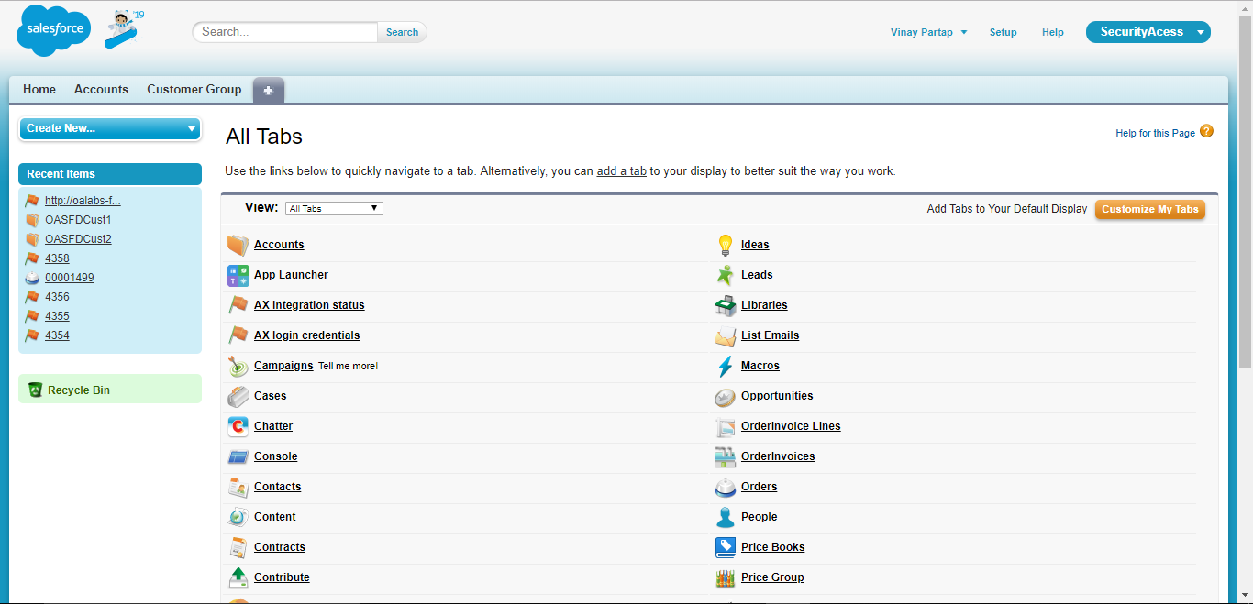
Figure 4.3 AX Login Credentials Setup on Salesforce.
Open the form and click on new
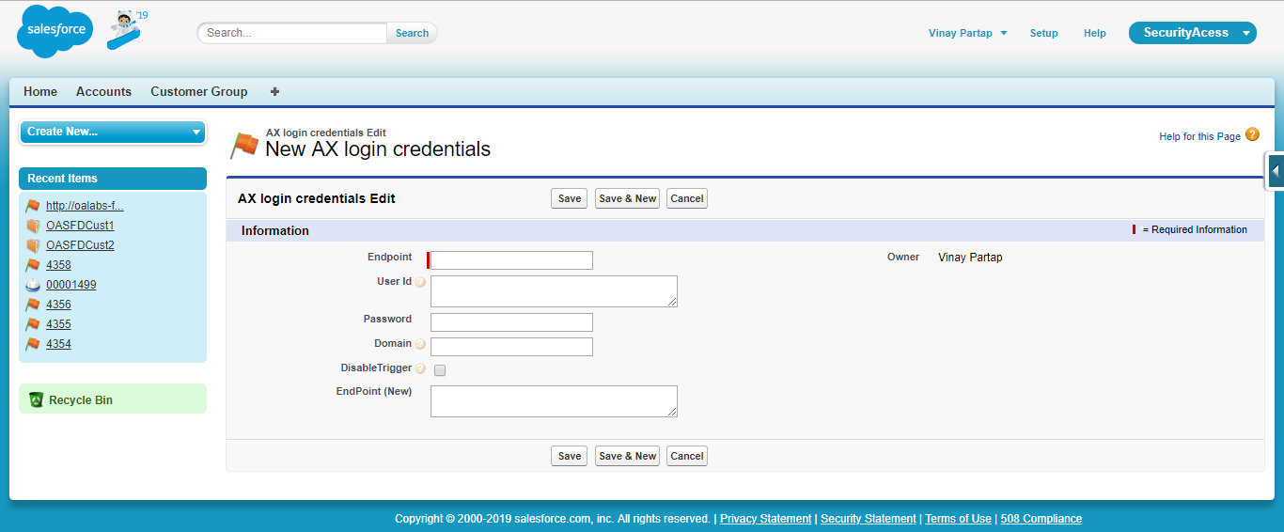
Figure 4.4 AX Login Credentials Setup form

Provide information such as Endpoint URL and the same must be provided in Endpoint (New). Provide User Id, password , domain if applicable. Save the record on completion.

