Software Assurance Training Vouchers (SATV) FAQ
Contents
Class cancellations 3
What is the class cancellation policy for the SATV program? 3
How does a trainee cancel a class reservation? 3
What if a trainee wants to cancel the reservation after the course cancellation date, or is a “no-show”? 3
What happens if I must cancel a class? 3
If I have reserved SATV vouchers for classes and withdraw from the program, do I have to honor them? 3
If a customer wants to change courses after I have reserved the voucher, what do I do? 3
Course eligibility 3
Can training vouchers be used for all official Microsoft Learning products courses? 3
Are Microsoft Dynamics courses eligible for SATV vouchers? 4
Can Learning partners create custom courses that are eligible for SATV vouchers? 4
How do I submit custom courses for SATV vouchers? 4
Are role-based Instructor-led courses eligible? 4
Can SATV vouchers be redeemed for training with any Microsoft Partner Network (MPN) member or IT Academy partner? 6
Am I required to offer all available SATV courses? 6
May a trainee use training vouchers for a class that is not in the training benefit catalog? 6
Can training be conducted remotely? 6
Can customers pay for extra training days if they do not have enough vouchers to pay for a training course? 6
Are Learning partners required to use a Microsoft Certified Trainer (MCT) to deliver an eligible SA training course? 6
Exams and Microsoft Course Certificate vouchers 6
How can students redeem Microsoft Course Certificate vouchers? 6
How do I process vouchers for exams and Microsoft certificates? 7
How many SATV days do I get for exams and Microsoft Course Certificate vouchers and what are the rates? 7
How do I resolve common error messages for exam and Microsoft Course Certificate voucher codes? 7
By when must customers activate codes? 7
Microsoft Official Courseware (MOC) 8
Am I required to provide each student with a copy of the Microsoft Official Courseware (MOC)? 8
Must MOC be used to train students redeeming SA training vouchers? 8
Will Microsoft pay for courseware used to teach classes to students? 8
What should I do if the courseware purchased does not match the course for which the voucher was reserved? 8
If partners in China cannot order MOC, what process should they follow? 8
How do I resolve common error messages in SAVB when ordering printed MOC? 9
What if a student does not activate the digital MOC license number? 9
Can the same MOC code be used if vouchers were stacked for one training? 9
How do I resolve common error messages in SAVB when obtaining digital MOC license numbers? 9
Payments 10
If I have not received my payment in the allotted time frame, whom do I contact? 10
How do I add users in SAVB? 10
How do I manage users in SAVB? 14
How do I search for vouchers and create reports in SAVB? 16
How do I search for payment requests in SAVB? 17
How do I update my banking information in SAVB? 19
Pricing 19
What is the value of each SA training voucher? 19
What is the SA training voucher redemption price for my country? 19
Do price rates vary by course type?​ 19
Will my customers or their SA benefits manager know the SA training voucher redemption price paid to me? 20
Am I responsible for taxes on SA training voucher reimbursements? 20
Vouchers 20
Is it possible to extend the life of a reserved voucher? 20
Can a customer use training vouchers for Planning Services days? 20
Can multiple vouchers be used for one training? 20

Class cancellations

What is the class cancellation policy for the SATV program?
As a Learning partner participating in the SATV program, you are expected to ensure compliance with all current Learning partner and SA Training Voucher program terms and conditions, including cancellation and satisfaction policies. Your local cancellation policy applies. It is your responsibility to inform the trainee of your cancellation or “no-show” policy and any applicable penalties. You may not redeem the trainee’s voucher as a penalty for late cancellation or “no-show.”

How does a trainee cancel a class reservation?
The trainee should contact you to indicate that he or she is no longer taking the class. You then should cancel the voucher reservation. Your local cancellation policies apply. Note: You may not use the reserved voucher as payment for late cancellation or “no-show.” Any applicable penalties under your cancellation policy must be settled by some other payment means.

What if a trainee wants to cancel the reservation after the course cancellation date, or is a “no-show”?
​​Local cancellation policies apply. NOTE: You may not use the reserved voucher as payment for a trainee’s late cancellation or “no-show.” Any applicable penalties under your cancellation policy must be settled by some other payment means. You must also immediately cancel the reservation of the unused voucher.

What happens if I must cancel a class?
Your cancellation policies apply. You must notify trainees that the class has been canceled and immediately cancel their reserved vouchers. If trainees wish to reschedule, you may again reserve the vouchers for another scheduled class date.

If I have reserved SATV vouchers for classes and withdraw from the program, do I have to honor them?
You have the option of honoring these SA training vouchers, but please contact the customer if you choose not to honor them. If the cancellation date of the class has passed, you must honor any vouchers for classes that are scheduled.

If a customer wants to change courses after I have reserved the voucher, what do I do?
If the voucher is not expired and is still in "reserved" status, you may cancel the reservation of the voucher and then re-reserve it under the correct course number.

Course eligibility

Can training vouchers be used for all official Microsoft Learning products courses?
​​No, only IT professional and developer courses are eligible. First Look Clinics, Fresh Editions, and Hands-on Labs are not eligible. Topics for information workers (such as courses on Microsoft Excel, Word, and PowerPoint) are also not eligible​.

Are Microsoft Dynamics courses eligible for SATV vouchers?
Select Microsoft Dynamics courses are eligible for SA training vouchers. Visit the Software Assurance Training Benefit Product Catalog​ and use the following filter settings:
- Product Technology: select all relevant Microsoft Dynamics options
- Training Type: Classroom
- Program Type: SA

Can Learning partners create custom courses that are eligible for SATV vouchers?
Yes, Learning partners can combine eligible SATV courses together to create customized training sessions. Customized training sessions are training sessions teaching Microsoft courseware that has been customized using Courseware Marketplace's custom courseware tool. Training sessions using customized courseware of two or more courses requires a custom code. Six hours of customized courseware training is equal to one SATV day. See the Microsoft SATV Program Agreement​ for complete details.

How do I submit custom courses for SATV vouchers?
​​Submit the following information in the request field in the Voucher Dashboard in Partner Center when using a custom code:
- Course number(s)
- Course name(s)
- List of which modules they will be teaching
Use the following custom code numbers:
- 7055 = 5-day course
- 7054 = 4-day course
- 7053 = 3-day course
- 7052 = 2-day course
- 7051 = 1-day course

Are role-based Instructor-led courses eligible?
New role-based instructor-led training (ILT) courses are now available as eligible courses within the Microsoft Software Assurance Training Vouchers (SATV) program. These new role-based ILT courses can be purchased individually or as packaged sets in Courseware Marketplace . Follow the instructions below on how to process these courses using SA Training Vouchers.
Individual course purchase
Individual purchase of these courses means that you have a unique MOC code per course
- Reserve the voucher using the assigned single-course number (ex: AZ-100T01) per training with a student. You need to ensure that the customer is giving you a single day voucher per course. ​You will be entering a unique MOC code per training per voucher during in the payment request.
Packaged set purchase​
A packaged set purchase means that you have one MOC code with multiple trainings in the order.
- When purchasing these courses via the packaged set option, you will have multiple courses under one order. Please use one of the following temporary course codes to reserve these vouchers:
  - 6054: for a 4-day packaged set course
  - 6055: for a 5-day packaged set course
- Follow the below steps for the 6 and 7-day packaged set courses:
- ​The Volume Licensing Service Center (VLSC) tool​ limits customers to creating vouchers for five or fewer training days. Your customer will need to create two separate training vouchers that total six or seven days (depending on desired course length) for you to stack and process in the Partner Center training vouchers management page (that is, a five-day voucher plus a one-day voucher for a six-day packaged-set course, or a five-day voucher plus a two-day voucher for a seven-day packaged-set course).
- After your customer sends you both vouchers to process, use the relevant temporary course code from the following list when reserving the two vouchers together:
  - ​Course code 6056 for a six-day packaged-set course
  - Course code 6057 for a seven-day packaged-set course
- During the voucher reservation step in the VVR tool:
  - ​​​​Reserve the vouchers using the single relevant course code.
  - After entering the course start and end dates, you will encounter a pop-up window informing you that the voucher is insufficient to cover the entire course. To complete the voucher reservation process, click the OK button in that window.
​ 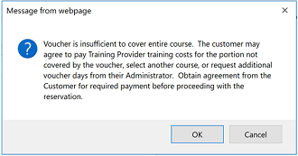
- When you submit the payment request for these vouchers in CHIP/SAVB, enter the same Microsoft Official Courseware code for both vouchers that you stacked to reserve the packaged-set course.

Can SATV vouchers be redeemed for training with any Microsoft Partner Network (MPN) member or IT Academy partner?
​No, the SATV program is an exclusive program delivered by Learning partners only. Training vouchers may be redeemed only at participating Learning partner locations.

Am I required to offer all available SATV courses?
Learning partners who participate in the SATV program should be prepared to offer any classes listed in the Software Assurance Training Benefit Product Catalog for which there is sufficient customer demand.

May a trainee use training vouchers for a class that is not in the training benefit catalog?
​​​No. Inform your trainee that SA training vouchers may be used only for courses listed in the Software Assurance Training Benefit Product Catalog.

Can training be conducted remotely?
Yes. Depending on the preference of the customer, training can be conducted remotely or in-person.

Can customers pay for extra training days if they do not have enough vouchers to pay for a training course?
​​​Yes, customers may for the extra days themselves. For example, if your customer wants a 5-day course but only has 2 voucher days, he or she can pay out-of-pocket for the extra 3 days.
Be explicit about this in the SOW/WO you sign with the customer. You can reserve the voucher per the normal reservation process​, and Microsoft will only pay you the amount of the voucher days. Payment for the remaining days should come from your customer.

Are Learning partners required to use a Microsoft Certified Trainer (MCT) to deliver an eligible SA training course?
Yes, all Microsoft course delivery requirements apply to courses delivered as part of the SATV program.

Exams and Microsoft Course Certificate vouchers

How can students redeem Microsoft Course Certificate vouchers?
​​​Share this information with your students:
- Unless otherwise stated on the product details page, standard Microsoft Course Certificate vouchers​ have a validity of 12 months from your purchase date on the Courseware Marketplace.
- Validity period may vary for some special promotional vouchers. Voucher expiration will be provided to partners at the time of purchase.
- After providing your students with Pearson VUE Exam Vouchers, registration by the student is accomplished by first creating a profile at the Microsoft Learning site. Pearson VUE exams can then be scheduled online from the Microsoft Learning site or directly from a Pearson VUE test or call center.
- The list of feasible countries the voucher code can be redeemed in can be found on the product details page.
- No refunds will be granted by Arvato.
- Pearson VUE exam registration begins by creating a profile on the Microsoft Learning site. For customer support, contact Microsoft training and certification help.
- For Pearson VUE exam scheduling and appointment assistance, visit Pearson VUE.
Note: Unless otherwise stated on the product details page, the standard Microsoft Certification Exam Vouchers are valid for a period of 12 months.

How do I process vouchers for exams and Microsoft certificates?
​​If you use exams or Microsoft Course Certificate vouchers with a customer, you must reserve the voucher using these course codes:
- For exams: course number 70-999
- For Microsoft Certificates (LaaS): CCV9999

How many SATV days do I get for exams and Microsoft Course Certificate vouchers and what are the rates?
​​​Exams and Microsoft Course Certificate vouchers​ are worth one SATV day. For rate questions, please review the SATV legal agreement appendix page.

How do I resolve common error messages for exam and Microsoft Course Certificate voucher codes?
​​Error message: Code(s) XXXXXXXX is/are not valid.
Issue: You are entering incorrect exam or Course Certificate voucher codes.
Resolution: Make sure you are entering the correct code found in Courseware Marketplace.
​Error message: Code(s) XXXXX has already been used in a payment request.
Issue: You have already used this exam/ Course Certificate voucher code when submitting a payment request in the past.
Resolution: You cannot use the same exam/ Course Certificate​ voucher code for multiple vouchers. You will need to buy additional codes to request payment for this voucher.​​

By when must customers activate codes?
​Customers must activate codes within 12 months from the date on which you purchased the codes on Courseware Marketplace. ​​

Microsoft Official Courseware (MOC)

Am I required to provide each student with a copy of the Microsoft Official Courseware (MOC)?
​Yes, it is the responsibility of the Learning partner to purchase and deliver to each student a licensed copy of the complete student kit. MOC is available in digital, hard-copy (print), or MOC On-Demand formats.

Must MOC be used to train students redeeming SA training vouchers?
​Yes, Learning partners must use eligible Microsoft official Courseware (MOC) to deliver training to students redeeming SA training vouchers. Microsoft will not reimburse partners for training delivered to students who redeem SA training vouchers if MOC is not used.

Will Microsoft pay for courseware used to teach classes to students?
No, the Learning partner who reserves and redeems the training vouchers is responsible for ordering and paying for all students’ materials and courseware, as well as ensuring that courseware is distributed to the students. Courseware costs cannot be transferred to the student.

What should I do if the courseware purchased does not match the course for which the voucher was reserved?
​​Email SA Training Vouchers Escalation​ with the following information:
- Printed MOC order number
- Number of voucher days
- Course number
- Voucher number
- Location ID associated to the voucher
- Partner name
- Description of issue

If partners in China cannot order MOC, what process should they follow?
Email SA Training Vouchers Escalation​ ​with an explanation and include the following information:
- Voucher number
- Number of voucher days
- Course number
- Partner location ID
- Student name
- Student email
- Date of training corresponding to each voucher

How do I resolve common error messages in SAVB when ordering printed MOC?
- ​​​“Applicable credits for Order No. XXXXXXXX is 5 and 5 (or greater) have already been utilized.”​
  - Issue: You have used up all the credits for the order number associated to that course, but you are still trying to use the same order number for additional trainings.
  - Resolution: You must supply a new printed MOC order number that includes enough​ training credits for redemption. One order credit equals one training engagement.
- “Order No. XXXXXXXX does not contain the Course ID XXXXX specified.”
  - Issue: You are using a printed MOC order number that does not have that course associated to that order.
  - Resolution: You must find the printed MOC order number in Courseware Marketplace associated to the course you want to redeem.
- “The order date for order no. XXXXXXXX is invalid/expired.”
  - Issue: The 6-month deadline for using your printed MOC order has passed.
  - Resolution: You must buy new printed MOC that for that course.
- “License No.(s)/Order No.(s) XXXXXXXX are not valid, ​ or the License No.(s) has not been activated by the student.”
  - Issue: The printed MOC order number you entered is incorrect.
  - Resolution: Return to Courseware Marketplace to retrieve the correct number.

What if a student does not activate the digital MOC license number?
Contact your customer and have them activate the digital MOC voucher code so that you can proceed to submit the SATV payment request.
If the student failed to attend the training and thus did not activate the license number, you cannot process a ​training voucher for that student. Discuss compensation with the customer directly. ​​

Can the same MOC code be used if vouchers were stacked for one training?
If a partner has a 5-day training with a customer, and the customer gave them five single day vouchers, the partner can use the same MOC code in the payment request. The partner needs to make sure the vouchers are reserved with the same course number, and that they are submitting all the stacked vouchers in the same single payment request. The system will still block the use of the same MOC code for vouchers with different course numbers (i.e., for different trainings). Remember: partners must still purchase unique MOC for each training session with a student.

How do I resolve common error messages in SAVB when obtaining digital MOC license numbers?
- ​​​“We are unable to process your request due to missing or invalid information. Please compete and/or modify your information and resubmit.”​
  - Issue: The license number field in SAVB is blank or has missing characters.
  - Resolution: Ensure you are entering the correct license number by confirming it in Courseware Marketplace.
- “Duplicate License No. cannot be added for a Payment Request. Please verify License No. for Voucher No.(s) XXX- XXXX, XXXX-XXXX, XXXX-XXXX.”
  - Issue: You are using the same license number for multiple vouchers in your payment request.
  - Resolution: Each training engagement requires a unique digital MOC license number.
- “License No.(s) 1234-5678-9123-4567 has already been used in a payment request OR License No.(s) has already been activated.”
  - Issue: You have already used this digital MOC license ID when submitting a payment request in the past.
  - Resolution: You cannot use the same digital MOC license ID for multiple training engagements. You will need to buy additional digital MOC to request payment for this voucher.
- “License No.(s)/Order(s) XXXXXXXX are not valid OR the license No.(s) has not been activated by the student.”
  - Issue: Either the digital MOC license number is incorrect or the digital MOC has not been activated by the student.
  - Resolution: Make sure you enter the 16-digit license ID found in Courseware Marketplace and not the order number. If the digital MOC license ID has not been activated, contact your customer to active it so that you can submit the voucher for payment. ​

Payments

If I have not received my payment in the allotted time frame, whom do I contact?
​​First, check the status of your payment request from your home page in the SAVB tool and verify that any supplemental documentation, if required (such as a copy of your company’s invoice), has been provided to Microsoft. If you have satisfied all requirements and have not received your payment within the allotted time frame, contact your Microsoft Regional Service Center​ team.

How do I add users in SAVB?
Multiple users from the same organization may access the Software Assurance Voucher Benefit (SAVB) Online Payment Tool​ concurrently to perform tasks. There are two user roles in ​​​​SAVB: Partner Program Administrator (PPA) and Partner User. An organization can have no more than twelve PPAs; there is no limit on the number of Partner Users in an organization. The table below outlines their respective permissions in SAVB: ​​​
​Tasks | ​​SAVB Roles  ​
​ | Partner Program Admin​* | ​Partner User
Perform Voucher Search​ | X​ | X​
Perform Payment Request Search ​ | X​ | X​
Create and submit payment request​ | X​ | X​
Add / edit / update users to SAVB roles​ | X​ | ​
Map payment profile to locations​ | X​ | ​
Register Program ​ | X​ | view only​
*Limit 12 PPAs per organization.
​
Follow the steps below to add users: ​
- From your home page, select Add New Users from the I Need To… menu.
- Enter the individual’s contact details, including first and last name, and company email address (which should be a Microsoft account associated to your company’s partner profile in MPN).
- In the Assign User Role pane, select the role based on the tasks they must perform: Partner User or Partner Program Administrator.
  - Partner User: can view only the voucher and payment request information for the location with which he or she is associated as a Partner User.
  - PPA: can view all vouchers and payment requests for all locations in the organization.
- Select Add Role. You will see the role and the location it applies to in the list of User Roles.
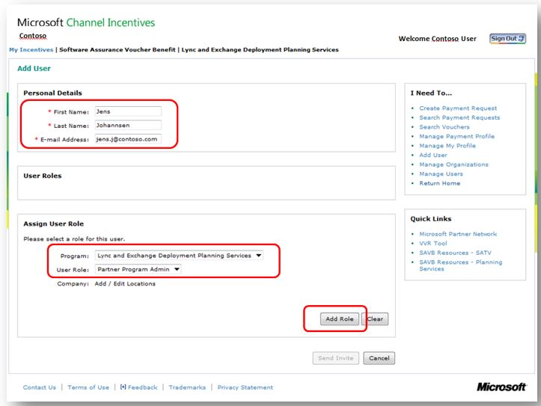
- Select Send Invite to send an email invitation from SAVB to the added user.
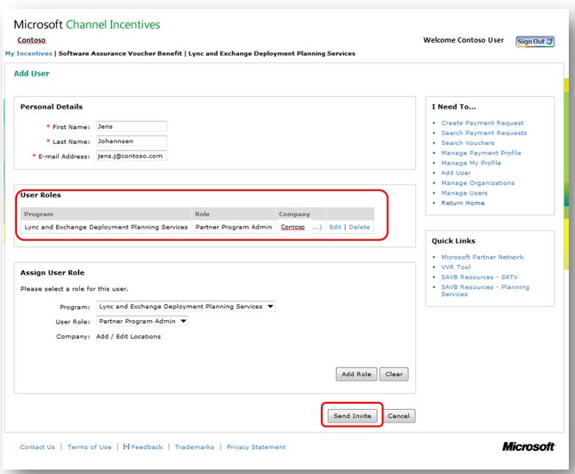
- ​​​When the new user receives the email invitation, he or she must activate their user account in SAVB by clicking on the link in the email. ​
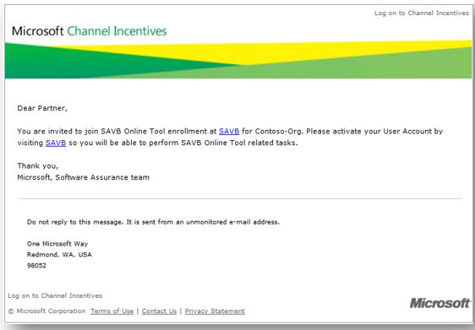
​

How do I manage users in SAVB?
- From your home page, select Manage Users from the I Need To… menu.
- Look up users in your organization by using the available filters to narrow your search, then select Search. The results will display in the lower pane, including full name, email address, current user role, location, and current status.
- To edit a user’s status or location, select Edit/Deactivate, which takes you to the New User page where you can edit user details, role, and location. ​
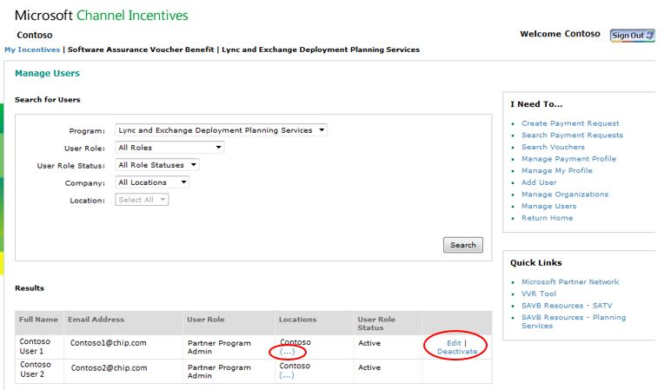
- To review the locations associated with a user, select “…”. The screenshot below illustrates the View Locations window with the list of locations associated with the user. ​​
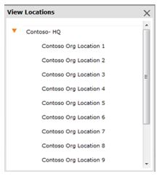

How do I search for vouchers and create reports in SAVB?
The Software Assurance Voucher Benefit (SAVB) Online Payment Tool​ allows users to filter and search for vouchers to facilitate verification or reporting needs.​ Follow these steps to search for vouchers:
- From your program home page, select Search Vouchers from the I Need To… menu.
- ​Search for a voucher by selecting your criteria. Filters may include​:
  - Country: displays all vouchers within a specific country in which the partner has locations
  - Partner Location: displays all of the partner’s locations in the program
  - Voucher Status: displays partner’s vouchers in all or one of the following statuses: ​
    - Redeemed: vouchers that have been redeemed in VVR and are now eligible for attaching to a payment request
    - Processed: vouchers that have already been attached to a payment request and submitted
    - Past Invoice Date: vouchers that have never been attached to a payment request, and have passed the 60 days from end date of engagement or training​
  - ​Customer Name: displays partner’s vouchers by their customer company name
  - Customer Email: displays partner’s vouchers by the customer email address assigned to the voucher
  - Voucher Number: displays partner’s vouchers sorted by their unique voucher numbers
  - Start/End Date: displays partner’s vouchers, inclusive of all statuses, within a particular date range
  - Microsoft Reference No.: displays partner’s vouchers that have already been invoiced, sorted by the Microsoft Reference No. assigned at time of payment request
- Select Search to see results in the table below.
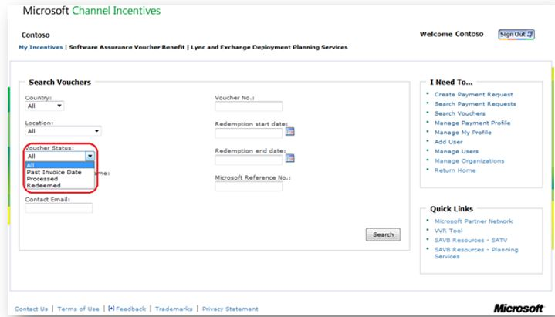
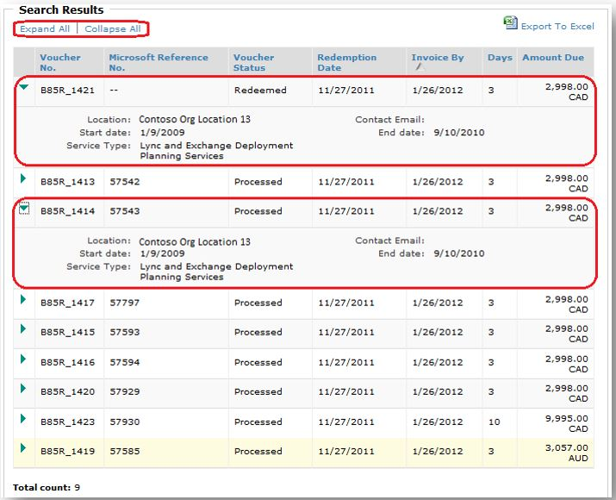
- ​To view the Voucher Details of a particular voucher listed in the table, select the arrow next to the voucher record, or use Expand All/Collapse All to see all details for all vouchers.
  - Days in this view i​ndicates the total number of days included in the voucher.
To create a report from a voucher search based on the selected criteria and search results, select Export to Excel at the top of the Search Results table.

How do I search for payment requests in SAVB?
​The Software Assurance Voucher Benefit (SAVB) Online Payment Tool allows users to quickly find payment requests which have been created and saved, or have been submitted for payment processing. ​​Follow these steps to search for payment requests and create a ​report:
- From your program home page, select Search Payment Requests from the I Need To… menu.
- Search payment requests by selecting your criteria. Filters may include:
  - Country: displays all payment requests saved or submitted within a specific country in which the partner has locations
  - Partner Location: displays all payment requests submitted or saved for all or one of the partner’s locations in the program
  - Status: displays partner’s payment requests based upon the following statuses:
    - Saved: payment requests created by the partner and saved for later submission
    - Pending Approval: submitted payment requests awaiting approval by Microsoft due to requirement for partner to submit a hardcopy of their own company invoice, or validation of softcopy upload of the partner’s own company invoice. (This may be required to comply with tax regulations.)
    - Approved: submitted payment requests that have been approved and are now in payment processing
    - Denied: submitted payment requests deemed ineligible for payment
    - Action Required: submitted payment requests that have been reviewed by the RSC and require partner’s action in order to be approved for payment processing (detailed on your home page)
  - Invoice Number: displays partner’s submitted or saved payment requests sorted by the partner’s own company invoice number
  - Microsoft Reference Number: displays partner’s submitted or saved payment requests sorted by the unique reference number assigned by SAVB when the payment request is created and then saved or submitted
  - Submitted By: displays partner’s submitted or saved payment requests sorted by the email address of the user who created the payment request in SAVB
  - Start/End Date: displays partner’s submitted or saved payment requests within a particular date range​
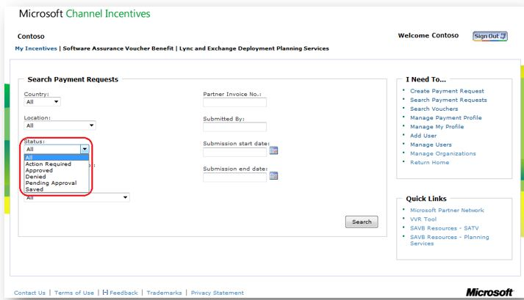
- Select Search to see results.
- To view the Invoice Details of a particular payment request listed in the table, select the arrow to the left of the Microsoft Reference Number, or use Expand All/Collapse All to see all details for all listed payment requests​.
  - ​​​ Invoice Number: the partner’s own company invoice number
  - Invoice Hardcopy Required: notation by SAVB to indicate to the partner if a hardcopy of the partner’s own company invoice must be submitted to the RSC for payment processing approval
  - Age: the number of days elapsed since the payment request was submitted
​
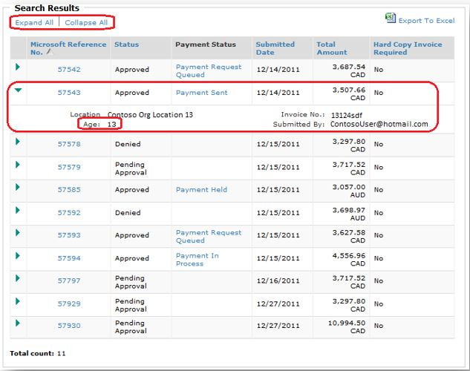
​
To create a report from a payment request search based on the selected criteria and search results, select Export to Excel at the top of the Search Results table.

How do I update my banking information in SAVB?
​​You will need to log into Payment Central to update your banking details. View Payment Central FAQs​ for instructions how to manage bank information.​

Pricing

What is the value of each SA training voucher?
One (1) SA training voucher day is worth one (1) day of classroom ​training.

What is the SA training voucher redemption price for my country?
​Voucher redemption prices vary by country and per courseware type. You can refer to the bottom of the Microsoft SATV program agreement that you sign when enrolling into the program to review the different SATV courseware rates.

Do price rates vary by course type?​
There is a difference in payment for the type of courseware purchased by the partner. The SATV rate for digital and printed MOC is different from the rates for MOC On-Demand, exams and course certificates. Rates are found in the SATV Microsoft SATV program agreement.

Will my customers or their SA benefits manager know the SA training voucher redemption price paid to me?
​No, SA training voucher redemption pricing is confidential between you and Microsoft. Neither your customers nor their SA benefits manager has access to this pricing information.

Am I responsible for taxes on SA training voucher reimbursements?
Microsoft reimburses Learning partners for applicable taxes in specific jurisdictions. For more information, contact your Microsoft Regional Service Center.
You are responsible for properly invoicing Microsoft for the price of the redeemed SA training vouchers plus any applicable VAT, GST, or other local taxes when submitting your payment request in the SAVB tool and providing your company invoice (if required). Tax policies and invoicing requirements are subject to change.

Vouchers

Is it possible to extend the life of a reserved voucher?
If the customer’s EA is still active and the vouchers expire before redemption, the days will go back to the customer’s EA pool (the days will not be lost). Once the days are returned, they can create a new voucher for you to reserve/redeem, and the voucher will have a new lifecycle of 180 days.
​​If the customer EA expires and the voucher expires before redemption, the voucher days have been lost. If you still wish to receive payment for the training, you must ask the customer to create new vouchers from one of the customer's active EAs for your organization to process.

Can a customer use training vouchers for Planning Services days?
​​Trai​​ning vouchers may be converted to Planning Services vouchers at a 3:1 ratio. That is, for every three days of training vouchers an organization has, those vouchers can be converted into a 1-day Planning Services voucher using the Volume Licensing Service Center (VLSC) tool.

Can multiple vouchers be used for one training?
​​Yes. Follow the steps below to process multiple vouchers for one training:
- If a customer gives you five 1-day vouchers for a five-day course, reserve the vouchers normally using the same course number and trainee information.
- When it is time to redeem the vouchers, redeem them one at a time. They system does not permit the redemption of multiple vouchers all at once.
- When it is time to request payment​, create one payment request that includes all five vouchers. Use the same MOC code for all five vouchers, as the vouchers are only for one training. The system will still block the use of the same MOC code for vouchers with different course numbers (i.e., for different trainings). Remember: partners must still purchase unique MOC for each training session with a student.

