Software Assurance Training Vouchers workflow
May 14, 2019
Contents
Verify eligibility (new partners) 1
Enroll (new partners) 2
Confirm SATV course eligibility 7
Customer creates and assigns voucher (existing partners) 7
Validate and reserve voucher (existing partners) 9
Deliver training and activate product 10
Printed MOC 10
Digital MOC 11
MOC On-Demand 12
Exam​ guidelines 14
Microsoft Course Certificate vouchers (LaaS) for MOOC courses guidelines 19
Redeem voucher (existing partners) 19
Get paid (existing partners) 20
​Register for payment 20
Create vendor ID​ 22
Invoice against voucher 23

Verify eligibility (new partners)
​To verify your organization's eligibility, follow the steps below​​:
- Sign-in to your Partner Center Dashboard​.
- Click MPN on the navigation pane to expand the section.
- Expand Programs and select Software Assurance Enrollment.​
- Near the top of the page, select Software Assurance Training Vouchers.​
Your organization's status will be displayed on this page. It will indicate whether you have met the applicable competency and assessment (training) requirements. View instructions for how to access and complete the required SATV Business Process Online Training on Partner University.
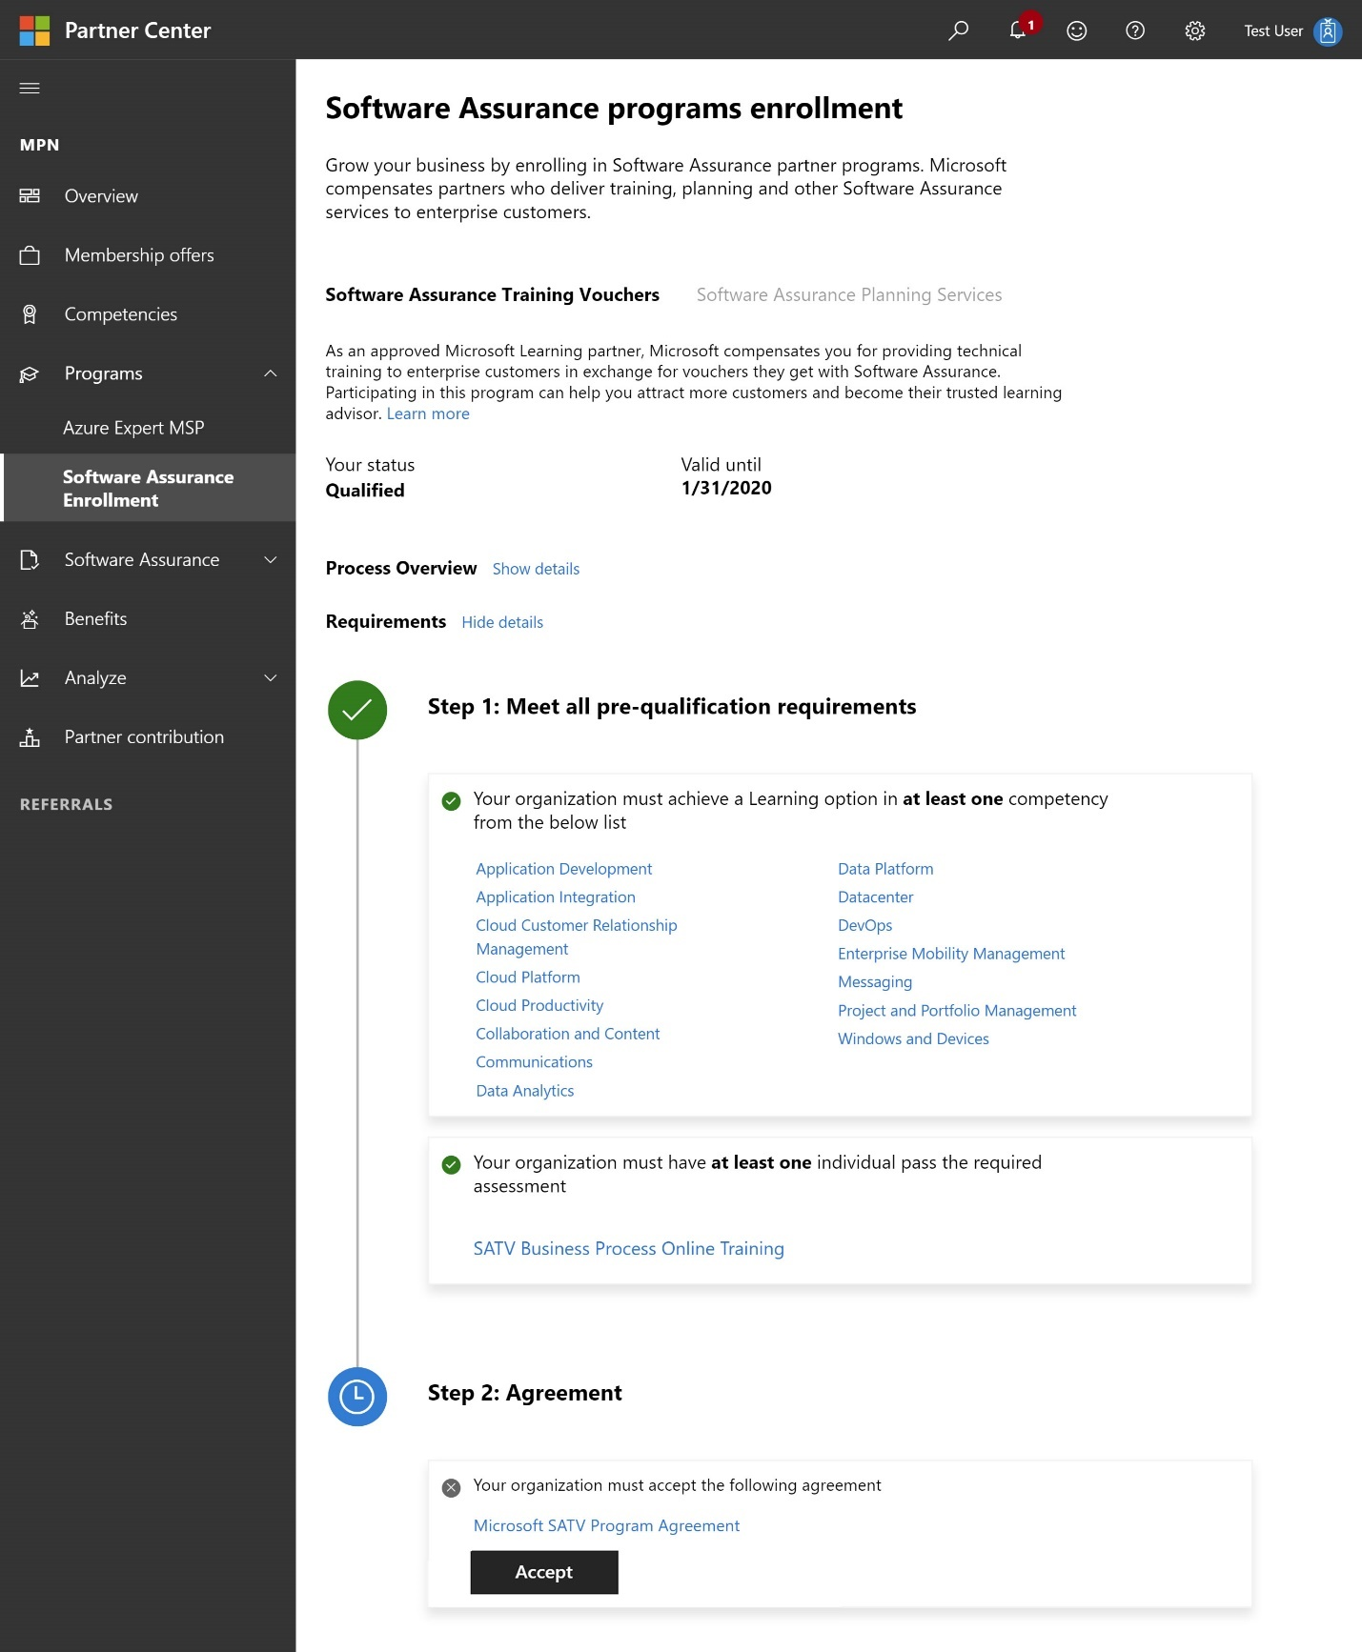

Enroll (new partners)

​​
​
To enroll your organization in the SATV program for the first time, you must hold Global Admin or MPN Partner Admin permissions in Partner Center. Global Admins can assign user roles, so if you do not see the navigation options required to enroll (shown below), reach out to your Partner Center Global Admin.
​To re-enroll: you must first wait for your present enrollment end date to pass. You will then have 30 days to complete the re-enrollment process, during which time you will continue to have access to program tools.​​​
​​
​​​​​​​​​​Once your organization has met the eligibility requirements​, you can enroll in the SATV program following the steps below:
- ​​​​​​​​​​Sign-in to your Partner Center Dashboard​.
- Click MPN on the navigation pane to expand the section.
- Expand Programs and select Software Assurance Enrollment.
- Near the top of the page, select Software Assurance Training Vouchers.
Before you can enroll, your organization must first meet all qualification requirements. Your organization's status will be displayed on this page. Satisfied steps will be denoted by a green checkmark icon and in-progress steps will be denoted by a blue clock icon.
Once your organization has met the competency and compliance training​ requirements, your status will be reflected as Active and the Accept button near the bottom of the page will become clickable. Next, you must review the Microsoft SATV Program Agreement (also known as the program provider legal agreement) and then accept the agreement.​
- ​Click on the Microsoft SATV Program​​ Agreement hyperlink to download agreement. Review the legal agreement and​ click Accept. You will be prompted to confirm acceptance. If you need to review the legal agreement in the future, return to this step to download and view the document.
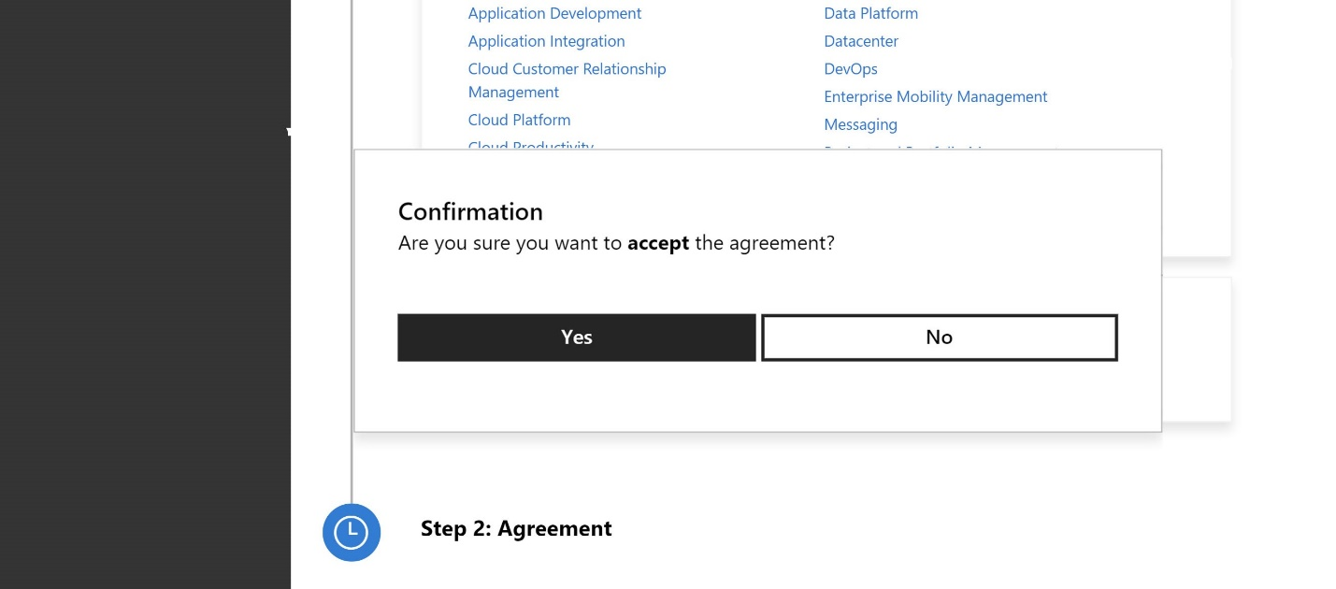
- After accepting the legal agreement, you will see a confirmation that your status is Active.

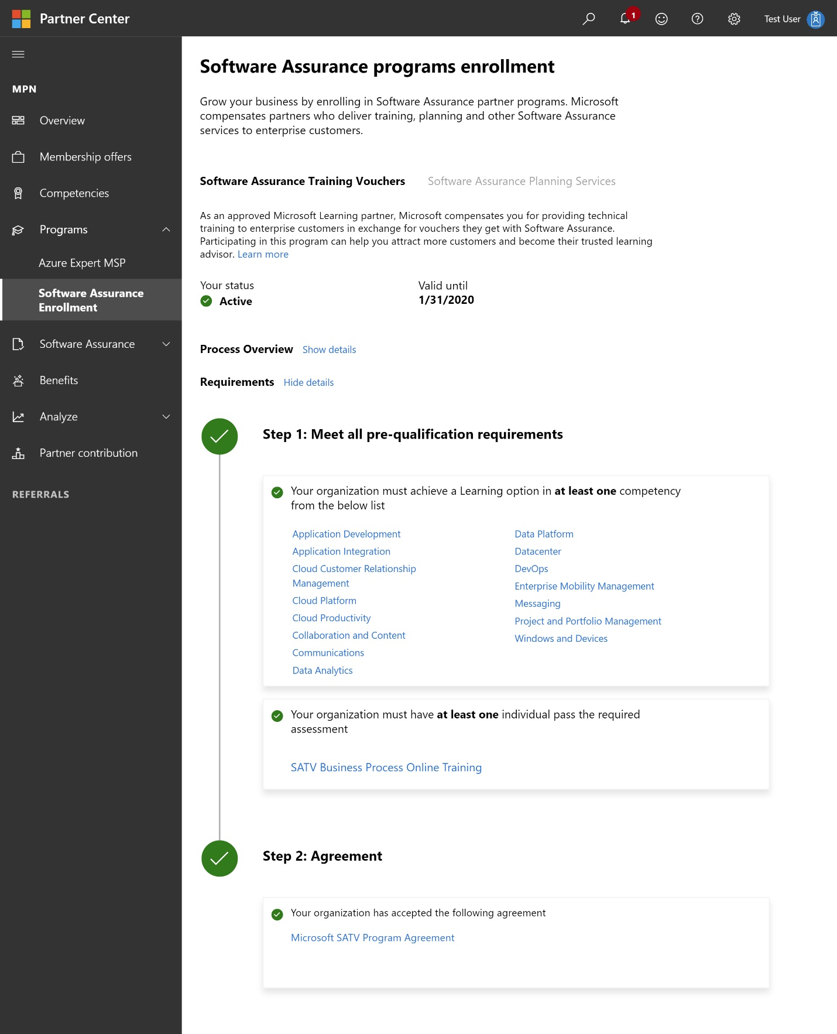

Confirm SATV course eligibility
​
SATV eligible courses
Once enrolled in the SATV program, partners can offer training sessions for SATV-eligible courses, for which customers can use their SA Training Vouchers.​ Eligible courses are listed in the SATV course eligibility catalog. Use the following filter settings: Training Type - Classroom; Program Type -​​ SA.
Examples of SATV-eligible courseware include:
- ​​Microsoft Official Courseware (MOC)​​ On-Demand
- MOC On-Demand 180 days​​
- Digital MOC
- Printed MOC
- Exams
- Microsoft Course Certificate vouchers​ (LaaS, or Learning as a Service)​
- Community c​​ourseware designated for an IT professional or d​eveloper audience
The following courseware are​ not SATV-eligible: ​
- First Look Clinics
- Hands-on Labs
- End user ILT training
- Fresh Editions
​
Technical training through SATV may also:
- Be delivered as custom training
- Be delivered in-classroom or through a virtual classroom environment​​
- B​e redeemed for public or private training sessions

Customer creates and assigns voucher (existing partners)
Before conducting a training, your customer must first activate their SATV benefit, ​and then assign it to your organization.
​​​​​​
​​​​​​​​​​​​​​​​​​​​​​​​Below are the steps your customer must take to ​​create the voucher. ​

Activate voucher benefit
The company's Software Assurance Benefits (SAB) administrator must activate the SATV ​benefit through the Volume Licensing Service Center (VLSC). The benefit only has to be activated one time, and the entire number of training days allotted to the organization will be activated for use.​​ The steps are as follows​:
- Sign in to VLSC using a Microsoft account associated with the SAB administrator.
- Select View Software Assurance Benefits, then select the benefit from the Software Assurance Summary list.
- Select the Licensing Agreement Number under which you wish to activate your SATV benefit and view the Benefits Available for Activation pane.​
- To activate the benefit, select the SA Training Voucher benefit name and follow the instructions in the subsequent screens.
​​Create and assign voucher
After activating the benefit, the benefits administrator can create and assign SA training vouchers to employees by entering the employee name, corporate email address, and number of days the voucher is worth. After a SA training voucher has been created and assigned, the employee has 180 days to use the voucher before it expires.
- Under Training Benefits Detail, review the number of Eligible Agreement Training Days and then select Create Training Vouchers.
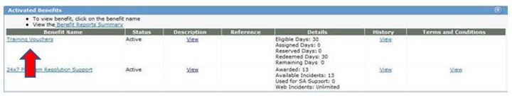​ 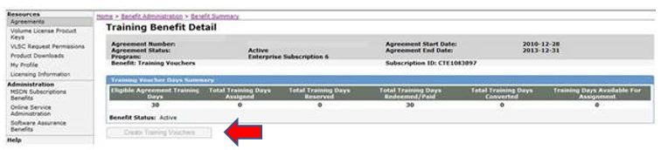
- ​​​​Enter the following data to create a training voucher​:
  - The name of the employee to receive training
  - The employee’s corporate email address
  - The length of the voucher, which can range from 1 to 5 days
- ​If the course length is unknown, it is best to select 5 days. If fewer than 5 days are ultimately needed for the course, and if the customer’ agreement is still active, the remaining days will automatically go back into the customer’s training voucher pool once the voucher has been paid to the training partner.
- Select Add Voucher, then Submit Voucher List. This creates and assigns the voucher to the employee.
- An email containing the voucher’s details is sent to the corporate email address entered at the time of voucher creation. This email will contain the voucher number, voucher expiration date, and the name of the Benefits Administrator who created and assigned it.
- Employees can then choose a participating Microsoft Learning partner who offers an SATV-eligible course​ they want to take. To reserve training, employees must provide the partner with the SA training voucher details found in their voucher confirmation email.
  - Note: the customer must provide you with the correct voucher number and email addresss in order for you to reserve that voucher.

Validate and reserve voucher (existing partners)
After a customer successfully assigns a voucher to your organization in VLSC, an email will be generated and sent to the customer's employee​​ and Software Assurance benefits (SAB) administrator, requesting them to forward the email to you (their chosen Learning partner). If you did not receive an email from your customer containing the voucher number and email address associated to the voucher, ask them to please forward the email to you so you may move forward with reserving the voucher and scheduling the training​.​​
- Sign In to your Partner Center Dashboard.
- Click MPN on the navigation pane to expand the section.
- Expand Software Assurance and select Software Assurance Training Vouchers ​​to reveal the voucher activity report​.
- Click on the Actions drop-down and select ​Validate and reserve voucher. ​​
- From the Validate Software Assurance training voucher​​ page, select the desired provider ID from the drop-down (vouchers must be processed under a provider location matching the country in which the MOC was purchased).
- Enter the voucher number and trainee email address, then select Validate voucher. ​
- After you've validated the SA training voucher and confirmed the voucher details, you will enter the course number, service start date, service end date, and optional comments before selecting Reserve voucher. Once the voucher is successfully reserved, it will become visible in the voucher list with a Reserved status and you can move forward with delivering the training.
​
All SA training vouchers expire 180 days after the date of creation​​.
V​o​uc​hers should be validated, reserved and redeeme​d by the executing partner—submitting all required deliverables to your customer and to Microsoft​—before the stated voucher expiration date.​​​
​
​​​ ​
How to cancel a reserved training voucher
- ​​Select the hyperlinked voucher number from the voucher list.
- From the Software Assurance training voucher details page, select Cancel Reservation.

Deliver training and activate product
Once a voucher is reserved, you may deliver the training to your customer. The guidelines below cover training engagements, as well as the activation and purchase of ​Microsoft Official Courseware (MOC), exams, and ​Microsoft Course Certificate vouchers​ (LaaS) for MOOC courses​​.​​​​​
SATV training engagement guidelines
- The training must be completed before the voucher expiration date​​. To find the voucher expiration date​​:
  - Sign In ​to your Partner Center Dashboard​.​
  - Click MPN on the navigation pane to expand the section.
  - Expand Software Assurance and select Software Assurance Training Vouchers to reveal the voucher activity report.
  - Select Reserved from the voucher status drop-down to filter the listed vouchers to display only reserved vouchers. Upon locating the voucher in question, you will find the expiration date under the Voucher Expiration Date column.
- For Digital MOC courses and MOC On-Demand courses, the student must activate the MOC during the course in order for the voucher to be valid for payment.
- Printed MOC trainings should be completed within 6 months of ​​the printed MOC purchase date.
- Exams and Microsoft Course Certificate voucher (LaaS) codes must be activated by the student within 12 months from the date purchased by the Learning Partner in Courseware Marketplace.​​​
​Microsoft Official Courseware​​ (MOC) guidelines

Printed MOC

- When selecting Printed MOC in the dropdown of the Software Assurance Voucher Benefit (SAVB) Online Payment Tool, you must submit a MOC order number as found in Courseware Marketplace.
- Printed MOC must have been purchased within the past 6 months, and you must have a balance of MOC credits in your order for your payment request to be accepted. MOC purchased greater than 6 months ago will not be counted in your MOC credits balance.
- Upon acceptance of a printed MOC order number, the MOC credits balance for that course will decrease by one.
To view the order number for printed MOC (needed to submit invoices in SAVB)​:
- In Courseware Marketplace, navigate to My Account and select Order History.
- Use the search fields to search for the course number and order date. The order number is displayed in the search results.
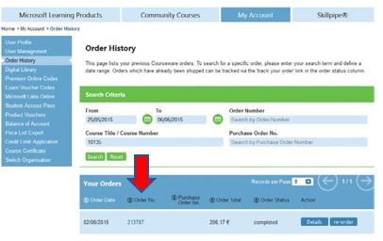

Digital MOC
- When selecting Digital​ MOC in the dropdown in SAVB, you must submit a 16-digit license number as found in Courseware Marketplace.
- The MOC license number must be activated by the student before you can submit the payment request. If the license number has not been activated, the payment request will be rejected. Verify the activation of license ID by confirming that the license ID shows as “Redeemed” in Courseware Marketplace.
- A MOC license ID can only be used for training with one student. If it has been used in a previous payment request, it will not be accepted.
To view the license for digital MOC (needed to submit invoices in SAVB):
- In Courseware Marketplace, navigate to My Account and select Digital Library.
- Use the search features to search for the specific course and select Share to navigate to the Management Dashboard.
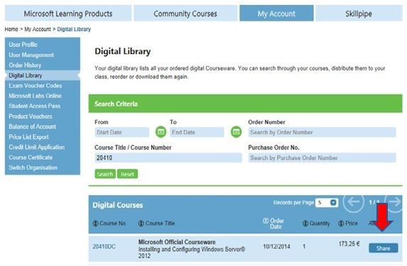
- The Management Dashboard will open in a new tab and display the license number.
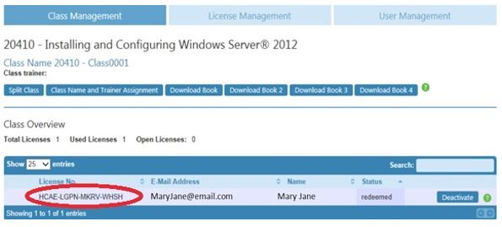

MOC On-Demand
MOC On-Demand are complete courses in a self-paced format, hosted by Microsoft and streamed directly to customers. The courses combine video, reading, hands-on labs, and knowledge checks to help IT Professionals and Developers build their Microsoft technology skills as their schedules allow—all at once or five minutes at a ​time. Learn more and find a ​​​list of MO​C On-Demand courses​.
There are two options for providing MOC On-Demand to your customers: the stand-alone option, which does not include services, or the packed set option, which does include services.
Stand-alone option: this entails using SATV for MOC On-Demand without additional services. When you purchase this option, two SATV days are used for MOC On-Demand, and your customer pays you directly for any additional services you provide; you cannot collect SATV days to pay for those services.
To process MOC On-Demand vouchers for the stand-alone option, follow the steps outlined in these instructions​. Note these important tips:
- Reserve the voucher using the MOC On-Demand course number. All MOC On-Demand courses contain the letters “od” before the course number.
- ​Once the voucher is reserved and redeemed in VVR, you must enter an activated MOC On-Demand voucher code when submitting payment in SAVB tool. This voucher code is activated by the customer once they take they the MOC On-Demand course.
P​ackaged set option: this provides you three or five SATV days for redemption and includes services. Any additional services you provide—such as a full classroom delivery, 1:1 mentoring, 1:many mentoring, or any other services—are included and you cannot charge the customer additional fees.
To process MOC On-Demand vouchers for the packaged set option, follow the steps outlined in these instructions​. Note these important tips:
- Reserve the voucher using the digital MOC course number. Digital MOC courses do not contain the letters “od” before the course number. This allows you to get the full three or five days’ worth of SATV days depending on the course.
- ​​​When submitting the payment request in SAVB, do not use the MOC On-Demand voucher code that is part of the packaged set. Instead, enter the digital MOC license ID (which must first be activated by the student).
MOC On-​​Demand 180 days option: this extends the time that customers have to take and activate their MOC On-Demand course from the regular 90 days to 180 days. ​​
- When selecting MOC On-Demand in the dropdown of SAVB, you must submit a MOC On-Demand voucher code in the field as found in Courseware Marketplace.
- The MOC On-Demand voucher code must be activated by the student before you can submit the payment request. If the voucher code has not been activated, the payment request will be rejected. Verify the activation of a voucher code by confirming the license code shows as “Redeemed” in Courseware Marketplace.
- A MOC On-Demand voucher code can only be used one time. If it has been used in a previous payment request, it will be rejected.
​To view MOC On-Demand voucher code and activation status:
- In Courseware Marketplace, navigate to My Account and select MOC On-Demand Codes.
- Locate the course and select View Codes.
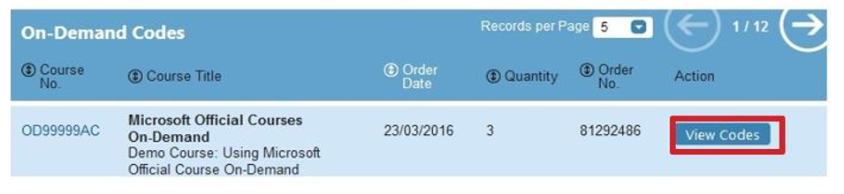
- The next view shows the redemption status:
  - Available – not redeemed
  - Redeemed – redeemed

Exam​ guidelines
A Microsoft Exam voucher is a code that can be used to register for a Microsoft Certified Professional exam. Once a student takes and passes the exam, they become a Microsoft Certified Professional.

Purchase exam vouchers and view exam codes
- Navigate to Courseware Marketplace​.
- In the Search box in the top right corner, type Exam Vouchers and press your Enter key to view search results.
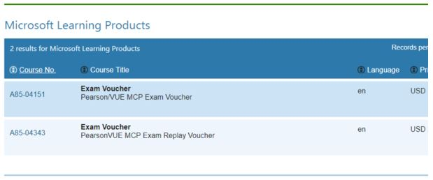
- Alternatively, find exam vouchers by selecting the Microsoft Learning Products blue button in the top left corner.
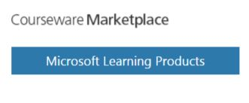
- ​​​​Then select the Microsoft Exam Voucher option in the blue menu, and view the list of exams/exam vouchers.
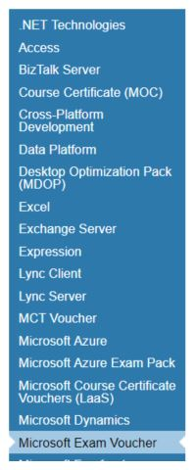
- ​​​From the displayed results, select the exam vouchers to add to your cart, and continue through the shopping and payment process as needed.
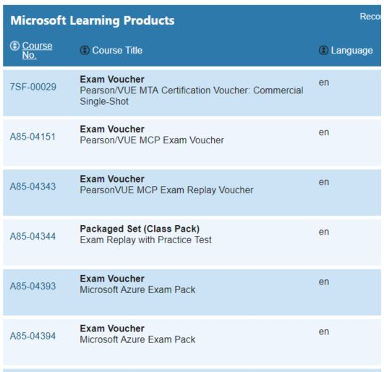
- ​​​Once the codes have been paid for, you can access exam codes for distribution by selecting the blue My Account button near the top right corner of Courseware Marketplace.
- ​Select the Exam Voucher Codes option in the blue menu that will appear on the left.
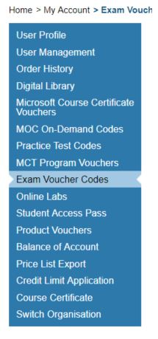
- A list of code orders along with a search tool will appear.
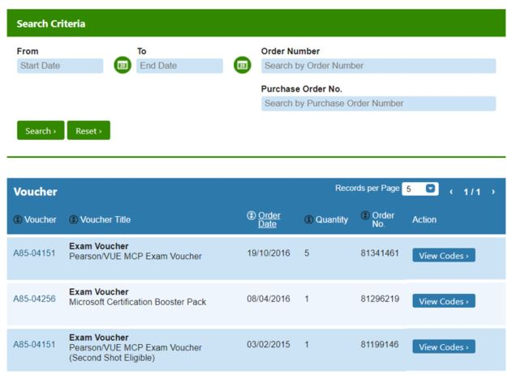
- You have the following options for searching for exam voucher codes placed within a specific order:
  - Enter the order number in the Search by Order Number box and press your Enter key or select the green Search button
  - Enter the purchase order number in the Search by Purchase Order Number box and press Enter or select Search
  - Search for orders placed within a date range by selecting a date in both the Start Date and End Date boxes and press Enter or select Search
- Once the search results that match your search criteria are displayed, select the blue View Codes button to display your codes.
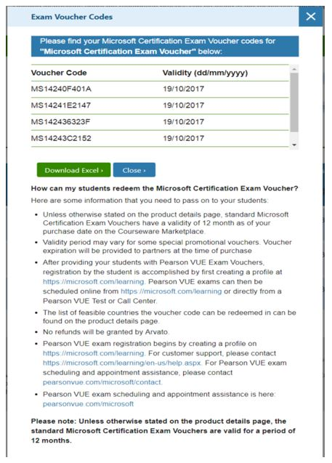
- ​​​​​​You may copy and paste the voucher codes, or download the codes to an Excel file by selecting the green Download Excel button.​​
​
Once exam vouchers are purchased, students can redeem exam voucher codes by following these instructions​​.​​

Microsoft Course Certificate vouchers (LaaS) for MOOC courses guidelines
A Microsoft Course Certificate voucher (LaaS, or Learning as a Service) is a voucher that can be used to earn a certificate once a Microsoft MOOC (Massive Open Online Course) has been completed and the student has achieved all the necessary goals for the course.

Locate and purchase Microsoft Course Certificate vouchers​ in Courseware Marketplace
Additional terms and conditions are as follows: ​
- Microsoft Course Certificate Vouchers are not returnable or refundable.
- Microsoft Course Certificate Vouchers are void​ if altered in any way.
- Each voucher code may only be used once and only for the eligible Microsoft Online courses designated by Microsoft.
- You will assign one unique code to each Microsoft Course Certificate Voucher and will track your distribution of voucher codes to ensure each code is only used and distributed once.
- You are responsible for keeping the Microsoft Course Certificate Vouchers and voucher codes in a secure place to ensure they are not copied or misappropriated.
You must provide the following information to your students:
- This Microsoft Course Certificate Voucher expires on DAY/MONTH/YEAR. You must successfully complete the Microsoft online course and request the course completion certificate prior to the voucher expiration date. Expiration dates will not be extended under any circumstances.
- Voucher can only be used once.
- Voucher may not be redeemed for cash, credit, or refunds.
- Expired, stolen or lost vouchers will not be replaced.
- Any sale or transfer of this voucher is expressly prohibited.
- Voucher is non-transferable and void if altered in any way.
- Microsoft and its distributors/resellers are not responsible for lost or stolen Microsoft Course Certificate Vouchers or voucher codes.​

Redeem voucher (existing partners)
Once you complete a training, you must redeem the voucher.​ This can be completed on or after the last class day of training. Training should always be scheduled and delivered—and the voucher redeemed—​before the voucher’s expiration date. A voucher cannot be redeemed before training has been delivered, and a training cannot be held “on account” for customers. Such actions may result in a partner's suspension ​​from the SATV program.
- Sign In to your Partner Center Dashboard.
- Click MPN on the navigation pane to expand the section.
- Expand Software Assurance and select Software Assurance Training Vouchers to reveal the voucher activity report​.
- Select Reserved from the voucher status drop-down to filter the listed vouchers to display only reserved vouchers. The list of reserved vouchers can then be sorted to help you locate the voucher(s) to be redeemed.
- Tick the checkbox(es) next to the desired voucher(s) then click Redeem selected vouchers.
- From the Confirm voucher redemption page, review the voucher information for accuracy, then select Yes to redeem the voucher.
​​​​​​​​​​​​​​​​
Submit payment requests within 60 days of redeeming vouchers.​
After redeeming a voucher, you have 60 days in which to submit a payment request in the SAVB Online Payment Tool. Any non-compliance issues with the voucher must also be resolved within this 60-day period. If the 60-day period ends before compliance issues are remediated or a payment request is submitted, the voucher is forfeited and payment cannot be processed for the engagement delivered under that voucher.​

Get paid (existing partners)
After redeeming a voucher, you must create and submit a payment request in the Software Assurance Voucher Benefit (SAVB) Online Payment Tool in order to invoice Microsoft.

​Register for payment
This step is required only for your organization’s first redeemed ​training voucher. If your organization has already registered in SAVB for payment, please start at the Invoice against voucher step​.

A Global Administrator for your organization in the Microsoft Partner Network (MPN) is required to complete this initial registration process in SAVB. The Global Administrator may also function as one of your organizations’ designated Partner Program Administrators (PPA) in the SAVB tool.

Tips
If your organization is active in more than one voucher program (for example, Software Assurance Training Vouchers (SATV) and Desktop Deployment Planning Services), you must go through this registration step for each voucher program (see Registration​​ for additional programs below).
​
Initial registration​​​
- Global Administrator must log into Microsoft’s Channel Incentives Platform (CHIP)​ (where the SAVB tool resides).
- On the initial Registration page, select the Organization name from the drop-down menu. (If this is your first time in SAVB, you will not see anything listed in the Programs Registered section of the page.)​​
- In the Programs Available for Registration section, select the program(s) for which you are now registering, then select Register.
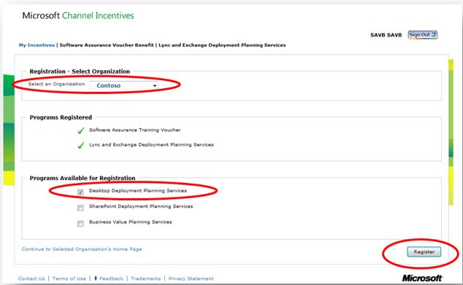
- On the Confirmation page, check to ensure the listed program is the one you registered on the previous screen, then select go to Home to return to your program homepage in SAVB.
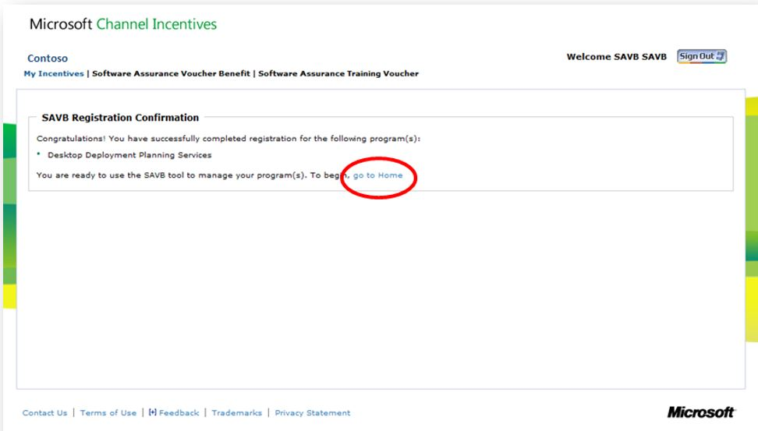
- ​​After completing initial program registration, you can access SAVB directly at channelincentives.microsoft.com​​, using your Microsoft account to sign in.
​Registration​​ for additional programs​
If you want to redeem vouchers for an additional program, you must complete the program registration process again for each new program. Follow the steps below:
- From one of the program home pages in CHIP, under the I Need To menu, select Manage Organizations.​
- Follow the prompts to register your additional program.
- Wait 24-48 hours for your vendor ID to be mapped.
- Assign your vendor ID to your location in your newly register program.

Create vendor ID​
​
After completing your new program registration, the Regional Service Center (RSC) team creates a new vendor ID request for your Primary Contact for that location ID in MPN. This vendor ID will be linked to the bank account you designated to receive payment from Microsoft for Software Assurance trainings delivered.​ ​The Primary Contact will be sent an email from Microsoft Payment Central with an access invitation.​ ​
- As the Primary Contact, sign into your Payment Central account using the email address at which you received the invitation (this email address should be linked to your Microsoft account; ​view instructions).
- After accessing your new supplier/vendor account, enter the required details in the five sections displayed. Select Submit to send the information to the Microsoft accounts payable team for review.
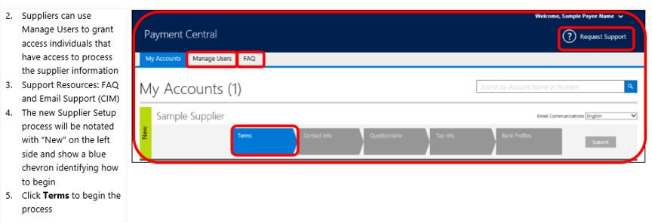
- Once approved by the accounts payable team, a new vendor ID will be created. You will receive a confirmation email with the new vendor ID. The RSC team will transfer the new vendor ID to your organization’s SAVB payment profile.
- ​Assign the payment profile to your l​​ocation ID in SAVB (this will need to be done for each new program) by following these steps:
  - As the Primary Contact, navigate to your program homepage and select Manage Payment Profile from the I Need To… menu. From here, you can see your payment profile(s) and location IDs registered for that program.
  - Select Edit Assignments to assign the correct payment profile to the correct location ID.
​
You can now create payment requests for your redeemed vouchers.​​​​​

Tips
- You may use the same bank account for locations in different countries as long as those countries are located in the same Microsoft Company Code.
- Once you complete the forms in Payment Central, it may take up to two weeks for your vendor ID to be created.

Invoice against voucher
Follow the steps below to create your payment request. Note that SAVB only displays vouchers that have already been redeemed; it does not display vouchers that are in “reserved” status.​​​

Submit payment requests within 60 days of redeeming vouchers.​​​ After redeeming a voucher, you have 60 days in which to submit a payment request in the SAVB Online Payment Tool. Any non-compliance issues with the voucher must also be resolved within this 60-day period. If the 60-day period ends before compliance issues are remediated or a payment request is submitted, the voucher is forfeited and payment cannot be processed for the engagement delivered under that voucher.
- From your program home page, select Create Payment Request from the I Need To… menu.
- Using the voucher Search Criteria filters to narrow your voucher selection:
  - Select the Country for which you are creating the payment request. Note: you can only select one country. You cannot combine redeemed vouchers from locations that are in different countries on the same payment request.
  - Select the Locations for which you would like to view redeemed vouchers.
  - Select the Payment Profile that maps to the location(s) you want to view. This is the payment profile under which you want payment to be made for the location(s) you are going to include in your payment request.
  - Select the Tax Jurisdiction that correctly applies to the country and locations you have selected.
  - Select Search
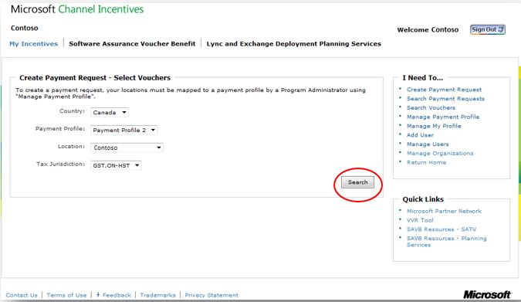
- Review the redeemed vouchers in the Create Payment Request – Select Vouchers pane in the lower half of the screen. These results are based on the search criteria used in the prior screen. (To change your search, select Change Criteria to reset your filters.)
- Select the Invoice By date next to the vouchers to ensure that you prioritize the ones that are closest to the date shown for submission first.
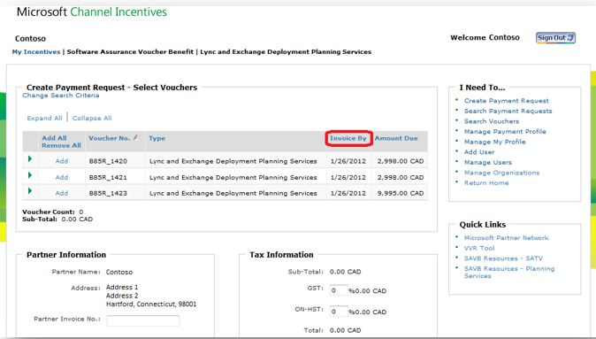
- ​​​To view the Voucher Details of a particular voucher listed in the table, select arrow next to the voucher record, or use Expand All/Collapse All to see all details for all vouchers.
- Select the vouchers you wish to attach to this payment request. Select Add in the row of each voucher to be included, where you can input the required Microsoft Official Courseware (MOC) information for each voucher. The notation will then change to Remove, which you can select to remove vouchers from your payment request.​
- For each voucher, select the appropriate Courseware Format (“Digital MOC”, “Printed MOC”, "MOC On-Demand”, "MOC On-Demand 180 days", "Exams", or "Microsoft Course Certificate vouchers (LaaS)") from the drop-down menu.
- Enter the 16-digit License No. (digital MOC), Order No. (printed MOC), or Voucher Code (MOC On-Demand, Exam, and Microsoft Course Certificate vouchers​ (Laas)) associated with the voucher.
Tips
Vouchers tied to Custom Courseware and Custom Course Codes are exempt from the MOC requirement. You do not need to select Courseware Format or input License No/Order No. for these vouchers​.
- Confirm the Voucher Sub-Total for the vouchers you have added to the payment request.
- Input the alpha/numeric invoice number created by your company’s financial system in the Partner Invoice No. field provided (required field which allows you and Microsoft to cross-reference your company invoice with its corresponding SAVB payment request number).
- Input Tax Rate (%) to be added to the payment request, based upon the applicable tax jurisdiction for the locations included in the payment request. SAVB will automatically calculate the tax amount and update the invoice total based upon the tax % you enter.​
  - Note: ​Microsoft does not reimburse tax to partners in all jurisdictions. If tax is reimbursable in a partner’s jurisdiction, it is the partner’s responsibility to enter the correct tax for the locations covered by the payment request.​​
- ​​ Attach Documentation: depending on the country associated with your payment request, SAVB may prompt you to submit your company’s invoice as supplemental proof of your valid payment request. Note: information on your own company invoice (softcopy or hardcopy) must exactly match the information in the online payment request—including Partner Invoice Number and Total—to avoid payment delays.
- Select Submit. Selecting Save for Later allows you to find the saved payment request by selecting Search Payment Requests on your home page.
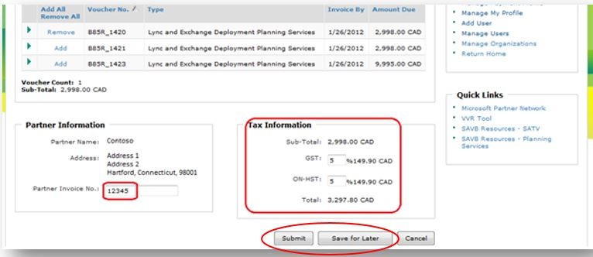
- ​​The Payment Request Confirmation screen shows the unique Microsoft Reference Number assigned by SAVB to your submitted or saved payment request. Reference this number if you require help from your Regional Service Center.​​
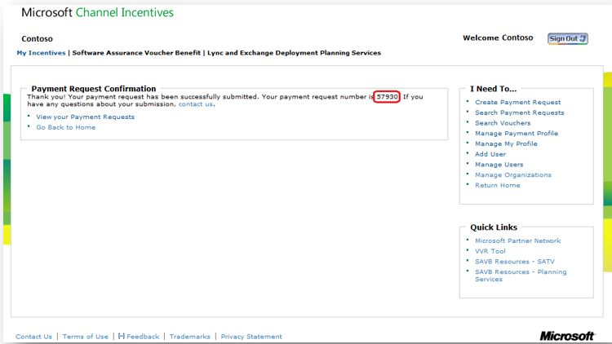
​ ​​​
Get paid through SAVB
Once your payment request is successfully submitted, Microsoft will initiate payment according to the terms you established while setting up the payment profile for the location ID​​​.​

