About

Flood is a cloud-based, distributed load testing platform that helps teams test how their applications scale with massive load generated from around the world. Flood can generate load using popular open source load testing tools (such as Apache JMeter, Gatling and Chrome) as well as Tricentis Tosca functional testing cases (API and UI).

Flood provides
- Straightforward ways to define, create and maintain load tests
- On-demand platform for running those load tests at scale
- Real-time results visualization and analysis
- Continuous insight into performance over time

Flood helps you
- Build and develop load test assets
  - We significantly reduce the time required to develop and maintain load tests with innovative Browser Level Users (with Flood Chrome and Tricentis Tosca).
  - We also support traditional high volume / concurrency approaches with Protocol Level Users using tools like JMeter or Gatling.
- Easily provision load test infrastructure
  - We leverage cloud-based infrastructure that provides unprecedented economy of scale compared to on premise solutions.
  - It typically takes 3 – 5 minutes to provision new load test infrastructure, on demand.
  - Dramatically reduce ongoing infrastructure costs with a cloud-based strategy.
  - Provide an integration path into your existing CI and CD pipelines.
- Analyze and share load test results
  - All of our dashboards are browser based, meaning you can easily share results with colleagues in real time.
  - “Down to 1 second” aggregated report resolution provides high-precision analysis in real time.
  - Innovative supplementary reporting features to extend open source tool sets—for example, insight into HTTP traffic to assist with debugging, screen shot captures for browser-level test documentation and traceability).
  - A continuous view of performance lets you more easily identify risks to production in terms of application bottlenecks, performance issues and regression.
  - An open API enables full control of test execution details as well as the ability to extract data for your own dashboards and reporting purposes.

Differentiating features
- Browser Level User approach reduces script creation, maintenance and complexity overheads.
- Tool agnostic, can integrate with new tools as they become available.
- Tosca Flood integration, including seamless load testing for both UI and API based test cases.
- Superior economy of scale with cloud-based load generation across multiple geographic regions around the world.
- Cluster-less, shared-nothing architecture which means we can scale out for very large tests without the typical bottlenecks found in our competitors with more traditional setups.
- Real time reports in an easy to share, intuitive, interactive dashboard.
- Long term storage of results, so you can continuously assess performance over time.
- Test-friendly pricing where you pay for the infrastructure you use, not per test or per simulated user like most of our competitors.
- First class support, talk to real performance engineers who can resolve most issues within a 4-hour period rather than get stuck in an escalation queue.

Customer case studies

https://flood.io/blog/laneone-load-testing-case-study/
https://blog.hotstar.com/scaling-is-not-an-accident-895140ac84c0
https://blog.hotstar.com/millons-scale-simulations-1602befe1ce5
https://www.rallyhealth.com/how-we-work/building-a-bigger-airplane-while-youre-flying
http://rea.tech/using-our-everyday-dev-tools-for-effective-load-and-performance-testing/

Customer examples
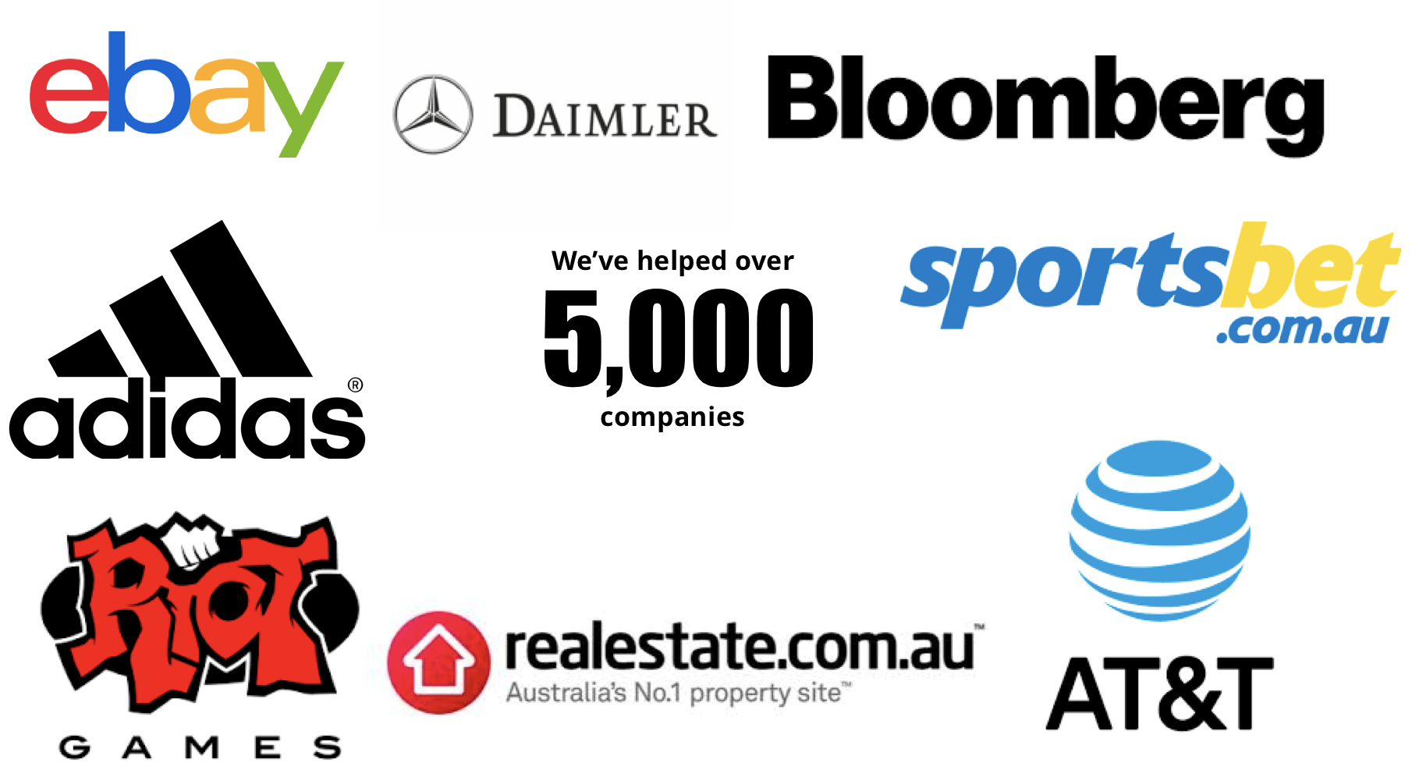

Featured references
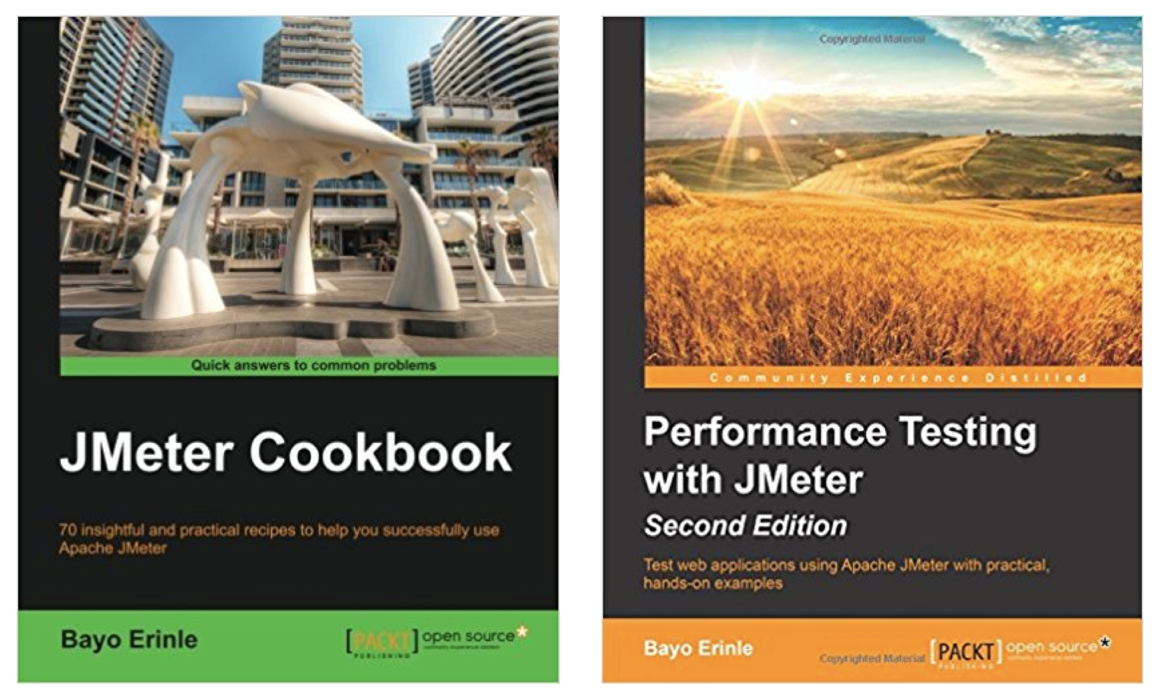

We’re the only cloud-based load testing platform that has appeared 2 years running in the Thoughtworks Technology Radar

