SNC/Mobile

Key Usage Scenarios

Setup

- 01 Start Setup: Launch SNC/Mobile from Tell Me
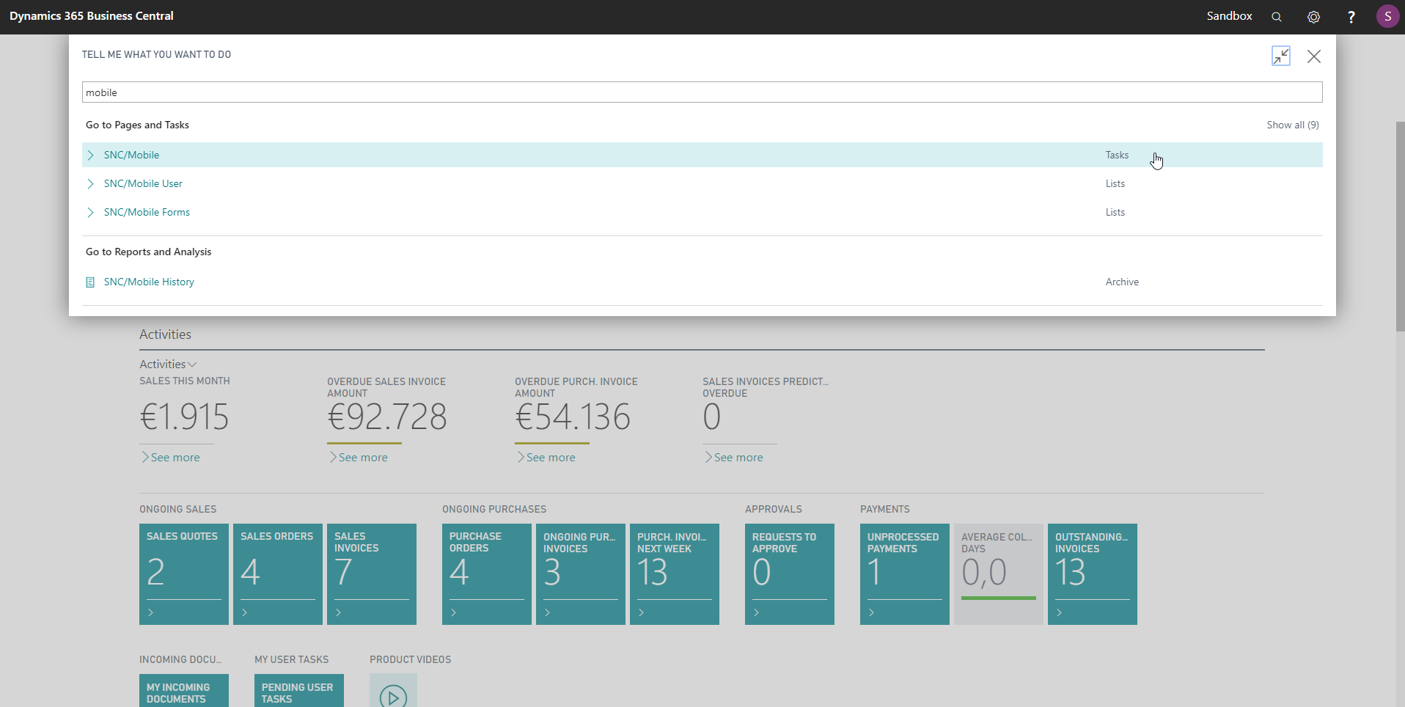

- 02 Empty Mobile Page Start Wizard: SNC Mobile shows a blank page because it is not setup yet. Click the notification for the setup wizard

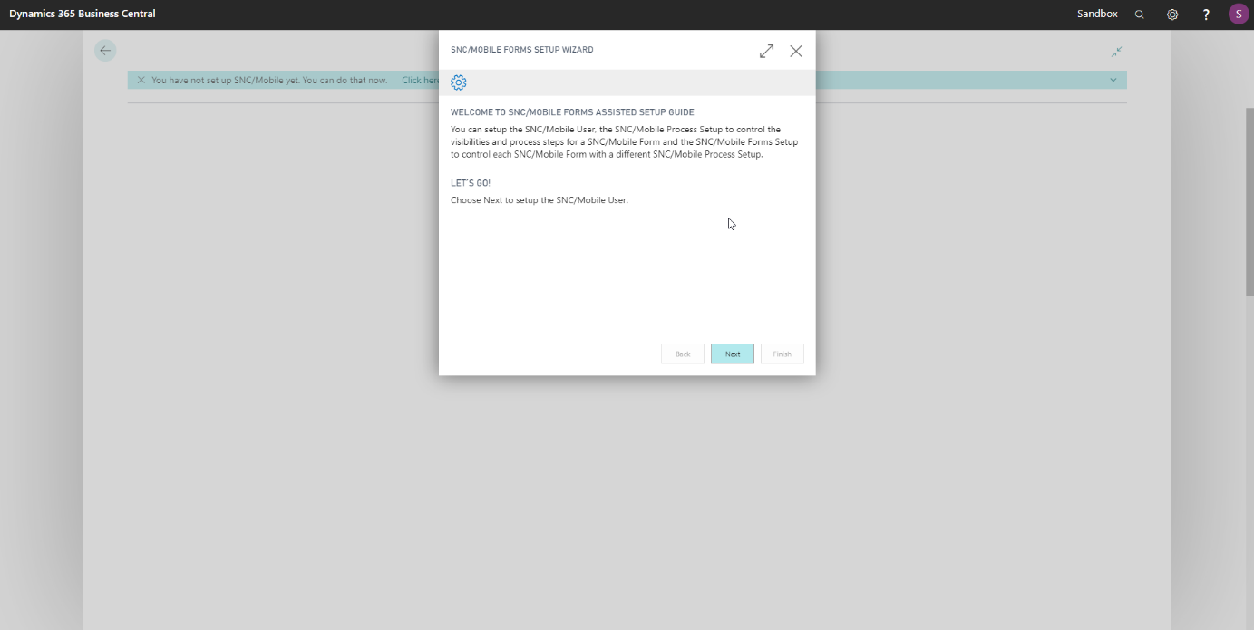
- 03 Wizard Welcome: The setup wizard welcomes you and explains the upcoming steps
- 04 Wizard SNC Mobile User
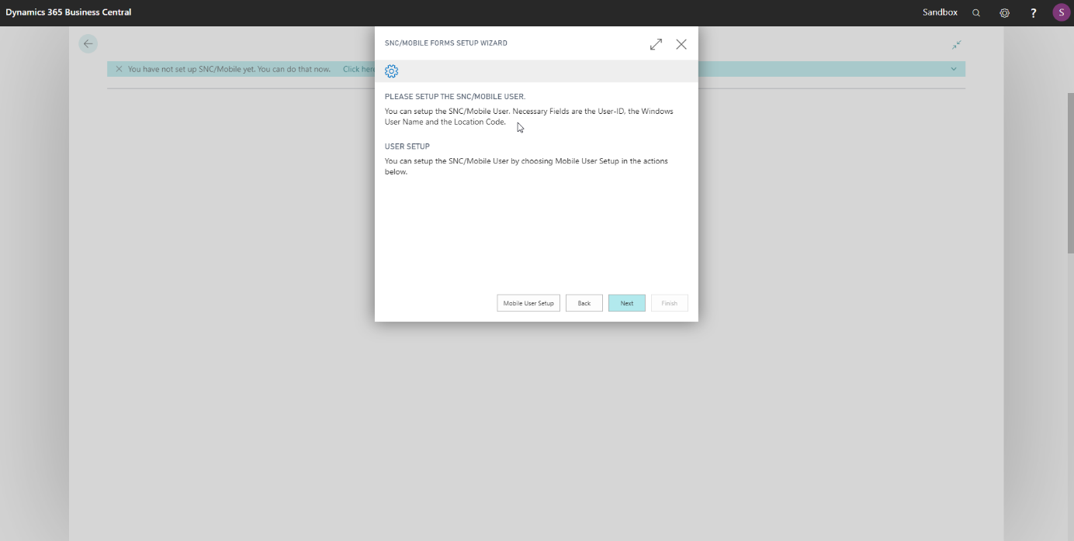

- 05 User Setup: Choose a User ID select your windows user and a Location Code. If there isn’t already a Warehouse Employee for your Windows User in the Database, you will be ask to create it.
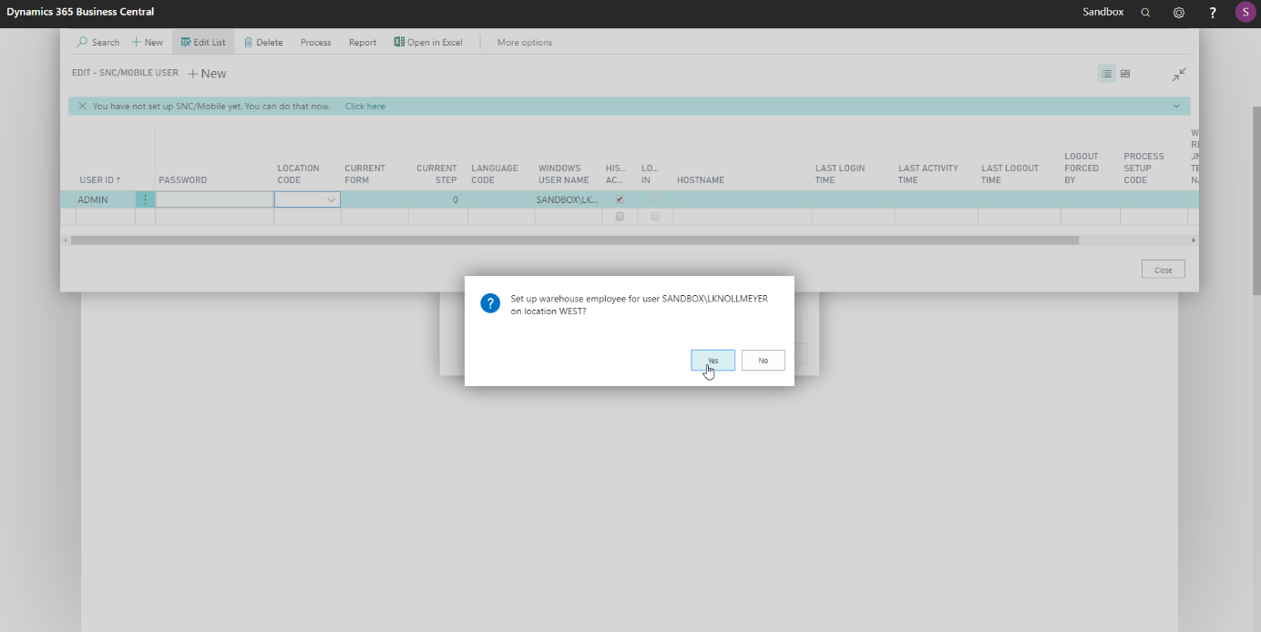

- 06 Wizard Process Explanation
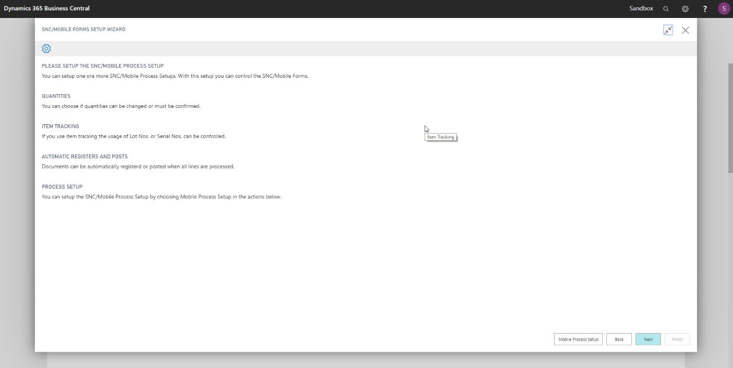

- 07 Process Setup: Choose a Process Code and select the options you would like to use.

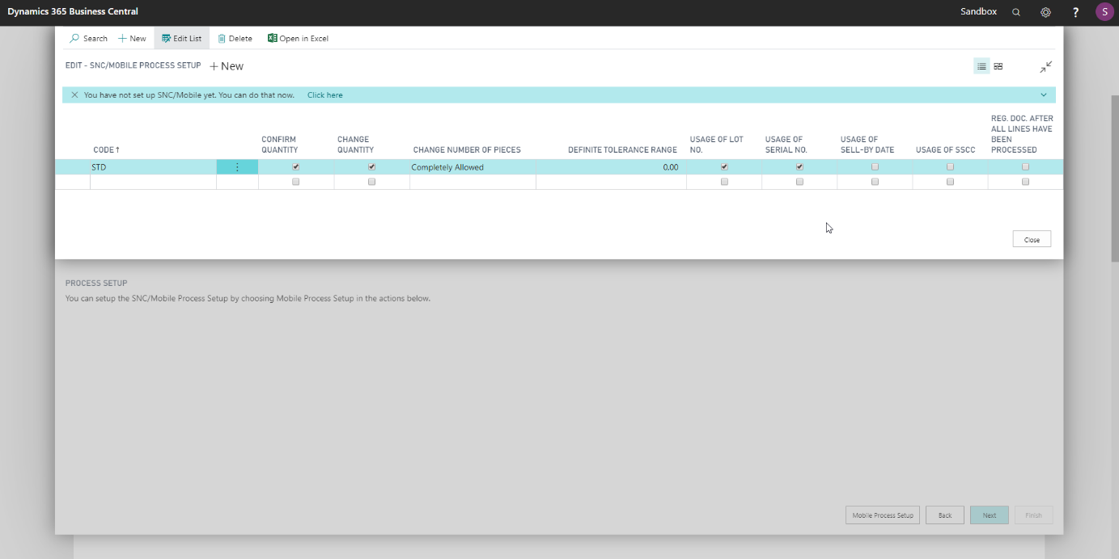
- 08 Wizard Forms Process Setup
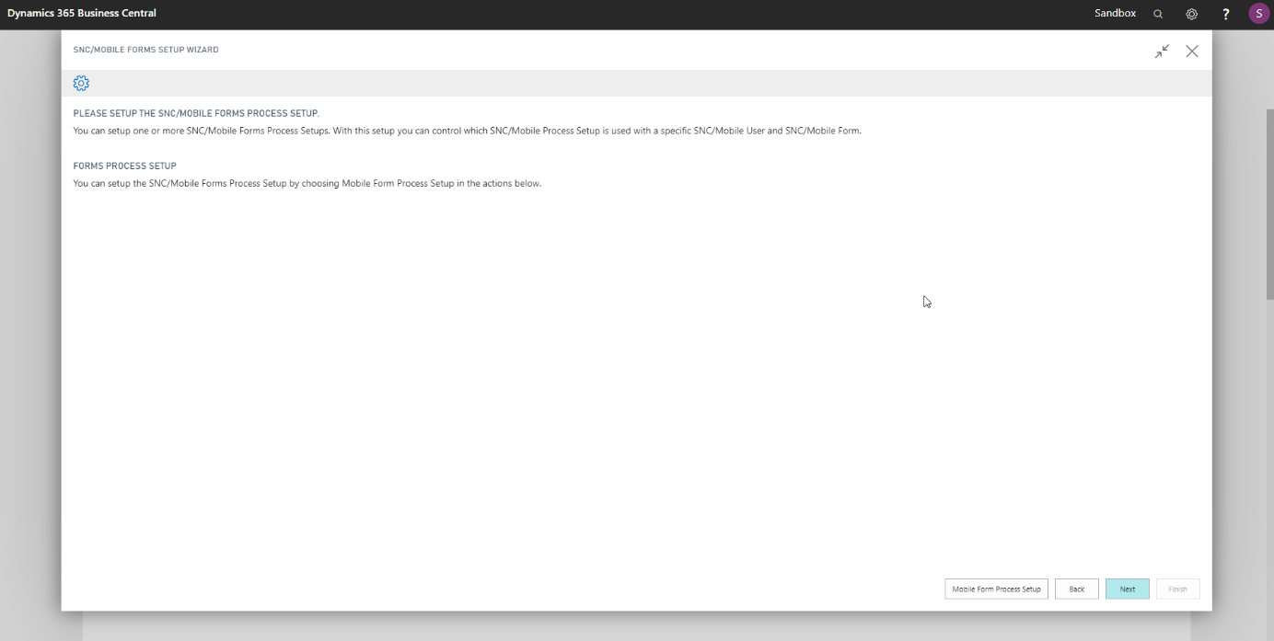

- 09 Form Process Setup: Select your Mobile User, the form and the Process Code this combination should use. You can also skip this step and define a general Process for all users and forms in the SNC/Mobile Setup
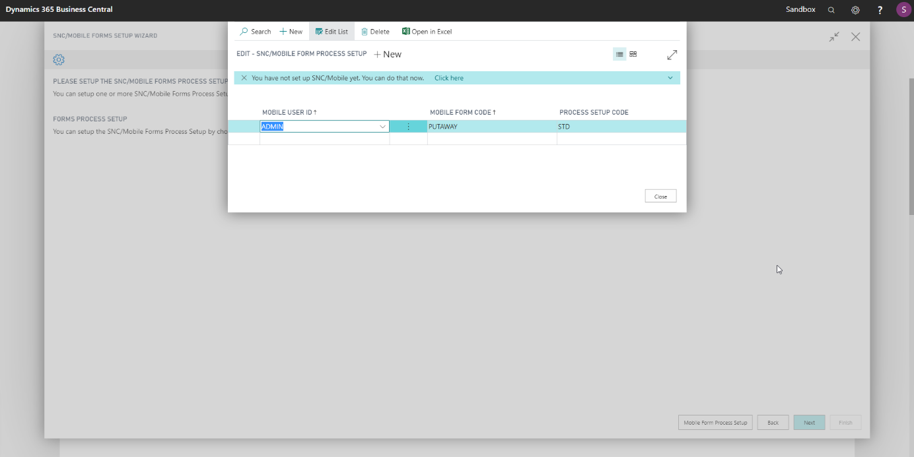

- 10 Mobile Main: Finish the Wizard and reload the SNC/Mobile Page with F5. The SNC/Mobile Main Menu should show up.
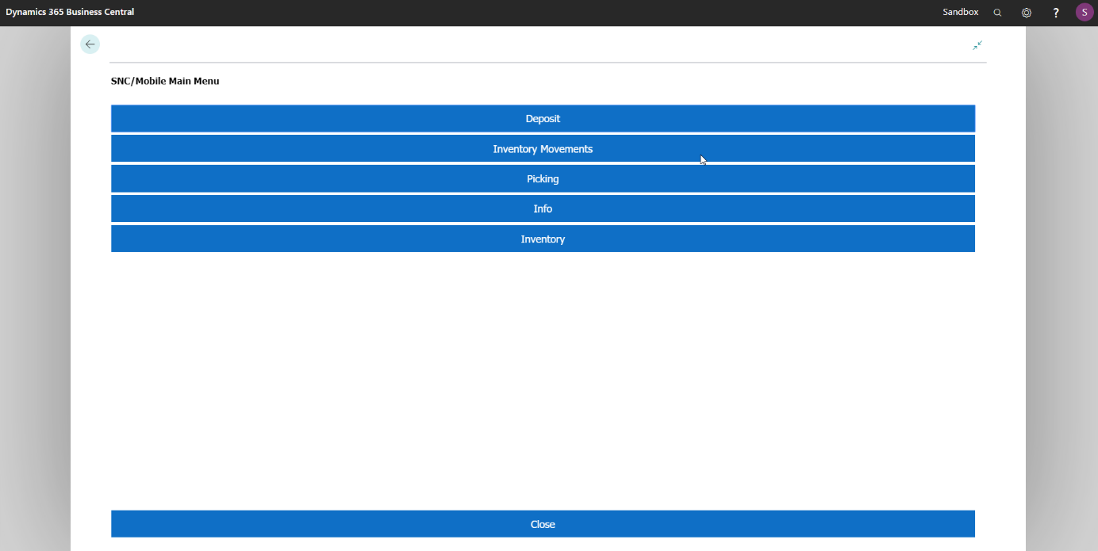

- 11 General Process Setup: If you want to define a General Process Code which will be used if there is no specific setup for a user-form combination open the SNC/Mobile Setup
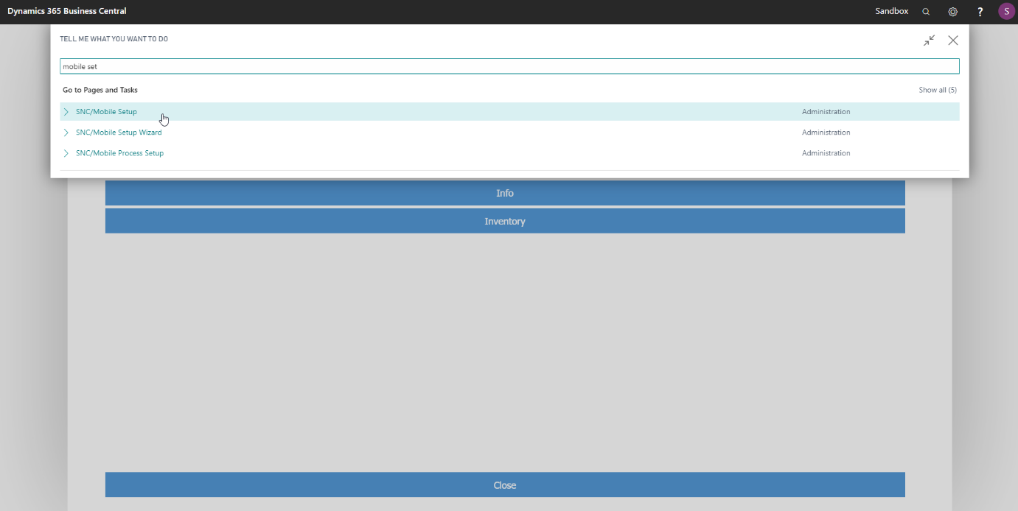

- 12 General Process Setup: Select a Default Process Setup

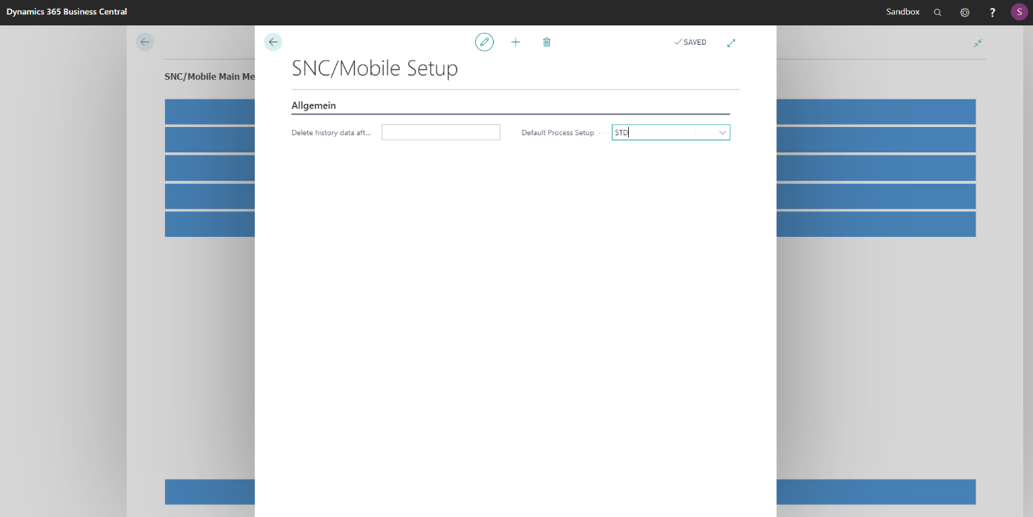

Deposit

- 01 Start with Putaway: Begin with a Warehouse Put-Away
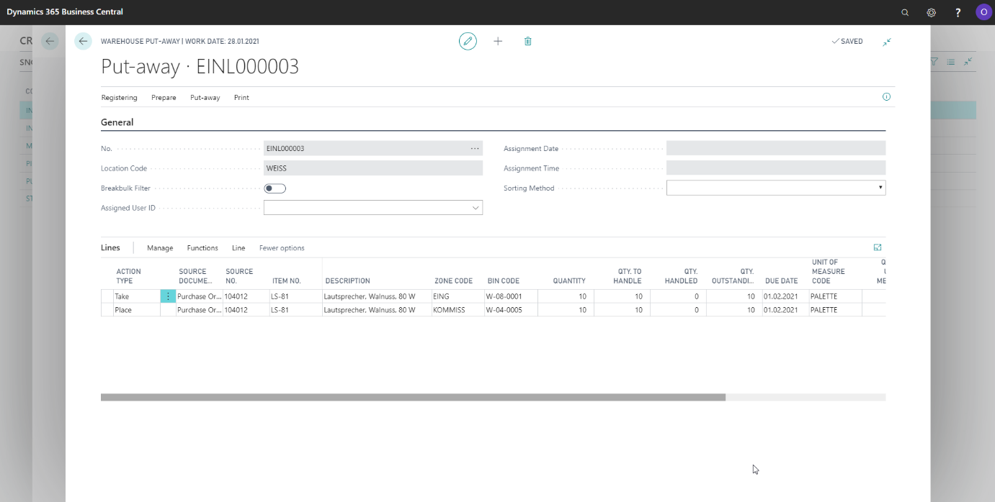

- 02 Launch Mobile Device: Launch Business Central App on a Mobile Device. Please use a user that has the SNC/Mobile Role Center selected. Start SNC/Mobile Client.
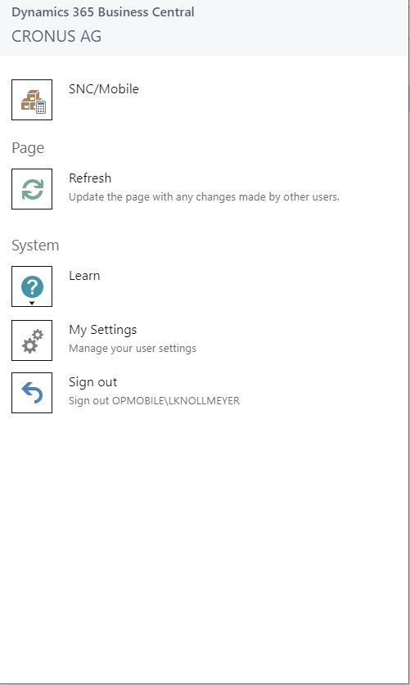

- 03 Select Depost: Select Deposit from Main Menu.
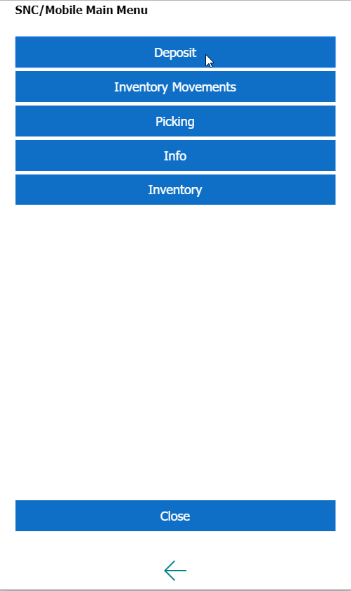

- 04 Get Next Line: Press ‘Next Line’ to retrieve the next Warehouse Put-Away Line
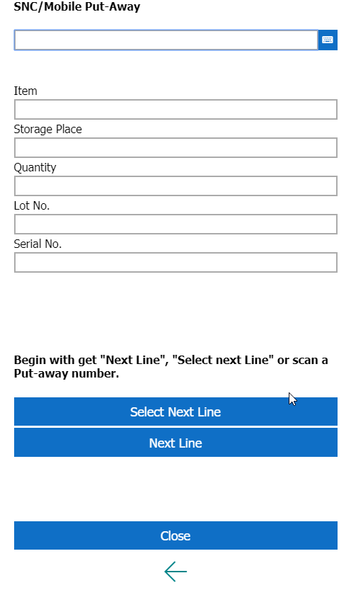

- 05 Scan Source Bin: Scan the source bin.
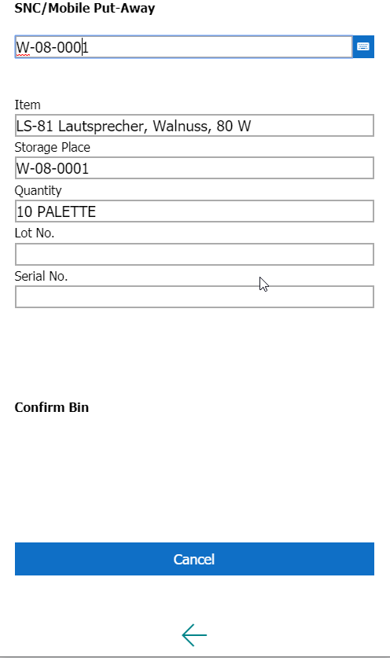

- 06 Confirm Amount: Follow the instructions.
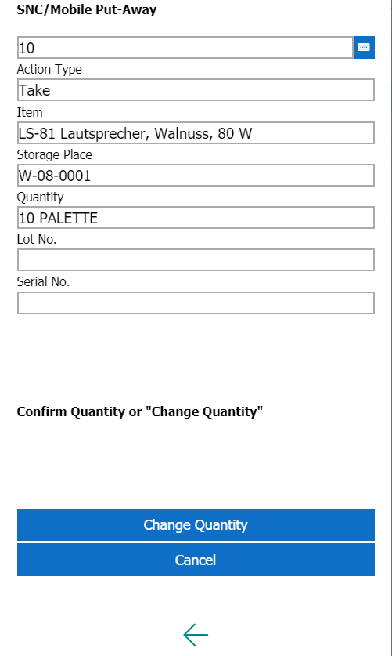

- 07 Scan Destination Bin: Scan the destination bin.
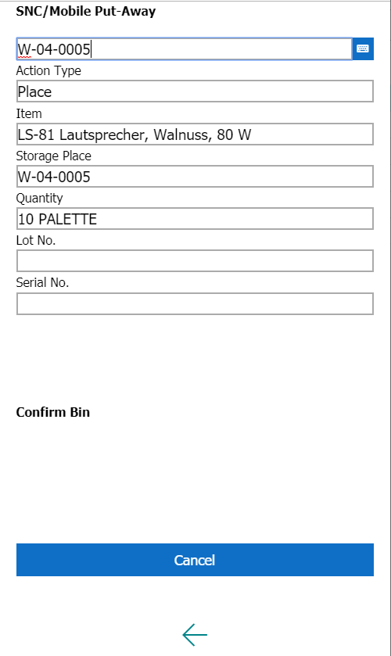

- 08 Confirm Amount
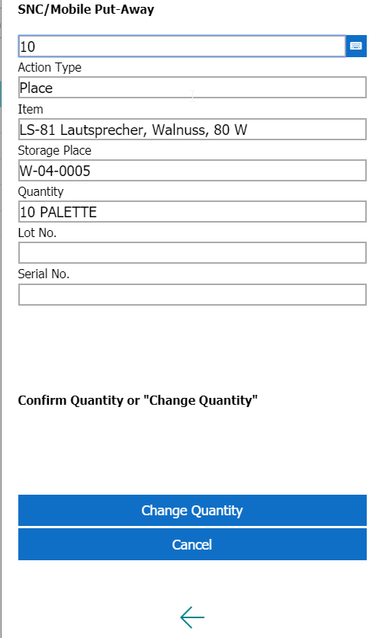

- 09 Finished: The Warehouse Put-Away has successfully been processed.
