Microsoft AppSource
Publishing Guide for Dynamics 365 Customer Engagement (xRM) Solutions
Table of Contents
1. Introduction 3
2. Dynamics 365 Solution Preparation 3
3. AppSource Package Preparation 4
a. Create a Package for the Package Deployer 4
b. Create an AppSource Package 6
4. Store your AppSource Package to Azure storage and generate a URL with SAS key 8
5. Setup your application in the Publishing Portal 12
Login and Create a New Offer 12
Fill out the Offer Settings form 13
Offer ID 13
Publisher ID 14
Name 14
Fill out the Technical Info form 14
Application Info 14
CRM Package 14
CRM Package Availability 15
Storefront Details 15
Offer Summary 15
Offer Description 15
Industries 15
Categories 15
App type 16
Help link for your app 16
Supported countries/regions 16
Supported languages 16
App version 16
App Release Date 16
Products your app works with (Max 3) 16
Search keywords (Max 3) 16
Hide key 17
Offer logo (png format, 48x48) 17
Offer logo (png format, 216x216) 17
Videos 17
Documents 17
Screenshots 17
Privacy Policy 17
Terms of use 17
Support URL 17
Lead Destination 17
Storefront Details 18
6. Request to publish the app 18
7. Special considerations for Microsoft Dynamics 365 Business Edition 19
8. Getting help 19

Introduction
Thank you for your interest in publishing your Dynamics 365 for Customer Engagement (formerly CRM) solution to AppSource. Microsoft is excited to work with our dedicated ISVs to provide the premier place for customers, resellers, and implementation partners to find and try business solutions and make the most of their investments. Below are the steps to get your solution published.

Dynamics 365 Solution Preparation

The Dynamics 365 solutioning system is a framework for packaging, installing, and uninstalling components that provide specific business functionality. Solutions are used by ISVs and other Microsoft Dynamics 365 partners to distribute extensions they create.
If you are an existing Dynamics 365 (xRM) ISV, you most likely already have created a managed solution and have a solution.zip file. In your solution, please make sure the “Display Name” and “Description” fields reflect what you want customers to see. These are displayed in the CRM Online Administration Center.
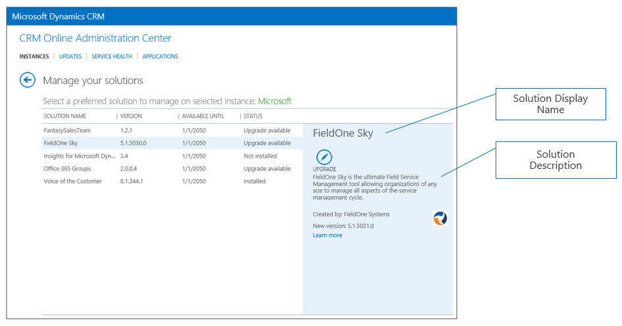
Note: In the package example that follows we will assume the solution name is “SampleSolution.zip.”
If you’re a new ISV, you can get more details on creating a solution here: https://msdn.microsoft.com/en-us/library/gg334530.aspx
If your solution requires supporting data:
- Create the sample data in your test environment
- Use the Configuration Migration Tool to create a Schema with comparison rules for your data.
- Save your configuration schema with your project files. You will need this later if you update your configuration data.
- Export your configuration data. Be sure to give the export file a name that is meaningful to your export.

AppSource Package Preparation

In addition to a solution.zip file, you’ll need an AppSource Package. This is a .zip file that includes all the assets needed to automate the process of deploying your solution into the customers’ CRM environment. The AppSource Package has the following components
- Package for the Package Deployer
- [Content_Types].xml file with the assets you use
- Input.xml file with your App specific data
- 32x32 logo that will display with your listing in the Admin Center
- License terms, privacy policy
The steps below will help you create your AppSource Package.

Create a Package for the Package Deployer
The Package for the Package Deployer is one part of the AppSource Package.
To create a Package for the Package Deployer, use the following instructions: https://msdn.microsoft.com/en-us/library/dn688182.aspx. When complete, your package will consist of the assets below:
- Package folder: contains all solutions, configuration data, flat files, and the contents for your package. Note: In the example that follows we will assume the package folder is called “PkgFolder.”
- PackageName.dll: The assembly contains the custom code for your package. Note: In the example that follows we will assume this file is called “MicrosoftSample.dll.”
Now, you need to create a file called “[Content_Types].xml.” This file will list all of the assets extensions that are part of your package. Here is example code for the file.
<?xml version="1.0" encoding="utf-8"?>
<Types xmlns="http://schemas.openxmlformats.org/package/2006/content-types">
<Default Extension="xml" ContentType="application/octet-stream" />
<Default Extension="xaml" ContentType="application/octet-stream" />
<Default Extension="dll" ContentType="application/octet-stream" />
<Default Extension="zip" ContentType="application/octet-stream" />
<Default Extension="jpg" ContentType="application/octet-stream" />
<Default Extension="gif" ContentType="application/octet-stream" />
<Default Extension="png" ContentType="application/octet-stream" />
<Default Extension="htm" ContentType="application/octet-stream" />
<Default Extension="html" ContentType="application/octet-stream" />
<Default Extension="db" ContentType="application/octet-stream" />
<Default Extension="css" ContentType="application/octet-stream" />
</Types>
The final step is to zip the following into one file. Please call it package.zip. It will contain
- PkgFolder (including everything inside the folder)
- PackageName.dll
- [Content_Types].xml
Steps to create package.zip:
- Put your package folder, [Content_Types].xml file, and PackageName.dll into one directory.
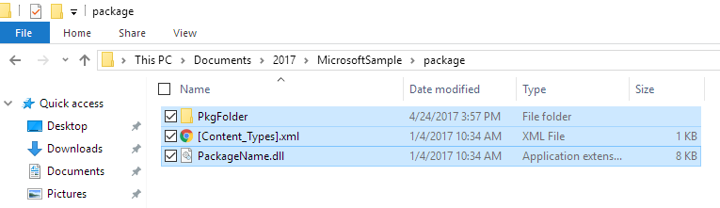
- Select all the items in the folder, right click and choose Send To Compressed (zip) folder
- Change the name to package.zip

Create an AppSource Package
The AppSource Package requires a few additional files.
- Logo32x32.jpg (32x32 resolution)
- TermsOfUse.html (HTML formatted file)
- [Content_Types].xml (same as above)
- input.xml
Here is example code for input.xml. See definitions in the below table.
<PvsPackageData>
<ProviderName>Microsoft</ProviderName>
<PackageFile>package.zip</PackageFile>
<SolutionAnchorName>SampleSolution.zip</SolutionAnchorName>
<StartDate>01/01/2016</StartDate>
<EndDate>01/01/2021</EndDate>
<SupportedCountries>US,CA</SupportedCountries>
<LearnMoreLink>http://www.microsoft.com</LearnMoreLink>
<Locales>
<PackageLocale Code="1033" IsDefault="true">
<Logo>logo32x32.png</Logo>
<Terms>
<PackageTerm File="TermsOfUse.html" />
</Terms>
</PackageLocale>
</Locales>
</PvsPackageData>

Where:
Field | Details
ProviderName | Who is the solution coming from. If a Microsoft team, this should be Microsoft.
PackageFile | Package Deployer assets zipped together with a content_types.xml file. This zip file should contain the package deployer assembly, and the folder with the package deployer assets. i.e. package.zip
SolutionAnchorName | Name of the solution zip file in the package deployer that is use for the display name and description of solution assets.
StartDate | This is the date that the solution package will become available. The format is MM/DD/YYYY
EndDate | This is the date that the solution package will stop being available. The format is MM/DD/YYYY
SupportedCountries | This is a comma delimited list of countries that should see this package. Please contact online services for a list of all current country codes. At the time of this writing the list was: AE,AL,AM,AO,AR,AT,AU,AZ,BA,BB,BD,BE,BG,BH,BM,BN,BO,BR,BY,CA,CH,CI,CL,CM,CO,CR,CV,CW,CY,CZ,DE,DK,DO,DZ,EC,EE,EG,ES,FI,FR,GB,GE,GH,GR,GT,HK,HN,HR,HU,ID,IE,IL,IN,IQ,IS,IT,JM,JO,JP,KE,KG,KN,KR,KW,KY,KZ,LB,LK,LT,LU,LV,LY,MA,MC,MD,ME,MK,MN,MO,MT,MU,MX,MY,NG,NI,NL,NO,NZ,OM,PA,PE,PH,PK,PL,PR,PS,PT,PY,QA,RO,RS,RU,RW,SA,SE,SG,SI,SK,SN,SV,TH,TM,TN,TR,TT,TW,UA,US,UY,UZ,VE,VI,VN,ZA,ZW
LearnMoreLink | URL to the more info page for this package. i.e. http://www.microsoft.com/en-us/dynamics/crm-help-center/default.aspx
Locales | One instance of this node for each UX Language you want to support in the Preferred solution UX. This node contains children that describe the locale, logo, and terms for each language
Locales: PackageLocale.Code | LCID of the language for this node. Example: US English is 1033
Locales: PackageLocale.IsDefault | Indicates that this is the default language. This is used as the fall back language if the UX Language chosen by the customer is not available.
Locales: Logo | This if the logo you wish to use for this package. Size for Icon is 32x32. Formats permitted are PNG and JPG
Locales: Terms: PackageTerm.File | This is the file name of the HTML doc that contains your license terms.

Here is where the logo will display:
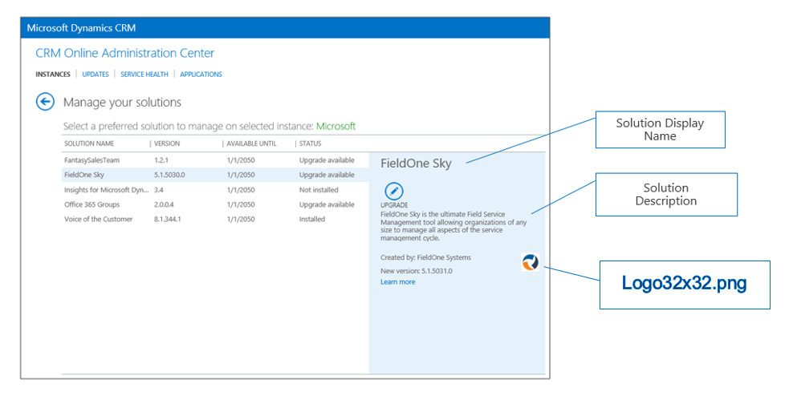
The final step is to zip the following into one file.
- package.zip (created earlier)
- [Content_Types].xml
- input.xml
- logo32x32.png
- TermsOfUse.html
Rename the file to something appropriate for your app. We prefer that you include your company name and app name. For example Microsoft_SamplePackage.zip.

Store your AppSource Package to Azure storage and generate a URL with SAS key
To maintain security of your files, we are asking all partners to store their AppSource package file in an Azure blob storage account and use a SAS key to share it. We will retrieve the package file from your Azure storage location for certification and to use it for AppSource trials.
Here are the steps to upload your package to blob storage.
- Go to http://azure.microsoft.com and create a free trial or pay as you go account.

- Login to Azure portal http://portal.azure.com/

- Create a new Storage Account by clicking the + New and going to Data + Storage Storage account
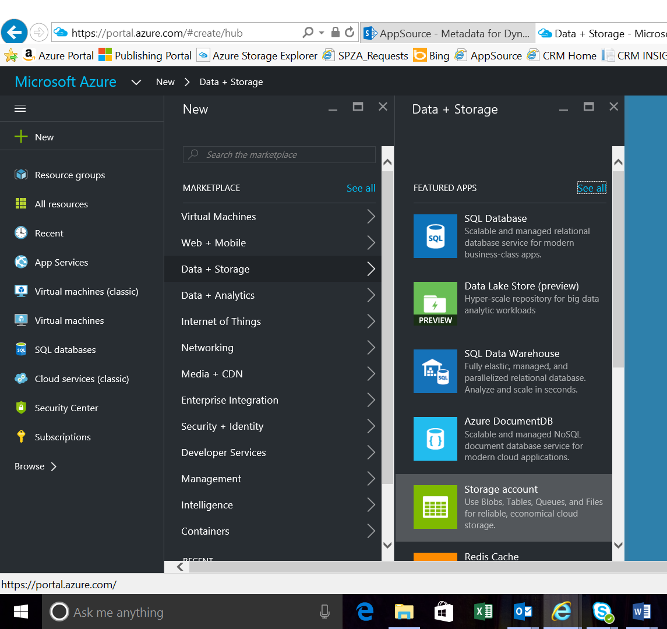
Enter a Name and Resource Group name and click “Create” button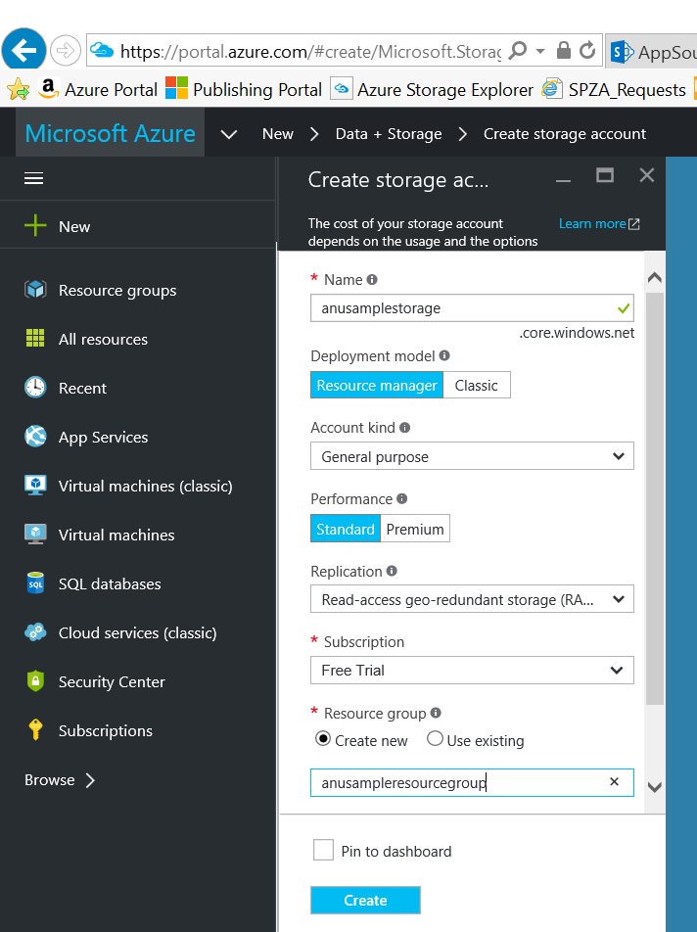

Navigate to your newly created resource group and create a new Blob container.
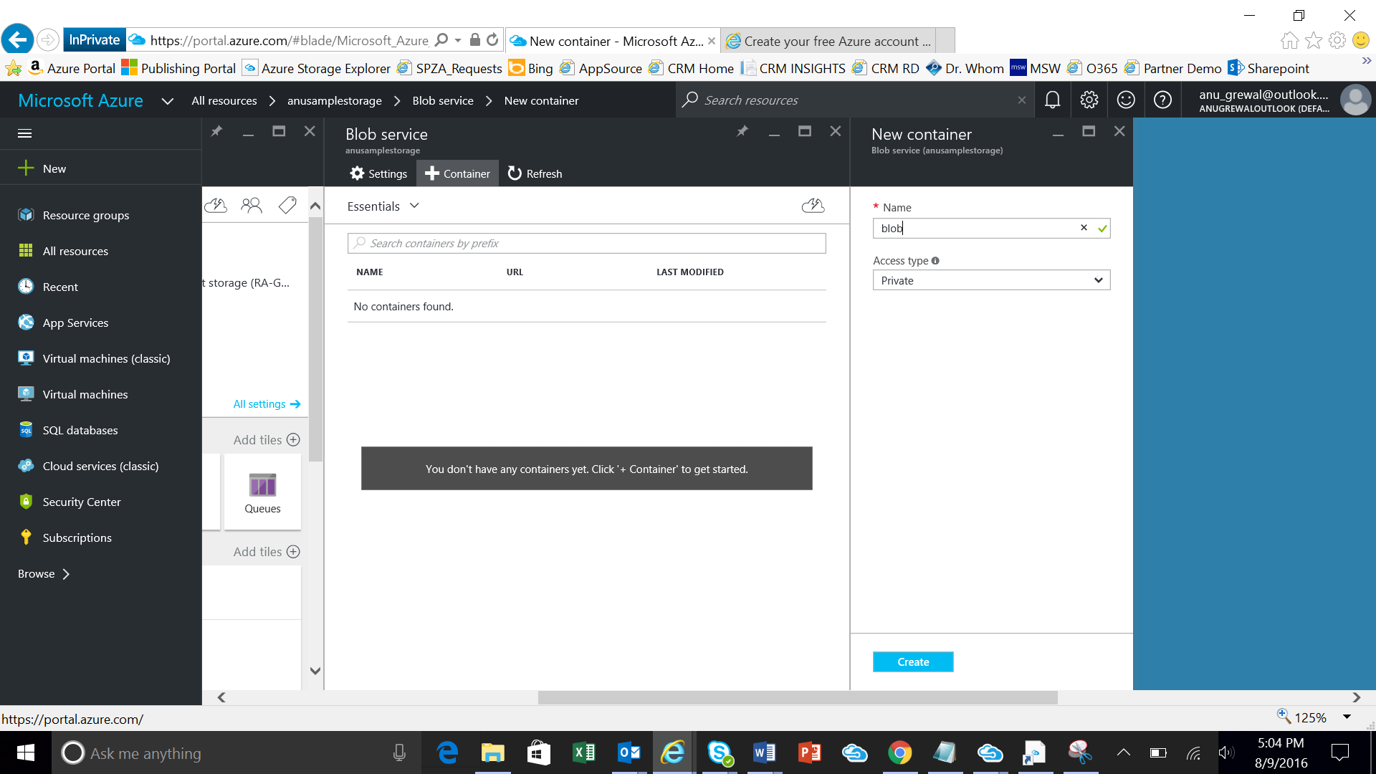

- Download and install the Microsoft Azure Storage Explorer from here: http://storageexplorer.com/
- Open Storage Explorer and use the icon to connect to your Azure storage account

- Navigate to the blob container you created and click Upload to add your package zip file
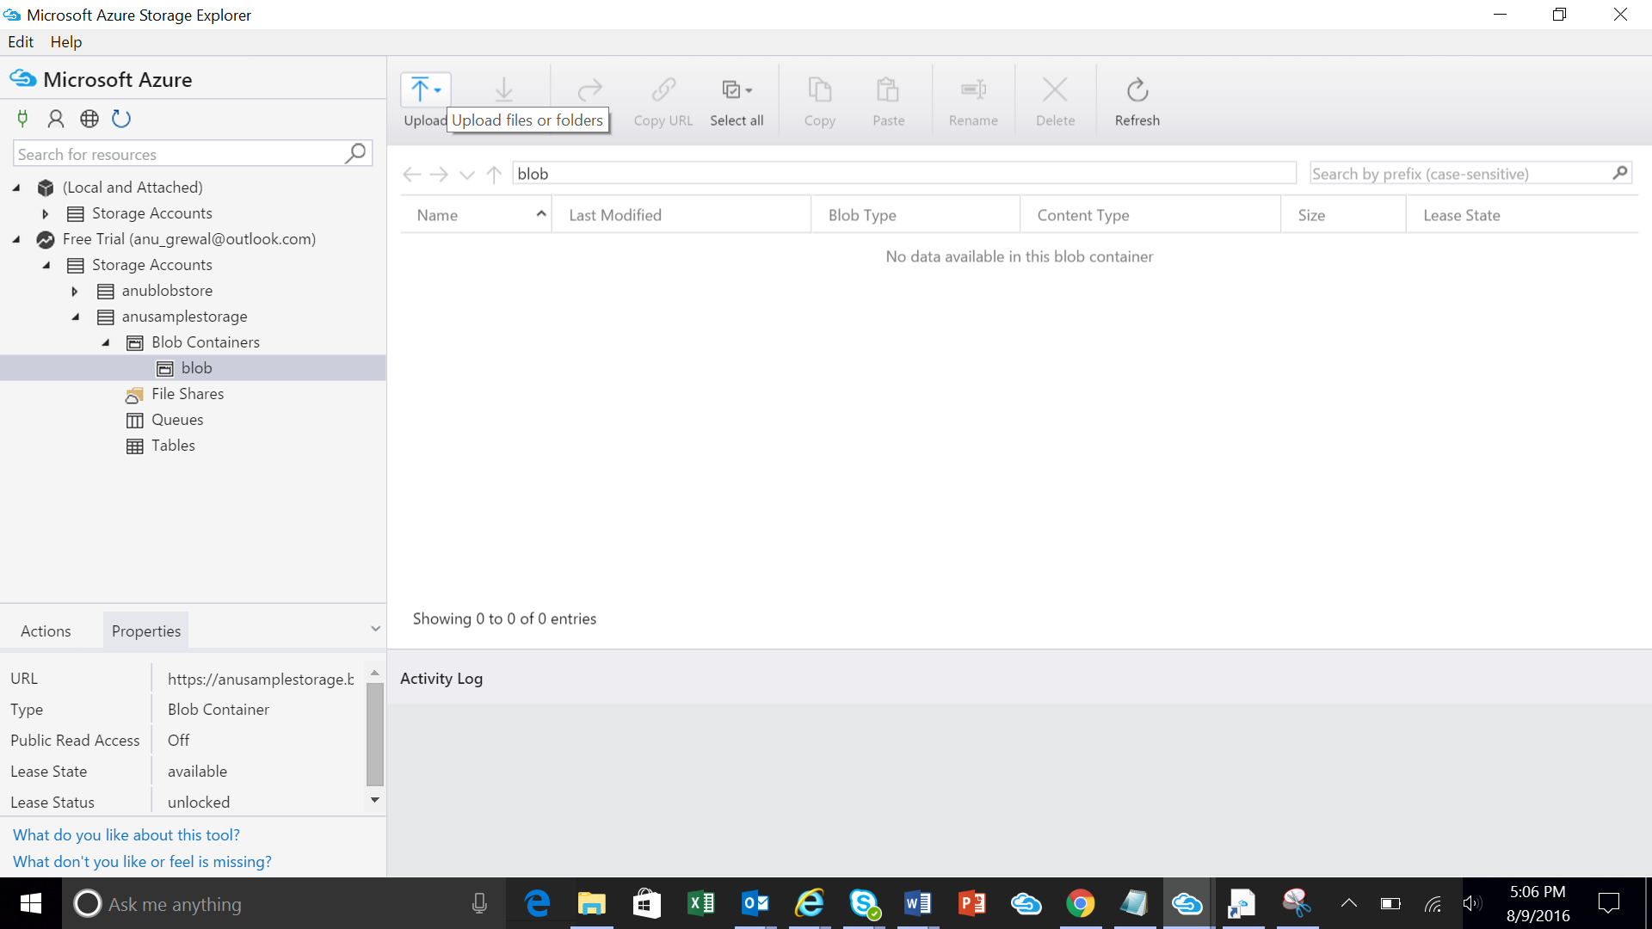

- Right click on your file and go to “Get Shared Access Signature”
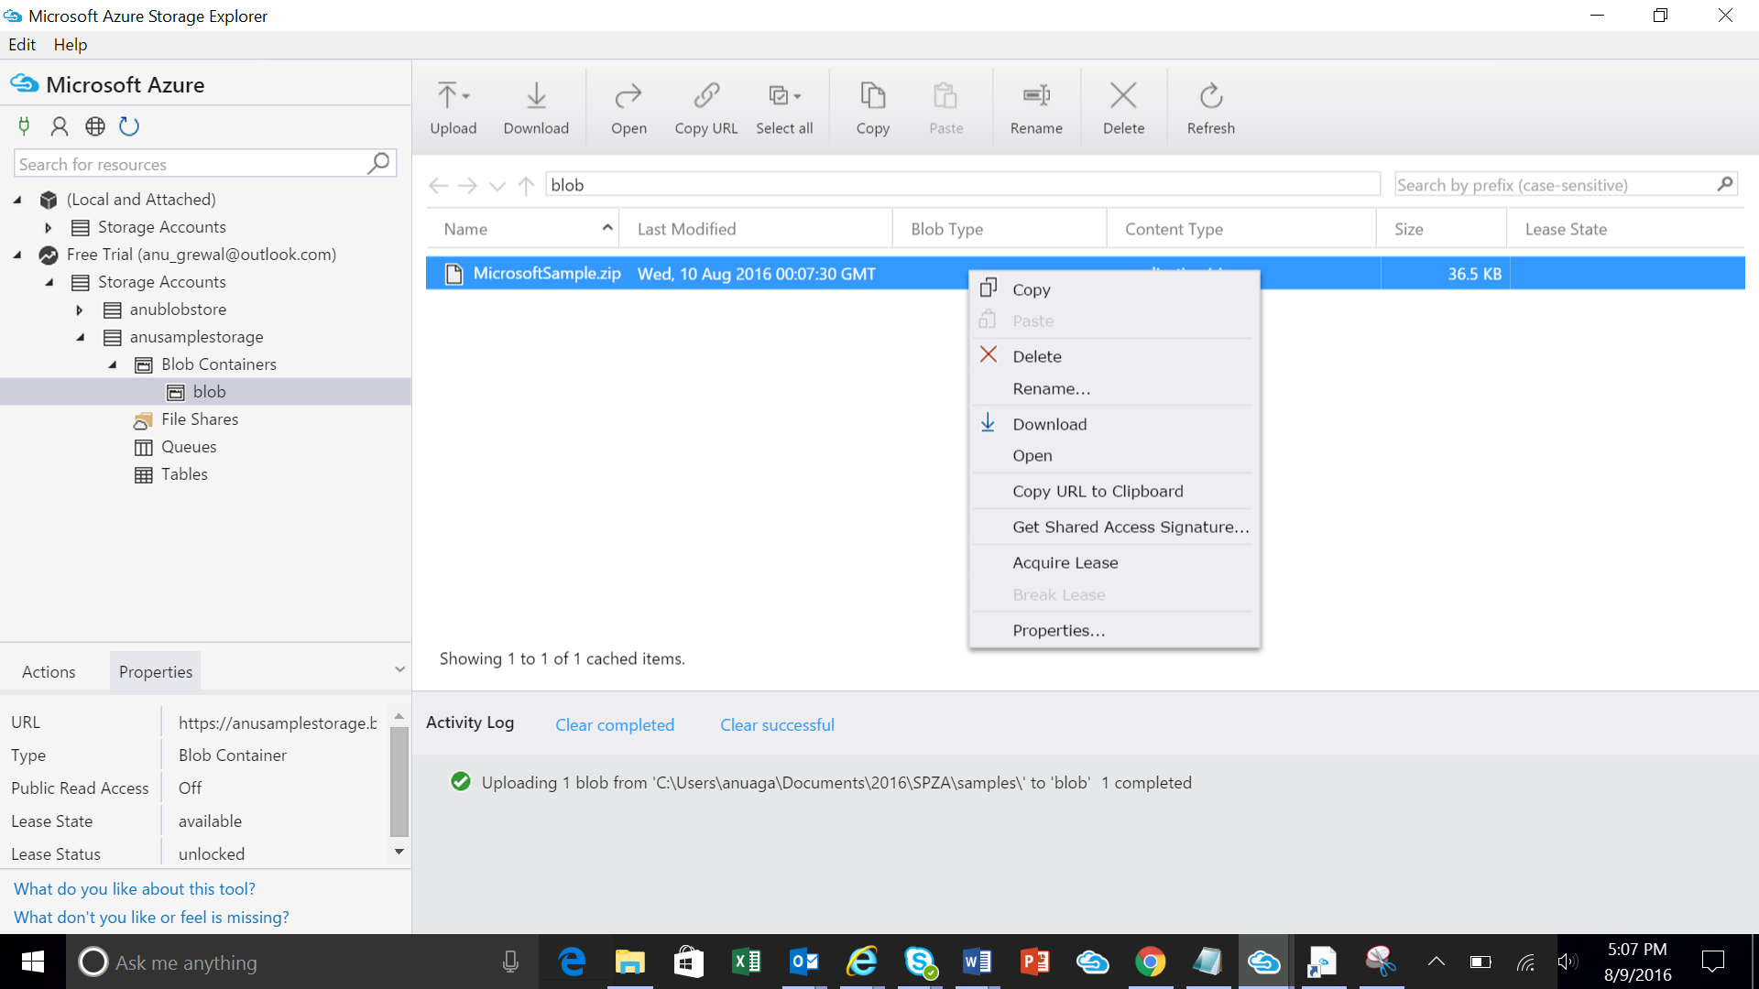

- Modify the Expiry date to make the SAS active for a month and click Create

- Copy the URL field and save it for later. You will need to enter this URL in the below step CRM Package

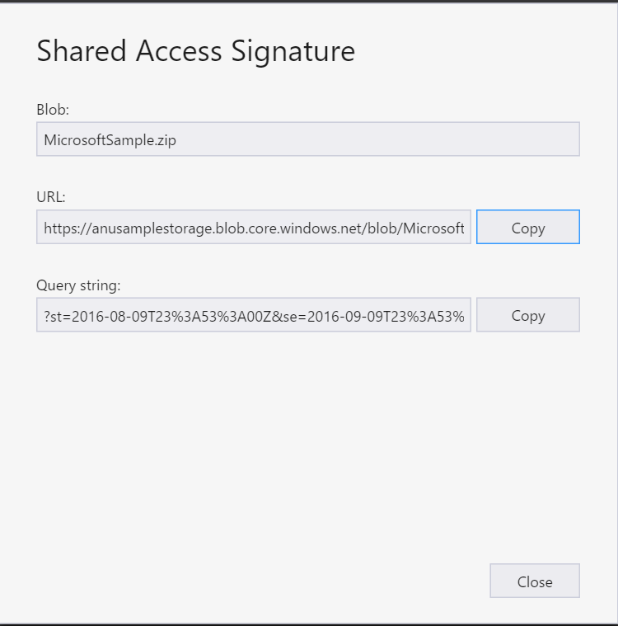

Setup your application in the Publishing Portal
You are now ready to setup your application in the publishing portal.

Login and Create a New Offer
- Login to the cloud partner portal.
- From the left navigation bar, click on "+ New offer" and select "Dynamics 365 for Customer Engagement.”
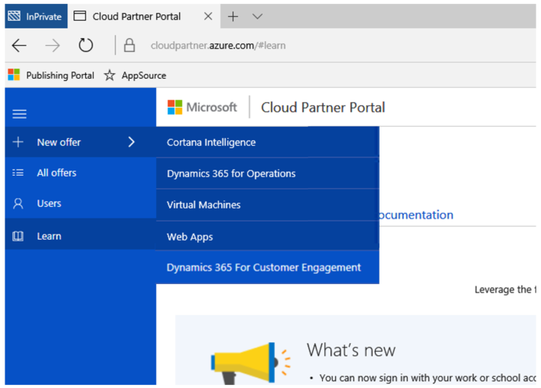

- A new offer "Editor" view is now opened for you, and we are ready to start authoring.
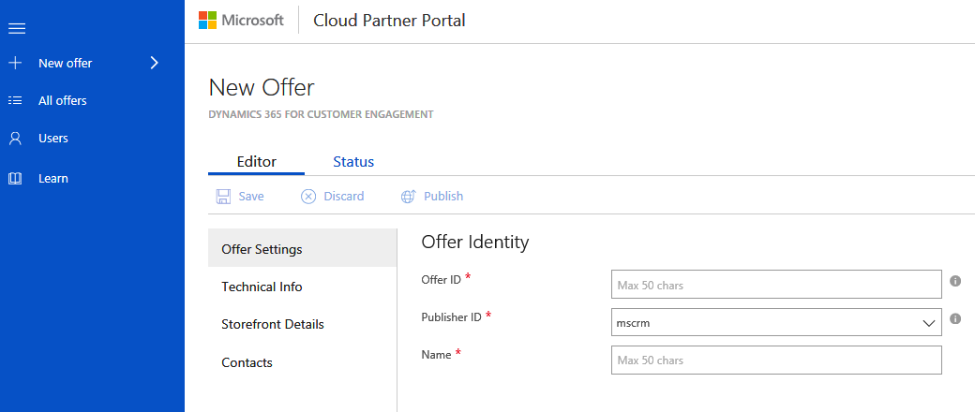
- The "forms" that need to be filled out are visible on the left within the "Editor" view. Each "form" consists of a set of fields that are to be filled out. Required fields are marked with a red asterisk (*).
There are 4 main forms for authoring a Dynamics 365 for Customer Engagement offer
- Offer Settings
- Technical Info
- Storefront Details
- Contacts

Fill out the Offer Settings form
The offer settings form is a basic form to specify the offer settings. The different fields are described below.

Offer ID
This is a unique identifier for the offer within a publisher profile. This ID will be visible in product URLs. It can only be composed of lowercase alphanumeric characters or dashes (-). The ID cannot end in a dash and can have a maximum of 50 characters. Note that this field is locked once an offer goes live.
For e.g., if a publisher "contoso" publishers creates an offer with offer ID "sample-Web App", it will show up in AppSource as "https://appsource.microsoft.com/marketplace/apps/contoso.sample-Web App?tab=Overview"

Publisher ID
This dropdown allows you to choose the publisher profile you want to publish this offer under. Note that this field is locked once an offer goes live.

Name
This is the display name for your offer. This is the name that will show up in AppSource https://appsource.microsoft.com/en-us/. It can have a maximum of 50 characters.
Click on "Save" to save your progress. Next step would be to add Technical Info for your offer.

Fill out the Technical Info form
The technical info form is where you will fill in information specific to your Dynamics 365 for Customer Engagement solution. Hovering over the will present you with more information. See the example below.
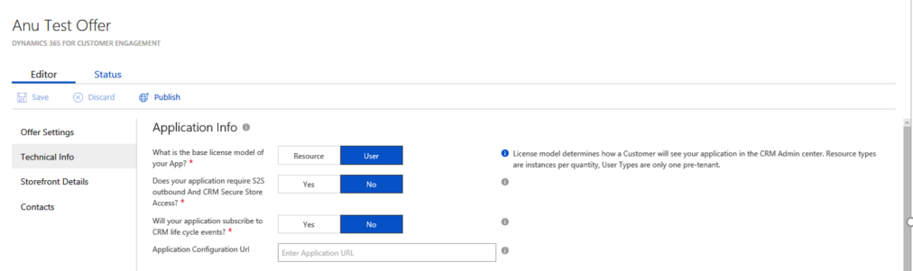

Application Info
Most publishers will leave these fields with the default values, User, No, No, and a blank Application Configuration URL as per the screenshot above.

CRM Package
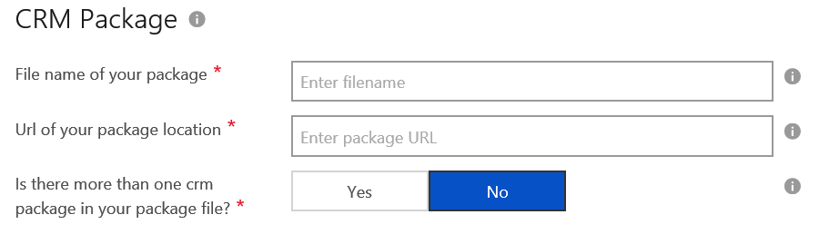
Here is an explanation for these fields:
- File name of your package: The file name you created in the above step when creating the zip file that is your CRM AppSource Package. In the above example it is “Microsoft_SamplePackage.zip” that was created using the step here.
- Url of your package location: This is the URL to the Azure Storage account that contains the package file name specified above. It is the URL created in Step 9 of the section above Store your CRM AppSource Package to Azure storage and generate a URL with SAS key.
- Is there more than one crm package in your package file: Select Yes ONLY if you are supporting multiple versions of crm with different packages. For most partners this will be “No.” If you select Yes, you need to create AppSource Packages for each version of your solution. Note: This is NOT asking if you have multiple solution.zip files. If you have multiple solution.zip files but only one version you should still select “No.” The packaging tool will bring these together in automatically .

CRM Package Availability
In this section select what regions of CRM your package will be made available to. For information on which regions serve which countries, please see the link: http://o365datacentermap.azurewebsites.net/
Note: Deploying to Germany – Sovereign and US Gov Cloud – Sovereign REQUIRES SPECIAL PERMISSION and VALIDATION DURING CERTIFICATION

Storefront Details

Offer Summary
This is a summary of your offer's value proposition. It will appear on your offer's search page. It should be a maximum of 100 characters.

Offer Description
This is the description that will appear on your app detail page. Maximum allowed is 1300 characters

Industries
Select the industry that your app is best aligned to. If you app has relates to multiple industries, you can leave this blank.

Categories
Select the categories that are relevant to your app. Select a maximum of 3.

App type
Select the type of trial that your app will enable on AppSource. 'Free' means your app is free. 'Trial' means customers can try your app for a short period on AppSource. 'Request for trial' is not supported for Dynamics 365 for Customer Engagement apps. Please do not select this option.

Help link for your app
Enter URL to a page that has help related information for your app.

Supported countries/regions
This field determines the countries/regions in which your offer will be available for trial.

Supported languages
Select the languages that your app supports. If your app supports additional languages that are not on this list, continue to publish your offer and email us at: appsource@microsoft.com to let us know.

App version
Enter the version number for your app

App Release Date

Enter the release date for your app

Products your app works with (Max 3)
List specific products that your app works with. You can list maximum of 3 products. To list a product, click on the plus sign (beside new) and a new open text field will be created for you to enter the name of a product that your app works with.

Search keywords (Max 3)
AppSource allows customer to do search based on keywords. You can enter the set of keywords for which your application will be shown to the customers.
For example if the application is "My Emailing Service" Emails, Mailing, Mail service might be some keywords. Choose words that users will likely use to search for your app in the AppSource search box.

Hide key
This is a key that will be combined with the offer preview URL to hide it from public view. It is not a password. You can enter any string here.

Offer logo (png format, 48x48)
This will appear on your app's search page. Only png format is allowed. Upload a png image with resolution of 48PX*48PX

Offer logo (png format, 216x216)
This will appear on your app's detail page. Only png format is allowed. Upload a png image with resolution of 216PX*216PX

Videos
You can upload maximum of four videos. For each video you want to upload, you need to fill in the video name, URL (YouTube or Vimeo only) and Thumbnail to associate with the video. Thumbnail must be in png format and must be 1280PX*720PX. To add new video(s), click on the plus sign. Videos thumbnail(s) will appears on your app's detail page.

Documents
You can upload maximum of three documents in PDF format. For each document you want to upload, you need to fill in the document name, and upload the document. Document must be in pdf format.
To add new document(s), click on the plus sign

Screenshots
These are screenshots that will appear on the AppSource detail page for your app.

Privacy Policy
Enter URL to your app's privacy policy

Terms of use
Enter the terms of use of your app. AppSource customers are required to accept these terms before they can try your app

Support URL
Enter the support URL for your app.

Lead Destination
Select a CRM system where you lead will be stored. Select "Azure Table" here if you have one of the following CRM systems: Salesforce, Marketo, Microsoft Dynamics CRM. The CRM system you select here is where we will write details of end users that try your app on AppSource (leads). Depending on the CRM system you select, click the corresponding URL below for information on how to complete the next set of fields
- Azure Table
- Marketo
- Microsoft Dynamics CRM
- Salesforce

Storefront Details
The contact details are used for internal communication between the partner and Microsoft only. Please note: It is very important to use an email address that is monitored in these fields. We will use this email to communicate with you on your progress in publishing to AppSource. Only the support URL will be visible to the customers.

Request to publish the app
Click the Publish button to submit your offer to our certification team. 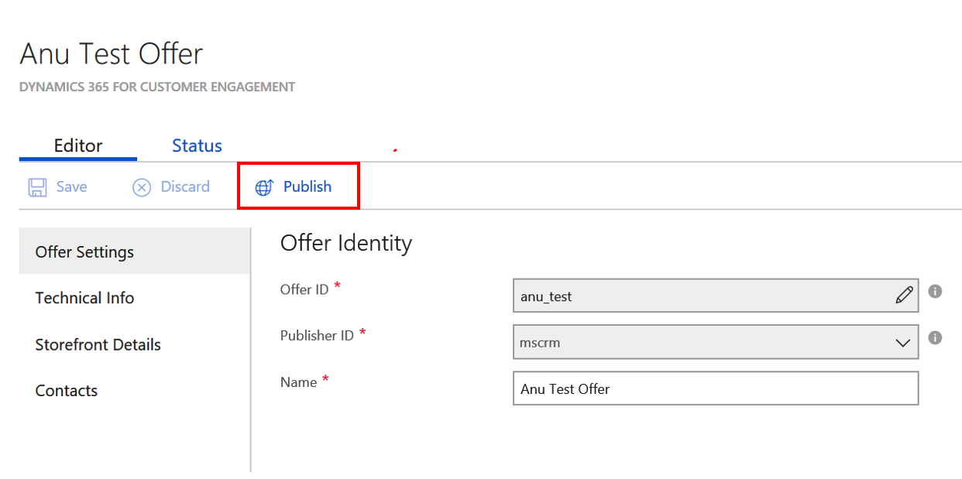
You will be able to view the status of your offer under that Status tab.

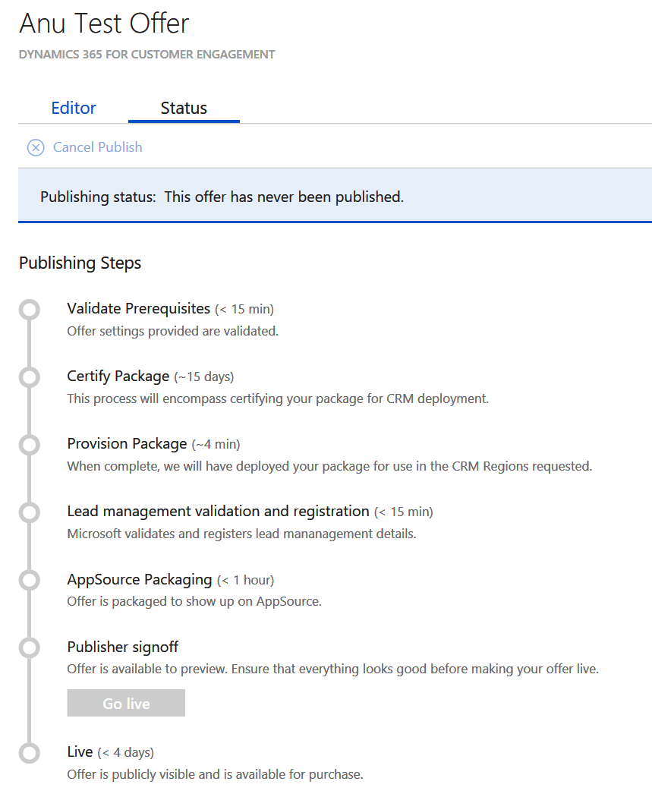

Special considerations for Microsoft Dynamics 365 Business Edition
Please note that solutions built for Microsoft Dynamics 365 Business Editions will undergo additional checks during certification to ensure the Business Edition limits are adhered to. The Business Edition limits are documented here.

Getting help
If you run into issues you can log a support ticket by clicking the 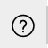 in the top right corner and going to 
