User Guide

Auto Number Configuration

Contents

1.Importing AutoNumber solution in D365

2.Configuration of AutoNumber solution in D365

3.AutoNumber functionality in D365

1.Importing AutoNumber solution in D365

Steps for the Installation of the AutoNumber solution in D365 are given below

Step 1:

Navigate to settings and go into solutions.
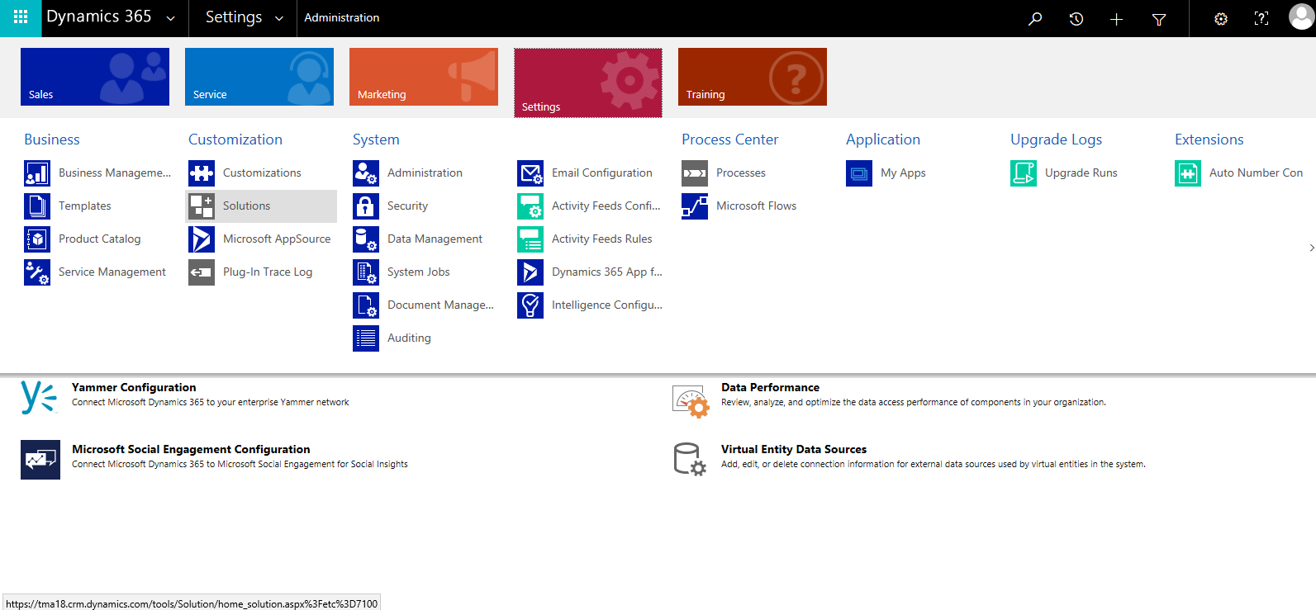

Step 2:

Click on Import
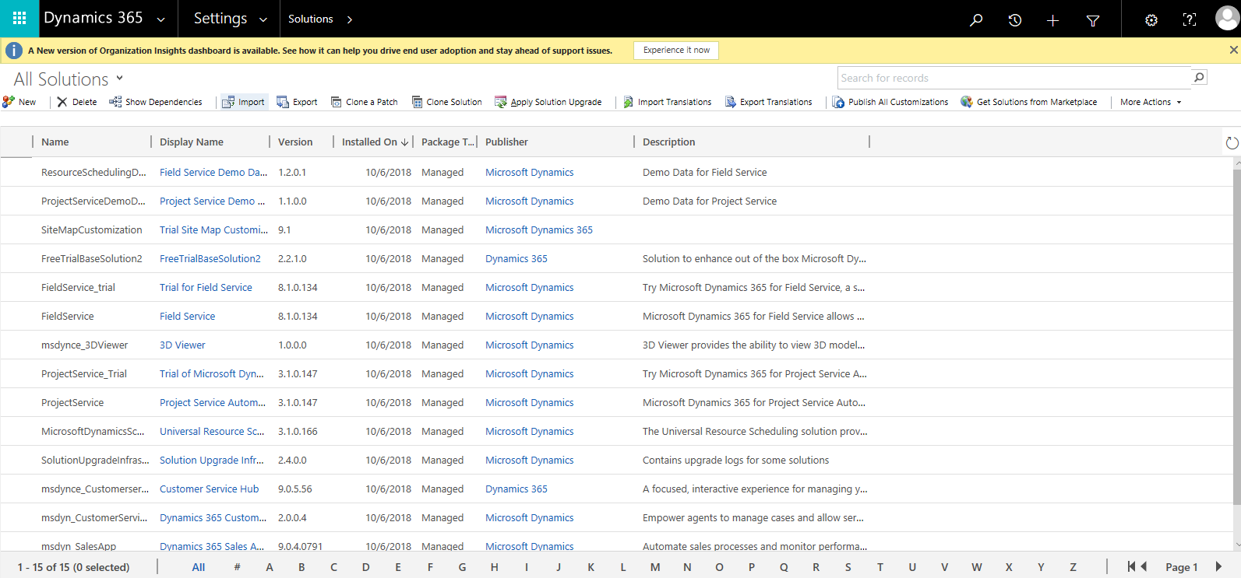

Step 3:

Select the AutoNumber zip file and click on next
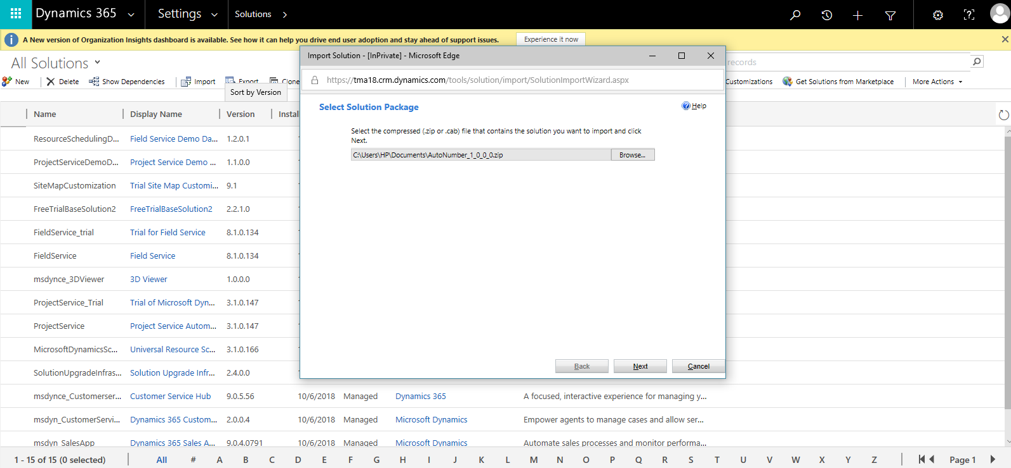

Step 4:

Check the box of Enable any SDK message processing steps included in the solution and click on import.
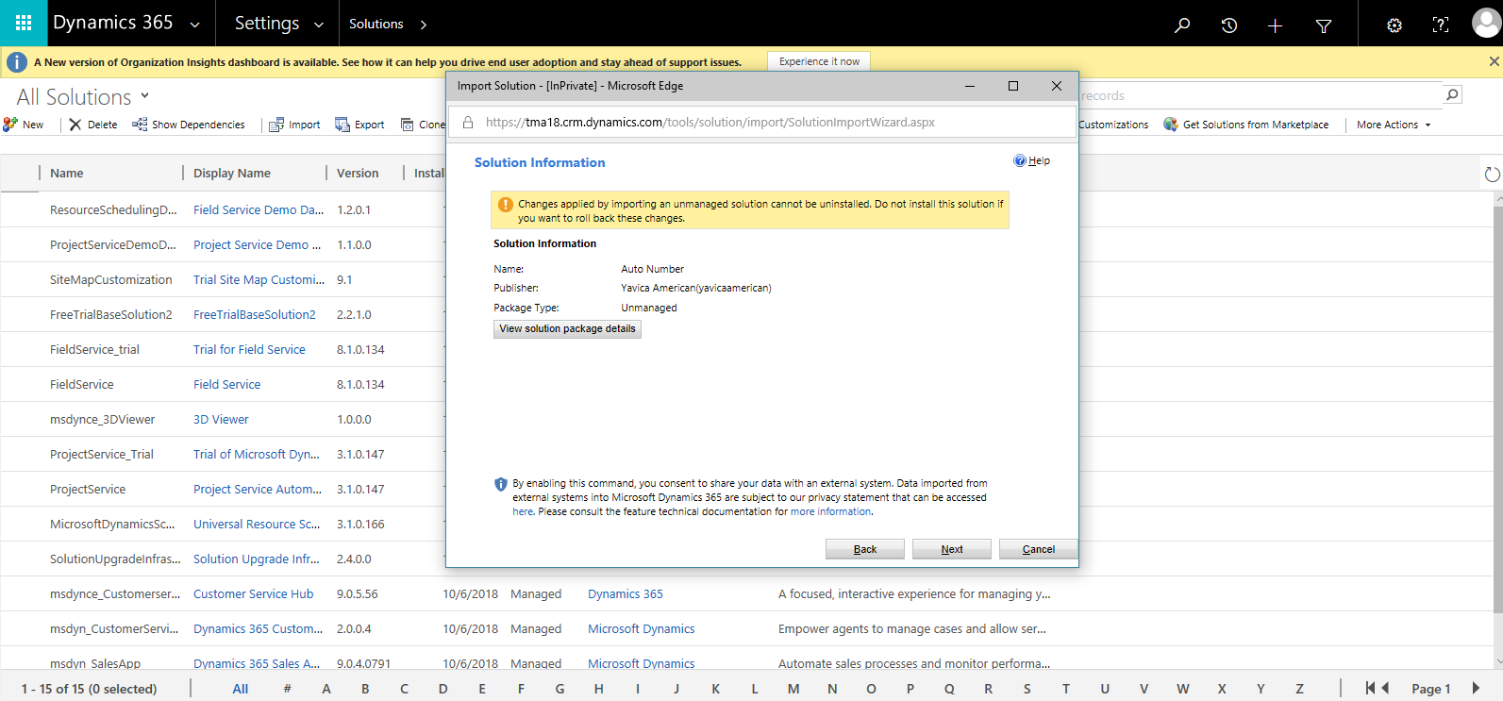
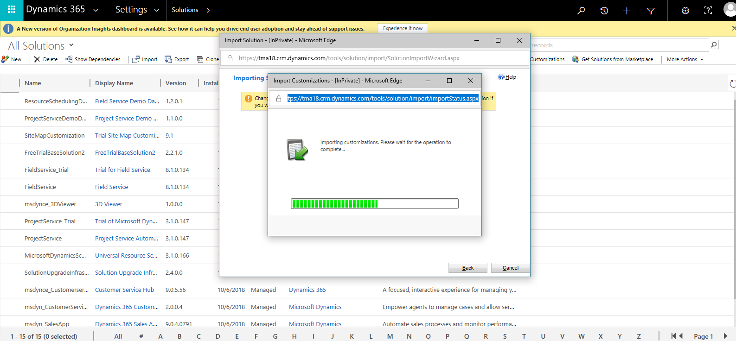

Step 5:

Once the customizations are done being published click on close and you can see the imported AutoNumber solution the in solutions view
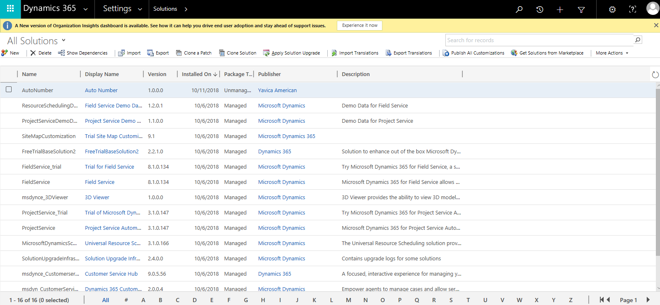

2. Configuration of AutoNumber solution in D365

2.1 Configuration of the AutoNumber solution is given below

Step 1:

Navigate to Advanced Find
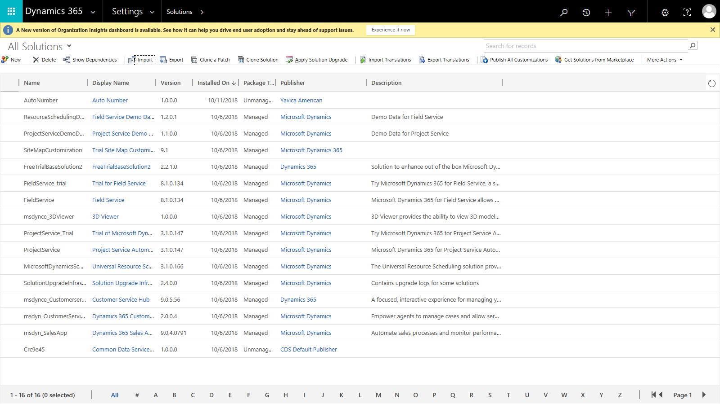

Step 2:

Select Auto Number Configuration
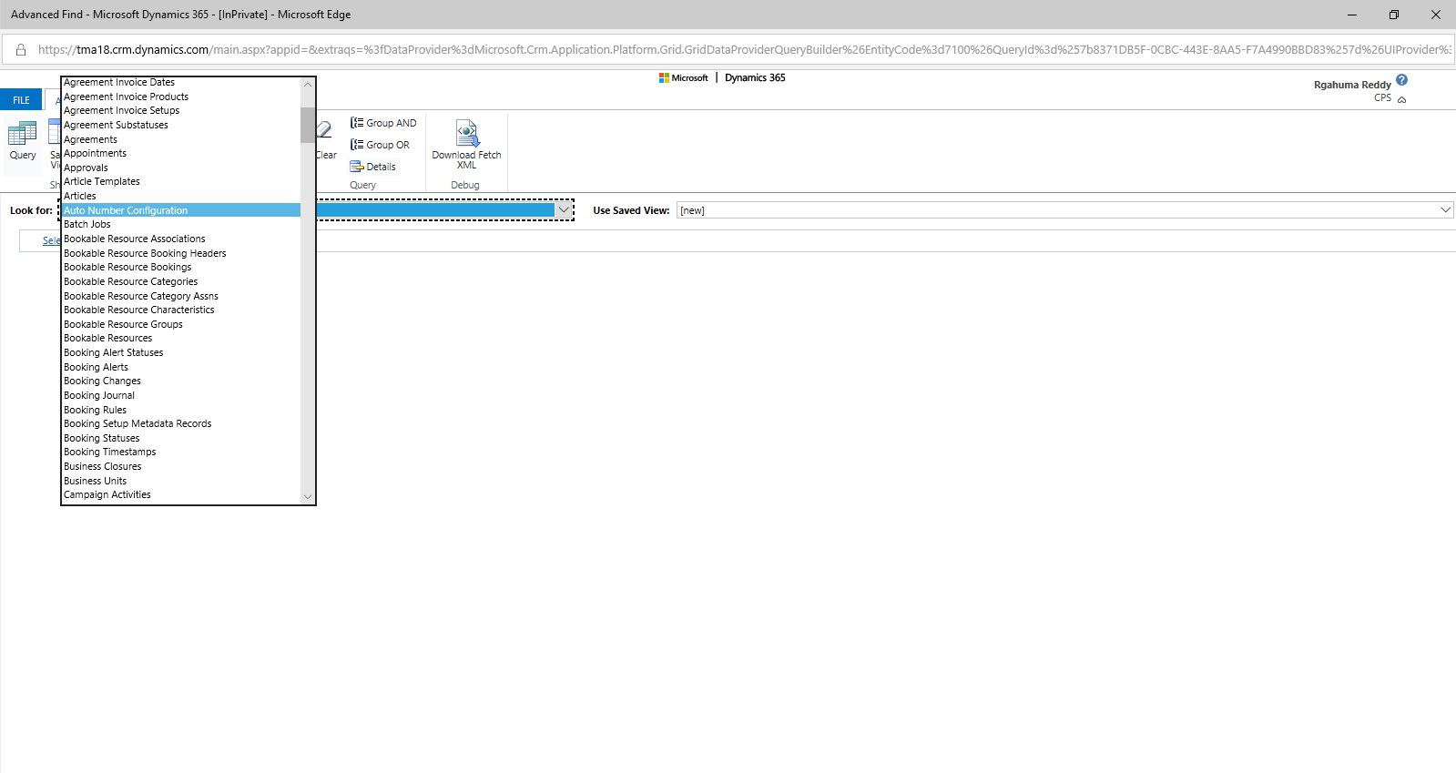

Step 3:

Click on Results and then on Auto Number Configuration to create a new record.

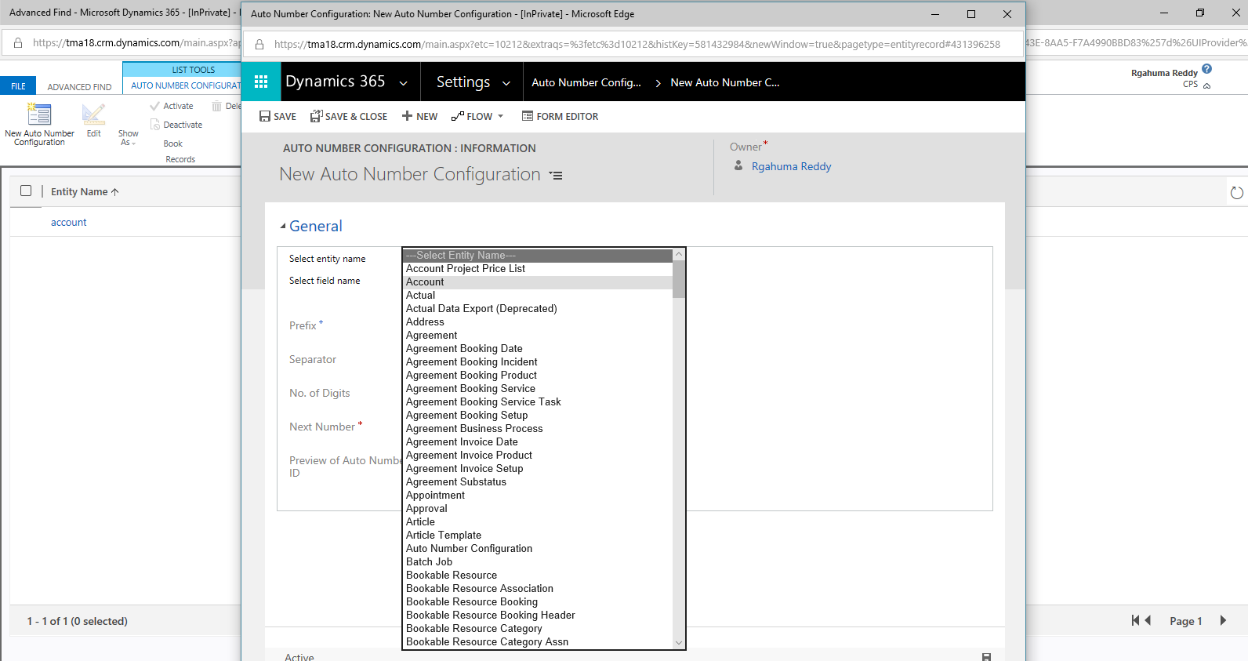

Step 4:

Select the entity name, entity field name and enter the remaining details and then save the record.
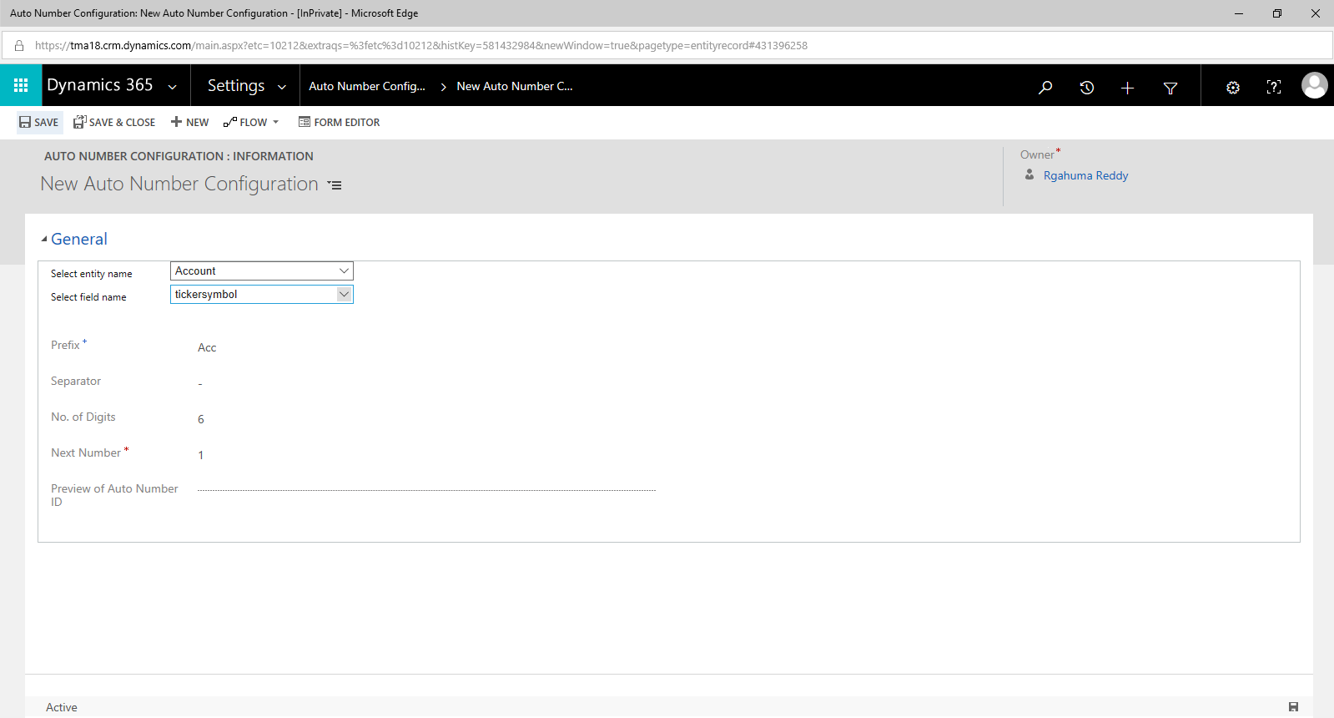

3. AutoNumber functionality in D365

3.1 This is the step by step functionality of AutoNumber Configuration.

Step 1:

Navigate and go to the entity name selected in AutoNumber Configuration (account in this case)
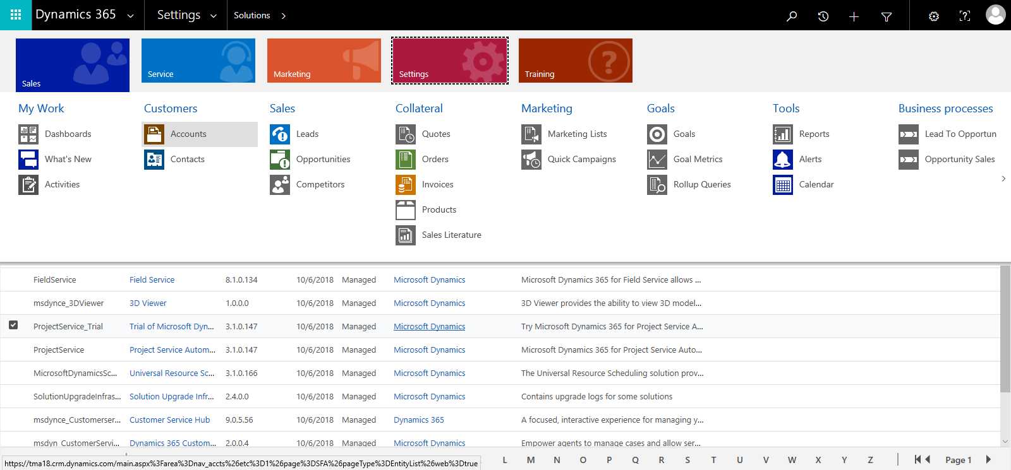

Step 2:

Create a new record and click on save
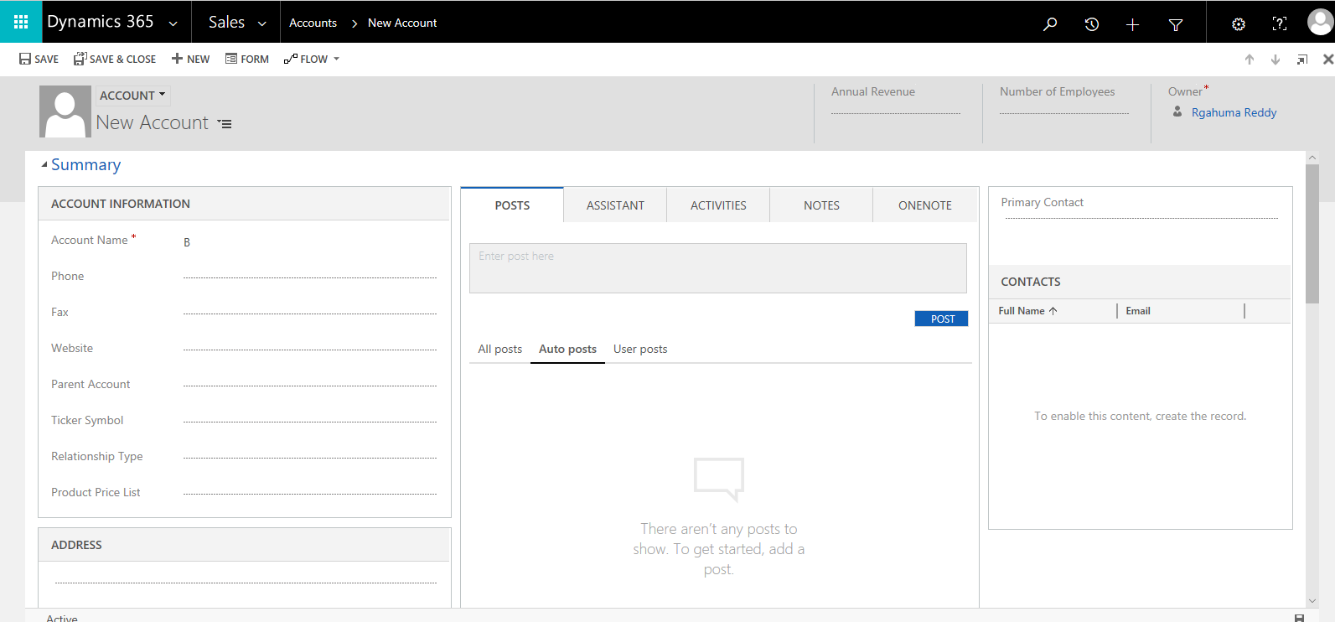

Step 3:

The entity field name (trickersymbol) will be updated automatically according to the Auto Number Configuration record created
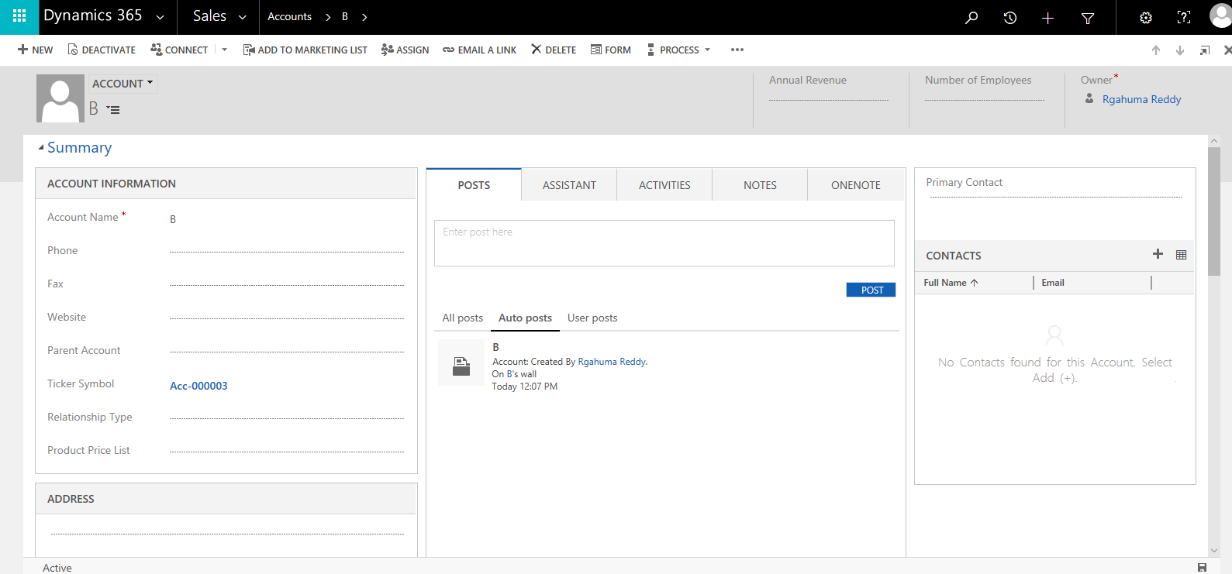
You can see that the trickersymbol has been updated.

