PAYMENT GATEWAY PREMIUM FOR DYNAMICS 365

TABLE OF CONTENTS
PAYMENT GATEWAY USER MANUAL 2
Set Up 2
Create a Customer (Account / Contact) Profile 5
Create a Transaction 6

PAYMENT GATEWAY PREMIUM USER MANUAL

Set Up

Step One:
To use our integration, go to Settings > Payment Gateway > Configurations and create a record of type Iframe. The URL will be provided by CRM Dynamics and will look something like this URL: https://crmdpaymentgateway.azurewebsites.net/{ENVIRONMENT}.{VERSION}/
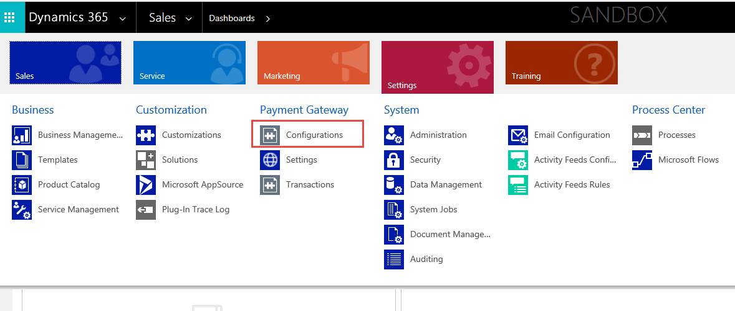
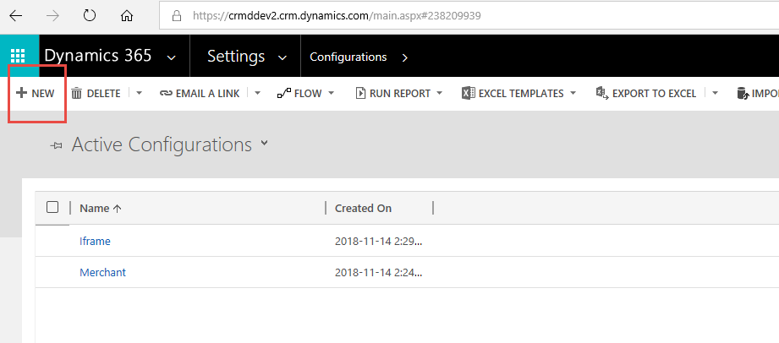
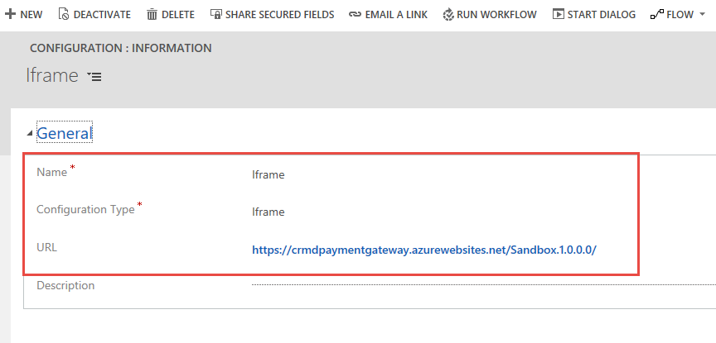

Step 2:
Sign into website by going to Settings > Payment Gateway > Settings. Authorize the website with your credentials. Note: Trial period lasts 30 days.
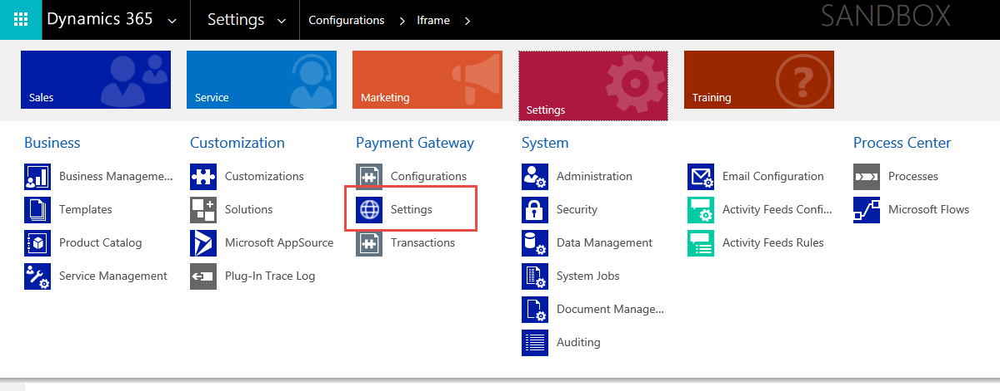

Step 3:
Sign into Merchant:
Go to Settings > Payment Gateway > Configuration. Create a record of type Authorize.NET Profile. A sample sandbox profile will be available by default to be signed in. You can sign into your merchant with API Client ID/ Transaction Key or via our Partner Account (OAuth 2.0). If you choose the latter, please contact CRM Dynamics for Client ID/Client Secret for PRODUCTION ENVIRONMENT. Multiple merchant profiles are supported so long as they are different currencies.

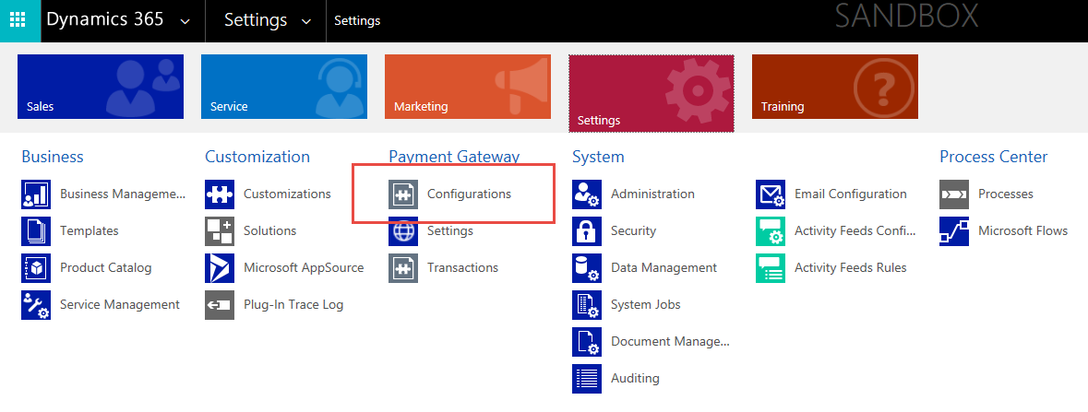
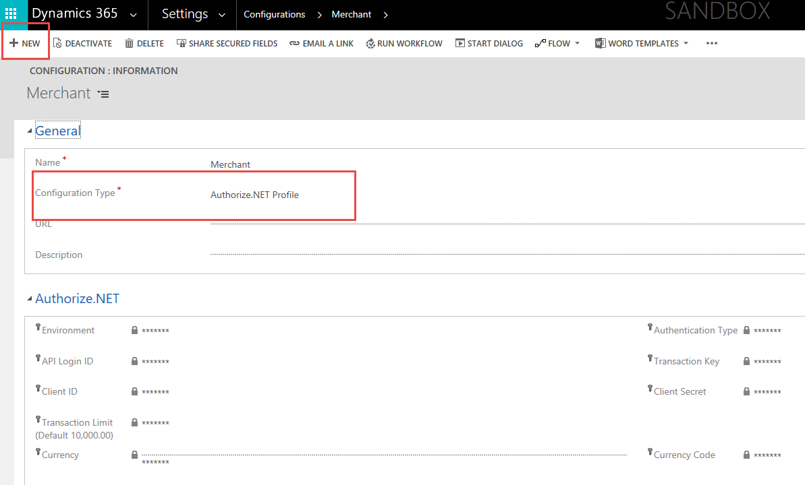

Create a Customer (Account / Contact) Profile
Step One:
Go to Sales > Account or Contact
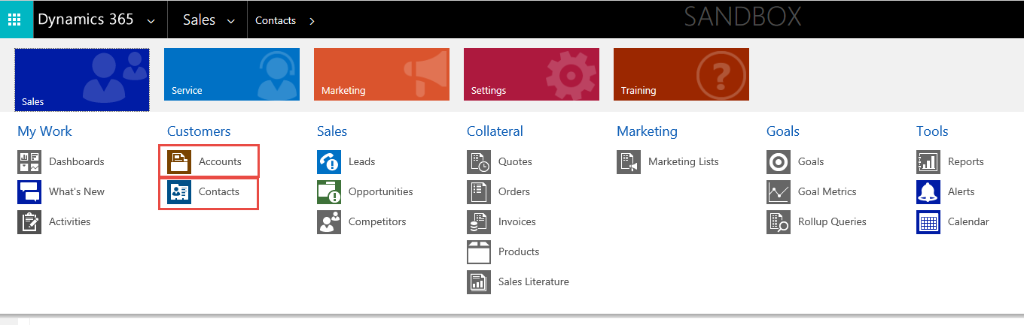
Step Two:
Use the Payment Gateway Form
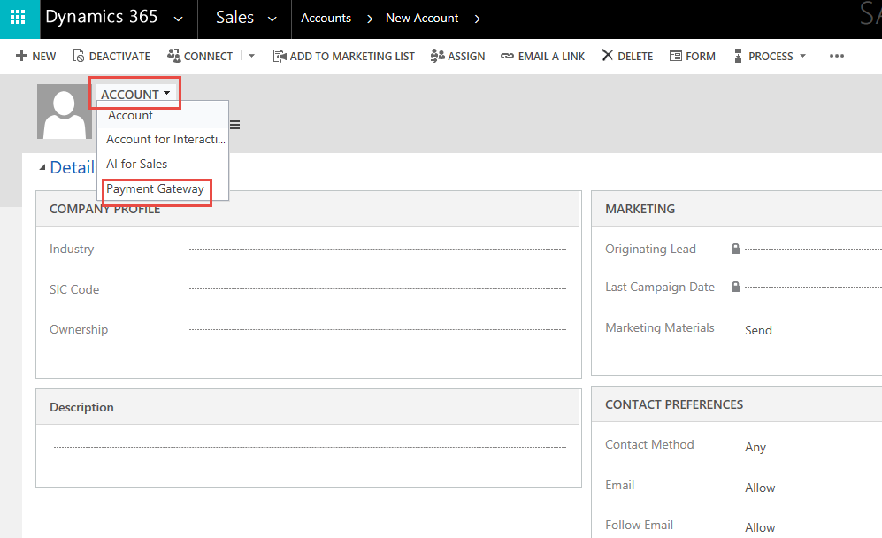

Step 3:
Account Type/Contact Type must be “Client” for the Authorize.NET tab to appear.
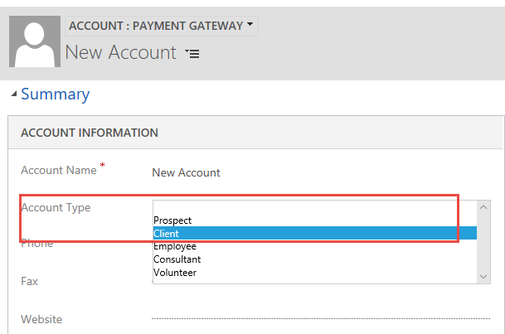

Step 4:
Add Payment Profile(s)
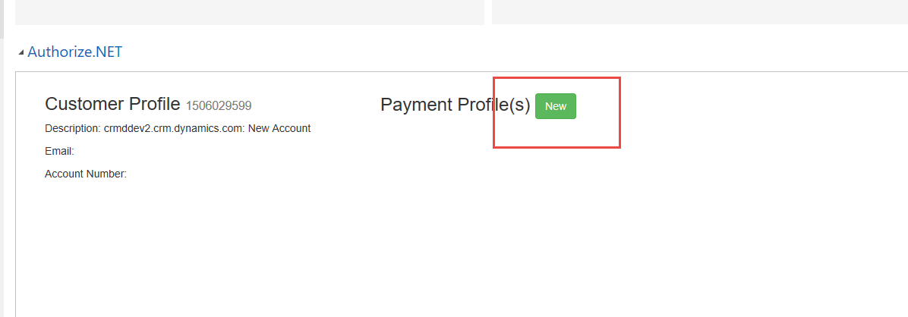

Create an Invoice

Step One:
Go to Contacts > New > Contact Type = Client then hit save. Make sure you are using the Payment Gateway contact form.
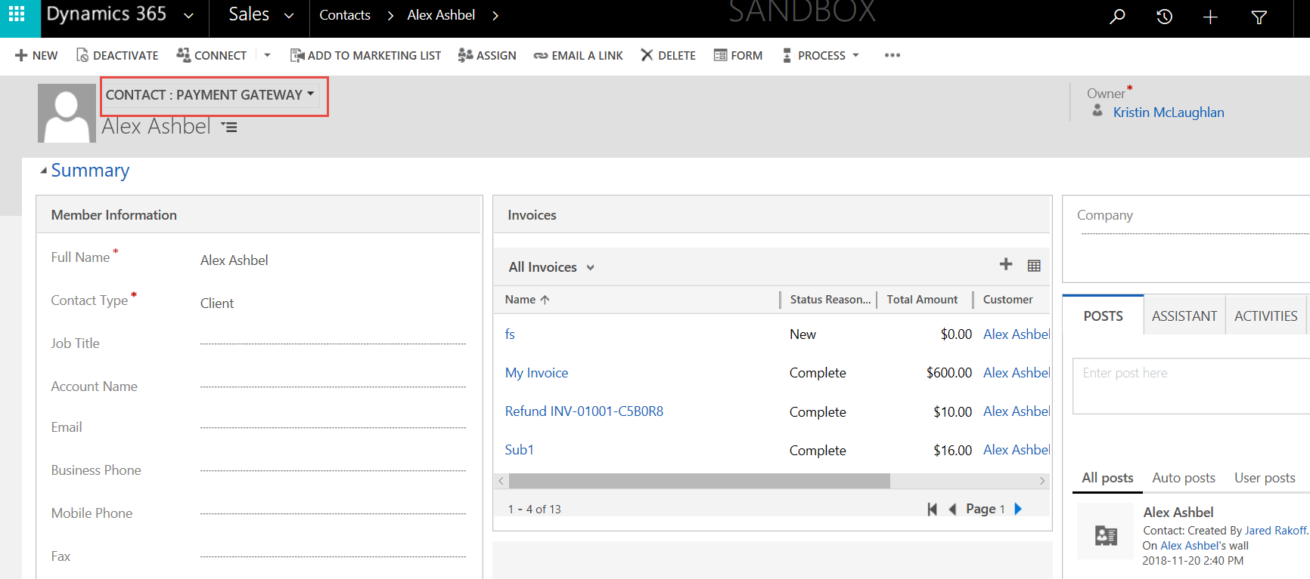

Step 2:
Authorize Payment Type can be a One Time Payment, Recurring, or Refund.

Go to Contacts > Choose your contact you saved previously > Create New Invoice
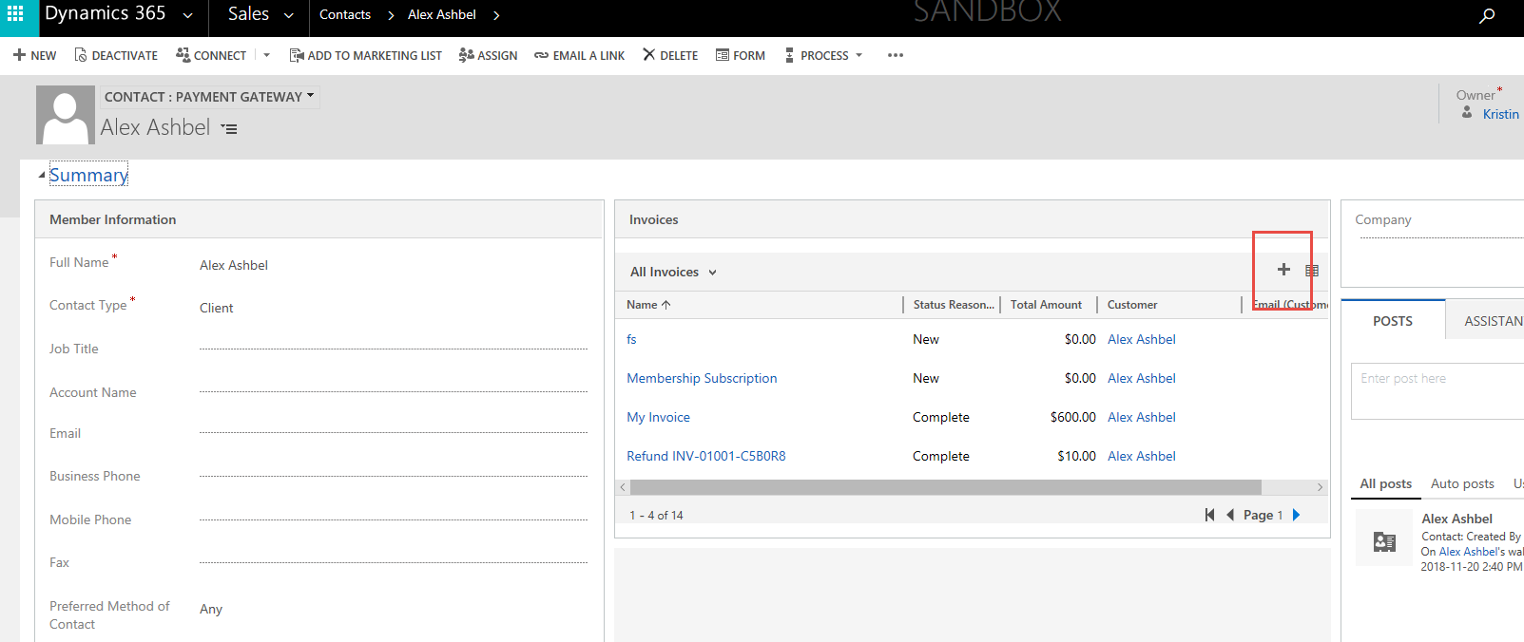

Step 3:
Fill in all the information you need for the invoice:
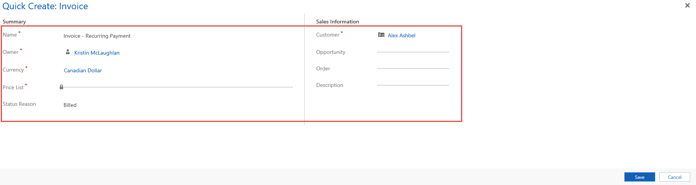

Step 4:
For a Recurring Payment: Open the Invoice you created in the last step and scroll down to the Authorize.NET area of the form.

- The Start Date must be on or after Today. The End Date can be ongoing (Empty) or a date after the Start Date. Authorize.NET will calculate the number of occurrences automatically.
- The Interval Period is defined with a Unit (Days/Months) and Length (Quantity)
- Optional Trial periods will precede the defined interval. First three months free will be Trial Amount of Zero with Trial Occurrences of 3.
- Authorize.NET will apply the transaction and an Invoice representing that Transaction will populate
- Subscriptions can be cancelled at any time.

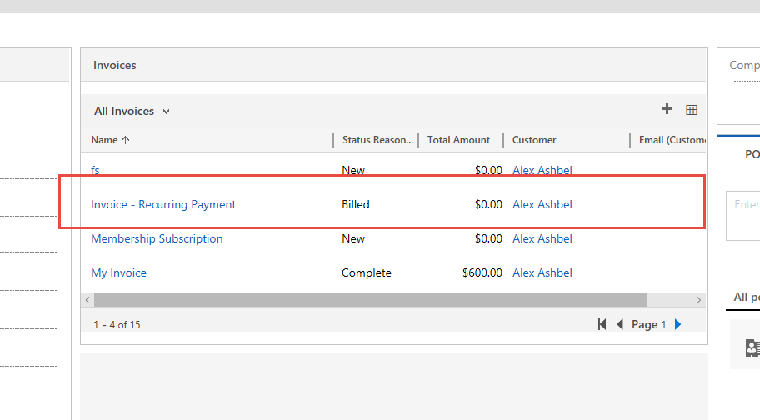

Make sure the Invoice form being used is for Payment Gateway:
