Grievance Request User Manual

Prepared for
CEM Business Solution

Project
Microsoft Dynamics AX 2012 – HRMS and Payroll

Prepared by
Dowlath

Change Record
Date | Author | Version | Change reference
30/11/2018 | Dowlath | 0.1

Reviewers
Name | Version approved | Position | Date

Abbreviations

Copy No. | Name | Location
 | CEM Business Solutions | Chennai & US

Disclaimer
© 2014 CEM Business Solution. All rights reserved.
The information in this user manual guide applies only to Microsoft Dynamics AX 2012 Payroll. It may be changed substantially prior to the final commercial release of the software described herein. This user manual guide also provides information that applies the uses of payroll
The contents of this package are for informational and training purposes only and are provided "as is" without warranty of any kind, whether express or implied, including but not limited to the implied warranties of merchantability, fitness for a particular purpose, and non-infringement.

No part of the text or software included in this training package may be reproduced or transmitted in any window or by any means, electronic or mechanical, including photocopying, recording, or any information storage and retrieval system, without permission from CEM Business Solution. Because CEM Business Solution must respond to changing market conditions, it should not be interpreted to be a commitment on the part of CEM Business Solution, and CEM Business Solution cannot guarantee the accuracy of any information presented after the date of publication. The names of actual companies and products mentioned herein may be the trademarks of their respective owners.

This content is proprietary and confidential, and is intended only for users described in the content provided in this document. This content and information is provided to you under a non-disclosure agreement and cannot be distributed. Copying, disclosing all or any portion of the content and/or information included in this document is strictly prohibited.

Contents
Table of Contents
Disclaimer 3
Introduction 4
Overview 4
Contents 5
1. Process Overview 6
2. Introduction 6
3. SET-UP 7
3.1 Grievance type 7
3.2 Final Action 8
3.3 Warning letter template 9
4. COMMON PROCESS IN RICH CLIENT 11
4.1 Create Grievance 11
4.2 Grievance Approval 13
4.3 Grievance History 15
5. COMMON PROCESS IN ENTERPRISE PORTAL 16
5.1 Create Grievance 16
5.2 Grievance Approval 18

Process Overview

A grievance is any dissatisfaction or feeling of injustice having connection with one's employment situation which is brought to the attention of management.
Disputes occur frequently in organizations big and small across the country. Thankfully most are resolved in an informal way internally and do not end up as a costly and time consuming case at the Labor Relations Commission, the Employment Appeals Tribunal or the Labor Court. In fact conflict is normal and largely unavoidable and if harnessed correctly can be used to benefit your organization in order to stimulate creativity and facilitate change.

Introduction

Grievance management process is set up through the following processes;
- Setting up Grievance types and Final Actions
- Grievance request for an employee
- Grievance request approval and processing

SET-UP

Grievance type

This form is used to enter the different types of grievances that may occur in the organization. Typically, you set these parameters before you start to manage grievances. You can change these parameters at any point of time. To get started, you will have to enter the type of grievance by following the path
Path: Legal Entity | modules| Grievance |setup| Grievance Types (human errors at work)
Demonstration:
This demonstration shows how to set up a Grievance type
- Click Grievance| Setup | Grievance Types.
- Click New.
- Enter the Grievance ID and the Description of the offence.
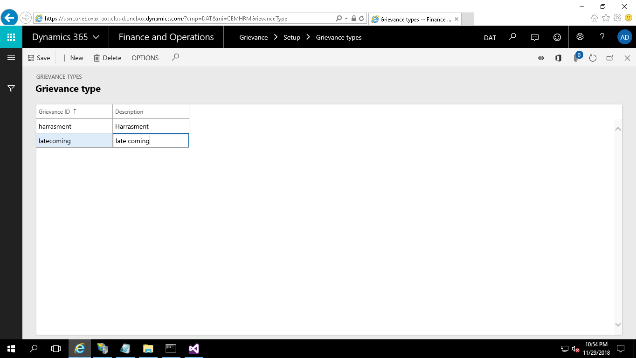

Final Action

The ’Final Action’ refers to the culminating decision of the HR Manager in response to an employee's misconduct.
Path: Legal Entity | modules| Grievance |setup| Final Action
Demonstration:
This demonstration shows how to set up a Final action
- Click Grievance| Setup | Final Action.
- Click New.
- Enter the Action ID which is the final action that will be taken, and enter the Action Description to describe the final action
- Warning Letter checkbox is used to check for issuing of warning letter. If checked a warning letter will be posted to the corresponding person or group-of-people else no.
- Final Action Letter lists out all the final actions which are Not Required, Warning letter1, Warning letter2, Suspension letter, Termination letter

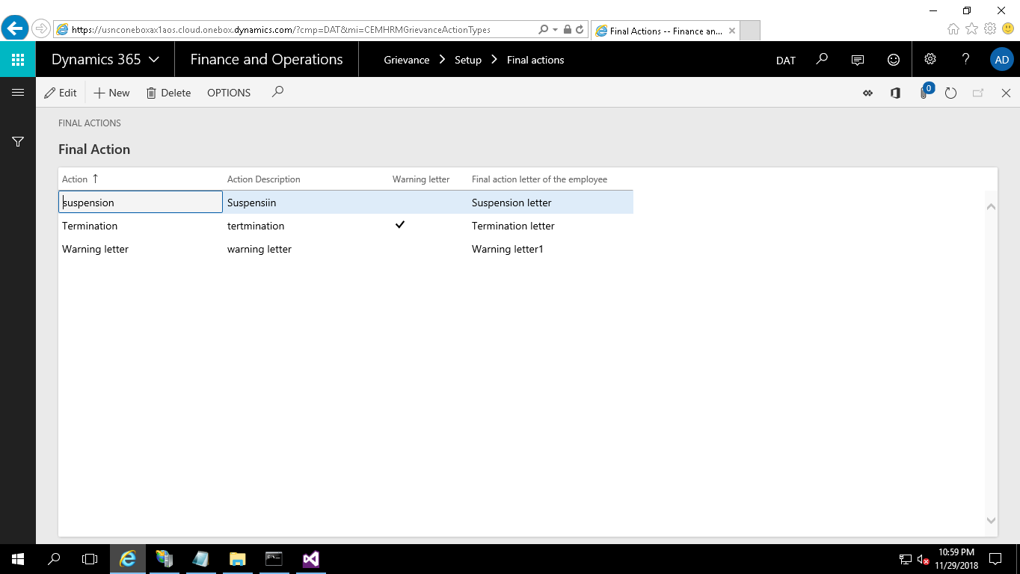

Warning letter template

Warning letters can be issued to the employees against whom grievance is proved.
This warning letters will be generated in MS Word format using pre-defined templates. To setup warning letters against each action type navigate to
Path: Legal Entity | Modules | Setup | HCM addon Parameters
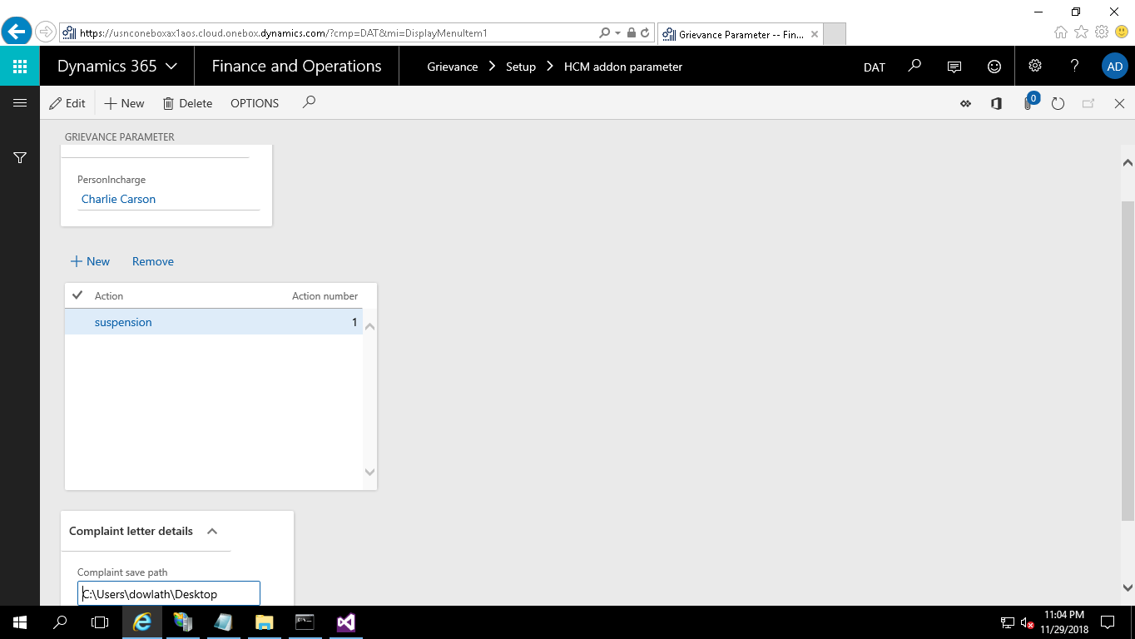

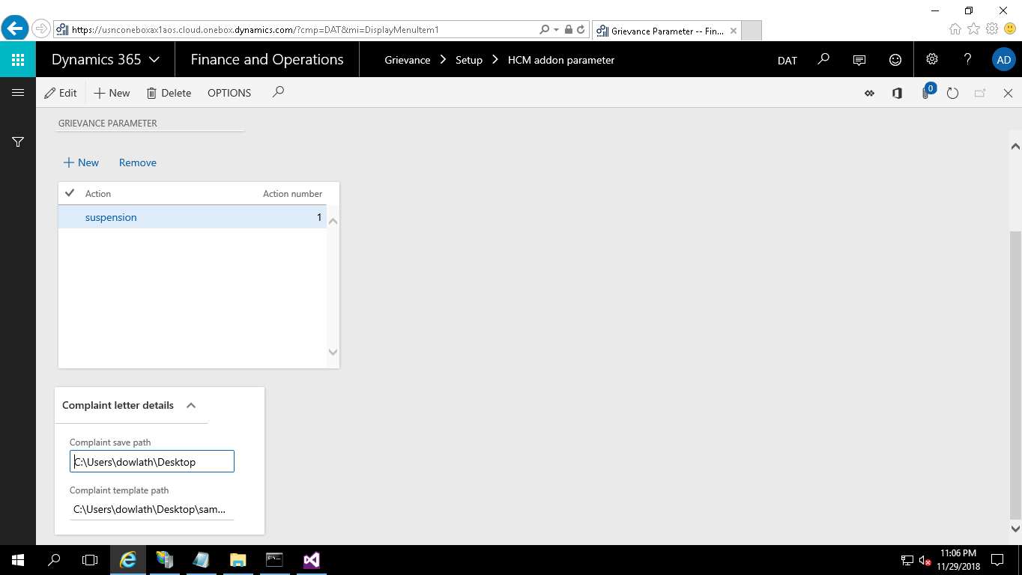

Demonstration:
This demonstration shows how to set up document details for the warning letter
Complaint Template path: Select the folder path where all the templates are stored.
Complaint Save path: Select a folder to save generated warning letters.
- Click New button.
- Select Action type. Ex: Suspension.
- System will generate action number as 1. If you add same action again, action number will become 2.
- Select the template name in Document ID field

COMMON PROCESS IN RICH CLIENT

Path: Legal Entity | Grievance | Common | Grievance requests
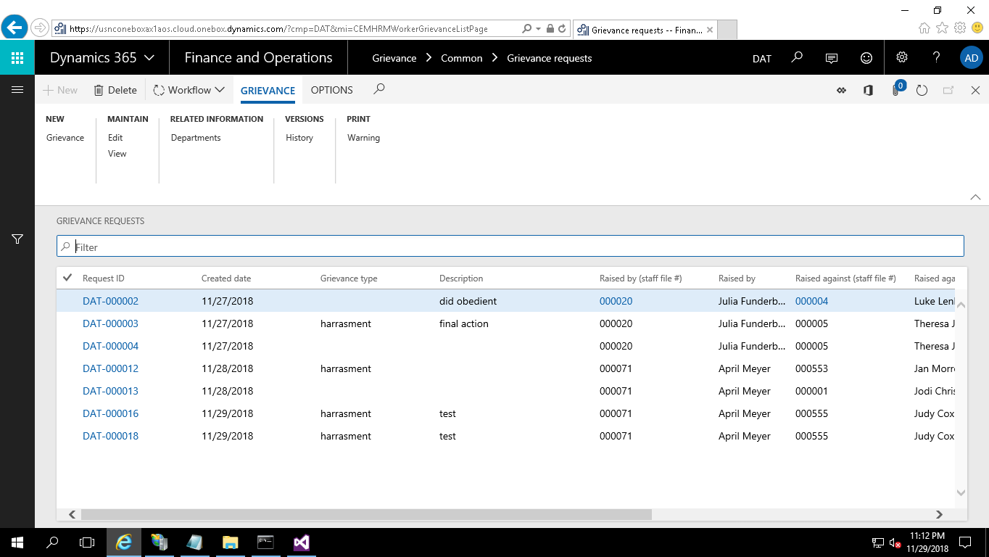

Create Grievance

To create Grievance the mandatory fields Grievance ID, Justification, Requested for employee details must be filled in.

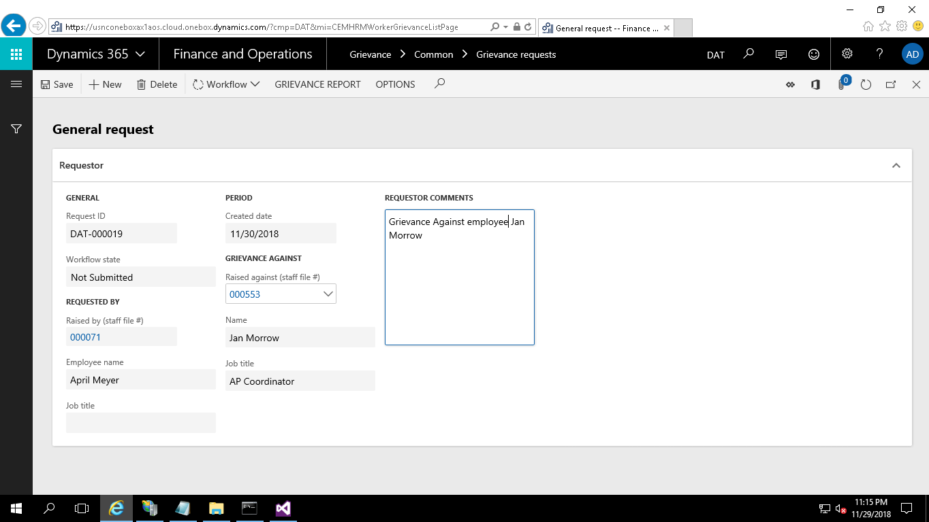

Demonstration:
This demonstration shows how to create Grievance for an employee
- Click Human Resource |Common | HR-Operations | Grievance requests.
- Click Grievance button under New group
- Select the Employee for grievance.
  - Expand the Requestor/Manager fast tab.
  - Request ID, workflow state and created date fields under Requested by group is automatically updated with general setup.
- In requested by field
  - Raised by field is updated automatically based on the person who raises the request. Based on that the employee name will be updated.
  - Job title updated automatically based on employee master.
- In “Grievance against” field
  - Raised against field is updated automatically based on the person who raises the request. Based on that the employee name will be updated.
  - Job title updated automatically based on employee master.
- Requestor comments are filled by the requestor.
- Hit Ctrl+S keys to save the form.

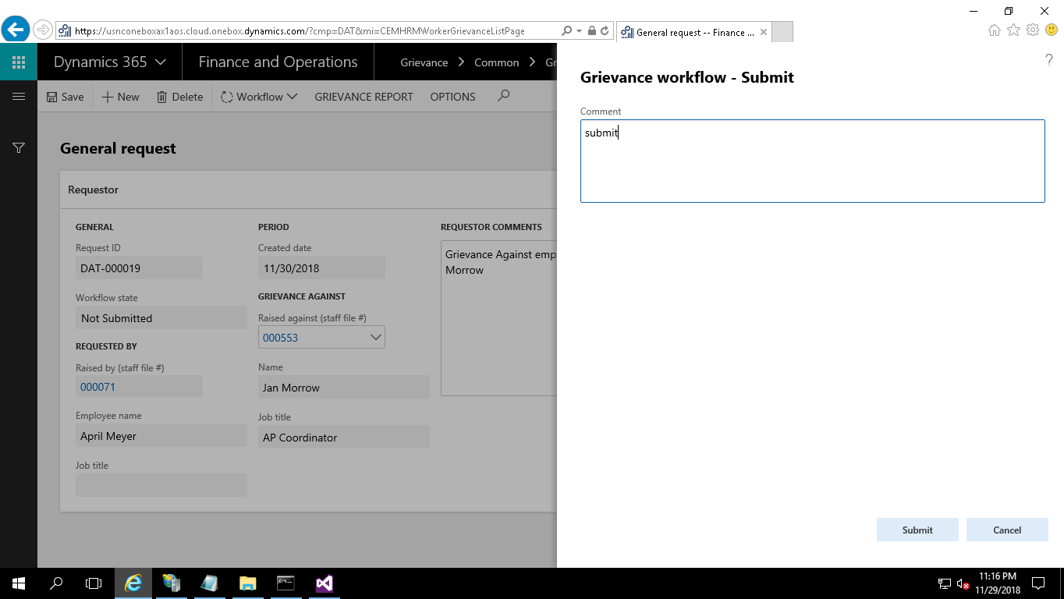

- Click the Submit button to initiate the Grievance Approval Workflow.

Grievance Approval

- Once the grievance request is submitted, a workflow is initiated and channeled for HR’s approval.
- The approving HR will receive a notification to approve the Grievance request and it is either approved or rejected.
- The Human Resources fast tab is enabled to the approving HR.
- Under Grievance Tab, grievance type feed is selected from the dropdown which is maintained in setup.
- Under Final Action tab, the final action is selected from the dropdown which is also maintained in setup.
- Valid from and valid to field should be updated based on the time period estimated for the grievance.
- Once the process is complete, click on approve so that the record status changes to ‘Approved’.

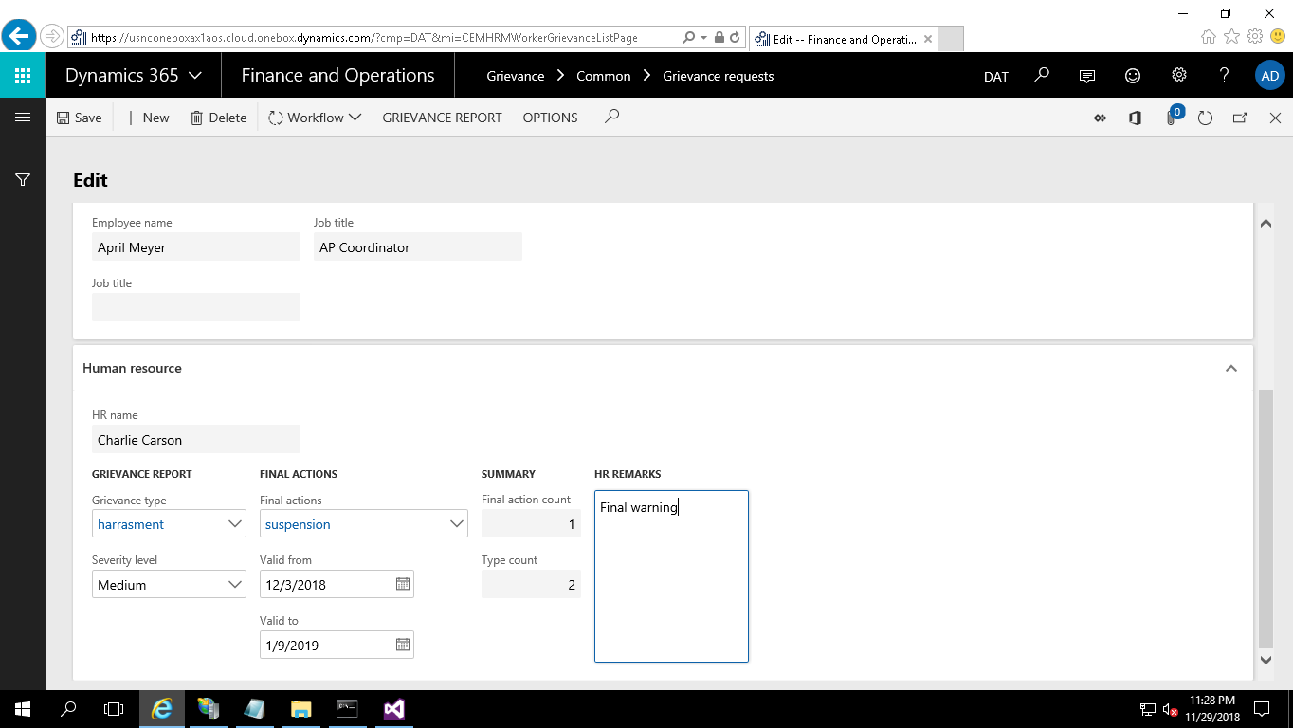
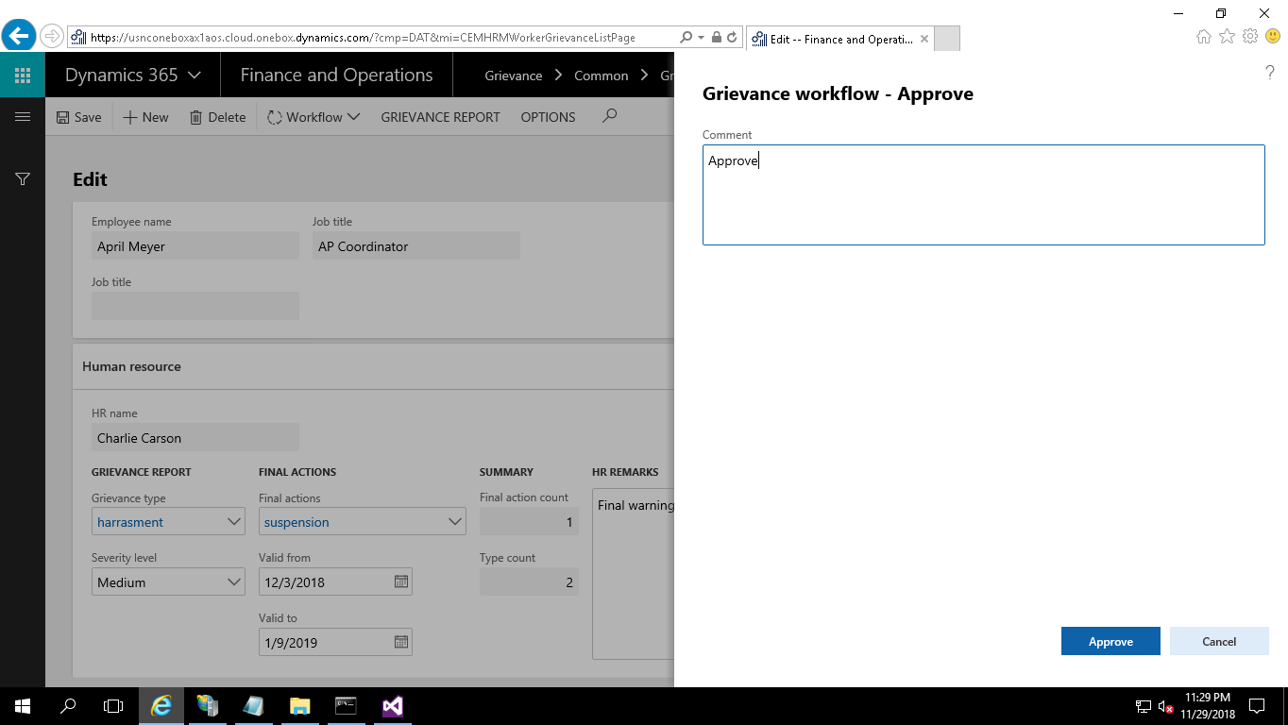
Once the grievance request is approved by the HR, it gets updated in the grievance details form.
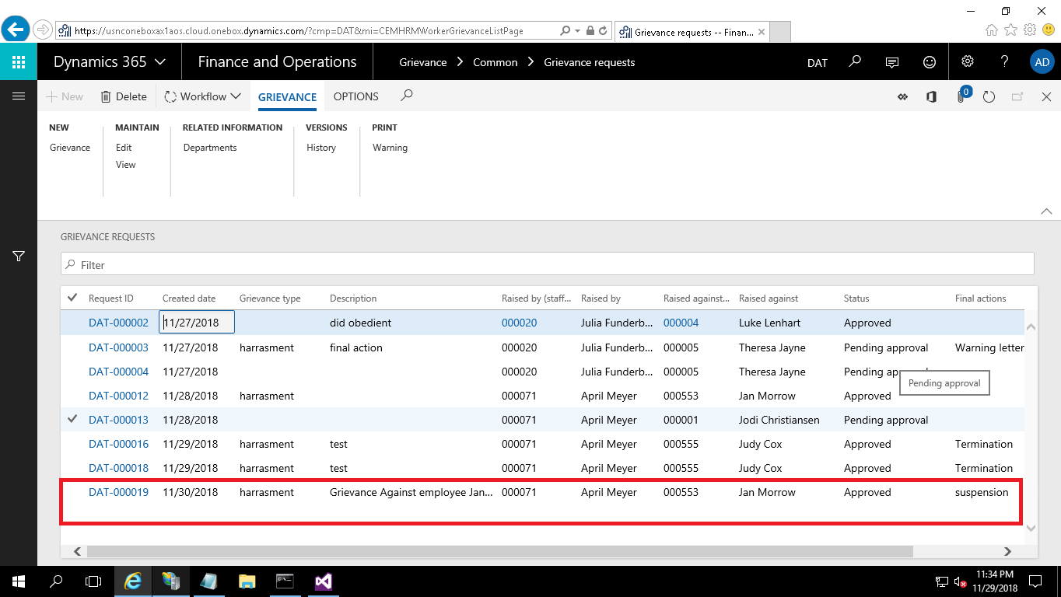

Grievance History

The grievance details can be found in grievance history form as shown below.

