Recognition User Manual

Prepared for
HR and Payroll process

Project
D365 for Finance and Operations

Prepared by
CEM Business Solutions

Change Record
Date | Author | Version | Change reference

Reviewers
Name | Version approved | Position | Date

Abbreviations

Copy No. | Name | Location
 | CEM Business Solutions | Chennai & US

Disclaimer
© 2014 CEM Business Solution. All rights reserved.
The information in this user manual guide applies only to D365 for Finance and Operations. It may be changed substantially prior to the final commercial release of the software described herein. This user manual guide also provides information that applies the uses of payroll
The contents of this package are for informational and training purposes only and are provided "as is" without warranty of any kind, whether express or implied, including but not limited to the implied warranties of merchantability, fitness for a particular purpose, and non-infringement.

No part of the text or software included in this training package may be reproduced or transmitted in any window or by any means, electronic or mechanical, including photocopying, recording, or any information storage and retrieval system, without permission from CEM Business Solution. Because CEM Business Solution must respond to changing market conditions, it should not be interpreted to be a commitment on the part of CEM Business Solution, and CEM Business Solution cannot guarantee the accuracy of any information presented after the date of publication. The names of actual companies and products mentioned herein may be the trademarks of their respective owners.

This content is proprietary and confidential, and is intended only for users described in the content provided in this document. This content and information is provided to you under a non-disclosure agreement and cannot be distributed. Copying, disclosing all or any portion of the content and/or information included in this document is strictly prohibited.

Contents
Table of Contents
Disclaimer 3
Contents 4
Process Overview 5
Introduction 5
COMMON PROCESS 6
Create Recognition 7
Recognition Approval 10
COMMON PROCESS 12
Create Recognition 13
Recognition Approval 15

Process Overview
Employee recognition is the acknowledgement of an employee’s behavior, effort and accomplishments that support the organization's goals and values. By acknowledging employee efforts and making them feel valued and appreciated, organizations can increase employee satisfaction, morale, and self-esteem.

Introduction
Recognition management process is set up through the following processes;
- Setting up Recognition types
- Recognition request for an employee
- Recognition request approval and processing
SET-UP
Recognition type:
To set up a Recognition request for an employee, you must first create the Recognition type
Path: Legal Entity | Recognition process | Area page | Setup | Worker Recognition Types

Demonstration:
This demonstration shows how to set up a Recognition type
- Click Worker Recognition Types.
- Click New.
- In the Recognition type field, type a unique name to identify the Recognition type.
- In the Description field, type a description for the Recognition type.

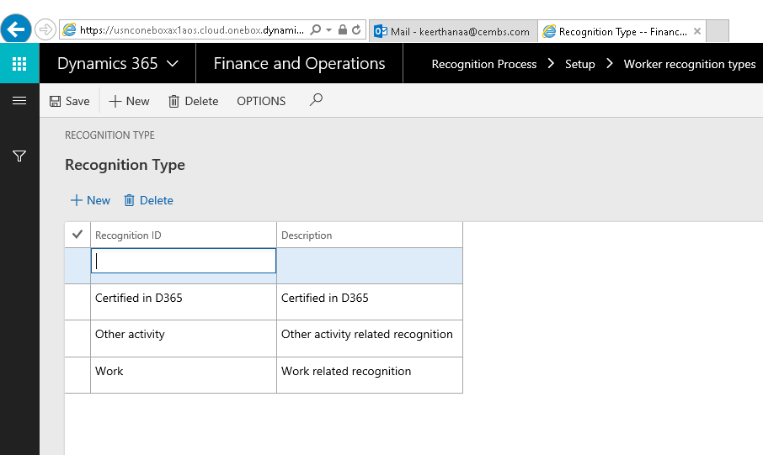

COMMON PROCESS

Path: Legal Entity | Recognition process | Common | Recognition list page
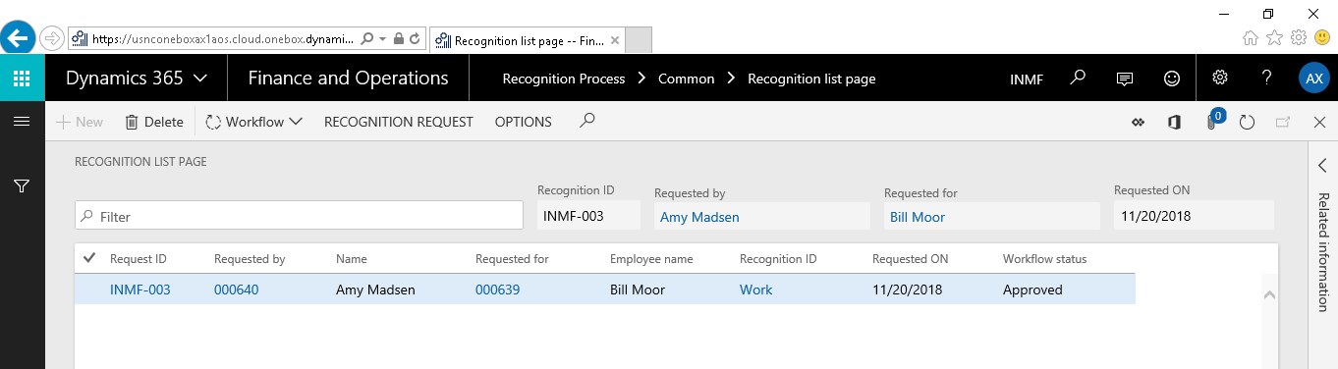

Create Recognition
To create Recognition the mandatory fields Recognition ID, Comments , Requested for employee details must be filled in.
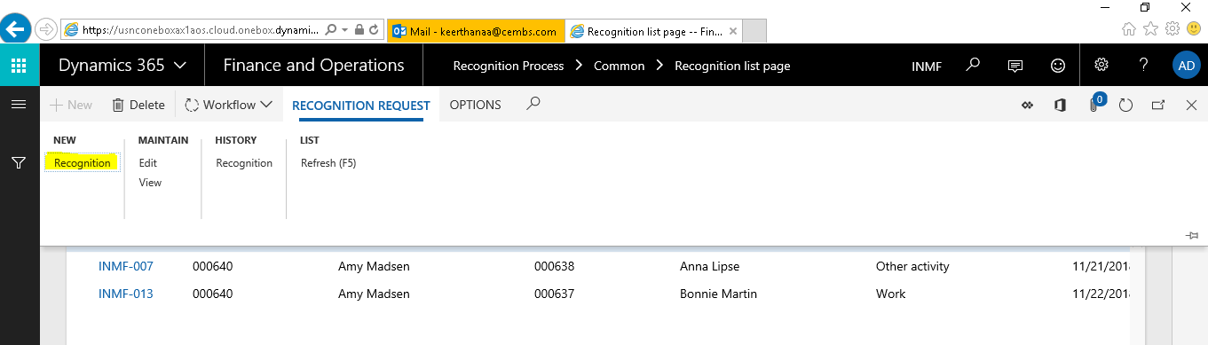
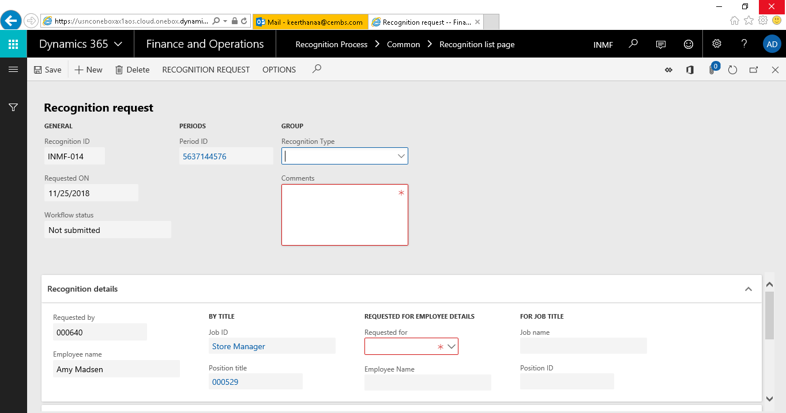

Demonstration:
This demonstration shows how to create Recognition for an employee
- Click Recognition requests.
- Click Recognition button
- Select Recognition type.
  - In the Recognition type dropdown field, select a recognition type.
  - In the Comment field, justify your reason for the employee recognition.
- Select the Employee for recognition.
  - Expand the Requestor details fast tab.
  - Requested by and Employee name fields under Requested by group is automatically updated with your Name and Employee ID.
  - In the Employee field, select the Employee ID of the worker to whom the recognition is requested for.
  - The Employee name field gets updated automatically.
  - Position and Job fields get updated automatically.
- Hit save button to save the form.
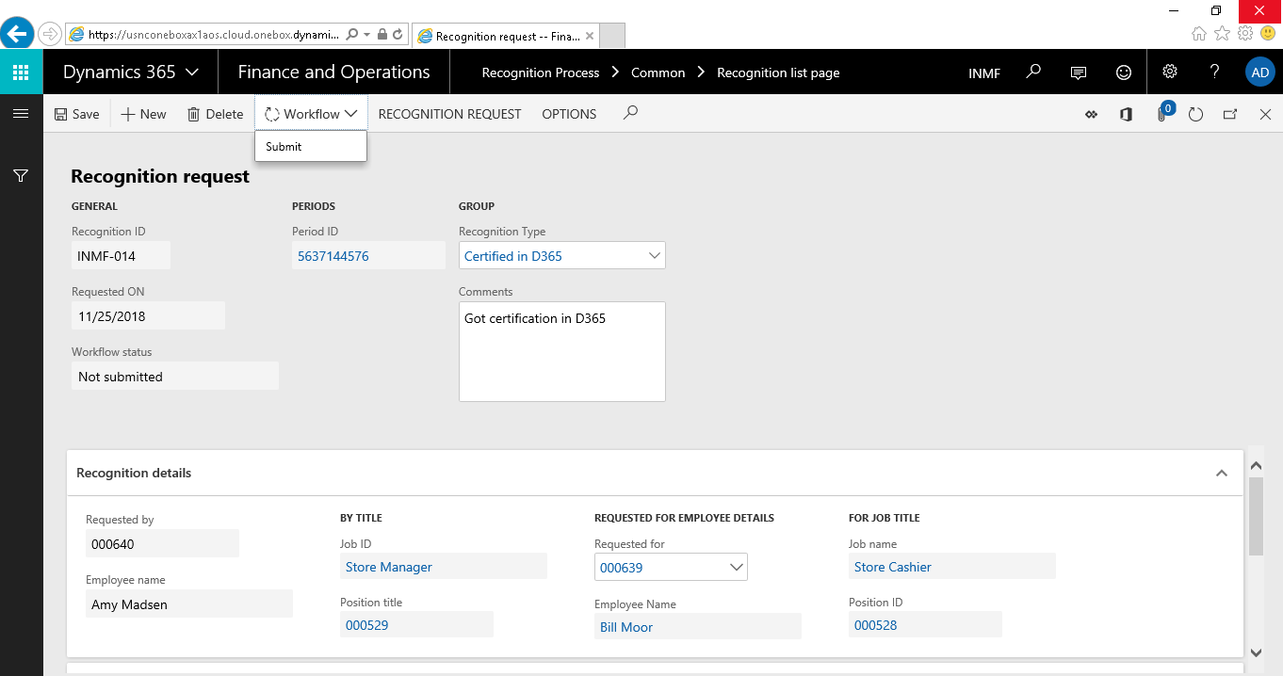

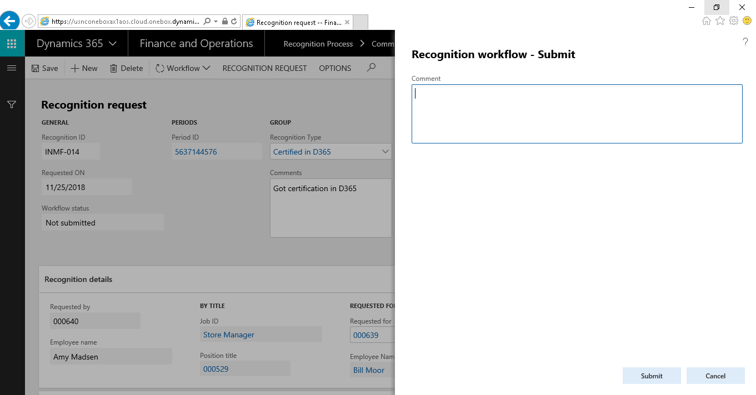

- Click the Submit button to initiate the Recognition Approval Workflow.

Recognition Approval
- Once the recognition request is submitted, a workflow is initiated and channeled for HR’s approval.
- The approving HR will receive a notification to approve the Recognition request and it is either approved or rejected.
- The HR- Operation Remarks fast tab is enabled to the approving HR. HR Remarks (Optional) is entered in HR Comments field.
- Once the approval process is complete, the record status changes to ‘Approved’. Once the recognition request is approved, it gets updated in the recognition details form.
The recognition requests can be viewed from recognition History button in task pane.
