NUSOFT CRM FOR M&A 2016
INSTALLATION GUIDE

Table of Contents
Table of Contents 2
1 Introduction 3
1.1 COMPATIBILITY 3
1.2 Incompatibility with free version of NuSoft Alert 3
2 Installing NuSoft CRM for M&A 4
2.1 Installing NuSoft CRM for M&A 4
3 Assign User Roles 9
4 Product Key 11
Support 12
Disclaimer 13

Introduction

COMPATIBILITY
NuSoft CRM for M&A is available for most of today’s platforms. It can be used with Outlook 2010, Outlook 2013, and Outlook 2016 as well as through multiple browsers for laptops and desktops. Apps are also readily available to provide access to mobile phones and tablets.
Compatible Browsers:
- Internet Explorer on Windows
- Firefox on Windows
- Safari on Mac OS X
- Chrome on Windows or Google Nexus 10
Mobile Devices with a CRM App:
- Microsoft Dynamics CRM for iPad
- Microsoft Dynamics CRM for Windows 8
- Dynamics CRM for Android Tablets
Supported Phone OS:
- iOS 7.x and 8.x
- Android 4.4
- Windows Phone 8.1
For a full list of supported hardware visit; https://technet.microsoft.com/en-us/library/dn531131.aspx

Incompatibility with free version of NUSOFT Alert
Uninstall free version of NuSoft Alert
NUSOFT CRM for M&A Featured pack already contains a field called NuSoft_AlertNote on Acount, Contact, Lead and Opportunities. If you previously installed the free version of NuSoft Alert, please unistall it before proceeding with the installation of this solution.

Installing NUSOFT CRM for M&A

Installing NUSOFT CRM for M&A
- Navigate to Settings -> Solutions
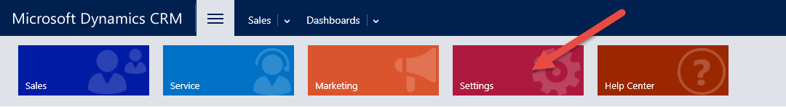

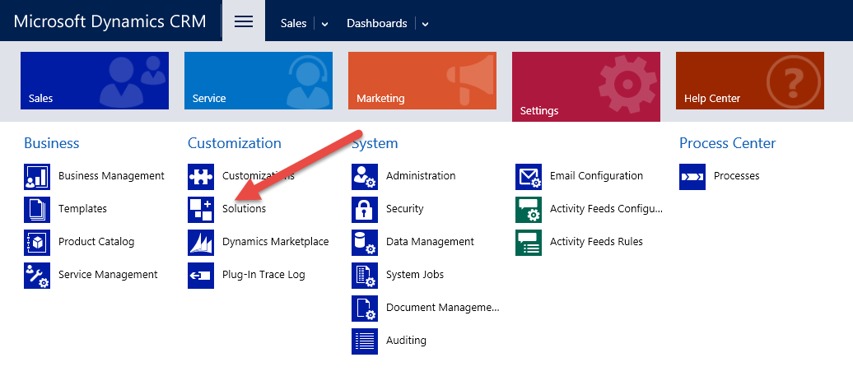

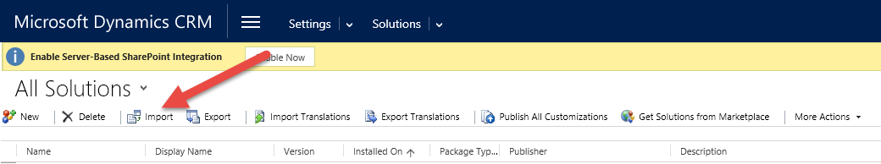
- Click Import, then select the downloaded NuSoft CRM for M&A managed solution file.
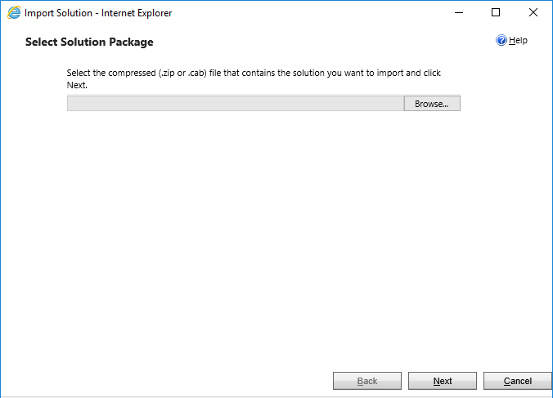
Click next to continue with installation
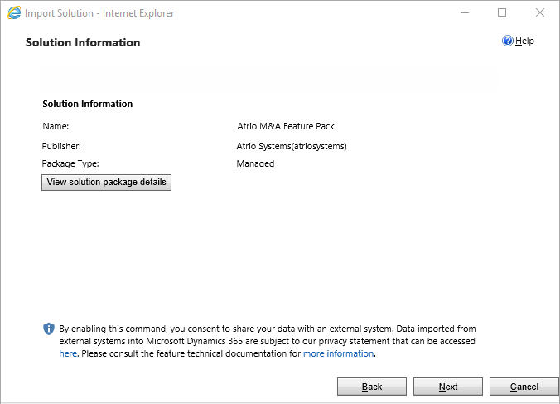

- Leave box checked and click Import and the import wizard will finish installing NuSoft CRM for M&A.
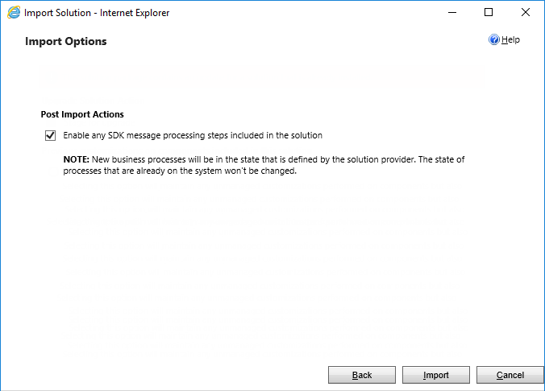

- A dialogue box will open. Hit Close. NuSoft CRM for M&A will be properly installed when the NuSoft CRM for M&A solution shows up on the All Solutions page.

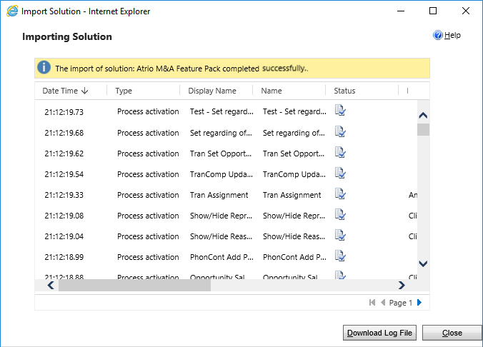

- NuSoft Common solution is required for NuSoft CRM for M&A and will be included when you purchase the product. To install NuSoft Common solution, repeat the steps above as you did with NuSoft CRM for M&A.

Assign User Roles
Anyone who needs to see NuSoft CRM for M&A needs the NuSoft CRM for M&A security role.
- Navigate to Settings->Security->Users.
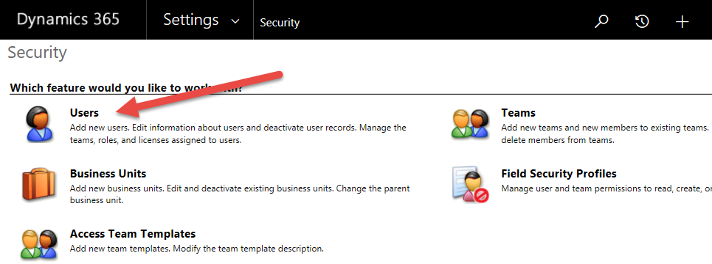

- Select the users whom you wish to use NuSoft CRM for M&A.

- Select Manage Roles in the ribbon.
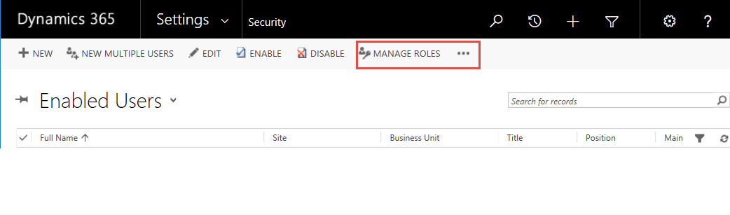
- Choose the a role according to the user’s position and select OK.
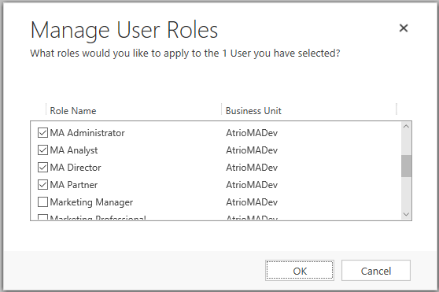

Product Key
After 30 days of use, NuSoft CRM for M&A Pro trial will no longer work. To enter a purchased product key, follow the steps below.

- Navigate to the Solutions page again and open up the NuSoft CRM for M&A solution.
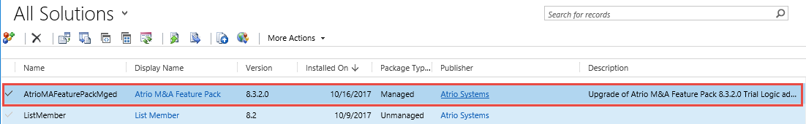
- The Configuration Page will appear. Towards the bottom of the page will be a slot for the product key. Type in the product key you received from NuSoft and click Submit. If you do not have a product key, contact NuSoft at support@nusoftsolutions.com to receive one.

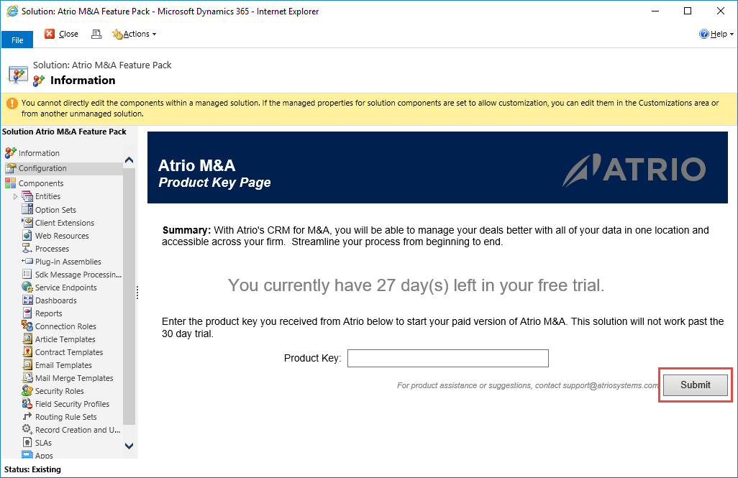

Support
Please send any product issues or suggestions to support@nusoftsolutions.com.

Atrio Systems, Inc. DBA NuSoft Solutions
6001 N. Adams Rd, Suite 285
Bloomfield Hills, MI 48304
248-594-1500

Disclaimer
THIS SOFTWARE IS PROVIDED "AS IS", AND ATRIO SYSTEMS, INC. DBA NUSOFT SOLUTIONS DISCLAIMS ALL WARRANTIES WITH REGARD TO THIS SOFTWARE INCLUDING ALL IMPLIED WARRANTIES OF MERCHANTABILITY AND FITNESS FOR A PARTICULAR PURPOSE. IN NO EVENT SHALL ATRIO SYSTEMS, INC. DBA NUSOFT SOLUTIONS BE LIABLE FOR ANY SPECIAL, INDIRECT, OR CONSEQUENTIAL DAMAGES OR ANY DAMAGES WHATSOEVER RESULTING FROM LOSS OF USE, DATA OR PROFITS, WHETHER IN ACTION OF CONTRACT, NEGLIGENCE, OR OTHER TORTIOUS ACTION, ARISING OUR OF OR IN CONNECTION WITH THE USE OR PERFORMANCE OF THIS SOFTWARE.

