Prepayment Inc. Withholding Tax - FTDD
365 for Operations | System
Israel Localization | Project
Shimrit Snapir | Functional Person
Shimrit Snapir | Technical Person
271,272,276 | VSTS Story Id
Prepayment Inc. Withholding Tax | Design Name
15.08.2017 | Date

Business Overview

Background
Israeli regulation allows creation of prepayment for vendor that includes withholding tax

Current process
Current prepayment journal does not allow withholding tax for vendor. The user is blocked when trying to create a payment that includes withholding tax and not settled with an invoice.

Goals/Purposes
Enable the functionality of withholding tax transaction when a prepayment is created.

Assumptions

Functional Overview

Create a prepayment journal
When creating a vendor's payment journal a new functionality will be added to the journal lines.
- A new button will be added to the Payment Journal lines form (Accounts payable > Payments > Payment Journal > Lines button). The button will be added to the lines grid.

Language | Button Name | Field Help
En-us | Prepayment Incl. withholding tax | This process enables creating a prepayment transaction with a withholding tax transaction.
He-il | תשלום מקדמה עם ניכוי מס | תהליך זה מאפשר להגדיר תשלום מקדמה עם שורת ניכוי מס במקור

- Functionality Input:
Prepayment amount – Total amount for prepayment
- Functionality output:
Two lines will be created on the payment journal
  - Prepayment amount excluding withholding tax
  - Withholding tax amount according to the withholding tax group on the journal.
Offset account for line will be the withholding account on the current withholding tax code.
A new line will be added to withholding tax transaction table to reflect the withholding tax amount.
- Functionality validations:
  - Prepayment amount on input Is mandatory:
"Prepayment amount is mandatory"
  - Vendor account on journal line is required:
"Please enter vendor account for prepayment transaction"
  - Vendor account is subject to withholding tax calculation (Calculate withholding tax check box on vendors form):
" Calculate Withholding tax is not marked for vendor. Withholding tax will not be calculated."
  - Transaction date on journal line is required:
" Please enter transaction date for prepayment transaction"
  - Tax withhold group on journal line is required:
" A valid Withholding tax group is mandatory for a vendor subject to withholding tax calculation."
  - Tax deduction type on journal line is required:
" A tax deduction type is mandatory for a vendor subject to withholding tax calculation."
  - Tax withhold code and value is required:
" Withholding tax code XXX has no withholding tax value"
  - Tax withhold account on tax withhold code is required:
" There is no account for the withholding code tax XXX"
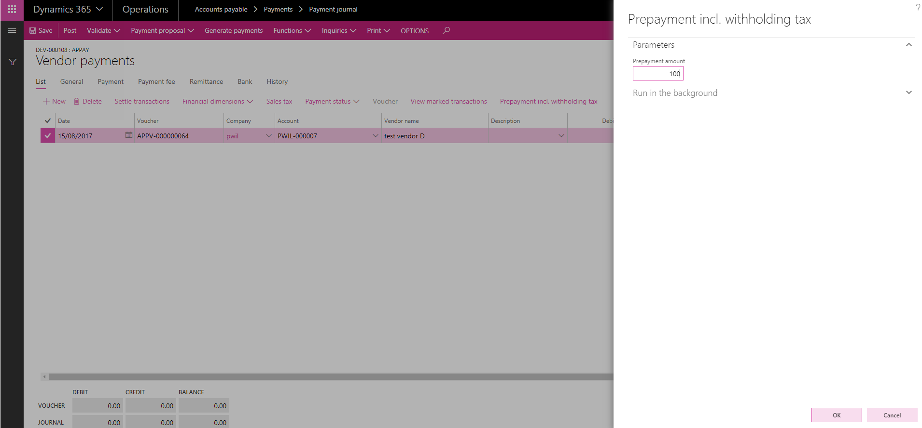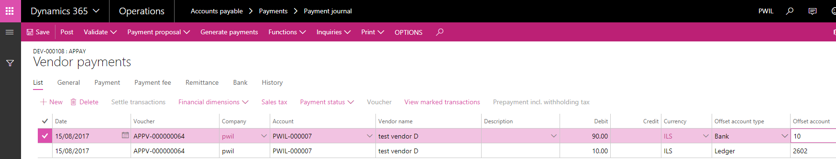

WHT Reverse prepayment transaction

All prepayment transaction will be blocked for reversal on vendor transaction form (Accounts Payable > All Vendors > Transaction button)
Reverse transaction button will be disabled on prepayment transactions
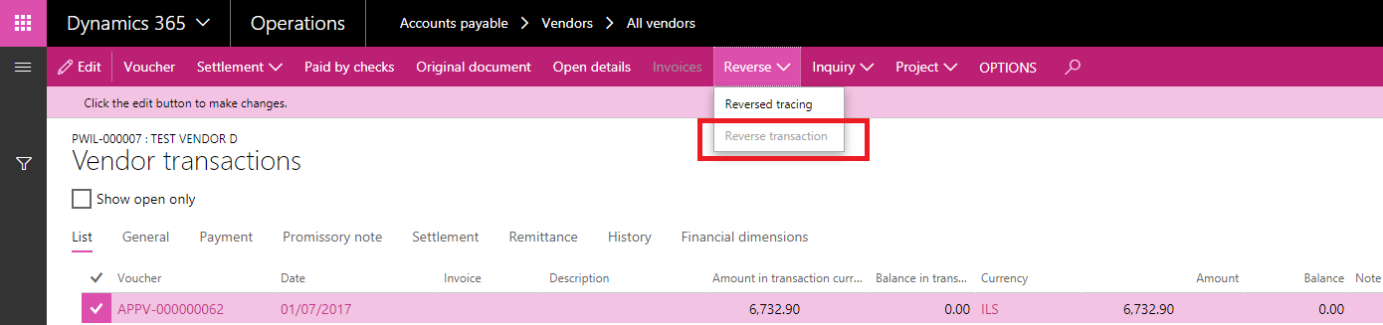

Technical Overview

Test Cases
Refer to VSTS Test Manager – Prepayment For Vendor

Security Definitions
A new privilege will be added to View and Manage Withholding Tax Approvals
- Manage prepayment incl. withholding tax process

