Prodware Israel
Withholding tax

Withholding Tax Setup Design Document
365 for Operations | System
Israel Localization | Project
Shimrit Snapir | Functional Person
Shimrit Snapir | Technical Person
40,449,38,221,384,467 | VSTS Story Id
Withholding Tax Setup Design Document | Design Name
26.04.2017 | Date

Business Overview

Background
Necessary setup data is necessary for Israel withholding tax process. The setup is mostly relevant for Israeli regulation reports.

Current process
Current standard WHT process does not support the needed data for WHT Israel regulations.

Goals/Purposes
Enable Israel WHT setup according to Israel regulations.

Assumptions
The setup data is only relevant for Israeli regulations.
The setup data will not be mandatory.

Functional Overview

WHT Employee Type for 856 report
4 | 16 | 1 | זיהוי עובד | נומרי | 2=מקבל תשלום שהוא תושב הרשות הפלשתינית  5 = חברות בינלאומיות (דיווח השמות באנגלית)
According to record "60" line 4 of 856 electronic reporting there is a need to define a vendor's employee type:
Type | Language | Field Name | Field Help
enum | En-us | Employee type for tax authority | Employee type for tax authority used for report 856
 | He-il | זיהוי עובד למס הכנסה | זיהוי עובד למס הכנסה עבור דו"ח 856

A new field will be added to the Vendors Table and form. The field will be placed on Invoice and delivery tab, Withholding tax group.
Value | Language | text
Blank | En-us | Empty
 | He-il | ריק
Palestinian Authority | En-us | Payment to a resident of the Palestinian Authority
 | He-il | מקבל תשלום שהוא תושב הרשות הפלשתינית
International companies | En-us | International companies (Report names in english)
 | He-il | חברות בינלאומיות (דיווח השמות באנגלית)
Field Values:

WHT File Type for 856 report

According to record "60" line 5 of 856 electronic reporting there is a need to define a vendor's file type for tax authority:
5 | 17 | 1 | הסבר על מספר התיק במס הכנסה | נומרי | עצמאי "1", חברה "2", עוסק מורשה "3".
Type | Language | Field Name | Field Help
enum | En-us | File type for tax authority | File type for tax authority used for report 856
 | He-il | סוג תיק למס הכנסה | סוג תיק למס הכנסה עבור דו"ח 856
A new field will be added to the Vendors Table and form. The field will be placed on Invoice and delivery tab, Withholding tax group.
Field Values:
Value | Language | text
Blank | En-us | Empty
 | He-il | ריק
Independent | En-us | Independent
 | He-il | עצמאי
Company | En-us | Company
 | He-il | חברה
Licensed Dealer | En-us | Licensed Dealer
 | He-il | עוסק מורשה

Tax Authority Units

According to record "60" line 16 of 856 electronic reporting there is a need to define a vendor's tax authority unit.
16 | 135-146 | 12 | שם משרד השומה נותן האישור  וסמל פקיד השומה | אלפא נומרי | לדוגמא: טבריה 01
A new table and form will be added to manage Tax Authority Units.
The table will be added under Tax>Setup>Withholding Tax
Table will be added to the Data Management module as an entity.
Table/Form name: Tax Authority Units
Type | Size | Language | Field Name | Field Help
String | 10 | En-us | Tax authority unit ID | Tax authority unit Identifier
 |  | He-il | מזהה משרד שומה | קוד מזהה משרד שומה של רשות המיסים
String | 60 | En-us | Description
 |  | He-il | תאור
Table/Form fields:

Tax Deduction Types

According to record "60" line 19 of 856 electronic reporting there is a need to define a vendor's tax deduction type.
19 | 213-214 | 2 | סוג הניכוי | נומרי
A new table and form will be added to manage Tax Deduction Types.
The table will be added under Tax>Setup>Withholding Tax
Table will be added to the Data Management module as an entity.
Table/Form name: Tax deduction types
Type | Size | Language | Field Name | Field Help
String | 10 | En-us | Tax deduction type ID | Tax deduction type Identifier
 |  | He-il | מזהה סוג ניכוי | קוד מזהה סוג ניכוי
String | 60 | En-us | Description
 |  | He-il | תאור
Real | 3 | En-us | Default deduction percent | Default deduction percent when vendor doesn't have approval for deduction type
 |  | He-il | אחוז ניכוי ברירת מחדל | אחוז ניכוי ברירת מחדל כאשר לספק אין אישור לסוג ניכוי זה

WHT Deduction Rate for 1000 Interface

According to Shaam - 1000 Interface there is a need to define a vendor's Tax deduction rate:
שיעור הניכוי | סעיף הפטור
00 | שירותים או נכסים
00 | תוצרת חקלאית
00 | עמלת ביטוח
00 | תקנות מס הכנסה
00 | ריבית והפרשי הצמדה

Type | Language | Field Name | Field Help
enum | En-us | Tax deduction rate | Tax deduction rates according to Shaam (1000 Interface)
 | He-il | שיעור ניכוי מס | שיעורי ניכוי מס בהתאם לממשק שע"מ (ממשק 1000)
A new field will be added to the Vendors Table and form. The field will be placed on Invoice and delivery tab, Withholding tax group.
Field Values:
Value | Language | text
ServicesOrAssets | En-us | Services or assets
 | He-il | שירותים או נכסים
AgricultureProducts | En-us | Agriculture products
 | He-il | תוצרת חקלאית
InsuranceFee | En-us | Insurance fee
 | He-il | עמלת ביטוח
TaxAuthorityRegulations | En-us | Tax authority regulations
 | He-il | תקנות מס הכנסה
InterestNAdjustmentDiff | En-us | Interest and adjustment differences
 | He-il | ריבית והפרשי הצמדה

Technical Overview

WHT Employee Type for 856 report
- Add a new enum ILWHTEmployeeType. Enum values:
  - 1 – Blank
  - 2 - Palestinian Authority
  - 3 - International companies
- Add enum as a field to VendTable and VendTable groups ILIsraelLocalization, WithholdingTax.
- Rebuild VendTable form and see field was added.

WHT File Type for 856 report
- Add a new enum ILWHTFileType. Enum values:
  - 1 – Blank
  - 2 – Independent
  - 3 – Company
  - 4 – Licensed Dealer
- Add enum as a field to VendTable and VendTable groups ILIsraelLocalization, WithholdingTax.
- Rebuild VendTable form and see field was added.

Security Definitions
New privileges for new tables:
    - View Israel Tax Setup – Read privileges on:
      - Tax authority units
      - Tax deduction types
    - Maintain Israel Tax Setup – Delete privileges on:
      - Tax authority units
      - Tax deduction types
Add Privileges to Israel Localization Duty.

Tax Withholding for Vendor - FTDD
365 for Operations | System
Israel Localization | Project
Shimrit Snapir | Functional Person
Shimrit Snapir | Technical Person
220,43,44,46,267 | VSTS Story Id
Tax Withholding for Vendor | Design Name
22.06.2017 | Date

Business Overview

Background
When a vendor is subject to tax withholding the Israeli regulation requires information to be saved on the vendor and used for reporting process.
Tax withholding process should support Israeli regulations and demands of tax authority.

Current process
Current standard WHT process does not support the needed regulations for WHT in Israel.

Goals/Purposes
Enable Israel WHT full process according to Israel regulations

Assumptions

Functional Overview

Vendor WHT Fields
The following fields are added to the Vendors form - Invoice and delivery Tab > Withholding Tax Israel. More details on the fields in WHT Setup design document.
- Deduction File Number
- Employee type for tax authority
- Tax authority file explanation
- Tax deduction rate
- Tax authority unit ID
- Tax deduction type
Fields enabled when Calculate withholding Tax check box is set to Yes.
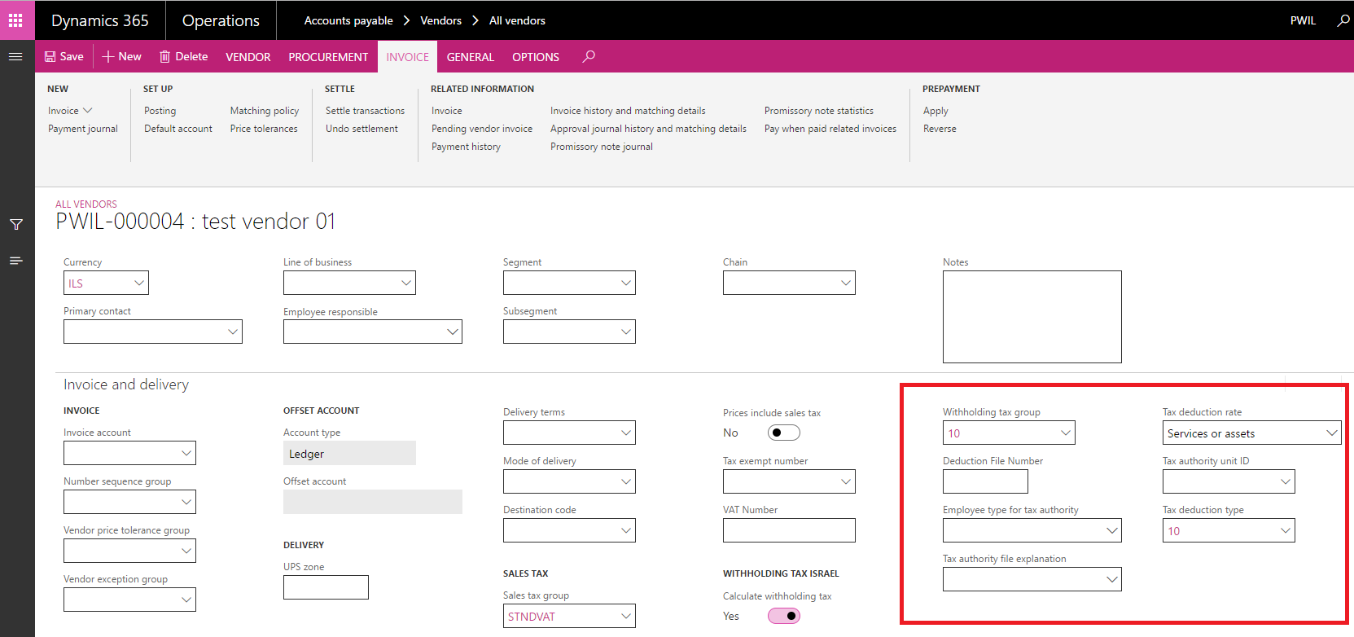

Mandatory WHT for Vendor
When "Calculate withholding tax" check box is set to Yes the field "Withholding tax group" will automatically be populated with the value "N\A". "N\A" is a disabled withholding tax group that should be changed before payment.

WHT Approvals for Vendor
Israel regulations require managing the vendor's tax authority approvals for withholding tax deductions. A new table and form "Withholding tax approvals" will be added to manage WHT approvals.
Form will be added to:
- Accounts Payable Module > Vendors Form > Vendor Panel > Set Up Group
- Tax Module < Inquiries and reports Menu > Withholding tax inquiries sub menu
Form Withholding tax approvals – אישורי ניכוי מס fields list:
Type | Size | Language | Field Name | Field Help
String |  | En-us | Vendor Account | Standard field help
 |  | He-il | חשבון ספק | עזרה משדה סטנדרטי
String |  | En-us | Vendor Name | Standard field help
 |  | He-il | שם ספק | עזרה משדה סטנדרטי
String |  | En-us | Withholding tax group | Standard field help
 |  | He-il | קבוצת ניכוי מס במקור | עזרה משדה סטנדרטי
Date |  | En-us | Effective | Standard field help
 |  | He-il | תקף | עזרה משדה סטנדרטי
Date |  | En-us | Expiration | Standard field help
 |  | He-il | פג תוקף | עזרה משדה סטנדרטי

Only one active record per vendor and withholding tax group is possible.
Form will be date effective according to standard Valid Time State functionality. History and future effective records will be filtered and only active records will be shown as default.
To view history\future records use "View" field on form header:
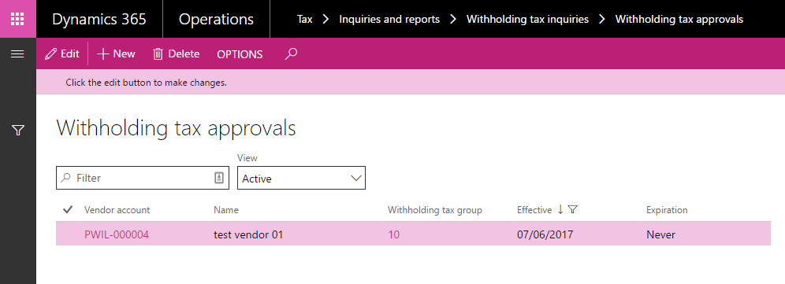

WHT Calculation on payment journal
When creating a new vendor's payment journal using "Settle transactions" or "Payment proposal" functionalities, the following fields will be filled:
- Tax deduction type – The default "Tax deduction type" from vendor is set on payment journal's tax deduction type.
- Withholding tax group The default "Withholding tax group" from the vendor is set on the payment journal (Standard system functionality). A new validation will be added: If the vendor does not have an active withholding tax approval for the default, withholding tax group the field will be set according to default withholding group from tax deduction type and the following warning message will appear: " Vendor XX doesn't have an approval to deduct tax withhold group YY. Group changed to default value ZZ according to deduction type." If no default group is found field will be set to "N\A".
When posting a vendors payment journal the following validation will occur:
- If the field "Withholding Tax Group" on payment journal is "N\A" or null, the following warning will appear: "A valid Withholding tax group is mandatory for a vendor subject to withholding tax calculation."
The payment journal will not be posted. Validation will be checked on both "Validate" and "Post" functionalities.
- If the field "Tax deduction type" on payment journal is null, the following warning will appear: "A tax deduction type is mandatory for a vendor subject to withholding tax calculation."
The payment journal will not be posted. Validation will be checked on both "Validate" and "Post" functionalities.

WHT reverse settlement
When reversing a settlement of a payment that includes withholding tax, the withholding tax transaction reversed (canceled) due to standard AX logic.
Due to the need to enable resettlement of the payment transaction with the WHT transaction, a new WHT transaction created using the prepayment functionality.
The new WHT transaction linked to the original payment transaction and can be settled again with it.
See payment, WHT reversal and new WHT transaction (highlighted) below:
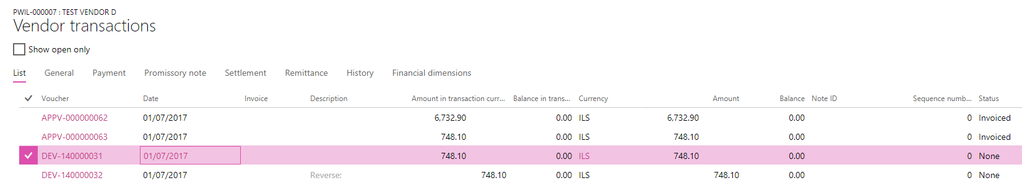

Technical Overview

Security Definitions
A new privilege will be added to View and Manage Withholding Tax Approvals
- View Israel Tax Setup
- Manage Israel Tax Setup

WHT Reports and Files - FTDD
365 for Operations | System
Israel Localization | Project
Shimrit Snapir | Functional Person
Shimrit Snapir | Technical Person
47,48 | VSTS Story Id
WHT Reports and Files | Design Name
16.08.2017 | Date

Business Overview

Background
Israeli regulation requires delivering tax authorities reports for withholding tax information:
- Electronic report 856
- Report 857\806

Current process
Standard system does not support these reports formats

Goals/Purposes
Enable delivering the regulatory reports to tax authorities and vendors

Assumptions

Functional Overview

856 Electronic reporting
Electronic report 856 generated according to Tax authorities regulations: Report 856.
Report location: Tax > Inquiries and reports > Withholding tax reports > Withholding tax 856 report
Report input:
- From date – start date of payment transactions
- To date – end date of payment transactions
- Print to file – download report to file
- Query – Vendors table
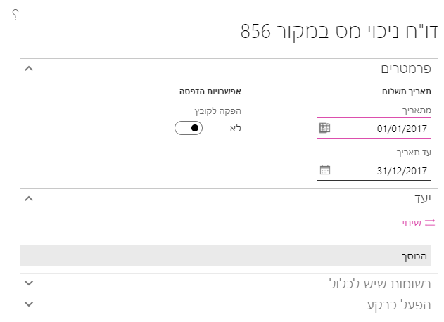

Report output:
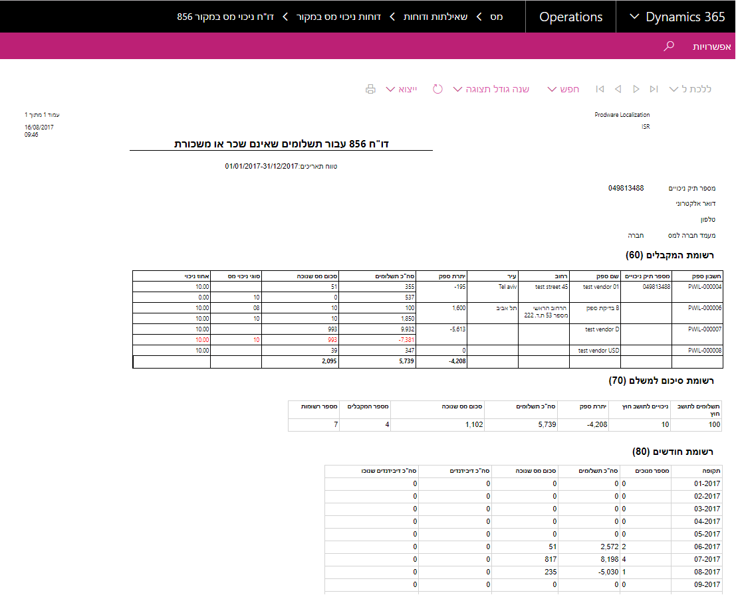

857\806 Electronic reporting
Electronic report 857\806 generated according to Tax authorities regulations: Report 857\806.
Report location: Tax > Inquiries and reports > Withholding tax reports > Withholding tax 857\806 report
Report input:
- From date – start date of payment transactions
- To date – end date of payment transactions
- Query – Vendors table
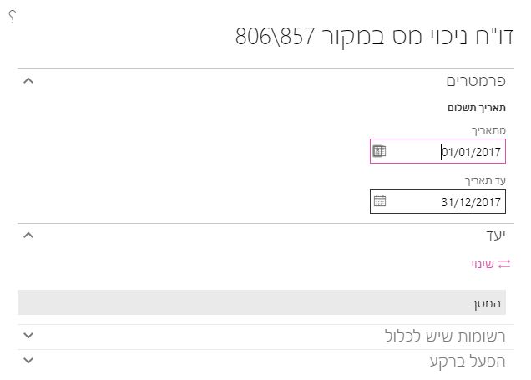
Report output:
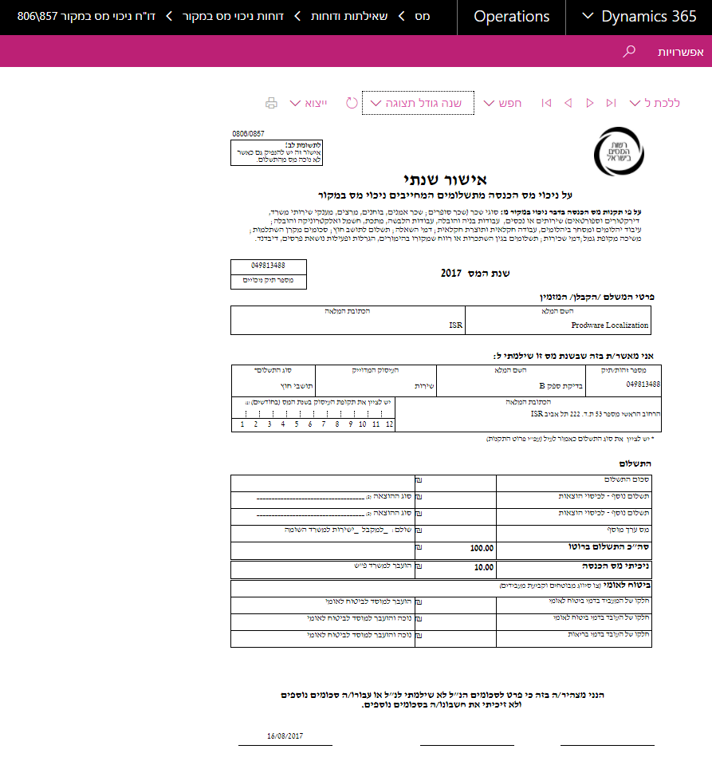

Technical Overview
Describe the necessary technical changes required according to functional overview. Add detailed object and code changes, relevant properties as names, size, descriptions etc. for all relevant additions. Add code logic if possible.

Security Definitions
A new privilege will be added to Manage Withholding Tax reports
- Maintain Israel withholding tax reports

