Open format Design Document
365 for Operations | System
Israel Localization | Project
Shimrit Snapir | Functional Person
Shimrit Snapir | Technical Person
74 | VSTS Story Id
Open format | Design Name
30.01.2018 | Date

Business Overview

Background
Open format enables exporting company’s transaction according to Israel tax regulations. The files are then uploaded to tax authorities for review

Current process
Current standard system doesn’t support open format process.

Goals/Purposes
Enable export of open format data.

Assumptions

Functional Overview

Setup Open Format document types
On General Ledger > Setup > Open format setup > Open format transaction types
If form empty press ‘Initialize data’ button. Transaction types data will be filled automatically.
Set include in run check box for relevant documents.
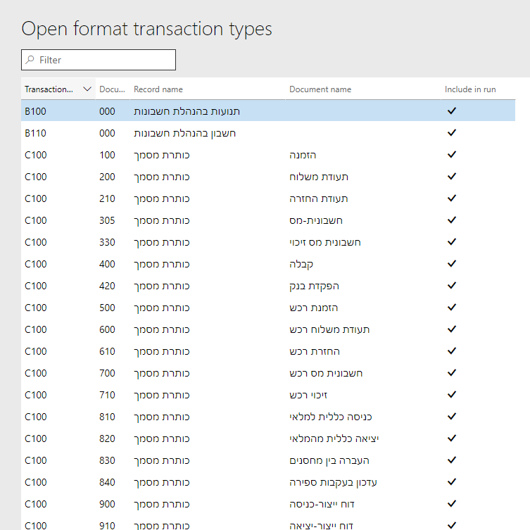

Open format generation
On General Ledger > Periodic tasks > Open format > Open format generation
On input form choose relevant documents and fill input fields:
- Company – legal entity data to export
- From date
- To date
- Log level – type of data written to history log
Export file generation will be executed in the background. User will be alerted when done and file downloaded locally.
Output zip file can be extracted and uploaded to tax authority simulator:
https://www.misim.gov.il/TmbakmmsmlNew/frmCheckFiles.aspx
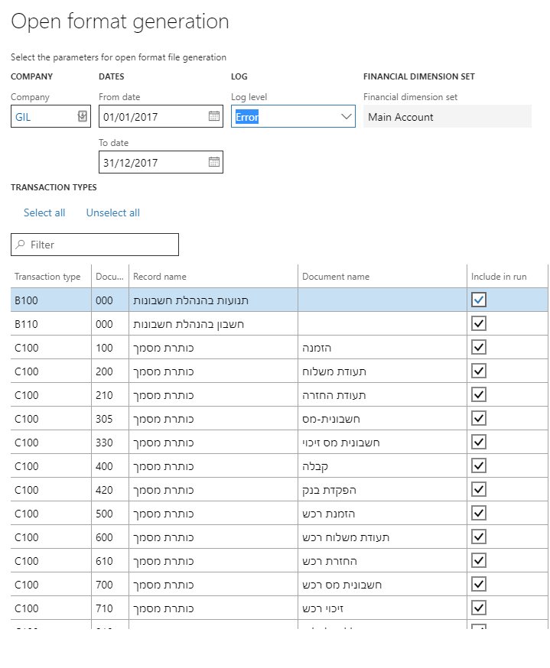

Open format process history
On General Ledger > Periodic tasks > Open format > Open format process history
View open format runs log and produce reports on run:
- Doucuments totals report
- Run output report

Technical Overview

Test Cases

Security Definitions
New privileges will be added to View and Manage open format process
- View open format setup
- Maintain open format setup
- View open format running history
- Process open format file generation

