eAuth

Why it’s needed?
- Invalid data is a big problem today. Invalid emails residing in our database ends up resulting all our marketing emails in junk or Spam which destroys the purpose of our email marketing campaign.
- It’s very tedious task to verify emails when and CSR is entering data into CRM. Correcting these emails from our database, becomes a tedious and lengthy job to clean all your data at the last moment when you actually need it for your bulk email activities.
eAuth Solution helps:
- This solutions provides a unique feature of validating the emails, which will intimate user whether the email is valid or invalid immediately at the time of entering.
Importing Dynamics CRM Solution:
- Log on to the Microsoft Dynamics CRM server website as an administrator.
- From the menu, click SETTINGS > Solutions.
- On the All Solutions page, click Import.
- On the Select Solution Package page, click Browse to locate the Dynamics CRM eAuth solution.
- Click Next on the Select Solution Package and Solution Information page, and then click Import on the Import Options page.
- By default, the Enable any SDK message processing steps included in the solution check box is selected.
- In the Importing Solution dialog, click Close.
- And click publish all customizations.
Configure the eAuth Option set setting:
- On the All Solutions page, double-click eAuth to open the Configuration page.
- Perform the following steps to work with/ verify emails of contacts.
- Find the solution from solutions.
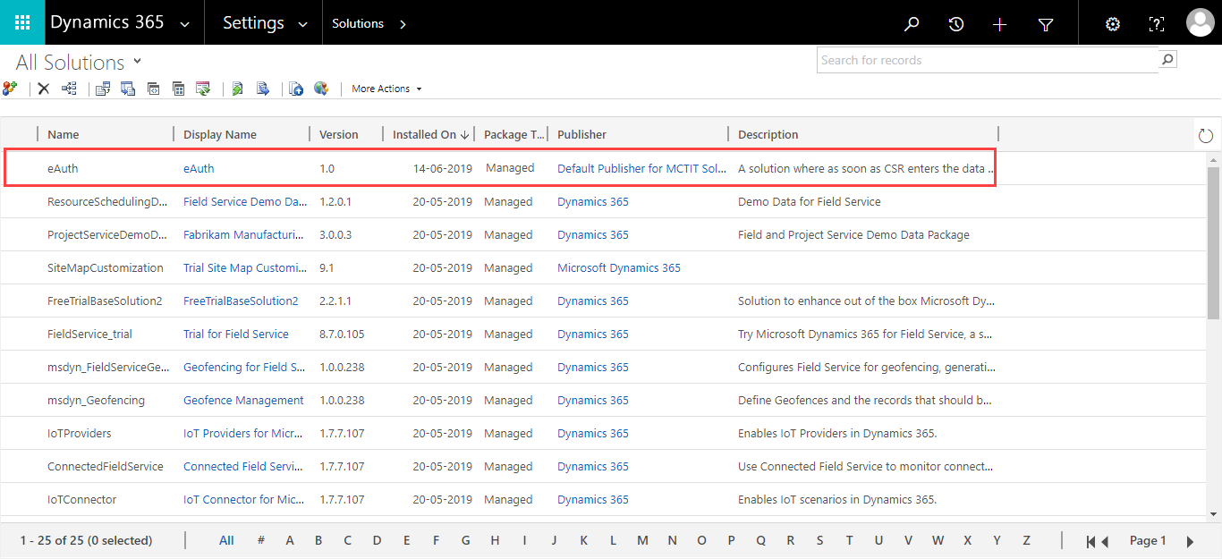
- Open the solution.
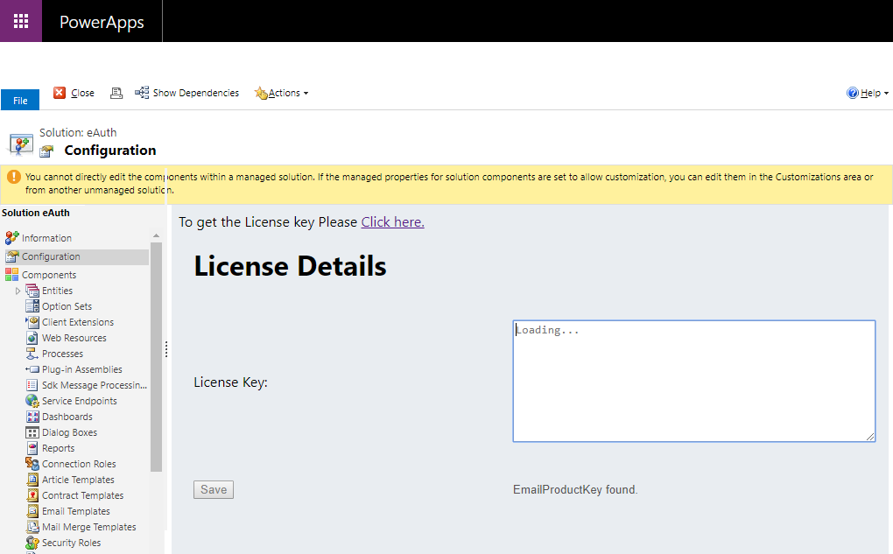

- Click on the link.
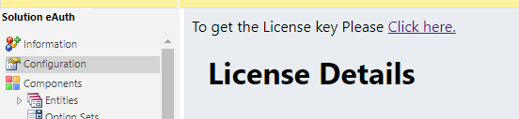
- Please fill the details with the correct email ID and correct Organization name.
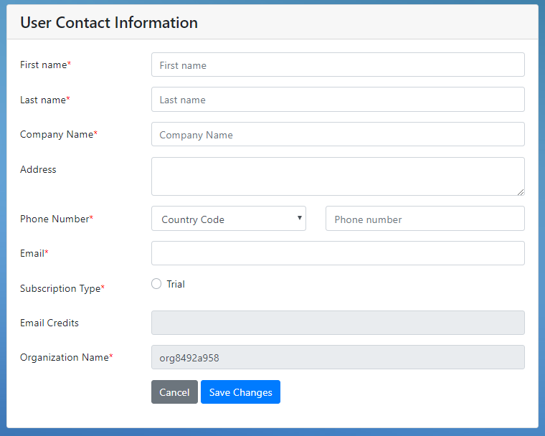
- Click on Save Changes.
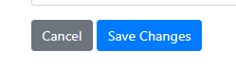
- Please check the inserted mail id’s Inbox. And Copy the License Key.
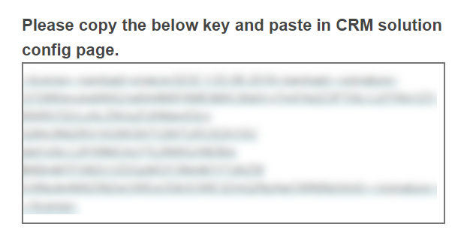
- Paste the License Key.
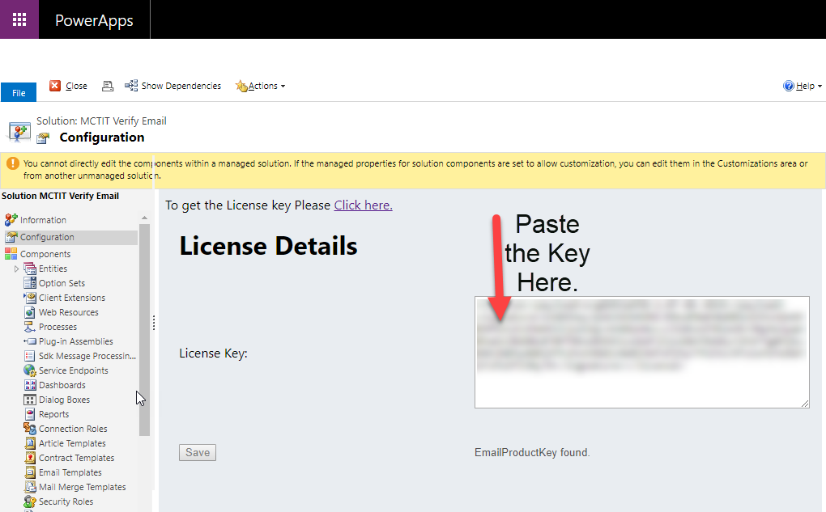
- Click on the Save.
- Check the email Id in contact : EAUTH form.
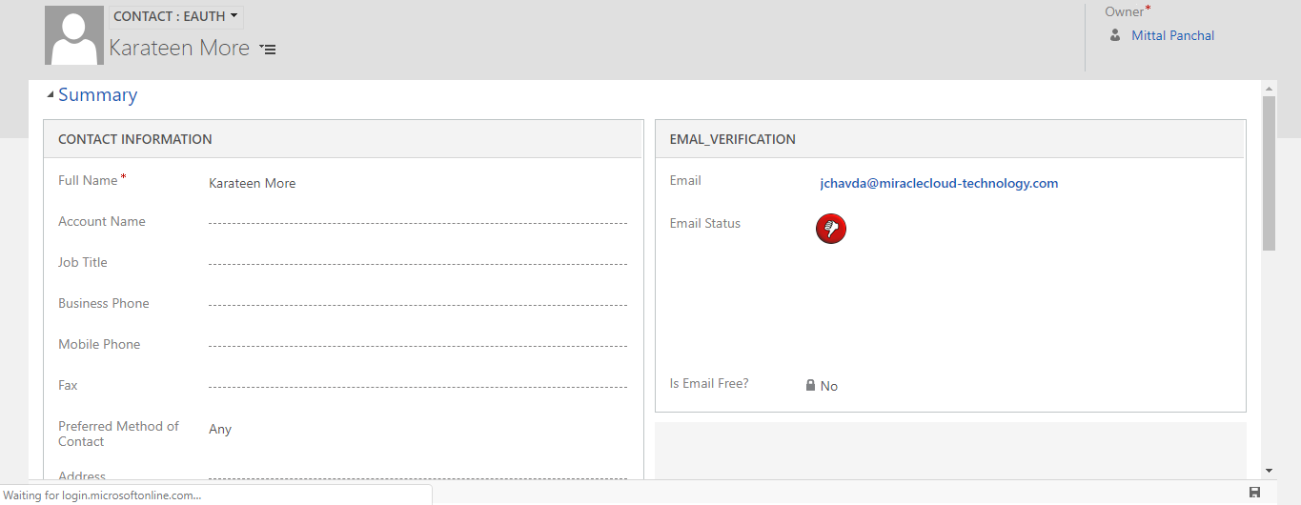
- Get the notification of valid or invalid.
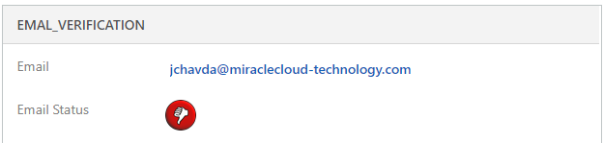

- You can notify with icon in view also.
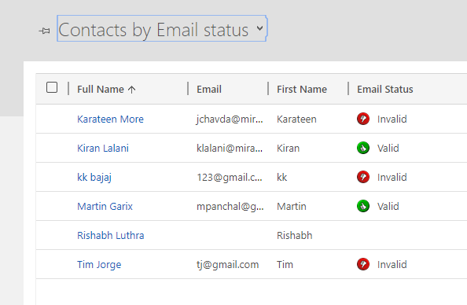

- Check the dashboard for number of valid and invalid emails.
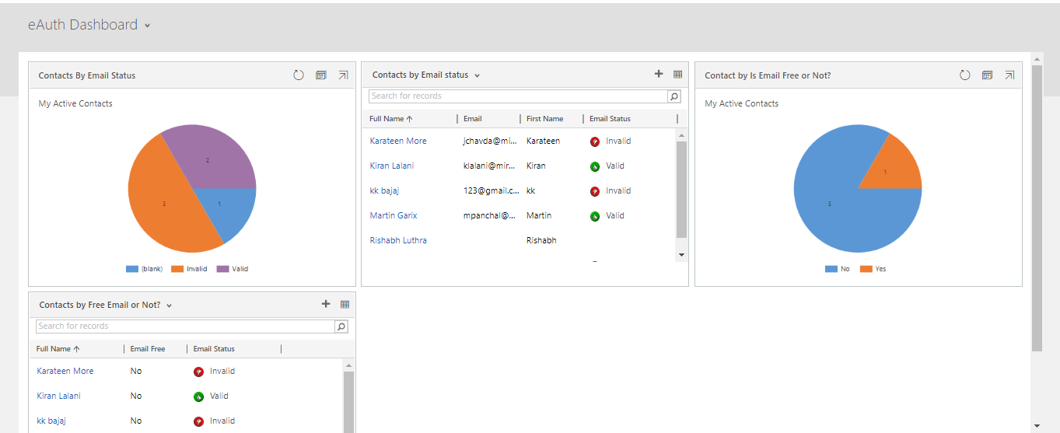

Thank You!!!

