Installing Data8 TPS for Microsoft Dynamics CRM 365

Table of Contents
Installing Data8 TPS for Microsoft Dynamics CRM 365 1
Installing the solution 3
Configuring the TPS system 5
Initial Configuration 5
Quick Field Configuration 5
Advanced Field Configuration 5
Setting up how to view TPS and CTPS status 7
Keeping your system up to date 7
Security Roles 7
Customised Configuration 8

Installing the solution
You will have been provided with a zip file containing the TPS solution. To install it, open Microsoft Dynamics CRM and go to Settings > Solutions. Click “Import” to start the installation.
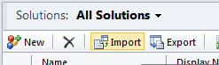
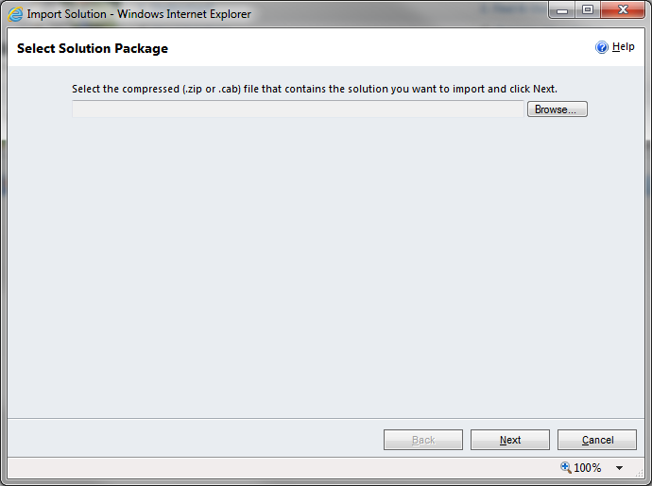
Click “Browse” and select the zip file you have been sent, and then click “Next”.
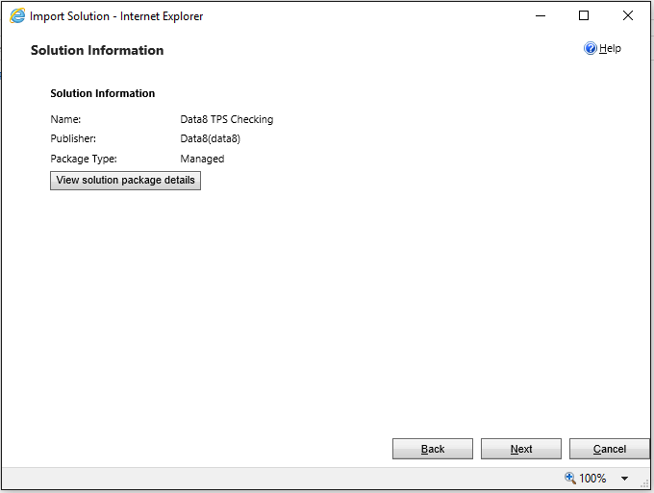
Click “Next” again to view the import options.
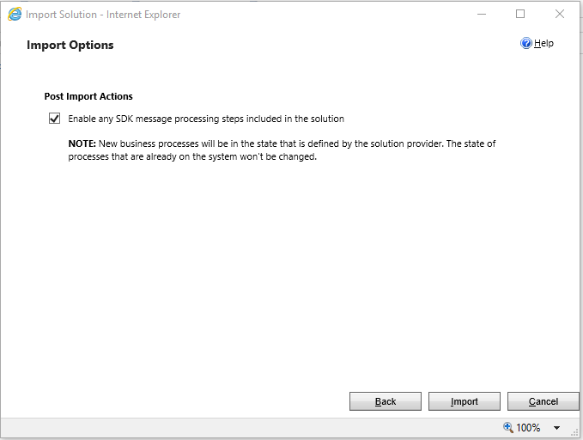
Ensure the “Enable any SDK message…” option is ticked. Click “Next” again and the solution will be imported.
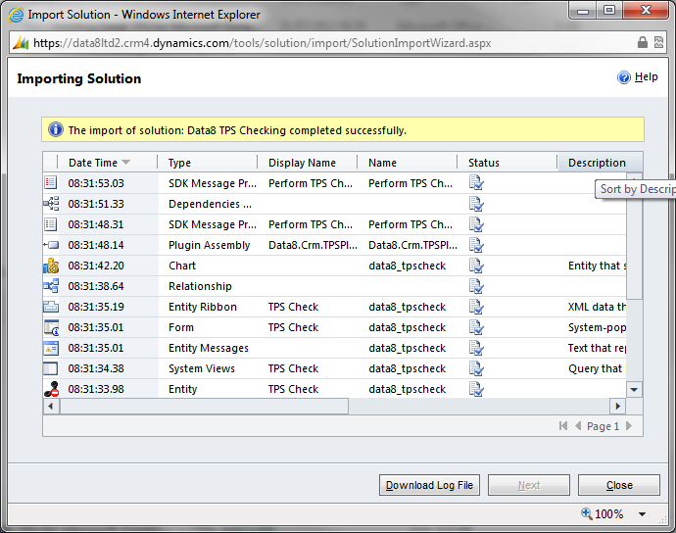
Click “Close” and the solution has now been imported.

Configuring the TPS system
The latest Data8 TPS solution has all resources neatly packaged with the solution – in order to use it to its full capacity, there are a few steps required.

Initial Configuration
After install, please open the solution and navigate to the configuration page.
Here you will need to enter 2 API keys, one website one (for your immediate update) and one server one (for your commit on save and update).
In order to access your API Keys, please access your Data8 dashboard. When creating a new key, you will be asked if you want your key to be a website key or a server key
When you make the website key, you will need to add a domain - just enter the URL of the system you are configuring.
Paste the API keys into the relevant boxes and click save.

Quick Field Configuration
The Data8 TPS solution can be configured to map TPS and CTPS status’ to any phone number field in any entity. In order to do this, you will need to do some configuration.
Once you have saved your API keys from the step above, you will see more details around your “Current License Status” and also “Entity Types”. Entity Types is where we will focus.
If you haven’t configured up the solution yet, you will see this warning.
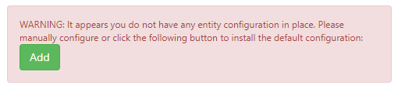
This is to help you with quick configuration and pressing “Add” will copy the basic configuration into your system for you. You can then make your own amended as required.

Advanced Field Configuration
In order to add a custom configuration, you will need to select the entity. If you have configured TPS or CTPS for at least one field in an entity, the entity will be listed with a “Reconfigure” button. If not, click to “Add a TPS configuration for” and select the relevant entity. Either pressing “Reconfigure” for existing or “Add” for a new entity will take you to the same page.
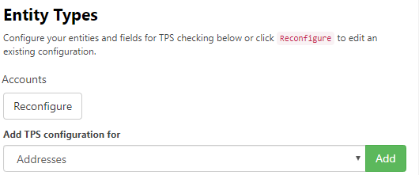

Once your page has reloaded, you will see a list. The basic idea is to map a telephone field to a status field and assign a relevant icon in order to display it in a friendly manner on the form.
Under “Add New Mappings”, the following are your options:
- Source Field – This is the field that contains the phone number you with to TPS/CTPS check
- Target Field – This is the field you will store the TPS/CTPS. This field must be defined using the existing option set “data8_tps_status”.
- Icon – This is the FontAwesome Icon you wish to show in the grid. For more information, please refer here: https://fontawesome.com/v4.7.0/icons/
Each time you add a new mapping and save, the page will reload to confirm.
You also have some more advanced settings to set on this page.
- TPS Override Lookup – If you are storing your TPS overrides within your system, this is the lookup field to the related record. Any lookup field that is a lookup of type “data8_tpsoverride” will appear in this list. The “TPS Override Lookup” field is optional.
- Last Checked Date – The last checked date is a date time field that just stores the last time this record was TPS/CTPS checked through the Data8 batch tool. Any date time field will be selectable here. The “Last Checked Date” is optional.

Setting up how to view TPS and CTPS status
Included within the Data8 TPS solution is an easy way to visually see all TPS and CTPS statuses from any form.
Open the relevant form you want to discuss TPS status (i.e. the contact “Main” form). On this form, insert the WebResource named “data8_tpsstatus_dynamic.html” onto your form, giving it a label and a name useful to your system – the name is only for your reference.
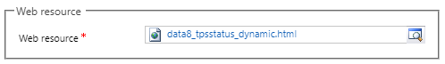
From here you can just save and publish your form.

Keeping your system up to date
As well as real time updates from your phone numbers, the TPS solution offers the ability to keep up to date with your TPS checking if you are licensed to do so.
In order to do, the first step you will be required to do will be to set us up with an active CRM connection. This doesn’t need to be a user, it can be a service account. For more information and steps on how to configure this, please visit this page.
Once this is configured, your system will be kept up to date overnight.

Security Roles
We recommend any of your users who will be required to TPS check to have the “Data8 TPS User” security role assigned to their account. This will ensure they can read the correct configuration when viewing or amending a record.

Customised Configuration
Should you want to use your own methods, you can do so using the following steps.
The imported solution includes a custom entity type called “TPS Check”, found in the Settings section of the CRM interface, that performs the TPS and CTPS checks.
Important: If after publishing the customisations the “TPS Check” entity is not shown in the Settings section of the CRM interface, you can force it to be displayed by going to Settings > Customization > Customizations > Customize the System, select the TPS Check entity, tick “Settings” under “Areas that display this entity”, click Save, Publish and then refresh the main CRM interface.
To check a number, create a new TPS Check record, enter the telephone number to check, your Data8 username and password and select whether to check the number against TPS, CTPS or both. Save the record and the following additional attributes will be filled out:
- On TPS / On CTPS – indicates if the number was found on either the TPS or CTPS
- TPS Check Time / CTPS Check Time – indicates the time at which the number was checked for auditing purposes
- Callable – indicates if the number is allowed to be called, i.e. not on TPS or CTPS
You can perform ad-hoc TPS and CTPS queries by creating a TPS Check record manually, but it is recommended that you set up automated workflows to perform these checks automatically as required by the business processes.

