NuSoft Last Contact
Version 8

Installation and Configuration Guide

Table of Contents
Introduction 3
System Requirements 3
Installation 3
Configuration 6
Configuring NuSoft Last Contact 6
Choose which activity you want to track 6
Deactivate an Activity Type 7
Change the Activity Criteria 9
Add Last Contact Date to Views 13
Configuration Page 20
Product Key 21
Support 22
Disclaimer 22

Introduction
This document is designed as an introductory guide for Microsoft Dynamics CRM users to learn the basics of using NuSoft Last Contact. It includes step by step instructions on how to install and configure NuSoft Last Contact.

NuSoft Last Contact is a CRM utility that tracks your last interactions with Leads, Accounts, Contacts, and Opportunities.

Features:
- Automatically update Last Contact date fields on all records based on phone calls, appointments, and service activities
- Custom views on Account, Lead, and Opportunity:
  - My Neglected Records
  - All Neglected Records
- Neglected Customer Dashboard
  - Neglected Accounts, Leads, and Opportunities views
  - Neglect Accounts, Leads, and Opportunities charts by owner

System Requirements
NuSoft Last Contact is compatible with the following installations of CRM:

Microsoft Dynamics CRM Online, On-Premise, and Partner Hosted
- CRM 2016
- CRM 2016 Update 1
- NuSoft Common Solution

The following browsers are supported:

- Internet Explorer 10+
- Google Chrome 43+
- Safari 8.0.5+
- Firefox 38.0.5+

Installation
- Navigate to Settings -> Dynamics Marketplace

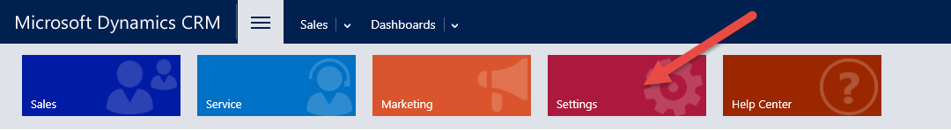

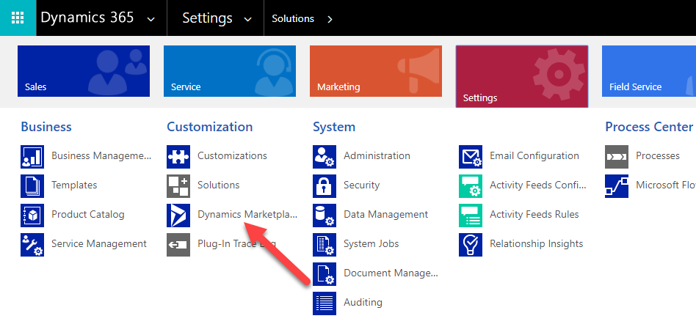
- Enter “NuSoft” in the search box and click on “Get it now” for NUSOFT Last Contact.

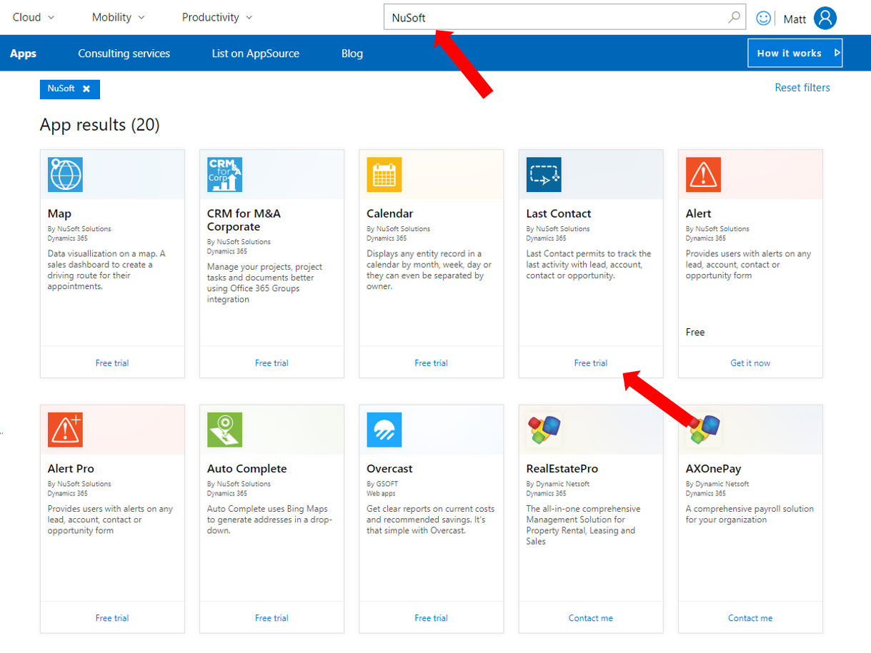
- Check the box and click Continue
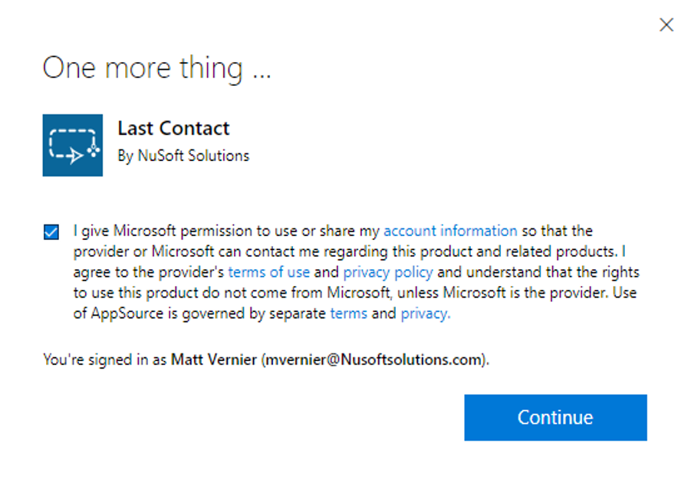

- Agree to the conditions and click Agree
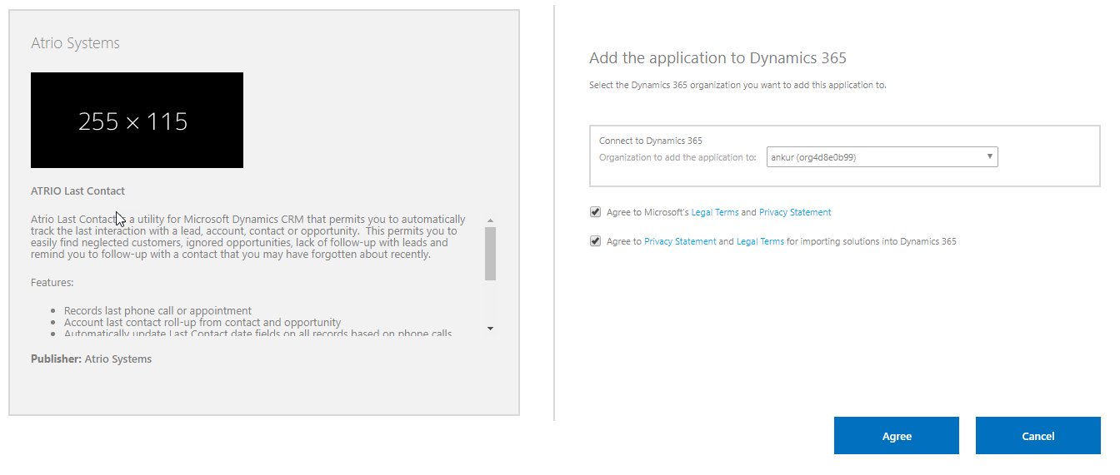
- Come back to Settings > Solutions > All Solutions records page after the installation has completed, NUSOFT Last Contact solution file should show up in the records.

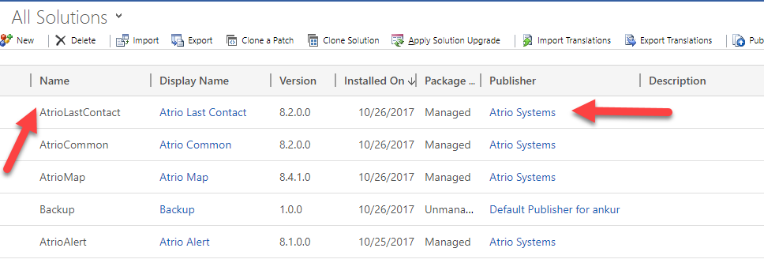

Configuration

To retroactively update the Last Contact information using existing activities you must follow the steps below.

Configuring NuSoft Last Contact
All of the configurable options for NuSoft Last Contact are contained within the 8 installed workflows. The 4 update workflows are responsible for the regular functions. The 4 retrieve functions are only used when first installing Last Contact to get historical data. This section will describe how to configure the update workflows in order for Last Contact to meet your business needs.

To configure NuSoft Last Contact log into CRM as the CRM Administrator.

Choose which activity you want to track
Choose which activity you want to track for last contact. By Default, Phone Call, Appointment, Service Activity should all be set to Yes.:

- Under Settings>Solutions select the NuSoft Last Contact solution and open the configuration page. Mark the checkboxes of the activities that you want to update the last contact information. Press Submit to confirm your choices.

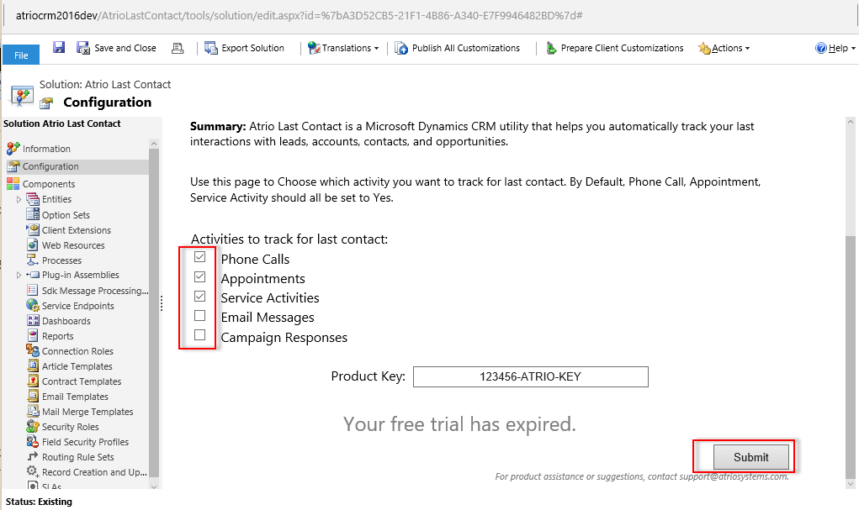

Deactivate an Activity Type
For this example, we have decided that we do not want use emails to update the Last Contact field. In order to disable an activity:

- Under Settings>Processes select the Last Contact (Update) – Email workflow and click the Deactivate button.

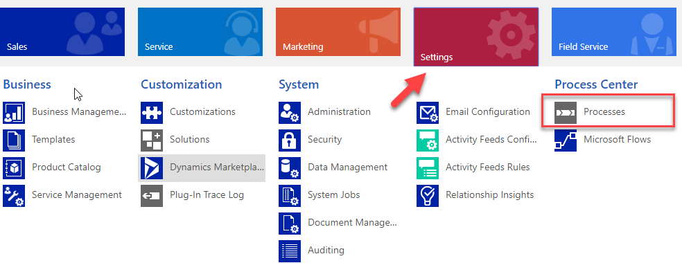

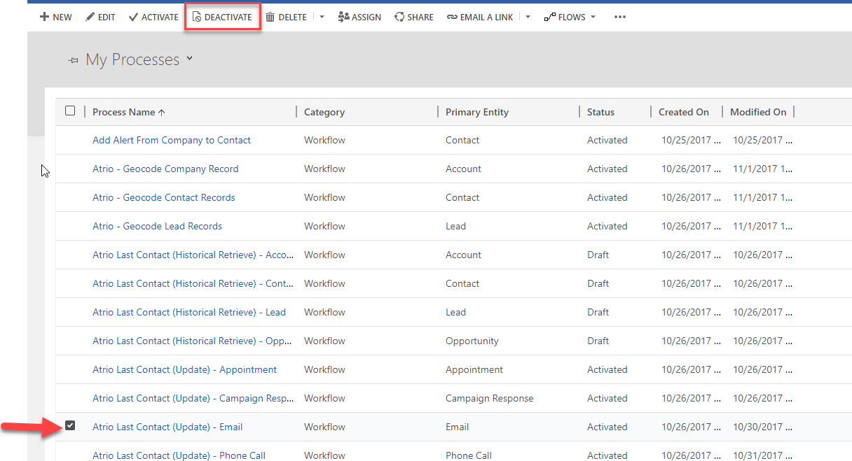

- Press Deactivate to confirm your choice.

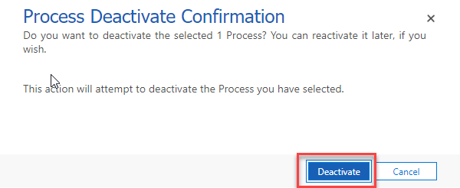

- Observe that the Last Contact (Update) – Email process is now listed in the Draft status. If you decide later that you want emails to update the Last Contact you can simply Activate the workflow and it will begin to function.

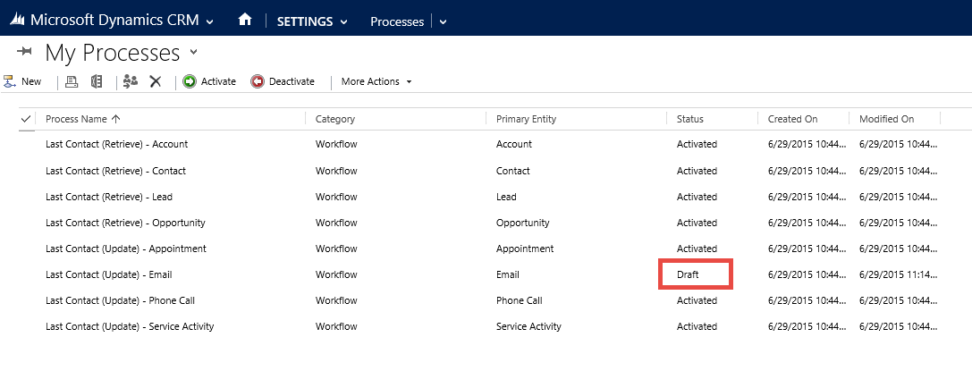

Change the Activity Criteria
For this example, we have decided that we want received phone calls to update the Last Contact field in addition to made phone calls. In order to change an activity criterion:

- Select the Last Contact (Update) – Phone Call process
- In order to edit the workflow, you need to deactivate it to move it to the draft status. Press the Deactivate button on the process form and again on the confirmation dialog.

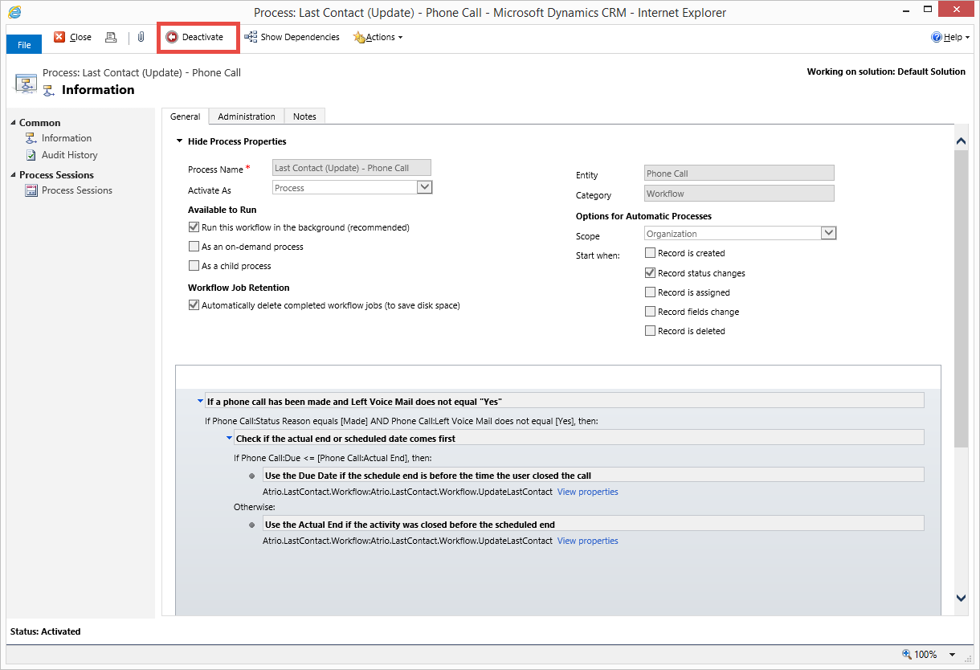

- For this example, we want to change the first if statement. Click on the if statement to edit it.
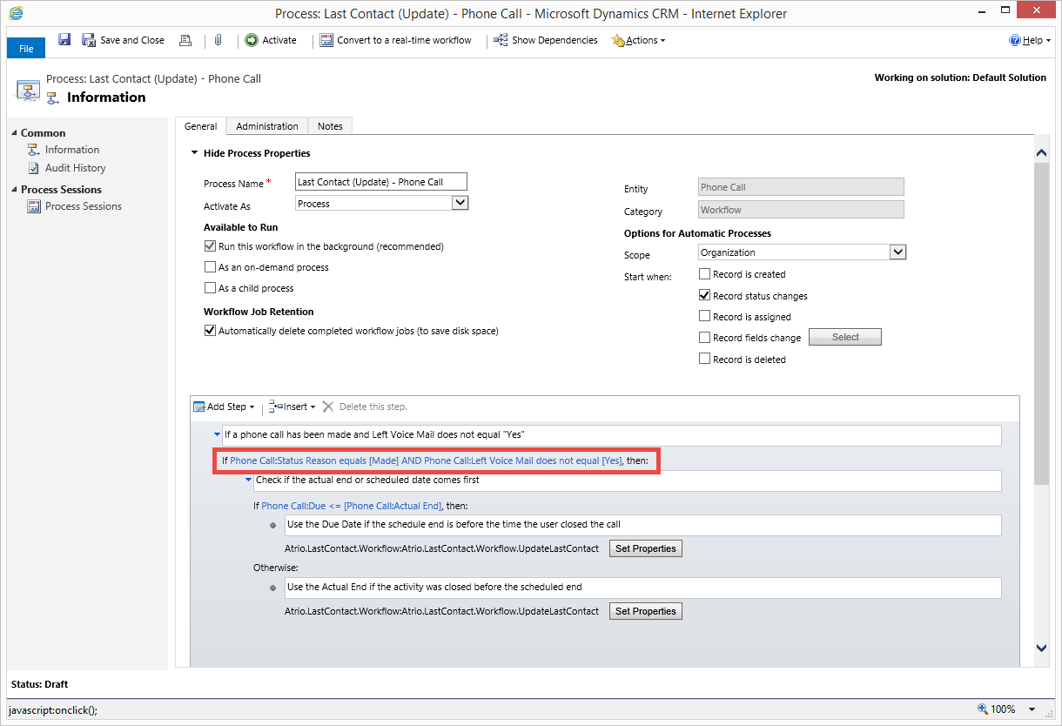

- Click on the value field at the far right of the Status Reason line to change the values.

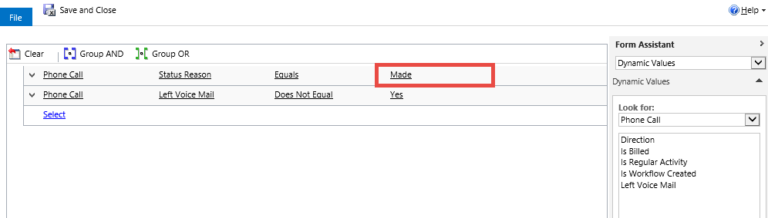

- Click Received in the Available Values list and then click the >> button to move it into the Selected Values list. Click OK.
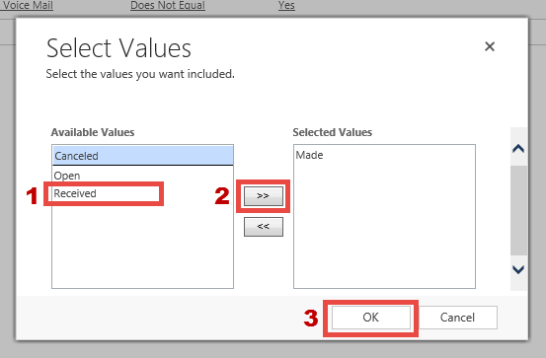

- Verify that Received has been added to the Status Reason line. Click Save and Close to make the changes.

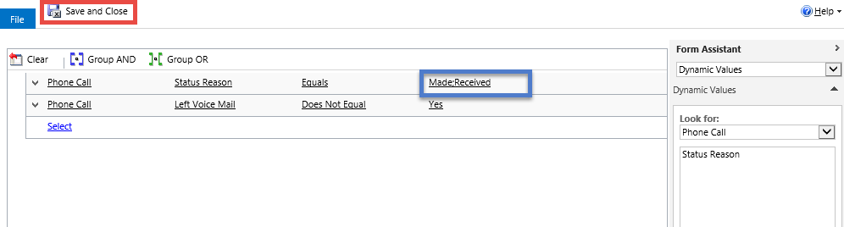

- Observe that the if statement has been changed to include Received. Change the comment above the statement to reflect the changes made. Press the Activate button on the process form and again on the confirmation dialog.
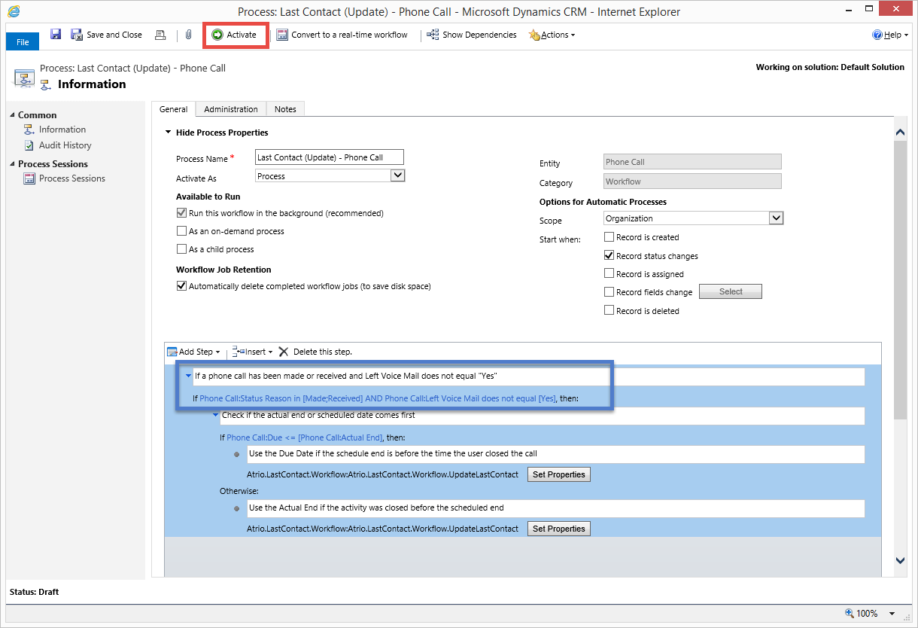

Add Last Contact Date to Views
In addition to the views that come with Last Contact, you can add the Last Contact field to any existing or new views. Here is an example of how to create a new personal view using the Last Contact field in order to gain additional insight for your business.

- Navigate to the entity that you wish to create a new view in.
- Go to Sales > Account/Contacts or Leads
- Click the view drop down selector (v) and click Create Personal View.

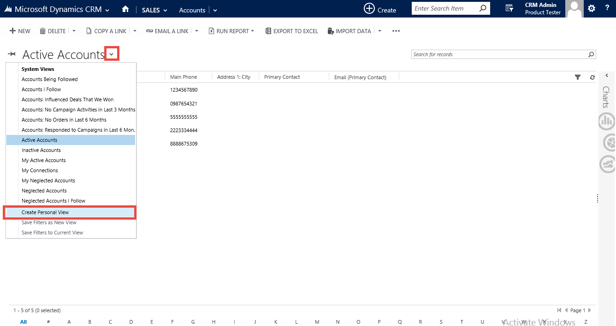

- In order to set the Criteria, click the select button.

- Select Last Contact Date from the dropdown list.
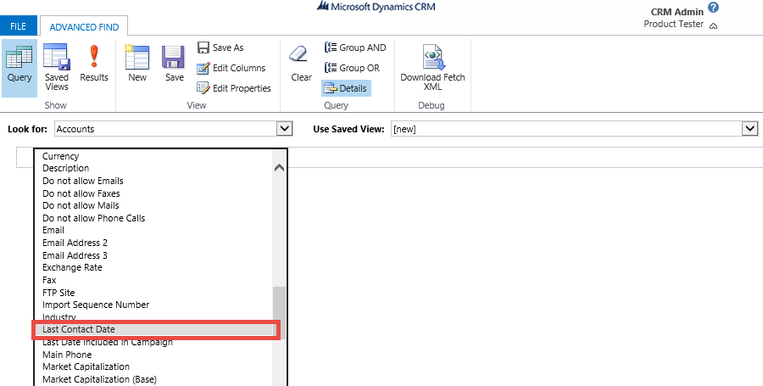

- For this example, we want to view all accounts with a Last Contact date older than 1 month. Fill the view criteria as it applies to your desire. Add additional criteria as necessary. Click Edit Columns to modify the view data.

- Select the Account Name column and then click Add Columns.
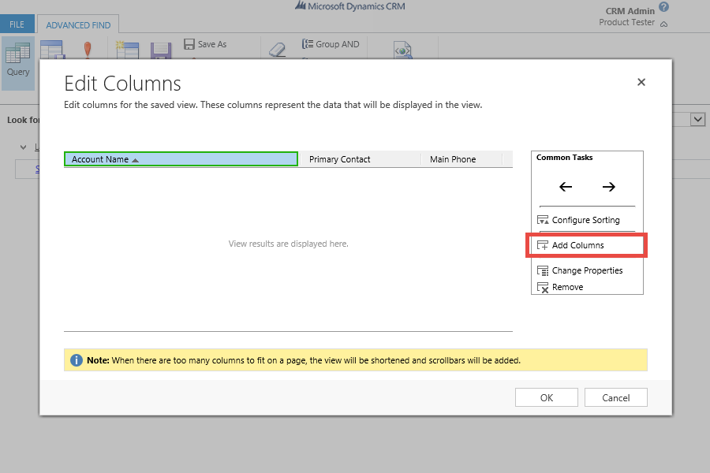

- Check Last Contact Date from the list and click OK.

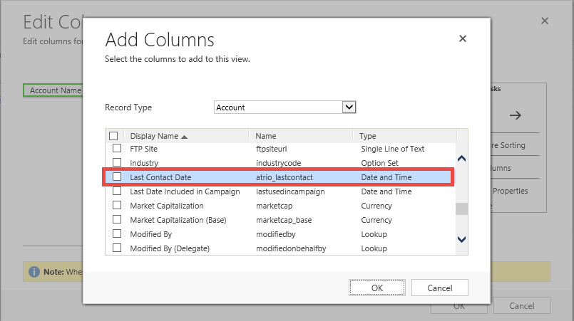

- The Last Contact date column has been added to the view. Use the <- and -> buttons to move the column to the desired position. Click Configure Sorting.

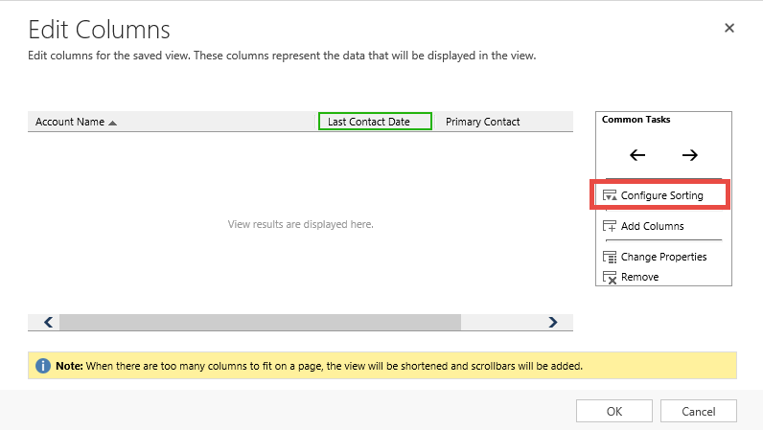

- In the sort by drop down select Last Contact Date and then choose the ascending option in order to display the oldest account first. Click OK and then OK again to save the changes.

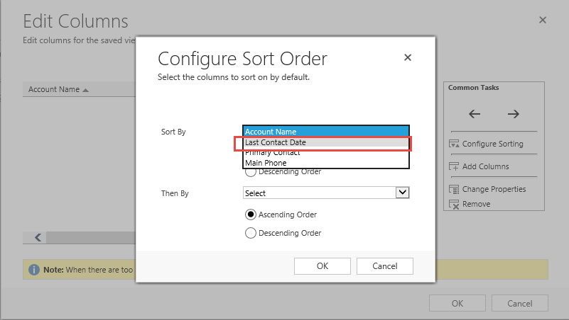

- Press the Save As button in order to save the view.

- Fill in the name for the view and press the Save button. Close out of the Advanced Find window to return to the main CRM window.
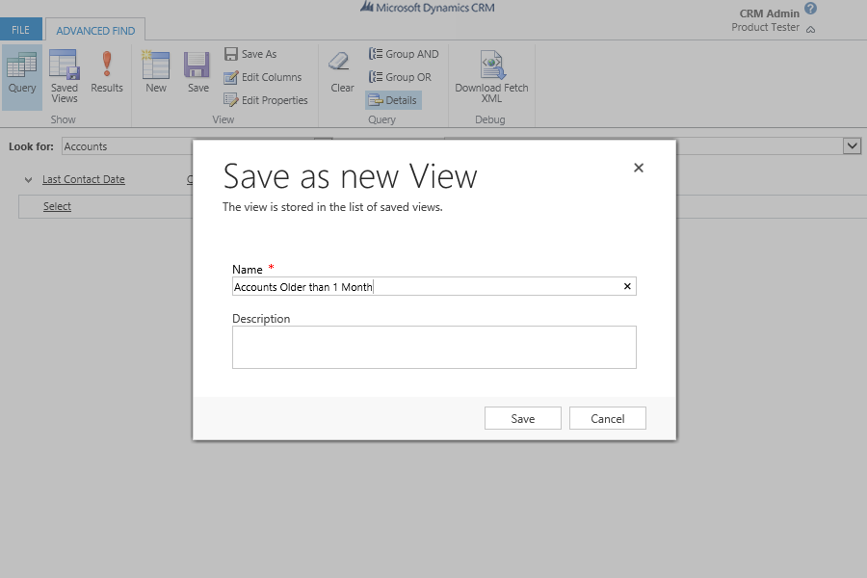

- Click the view drop down selector and click the view that was created.

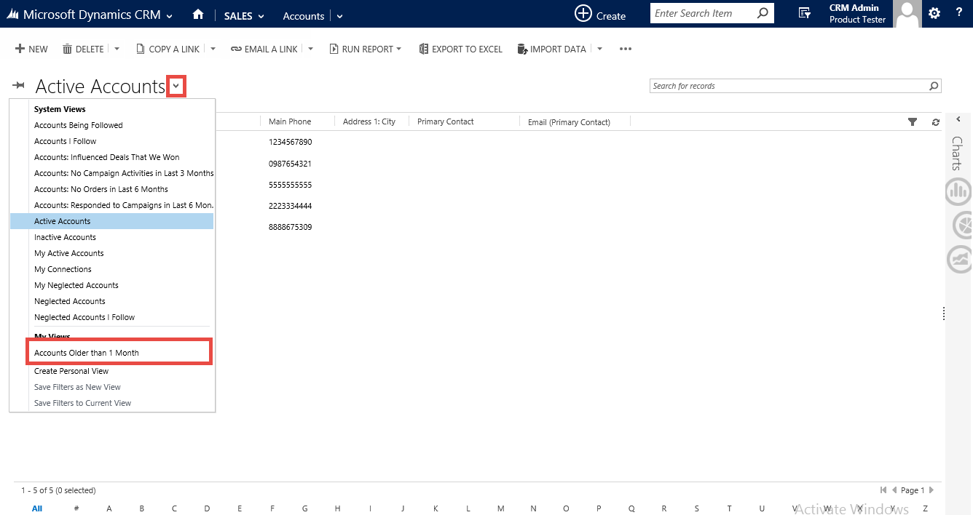

- You have successfully added Last Contact Date to a personal view.

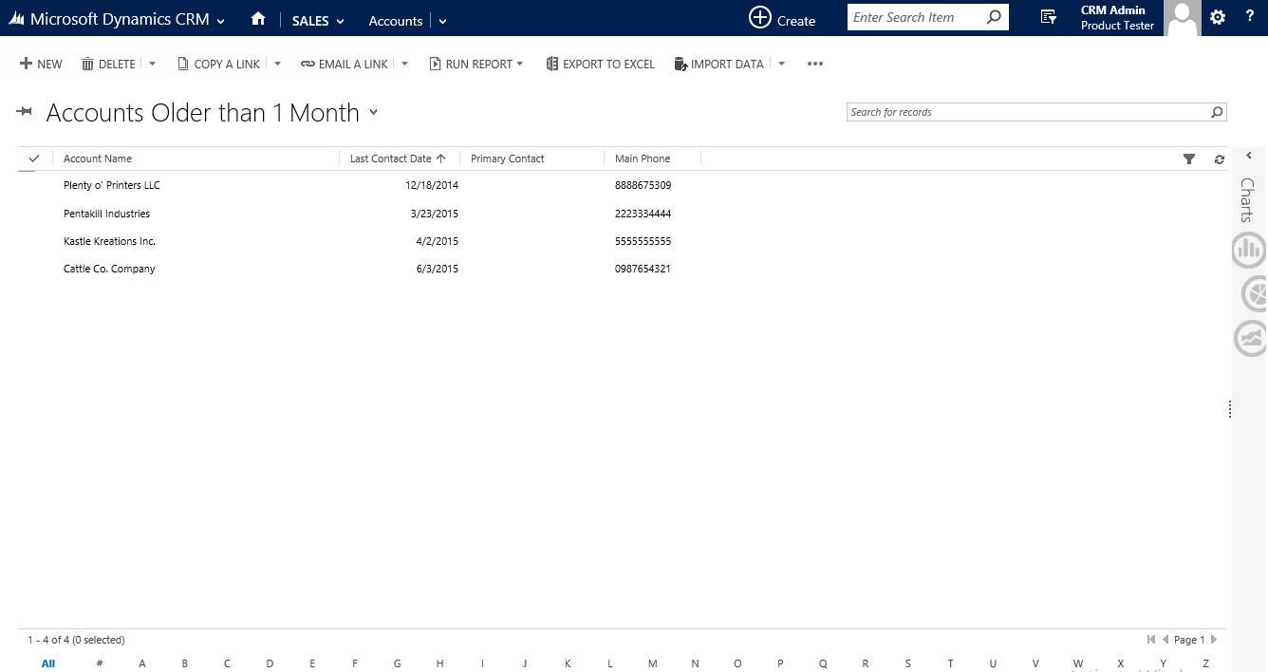

Configuration Page

Use this page to Choose which activity you want to track for last contact and to enter product key for NuSoft Last Contact.

- Navigate to the Solutions page again and open the NuSoft Last Contact solution.
- The Configuration Page will appear. In this page, will be a set of checkboxes. Click and check the activity type you want to track. By Default, Phone Call, Appointment, Service Activity should all be set to Yes.
NOTE. Corresponding “NuSoft Last Contact (Update) - <activity>” workflows must be activated to track selected activities types.

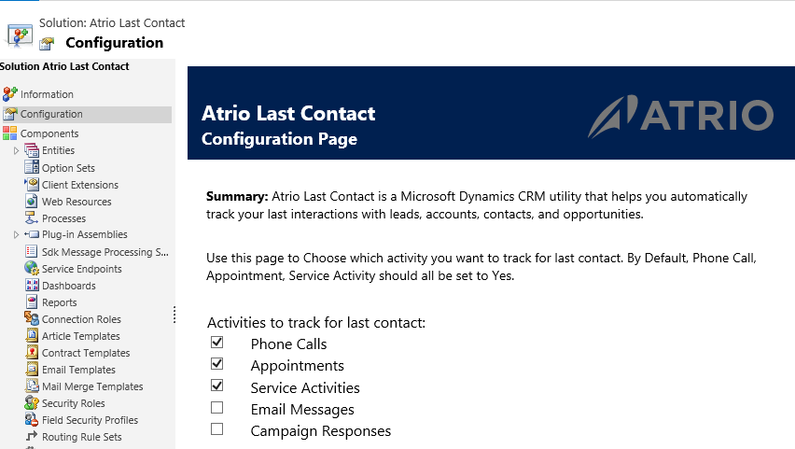

Product Key
Also use this page to enter product key for NuSoftLast Contact.
After 30 days of use, NuSoft Map will no longer work. To enter a purchased product key, follow the steps below.

- Navigate to the Solutions page again and open the NuSoft Last Contact solution.
- The Configuration Page will appear. Towards the bottom of the page will be a slot for the product key. Type in the product key you received from NuSoft and click Submit. If you do not have a product key, contact NuSoft at support@nusoftsolutions.com to receive one.
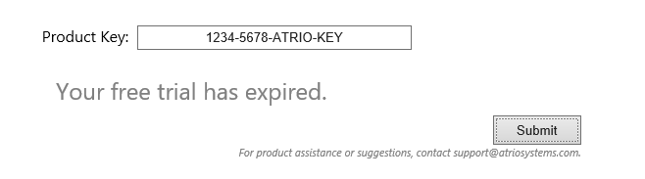

Please send any product issues or suggestions to support@nusoftsolutionss.com.

Support
Please send any product issues or suggestions to support@nusoftsolutions.com.

Disclaimer
THIS SOFTWARE IS PROVIDED "AS IS", AND ATRIO SYSTEMS, INC. DBA NUSOFT SOLUTIONSDISCLAIMS ALL WARRANTIES WITH REGARD TO THIS SOFTWARE INCLUDING ALL IMPLIED WARRANTIES OF MERCHANTABILITY AND FITNESS FOR A PARTICULAR PURPOSE. IN NO EVENT SHALL ATRIO SYSTEMS, INC. DBA NUSOFT SOLUTIONS BE LIABLE FOR ANY SPECIAL, INDIRECT, OR CONSEQUENTIAL DAMAGES OR ANY DAMAGES WHATSOEVER RESULTING FROM LOSS OF USE, DATA OR PROFITS, WHETHER IN ACTION OF CONTRACT, NEGLIGENCE, OR OTHER TORTIOUS ACTION, ARISING OUR OF OR IN CONNECTION WITH THE USE OR PERFORMANCE OF THIS SOFTWARE.

