NuSoft Last Contact
Version 8

User Guide

Table of Contents
Introduction 3
Using NuSoft Last Contact 3
View Neglected Records 5
Views 5
Last Contact Dashboard 6
Support 6
Disclaimer 6

Introduction
This document is designed as an introductory guide for Microsoft Dynamics CRM users to learn the basics of using NuSoft Last Contact.

NuSoft Last Contact is a CRM utility that tracks your last interactions with Leads, Accounts, Contacts, and Opportunities.

Features:
- Automatically update Last Contact date fields on all records based on phone calls, appointments, and service activities
- Custom views on Account, Lead, and Opportunity:
  - My Neglected Records
  - All Neglected Records
- Neglected Customer Dashboard
  - Neglected Accounts, Leads, and Opportunities views
  - Neglect Accounts, Leads, and Opportunities charts by owner

Using NuSoft Last Contact
- Navigate to Sales -> Contact.
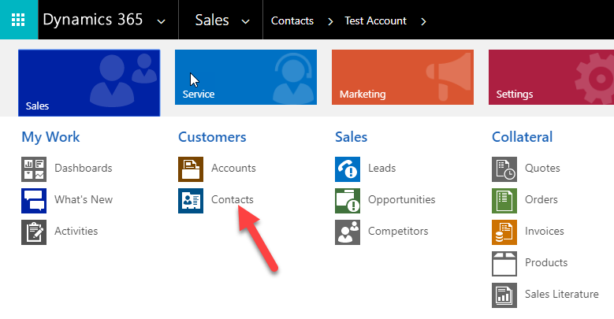
- Create a contact and Save it or Open an existing contact.
- On the Social Pane, click on Add Phone Call link. Go to Activities tab > Click On “Add Phone Call” link
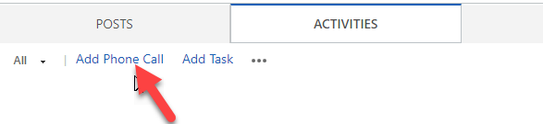
- Enter detail of the phone call and click ok
- Wait for 30 seconds to 1 minute
- Refresh the page
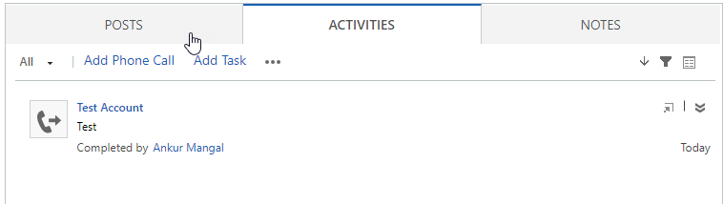
- Expand Last Contact Tab (at the end of the page)
- Last Contact Activity information - Last Contact Date (date field) and Last Activity Subject (webresource) - should be displayed on the form.

View Neglected Records
NuSoft Last Contact allows for a quick look at which records need attention. This product comes with system views and a Last Contact Dashboard.

Views
Go to any Lead, Account, or Opportunity list. Under the view list will be system views that list records that have not been contacted in the last 3 months in order of oldest Last Contact Date. Note: this range may be modified by your system administrator (see the Installation and User Guide). These views filter which record has been neglected, so you can easily see who you need to contact.
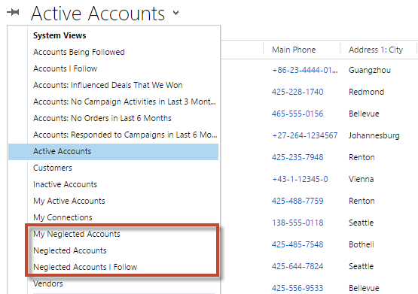

Last Contact Dashboard

Go to Sales->Dashboards to open up system dashboards. Select Last Contact to get a quick overview of all neglected records in CRM.

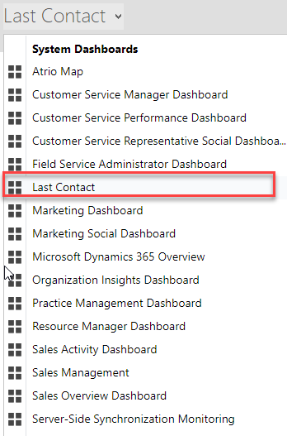

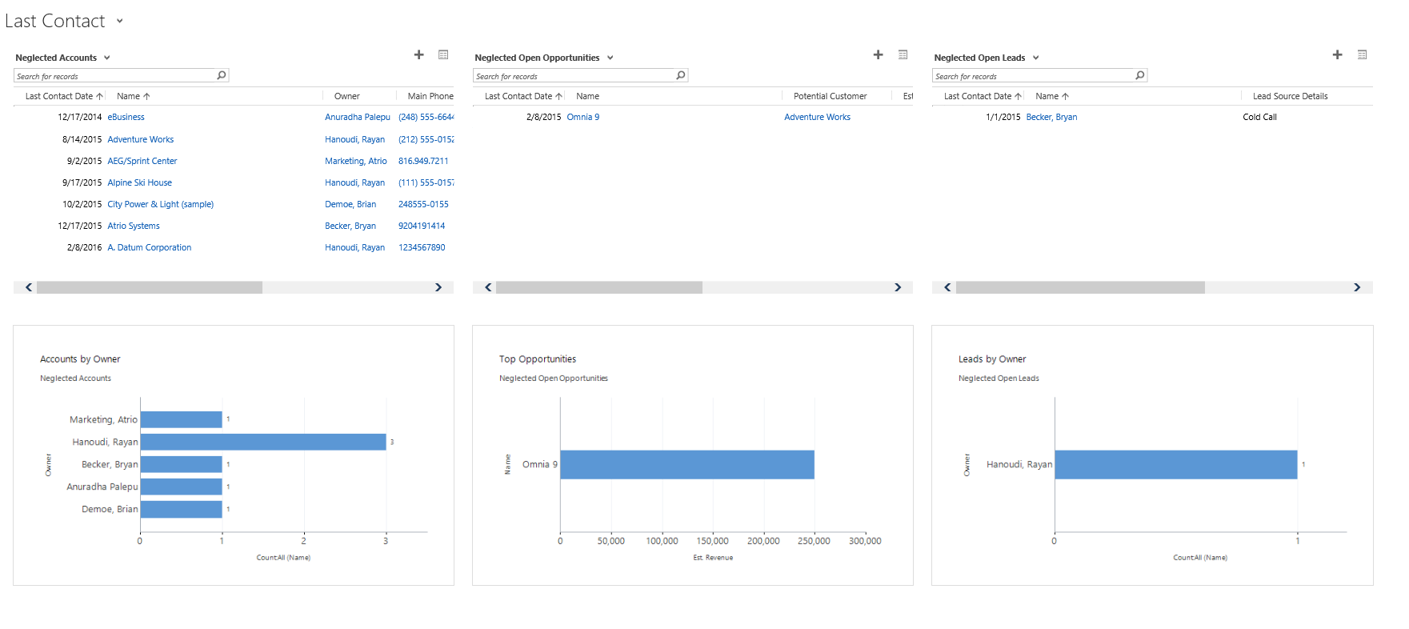

Support
Please send any product issues or suggestions to support@nusoftsolutions.com.

Disclaimer
THIS SOFTWARE IS PROVIDED "AS IS", AND ATRIO SYSTEMS, INC. DBA NUSOFT SOLUTIONS DISCLAIMS ALL WARRANTIES WITH REGARD TO THIS SOFTWARE INCLUDING ALL IMPLIED WARRANTIES OF MERCHANTABILITY AND FITNESS FOR A PARTICULAR PURPOSE. IN NO EVENT SHALL ATRIO SYSTEMS, INC. DBA NUSOFT SOLUTIONS BE LIABLE FOR ANY SPECIAL, INDIRECT, OR CONSEQUENTIAL DAMAGES OR ANY DAMAGES WHATSOEVER RESULTING FROM LOSS OF USE, DATA OR PROFITS, WHETHER IN ACTION OF CONTRACT, NEGLIGENCE, OR OTHER TORTIOUS ACTION, ARISING OUR OF OR IN CONNECTION WITH THE USE OR PERFORMANCE OF THIS SOFTWARE.

