Property Listing Module  User Guide | Abstract  The Property Listing Module adds a new entity to your D365 installation allowing you to track property-specific information.  Surya Singh  Dynamics 365 Add-on by CanCClear

# | Date | Author | Reason | Version
1 | 25/02/2019 | CanCClear | Initial Version | 1.0

Contents
1.)Property Listing Module 3
1.1)Introduction 3
2.Creation of the Property 3
2.1)Step to follows: 3

Property Listing Module

1.1) Introduction
The Property Listing Module adds a new entity to your D365 installation allowing you to track property-specific information.
Linking Accounts and Contacts, the Property Listing Module allows a Property Manager to add their properties under management and keep track of property-specific information such as contracts, on-site contacts, and more.
If the property needs to be transferred to a new manager, all the historical information goes with it.
We are providing a solution by which user can add the customer property information and can also add the property manager and on-site contact.

2.Creation of the Property

2.1) Step to follows:
- Click on Settings sitemap and go to the extension click on the property option.

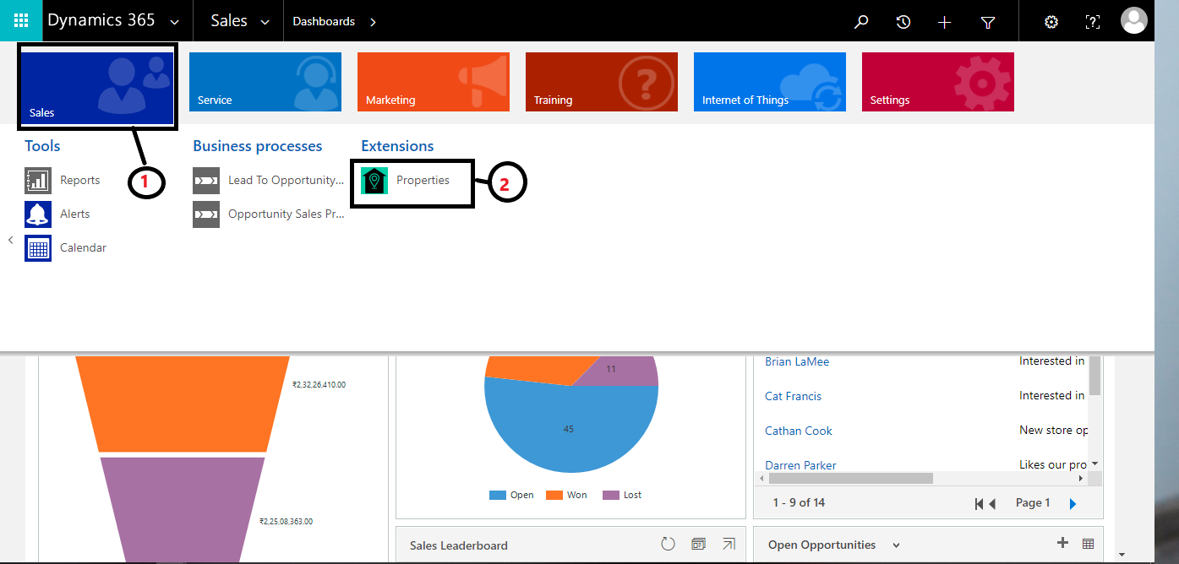
- Click on the ‘+’button to create new property record.
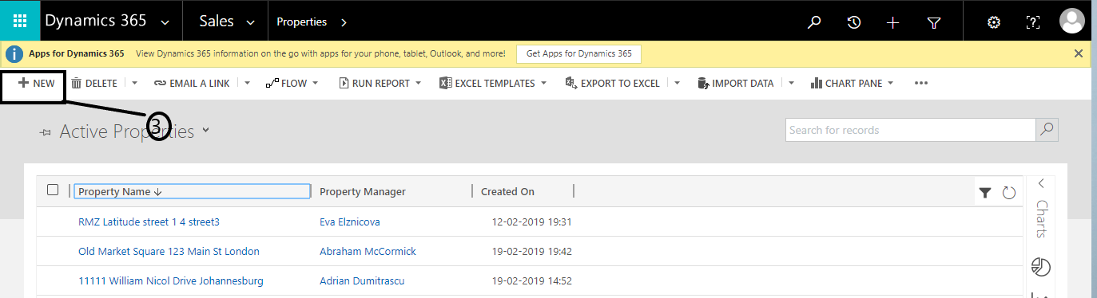
- Select the type of property, Property manager and add who will be the on-site contacts at property location.

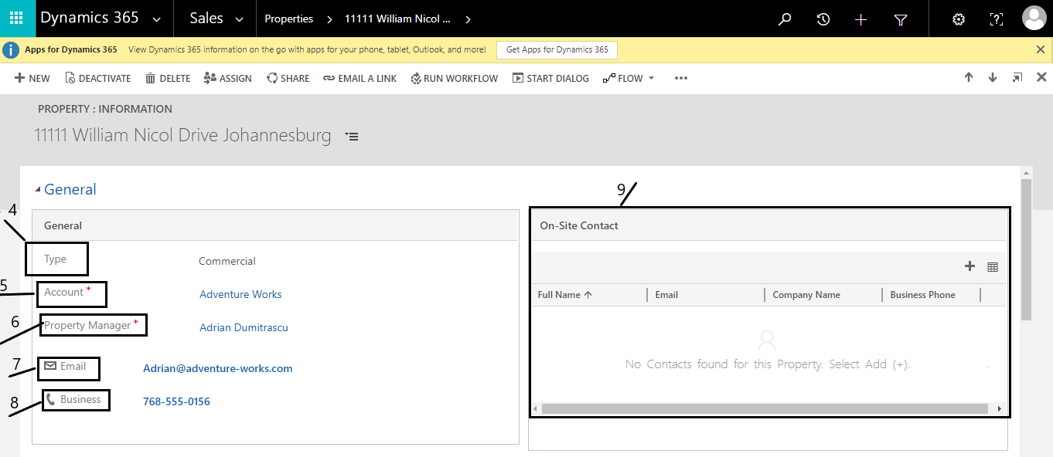
- Enter property Billing and shipping address. Save the Record.

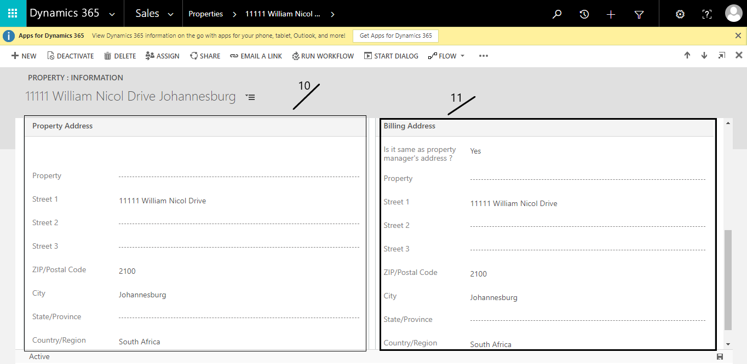

- User can associate N numbers of the property With Property Manager and specify the on-site contacts of the property.
- Give Property name, street, Zip, city, state and Country information in property address bar.
- User can add Billing address or can inherit the Property manager address (by setting field value “Is same as Property Manager Address” as yes).

