Functionality validation guide

This technical document is aimed at Microsoft partners who publish Dynamics 365 Customer Engagement and Power Platform solutions to AppSource. It contains templates and guidelines for conducting functional validation on your solution.
  - End-to-end scenarios for verifying your solution

Contents
Introduction 1
Purpose of this document 2
E2E document history 2
Solution overview 2
Source candidates faster and manage recruitment processes with Dynamics 365 for Recruitment | Mercury xRM. 2
Embrace best-in-class technology from Microsoft and their partners 2
Template for model-driven app or Dynamics 365 Customer Engagement app 4
Create a Client 4
Create a Contact 6
Create a Vacancy (Permanent) 8
Create a Vacancy (Contract) 10
Create a Vacancy (Temporary) 12
Create a Candidate 14
Create activities on a Client 15
Create activities on a Contact 17
Create activities on a Candidate 19
Shortlist a Candidate to a Vacancy 21
Submit a Candidate for Client Review 23
Have a Client Shortlist a Candidate for review 27
Progress a Candidate to attend an Interview 30
Offer made to the Candidate 35
Candidate Accepting an Offer 38
Candidate Rejecting an Offer 42
Progress a Placement to Start 45
Best practices for writing good test cases 47
Glossary 47

Introduction
Functional validation determines if the solution is behaving according to specifications. This document is aimed to capture the functional requirements of your system. Functional requirements define what the system is supposed to do and what it will provide to the end-user. It describes the functionality or behavior of the system.

Purpose of this document
The purpose of this document is to describe the integration endpoints and the components used in your solution along with the list of end-to-end scenarios offered by your solution. This document would be used by Microsoft to verify the functionality offered in this solution.
The reviews in this area will be to validate whether partners’ solution meets Microsoft guidelines, and passes the functional validation. Currently, this process is done by Microsoft using artifacts provided by the partner. The artifacts required are:
Required artifacts:
Solution architecture diagram
End-to-end user scenarios

E2E document history
Date | Version no. | Description of creation/change | Prepared by | Reviewed by
07/06/2019 | 1.0.0 | Creation of E2E document | Mercury xRM
Update the document history table every time the offer is republished with code/feature changes.

Solution overview

Source candidates faster and manage recruitment processes with Dynamics 365 for Recruitment | Mercury xRM.
Mercury xRM enables you to recruit permanent or temporary/contract positions, allowing the recording of all activities with hiring contacts and candidates and management of the recruitment process in what is usually known as an Applicant Tracking System. By combining the capabilities of Dynamics 365 for Sales, CRM and ATS recruiters can manage their recruitment pipeline, use Leads and Opportunities for sales automation and communicate using the integrated production suite of Office 365.
Mercury xRM is a full offering for Medium, Large and Enterprise organisations offers the following additional features:
- CV/Resume parsing - Extract contact details, skills, work history and education
- Automate branded candidate profiles
- Powerful search across candidates and contacts
- Promote vacancies across multiple job boards from a single screen and directly import candidates.
- Promote vacancies via direct posting to job boards and social media.
- Bulk email capability
- Candidate Portals for self-service management of data protection, compliance, placement offers and timesheets.
- Business Intelligence reporting packs

Embrace best-in-class technology from Microsoft and their partners
Unlock the value from Microsoft’s technology stack with seamless integration with:
- Outlook and Office 365: Leverage the world’s best known productivity suite. Single sign on, access documents, calendar, Office applications, synchronise emails, contacts, tasks and appointments.
- Teams / Skype for Business: Host calls and meetings quickly.
- Telephony: Host your phone system fully in the cloud with optional telephony solutions (Microsoft Teams/Skype for Business or choose a Microsoft partner solution.
- Power BI: Develop your own Business Intelligence or use a partner content pack.
- Marketing Automation: Use native integration with Microsoft Dynamics 365 or that of another market leading provider.
- Financial Applications: Full front and back office integration with Microsoft or partner integrations including Business Central, Finance and Operations, Xero and QuickBooks.
- E-signatures: Electronically sign terms and documents faster using integration with a choice of providers including Adobe and DocuSign.
- Gamification: Use Microsoft’s gamification offering or one of its Market place partners to create internal competition and incentives.
Figure 1: Sample end-to-end solution architecture

Template for model-driven app or Dynamics 365 Customer Engagement app

Create a Client
App name: Mercury xRM

User scenario: As a recruitment consultant, I want the ability to create a Client and record details in order to interact with and to record individual contacts for this Client, create vacancies and submit Candidates those Vacancies.

Business scenario:

Instructions:

Scenario description:  Solution version #: | Prerequisites for achieving this scenario:
 | Configuration settings:
 | Software/tools needed to achieve this scenario with version details:
 | System post-condition after this scenario:
Notes:

Test steps to execute the scenario
Step # | Test step/Input | Expected result | Actual result (To be filled by Microsoft) | Pass/Fail  (To be filled by Microsoft)
1 | From the main homepage, select ‘Clients’ from the grid on the left | Navigate to ‘Active Records’ view
2 | Click ‘New’ on the ribbon at the top | Opens a new Client record with no information
3 | Populate required information (mandatory fields which are highlighted by an asterisk). Once populated, click ‘Save & Close’. | Client details have been populated and created a new Client. Upon clicking ‘Save & Close’ this will take you back to the Clients homepage where you can see the Client you have just created.

Create a Contact
App name: Mercury xRM

User scenario: As a recruitment consultant, I want the ability to create an individual at a Client of whom I / other users can contact and to make them the primary contact for a Client.

Business scenario:

Instructions:

Scenario description:  Solution version #: | Prerequisites for achieving this scenario:
 | Configuration settings:
 | Software/tools needed to achieve this scenario with version details:
 | System post-condition after this scenario:
Notes:

Test steps to execute the scenario
Step # | Test step/Input | Expected result | Actual result (To be filled by Microsoft) | Pass/Fail  (To be filled by Microsoft)
1 | From the main homepage, select ‘Contacts’ from the grid on the left | Navigates to ‘Active Contacts’ view
2 | Click ‘New’ on the ribbon at the top | Opens a new Contact record with no information
3 | Populate required information (mandatory fields which are highlighted by an asterisk) including ‘Client’. Once populated, click ‘Save & Close’. | Individual Contact details have been populated and created a new Contact. Upon clicking ‘Save & Close’ this will take you back to the Clients homepage where you can see the Contact you have just created.
4 | Check the Contact is associated with the Client record by selecting ‘Clients’ on the left, then opening the specific Client record (who you just created the Contact for) and selecting ‘Contacts’ tab | The Contact you have just created should appear in the Contact view, under the Contacts tab on a Client.
5 | On the ‘General’ tab for the Client, populate the ‘Primary Contact’ field and select the Contact you have just created | Should see the Contacts name populated in the ‘Primary Contact’ field

Create a Vacancy (Permanent)
App name: Mercury xRM

User scenario: As a recruiter, I want the ability to create a Vacancy for a permanent role for a specific Client which they are looking to fill.

Business scenario:

Instructions:

Scenario description:  Solution version #: | Prerequisites for achieving this scenario:
 | Configuration settings:
 | Software/tools needed to achieve this scenario with version details:
 | System post-condition after this scenario:
Notes:

Test steps to execute the scenario
Step # | Test step/Input | Expected result | Actual result (To be filled by Microsoft) | Pass/Fail  (To be filled by Microsoft)
1 | From the main homepage, select ‘Clients’ from the grid on the left and open the required Client record. | Opens the Client record
2 | Select Vacancies from the tabs | Takes you to the Vacancies sub-grid for this Client
3 | Select ‘Add New Vacancy’ from within the sub-grid | Will open a new Vacancy record with minimal information
4 | Within this new record, select ‘Permanent’ from ‘Type of Position’ field and populate the mandatory fields then ‘Save & Close’. | Upon selecting ‘Permanent’ from ‘Type of Position’ field, new fields within the ‘FINANCIALS’ section will appear as these are related to the ‘Type of Position’ along with ‘BENEFITS’ section. The following fields have been pre-populated; ‘Client’, ‘Consultant’, ‘Hiring Manager’, ‘Email’, ‘Mobile’, ‘No. Positions’ (default value), ‘Currency’ (default value) & ‘Frequency’ (default value).

Create a Vacancy (Contract)
App name: Mercury xRM

User scenario: As a recruiter, I want the ability to create a Vacancy for a contract role for a specific Client which they are looking to fill.

Business scenario:

Instructions:

Scenario description:  Solution version #: | Prerequisites for achieving this scenario:
 | Configuration settings:
 | Software/tools needed to achieve this scenario with version details:
 | System post-condition after this scenario:
Notes:

Test steps to execute the scenario
Step # | Test step/Input | Expected result | Actual result (To be filled by Microsoft) | Pass/Fail  (To be filled by Microsoft)
1 | From the main homepage, select ‘Clients’ on from the grid on the left and open the required Client record. | Opens the Client record
2 | Select Vacancies from the tabs | Takes you to the Vacancies sub-grid for this Client
3 | Select ‘Add New Vacancy’ from within the sub-grid | Will open a new Vacancy record
4 | Within this new record, select ‘Contract’ from ‘Type of Position’ field and populate the mandatory fields then ‘Save & Close’. | Upon selecting ‘Contract’ from ‘Type of Position’ new fields within the ‘FINANCIALS’ section will appear as these are related to the ‘Type of Position’. The following fields have been pre-populated; ‘Client’, ‘Consultant’, ‘Hiring Manager’, ‘Email’, ‘Mobile’, ‘No. Positions’ (default value), ‘Hours per Day’ (default value), ‘Days per Week’ (default value), ‘Currency’ (default value) & ‘Frequency’ (default value).

Create a Vacancy (Temporary)
App name: Mercury xRM

User scenario: As a recruiter, I want the ability to create a Vacancy for a temporary role for a specific Client which they are looking to fill.

Business scenario:

Instructions:

Scenario description:  Solution version #: | Prerequisites for achieving this scenario:
 | Configuration settings:
 | Software/tools needed to achieve this scenario with version details:
 | System post-condition after this scenario:
Notes:

Test steps to execute the scenario
Step # | Test step/Input | Expected result | Actual result (To be filled by Microsoft) | Pass/Fail  (To be filled by Microsoft)
1 | From the main homepage, select ‘Clients’ on from the grid on the left and open the required Client record. | Opens the Client record
2 | Select Vacancies from the tabs | Takes you to the Vacancies sub-grid for this Client
3 | Select ‘Add New Vacancy’ from within the sub-grid | Will open a new Vacancy record
4 | Within this new record, select ‘Temporary’ from ‘Type of Position’ field and populate the mandatory fields then ‘Save & Close’. | Upon selecting ‘Temporary’ from ‘Type of Position’ new fields within the ‘FINANCIALS’ section will appear as these are related to the ‘Type of Position’. The following fields have been pre-populated; ‘Client’, ‘Consultant’, ‘Hiring Manager’, ‘Email’, ‘Mobile’, ‘No. Positions’ (default value), ‘Hours per Day’ (default value), ‘Days per Week’ (default value), ‘Currency’ (default value) & ‘Frequency’ (default value).

Create a Candidate
App name: Mercury xRM
User scenario: As a recruiter, I want the ability to create a Candidate in the system that I could potentially put forward for a Vacancy that I think they will be suitable for.

Business scenario:

Instructions:

Scenario description:  Solution version #: | Prerequisites for achieving this scenario:
 | Configuration settings:
 | Software/tools needed to achieve this scenario with version details:
 | System post-condition after this scenario:
Notes:

Test steps to execute the scenario
Step # | Test step/Input | Expected result | Actual result (To be filled by Microsoft) | Pass/Fail  (To be filled by Microsoft)
1 | From the main homepage, select ‘Candidates’ from the gird on the left | Opens the ‘Recently Modified Candidates’ view
2 | Click ‘New’ on the ribbon at the top | Opens a new Candidate record with no information
3 | Populate required information (mandatory fields which are highlighted by an asterisk). Once populated, click ‘Save & Close’. | Candidate details have been populated. Upon clicking ‘Save & Close’ this will take you back to the Candidates homepage where you can see the Candidate you have just created.

Create activities on a Client
App name: Mercury xRM
User scenario: As a recruitment consultant, I want the ability to record an activity (appointment, email, phone call, task) against a Client in order to record communication/s with that specific Client and for all users to see what activities have happened with this Client.

Business scenario:

Instructions:

Scenario description:  Solution version #: | Prerequisites for achieving this scenario:
 | Configuration settings:
 | Software/tools needed to achieve this scenario with version details:
 | System post-condition after this scenario:
Notes:

Test steps to execute the scenario
Step # | Test step/Input | Expected result | Actual result (To be filled by Microsoft) | Pass/Fail  (To be filled by Microsoft)
1 | From the main homepage, select ‘Clients’ from the grid on the left | Navigates to ‘Active Records’ view
2 | Open the specific ‘Client’ you want to add an activity to | Opens the existing Client record
3 | From within the timeline in the middle column of the form, click the ‘+’, which will present a dropdown, where you can select the communication method. Once selected this will open a new ‘Quick Create Form’ where you can input the relevant details of the communication, then click ‘Save & Close’ | Quick Create Form to appear on right hand side of page or new record to open. Once clicked ‘Save & Close’ the quick create form or new entity form will close and the newly created activity will appear within the timeline of the middle of the form.

Create activities on a Contact
App name: Mercury xRM
User scenario: As a recruitment consultant, I want the ability to record an activity (appointment, email, phone call, task) against a Contact in order to record communication/s with that specific Contact and for all users to see what activities have happened with this Contact.

Business scenario:

Instructions:

Scenario description:  Solution version #: | Prerequisites for achieving this scenario:
 | Configuration settings:
 | Software/tools needed to achieve this scenario with version details:
 | System post-condition after this scenario:
Notes:

Test steps to execute the scenario
Step # | Test step/Input | Expected result | Actual result (To be filled by Microsoft) | Pass/Fail  (To be filled by Microsoft)
1 | From the main homepage, select ‘Contacts’ from the grid on the left | Navigates to ‘Active Contacts’ view
2 | Open the specific ‘Contact’ you want to add an activity to | Opens the existing Contact record
3 | From within the timeline in the middle column of the form, click the ‘+’, which will present a dropdown, where you can select the communication method. Once selected this will open a new ‘Quick Create Form’ where you can input the relevant details, then click ‘Save & Close’ | Quick Create Form to appear on right hand side of page or new record to open. Once clicked ‘Save & Close’ the quick create form or new entity form will close and the newly created activity will appear within the timeline of the middle of the form.

Create activities on a Candidate
App name: Mercury xRM
User scenario: As a recruitment consultant, I want the ability to record an activity (appointment, email, phone call, task) against a Candidate in order to record communication/s with that specific Candidate and for all users to see what activities have happened with this Candidate.

Business scenario:

Instructions:

Scenario description:  Solution version #: | Prerequisites for achieving this scenario:
 | Configuration settings:
 | Software/tools needed to achieve this scenario with version details:
 | System post-condition after this scenario:
Notes:

Test steps to execute the scenario
Step # | Test step/Input | Expected result | Actual result (To be filled by Microsoft) | Pass/Fail  (To be filled by Microsoft)
1 | From the main homepage, select ‘Candidates’ from the grid on the left | Navigate to ‘Active Candidates’ view
2 | Open the specific ‘Candidate’ you want to add an activity to | Opens the existing Candidate record
3 | From within the timeline in the middle column of the form, click the ‘+’, which will present a dropdown, where you can select the communication method. Once selected this will open a new ‘Quick Create Form’ where you can input the relevant details, then click ‘Save & Close’ | Quick Create Form to appear on right hand side of page or new record to open. Once clicked ‘Save & Close’ the quick create form or new entity form will close and the newly created activity will appear within the timeline of the middle of the form.

Shortlist a Candidate to a Vacancy
App name: Mercury xRM
User scenario: As a recruiter, I want the ability to select a Candidate from a pool of Candidates, that I deem suitable for a current Vacancy I must fill for a specific Client. I need to ensure that this is recorded so any user can view that this Candidate has been shortlisted for this Vacancy.

Business scenario:

Instructions:

Scenario description:  Solution version #: | Prerequisites for achieving this scenario:
 | Configuration settings:
 | Software/tools needed to achieve this scenario with version details:
 | System post-condition after this scenario:
Notes:

Test steps to execute the scenario
Step # | Test step/Input | Expected result | Actual result (To be filled by Microsoft) | Pass/Fail  (To be filled by Microsoft)
1 | From the main homepage, select ‘Vacancies’ from the grid on the left | Navigates to ‘All Active Vacancies’ view
2 | Open the specific ‘Vacancy’ you are trying to find a suitable Candidate for. | Opens the existing Vacancy record
3 | Select the Candidates tab at the top | Shows the sub-grid of Candidates associated with this Vacancy
4 | From within the sub-grid of ‘Shortlisted Candidates’ click ‘Add New Shortlist’ | Will open a new Quick Create Shortlist Form with Vacancy field already populated
5 | Once the Quick Create Form is open, you can populate the relevant fields on the form including ‘Candidate’ & ‘Shortlist Method’, then click ‘Save & Close’ | Once selected ‘Save & Close’ this will take you back to the Candidates sub-grid view on the Vacancy where you can now see that your Candidate is linked to this Vacancy. Within the Shortlist Record (record just created) the following fields will have been updated; ‘Vacancy’, ‘Client’, Hiring Manager’, ‘Status Reason’, ‘Currency’ (which is mapped from Vacancy), ‘Frequency’ (mapped from the Vacancy) along with the ‘Selected’ & ‘Status Update’ date fields will be populated under ‘Audit & Activities’ with date the Candidate was selected.

Submit a Candidate for Client Review
App name: Mercury xRM
User scenario: As a recruiter, after I have selected a Candidate that I deem suitable for a current Vacancy, I want to progress this Candidate through the relevant stages of the recruitment process, beginning with submitting this Candidate to the Client for them to review for their current Vacancy.
I need to ensure that this is recorded so any user can view that this Candidate has been sent to the Client for Review for this Vacancy.

Business scenario:

Instructions:

Scenario description:  Solution version #: | Prerequisites for achieving this scenario:
 | Configuration settings:
 | Software/tools needed to achieve this scenario with version details:
 | System post-condition after this scenario:
Notes:

Test steps to execute the scenario
Step # | Test step/Input | Expected result | Actual result (To be filled by Microsoft) | Pass/Fail  (To be filled by Microsoft)
1 | From the main homepage, select ‘Vacancies’ from the grid on the left | Navigates to ‘All Active Vacancies’ view
2 | Open the specific ‘Vacancy’ you wish to submit to the Client for their Review | Opens the existing Vacancy record
3 | Select the Candidates tab at the top | Shows the sub-grid of Candidates associated with this Vacancy
4 | Open the relevant Candidate Shortlist record. Once opened, from the ribbon at the top, select ‘Progress Candidate’. From here you can select ‘Submit’ (illustration 1) | Once selected ‘Submit’ this will open a new window
5 | Within the new window you can amend the relevant details (depending on the type of Vacancy ((Permanent, Contract, Temporary)) will depend on the fields shown to update/amend) regarding the submission to the Client for this Candidate. Then you have the option to either ‘Save & Close’ or ‘Send CV’s by Email’ to the Client. Select ‘Send CV’s by Email’. (illustration 2) | If any updates or amendments are made to the pay details, then the relevant fields on the Shortlist record will be updated. If ‘Send CV’s by Email’ is selected, then an email window will appear automatically attaching the Candidates CV to the email. The email will populate the email recipient email address.
6 | This will open a new email window where you can add the subject and the body of the email with the option of either ‘Send Email’ or ‘Live Preview’ (illustration 3) | If selected ‘Live Preview’ this will expand the window and show the email as it would be sent. Once selected ‘Send Email’ the email will be sent from the system. The ‘Status Reason’ will be automatically updated from ‘Selected’ to ‘Submitted’. The window will now close. Within the Shortlist Record under ‘Audit & Activities’ the field ‘Selected’ will be populated with date the Candidate was selected.

Illustration 1.
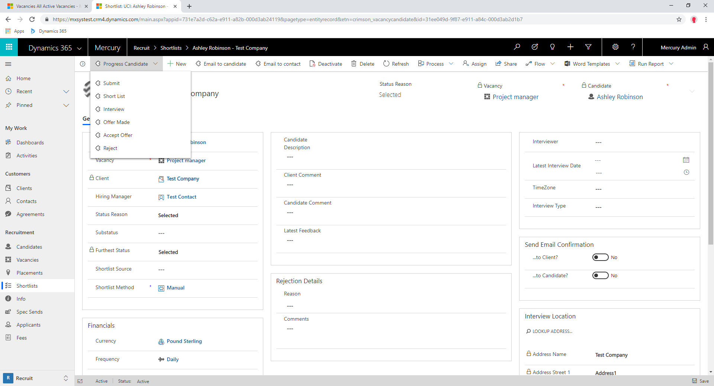
Illustration 2.
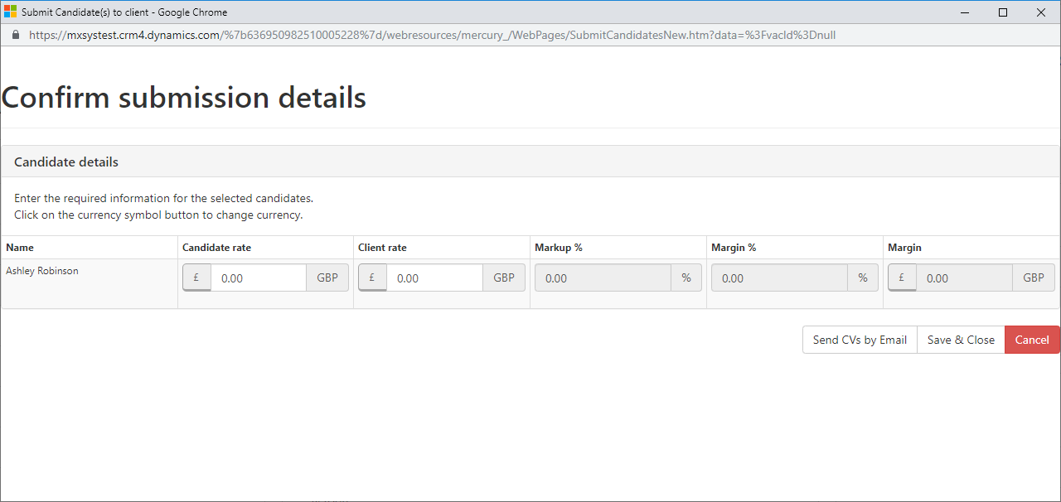
Illustration 3.
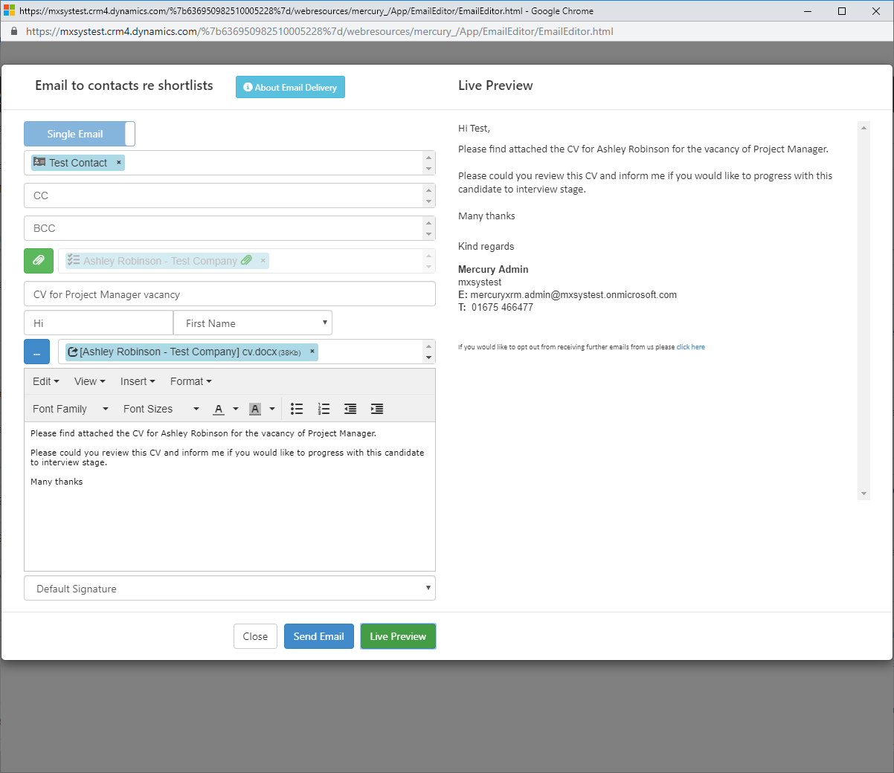

Have a Client Shortlist a Candidate for review
App name: Mercury xRM
User scenario: As a recruiter, I have received notification from a Client that they have shortlisted a Candidate to review, I need to be able to amend the shortlist record to reflect this update and ensure that this is recorded so any user can view that, this Candidate has been short listed by the Client for this Vacancy.

Business scenario:

Instructions:

Scenario description:  Solution version #: | Prerequisites for achieving this scenario:
 | Configuration settings:
 | Software/tools needed to achieve this scenario with version details:
 | System post-condition after this scenario:
Notes:

Test steps to execute the scenario
Step # | Test step/Input | Expected result | Actual result (To be filled by Microsoft) | Pass/Fail  (To be filled by Microsoft)
1 | From the main homepage, select ‘Vacancies’ from the grid on the left | Navigates to ‘All Active Vacancies’ view
2 | Open the specific ‘Vacancy’ for the Client | Opens the existing Vacancy record
3 | Select the Candidates tab at the top | Shows the sub-grid of Candidates associated with this Vacancy
4 | Open the relevant Candidate Shortlist record. Once opened, from the ribbon at the top, select ‘Progress Candidate’. From here you can select ‘Short List’ (illustration 4) | Once selected ‘Short List’ this will appear to do nothing, however, ‘Status Reason’ will be automatically updated to show as ‘Short listed’ along with the ‘Reject Reason’ section being hidden on the form as this is no longer relevant at this stage. A ‘Status Update’ record will be created at the same time in the background which will be logged against the Candidate record, so any user can see the latest activity for that Candidate. Within the Shortlist Record under ‘Audit & Activities’ the fields ‘Status Update’ & ‘Shortlisted’ will be populated with date the Candidate was shortlisted. If this is the furthest point a Candidate has progressed through the ‘Progress Candidate’ process, then ‘Furthest Status’ field on a Vacancy will be updated to ‘Shortlist’.

Illustration 4.

Progress a Candidate to attend an Interview
App name: Mercury xRM
User scenario: As a recruiter, I have received notification from a Client that they want to interview a Candidate for a Vacancy. I want the ability to amend the shortlist record to reflect this update and send email notifications to both, the Candidate and the Client. I need to ensure that this is recorded so any user can view that this Candidate has been selected for interview stage for that specific Vacancy.

Business scenario:

Instructions:

Scenario description:  Solution version #: | Prerequisites for achieving this scenario:
 | Configuration settings:
 | Software/tools needed to achieve this scenario with version details:
 | System post-condition after this scenario:
Notes:

Test steps to execute the scenario
Step # | Test step/Input | Expected result | Actual result (To be filled by Microsoft) | Pass/Fail  (To be filled by Microsoft)
1 | From the main homepage, select ‘Vacancies’ from the grid on the left | Navigates to ‘All Active Vacancies’ view
2 | Open the specific ‘Vacancy’ you wish to book interviews for. | Opens the existing Vacancy record
3 | Select the Candidates tab at the top | Shows the sub-grid of Candidates associated with this Vacancy
4 | Open the relevant Candidate Shortlist record you wish to book an interview for. Once opened, from the ribbon at the top, select ‘Progress Candidate’. From here you can select ‘Interview’ (illustration 5) | Once selected ‘Interview’ this will open a new window, where details of the Interview can be updated.
5 | Populate details of the Interview for the Candidate and tick ‘Email Client’ and ‘Email Candidate’ then click ‘Save & Close’ (illustration 6-10) | Window will close and trigger multiple fields to update within the system along with email confirmation being sent to the Client and Candidate. ‘Send Email Confirmation’ section will be temporary set to ‘Yes’ before resetting back to ‘No’. Following fields will be updated ‘Interviewer’, ‘Latest Interview Date’ & ‘Interview Type’. ‘Status Reason’ will be updated depending on the ‘Interview Stage’ selected from within the window. ‘Interview Location’ section will be automatically populated, if selected ‘Face to Face’. The relevant date field (depending on the Interview Stage selected) will be populated under the ‘Audit & Activities’ tab on the Shortlist record. An automatic email will be sent to the Client and Candidate, informing them of the date and time of the interview which can be found under ‘Activities’ on the ‘Client’ and ‘Candidate’ record. Along with an automatic email being sent, an Appointment is created for the individual user who has progressed the candidate for the date and time of the Interview, which is used to remind the user that an Interview is due that day and to call the Candidate for feedback. If this is the furthest point a Candidate has progressed through the ‘Progress Candidate’ process, then ‘Furthest Status’ field on the Vacancy will be updated to either ‘Interview’, ‘Interview further’ or ‘Interview final’ depending on the Interview stage selected.

Illustration 5.
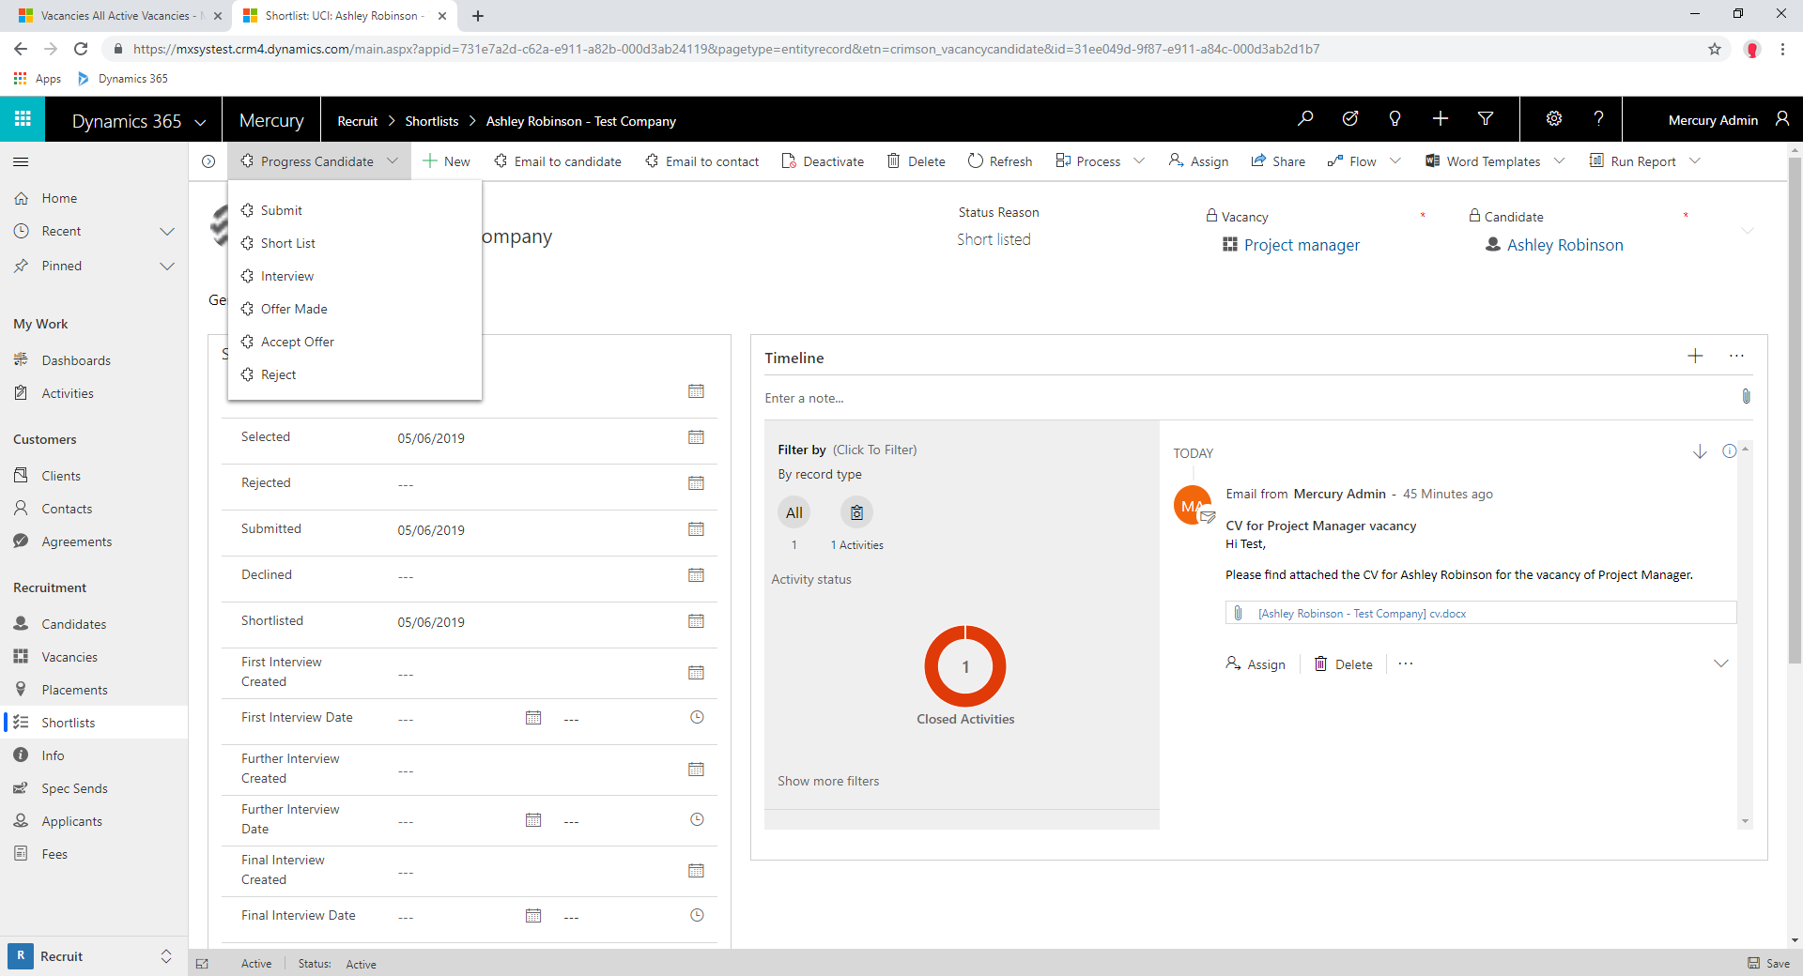
Illustration 6.
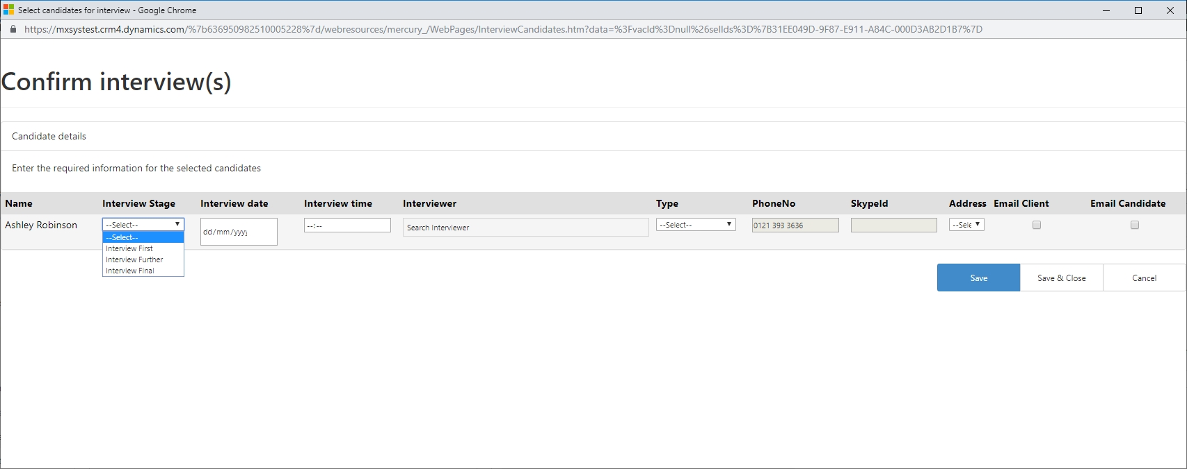
Illustration 7.
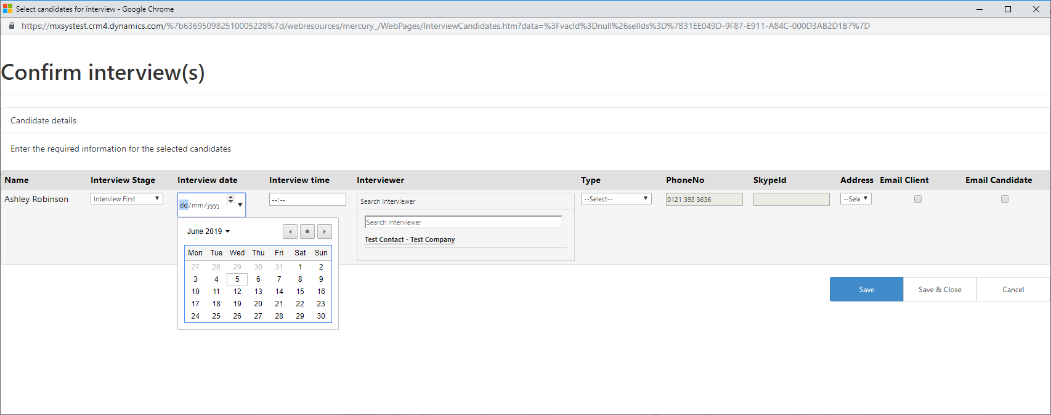
Illustration 8.
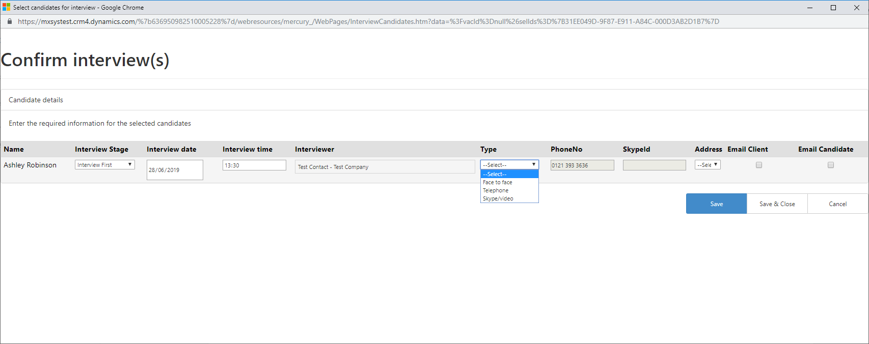
Illustration 9.
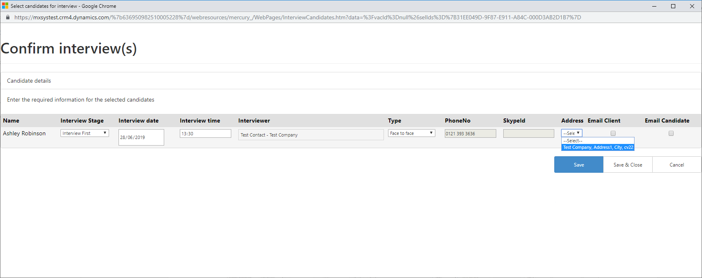
Illustration 10.
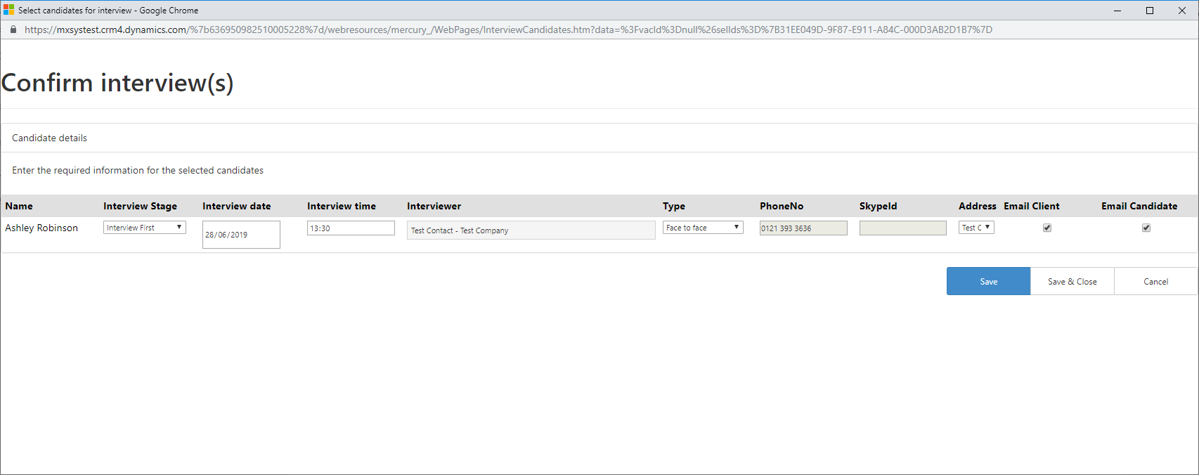

Offer made to the Candidate
App name: Mercury xRM
User scenario: As a recruiter, I have received notification that a Candidate has accepted an offer from a Client regarding a specific vacancy. I want the ability to record this information and it is a priority that any user can view that this Candidate has accepted an offer from the Client for that specific Vacancy.

Business scenario:

Instructions:

Scenario description:  Solution version #: | Prerequisites for achieving this scenario:
 | Configuration settings:
 | Software/tools needed to achieve this scenario with version details:
 | System post-condition after this scenario:
Notes:

Test steps to execute the scenario
Step # | Test step/Input | Expected result | Actual result (To be filled by Microsoft) | Pass/Fail  (To be filled by Microsoft)
1 | From the main homepage, select ‘Vacancies’ from the grid on the left | Navigates to ‘All Active Vacancies’ view
2 | Open the specific ‘Vacancy’ you wish to update following an offer from the Client | Opens the existing Vacancy record
3 | Select the Candidates tab at the top | Shows the sub-grid of Candidates associated with this Vacancy
4 | Open the relevant Candidate Shortlist record you wish to offer. Once opened, from the ribbon at the top, select ‘Progress Candidate’. From here you can select ‘Offer Made’ (illustration 12) | Once selected ‘Offer Made’ this will open a new window, where details of the offer can be updated/ recorded.
5 | Review / amend the offer details for the Candidate then click ‘Save & Close’. Depending on the type of Vacancy (Permanent, Contract, Temporary) will depend on the fields shown to review /amend (illustration 13) | Window will close and the relevant fields on the Shortlist record would have been updated. ‘Status Reason’ will be updated to ‘Offer Made’. The ‘Offer Made’ date field under ‘Audit & Activities’ will be populated. A Shortlist Update record will be created against the Candidate, which will appear in the Timeline which will resolve the issue of ensuring all users can easily see the latest progress of the Candidate.

Illustration 12.
Illustration 13.
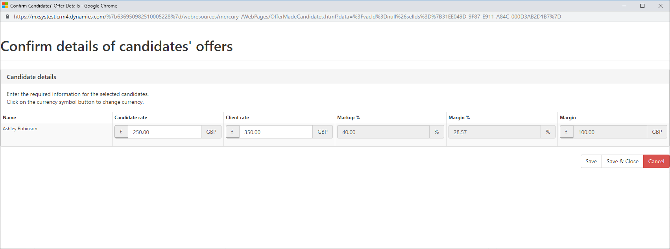

Candidate Accepting an Offer
App name: Mercury xRM
User scenario: As a recruiter, I have received notification from a Candidate that they want to accept the offer recently made to them for a Vacancy. I want the ability to amend the shortlist record to reflect this update and I need to ensure any user can view that this Candidate has accepted an offer for that specific Vacancy.

Business scenario:

Instructions:

Scenario description:  Solution version #: | Prerequisites for achieving this scenario:
 | Configuration settings:
 | Software/tools needed to achieve this scenario with version details:
 | System post-condition after this scenario:
Notes:

Test steps to execute the scenario
Step # | Test step/Input | Expected result | Actual result (To be filled by Microsoft) | Pass/Fail  (To be filled by Microsoft)
1 | From the main homepage, select ‘Vacancies’ from the grid on the left | Navigates to ‘All Active Vacancies’ view
2 | Open the specific ‘Vacancy’ you wish to update following an acceptance of an offer from the Candidate | Opens the existing Vacancy record
3 | Select the Candidates tab at the top | Shows the sub-grid of Candidates associated with this Vacancy
4 | Open the relevant Candidate Shortlist record following the offer acceptance. Once opened, from the ribbon at the top, select ‘Progress Candidate’. From here you can select ‘Accept Offer’ (illustration 14) | Once selected ‘Accept Offer’ this will open a new dialog box, where details of the acceptance can be updated / recorded.
5 | Within the dialog box you can progress through answering a series of questions with help from the ‘Tip’ section on the right-hand side (illustration 15) | The dialog is used to guide a recruiter through the acceptance process. Depending on the answers will depend on some of the outcomes from the dialog. If ‘Yes’ is selected for the question ‘Do you want to close the Vacancy?’ and ‘Won -filled’ answer is marked for Vacancy closure, then this will update ‘Status’ on the Vacancy record to ‘Won – all positions’ and make the Vacancy record ‘Inactive’. On the Shortlist record the following fields will be automatically updated ‘Status Reason’, ‘Accepted’ (within Audit & Activities tab) and ‘Furthest Status’. The Shortlist record will also be made Inactive. Following the dialog box closing a ‘Placement’ record will be created with links to the Candidate along with details you populated during the dialog. A Shortlist Update record will be created against the Candidate, which will appear in the Timeline which will resolve the issue of ensuring all users can easily see the latest progress of the Candidate.

Illustration 14.
Illustration 15.
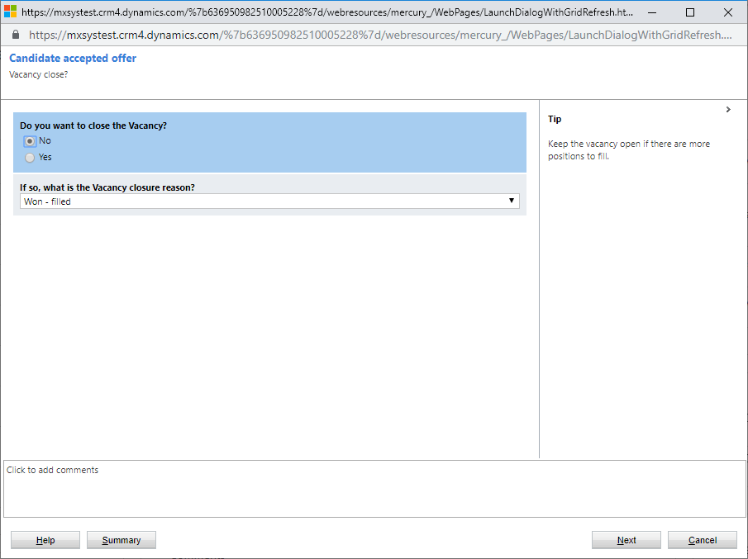

Candidate Rejecting an Offer
App name: Mercury xRM
User scenario: As a recruiter, I have unfortunately received notification from either a Client or Candidate confirming they do not want to proceed any further and reject this offer. I want the ability to amend the shortlist record to reflect this rejection by either the Client or Candidate along with ensuring any user can view that this Client / Candidate has rejected the offer for that specific Vacancy.

Business scenario:

Instructions:

Scenario description:  Solution version #: | Prerequisites for achieving this scenario:
 | Configuration settings:
 | Software/tools needed to achieve this scenario with version details:
 | System post-condition after this scenario:
Notes:

Test steps to execute the scenario
Step # | Test step/Input | Expected result | Actual result (To be filled by Microsoft) | Pass/Fail  (To be filled by Microsoft)
1 | From the main homepage, select ‘Vacancies’ from the grid on the left | Navigates to ‘All Active Vacancies’ view
2 | Open the specific ‘Vacancy’ you wish to update following a rejection of an offer from the Client or Candidate | Opens the existing Vacancy record
3 | Select the Candidates tab at the top | Shows the sub-grid of Candidates associated with this Vacancy
4 | Open the relevant Candidate Shortlist record following the rejection of the offer. Once opened, from the ribbon at the top, select ‘Progress Candidate’. From here you can select ‘Reject’ (illustration 16) | Once selected ‘Reject’ this will open a new window, where details of the rejection can be recorded.
5 | From within the new window you can select the reason for rejection from a pre-determined list and have the ability to add any comments, with the option of ‘Save & Close’ (illustration 17) | Following the closure of the window, the following fields will be updated depending on what was selected within the window; ‘Rejection Details’ section will be shown with ‘Reason’ being populated from what was selected from the pre-determined list along with ‘Comments’ if any were populated, ‘Latest Feedback’ will be populated, ‘Status Reason’ will also updated to ‘Rejected’ along with ‘Rejected’ date field under the ‘Audit & Activities’ tab. A Shortlist Update record will be created against the Candidate record, appearring in the Timeline which will resolve the issue of ensuring all users can easily see the latest progress of the Candidate.

Illustration 16.
Illustration 17.
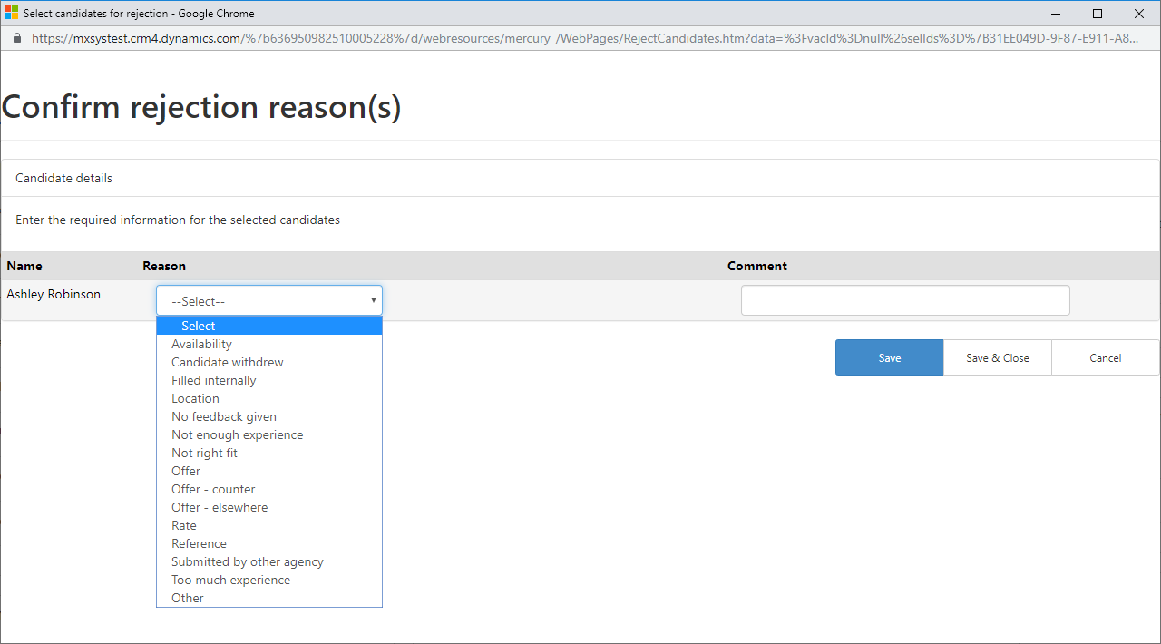

Progress a Placement to Start
App name: Mercury xRM
User scenario: As a recruiter, I have successfully placed a Candidate at a Vacancy for one of our Clients, which now needs approving

Business scenario:

Instructions:

Scenario description:  Solution version #: | Prerequisites for achieving this scenario:
 | Configuration settings:
 | Software/tools needed to achieve this scenario with version details:
 | System post-condition after this scenario:
Notes:

Test steps to execute the scenario
Step # | Test step/Input | Expected result | Actual result (To be filled by Microsoft) | Pass/Fail  (To be filled by Microsoft)
1 | From the main homepage, select ‘Placements’ from the grid on the left | Navigates to ‘Active Placements’ view
2 | Open the ‘Placement’ record for the specific Candidate. They are sorted by ‘Created On’ | Opens the existing Placement record
3 | Click on ‘Validate’ within the ribbon at the top. | If any fields have not been populated, a warning message will appear within the banner asking for these fields to be populated. If all fields have been populated, then a warning banner at the top will appear confirming all fields have been completed and instructions on how to proceed. The ‘Finalised’ field will become editable along with all tabs being hidden apart from ‘Placement Details’, ‘Addresses’ and ‘Related’.
4 | Change the ‘Finalised’ field to ‘Yes’ then save the record | ‘Status Reason’ will be updated to ‘Awaiting Approval’ and a ‘Placement Approval’ activity will be created.
5 | Navigate to ‘Activities’ under the ‘Related’ tab on the Placement record and open the ‘Placement Approval’ activity. Once opened the record select ‘Approved’ from the banner at the top | Once clicked ‘Approval’ this will close the activity and update the ‘Status Reason’ of the Placement to ‘Awaiting Paperwork’. If selected ‘Rejected’ from the activity, then the placement ‘Status Reason’ will be set back to ‘Pending’ where the Recruiter can make any changes and re-validate
6 | 8 weeks prior to the ‘Start Date’ of Placement, the ‘Status Reason’ will be updated to ‘Awaiting Start’ | ‘Status Reason’ changed to ‘Awaiting Start’
7 | Once the ‘Start Date’ of the Placement has passed the ‘Status Reason’ will be automatically updated to ‘Live’ | ‘Status Reason’ changed to ‘Live’
8 | 6 weeks prior to the ‘End Date’ on the Placement record, the ‘Status Reason’ will be automatically updated to ‘Ending Soon’ | ‘Status Reason’ updated to ‘Ending Soon’
9 | Once ‘End Date’ has passed, the ‘Status Reason’ will automatically be updated to ‘Ended’ | ‘Status Reason’ updated to ‘Ended’

Note:
- Repeat the above template for each user scenario available in your solution.
- Add screenshot and links in test steps to better explain the functionality covered by this scenario.
- Update this template for code/feature changes.

Best practices for writing good test cases
- User scenarios need to be simple and designed from end-user’s perspective.
- Avoid repetition and do not assume scenarios.
- Ensure 100% test coverage by including all the user scenarios.

Glossary
- Business scenario Sequence of business processes triggering each other and thereby
forming an end-to-end flow.
- User scenario Short statement that identifies the user and their need/goal.
- End-user Is a person that consumes the product.
- User functions List of actions performed by the user to achieve the end goal.

