NuSoft Calendar
Version 8

User Guide

Table of Contents
Introduction 3
Displaying Atrio Calendar 3
Changing Whose Calendar is Displayed 4
Navigation 5
Scheduling an Activity 6
Support 8
Disclaimer 9

Introduction

This document is designed as an introductory guide for Microsoft Dynamics CRM users to learn the basics of using the NuSoft Calendar product.

NuSoft Calendar is a component that allows for displaying any entity record in a calendar either by month, week, day or separated by ownership.

Features:
- Additional pane to show the calendar integrated in the Site Map
- Configurable to include any entity needed in the calendar
- Records to display selected by a FETCHXML query
- Holidays selected by a FETCHXML query
- Choice between three custom skins for the calendar
- Option to hide or display weekends
- Can display any user’s calendar in the CRM without security permissions needed

Displaying NuSoft Calendar

Once all the configuration records are added you can simply navigate to Navigation -> Sales -> Activity Calendar to view the calendar.

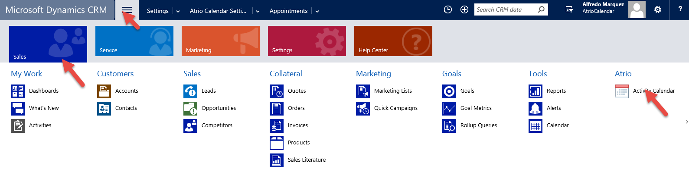

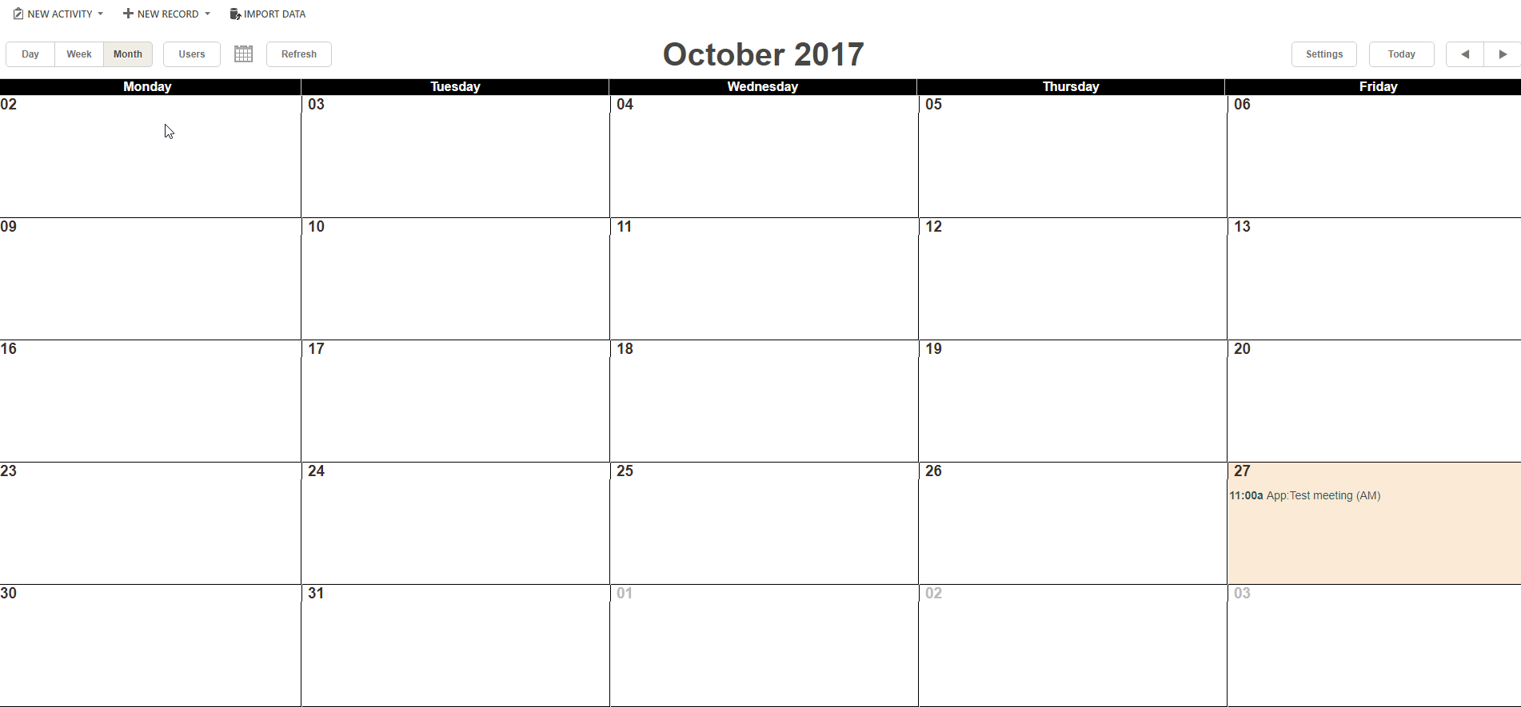

Changing Whose Calendar is Displayed
The calendar will appear blank when first opened. This is because no users are chosen to display. Each CRM user has a personal calendar and needs to follow the steps below to change the activity owners that are displayed.

- Click Settings at the top right of the calendar.
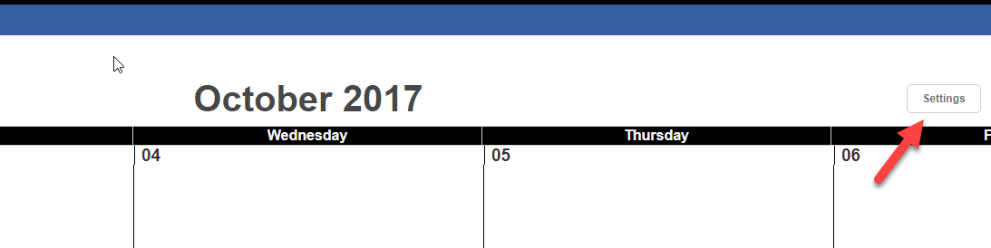
- A popup will appear with all of the active users in the system. Select the desired users, and click Select Users.
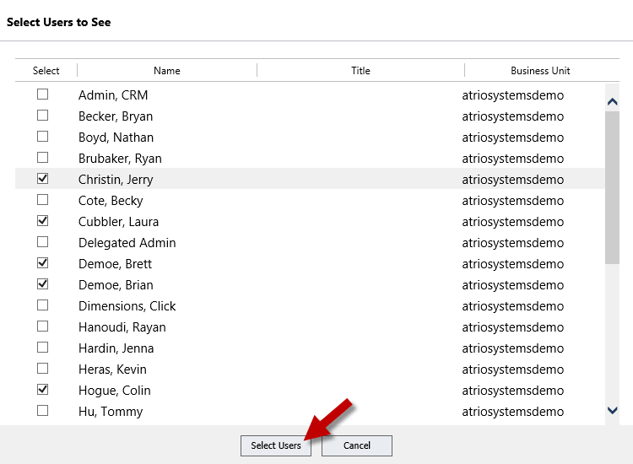

Activities that have the selected users marked as “Owners” will now appear on the calendar. This only needs to be done once, and will stay the same each time the user logs in.

Navigation
The activities calendar navigation buttons are found at the top, and can change the calendar type and day displayed.
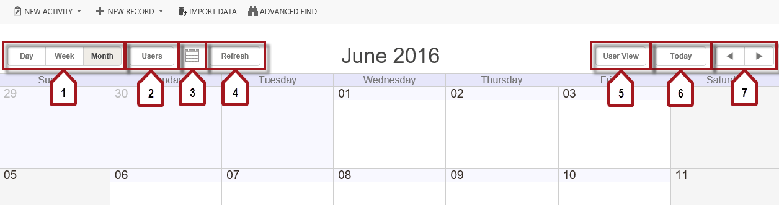

- Use these to switch between the different types of calendars. They will focus in on the first day of the month.
- This button will open up a daily calendar for all users displayed. They will appear in columns with the time from 7:00 am to 6:00 pm to the left. To change the users displayed, see “Customization and Views.”
- To find a specific day, click on the gray, small calendar highlighted by the number 3 and a small calendar will appear.
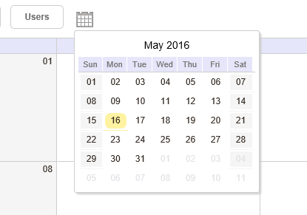
Click the number on the desired day, and the current calendar will switch to a calendar that contains that day.
- Click this button to refresh the calendar.
- This will open a popup to select the users displayed on the calendar. See “Changing Whose Calendar is Displayed” for more information.
- This button will automatically bring the calendar to focus in on the current day. For example, if today is August 12th and the calendar is in monthly view for June, this button will bring the calendar to the month of August.
- These arrows change the day, week, or month shown in the calendar. The right arrow will open up the next and the left arrow will display the previous day, week, or month.

Scheduling an Activity
- At the top left will be a New Activity button. Clicking this button produces a drop down box with different options that can be added to the calendar. Tasks and Appointments are included with the NuSoft Activity Calendar. Unless the activity has a corresponding record in the Activity Calendar Settings (see the installation and configuration guide), the activity will not appear in the calendar.

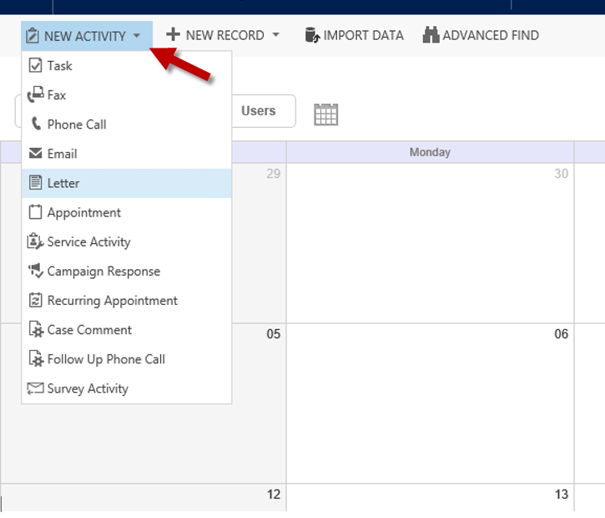
- To add an activity, click on the desired activity and a new page will load with fields of info. To make it a reaccuring event, click RECURRENCE. Make sure the “Owner” in the top right corner contains a user that is displayed on the calendar. If not, the activity will not be displayed until the user is added.

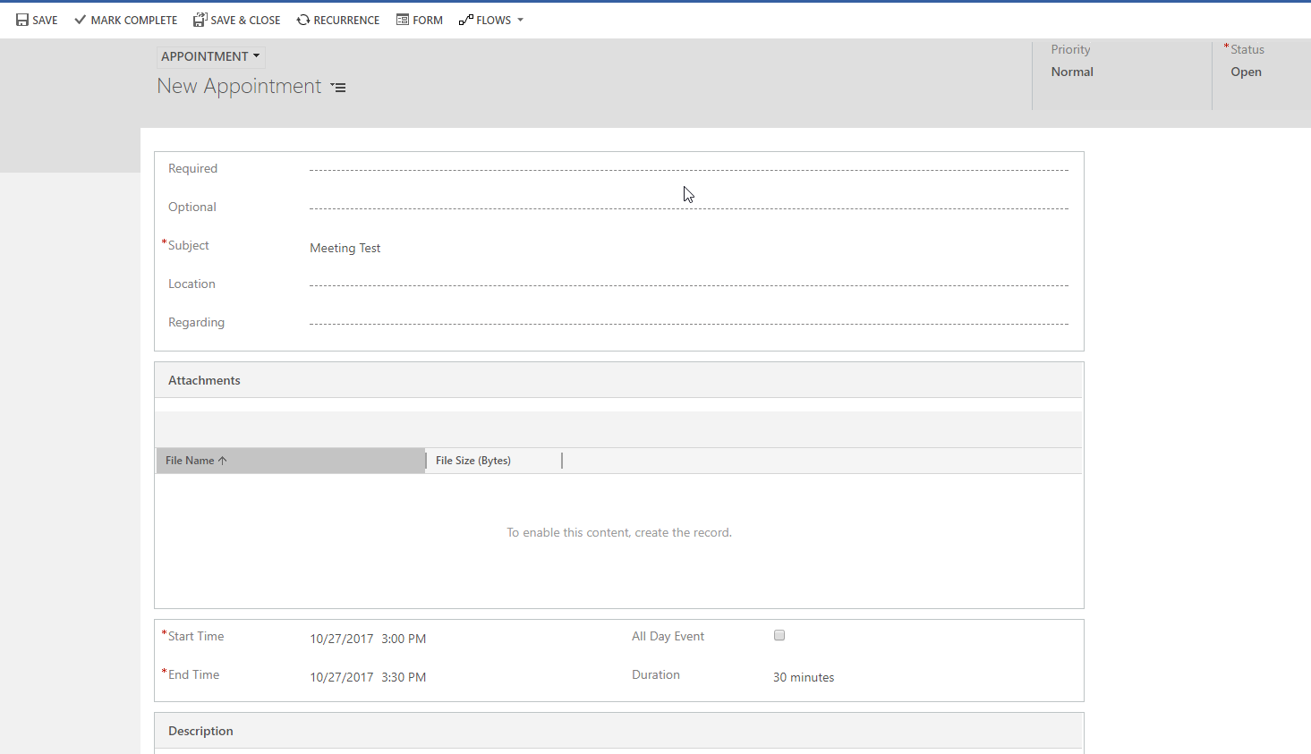
- After filling out the page and clicking SAVE & CLOSE, the activity will be saved and shown in the calendar.
Note: Events will show up starting at 12:00 am if there is no time specified. It is recommended that the start and end date fields be switched from “Date Only” to “Date and Time” in activities that are meant to be seen on the calendar.

Support

We value your feedback, please send product issues and suggestions to support@nusoftsolutions.com. We will take your suggestions to make the product better.

Disclaimer

THIS SOFTWARE IS PROVIDED "AS IS", AND ATRIO SYSTEMS, INC. DBA NUSOFT SOLUTIONS DISCLAIMS ALL WARRANTIES WITH REGARD TO THIS SOFTWARE INCLUDING ALL IMPLIED WARRANTIES OF MERCHANTABILITY AND FITNESS FOR A PARTICULAR PURPOSE. IN NO EVENT SHALL ATRIO SYSTEMS, INC. DBA NUSOFT SOLUTIONS BE LIABLE FOR ANY SPECIAL, INDIRECT, OR CONSEQUENTIAL DAMAGES OR ANY DAMAGES WHATSOEVER RESULTING FROM LOSS OF USE, DATA OR PROFITS, WHETHER IN ACTION OF CONTRACT, NEGLIGENCE, OR OTHER TORTIOUS ACTION, ARISING OUR OF OR IN CONNECTION WITH THE USE OR PERFORMANCE OF THIS SOFTWARE.

