NuSoft Auto Complete
Version 8

Installation and Configuration Guide

Table of Contents
Introduction 3
Requirements/Compatibility 3
Installation 3
Set Up 5
Assign User Roles 11
Adding a Second Address Auto Complete 12
Support 14
Disclaimer 15

Introduction
This document is a guide for Microsoft Dynamics CRM users to learn how to install and configure the NuSoft Address Auto Complete product.

NuSoft Address Auto Complete provides address suggestions as the user types in the address field, and then populates the address attributes once a suggestion is selected. The product is an addition to the address field of Account, Contact, and Lead forms. This prevents inconsistencies with abbreviations and allows for easy input.

Requirements/Compatibility
NuSoft Address Autocomplete requires the NuSoft Common solution to run, and is compatible with CRM 2016.

- Internet Explorer 8+
- Chrome 43+

NuSoft Address Auto Complete may work on previous browser versions, but the mentioned versions have been tested and are known to work.

Installation
NuSoft Address Auto Complete is a Microsoft Dynamics CRM Managed Solution. NuSoft recommends creating a backup solution before importing any solutions, and then importing the backup into CRM after the solutions have been imported.
To install NuSoft Address Auto Complete and NuSoft Common, follow the steps below:
- Navigate to Settings -> Dynamics Marketplace
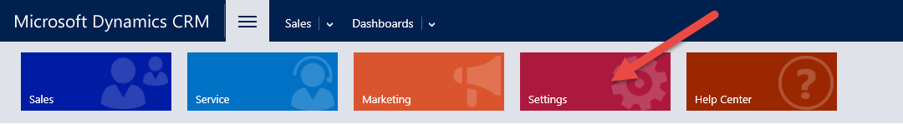

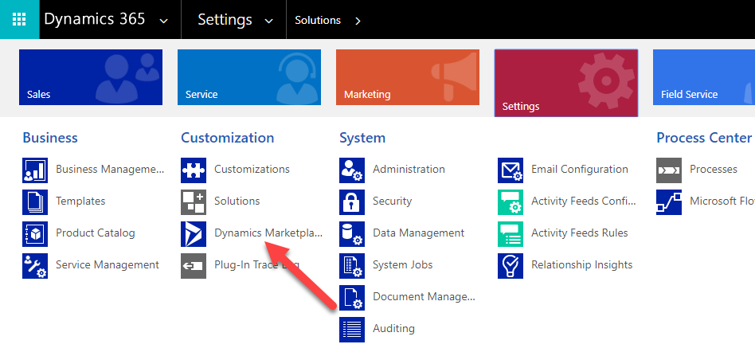

- Enter “NuSoft” in the search box and click on “Get it Now” for NUSOFT Auto Complete.

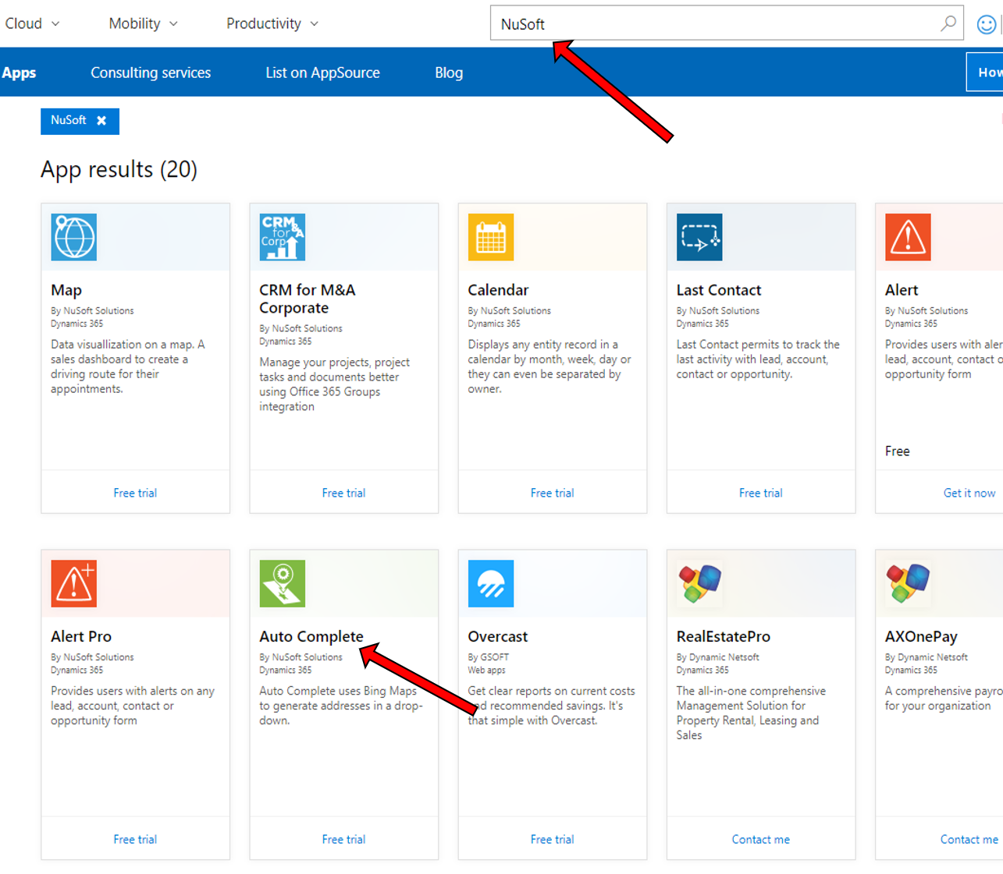

- Check the box and click Continue
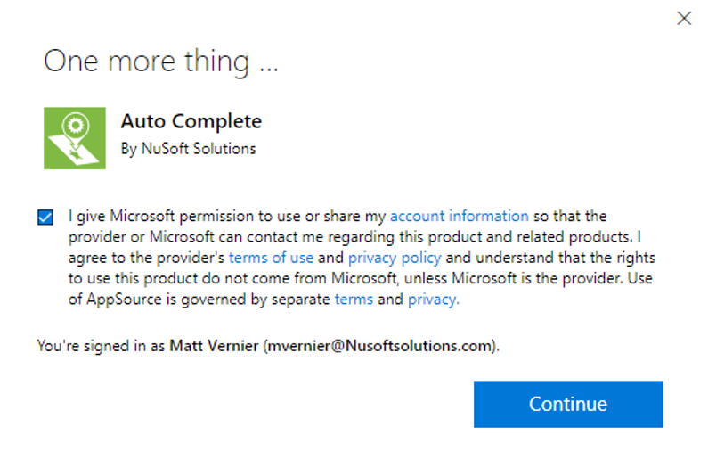

- Agree to the conditions and click Agree
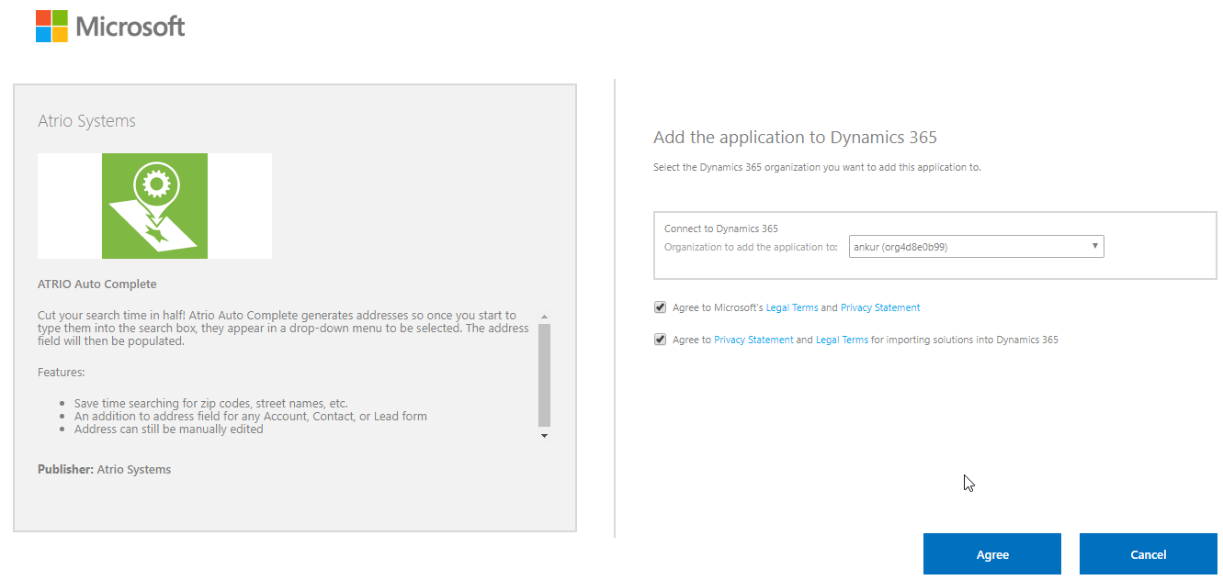
- Come back to Settings > Solutions > All Solutions records page after the installation has completed, NUSOFT Auto Complete solution file should show up in the records.

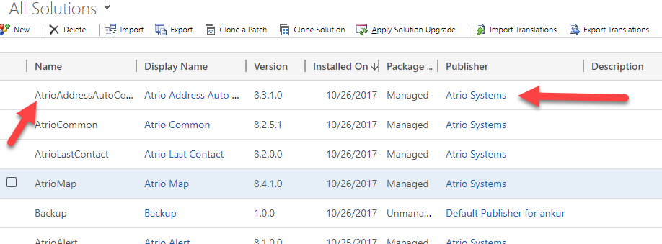

Set Up

NuSoft Address AutoComplete requires 3 parameters:
- Bing Maps Key Required
- Country Format Optional ISO2 or CountryName (Default)
- Product Key Required After 30 Days

Bing Keys

Entering in the Bing Maps Key has two separate steps depending if the CRM is online, or on-premise. If you need a Bing Maps key, go to www.bingmapsportal.com to sign up for one.

Online CRM

- Navigate to Settings -> Solutions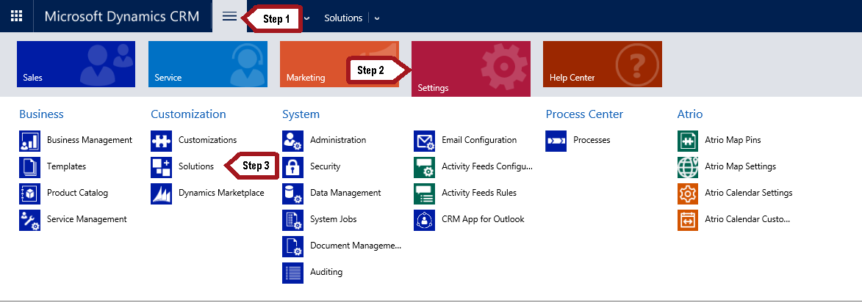
- Select the NuSoft Address Auto Complete solution.
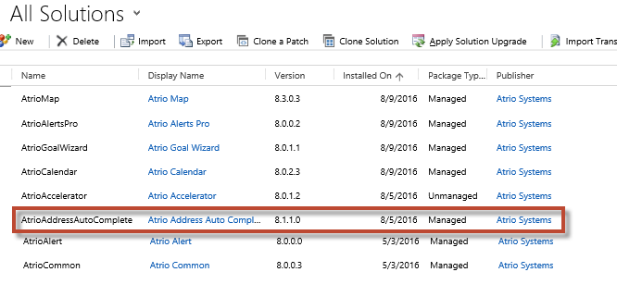
- A Configuration Page will appear. Enter a Bing Key.
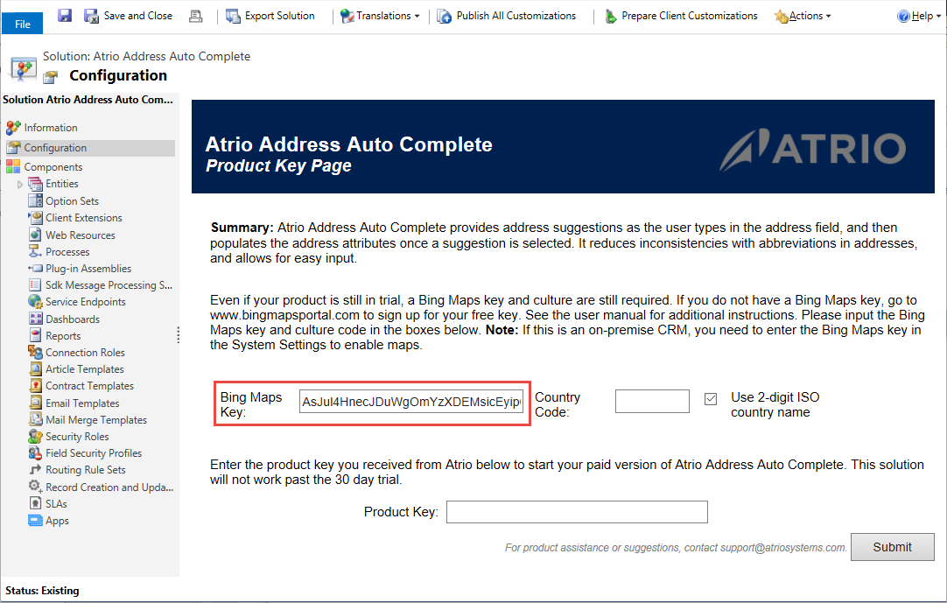

- Put in your Bing Key and Country code in the text box. Click Submit after that.

Acceptable country code formats are:
  - CountryName. Fill country field using name of country. i.e. Canada.
  - Use 2-digit ISO country name. Check mark this to return two letters in the resulted address. i.e. CA.

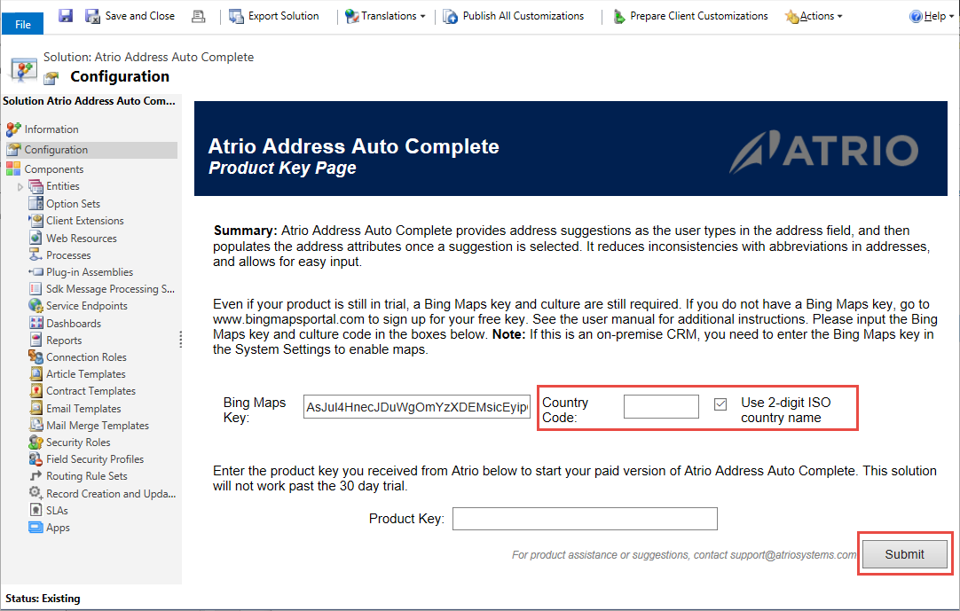

On-Premise CRM
- Navigate to Settings -> Administration. 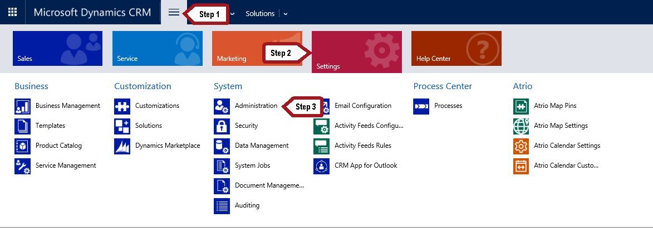
- Select System Settings.
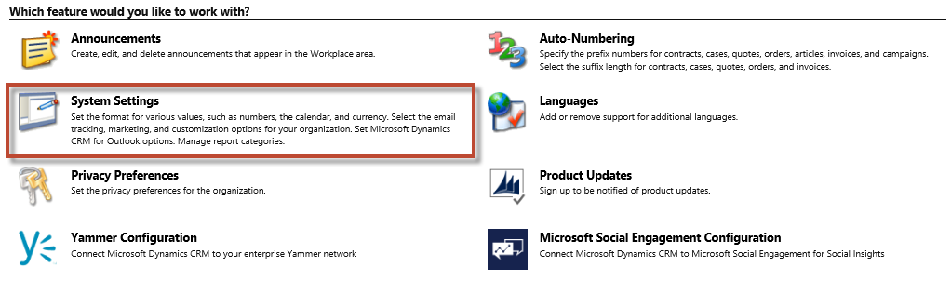

- Under the General tab will be the Enable Bing Maps settings. Enter your Bing Key here.

Product Key
After 30 days of use, NuSoft Address Auto Complete will no longer work. To enter a purchased product key, follow the steps below.

- Navigate to the Solutions page again and open up the NuSoft Address Auto Complete solution.
- The Configuration Page will appear. Towards the bottom of the page will be a slot for the product key. Type in the product key you received from NuSoft and click Submit. If you do not have a product key, contact NuSoft at support@nusoftsolutions.com to receive one.

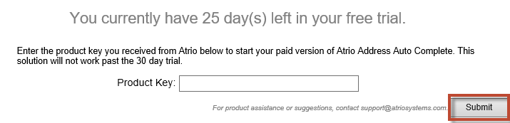

Assign User Roles

Anyone who needs to see NuSoft Auto Complete needs the NUSOFT Auto Complete User role.
- Navigate to Settings->Security->Users.
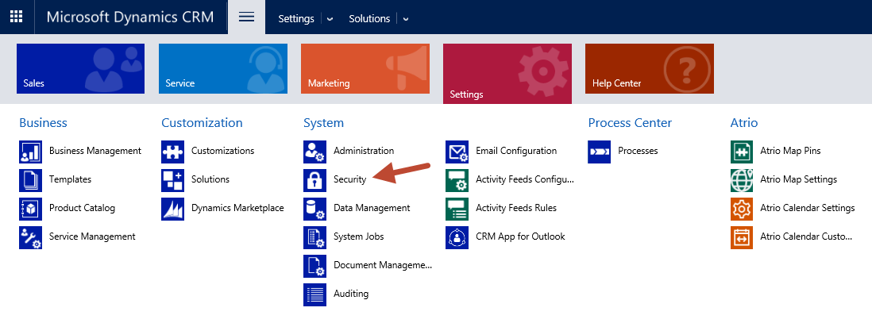
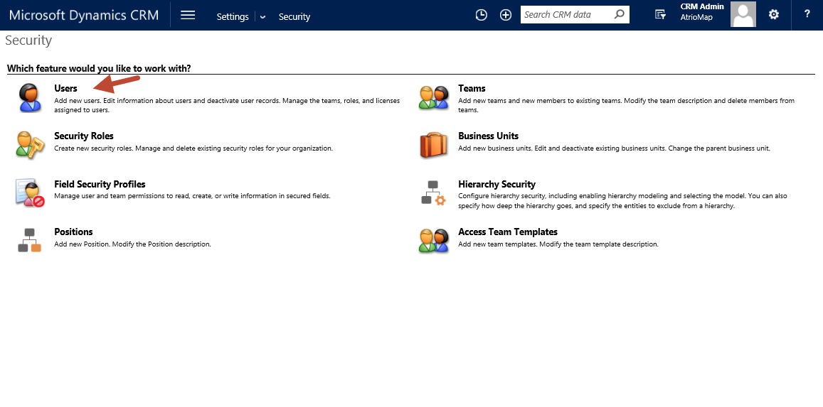
- Select the users whom you wish to use NUSOFT Auto Complete.
- Select Manage Roles in the ribbon.
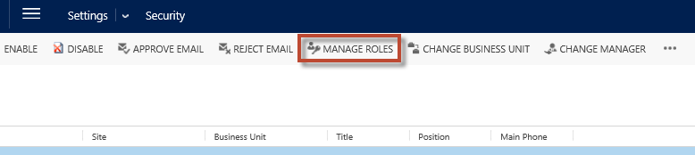
- Choose the NUSOFT Auto Complete role and select OK.
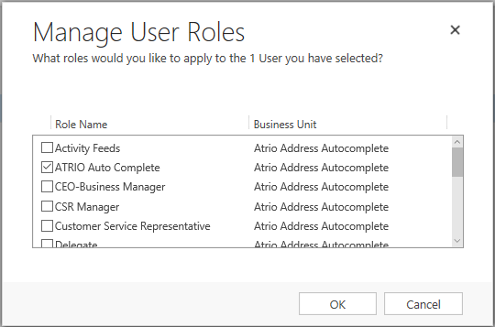

Adding a Second Address Auto Complete

- Navigate to Sales > Account, Contact, or Lead > Go to any record.
- Go to any Account, Contact, or Lead form and select the Form button in the ribbon.

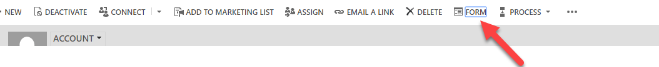
- Under the Insert tab, add a Web Resource.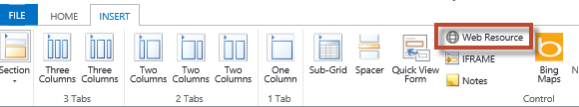
- Copy the information in the boxes below, and click OK.
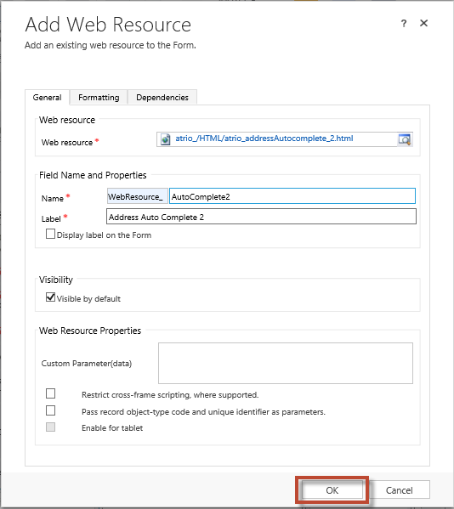
- After saving and publishing the form, the second Address Auto Complete box will appear in the form.
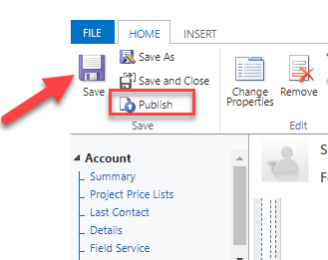

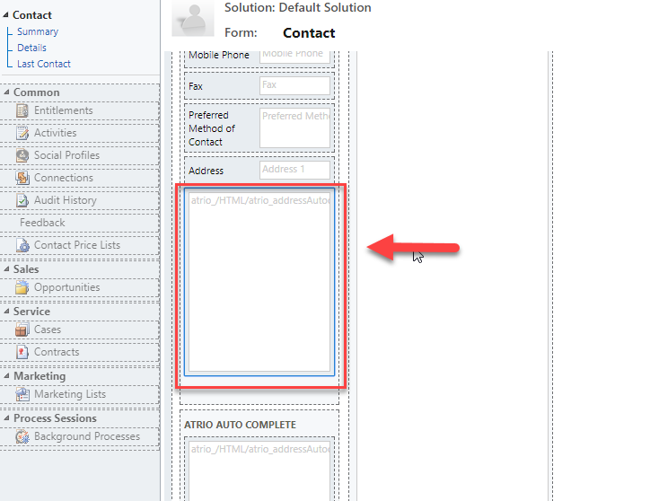

Support
Please send any product issues and suggestions to support@nusoftsolutions.com.

Disclaimer
THIS SOFTWARE IS PROVIDED "AS IS", AND ATRIO SYSTEMS, INC. DBA NUSOFT SOLUTIONS DISCLAIMS ALL WARRANTIES WITH REGARD TO THIS SOFTWARE INCLUDING ALL IMPLIED WARRANTIES OF MERCHANTABILITY AND FITNESS FOR A PARTICULAR PURPOSE. IN NO EVENT SHALL ATRIO SYSTEMS, INC. DBA NUSOFT SOLUTIONS BE LIABLE FOR ANY SPECIAL, INDIRECT, OR CONSEQUENTIAL DAMAGES OR ANY DAMAGES WHATSOEVER RESULTING FROM LOSS OF USE, DATA OR PROFITS, WHETHER IN ACTION OF CONTRACT, NEGLIGENCE, OR OTHER TORTIOUS ACTION, ARISING OUR OF OR IN CONNECTION WITH THE USE OR PERFORMANCE OF THIS SOFTWARE.

