NuSoft Auto Complete
Version 8

User Guide

Table of Contents
Introduction 3
Using Atrio Auto Complete 3
Support 5
Disclaimer 5

Introduction
This document is a guide for Microsoft Dynamics CRM users to learn how to use the NuSoft Auto Complete product.

NuSoft Auto Complete provides address suggestions as the user types in the address field, and then populates the address attributes once a suggestion is selected. The product is an addition to the address field of Account, Contact, and Lead forms. This prevents inconsistencies with abbreviations and allows for easy input.

Using NuSoft Auto Complete

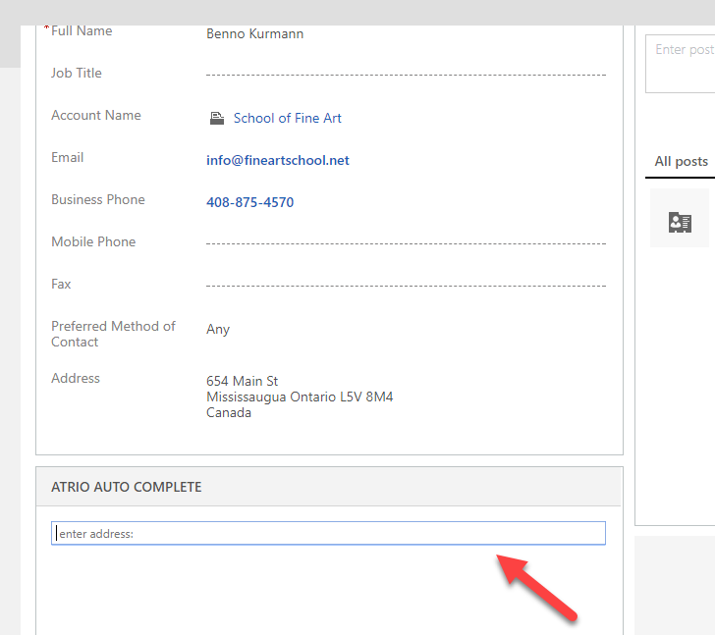After installation and set-up, the Account, Contact, and Lead forms will look like this:
Simply search with the search box, and select the address from the suggestions by clicking on it. 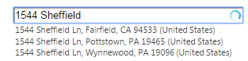

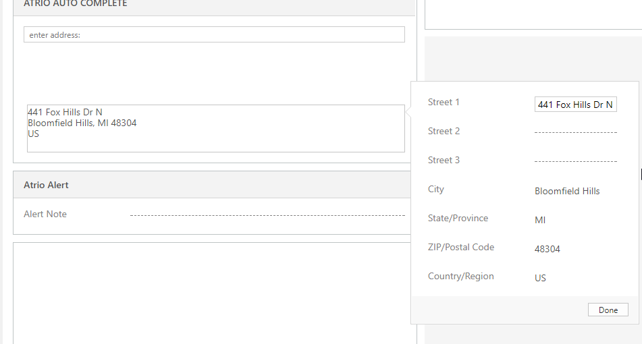 The address field will then be populated, but one can still manually edit the address if need be.

Support
Please send any product issues and suggestions to support@nusoftsolutions.com.

Disclaimer
THIS SOFTWARE IS PROVIDED "AS IS", AND ATRIO SYSTEMS, INC. DBA NUSOFT SOLUTIONS DISCLAIMS ALL WARRANTIES WITH REGARD TO THIS SOFTWARE INCLUDING ALL IMPLIED WARRANTIES OF MERCHANTABILITY AND FITNESS FOR A PARTICULAR PURPOSE. IN NO EVENT SHALL ATRIO DBA NUSOFT SOLUTIONS SYSTEMS, INC. BE LIABLE FOR ANY SPECIAL, INDIRECT, OR CONSEQUENTIAL DAMAGES OR ANY DAMAGES WHATSOEVER RESULTING FROM LOSS OF USE, DATA OR PROFITS, WHETHER IN ACTION OF CONTRACT, NEGLIGENCE, OR OTHER TORTIOUS ACTION, ARISING OUR OF OR IN CONNECTION WITH THE USE OR PERFORMANCE OF THIS SOFTWARE.

