NuSoft Alert
Version 8

Installation and Configuration Guide

Table of Contents
Introduction 3
Requirements/Compatibility 3
Installing Atrio Alert 3
Backing up Entities 3
Installing Atrio Alert 9
Reimporting Entities 12
Support 12
Disclaimer 12

Introduction

This document is designed as a guide for Microsoft Dynamics CRM users to install NuSoft Alert. It includes step by step instructions on how to complete the installation of NuSoft Alert.

NuSoft Alert is a handy tool that allows the users to add custom alert to Accounts, Contacts, Leads and Opportunities.

Features:
- Display custom note/alert on the top of a record (Accounts, Contacts, Leads or Opportunities) up to 200 characters.
- Ability to copy note/alert from Account record to related Contacts with workflow.

Requirements/Compatibility

NuSoft Alert is compatible with CRM 2016.

The following brwosers are supported:

- Internet Explorer 10+
- Google Chrome 43+
- Safari 8.0.5+
- Firefox 38.0.5+

NuSoft Alert may work on previous browser versions, the mentioned versions have been tested and are known to work.

Installing NuSoft Alert

Backing up Entities
Importing the NuSoft Alert solution can cause changes to be made to the following entities forms if they have been customized: Accounts, Contacts, Leads, and Opportunities.

To prevent this from happening, the 4 entities should be backed up and re-imported after importing NuSoft Alert.

- Navigate to Settings -> Solutions and create a new Solution.

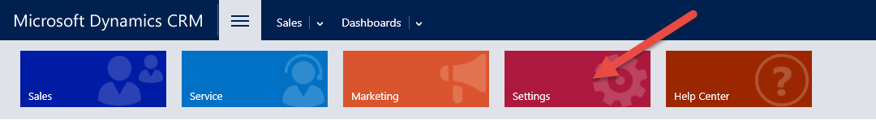

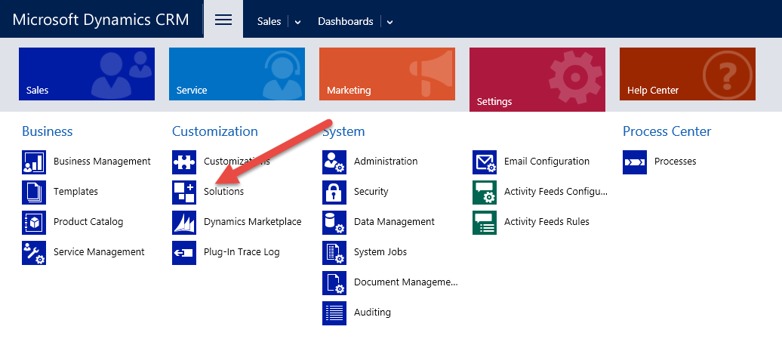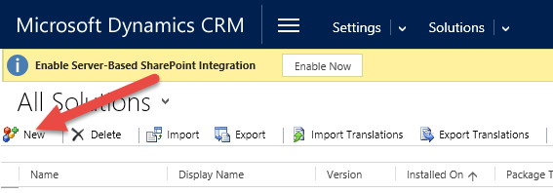

- Name the solution Backup, add values to all required fields and click save.

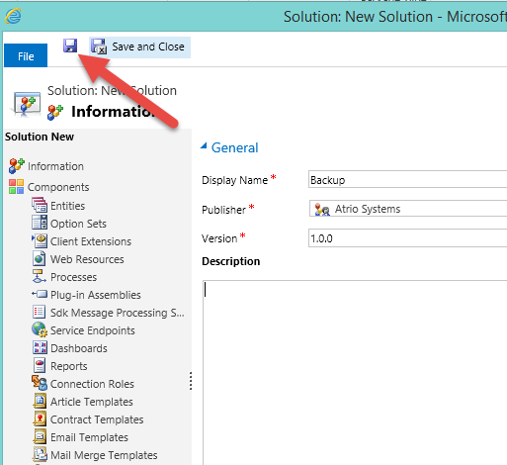

Select the “Default Publisher ” if you are working on a trial CRM platform.

- After saving click Entities and then Add Existing and select Accounts, Contacts, Leads and Opportunities from the list. Click Ok and the Click Next until you get to the Solution backup screen where you can see Accounts, Contacts, Leads and Opportunities in the list.
Now select each entity name and add the required components.

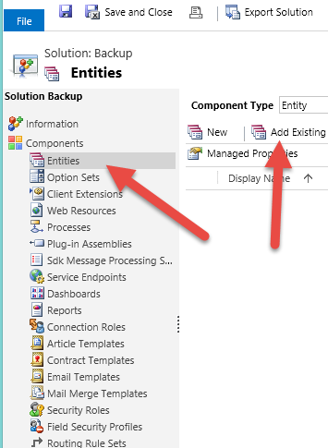

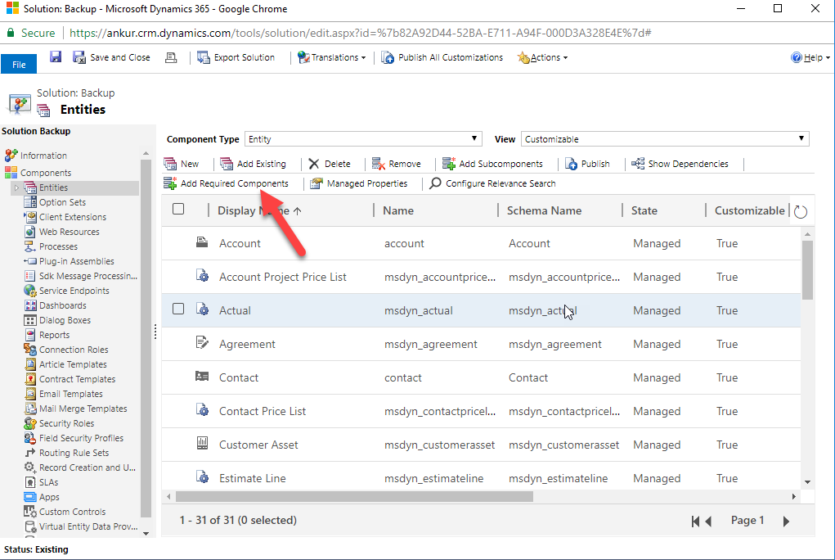
- Click Save and Close and then select the Backup solution click Export

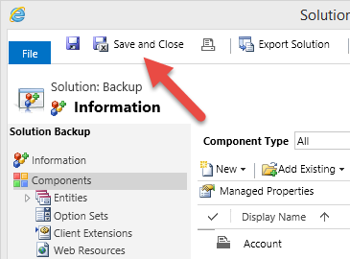

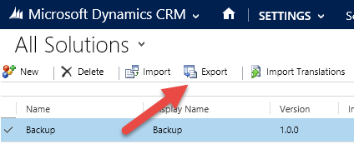

- Click Publish All Customizations then click Next

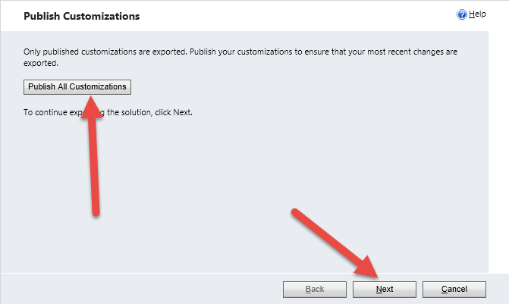

- Follow the wizard instructions and add any required components if required and ignore advanced settings.

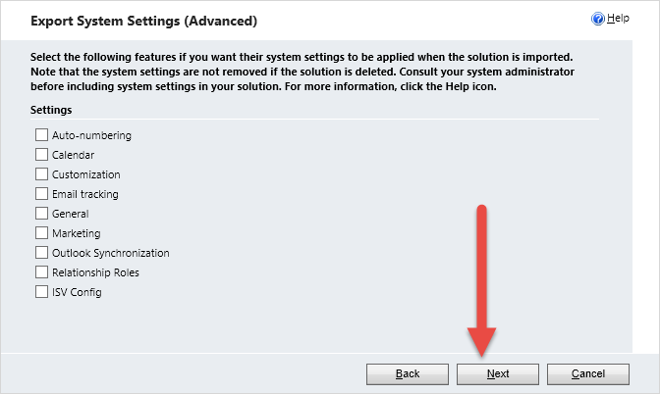

- Export as an unmanaged solution and your current CRM version

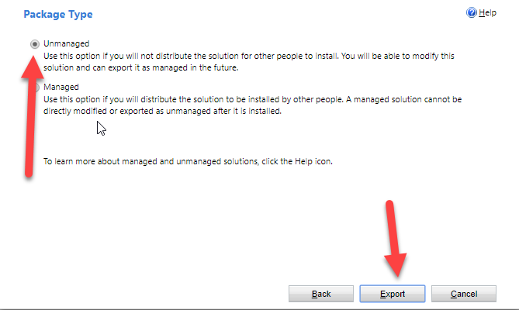

- Click Export and a backup zip file would be downloaded.

Installing NuSoft Alert
- Navigate to Settings -> Dynamics Marketplace

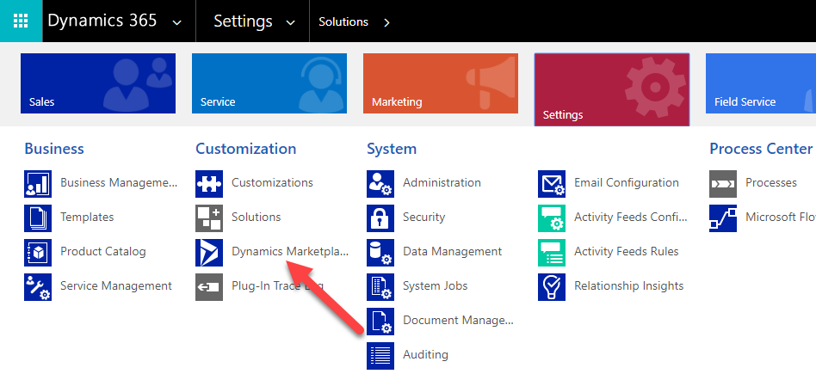

- Enter “NuSoft” in the search box and click on “Get it now” for NUSOFT Alert.
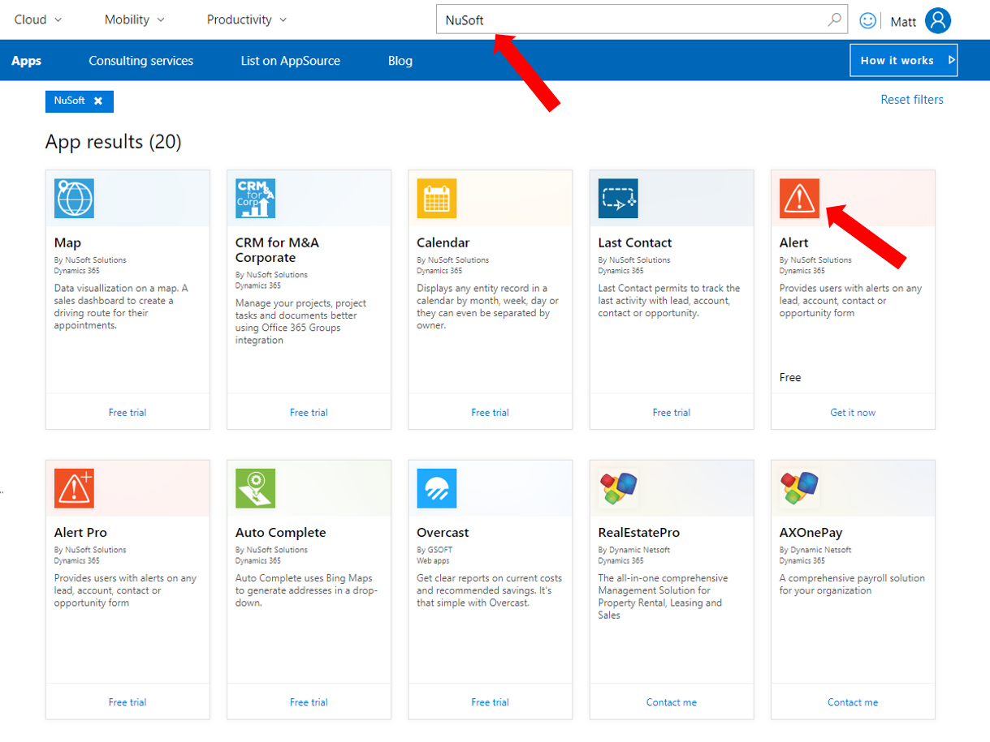

- Check the box and click Continue
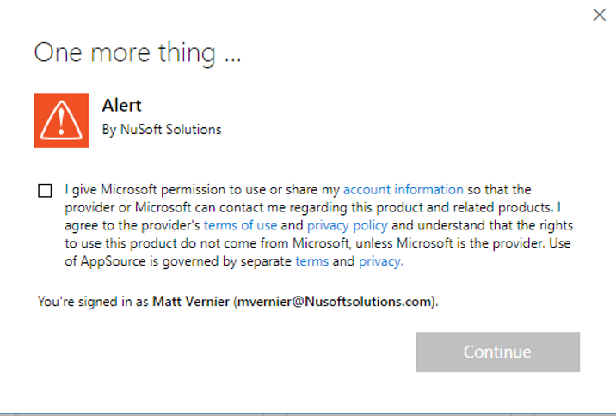

- Agree to the conditions and click Agree
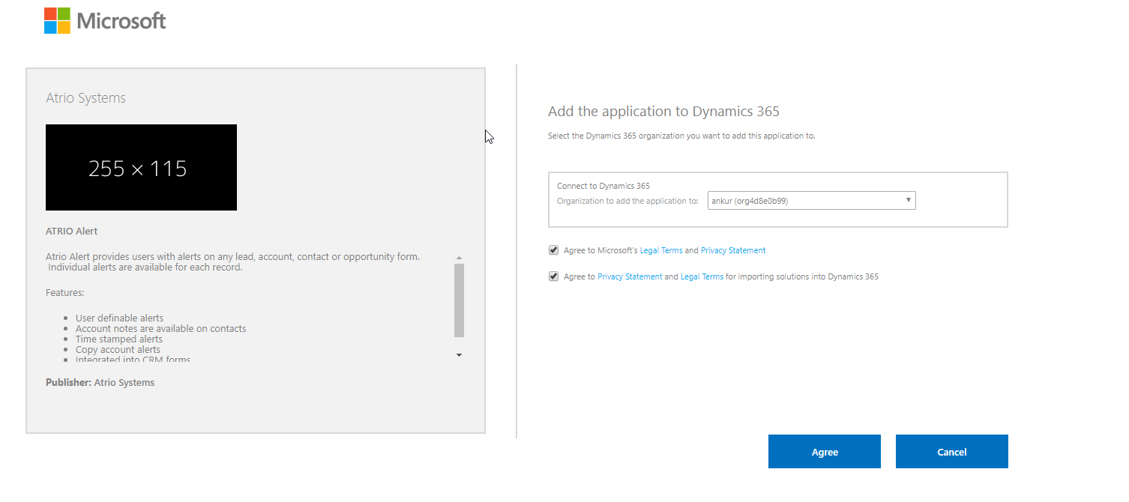
- Come back to Settings > Solutions > All Solutions records page page after the installation has completed, NUSOFTAlert solution file should show up in the records.

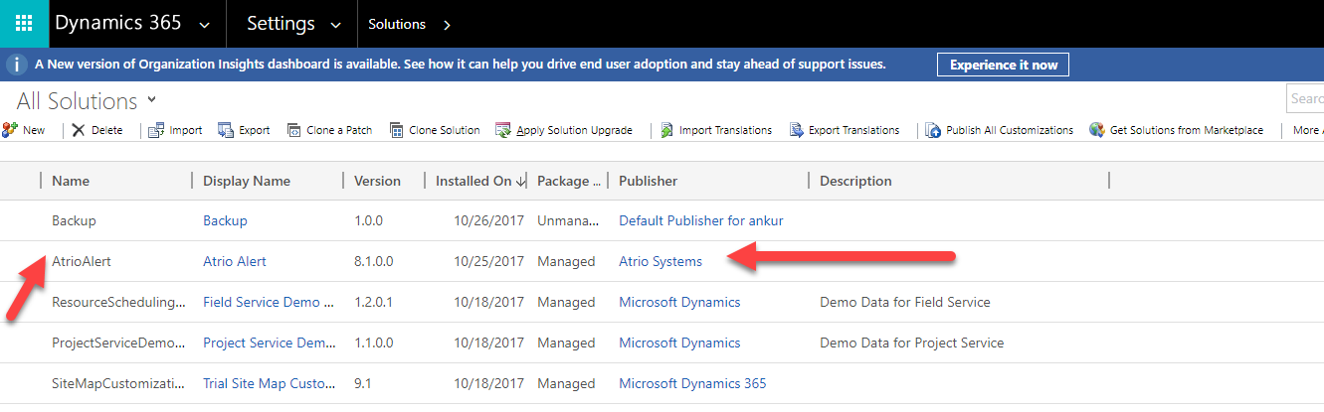

Reimporting Entities
If your CRM views or forms become modified after importing NuSoft Alert and publishing customizations, import your backup unmanaged solution created above in the “Backing Up Entities” section.

Support

Free products are provided without support, but we value your feedback. Please send product issues and suggestions to support@nusoftsolutions.com. We will take your suggestions to make the product better.

Disclaimer

THIS SOFTWARE IS PROVIDED "AS IS", AND ATRIO SYSTEMS, INC. DBA NUSOFT SOLUTIONS DISCLAIMS ALL WARRANTIES WITH REGARD TO THIS SOFTWARE INCLUDING ALL IMPLIED WARRANTIES OF MERCHANTABILITY AND FITNESS FOR A PARTICULAR PURPOSE. IN NO EVENT SHALL ATRIO SYSTEMS, INC. DBA NUSOFT SOLUTIONS BE LIABLE FOR ANY SPECIAL, INDIRECT, OR CONSEQUENTIAL DAMAGES OR ANY DAMAGES WHATSOEVER RESULTING FROM LOSS OF USE, DATA OR PROFITS, WHETHER IN ACTION OF CONTRACT, NEGLIGENCE, OR OTHER TORTIOUS ACTION, ARISING OUR OF OR IN CONNECTION WITH THE USE OR PERFORMANCE OF THIS SOFTWARE.

