NuSoft Alert
Version 8

User Guide

Table of Contents
Introduction 3
Using Atrio Alert 3
Creating New Alerts 3
Copying Alerts from Company to Related Contacts 7
Support 12
Disclaimer 12

Introduction

This document is designed as an introductory guide for Microsoft Dynamics CRM users to learn the basics of using NuSoft Alert.

NuSoft Alert is a handy tool that allows the users to add a custom alert to Accounts, Contacts, Leads and Opportunities.

Features:
- Display custom note/alert on the top of a record (Accounts, Contacts, Leads or Opportunities) up to 200 characters.
- Ability to copy note/alert from an Account record to related Contacts with workflow.

Using NuSoft Alert

Creating New Alerts
- To add an alert message to a Lead, Account, Contact, or Opportunity record navigate to Sales, then any one of the preceding entities. For this example we used Accounts.

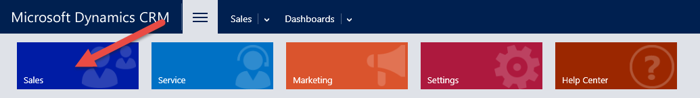

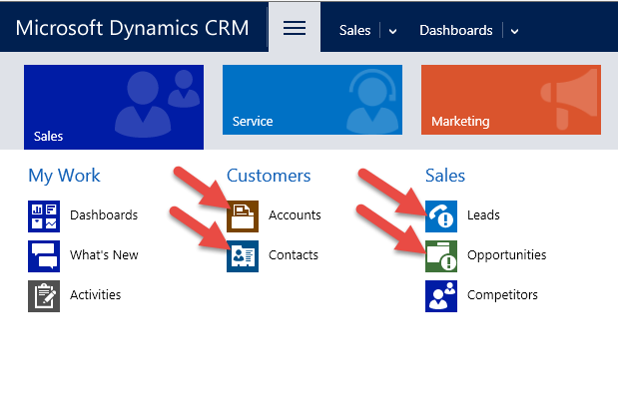

- Open a record from the previous entities and write your note in the Alert Note field. When you click out of the field the Alert is created.
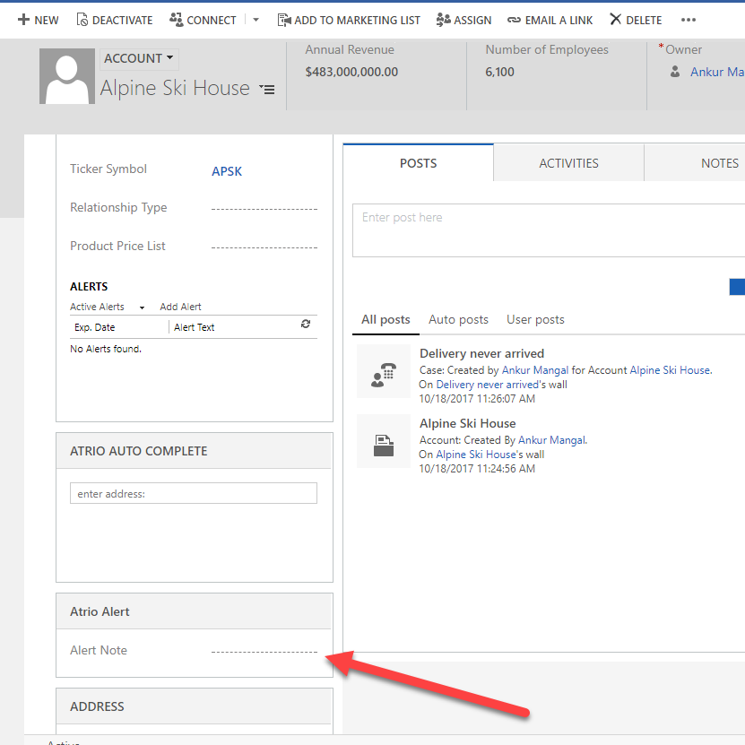

After clicking out of the Alert Note field, the current date is also saved to the Alert Note Date field, and is then displayed in the alert bar before your Alert Note text.

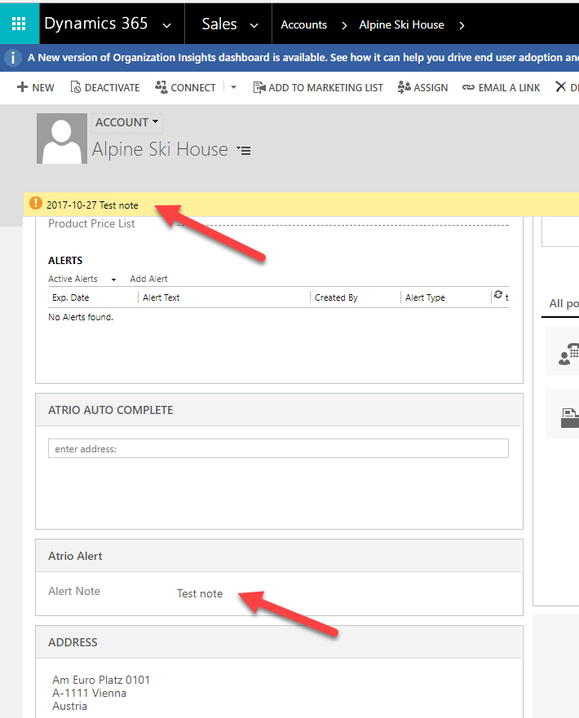

Copying Alerts from Company to Related Contacts
If a company record has an alert, the alert can be copied to any related contact from the contact entity.

- Navigate to Sales -> Contacts

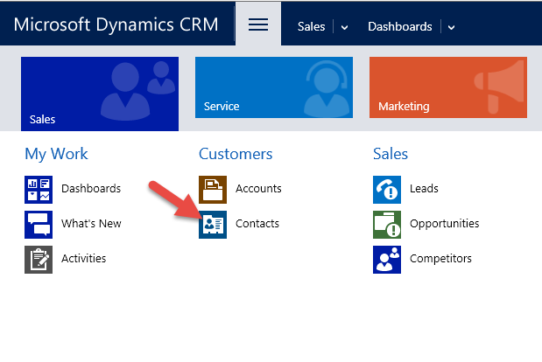
- Select Contact you wish to copy alert to, from parent company. Then select Run Workflow.

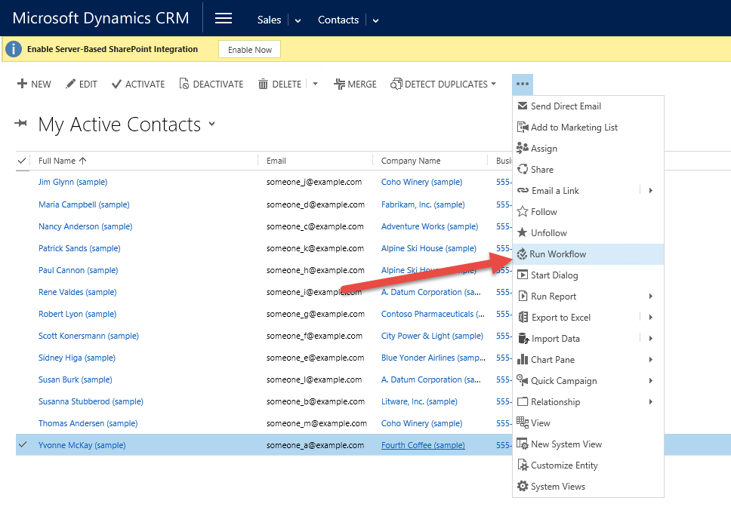

- Select Add Alert From Company to Contact and click Add then Ok.

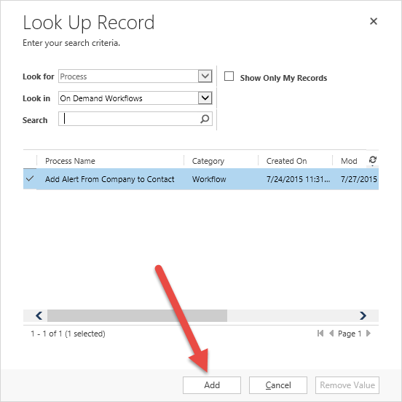

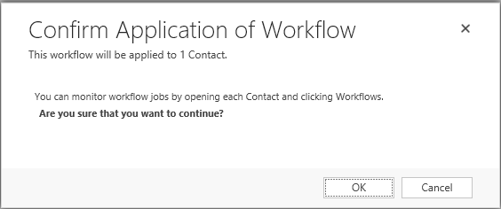
- After running the workflow the Alert Note field will be populated from the Account and the contact will show the same alert.

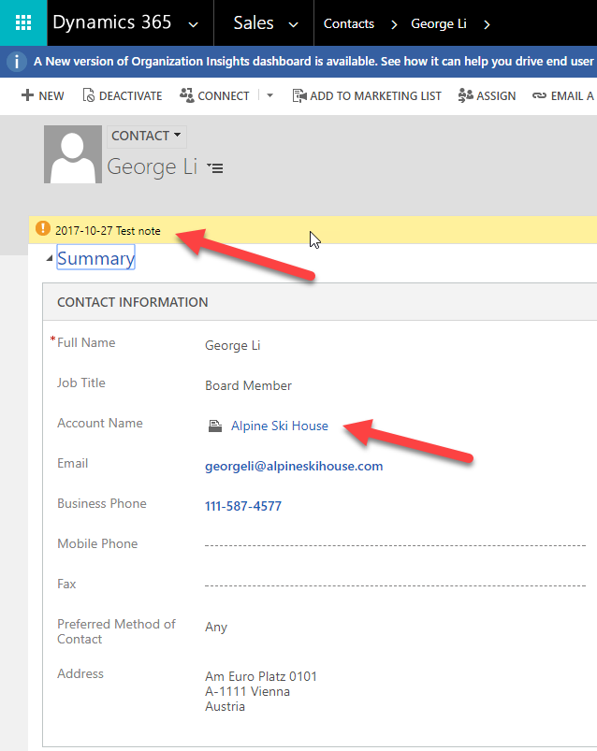

This workflow can be run from individual records as well. Open up the contact record and follow the same procedure of selecting the ellipses clicking on Run Workflow and then selecting the Add Alert from Company to Contact. Then click Add, and then Ok. Now wait approximately 30 seconds and refresh the Contact record. Upon refresh, the Alert Note field will be populated with the data from the company and the alert will be shown.

Note: If the contact has an alert already, it will be overwritten by the related Company alert.

Support

Free products are provided without support, but we value your feedback. Please send product issues and suggestions to support@nusoftsolutions.com. We will take your suggestions to make the product better.

Disclaimer

This software is provided "as is", and Atrio Systems, Inc. DBA NuSoft Solutions disclaims all warranties with regard to this software including all implied warranties of merchantability and fitness for a particular purpose. In no event shall Atrio Systems, Inc. DBA NuSoft Solutions Be liable for any special, indirect, or consequential damages or any damages whatsoever resulting from loss of use, data or profits, whether in action of contract, negligence, or other tortious action, arising our of or in connection with the use or performance of this software.

