GDPR – Import and Registration guide
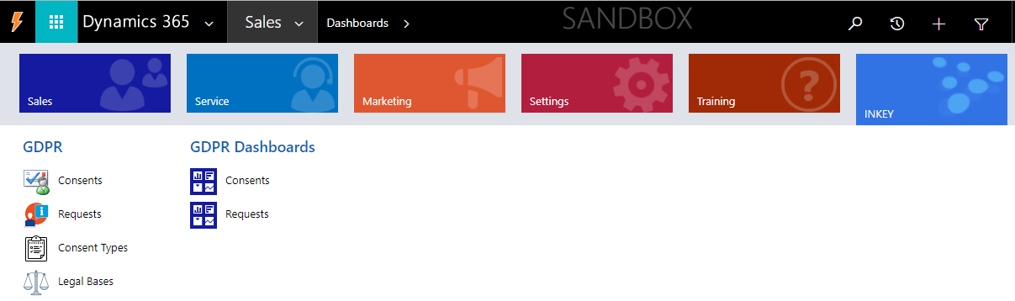

Contents

How to install the add-on?....................................................................................................................................................4 Register GDPR Add-on........................................................................................................................................................4
Security Role Privilege.........................................................................................................................................................6
Uninstalling the GDPR.........................................................................................................................................................6
Points to keep in mind..........................................................................................................................................................6

How to install the add-on?

Steps to install the ‘GDPR’ Add-on from AppSource.

Log in into your Dynamics 365 instance with an Admin credentials. In the same browser, the AppSource homepage using the below link:
https://appsource.microsoft.com

Search for the Add-on ‘GDPR’ in the search box as given in the below image:
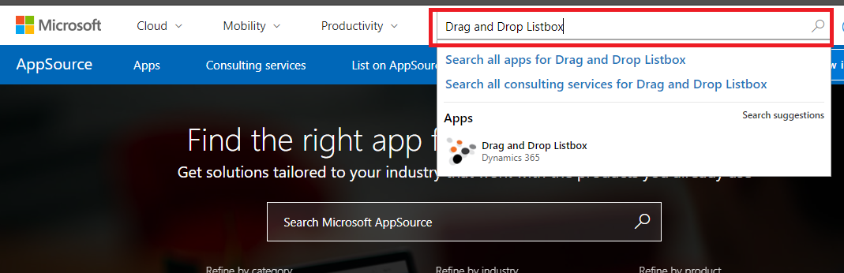

For information regarding registration steps and user manual guide, click on the documents link as shown in the below image or click on ‘Free Trial’ button to use the Add-on trial version.
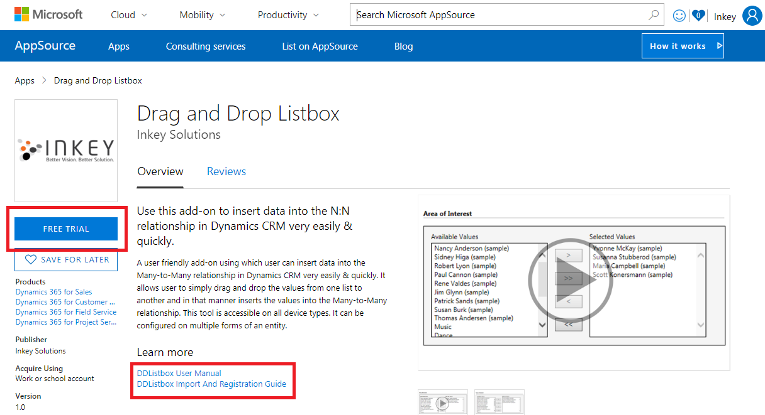

On click of the button ‘Free Trial’, a pop-up will get open as shown in the image below:
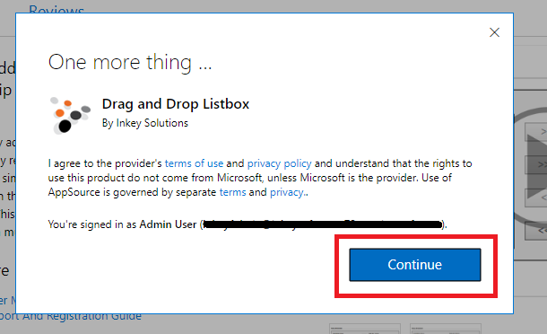

Click on ‘Continue’ to agree with the terms of use and privacy policy agreement.

On click of ‘Continue’, a pop-up will get open. Select the organization where you want to add the Add-on solution and select the check boxes to agree for the legal terms and privacy statement as given in below image.

Click on ‘Agree’ button to proceed further for installation of the Add-on (Please see the Add-on installed as seen in below image.)

The installation takes few minutes to complete. Refresh the web page to validate if the Add-on is installed.

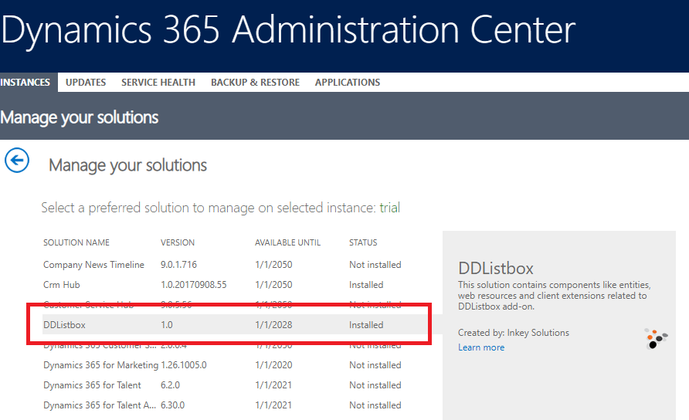

Once the installation is complete, you would be able to see the ‘INKEY’ area in the sitemap as shown in below image:

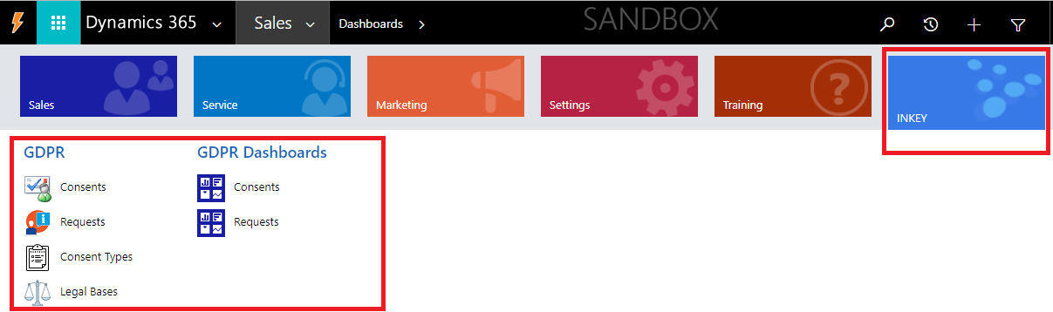

Register GDPR Add-on

1. Open the GDPR managed solution by navigating Settings -> Solutions -> GDPR.

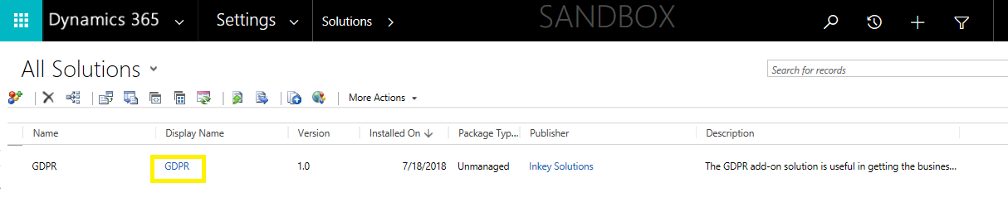

2. In the solution pop-up window, navigate to the ‘Configuration’ tab to provide necessary details for Add-on registration.
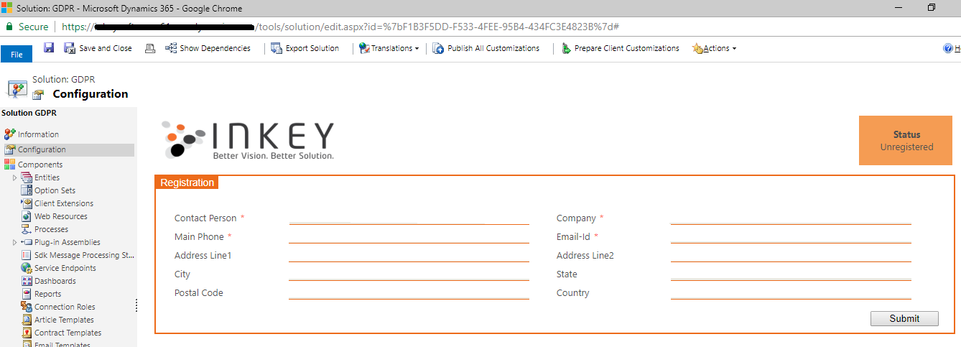

3. Fill all the required details as specified in the ‘Configuration’ and click on the ‘Submit’ button.

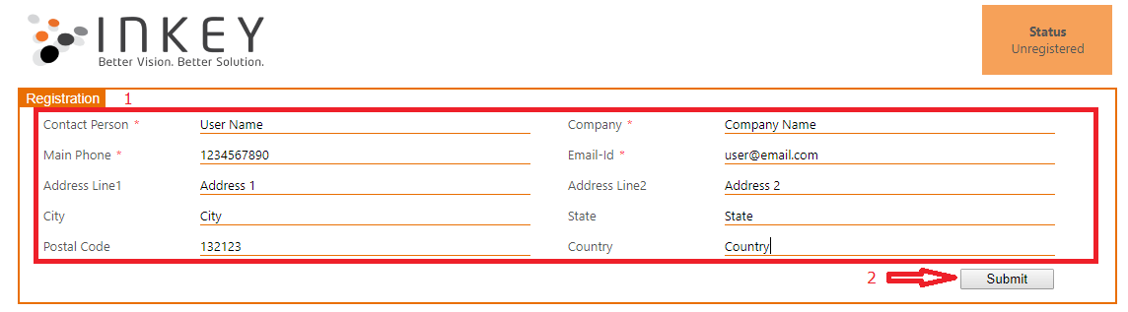

4. If everything goes well, the add-on will get registered successfully and you would be able to see the window as below:

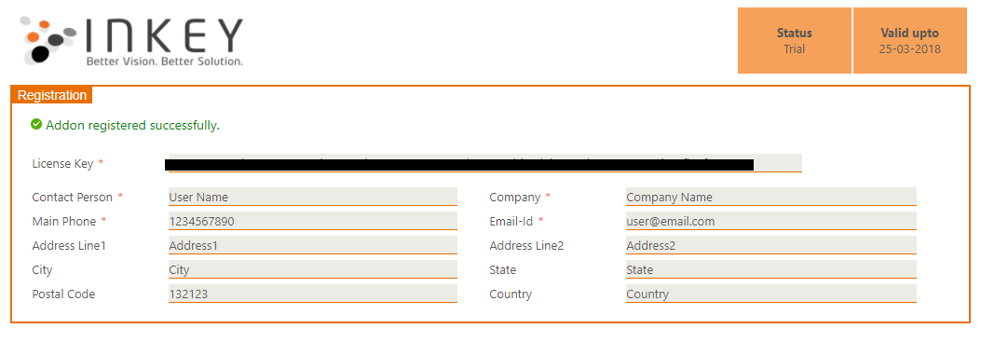

Security Role Privilege

To configure and access this tool, the user must have the role of GDPR.

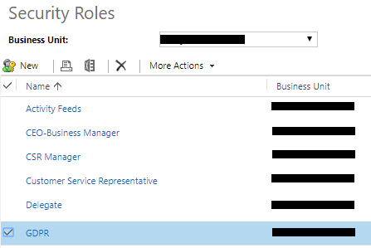

Un-installing GDPR

You can uninstall the ‘GDPR’ add-on as usual, by deleting the managed solution

Points to keep in mind

- Register the trial at free of cost, validate the features, and then contact us at ‘sales@inkeysolutions.com’ to purchase a licensed copy, if you’re interested.
- This add-on can be used as a trial, for 15 days.

