GDPR – User Manual

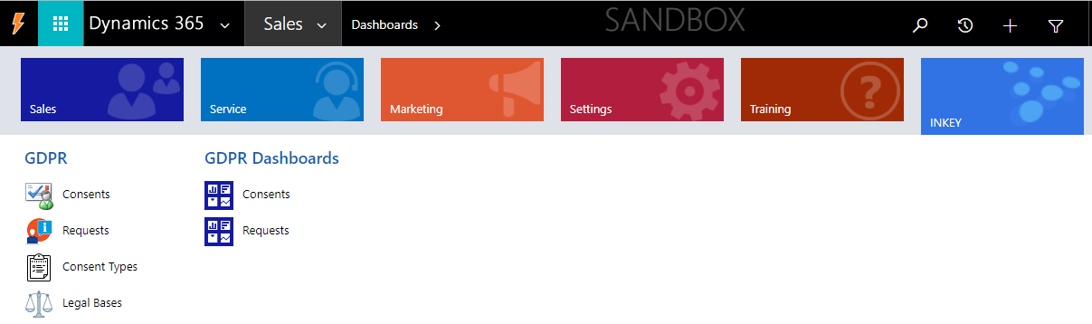

CONTENTS

1. Overview of GDPR.........................................................................................................................................................3

2. GDPR Add-On Modules.................................................................................................................................................4
- GDPR Consent.....................................................................................................................................................4
- Consent Types......................................................................................................................................................5
- Renewal of the Consent.......................................................................................................................................6
- Reversing of the Consent.....................................................................................................................................6
- Legal Bases..........................................................................................................................................................6
- Data Source..........................................................................................................................................................7
- GDPR Request.....................................................................................................................................................8
- GDPR Request Process Flow...............................................................................................................................9
- Consent Dashboard..............................................................................................................................................11
- Request Dashboard..............................................................................................................................................12

Overview of GDPR

The General Data Protection Regulation (GDPR) was approved by the EU Parliament and enforceable starting from May 25, 2018. It suggests important guidelines on how organizations must handle and protect the personal data of EU citizens. Apart from this, it also provides some Legal Rights to an individual to keep an eye on the use and processing of their personal data through practising Data Subject Requests (DSR's).

Our add-on "GDPR" for Microsoft Dynamics 365 is accompanied with the modules, which helps you in becoming GDPR compliant by covering some of the key aspects of GDPR regulation. The GDPR Consent Management module of our add-on allows you to manage the consents received from individuals time to time and helps an organization to avoid future data breaches and disputes. This add-on also comprises of a GDPR Request Management module that provides ways to manage the Data Subject Requests (DSR's) received from an Individual for accessing, deleting, or modifying their personal data.

GDPR Consent Management: Consent management is strictly related with the purpose for which the data will be processed. It’s a legal approval from the individual for using his / her personal data for the selected purposes and activities. Without the approval of an individual, the organization is not supposed to process the data further for any of the activities. There is also a provision for the data subject to withdraw the consent provided earlier.

GDPR Request Management: Request management deals with the rights of data subjects to know how their personal information is to be handled by the organizations. The General Data Protection Regulation (GDPR) outlines the various rights of data subjects that must be received, fulfilled, and documented by the organizations. Below are the requests, which can be implemented on data subjects:

- Request the information- The data subject should have the privilege to obtain from an organization the confirmation as to whether or not the personal data concerning him or her is being processed.
- Request for erasing the information- The data subject should have the privilege to obtain from the organization the confirmation for the erasure of the personal data concerning him or her.
- Request for portability of data- The data subject should have the privilege to have the personal data transmitted directly from one organization to another, where technically feasible.
- Request for objection of processing the data- The data subject should have the privilege to restrict the processing of the information related to him or her, in case there are any pending verifications required.
- Request for rectification of data- The data subject should have the privilege for the rectification of inaccurate information.

GDPR Add-On Modules

The GDPR add-on is specially designed for enabling the Microsoft Dynamics 365 Customer Engagement (formerly Dynamics CRM) for managing the consents of the individuals like Contact, Lead, and User entity record for accessing their personal data legally in order to avoid the data breaches that may occur in the future. This helps the organizations to process the information as per the consents of the data subjects which may be required in future audits.

Below are the modules, which are included in the GDPR add-on, and how the consents will be taken from the individuals based on a legal basis. Also, we have focussed on the rights of the data subjects for processing their information.

GDPR Consent: It is compulsory to get a consent of an individual when user is creating a new record in Dynamics CRM. Hence, the GDPR add-on automatically creates a consent related to a person soon after the person’s record is created. This applies to contact, lead, and user entities. If the consent is not yet approved, a follow up email is sent from the Admin to the owner of the record regarding the pending approval of the consent.

Sending Email To An Individual Requesting Consent: The owner of the record can send a consent request to an individual using the ribbon button ‘SEND CONSENT REQUEST’ as shown in the below screen-shot, requesting an individual to provide the consent.

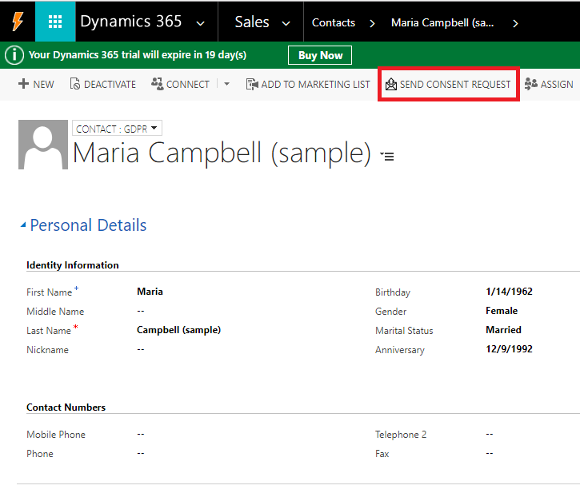

On click of the button, an email pop-up will be opened (as shown in below image). The content of the email gets populated from the email templates i.e. ‘Send Consent Request to Contact.’, ‘Send Consent Request to Lead.’ and ‘Send Consent Request to User.’ respectively for each entity.

Note: These email templates are configurable as per the business requirements.

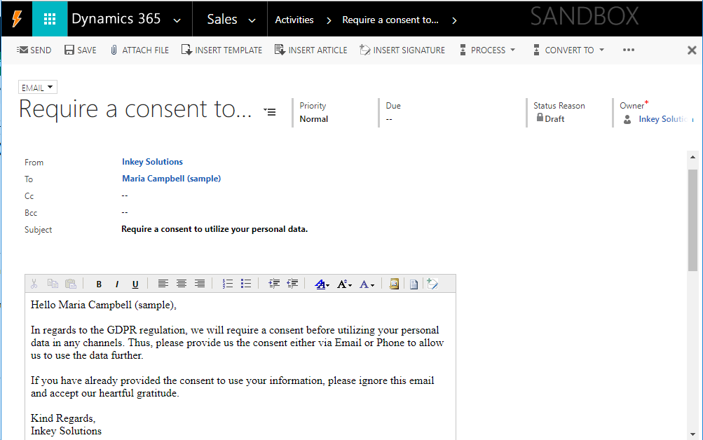

GDPR Consent Status: Initially, the status of the consent is set to “No Action” on the creation of the consent record. This can be updated to “Awaiting” till the data subject agrees to provide the consent. When the consent status is updated to “Awaiting”, the related contact/lead/user record is deactivated with the notification as in below image:
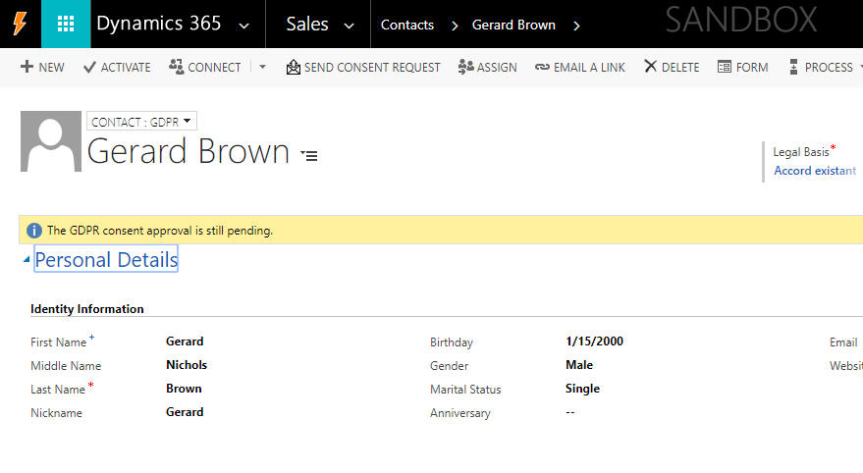

Once the consent is approved by the individual through phone, email, or any other mediums, the owner of the consent needs to update the status to “Consent Approved” and provide the values for the fields i.e. ‘Received Via’ and ‘End Date’ as shown below:
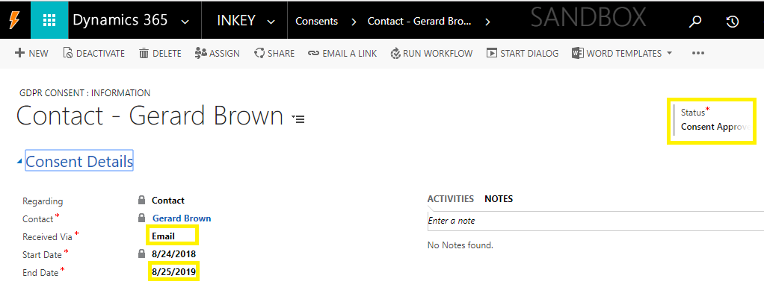

On approval of the consent, the related lead/contact/user is activated again.

GDPR Consent Types: This module is available on Consent entity and basically represents the type of technical areas where the data provided by the data subjects will be used. Here, the consent entity owner needs to select the type as required, then click on “>” button to select a particular consent type. Use “>>” button to select all the consent types. Refer the below screen-shot for further clarity.
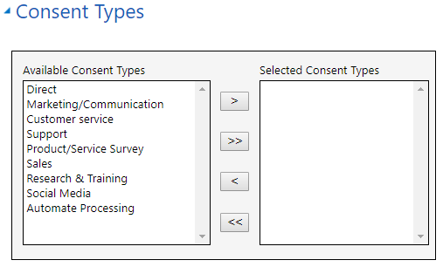

Renewal of the Consent: The owner of a consent is reminded about the consent renewal via email, before reaching the consent end date. This reminder email is first sent 30 days before the end date, then 7 days before the end date, and finally on the same day as the end date also. Also, this Add-on sends a notification email to the owner of an individual’s record after 1 day of the consent end date requesting either to renew the consent or delete the individual record from the system even if the data is required for further processing.

Reversing the consent:
- The data subject has the right to withdraw the consent at any time and the organizations cannot then after use the data without the consent of the individual. This feature can be achieved using the "REVERSE CONSENT" ribbon button.
- As soon as the button is clicked, the consent is updated with reversed status and the related (contact / lead / user) record is deactivated.
- End date of the consent is automatically set to the date on which the consent is reversed.
- A notification email is sent to the owner of the record informing about the consent reversed.
- A notification email is sent to the owner of an individual’s record after 1 day of the consent is reversed requesting either to renew the consent or delete the individual record from the system if the data not required further for processing.

Refer the below image to reverse the consent:

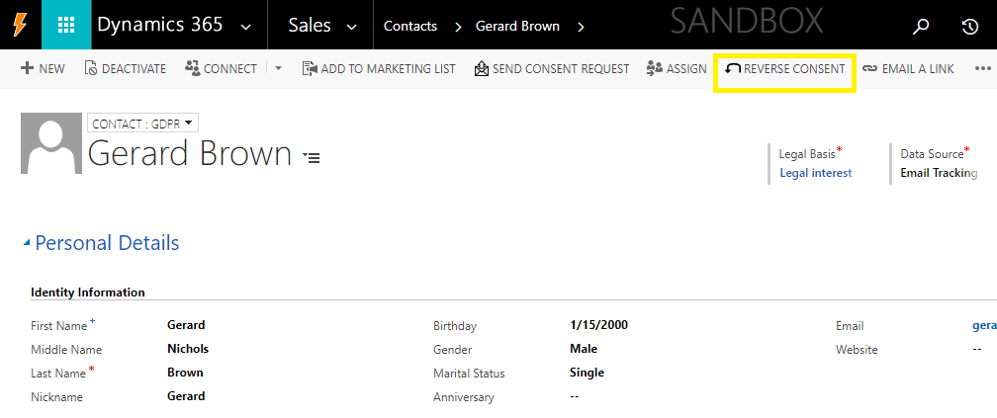
Legal Bases: It is a lawful agreement based on which the data is used by an organization. The ‘Legal Basis’ lookup field exist on the ‘GDPR’ form of the Contact, Lead and User entity and it allows the selection of the possible permission options according to Art. 6 of ‘GDPR’ regulation. The ‘Legal Bases’ options, which we provide with the Add-on are as below:

- Consent
- Existing agreement
- Legal interest
- Legitimate obligation
- People interest
- Pre-agreement action
- Transferring public authority
- Vital interests

Note: These Legal Bases records are configurable as per business requirements.

Data Source: The data collected from the data subject can be from any source of information like campaigns, email tracking, games/competitions etc. In order to track the source from where data has been collected, you can select the option from “Data Source” drop down of the concerned contact / lead / user record. The ‘Data Source’ options, which we provide with the Add-on are as below:

- Game/Competition
- Email Tracking
- Trade Exhibition
- Online Campaign
- Visiting Card
- Others

Note: These Data Source options are configurable as per business requirements.

Below is the screen-shot of Contact record for selecting the legal basis and data source:

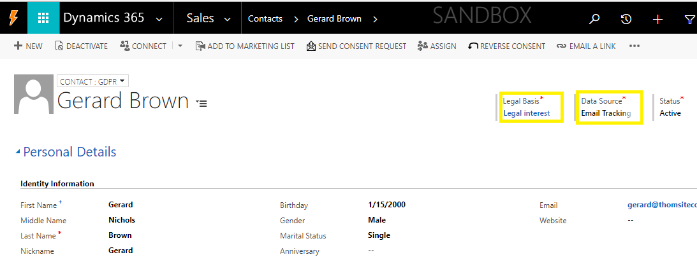
GDPR Request: GDPR request module is mainly focussed on the rights of the data subject over their data in the organization and it allows a user to handle Data Subject Requests (DSR’s) received from an individual time to time. Below are the request types provided in the Add-on:
- Information Request
- Erasure Request
- Portability Request
- Objection Request
- Rectification Request

For defining the rights of the data subject, you need to select a type of the GDPR Request as shown in the below image (GDPR Request record):
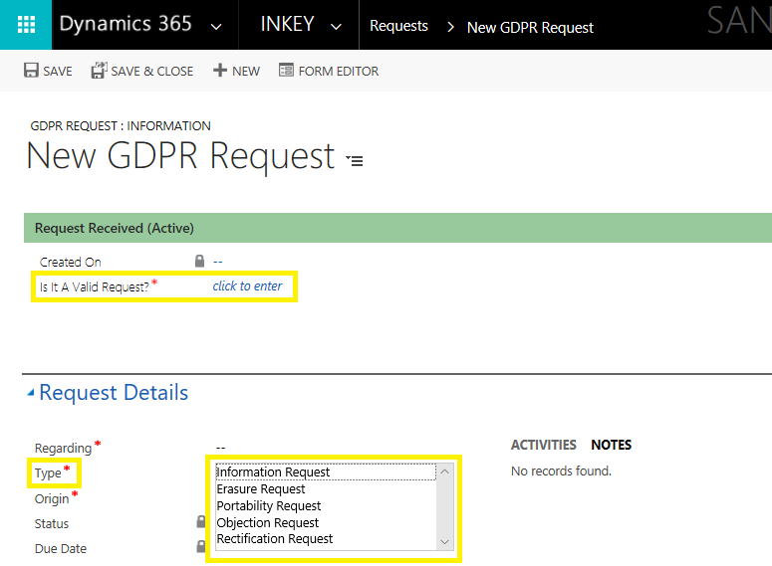

The owner of the request record needs to validate if the request received is valid or not valid. After validation, the field ‘Is it A Valid Request?’ (shown in the above image) must be set as Valid/Not Valid in order to move forward with the further processing of the request.

As per GDPR regulation, the ‘Data Subject Request’ received from an individual must be processed within 30 days from the date of receipt of the request. Thus, to comply with the same, on creation of the request record, the ‘Due Date’ is set 30 days after the record creation date.

Please know, for every pending requests, an email notification will be sent to an owner of the GDPR request record before 5 days of the due date of the request to work further on the request as early as possible.

GDPR Request Process Flow: The ‘GDPR Request Process Flow’ in the Add-on helps to know the status of the request being processed. It depends upon whether the request is valid or not.

If the GDPR request is valid, the BPF stages are shown as in below image:
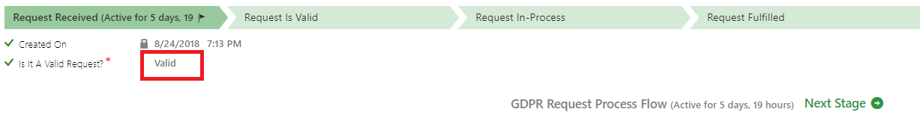
If the GDPR request is invalid, the BPF stages are shown as in below image:
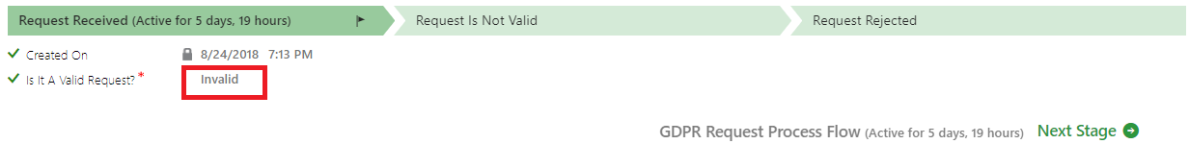
Working with GDPR Request Process Flow:

The Business process flow for a new GDPR request will be as follows:
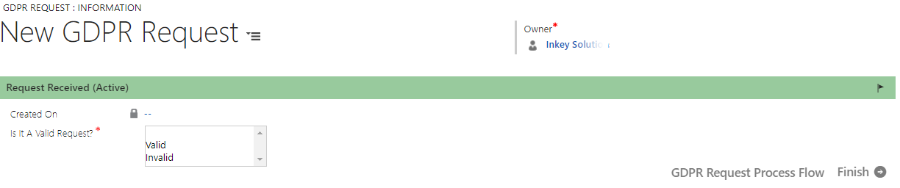
If the request is valid then the time required to fulfil the request is to be provided.

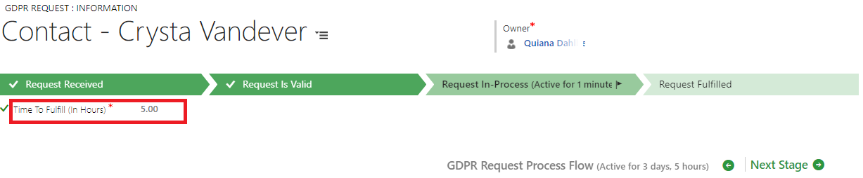

Finally, move the BPF stage to “Request Fulfilled”, once the processing of the request is completed as shown in below image:
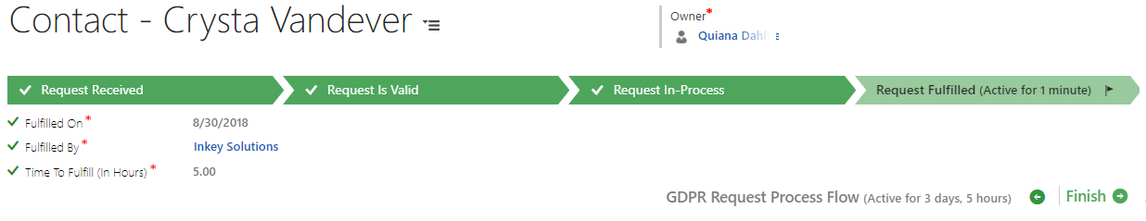

If it is not a valid request then the reason for the rejection of the request has to be provided. An email will be sent to an owner of the request regarding the rejected request.

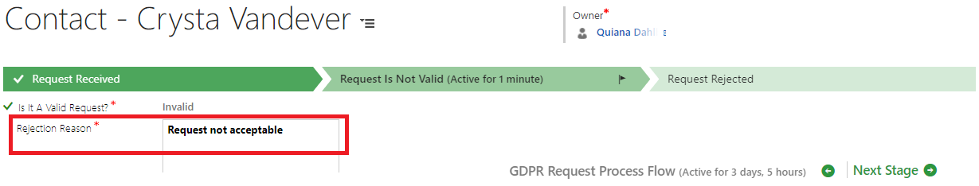

Move the BPF stage to “Request Rejected” if the request is not processed as shown in below image:
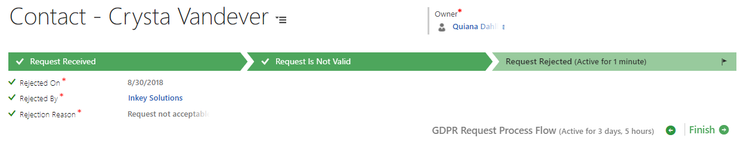

DASHBOARDS

GDPR Consent Dashboard: The GDPR add-on provides the complete tracking of the consents based on the data subjects, the status of consents, consents received via, active consent types, status over time, consents ending this week and consents to end this month.

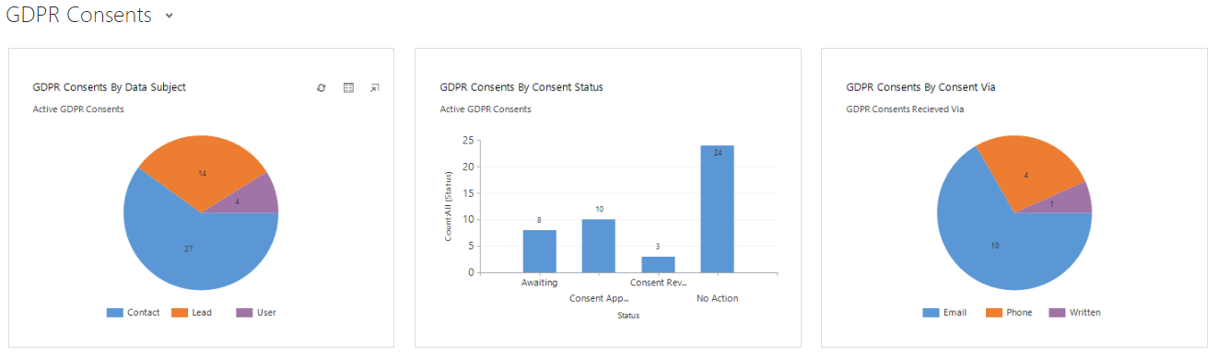
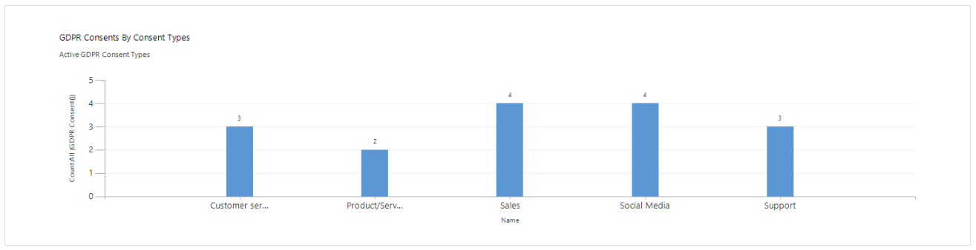
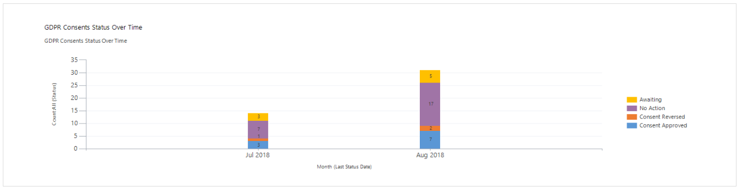
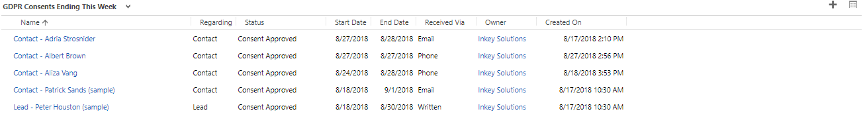
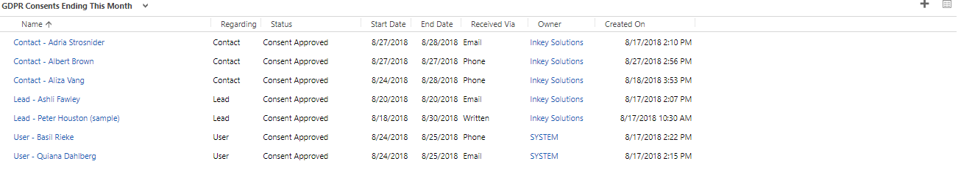

GDPR Request Dashboard: The GDPR add-on provides the complete tracking of the requests based on the data subjects, the status of requests, requests by types, requests by owner, status over time, requests due this week, and requests due this month.

