**Requirements:**

**MSCRM Online**

(Version 2011 or later)

**Shopify**

**Pricing**

Shopify andMSCRM On-Premise/Online

Starting at $6000

(customizable)

Shopify, SkuVault, Microsoft GP, NetSuite, NAV etc starting at $12000

**Integrate Orders, Track Order Fulfilment and Manage Inventory between MSCRM and Shopify**

* DBSync provides bidirectional integration between MSCRM and Shopify with the pre-built, customizable field-to-field mappings along with flexibility for more complex and dynamic mapping and data transformation capabilities.
* DBSync for MSCRM & Shopify bi-directional template provides an easy to use solution to integrate MSCRM Accounts, Invoice Module and Products with Shopify Customer / Sales channels, Orders and Products respectively.
* Track Order Fulfilment, AR and Inventory Updates effectively.
* The application also provides periodic automatic online updates and enhancements without needing any manual intervention by the customer or support teams involved.

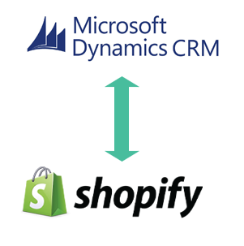

# Data Flow

|  |  |
| --- | --- |
| **MSCRM** | **Shopify** |
| Accounts | Customer / Channel |
| Opportunity / Order | Orders |
| Product | Product |
| Custom Object | Any Entity / Table |

# Features

* Easily extend, map and create new business processes and mappings
* Supports custom objects in MSCRM
* Supports Multiple Shopify instance Integration
* Migrate data from Shopify to MSCRM or vice-versa
* Run your application on-premise or on-demand

**KEY BENEFITS**

* Improve productivity by reducing double data entry
* Increase data visibility across multiple systems
* Integrate with other applications like eCommerce, WMS systems to simplify business, Inventory Tracking and Inventory Movement

# Contact Us

Email: [sales@mydbsync.com](mailto:sales@mydbsync.com)

Website: www.mydbsync.com

Phone/Fax: 1-877-739-2818

**DBSync LLC**

750 Old Hickory Blvd

Bldg 2, Suite 150

Brentwood TN 37027

Free Trial at [http://www.mydbsync.com/register_now](https://dbsync05.appmashups.com/appcenter/c/register/DBSync2-Register)