Payment Gateway PsiGate
Manual
V 1.0

Table of Contents
Purpose 3
Sign In 3
Sign into Merchant 4

Purpose
The manual will give instructions on how to sign into PsiGate on a CRM instance

Sign In

- Install the two solutions that were provided: CRM Dynamics Foundation API and Payment Gateway PsiGate.
- Verify that there are two configuration records in the API Configuration entity. If they are not present, please ask CRM Dynamics.
- Login to Core API by going to Foundation API > Settings. The credentials provided will be used by the Payment Gateway to talk to your CRM instance.

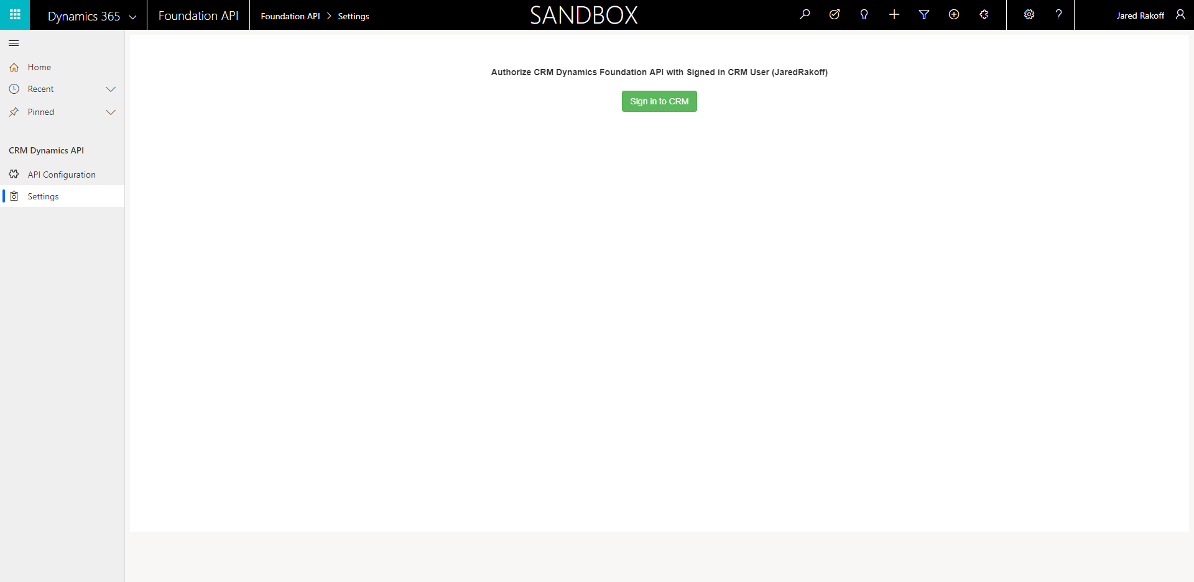

Sign into Merchant

- Navigate to Foundation API and confirm the API Configuration records Environments’ are all pointing to either Sandbox or Production.
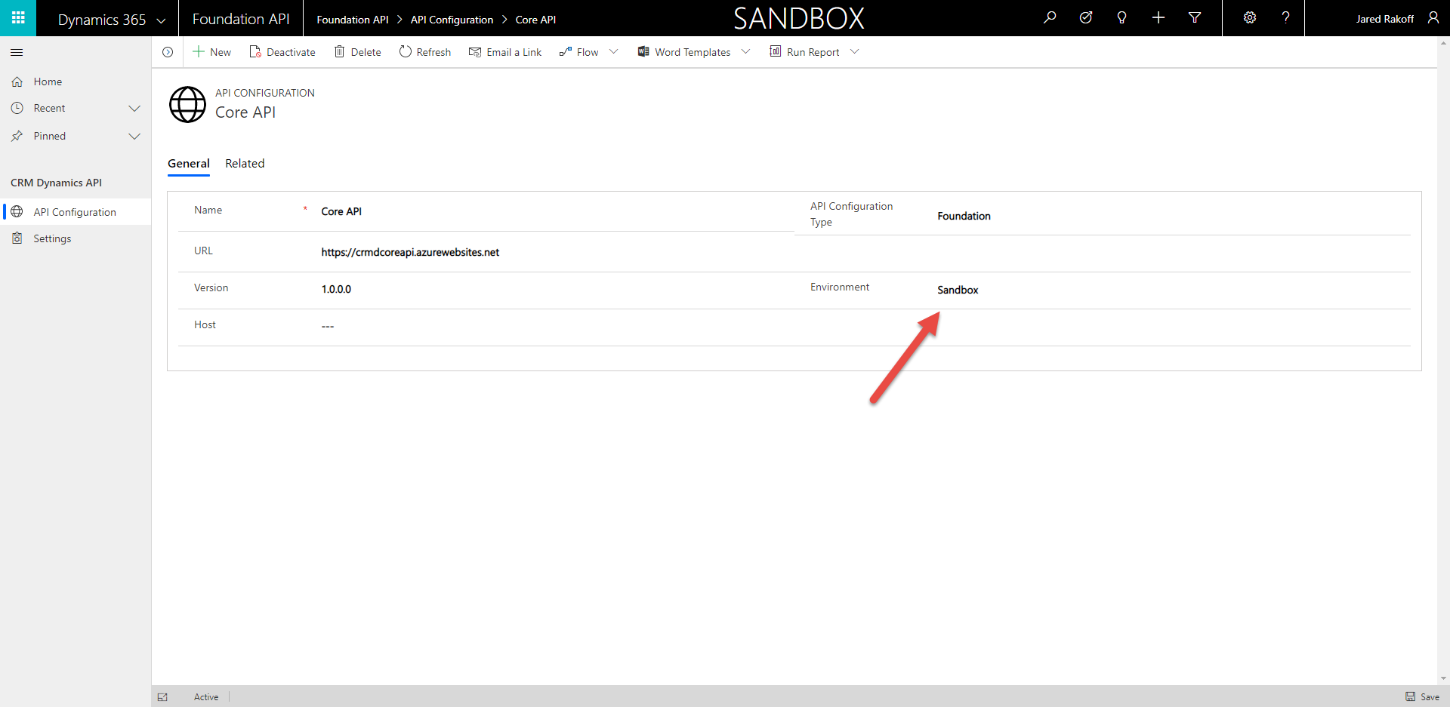
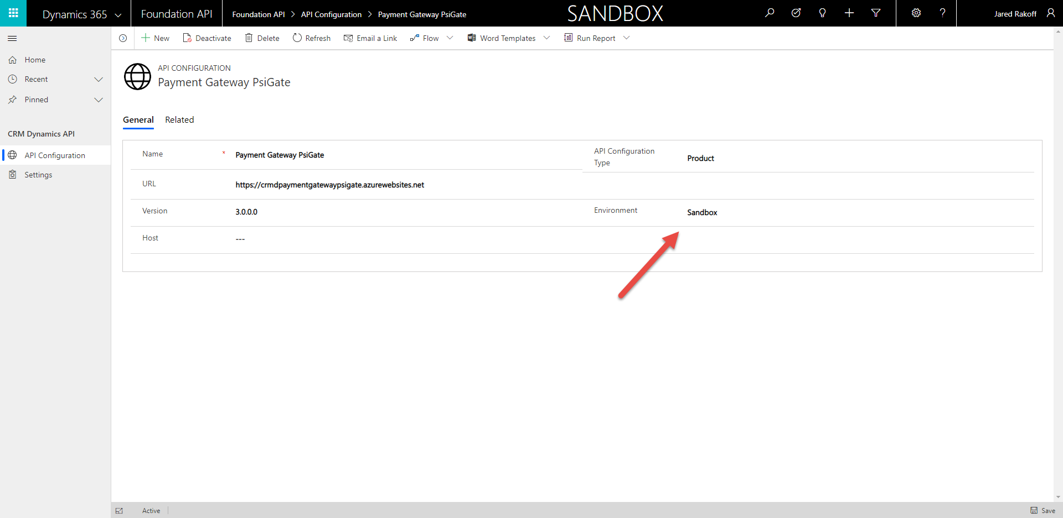

- Navigate to Payment Gateway PsiGate.
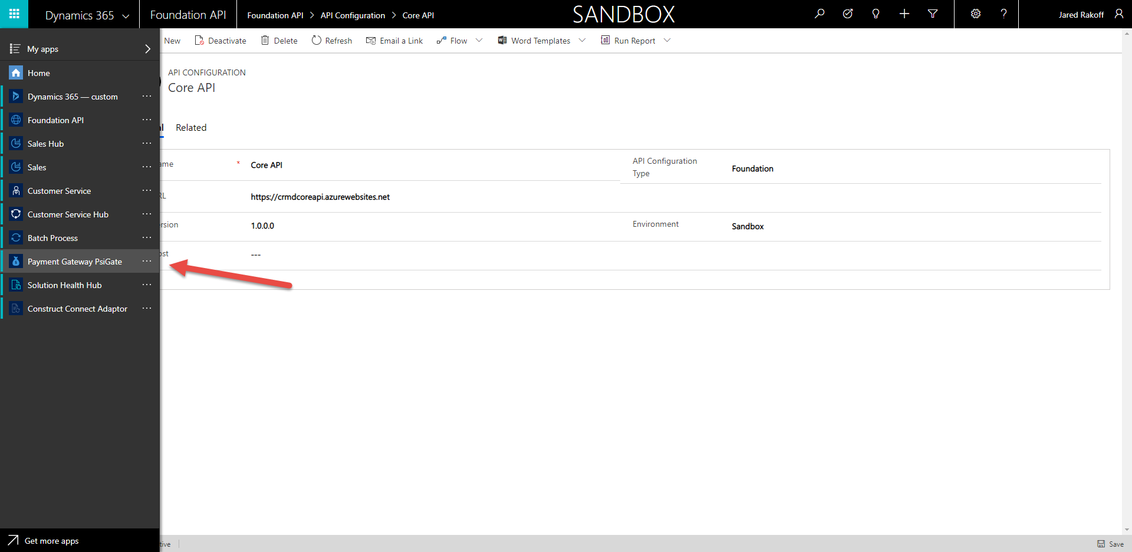

- Sign into the PsiGate merchant

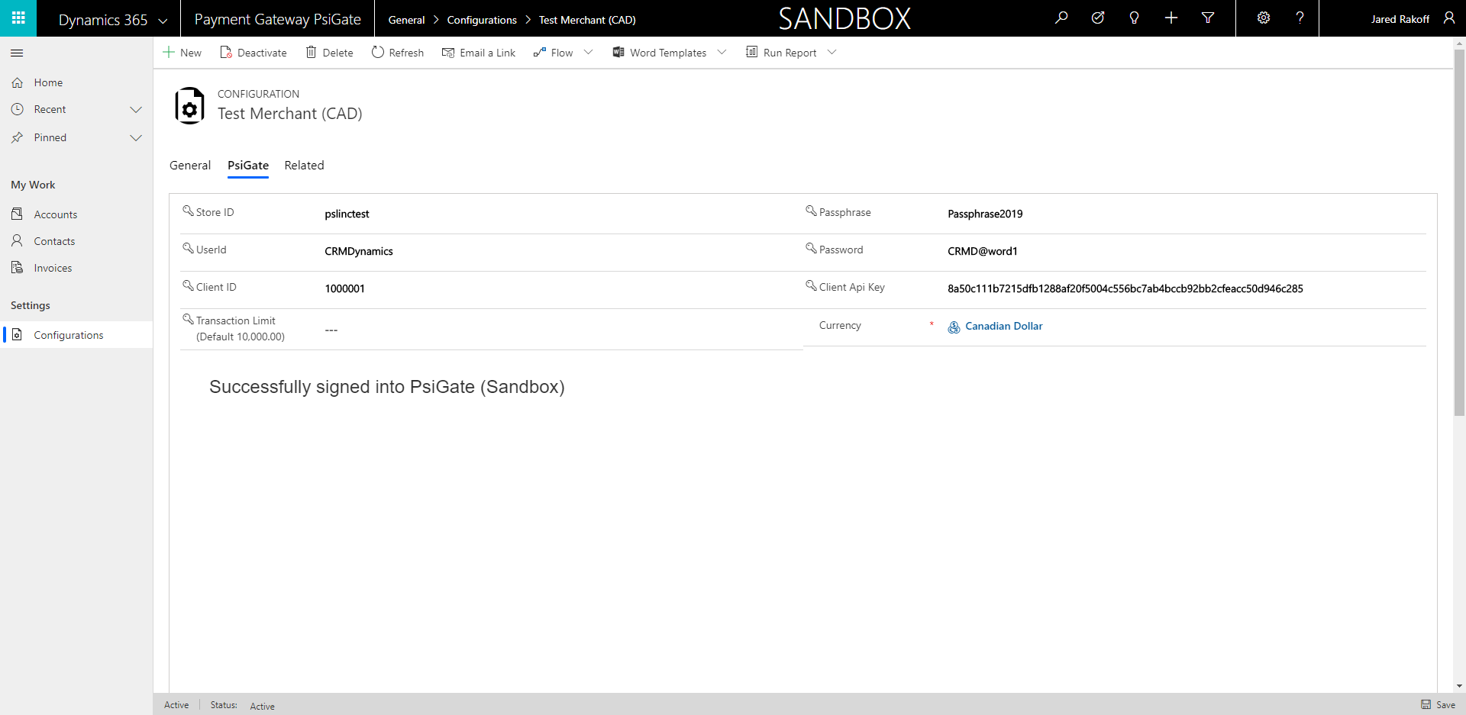

- To add a credit card to a customer, navigate to an Account or Contact (Customer). Set Account/Contact Type to Prospect or Client and assign the Billing Currency. The currency must equal the Merchant’s currency which automatically is set after the merchant is signed in. 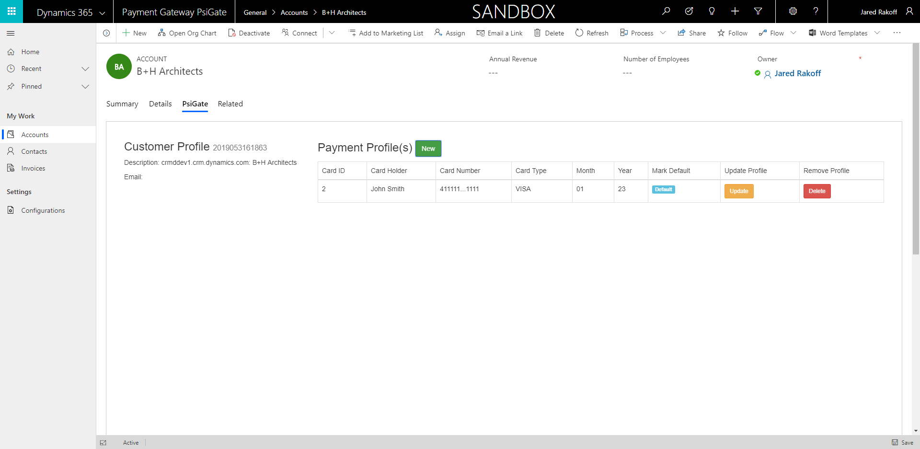

- Create an Invoice related to this customer. Make sure the invoice Total Amount exceeds zero dollars. Set the invoice to One Time Payment and click Process Payment. The invoice will be marked as Paid if successful.
