Table of Contents
Table of Contents 2
What Is The Artis Note Manager For Dynamics 365? 3
What Do I Need To Use The Artis Note Manager For Dynamics 365? 4
How Does The Artis Note Manager For Dynamics 365 Work? 5
Lead To Opportunity Artis Note Manager for Dynamics 365 Example 6
Great, But What If The Current Version Of The Artis Note Manager For Dynamics 365 Doesn’t Do Something I Need It To? 10

What Is The Artis Note Manager For Dynamics 365?
A frequent issue faced in Dynamics implementations is the management of Notes that are applicable for a set of related entities. For example, if when processing a lead in the sales process a Note is created that contains an attachment for a competitor’s quote, you don’t want to have to navigate back to the lead once it has been qualified to an opportunity. This is where the Artis Note Manager can assist, by providing a simple workflow step that replicate the Note from one record to another. This allows for Note replication based on any of the trigger criteria the out of the box Dynamics 365 workflow engine provides, as well as in batch via on demand workflows.

What Do I Need To Use The Artis Note Manager For Dynamics 365?
The following is required to use the Artis Note Manager:
- An up-to-date (version 9+) Dynamics 365 online organisation - We may be able to assist with an on-premise version if required, please contact us.
- A moderate understanding on Dynamics 365 Workflows, Entities, and Security.
- Two entities you would like to move Notes between.

How Does The Artis Note Manager For Dynamics 365 Work?
As we wanted to maximise the flexibility of the Artis Note Manager, we chose to implement a workflow step that simply points at the records that you are moving the record between. Once installed you simply add the workflow step as required and set the following properties:
Source Record URL: Simply pick the entity that the Notes are coming from and choose the “Record URL(Dynamic)” property.
Destination Record URL: Similar to source, except for the entity where you want the notes copied to.
Delete Source Note?: A feature we have added to allow for the automatic removal of the source version of the note if it is no longer required there (this is a great way to reduce redundancy in data and minimise storage usage in online environments).

Lead To Opportunity Artis Note Manager for Dynamics 365 Example
This example will demonstrate how Notes can be moved from a Lead to an Opportunity
- Navigate to the Settings > Processes section of Dynamics 365 as shown below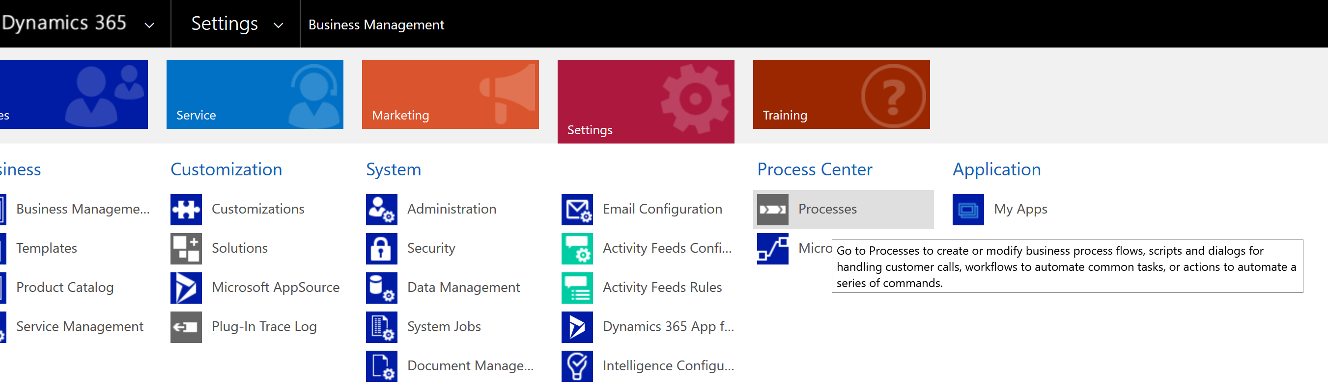
- Create a New Process with the following attributes:
Process Name: Move Annotation From Lead To Opportunity On Qualification*
Category: Workflow
Entity: Lead
Run This Workflow In The Background (Recommended): False
Type: New Blank Process
*This title is just a suggestion, please feel free to call the workflow whatever makes the most sense for your organisation.
Once the above settings have been set, click OK
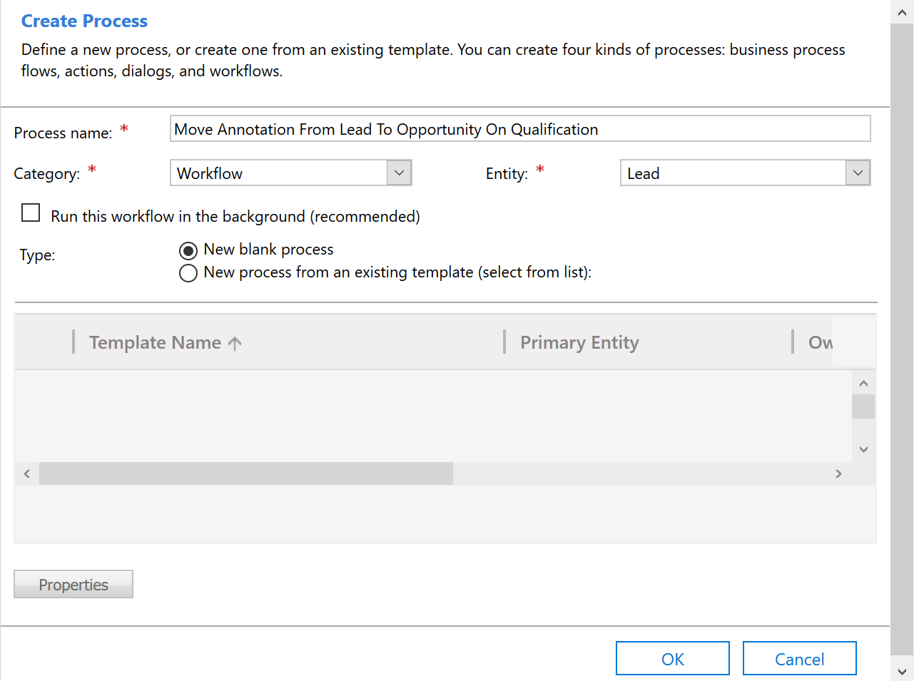
- Once the workflow has been created, set the following workflow options
Scope: Organization
Start When: Records Fields Change – in the select box ensure the “Qualifying Opportunity” field is selected 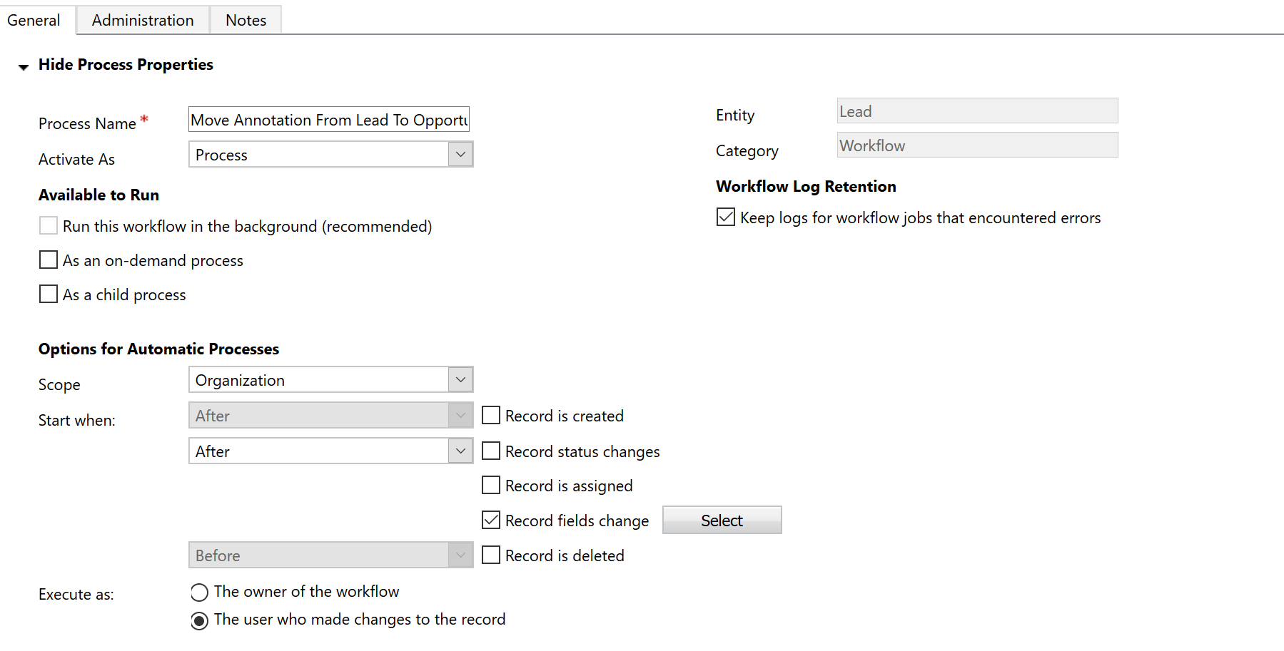
*Please note, depending on the configuration of your Dynamics 365 environment you may need to make a few more adjustments to these settings. For example, if you set the delete source version of the note setting to yes, this workflow will not work if the user running the workflow doesn’t have delete permission on the Note entity.
- Now we want to start working on the workflow steps to do the actual work, starting with adding a check condition step 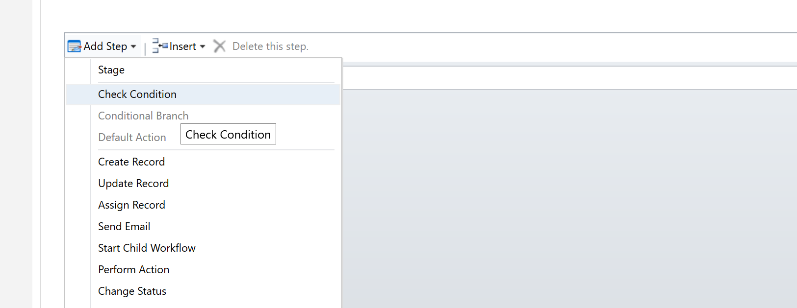
For ease of reading later add “If Qualifying Opportunity Has A Value” into the step description, and set the Condition to be where the Lead – Qualifying Opporunity – Contains Data in the step properties.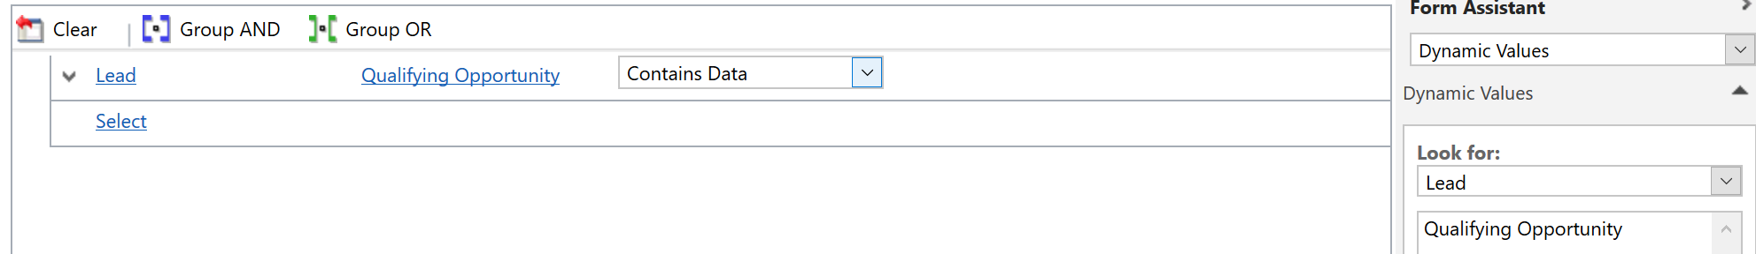
Once saved, your workflow steps should now look like this 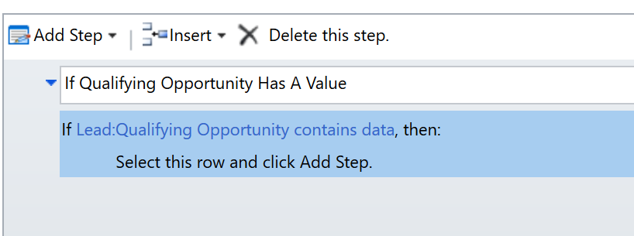
- Click on the row that says “Select this row and click Add Step,” and add the Artis.AnnotationManager.CopyAnnotation workflow step 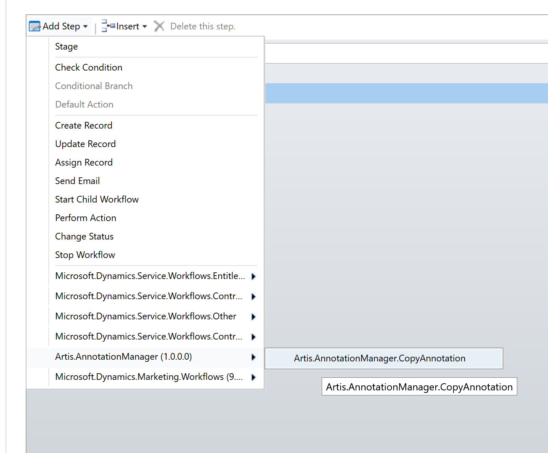
Set the description on the CopyAnnotation Step to “Copy The Annotation From Lead To Opportunity,” and set the following properties
Source Record URL – Lead – Record URL(Dynamic)(Lead)
Destination Record URL – Qualifying Opportunity (Opportunity) - Record URL(Dynamic)( Qualifying Opportunity)
Once complete this look similar to the below:
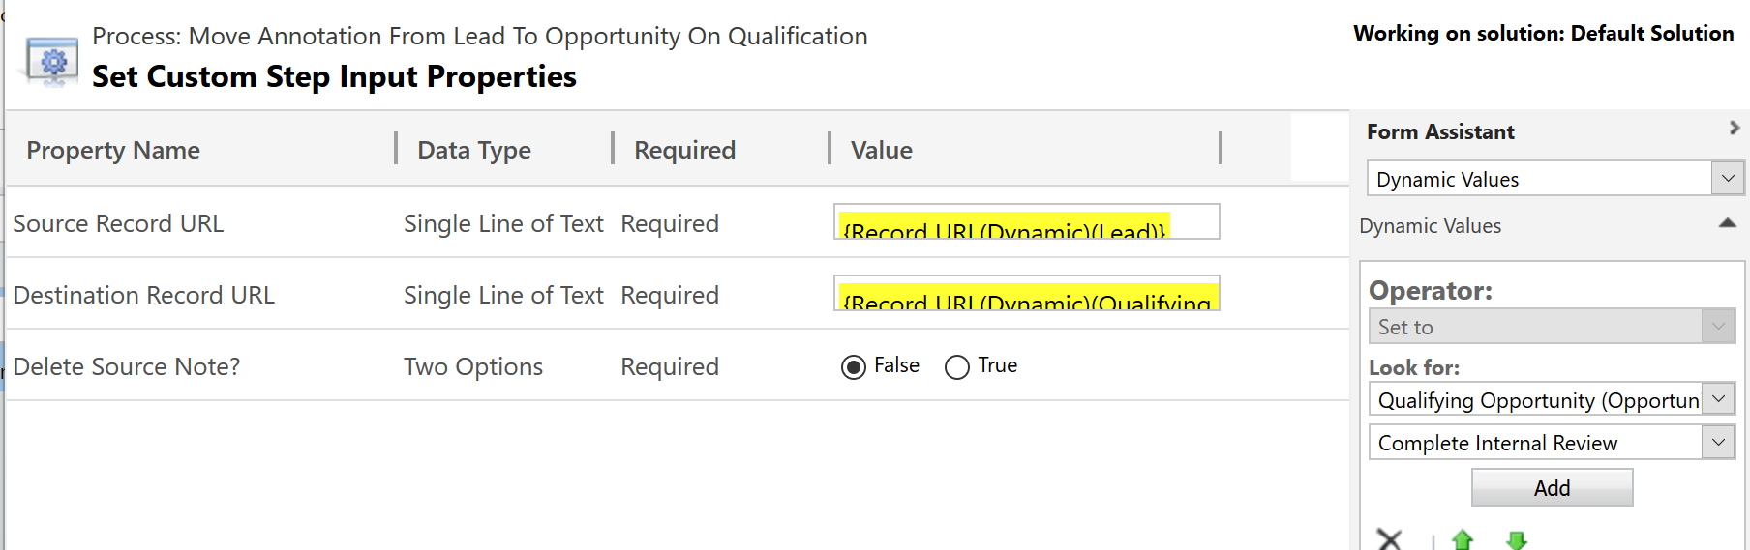
- Your workflow should now look similar to the below
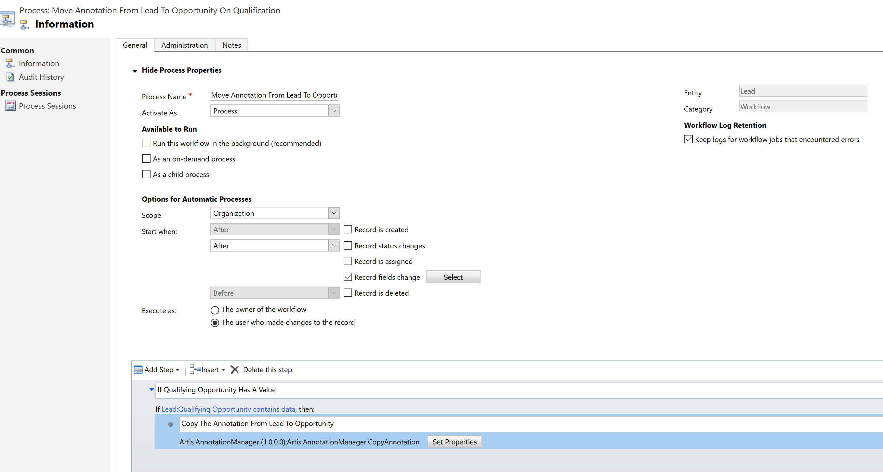
When it does, save and activate the workflow and Notes will now automatically be copied from Leads to Opportunities when the Lead is Qualified.

Great, But What If The Current Version Of The Artis Note Manager For Dynamics 365 Doesn’t Do Something I Need It To?
We love solving problems and would like to hear any suggestions you have for new features. Please contact us with any suggestions/feedback, and we will endeavour to get back to you as soon as possible.

