PAYMENT GATEWAY FOR DYNAMICS 365

TABLE OF CONTENTS
PAYMENT GATEWAY USER MANUAL 2
Set Up 2
Create a Customer (Account / Contact) Profile 5
Create a Transaction 6

PAYMENT GATEWAY USER MANUAL

Set Up

Step One:
To use our integration, go to Settings > Payment Gateway > Configurations and create a record of type Iframe. The URL will be provided by CRM Dynamics and will look something like this URL: https://crmdpaymentgateway.azurewebsites.net/{ENVIRONMENT}.{VERSION}/
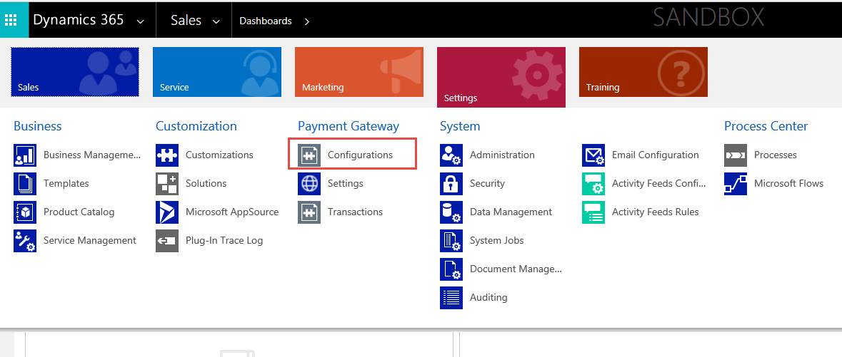
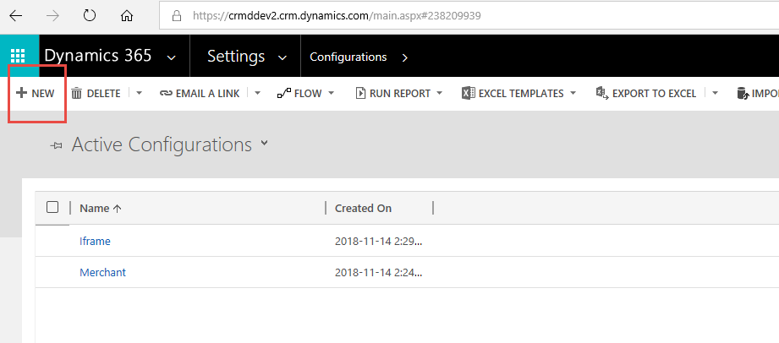
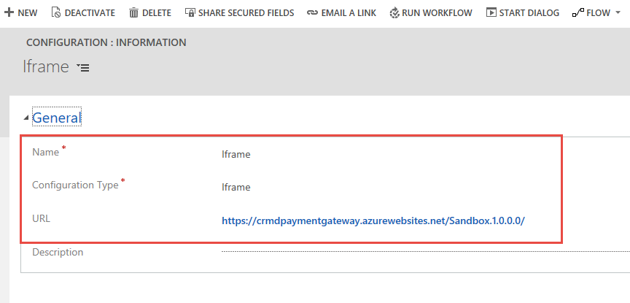

Step 2:
Sign into website by going to Settings > Payment Gateway > Settings. Authorize the website with your credentials. Note: Trial period lasts 30 days.
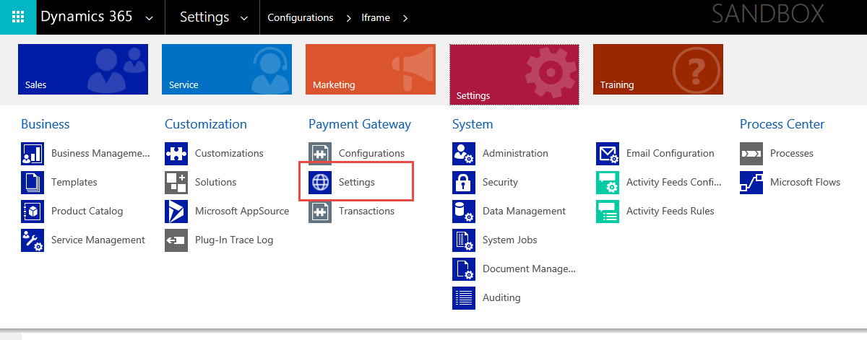

Step 3:
Sign into Merchant:
Go to Settings > Payment Gateway > Configuration. Create a record of type Authorize.NET Profile. A sample sandbox profile will be available by default to be signed in. You can sign into your merchant with API Client ID/ Transaction Key or via our Partner Account (OAuth 2.0). If you choose the latter, please contact CRM Dynamics for Client ID/Client Secret for PRODUCTION ENVIRONMENT. Multiple merchant profiles are supported so long as they are different currencies.

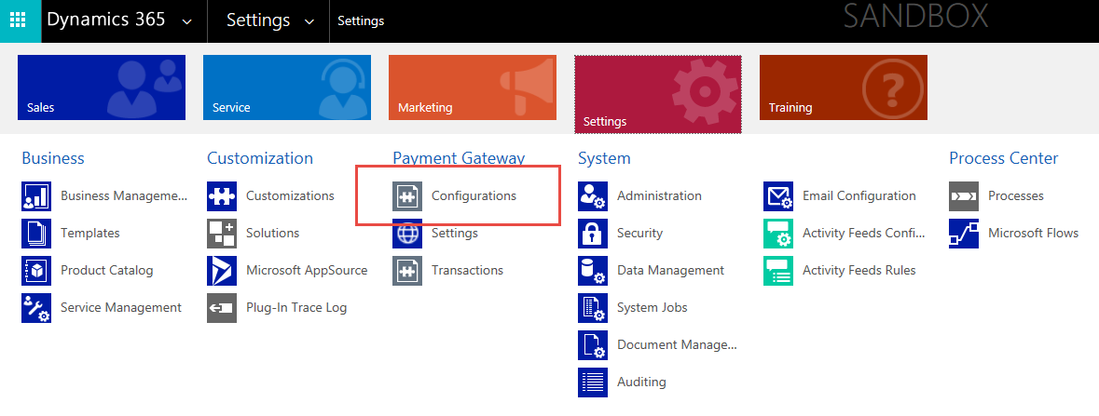
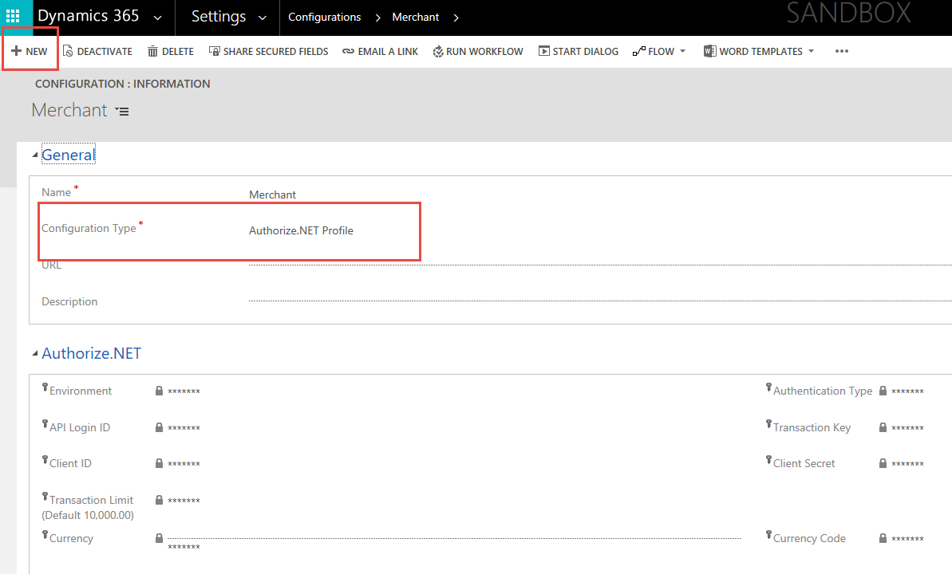

Create a Customer (Account / Contact) Profile
- Go to Sales > Account or Contact
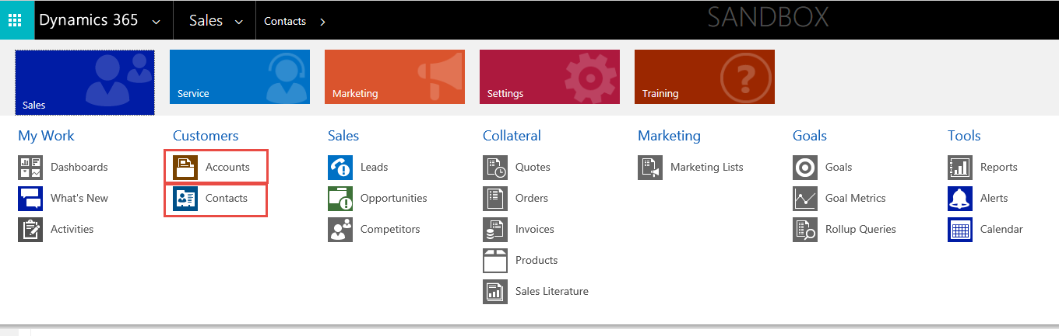
- Use the Payment Gateway Form
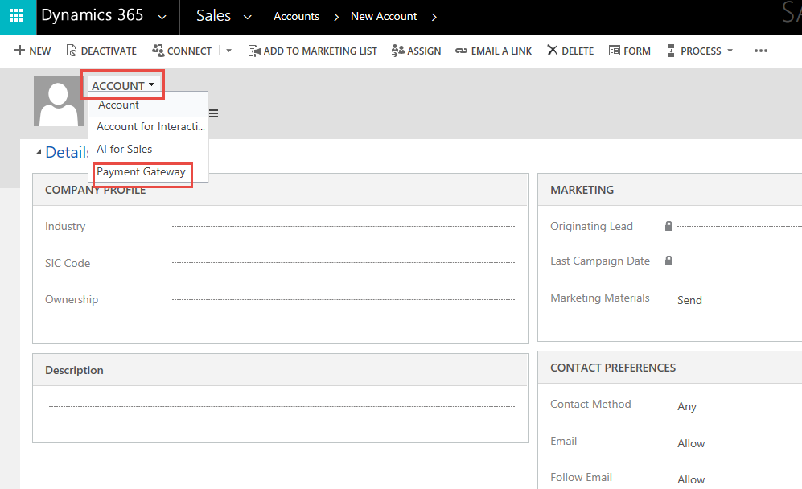
- Account Type/Contact Type must be “Client” for the Authorize.NET tab to appear.
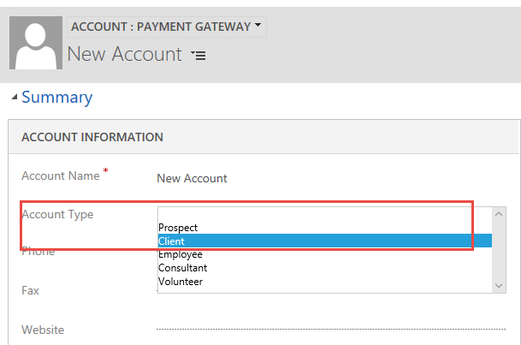

- Add Payment Profile(s)
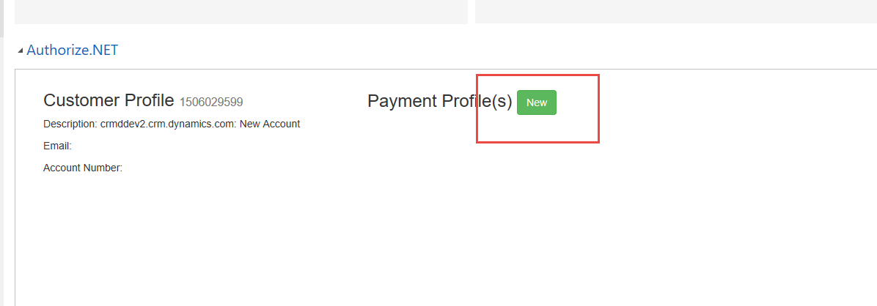

Create a Transaction

Authorize Payment Type can be a One Time Payment or Refund.
