CRMXL VIES VALIDATION

Manual
NORRIQ Belgium

Index
1 Usage 2
2 Configuration 3
2.1 Adjust your Security setup 3
2.2 Add or Configure the Enterprise number Field 5
2.3 Add or Configure the VAT Number Field 9
2.4 Add the Fields to the Form 10
2.5 Do the VIES validation setup 12
3 Troubleshooting 13
3.1 I keep getting the error stating that the fields are not found. 13
3.2 How does the VIES Validation know which memberstate it needs to use. 13

Usage
On the account form, a new button should be visible in the command bar. Pressing this button will validate the account’s VAT or Enterprise Number against the European VIES validation site (http://ec.europa.eu/taxation_customs/vies/?locale=en)
If you click ‘VIES VALIDATION’ after installation, an error message will appear claiming that no VAT or enterprise number field has been found. To fix this, please follow the steps mentioned in the configuration section of this document.
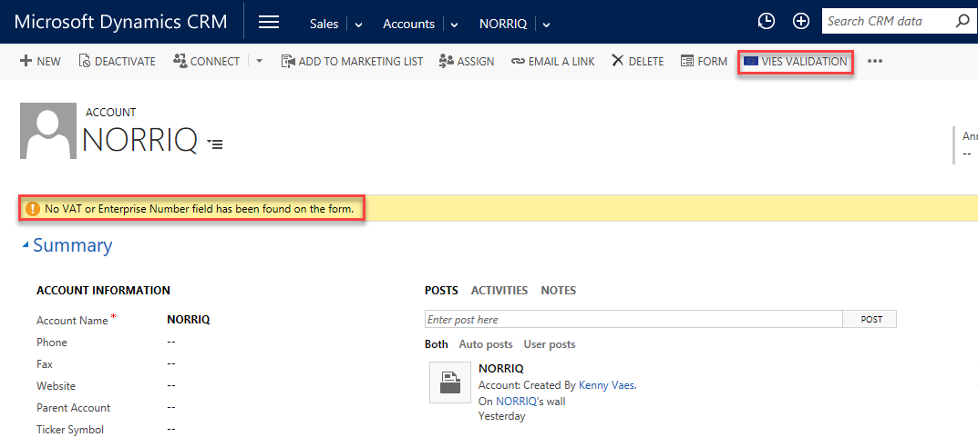

Configuration

Adjust your Security setup
With the deployment of the VIES validation, 2 new entities ’crmxl_country’ and ’crmxl_appsetting’ are created. Users need read access to these entities. Rather than installing a separate security role for each crmxl (-Yes, there are more!) feature, we opt to give environment administrators the option to choose which base security layer they adjust.
For each end-user that needs access to the VIES Validation functionality, their security role needs to be adjusted.
Follow these steps to adjust a security role. We will use the Salesperson role as an example.
First, you will need to log in with the system administrator role. Then navigate to Settings > Security.
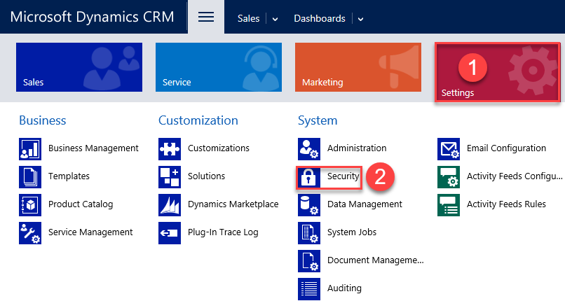

Click ‘Security Roles’.
Select the Security Role you wish to modify. In this case this will be ‘Salesperson’.
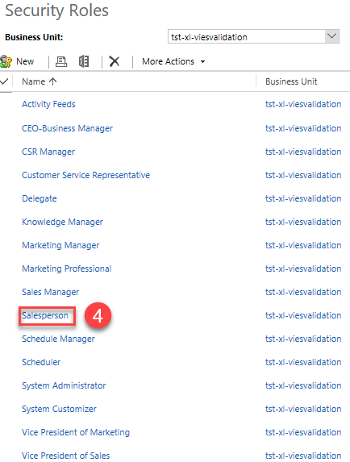
Navigate to the ‘Custom Entities’ tab and select the ‘Read’ privilege for both ‘App Setting’ and ‘Country’
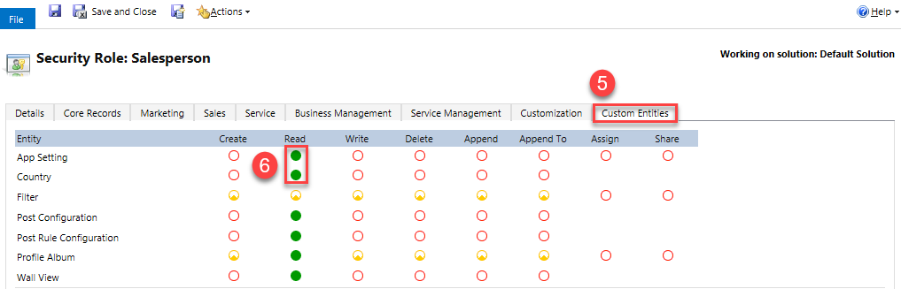
Click the save icon in the top left corner.
The next step would be to create the ‘Enterprise Number’ field and the ‘VAT number’ field, then add them to the Account form.

Add or Configure the Enterprise number Field
The VIES validation for Belgian customers needs an enterprise number. This field is not created by the solution and is required. If you do not already have this field in the system, create a new textfield called ’Enterprise Number’ and copy or remember the name.
To create a field, navigate to Settings > Customizations.
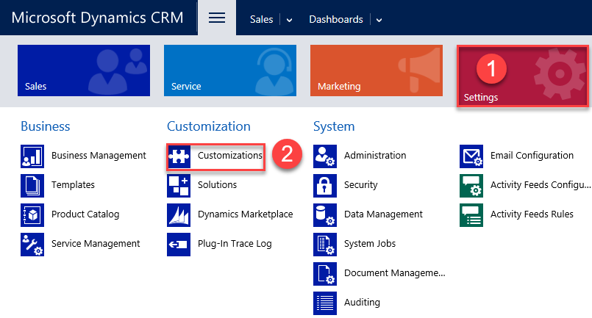
Click “Customize the System”
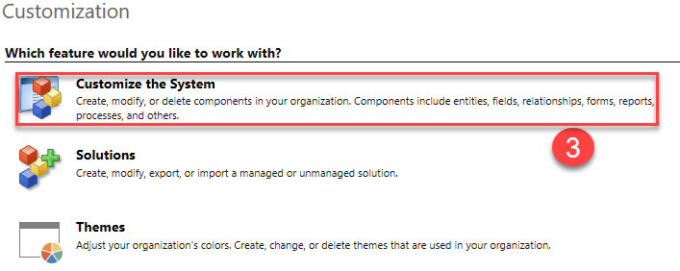

Navigate to Entities > Account > Fields and click on ‘New’ to create a new field.
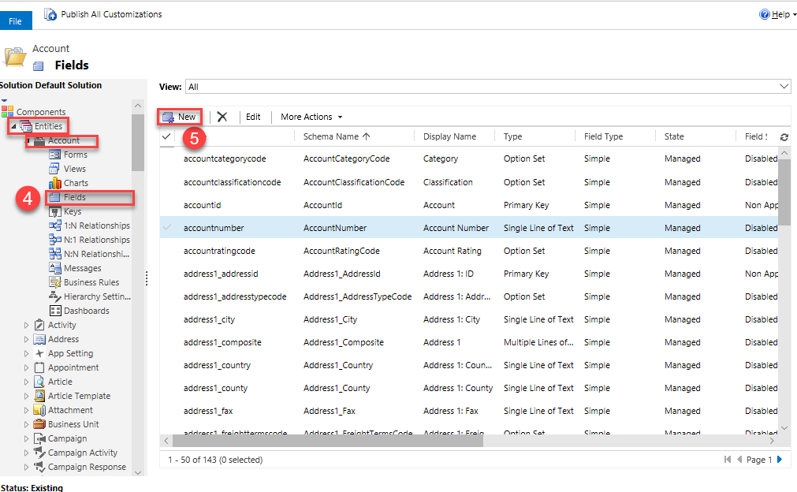

Fill in the display name and click the save icon in the top left corner to save the field. Try to remember or copy the name with the correct prefix, as you will need this later.
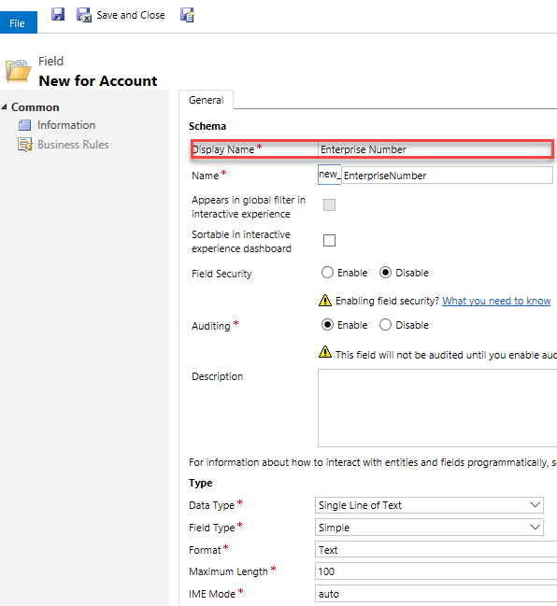

Add or Configure the VAT Number Field
Using the same method, create a new field, this time with the name “VAT Number”,then click the save icon in the top left corner to save the field. Try to remember or copy the name with the correct prefix, as you will need this later.
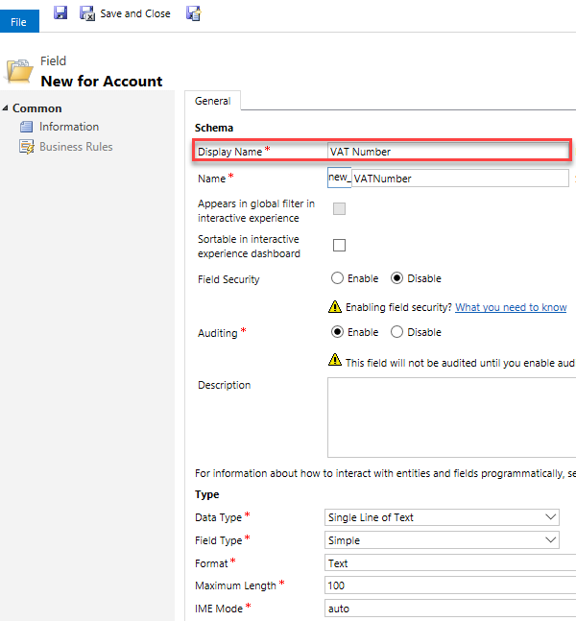

Add the Fields to the Form
After creating the fields, you will need to add them to the ‘Accounts’ form.
Go to an Account and click ‘Form’ to customize the form.
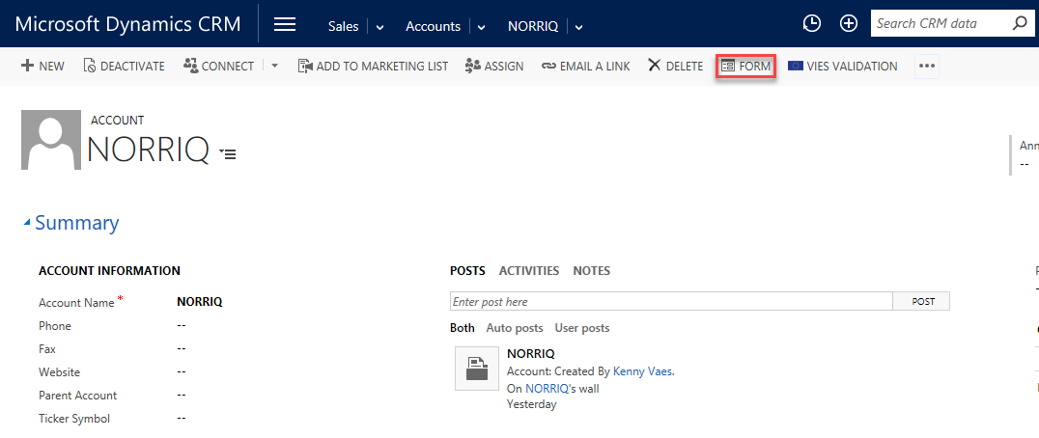

The form editor will open. Drag and drop the fields ‘Enterprise Number’ and ‘VAT Number’ to your desired location on the form. Then click ‘Save’ and ‘Publish’ to make the changes visible.
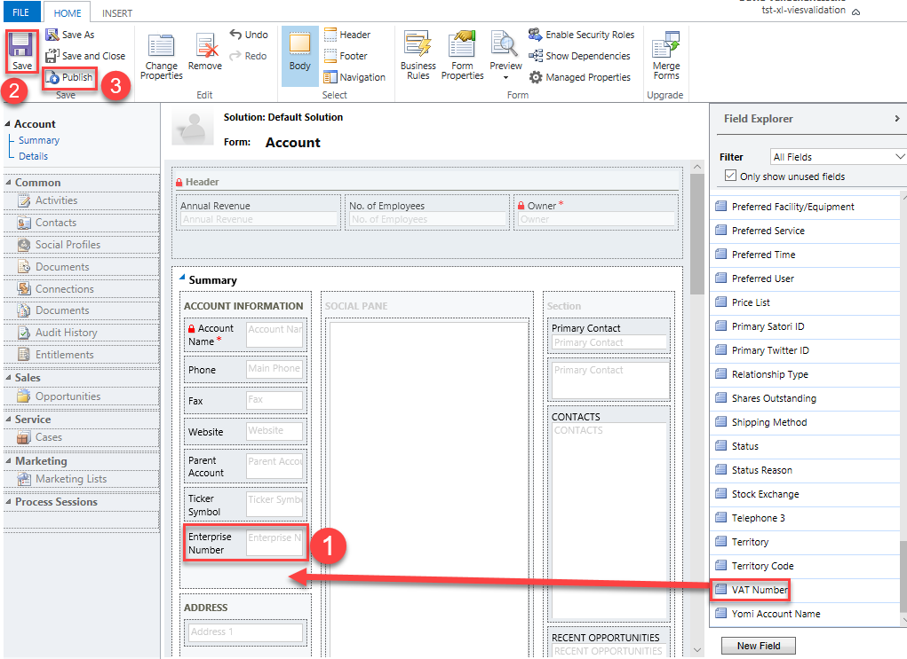

Do the VIES validation setup
To enable VIES validation, navigate to Settings > Solutions and open the ‘CrmXlVatViesValidation’ solution.
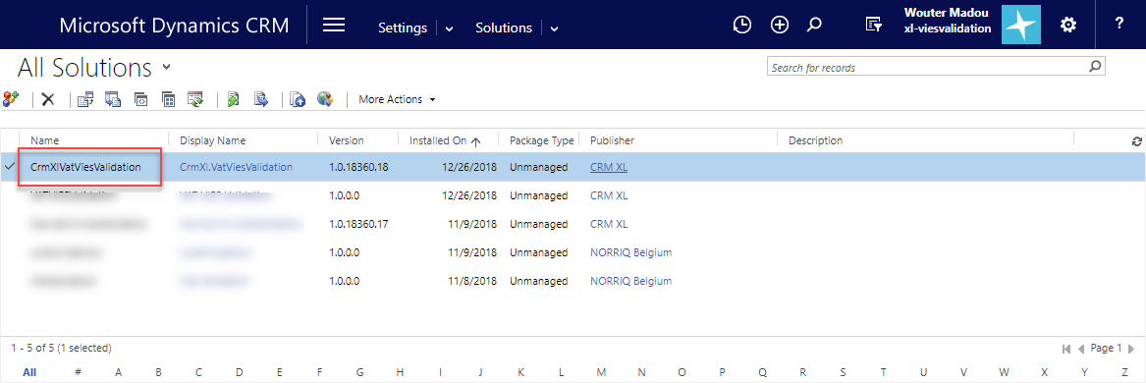
In the Configuration screen, make sure the ‘enabled’ checkbox is ticked, fill in the correct field names and the following URL’s. Use lower case in the field names, otherwise an error might occur.
VIES URL: http://ec.europa.eu/taxation_customs/vies/
Vies Response URL: http://ec.europa.eu/taxation_customs/vies/vatResponse.html

Lastly, click ‘Save’ to end the setup.
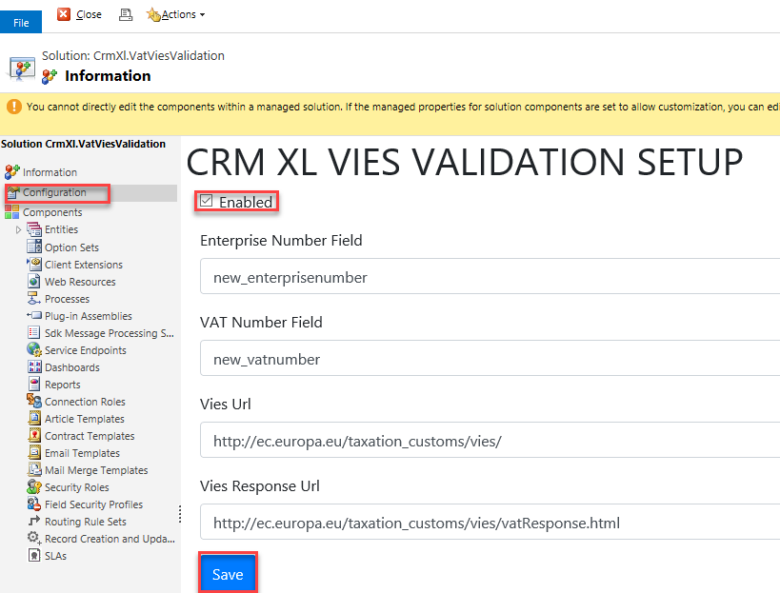

Troubleshooting

I keep getting the error stating that the fields are not found.
Make sure you have added the fields for VAT number and Enterprise Number to the account form. Also make sure that the Field names are setup in the VIES Validation Configuration page. Do not enter the Schema name, but use the lowercase field name for this configuration.

How does the VIES Validation know which memberstate it needs to use.
We opted not to add the Country lookups on the account form as most companies already use their own country entity or option sets. The VIES Validation button will use the contents of the default country field used by Dynamics 365 to look for the ISO country code in the crmxl_country entity.
This lookup is done using the text value of the address1_country field. So if your company is using a country lookup or optionset, make sure that the default Dynamics 365 country field is also filled.
If your system supports translated values, make sure that any possible language supported by your system is added to the crmxl_country entity. The default installation comes with a list of countries in English.
For more structured Address data, please have a look at CRMXL’s structured address solution.

