Free Trial Manual

Mathilde Verbrugge
CRM Partners BV
Baron van Nagellstraat 136m 3771 LL Barneveld
[Publish Date]

Introduction
This User Manual contains all essential information for you, the user to make full use of the free trial of the AgriLife environment from the Microsoft AppSource. This manual includes a description on how the set up the Free Trial version, and all the essential information about working with AgriLife using screenshots and external links. If you have any questions, don’t hesitate to mail our contact Mathilde Verbrugge: Mathilde.verbrugge@crmpartners.com

Index
1. Create a Free Trial Dynamics 365 environment
2. Create a Free Trial AgriLife account
3. Working with AgriLife

Free Trial Dynamics 365
In order to be able to use the AgriLife free trial, you should first have a Dynamics 365 environment where you can install AgriLife. If you do not have a Dynamics 365 environment yet, please use the below steps to create a free trial.

- Use the following link to navigate to the Microsoft Dynamics 365 Trial request page
https://signup.microsoft.com/Signup?OfferId=bd569279-37f5-4f5c-99d0-425873bb9a4b&dl=DYN365_ENTERPRISE_PLAN1&Culture=en-us&Country=us&ali=1

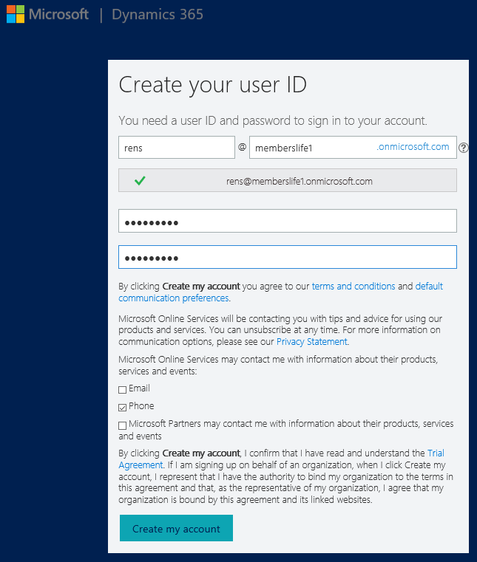
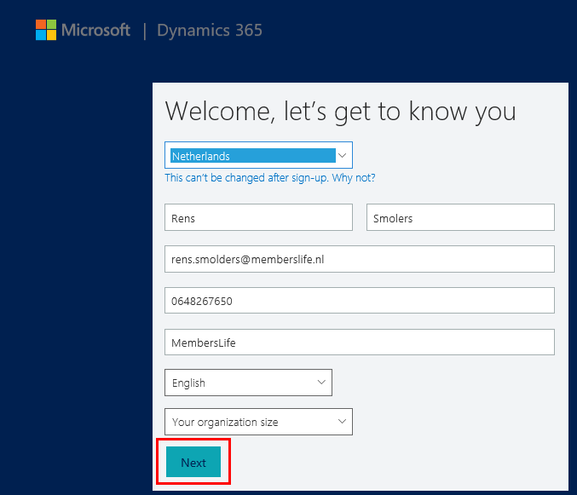
- Create an Account

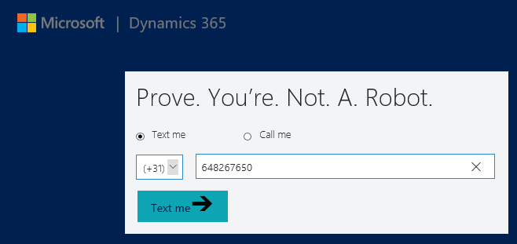
- Verify you are not a robot

- Select All of these to complete the setup

- 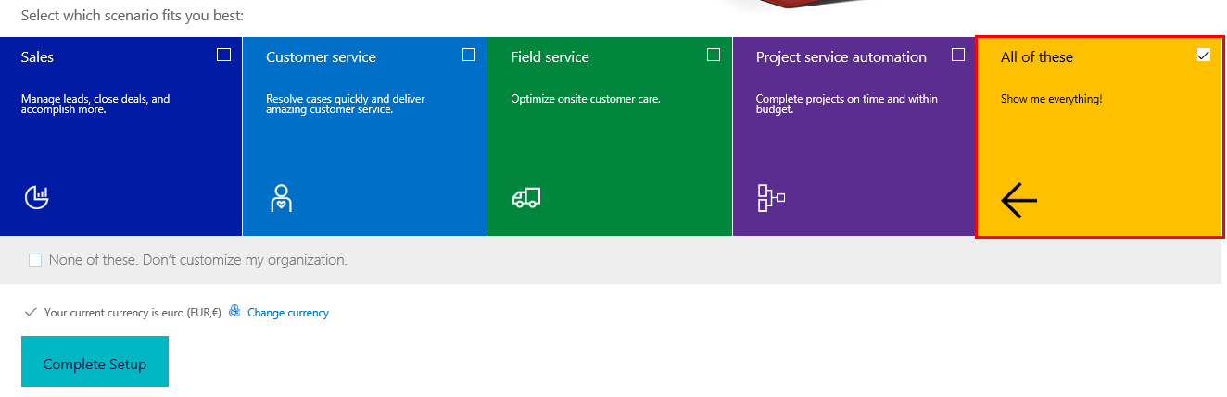

Free Trial AgriLife Account
Once you have set up your Dynamics 365 environment, you will be able to go to the Microsoft AppSource to download the free trial of AgriLife.

- Navigate to the AgriLife AppSource through the following link
https://appsource.microsoft.com/en-us/product/dynamics-365/

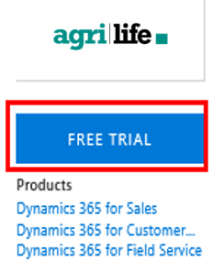
- Click on Free Trial

- Connect to the Dynamics 365 environment that you have just set up
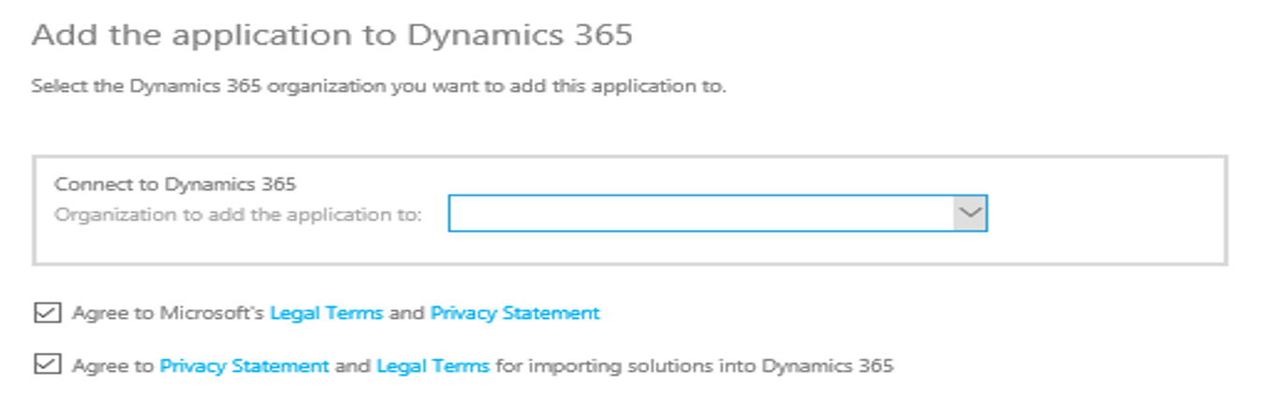
- Wait several minutes for the application to install until the status is Installed
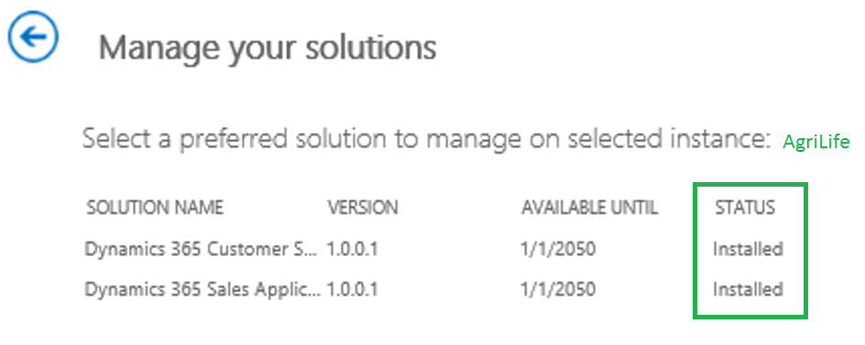
- The final step is to navigate to the Dynamics 365 environment that you have created and you will able to see and use all AgriLife components.

