User Guide

Field Service Inventory Serialization

by JourneyTEAM

Introduction
The Field Service Inventory Serialization solution from JourneyTEAM enables Dynamics 365 for Field Service for serialized inventory item tracking. From item receipt to ultimate disposition, you will track individual items through each inventory transaction with fully visible individual item history.

Licensing
A 30-day trial is available so you can examine the product in your own environment. Please see the “Register the solution” section below for details on enabling the license. Please contact us via journeyteam.com or +1(800) 439-6456 to extend serialization capability beyond the 30-day trial.

Install the solution
This solution requires the prior installation of Microsoft Field Service add-on for Dynamics 365. Installing from Appsource, the solution will automatically install.

Register the solution
As a logged in administrator, go to Settings, then Solutions. Open the FieldServiceSerialization solution (the Publisher is JourneyTeam). The solution should open to the Configuration page. On the Configuration page, press the blue “Register” button (pictured below). 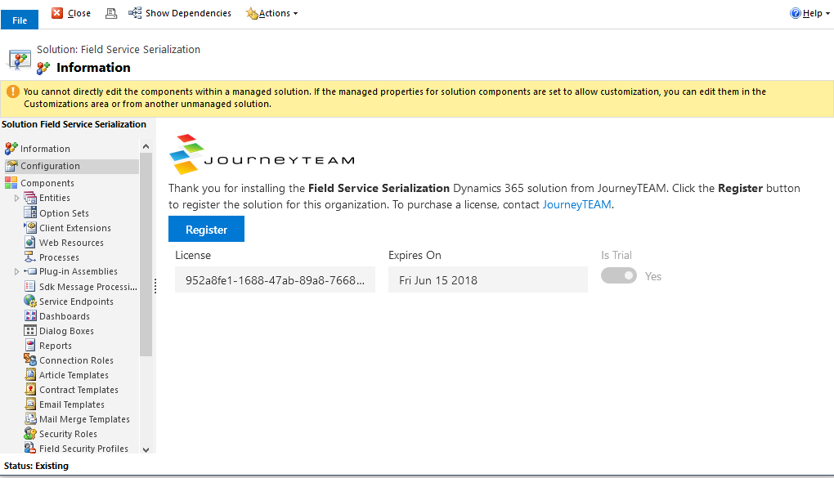
This registers the solution and your Dynamics 365 org with our licensing server. When you are ready to convert to a paid subscription, JourneyTEAM will extend the license and the new expiration date will be visible on this solution configuration page.

Sample Security Roles

Set products as serialized
In this step, you identify the individual products in the Dynamics 365 Product Catalog to begin tracking as serialized items. NOTE: When serial numbers are associated to a product, you cannot remove serialization from a product. Only apply this process to Products that you are sure you want to set as serialized.
Go to Settings, then Product Catalog. Open Families & Products, then create the product you need to serialize. To add serialization to an existing product, modify the form to unlock the Serialized checkbox control or use an extension to enable all fields.
Check the Serialized checkbox. Once this is set, inventory transactions for this product will require each transaction to be tied to serial numbers.
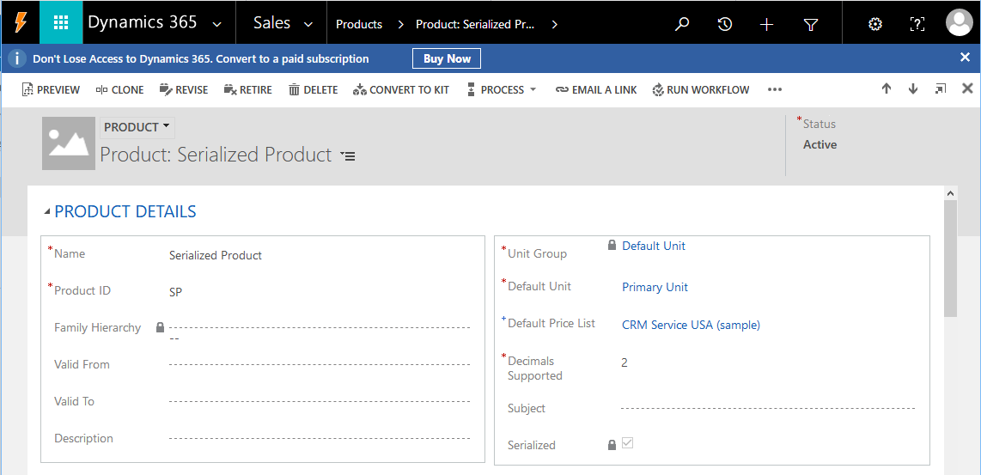
There are several ways to create serial numbers for later transactions. You may already have an inventory of serial numbered items. In this case, begin by adding existing serial numbers. Otherwise, you can also add new serialized items by receiving them on a purchase receipt, or by way of an inventory adjustment.

Serial Numbers
A Serial Number is a record of an individual serial numbered item. For example, for the Serialized Product pictured above, a specific unit of Serialized Product might have a serial number “UK374999”. This record displays the serial number, the related product, whether the item is on hand or allocated to a work order, and the related Inventory Journals Serialized records.

Inventory Journals Serialized
An Inventory Journal Serialized is a record relating a Serial Number to an Inventory Journal.

Adding existing serial numbers in inventory
Existing serial numbers can be added by way of import. Go to Settings, then Data Management. Go to Templates for Data Import and download the Serial Number template. In the template, fill in the Serial Number, Product, Product Inventory, Warehouse, and set Is On Hand = yes for each item you already have on hand and for which you want to add a serial number. Import this filled template.

Purchase Receipt
Serial Numbers can also be added by way of Purchase Receipt. Receiving a serialization-enabled Purchase Order Product will bring up the Serial Numbers dialog. In this dialog (pictured below), you add and choose serial numbers to complete the transaction. Add the new serial numbers you are receiving in the Selected Serials | “New serial” field highlighted below. Once the Purchase Order Receipt is completed, the new serial numbers will be created and you can track these newly received items throughout your Field Service inventory transactions.
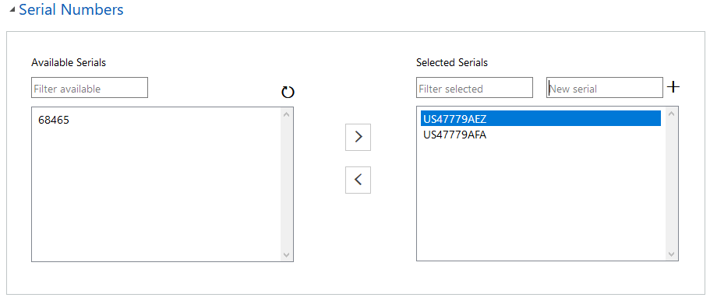

Inventory Adjustment, Inventory Transfer
Inventory Adjustments can be used to add and remove serial numbered items from inventory. Serial Numbers can be added by way of Inventory Adjustment in the same way as a purchase receipt (pictured above). If you are adjusting the quantity of a serialized product downward, meaning you are reducing reported inventory to match your inventory count, enter a negative value in the quantity field. The dialog appears (pictured below) having its left side populated with the in-stock serial numbers you can select for removal from inventory. When this transaction is complete, the serial number will no longer be marked Is On Hand and an Inventory Journal will be linked to the negative quantity Inventory Adjustment record.
Inventory Transfers move inventory from the source to the target Warehouse. There is no ability to add or remove Serial Numbers from inventory using an Inventory Transfer. When transferring a serial-enabled Product, you select the specific Serial Numbers to be moved using the Serial Numbers dialog (pictured below).
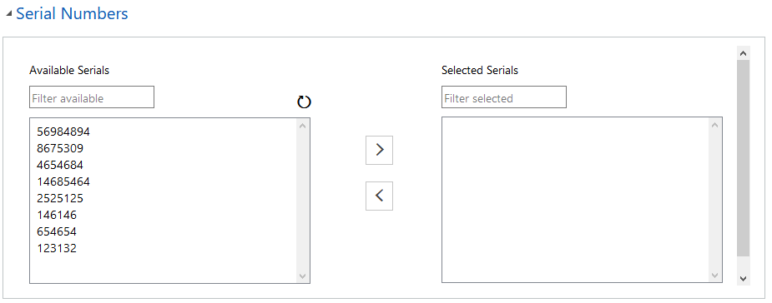

Work Order Product-- Allocation, Use and Transfer
You will interact with Serial Numbers on Work Order Products in the following three ways.
Allocate Work Order Products in Estimated status can reserve a specific Serial Number to be used to complete the Work Order. This reservation is called an allocation and results in an Inventory Journal and the Serial Number being unavailable to other Work Orders. To allocate a specific Serial Number to a Work Order Product, set Allocated = Yes and select the Serial Number using the familiar Serial Numbers dialog.
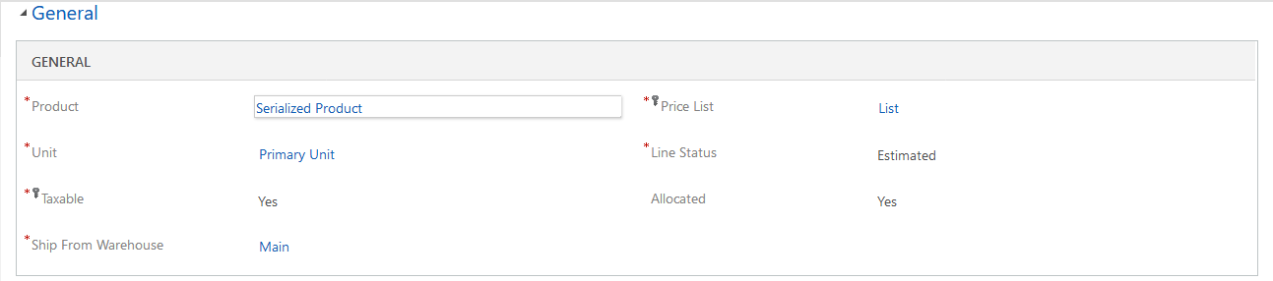
Use Work Order Products can be marked with Line Status = Estimated or Used. When a serialized Work Order Product is marked as Used, you must select Serial Numbers from the Serial Numbers dialog to match the number of units used. Once Serial Numbers are assigned to a Used Work Order Product, they are no longer marked as on-hand and are not available for further inventory transactions.

Transfer Work Order Products’ Product and sufficient Quantity must be present in the Ship From Warehouse before they can be used. This solution includes the capability to requisition the product from a warehouse that has the product on hand. In the Request Product, set Requisition = Yes and select the desired warehouse in Transfer From. Only warehouses having available product on hand will be listed. Click the TRANSFER INVENTORY button to create an Inventory Transfer transaction moving product from the Transfer From warehouse to the Ship From Warehouse. See the image below for the location of these fields and button.
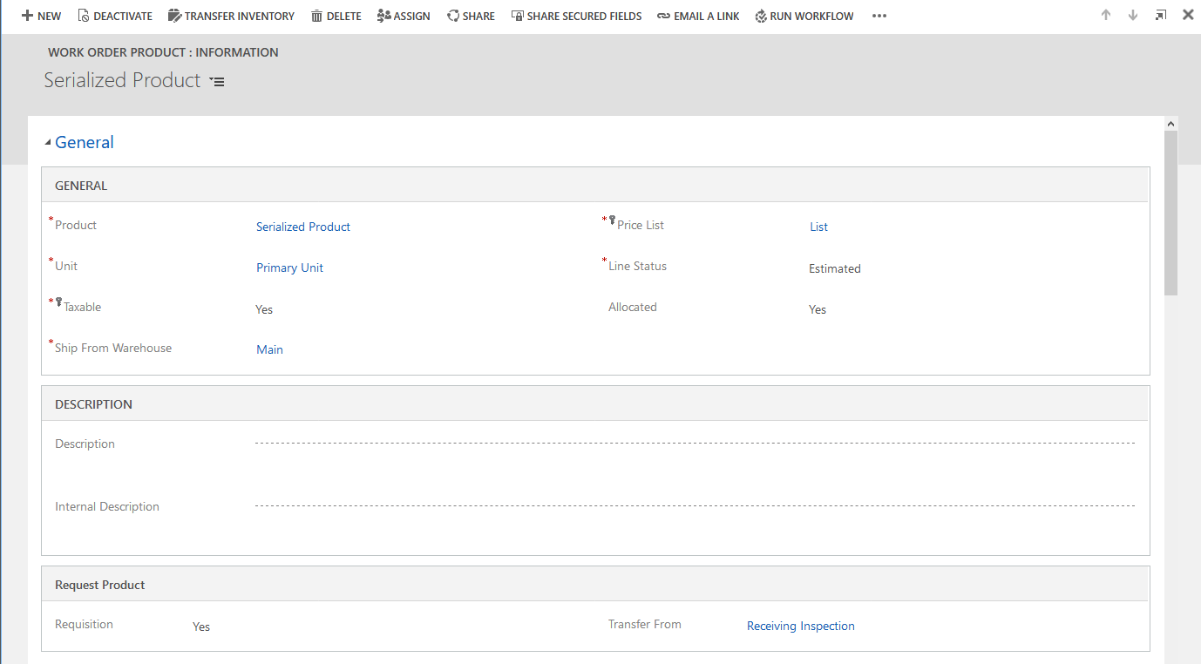

RMA Product Receipt
When you receive a serialized product as part of a RMA, you are required to select the Serial Number being received. This could be an existing Serial Number already stored in Dynamics 365, or could be a new one that needs to be created. Use the familiar Serial Numbers dialog (pictured below).
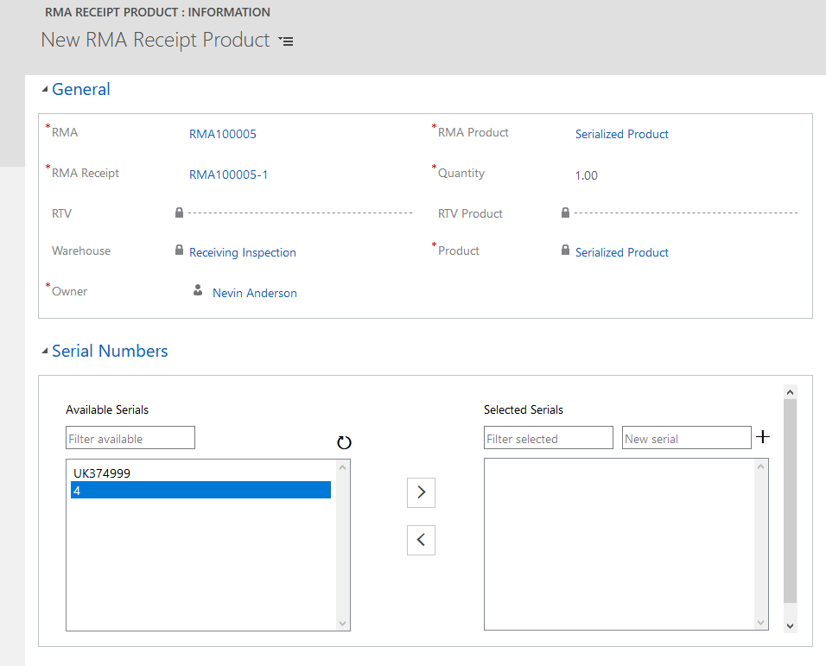

Warehouse, Serial Numbers
You can see Serial Numbers present within the various Warehouses in the Serial Numbers section of the Warehouse:Information form (pictured below).
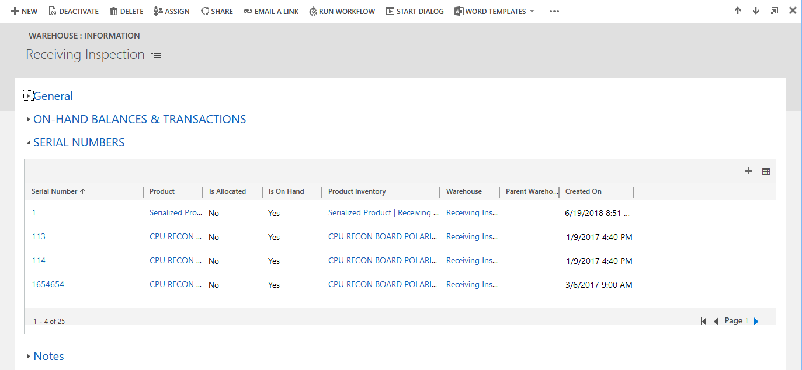

Serial Number, Inventory Journals Serialized
From within the Serial Number record, there is complete visibility of all the related Inventory Journals Serialized. This allows you to track each inventory transaction relating to this Serial Number.
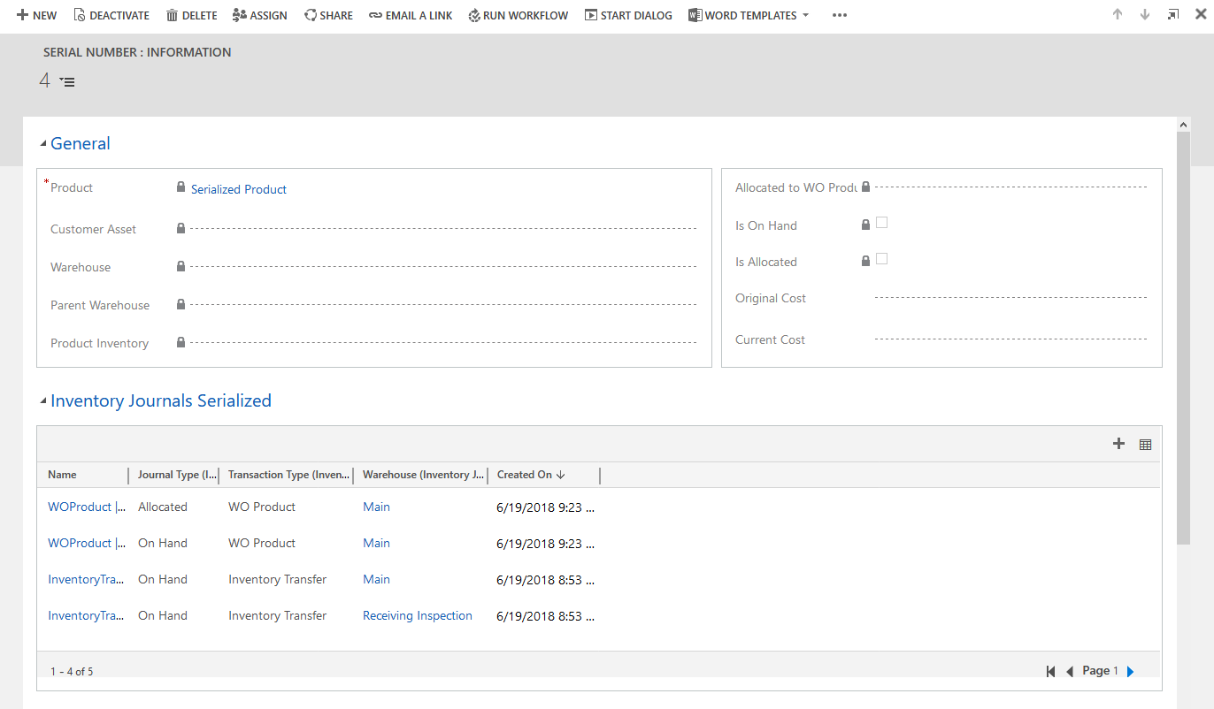

Contact
Please contact JourneyTEAM for technical support and product questions.
http://www.journeyteam.com
info@journeyteam.com
+1 (800) 439-6456

